RESISTANT STARCH-A PROMISING FUNCTIONAL INGREDIENT

Archana Y. Kalal¹, Udaykumar Nidoni², Sharanagouda Hiregoudar² and Pramod Katti³

¹Ph. D. (Agril. Engg.), Dept. of Processing and Food Engineering, College of Agricultural Engineering, University of Agricultural Sciences, Raichur-584102
²Professor, Dept. of Processing and Food Engineering, College of Agricultural Engineering, University of Agricultural Sciences, Raichur-584102
³Professor and Administrative Officer, University of Agricultural Sciences,
Raichur-584102, Karnataka
Abstract
Starch and components of plant cell walls make up the polysaccharides found in food. The human body uses energy mostly from carbohydrates, which are consumed before energy from proteins and lipids. The main form of carbohydrate found in the majority of foods is starch. The two main components of starch are amylose and amylopectin. Raw starch is indigestible, and heating greatly increases the digestibility of starch. After cooking, the majority of the starch is digestible, but some portions are still difficult to digest (Raigond et al., 2015). Starch is categorised into three classes according to how easily it may be digested: easily digestible starch, moderately resistant starch, and resistant starch. "Resistant starch" (RS) is the term for the portion of dietary starch that does not break down or absorb in the small intestine but instead ferments in the colon to produce short-chain fatty acids (SCFA). Starch can be categorised into type A, type B, type C, and type V based on their X-ray diffraction patterns. As per the definition and physical characteristics of RS, there are four subtypes that can be distinguished: RS1, RS2, RS3, RS4, and RS5 (Englyst et al., 1992; Nugent, 2005; Sajilata et al., 2006).
RS is the portion of ingested starch that is partially hydrolyzed but not entirely broken down, escapes via the small intestine, and enters the large intestine. It is calculated as the difference between the amount of starch hydrolyzed by amylolytic enzymes and the amount of glucose (made as the equivalent amount of starch) produced by these enzymes. According to the RS content, which ranges from minimal (1.0%) to extremely high (>15.0%), the food components are categorised. These include different cereals, pulses, fruits, vegetables, and their by-products (Goni et al., 1996).
The determination of RS in raw and processed foods is required in order to give nutritional information to consumers and others. In order to effectively apply research findings on RS for food processing and nutritional applications, analytical methods for the determination of RS need to be compared. A standard procedure for estimating total and resistant starch from foods was devised (Englyst et al., 1992). RS is becoming increasingly essential not just for its functional qualities, but also for its nutritional value (Raigond et al., 2014). Because of its beneficial qualities such as swelling, viscosity increase, gel formation, and water binding capability, RS can be employed in a wide range of food products (Fausto et al., 1997).
The food industry is looking at new ways to manufacture functional foods with added health advantages in order to meet the rising demand for such products. RS is a high GI food with a low-calorie content and a number of health advantages, including a good impact on gut flora, blood cholesterol, GI, and even diabetes management. It is a fortification tool that can be used to create low GI foods (Raigond et al., 2015). There are several methods available to alter the GI and rate of starch digestion. These methods include the addition of little or no sugars to essential functional components, the formation of starch-lipid complexes, or the use of processing procedures as moisture heat treatment or extrusion.
RS is added to food to enhance its physical qualities, including its texture, ability to retain water, processing stability, and nutritional value. In order to preserve the nutritional performance of foods containing RS, the stability of RS during processing is crucial (Thompson, 2000). There are several ways to make RS, including heat treatment, enzyme, enzyme heating, and chemical. The first commercial RS is made available by Starch Australia Ltd. as Hi-Maize. CrystalLean® (RS3), Novose® 240 (RS2), Novelose® 260 (RS2), Novelose® 330 (RS3), Eurylon® (RS2), Amyloomaize VII (RS2), and Neo-amylose (RS3) are further commercially available RSs (Raigond et al., 2014).

Keywords: Resistant starch, Digestibility, Glycemic index (GI), Enzymes, Acidification,
Esterification, Hi-Maize, Novelose
- Introduction
The body uses carbohydrates as its primary source of energy before using proteins and lipids. The primary source of carbohydrates in the majority of foods is starch. Amylose and amylopectin, the two primary components of starch, can be found in varying amounts in various plants and foods. The proportion and arrangement of these two molecules in starch grains determine the quality of the starch (Bello-Perez and Paredes-Lopez, 2009). Starch cannot be digested while it is in its raw form, however during cooking, it becomes significantly more digestible. After cooking, the majority of the starch is digestible, but some of it is still indigestible. The portion of dietary starch that does not get digested and absorbed in the small intestine but instead gets fermented in the colon and turns into short-chain fatty acids (SCFA) is called as "resistant starch" (RS).
Starch
Granular starch (Greek amylon) is present in the endosperm of grains and legumes, tubers (potatoes and sweet potatoes), unripe fruits (bananas and mangoes), and storage organs of several other plants. Depending on the plant source, starch is the most prevalent storage polysaccharide and comes in a variety of shapes, including round, oval, lenticular, and angular, with a grain size that typically ranges between 1 and 100 µm. Starch granules are made up of numerous monosaccharide or glucose molecules linked together by α 1-4 and α 1-6 bonds. Amylose and amylopectin are the two main components of starch. Amylopectin is a branching polymer with a degree of polymerization of up to 2 million, whereas amylose is a linear glucose chain with a degree of polymerization of 6000.
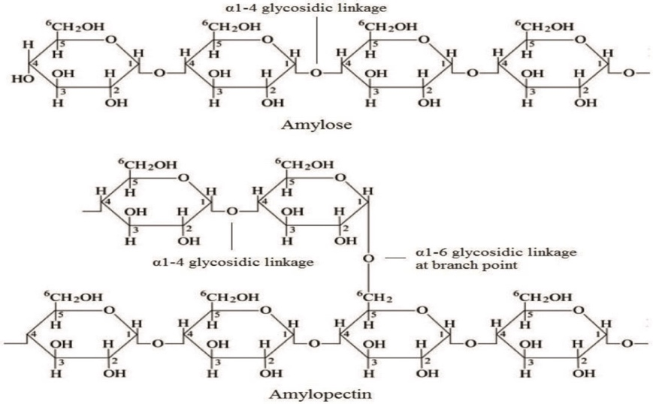
Fig. 1: Amylose and amylopectin structure in starch
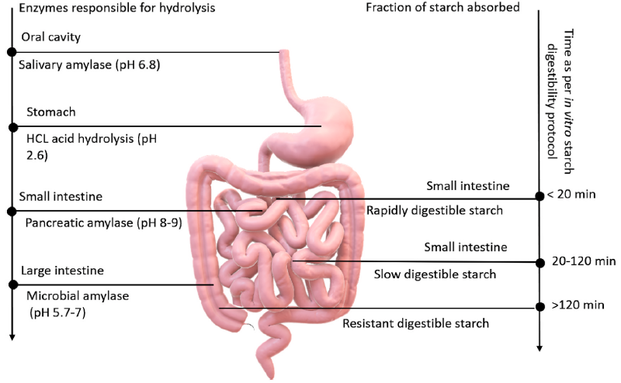
Fig. 2. Schematic illustration of starch hydrolysis and absorption of various starch fractions (Kaimal et al., 2021)
Diagrammatic illustration of in vitro starch hydrolysis kinetics simulating the in vivo digestive system of human being. Rapidly digested starch (RDS), slow digestible starch (SDS), and resistant starch (RS) are the three types of starch fractions. The oral cavity is where salivary amylase breaks down starch into maltose units, and the bolus proceeds to the stomach, where the enzymes are inactivated (due to the acidic environment). Carbohydrates are not broken down in the stomach, therefore the bolus is transported to the small intestine. The RDS portion is completely digested in the small intestine's jejunum, whereas the SDS portion is processed farther up to the ileum. Pancreatic amylase breaks down the RDS and SDS portions in the small intestine. After escaping digestion in the mouth, stomach, and intestine, RS goes to the large intestine (colon), where the gut microbiota SCFAs breakdown, ferment, or biotransform RS granules into short-chain fatty acids (SCFAs).

2. Starch classification
I) Based on enzyme action
In the digestive system, amylolytic enzymes are active, which causes starch to go through hydrolysis. Starches are categorised according to the rate and amount of digestion as well as their physiological qualities. Starch is classified into three types: rapidly digested starch (RDS), slowly digestible starch (SDS), and resistant starch (RS) (Englyst et al., 1992).

Table 1: Classification of starch (Englyst et al., 1992)
Starch fraction | RDS | SDS | RS (Type 1-4)
In vitro digestion location and timeline | Mouth and small intestine within 20 minutes | Small intestine, 20-120 minutes | major action in colon, not small intestine. It takes >120 minutes for digestion
Example | Fresh prepared food | Waxy native maize starch, millet, and legumes | Raw potato, stale bread
Amount (g/100 g) | Boiled hot potato: 65 | Boiled millet: 28 | Raw potato starch: 75
Physiological property | Rapid source of energy | a slow, consistent energy source that maintains blood glucose levels | Effects on digestive health (e.g., prebiotics, butyrate fermentation with potential anticarcinogenic effects)
Starch structure | Mainly amorphous | Amorphous/crystalline | Depending on the kind, mostly crystalline

II) According to X-ray diffraction
Starches are categorised into four major groups based on X-ray diffraction patterns. Type A: In amylopectin, this structure has a chain length of 23-29 glucose units. This form includes a double helix packing and 4 water molecules for every 12 glucose residues (Lebail et al., 2000). A-starch is mostly present in grains. Type B: This structure in amylopectin has a chain length of 30-44 glucose units. Type B contains a loosely packed double helix with 36 water molecules per 12 glucose residues (Lebail et al., 2000). Tuber and banana starch follow this natural pattern. Type C: Amylopectin with a chain length of 26-29 glucose molecules makes up the type C structure, which is found in peas and beans. Type V: A single-helical structure generated by amylose complexed with lipids or other agents (Zobel, 1988; Lebail et al., 2000).
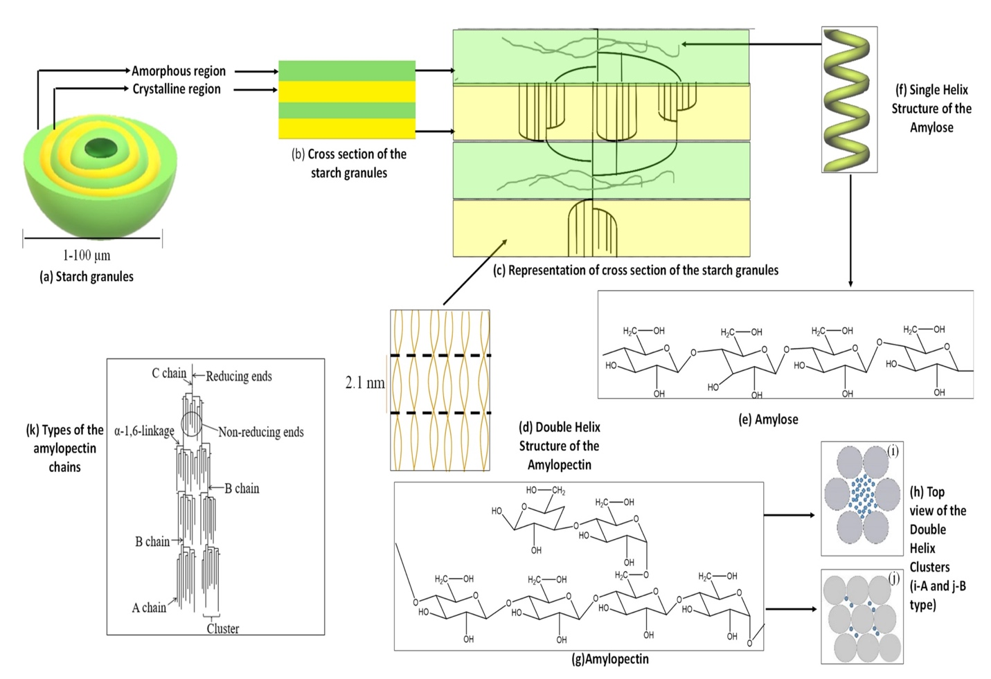
Fig. 3: Schematic illustration of the (a) Starch granules; (b) Cross section of the starch granule; (c) A representation of the cross section of the starch granules; (d) Double helix structure of amylopectin; (e) The structure of amylose; (f) Single helix structure of amylose; (g) The structure of amylopectin; (h) Top view of the double helix clusters: (i) A type, (j) B type, and (k) Types of amylopectin chains.
Starch is primarily composed of amylose (80%), amylopectin (20%), lipids, proteins (0.6%), and trace amounts of minerals (0.4%) (Alcazar-Alay et al., 2015). The amount of amylose and amylopectin varies depending on the starch source (Bertolini, 2009). Unlike amylopectin, which is soluble in water (Bertolini, 2009), amylose is not soluble in water. Starch also contains trace amounts of "intermediate compounds" that exhibit qualities intermediate between amylose and amylopectin (Vilaplana et al., 2012). Amylose has a molecular weight of around 10⁵-10⁷ Da, whereas amylopectin has a molecular weight of 10⁷-10⁹ Da. Furthermore, the intermediate molecule has a lower molecular weight than amylopectin but a higher molecular weight than amylose (Vilaplana et al., 2012). Starch granules are made up of alternating layers of amorphous and crystalline lamellae with a thickness of 100 to 400 nm (BeMiller and Whistler, 2009). The density of starch grains measures approximately 1.5 grams per cubic centimeter. These granules typically exhibit diameters ranging from 1 to 100 micrometers, as depicted in Figure 3a. Their shapes can vary widely, ranging from regular forms like spheres, ellipsoids, and angular structures to highly irregular shapes (Bertolini, 2009). Furthermore, the morphology, dimensions, internal structure, and chemical composition of starch grains are intricately linked to their botanical origins (Alcazar-Alay et al., 2015). However, the strong hydrogen bonds formed among starch chains render starch granules insoluble in cold water and at room temperature
(BeMiller and Whistler, 2009). This property is illustrated in Figure 3b, where one can observe alternating layers comprising crystalline and amorphous lamellae. As depicted in Figure 3c and d, the crystalline lamellae within starch granules consist of clusters formed by double-helical amylopectin side chains. In contrast, the amorphous lamellae are made up of branching sections containing both amylopectin and amylose chains (Bertolini, 2009). Amylose, as shown in Figure 3e (Bertoft, 2017), is composed of D-glucose units linked by α-1,4-glycosidic bonds and features small branches within its structure.
Typically, under the influence of complexing agents, amylose tends to form single-helical complexes, as shown in Figure 3f (BeMiller and Whistler, 2009). On the other hand, amylopectin comprises α-D-glucose units interconnected by α-1,4 and α-1,6-glycosidic bonds, as depicted in Figure 3g (Bertolini, 2009). Notably, amylopectin's linear chains are comparatively shorter when compared to amylose chains. Additionally, amylopectin exhibits a significantly higher degree of branching in contrast to amylose (Bertolini, 2009). Moreover, Figure 3d illustrates that the degree of polymerization (DP) for these outer strands typically ranges from 10 to 20. This is because the two strands together form a double helix, featuring 6 glucose units per turn per strand and a pitch of 2.1 nm (Bertoft, 2017). These double helices are approximately 4–6 nm long and can crystallize in one of two polymorphic forms referred to as the A-form or the B-form (Bertoft, 2017). As presented in Figures 3h, i and 3h, j, the A-type is characterized by a monoclinic unit cell containing 8 water molecules, while the B-type comprises a hexagonal unit with 36 water molecules (Bertolini, 2009).
Further, as illustrated in Figure 3k, the structure of amylopectin comprises three distinct chain types referred to as A, B, and C (Bertolini, 2009). Chain A is attached solely to the α-D-glucose unit at the reducing end, without binding to another chain. The B chain, in contrast, connects to either the A chain or another A or B chain through one or more hydroxyl groups
(-OH) present in the amylopectin chain. Typically, the reducing end group is held by the C-type chain (Bertolini, 2009). The physicochemical properties of starch primarily hinge on the amylose-to-amylopectin ratio. One such property is the glass transition temperature (Tg), which characterizes the temperature at which these polysaccharides shift from an amorphous state to a viscous state (Alcazar-Alay et al., 2015). At the Tg, the polymer material undergoes a transition from a rigid, brittle state to a more pliable and flexible state. Due to the presence of both amorphous and crystalline regions within starch, determining its precise Tg is a complex endeavor (Alcazar-Alay et al., 2015).

- Why Resistant starch?
Many foods rich in carbohydrates typically cause an increase in blood sugar levels. The glycemic index (GI) is a system that ranks foods based on their impact on blood sugar levels, with high-GI foods being associated with health issues like diabetes and obesity. Therefore, there is a growing demand for the creation of functional foods that are low on the GI scale. Given the inverse relationship between GI and resistant starch (RS), nutrition experts are exploring the incorporation of RS as a fortifying agent to reduce the GI of foods. In the development of functional foods, fortification offers a cost-effective means of delivering specific components, such as RS, to target populations. RS is naturally found in various plant sources, presenting valuable opportunities for its utilization as a functional ingredient (Raigond et al., 2015).
Resistant Starch
The term "resistant starch" was first introduced by Englyst et al. This designation refers to a subset of starches that exhibit resistance to hydrolysis when subjected to in vitro treatments involving α-amylase and pullulanase enzymes (Englyst et al., 1992). Resistant starch (RS) distinguishes itself by evading digestion and absorption within the small intestine and instead undergoing fermentation in the large intestine. RS primarily consists of a linear α-1,4 D-glucan molecule, primarily derived from retrograde amylose found in cooked starchy foods. The process of starch digestion is influenced by a multitude of factors, all intricately interconnected, which adds complexity to our comprehension of the resilient characteristics of starch.
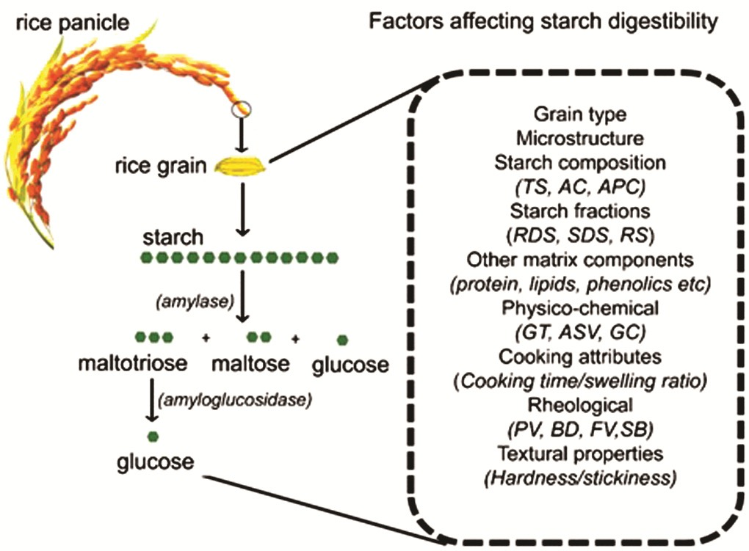
Fig. 4: Process of starch breakdown within the body and the multitude of factors influencing it (Rahaman et al., 2020)
The mechanisms involved in starch hydrolysis within the human body and the various factors that influence this process. Rice, which contains approximately 78% to 89% starch, undergoes hydrolysis through a two-stage process. In the accompanying figure (on the left), the actions of glycolytic enzymes, including amylase and amylglucosidase, are illustrated. In Step 1 of starch digestion, catalyzed by salivary amylase and pancreatic amylase, maltotriose, maltose, and glucose are produced. Step 2 involves the hydrolysis of these products into glucose, facilitated by brush-like disaccharide enzymes or glucosidases. The right side of the chart highlights individual factors, which often interact, affecting starch digestibility.
- Global Resistant Starch market size
The resistant starch market has witnessed a compounded annual growth rate (CAGR) of $8.46 billion in the year 2018 which is expected to increase to $12.73 billion by 2025. The CAGR of 6.1% will be witnessed during the year 2019-2025. The APAC market is anticipated to witness rapid growth over the forecast time period. Resistant Starch Type 3 finds extensive application in bakery products and is projected to experience a robust growth rate with a Compound Annual Growth Rate (CAGR) of 6.4% by the year 2025.
Fig. 5: Global Resistant Starch market size (www.gminsights.com)

Varieties and Composition of Resistant Starch
Resistant starch (RS) comprises a portion of ingested starch that undergoes incomplete digestion, entering the large intestine either in its original form or as a result of partial hydrolysis. Its quantification is derived by subtracting the amount of starch subjected to amylolytic enzyme activity from the quantity of glucose (in starch equivalent) produced through enzymatic hydrolysis (Sajilata et al., 2006).
- Types of Resistant Starch
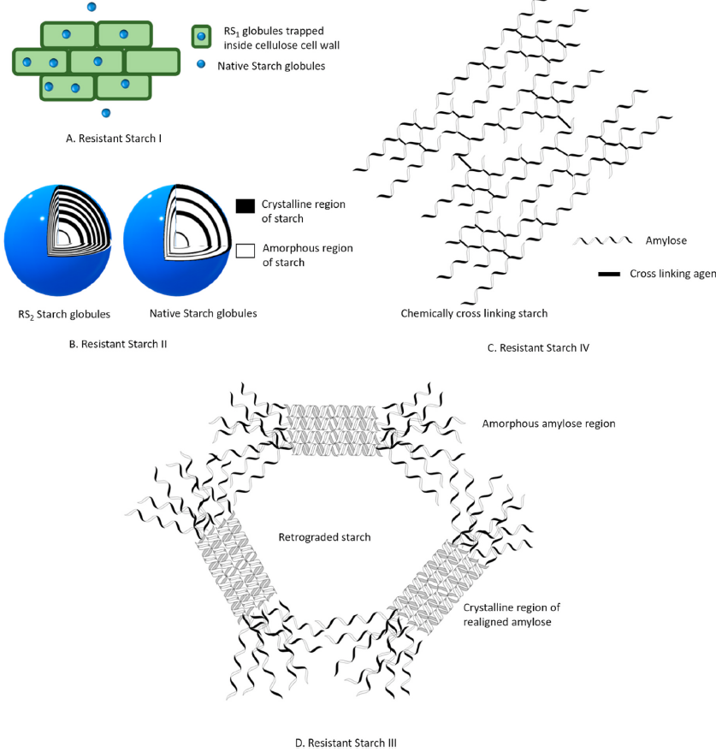
Fig. 6 Diagrammatic depiction of distinct fractions of resistant starch (Kaimal et al., 2021)
A substantial body of literature highlights various factors contributing to the resistance of starch to enzymatic hydrolysis. Based on these factors, resistant starch (RS) can be categorized into five main types: RS1, RS2, RS3, RS4, and RS5. RS1 refers to the portion of resistant starch that is embedded within the food matrix. This encapsulation within the food's structural material hinders enzymatic hydrolysis, rendering it resistant to breakdown (as depicted in Figure 5). RS1 is typically found in partially milled grains and remains resilient to heat during most cooking processes (Sajilata et al., 2006). Consequently, extensive milling may release the physically protected starch and reduce the RS1 content. RS2 represents a natural form of non-pregelatinized starch granules present in raw foods such as green bananas and raw potatoes. The radially compact crystal structure of these starch granules limits enzymatic hydrolysis, imparting resistance to digestion (as illustrated in Figure 5) (Sajilata et al., 2006). The majority of the resistant starch falls under the RS3 category, also known as retrograde starch.
Starch retrogradation is a phenomenon characterized by the recrystallization of helical amylose molecules, which occurs after cooling following the process of gelatinization. During gelatinization, these amylose molecules initially assume a random helical configuration but subsequently rearrange into a compact double-helical crystal structure, as depicted in Figure 5. These dense and impermeable structures act as barriers, impeding the access of amylolytic enzymes and thereby hindering the process of digestion (Sajilata et al., 2006). RS4 is a category of resistant starch that falls under the domain of chemically modified starches. Native starches typically undergo chemical alterations to bestow them with specific immediate physical, thermal, and functional properties (Dupuis et al., 2014). These chemical modifications, which encompass processes such as substitution, crosslinking, and esterification, create unique chemical bonds (Figure 5). Consequently, they alter the structure and solubility of starch, ultimately reducing the rate of hydrolysis (Sajilata et al., 2006). RS5 represents a complex form of resistant starch resulting from interactions between amylose and lipid compounds. These interactions involve lipid components like long-chain fatty acids and glycerol monostearate (Eliason, 1994), which render starch hydrophobic and resistant to both enzymatic hydrolysis and gelatinization (Meenu and Xu, 2019).
Table 2: Categorization of Resistant Starch (RS) Types, Dietary Origins, and Influencing Factors on their Resistance to Colon Digestion (Raigond et al., 2014)
RS type | Description of Resistant Starch (RS) Type | Source of food | Factors Reducing Resistance | Small Intestine Digestion
RS-1 | Shielded through physical means | Grains, seeds, or legumes that are either whole or partially milled. | Milling and Chewing | Gradual rate, partial extent, complete digestion achievable with thorough milling
RS-2 | Uncooked resistant granules exhibiting type B crystalline structure, undergoing gradual enzymatic hydrolysis by α-amylase | Uncooked potatoes, green bananas, certain legumes, and high-amylose corn. | Food preparation and cooking | Extremely gradual rate, minimal extent, complete digestion upon immediate cooking
RS-3 | Retrograded starch | Potatoes that have been cooked and cooled, bread and cornflakes. | Processing  Factors | Gradual rate, partial extent, digestion is reversible and improved through reheating
RS-4 | Starches that have been chemically altered through cross-linking with chemical agents | Food products containing modified starches, such as breads and cakes. | Reduce Susceptibility to in Vitro Digestion | A result of chemical modifications, can resist hydrolysis
RS-5 | Complexes formed between amylose and lipids | Food items rich in amylose content. | Resistant to α-amylase hydrolysis | Resistant to digestion

Table 3: Categorization of food materials based on their percentage of resistant starch content (per dry matter) (Goni et al., 1996)
Sl. No. | RS Range | Food materials
1 | Negligible (<1.0%) | Steamed potato (heated), Steamed rice (heated), Cooked pasta, Morning cereals rich in bran content, Wheat flour
2 | Low (1.0–2.5%) | Morning cereals, Cookies, Baked bread, Pasta, Boiled potato (chilled), Boiled rice (chilled)
3 | Intermediate (2.5–5.0%) | Morning cereals (corn flakes, rice flakes), Pan-fried potatoes, Extruded legume snacks
4 | High (5.0–15.0%) | Prepared legumes (lentils, chickpeas, beans), Fresh peas and uncooked rice, Sterilized and chilled starches (wheat, potato, maize), Starchy foods that have been cooked and then frozen
5 | Very high (> 15.0%) | Uncooked potatoes and legumes, Amylo-maize, Green bananas, Amylose with retrograded properties

- Methods of RS determination
Assessing resistant starch (RS) content in both raw ingredients and processed food products is essential for furnishing consumers and other stakeholders with valuable nutritional insights. Comparing various analytical techniques for RS determination becomes crucial to ensure that research findings on RS can be efficiently applied in food production and nutritional contexts. Presently, noteworthy disparities exist among these methodologies, particularly regarding sample preparation, enzyme selection, and the establishment of experimental conditions replicating starch digestion within the gastrointestinal system.
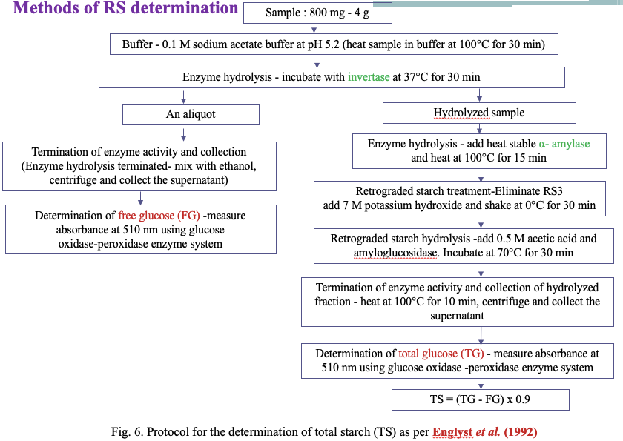
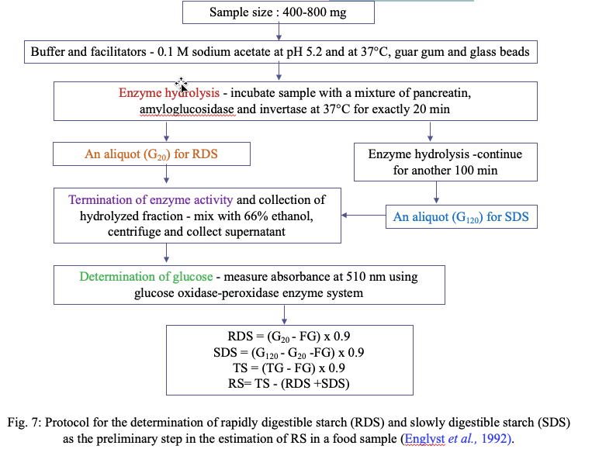
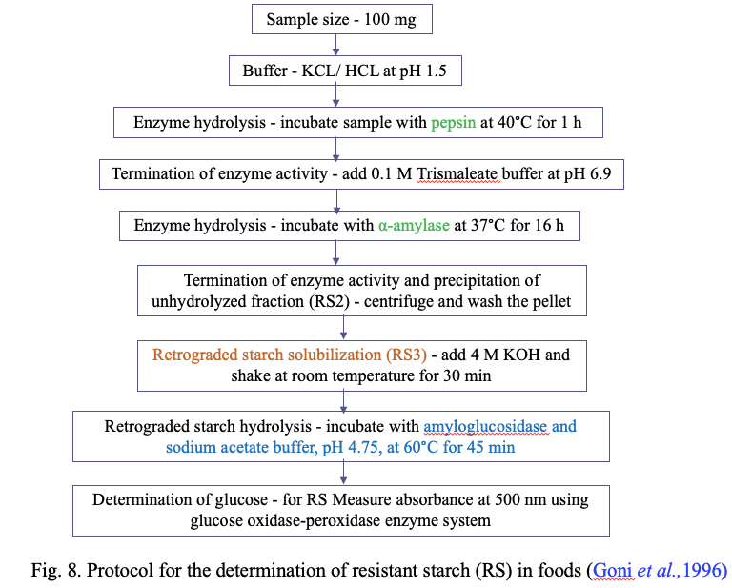
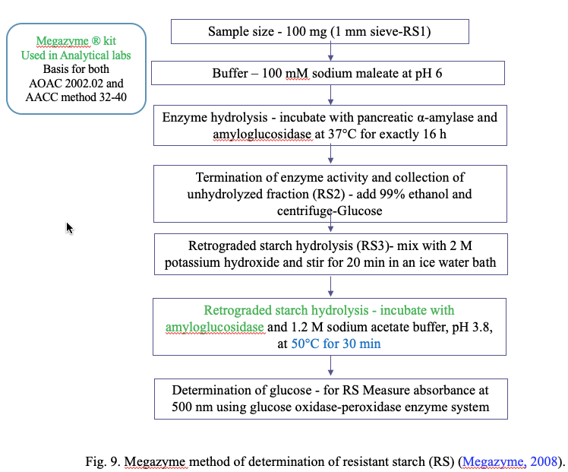
- Properties of RS
Resistant Starch (RS) has garnered attention due to its nutritional significance and functional attributes (Raigond et al., 2014). RS finds versatile application in various food products as desirable qualities, including swelling, enhanced viscosity, gel formation, and water-binding capacity (Fausto et al., 1997).
Some of its notable properties include:
- White coloration
- Elevated gelatinization temperature
- Fine particle size, resulting in minimal interference with texture
- Outstanding extrusion and film-forming capabilities
- Reduction in the caloric content of food items
- Enhancement of coating crispness in products.
- Facilitation of the creation of low-volume, high-fiber products, which exhibit improved texture, appearance, and mouthfeel, including enhanced sensory attributes compared to traditional high-fiber products (Raigond et al., 2015).
- RS Production Technologies
In response to the increasing demand for functional foods, the food industry is actively exploring innovative ways to create functional foods that offer additional health advantages. As consumers become more health-conscious and focused on nutrition, researchers and manufacturers are striving to develop functional foods that align with health-oriented goals (Aung et al., 2010). Collaborative efforts between researchers and nutritionists are concentrated on the creation of low Glycemic Index (GI) functional foods. Resistant Starch (RS), despite being a high GI food, possesses a range of health benefits, including positive effects on gastrointestinal function, gut microbiota, blood cholesterol, GI and diabetes management, and its low-calorie content. This makes RS a prime candidate for fortification, converting it into low GI foods (Raigond et al., 2015). The presence of naturally occurring sources of RS makes it an ideal functional ingredient for nutritional fortification purposes (Belo-Perez and Pardez-Lopez, 2009). Consumers are willing to invest more in RS-enriched foods to enhance their fiber intake. Various techniques are at hand to modify the GI and starch digestion speed, such as altering key functional components with low or zero sugars, forming starch-lipid complexes, or employing processing methods like moisture heat treatment or extrusion. Incorporating RS into foods serves to enhance their physical attributes, including texture, water retention, processing stability, and nutritional performance. Ensuring the stability of RS during processing is crucial to preserve the nutritional value of RS-containing foods (Thompson, 2000). Various methods are available for RS production, encompassing heat treatment, enzymatic approaches, enzyme-assisted heating, and chemical methods.
1) Heat Treatment
1.1) Heating Cooling Cycles
Repeated cycles of heating and cooling have traditionally played a significant role in the production of resistant starch (RS). Another method for RS production involves a sequence of steps: starch gelatinization, enzymatic breakdown of the gelatinized polymer, deactivation of the cleaving enzyme, and simultaneous drying, extrusion, or crystallization of the resulting product. This particular RS variant is created through the RS3 heating and cooling process. In a study conducted by Raigond et al. (2014), the impact of various cooking methods (boiling, microwave cooking, pressure cooking) followed by subsequent cold storage (at both 4 and 12 hours) for different time durations (12 hours and 48 hours) on the starch content under investigation was examined. In the case of hot boiled potatoes, when the potatoes were boiled at 4°C for 48 hours and subsequently cooled, the RS content increased to 63%.
  - ) Hydrothermal Treatment
Hydrothermal treatment involves inducing physical changes that alter the properties of starch without disrupting its grain structure. The primary hydrothermal treatments, namely Annealing (ANN) and Wet Heat Treatment (HMT), demand precise control over heating temperature and duration. These treatments are contingent upon the ratio of starch to moisture content. Annealing processing involves the use of excess water (more than 40%) and temperatures below the starch gelatinization threshold. On the other hand, Wet Heat Treatment relies on controlled humidity levels (10-30%) coupled with elevated temperatures (90-120°C) (Zeng et al., 2015). Additionally, the effectiveness of hydrothermal treatment can be enhanced through partial acid hydrolysis, resulting in the production of thermally stable granular RS. Notably, HMT represents a natural physical modification technique that is safer than chemically altering starch. In contrast, ANN processing necessitates maintaining temperatures below the gelatinization point to preserve the initial granular structure of starch. When moisture levels fall within the range of 40-60%, a combination of gelatinization and melting can cause a loss of grain structure. Enhanced grain stability, achieved through hydrothermal treatment, leads to a higher RS content (Thompson, 2000). ANN treatment is recognized for its ability to increase starch crystallinity, fortify the crystalline structure of granules, and order starch chains not only within the amorphous layer but also within the crystalline layer. These alterations enhance granule stability, diminish solubility and swelling capacity, consequently augmenting the resistance of starch granules to amylolytic enzymes (Hoover and Vasanthan, 1994). In a study by Lee et al. (2012), the highest RS yield, reaching 66.8%, was obtained using potato waxy starch (0% amylose) with a combination of 20% moisture, a temperature of 110°C, and a treatment duration of 5 hours.
  - ) Extrusion
Extrusion technology is widely employed in the food processing industry to craft a variety of food shapes. This method involves a brief, high-temperature process (HTST) that can enhance the resistant starch (RS) content in food products to some degree. During extrusion, the application of high shear forces leads to polymerization and subsequent thermal fragmentation of starch molecules. This results in the formation of a linear chain structure that is more inclined to convert into RS3 (Agustiniano-Osornio et al., 2005). In fact, the RS content of conventional corn starch saw an increase from 11% to 20% following acid hydrolysis coupled with low- or high-shear extrusion (Hasjim and Jane, 2009). Extrusion conditions, such as barrel temperature, screw speed, and shear force, yield a more significant influence on RS yield compared to starch moisture content (Dupuis et al., 2014). Notably, corn starch extrusion at moisture levels of 12-18% did not exhibit a substantial increase in RS content, whereas a moisture level of 20% resulted in a notable RS content boost. Furthermore, the source of starch plays a crucial role in RS production during extrusion. Banana starch, owing to its high gelatinization temperature and elevated amylose content, emerges as the most effective starch for RS generation through extrusion when compared to other starch types (Bello-Perez and Paredes-Lopez, 2009).
  - ) Heat and Enzyme Treatment
The production of resistant starch (RS) can be amplified by employing combinations of heat and enzymes or by conducting chemical and enzymatic modifications. Enzymes or chemical agents serve the purpose of eliminating the amorphous regions within retrograde starch. For instance, simultaneous heat and enzyme treatment involve subjecting gelatinized starch to pullulanase treatment, followed by product separation through drying or extrusion. Alternatively, RS can be generated through controlled heat treatment of starch, subsequent enzyme-assisted debranching, annealing, and drying processes. Treating gelatinized starch with debranching enzymes like isoamylase and pullulanase yields isolated amylopectin starch. This isolated amylopectin starch is employed in the formulation of low-fat foods and can be derived from any starch source containing amylopectin, such as regular corn starch or waxy corn starch. In the case of high-amylose corn starch, enzymatic cleavage followed by extrusion or drying can augment the RS content, and the addition of mineral salts or isolated starch before isolation further enhances the RS content (Sajilata et al., 2006). Moreover, debranching potato amylopectin using pullulanase before subjecting it to repeated heating and cooling cycles enhances the RS3 yield, similar to isolated corn starch (Zhang and Jin, 2011). However, for achieving a high RS3 yield from corn starch, it necessitates autoclaving the starch at 121°C for
1 hour before the debranching process.
2) Enzymatic Treatment
The enhancement of resistant starch (RS) production involves factors such as the low molecular weight of starch and the debranching of amylopectin, both of which are facilitated by the use of enzymes (Reddy et al., 2013). Specific enzymes, like pullulanase and isoamylase, exclusively target the α-1,6 glycosidic bonds at the branch points of amylopectin, cleaving these bonds. Consequently, this process increases the amylose content within the starch, leading to the formation of a robust crystalline structure responsible for starch resistance. Other enzymes, such as α-amylase and β-amylase, can also be employed to cleave α-1,4 glycosidic bonds. These enzymes act on distinct regions of the starch molecule: α-amylase cleaves all α-1,4 glycosidic bonds, leaving those near the branch points intact to release glucose monomers. In contrast,
β-amylase cleaves α-1,4 glycosidic bonds from the non-reducing end of amylopectin or amylose, resulting in the release of maltose units.
In practical RS production, pullulanase and isoamylase are more commonly utilized compared to α- and β-amylase. This preference arises because α-amylase, by breaking most
α-1,4 glycosidic bonds in starch, reduces starch paste viscosity and adversely affects crystal formation. In low viscosity starch pastes, the rapid movement of linear chains poses challenges for crystal formation (Gao et al., 2011). Hence, optimizing α-amylase activity is essential to achieve a sufficient RS yield. When determining the total dietary fiber content of RS samples with enzyme treatment, it becomes evident that the concentration of α-amylase holds greater importance compared to amylglucosidase (McCleary, 2000). Notably, α-amylase activity exhibits an inverse correlation with RS content. Poly 1,4-α-D-glucan offers another avenue for producing heat-stable, fermentable RS with optimal chain length. Additionally, pullulanase enzyme can be employed to create RS with the same baking qualities as rice starch or wheat flour. A variety of starch sources, including potato, barley, oats, sago, maize, wheat, tapioca, and arrowroot, can be harnessed for RS production through pullulanase treatment (Sajilata et al., 2006).

3) Chemical Treatment
Chemical agents are employed to hinder enzymatic access, thereby preventing the digestion of modified starch subsequent to chemical treatment. This chemical treatment leads to alterations in the molecular structure of starch and amplifies resistant starch (RS) production. The primary methods for chemically modifying starch include acidification, esterification, and cross-linking.

  - ) Acidification
The aim of acidification is to initially break down the amorphous portion of starch granules and subsequently target the crystalline regions. This process generates shorter amylopectin chains, which are then subject to degradation through autoclaving and subsequent acidification. During retrogradation, these chains rearrange to form a more ordered double-helix structure that exhibits resistance to enzymatic hydrolysis (Hoover, 2000). Several researchers have reported that acid modification followed by autoclaving and aging significantly enhances the resistant starch (RS) yield (Shin et al., 2004). Various acids, such as hydrochloric acid, orthophosphoric acid, and sulfuric acid, can be employed for starch modification (Wurzburg, 1995). For instance, Testers et al. (2004) achieved a 49.5% RS yield by subjecting lima beans (Phaseolus lunatus) to treatment with 1/60-part natural starch in hydrochloric acid at 90°C for
1 hour.
  - ) Cross-Linking
The food industry employs cross-linking techniques to enhance the functional properties, freeze-thaw stability, and storage resilience of starch pastes in refrigeration. Cross-linking strengthens and fortifies starch by introducing random intermolecular and intramolecular bonds (Acquarone and Rao, 2003). Woo and Seib (2002) elaborate on the utilization of various cross-linking methods to improve the performance of resistant starch (RS) in common starches sourced from diverse plants. These starches undergo chemical modification through multifunctional reagents that create ether or ester bonds between the hydroxyl groups of starch molecules (Singh et al., 2007). Chemically modified starches, whether in their raw or gelatinized state, exhibit resistance to enzymatic hydrolysis (Lehmann and Robin, 2007). During chemical modification, the substitution of starch hydroxyl groups with citryl, acetyl, octenylsuccinyl, and hydroxypropyl enhances starch tolerance (Xie and Liu, 2004). Starch phosphate cross-linking has yielded varying outcomes, with some researchers (Woo and Seib, 2002) reporting reduced starch digestibility and others (Chung et al., 2008) indicating altered starch digestibility. These disparities may arise from differences in starch origin, composition, and the conditions employed for starch modification.
Dual or multipurpose reagents, including sodium trimetaphosphate, phosphorus oxychloride, and mixed anhydrides of dicarboxylic acids like acetic acid and adipic acid, are employed to create networked starch. Researchers documented the use of reagents such as sodium triphosphate or a mixture with sodium tripolyphosphate for glucan cross-linking to produce RS. Various factors, including starch source, reaction parameters such as time, temperature, pH, and the type and concentration of cross-linking agents, influence the chemical and functional attributes of cross-linked starch (Singh et al., 2007). Chemically modified starches find utility as food additives, thickeners, gelling agents, and fat substitutes. Hydrothermal treatment renders chemically modified starch more susceptible to amylolytic enzyme activity. However, the degree of digestion hinges on the starch's source and the extent of substitution with chemical groups. Di-starch, classified as a modified RS, boasts a high dietary fiber content (70% w/w), and its resistance to amylase activity is directly proportional to the degree of chemical substitution (Woo and Seib, 2002). Retrograde acetylated starch, also considered chemically modified starch, is influenced by the degree of substitution and the raw materials utilized for esterification. Hydroxypropylation, roasting with glycine, and cross-linking with epichlorohydrin are further methods that bolster starch's resistance to amylolytic enzymes (Juansang et al., 2012).
4) Hydrostatic Pressure Treatment
Hydrostatic Pressure Processing (HPT) is a non-thermal technique for food processing, involving subjecting food to elevated hydrostatic pressure levels, typically ranging from 200 to 600 megapascals (MPa). This method employs water as a medium to transfer pressure (Martin et al., 2002). During HPT, various factors come into play that affect the microstructure of starch, including the level of pressure, the method used to apply pressure, the duration of treatment, temperature, the composition of the food, and the phase state of the food material (Katopo et al., 2002). In a study conducted by Li et al. (2012), they worked with a rice starch-water suspension containing 20% starch, subjecting it to HPT treatment ranging from 120 to 600 MPa for
30 minutes. This treatment led to a transformation from the A-type X pattern of starch to the B-type, particularly evident at 600 MPa, resulting in the complete gelatinization of starch granules.

- RS From Different Sources
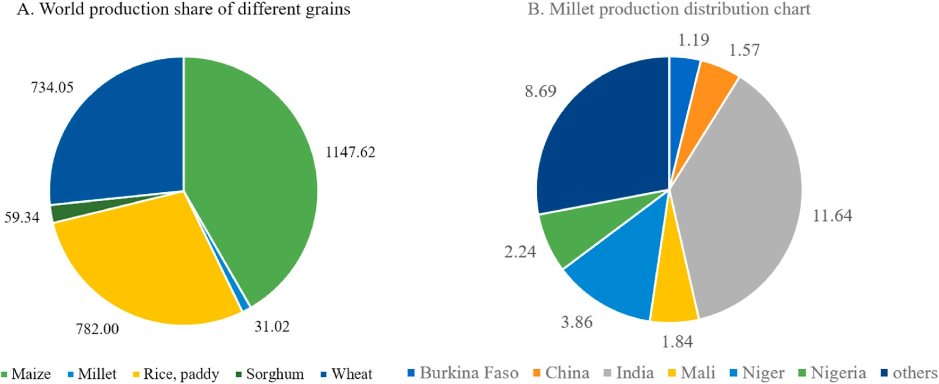
Fig. 10. Grain Statistics: A. Distribution of global grain production shares in million metric tonnes for the year 2018. B. Regional breakdown of millet production in million tonnes for the year 2018 (FAO, 2019).
Table 4: Analysis of starch fractions in various raw millet varieties from different regions
(Kaimal et al., 2021)
Sl.  No | Grain | Country  of origin | Starch  (g/100g dry wt.) | Amylose  (g/100g starch) | Amylopectin (g/100g starch) | RDSª (g/100g starch) | SDSª  (g/100g starch) | RSª  (g/100g starch) | Reference
1 | Finger millet | India | 55.00–65.00 | 15.20–16.00 | 83.80–84.20 | 21.28–20.94 | 67.69–66.60 | 1.89–2.05 | Thippeswamy et al. (2016)
2 | Finger millet | Sri Lankan | 59.03–65.00 | 19.61–21.47 | 38.72–45.03 | 17.54–18.52 | 75.00–75.42 | 6.35–7.02 | Jayawardana et al. (2019)
3 | Pearl millet | India | 53.00–68.00 | 13.61–18.12 | 81.88–86.39 | 46.30–50.10 | 37.20–38.70 | 9.00–16.50 | Sandhu and Siroha (2017)
4 | Foxtail millet | Taiwan | 56.2–73.1 | 1.38–12.35 | 87.65–98.62 | 13.10–26.80 | 32.20–43.10 | 35.2–51.2 | Yin et al. (2019)
5 | Proso millet | China | 58.0–77.87 | 2.24–38.67 | 25.44–69.00 | 31.13–40.09 | 47.56–51.04 | 8.12–19.00 | Shen et al. (2018)
6 | Barnyard millet | India | 48.20–60.20 | 8.90–18.50 | 81.50–91.10 | 24.8–36.56 | 21.99–30.7 | 41.45–44.6 | Sharma and Gujral (2020)
7 | Little millet | India | 42.00–57.30 | 11.90–17.90 | 82.10–88.10 | 20.20–33.58 | 19.87–32.10 | 46.54-47.70 | Sharma and Gujral (2020)
8 | Kodo millet | India | 47.60–60.30 | 15.30–17.50 | 82.50–84.70 | 19.20–21.80 | 29.60–33.20 | 37.5–51.20 | Annor et al. (2013)
ª wt.: Weight, RDS: rapid digestible starch, SDS: slow digestible starch and RS: resistant starch.

Table 5: Comprehensive description of various literature available for millet RS preparation

Sl.  No. | Millet | Treatment | Parameters |  | Initial RS content  (g/100g) starch | Final RS  content  (g/100g) starch) | Inference |  | Reference
Thermal treatments
1 | Foxtail millet | Annealing | 50◦C for 24 h followed by cooling to 4◦C within 24 h |  | 18.2 | 42.33 | Annealing was found to 2.3-fold increase in the resistant starch (RS) content of foxtail millet. |  | Babu et al. (2019)
2 | Foxtail millet | Hydro-thermal  treatment | 110◦C for 16h |  | 13.1 | 32.93 | Hydrothermal treatment could increase the RS content of foxtail millet by 2.5 times |  | Amadou et al. (2014)
3 | Proso millet | Autoclaving | 100°C and  121°C for 30 min. |  | 11.5 | 15.5 | They also noted that an increase in temperature can promote the formation of resistant starch (RS). |  | Ming-zhu et al. (2020)
Chemical treatments
4 | Pearl millet | Octenyl succinate  esterification | Esterified by 3% octenyl succinate anhydride for  2–5 h |  | 2.1 | 13.7 | The samples with a reaction time of 5 hours exhibited the highest resistant starch (RS) content. |  | Sharma et al. (2016)
5 | Different varieties of pearl millet | Crosslinking by chlorohydrin | Crosslinking by epichlorohydrin (0.5%) for 5 h |  | 9.7 | 19.4 | Crosslinking proved to be highly efficient, resulting in a substantial increase in the Resistant Starch (RS) content, ranging from 15.3% to 19.4%, across all pearl millet varieties. |  | Sandhu and Siroha (2017)
Novel technologies
6 | Barnyard millet | Microwave  drying | Drying at 110°C and  120°C for 10–20 min |  | 1.03 | 26.89 | The optimized parameters for enhancing resistant starch (RS) were a temperature of 180°C for a duration of 20 minutes. |  | Kanagaraj et al. (2019)
7 | Foxtail millet | Ultrasound | 33khz for 30 min at  50°C |  | 18.2 | 20.14 | The sample subjected to ultrasound treatment exhibited a slight 10.6% increase in resistant starch (RS). |  | Babu et al. (2019)
Combined treatments
8 | Finger millet | Thermo-  chemical  approach:  Sono-chemical  approach:  Acid pretreated  chemical  approach: | Annealing:  110ºC for 6 h  Sonication: 33 khz for 1 h at 40ºC  Acidhydrolysis: citric acid(1m)for 6 h at 45ºC  Succination: succinic anhydride (4%) for 2 h | 7.04 |  | Thermo-  chemical:  10.49  Sono-chemical: 15.53  Acid pretreated  chemical:  18.19 |  | Samples that underwent acid pretreatment before succination demonstrated a higher resistant starch (RS) content compared to other methods. |  | Babu et al. (2019)
9 | Foxtail millet | Thermo-  sonic  approach  Sono-thermal  approach | Annealing: 50ºC for 24 h followed by cooling to 4ºC within 24 h  Sonication: 33 khz for 30 min at 50ºC | 18.2 |  | Thermo-Sonic:  29.64  Sono-thermal:  45.59 |  | There was a synergistic correlation observed in the resistant starch (RS) content, resulting in a remarkable 150% increase in the ultrasound-pre-treated and annealed sample. |  | Babu et al. (2019)

Impact of food constituents on resistant starch in Millet
Starch can engage with diverse food components during processing and storage, thereby affecting the formation of resistant starch (RS) in millet.

Table 6: The Impact of Millet Constituents on Starch Digestibility and Their Mechanisms (Annor et al., 2017; Bae et al., 2016)

Sl. No. | Millet constituent | Impact on starch digestibility | Mechanism of Action
1 | Protein | Decreases | The protein-starch gel encapsulates starch globules, leading to reduced gelatinization and enzyme permeability
2 | Lipid | Decreases | Lipophilic amylo-lipid inclusion complex inhibits the entry of amylase
3 | Dietary fiber | Minimal effect | It reduces gelatinization by binding water
4 | Polyphenols | Decreases | Millet polyphenols function as amylase inhibitors
5 | Organic acid | Increases | It facilitates starch hydrolysis at higher concentrations.
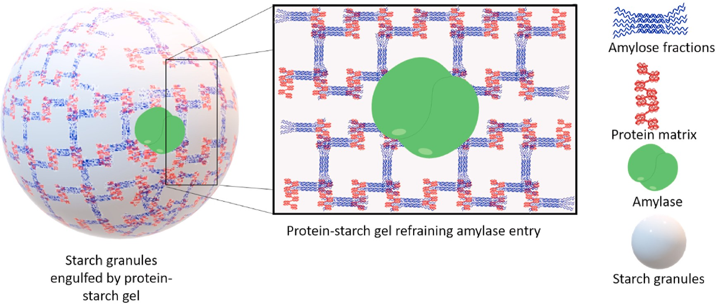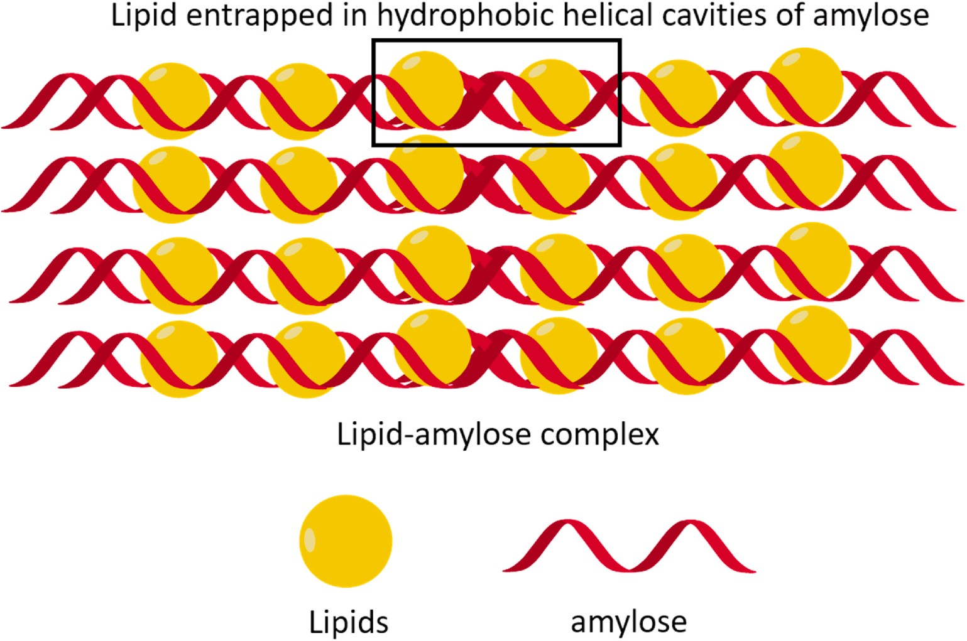
Figure 12: Schematic Depiction of a Lipid-Amylose Inclusion Complex.
Figure 11: Schematic Illustration of a Protein-Starch Gel Impeding Amylase Access to Starch Granules.

10. Commercially Available Resistant Starch (RS) Products
Starch Australia Ltd. introduced the pioneering commercial RS, known as Hi-maize. Subsequently, various other companies entered the market with new commercial starches, employing different preparation technologies. The commercially available RS products from different companies differ in terms of their RS content percentages. Some noteworthy commercial RS products include CrystaLean® (RS3), Novelose®240 (RS2), Novelose®260 (RS2), Novelose®330 (RS3), Eurylon® (RS2), Amylomaize VII (RS2), and Neo-amylose (RS3) (Table 7). CrystaLean is an RS3 product created through starch retrogradation using high-amylose maize starch ae-VII hybrid. National Starch and Chemical Co. (USA) introduced Hylon-VII, a naturally occurring high-amylose maize starch. Most of the RS3 products listed above are produced by subjecting high-amylose corn starch to amylose retrogradation through repeated heating and cooling cycles under controlled moisture and temperature conditions. These processes result in the production of granular RS with RS content ranging from 47% to 60%. Another highly crystalline RS3, Actistar Act*-RS3, has been developed using maltodextrins as the starting material, imparting a natural taste to the product.
High-amylose corn starch is also utilized to produce Fibersym HA, which is employed in a wide range of low-net-carbohydrate food products. Fibersym HA offers more than 70% dietary fiber and is used in the preparation of food items such as pizza crust, bread, tortillas, cookies, muffins, breakfast cereals, snacks, and nutritional bars. Potato starch serves as the base for Fibersym 80ST. Fibersym 80ST possesses slightly higher water-holding properties, impacting the characteristics of final food products like cookie spread and muffin volume. Nutriose FB06 and Fibersol-2 also contain substantial RS content, providing 85% and 90% dietary fiber content, respectively. Fibersym 80ST, Fibersym RW, Fibersym HA, and Fibersol-2 are all classified as RS4 preparations and are readily available in the market. These RS preparations maintain the organoleptic properties of food products while reducing the availability of certain saccharides. The fortification of food products with RS does not compromise their quality, and the sensory attributes of extruded, baked goods, and confectionery items remain unchanged (Raigond et al., 2014).

Table 7. Resistant starch, commercially produced, and commonly incorporated into a variety of food products (Raigond et al., 2014)
Brand name  of commercial RS | Type | RS/TDF% content | Physiological and/or Health Advantages | Producer or Manufacturer
Hi-maize | RS-2 | 30-60%  TDF | Prebiotic Attributes: Exhibits prebiotic properties, resulting in a decreased fecal pH and an elevated level of Short-Chain Fatty Acids (SCFA), particularly butyrate, which may contribute to a reduced risk of cancer. Additionally, it encourages bowel regularity with its mild laxative effect and promotes the growth of beneficial gut microflora. | National Starch Chemicals co.,  USA
CrystaLean | RS-3 | 19.2-41%  RS | Prebiotic Impact: Enhances the proportion of butyrate, stimulates cell proliferation in the proximal colon (in rats), and provides soluble dietary fiber with prebiotic effects. | Opta food  ingredients Inc., USA
Novelose 240 | RS-2 | 47% RS | It boasts a low glycemic index and reduces the glycemic response when used as a substitute for flour and other rapidly digested carbohydrates. | National Starch  and chemicals  co., USA
C*Actistar | RS-3 | 53% RS | Offers the potential for health benefits through its prebiotic effect, acting as a source of butyrate, supporting the immune system, and exhibiting a reduced glycemic response. It also has a low caloric value, is easily fermentable as Resistant Starch (RS), and is very well tolerated. | Cerestar (Cargill company), US
Nutriose FB | - | 85% TDF | Low Caloric Content | Roquette, Freres, France
HylonR VII | RS-2 | 23% TDF | Elevates SCFA Levels | National Starch and chemicals co., USA.

- Applications of Resistant Starch (RS)
The potential physiological benefits and distinct functional characteristics of Resistant Starch (RS) have garnered attention from nutritionists and food manufacturers. As consumer awareness of health and nutrition grows, there is a growing interest in RS beyond its traditional nutritional aspects, with consumers seeking additional health advantages through regular RS consumption (Aparicio-Saguilan et al., 2007). RS is a favoured ingredient for fortifying foods to enhance their nutritional value and health benefits. Given that RS naturally occurs in a wide range of starchy foods, it serves as a convenient functional ingredient for nutritional fortification. RS-enriched foods are gaining popularity among consumers, who are willing to pay a premium for such products to boost their dietary fiber intake (Buttriss and Stokes, 2008). At the commercial level, RS is available with a starch component under the name "resistant starch." Many of these RS-enriched products are fully digestible and serve as RS suppliers (Xie and Liu, 2004).
RS finds application in the production of dry foods. Cross-linked RS, derived from corn, tapioca, and potato starches, has been utilized in formulations requiring a pasty texture, smoothness, flowability, low pH, and high-temperature storage (Sajilata and Singhal, 2005). Baked goods, pasta products, and beverages are fortified with RS to enhance their texture and nutritional profile. Notably, RS has been employed as a fat replacement in imitation cheeses, resulting in reduced fat content without compromising meltability or firmness, while also providing its own health benefits. Numerous RS-fiber-fortified products are currently available in the market, including high-fiber bread, biscuits, and breakfast cereals. The availability of technology for preparing process-resistant RS has facilitated the creation of RS-rich foods. Dry pasta products containing up to 15% RS can be produced without altering the dough's rheology during extrusion. RS-fortified pasta, compared to unfortified pasta, exhibits a lighter colour and firmer texture resembling unfortified pasta (Sajilata et al., 2006). RS imparts turbidity to beverages, making it suitable for use in thick and opaque health drinks where insoluble fiber is desirable. RS stands out from other fibers due to its mild flavour, minimal gritty sensation, and significantly less flavour masking. In contrast, other fibers often possess strong flavours, coarse textures, and impart a dry and unpleasant mouthfeel (Raigond et al., 2014).

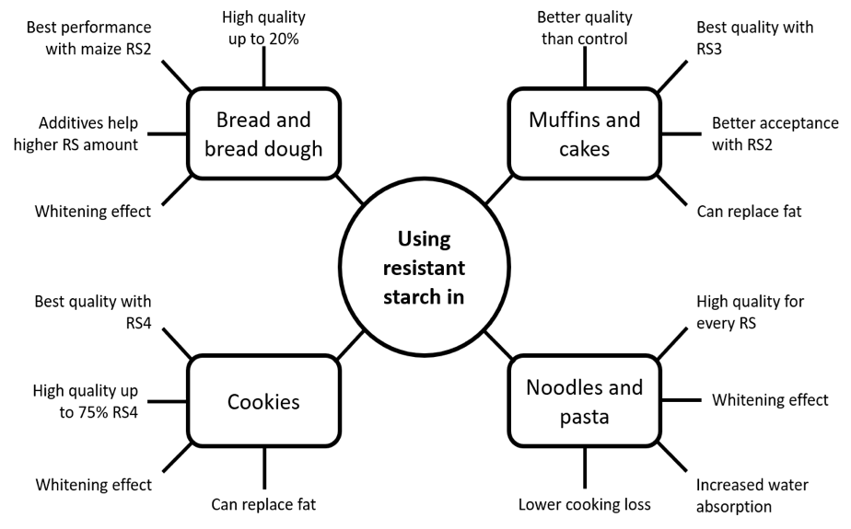
Fig. 13 Technological aspects of using resistant starch in wheat-based foods
- Potential Physiological effects
Table 8: Physiological properties of resistant starch (Brown, 2004; Champ, 2004)
Sl. No. | Potential Physiological Impacts | Situations Where a Protective Effect May Be Observed
1 | Enhanced Glycemic and Insulinemic Responses | Diabetes, Impaired Glucose Tolerance, and Altered Insulin Responses
2 | Enhanced Blood Lipid Profiles | Metabolic Syndrome, Including Cardiovascular Conditions and Lipid Metabolism
3 | Improved Gastrointestinal Well-being | Colorectal Cancer, Ulcerative Colitis, Inflammatory Bowel Disease, Diverticulitis, and Constipation
4 | Prebiotic Properties and Promotion of Beneficial Gut Microorganisms | Promotion of Colonic Well-being
5 | Augmented Satiety Leading to Reduced Caloric Intake | Obesity Management
6 | Enhanced Absorption of Micronutrients | Augmented Mineral Absorption with Potential Benefits for Osteoporosis
7 | Supportive Role in Oral Rehydration Therapy | Treatment for Cholera and Chronic Diarrhoea
8 | Synergistic Interaction with Other Dietary Components, such as Dietary Fibers, Proteins, and Lipids | Enhancement of Metabolic Control and Improved Bowel Health

- Conclusion
Resistant Starch (RS) is exceptionally well-suited for fortifying a wide range of food items, including ready-to-eat cereals, snacks, pasta, noodles, baked goods, and fried foods. These products can be accurately labelled as "starches providing added nutritional value." By modifying processing conditions, the nutritional content of these foods can be enhanced.
RS-enriched products offer superior attributes in terms of crispness, mouthfeel, colour, and flavour when compared to conventional fiber-containing products. The significance of RS lies in its physiological properties, which mitigate the risk of several diseases, including colon cancer and diabetes, while also aiding in the management of obesity and diabetes. Products fortified with RS are well-received by consumers due to their distinctive physical and chemical characteristics.

- References
Acquarone, V. M. and Rao, M. A., 2003, Influence of sucrose on the rheology and granule size of cross-linked waxy maize starch dispersions heated at two temperatures. Carbohydrate Polymers, 51:451–458.
Agustiniano-Osornio, J. C., Gonzalez-Soto, R. A., Flores-Huicochea, E., Manrique-Quevedo, N., Sanchez-Harnandez, L., Bello-Perez, L. A., 2005, Resistant starch production from mango starch using a single-screw extruder. Journal of Science Food Agriclture, 85:2105–2110.
Alcazar-Alay, S. C., Meireles, M. A. A., 2015, Physicochemical properties, modifications and applications of starches from different botanical sources. Food Science Technology, 35: 215–236.
Amadou, I., Gounga, M. E., Shi, Y.-H. and Le, G.-W., 2014, Fermentation and heat- moisture treatment induced changes on the physicochemical properties of foxtail millet (Setaria italica) flour. Food and Bioproducts Processing, 92(1): 38–45.
Annor, G. A., Marcone, M., Bertoft, E. and Seetharaman, K., 2013, In vitro starch digestibility and expected glycemic index of kodo millet (Paspalum scrobiculatum) as affected by starch–protein–lipid interactions. Cereal Chemistry, 90 (3): 211–217.
Annor, G. A., Tyl, C., Marcone, M., Ragaee, S. and Marti, A., 2017, Why do millets have slower starch and protein digestibility than other cereals? Trends in Food Science & Technology, 66: 73–83.
Aparicio-Saguilan, A., Sayagoayerdi, S., Vargastorres, A., Tovar, J., Ascencioatero, T. and Belloperez, L., 2007, Slowly digestible cookies prepared from resistant starch-rich lintnerized banana starch. Journal of Food Components Annuals, 20 (4):175–181.
Aung, K. H., Surjani, U., Udayasika, P., Ingrid, A. M. A., Amparo, L.R. and Elliot, P. G., 2010, The effect of acid dextrinisation on enzyme-resistant starch content in extruded maize starch. Food Chemistry,120:140–149.
Babu, A. S., Mohan, R. J. and Parimalavalli, R., 2019, Effect of single and dual- modifications on stability and structural characteristics of foxtail millet starch. Food Chemistry, 271, 457–465. https://doi.org/10.1016/j.foodchem.2018.07.197
Bae, I. Y., Jun, Y., Lee, S. and Lee, H. G., 2016, Characterization of apple dietary fibres influencing the in vitro starch digestibility of wheat flour gel. Food Science and Technology, 65:158–163.
Bello-Perez, L. A. and Paredes-Lopez, O., 2009, Starches of some food crops, changes during processing and their nutraceutical potential. Food Engineering Reviews, 1:50–65.
BeMiller, J. N. and Whistler, R. L., 2009, Starch: Chemistry and Technology; Academic Press: Cambridge, MA, USA.
Bertoft, E., 2017, Understanding starch structure: Recent progress. Agronomy, 7: 56.
Bertolini, A., 2009, Starches: Characterization, Properties, and Applications; CRC Press: Boca Raton, FL, USA.
Brown, I. L., 2004, Applications and Uses of Resistant Starch. Journal of Association of Official Analytical Chemists, 87 (3): 727–732.
Buttriss, J. L. and Stokes, C. S., 2008, Dietary fibre and health: an overview. British nutrition foundation. Food and Nutrition Bulletin, 33:186–200.
Champ, M. J., 2004, Physiological Aspects of Resistant Starch and in vivo Measurements. Journal of Association of Official Analytical Chemists, 87 (3): 749–755.
Chung, H. J., Shin, D. H. and Lim, S. T., 2008, In vitro starch digestibility and estimated glycemic index of chemically modified corn starches. Food Research International, 41:579–585.
Dupuis, J. H., Liu, Q. and Yada, R. Y., 2014, Methodologies for increasing the resistant starch content of food starches: A review. Comprehensive Reviews in Food Science and Food Safety, 13 (6): 1219–1234.
Englyst, H. N., Kingman, S. M. and Cummings, J. H., 1992, Classification and measurement of nutritionally important starch fractions. European Journal of Clinical Nutrition, 46:33–50.
Fausto, F.D, Kacchi, A.I. and Mehta, D., 1997, Starch products in confectionery. Beverage and Food World, 24(4):4–16.
Gao, Q., Suling, L., Jian, H. and Liang, S., 2011, Preparation and properties of resistant starch from corn starch with enzymes. African Journal of Biotechnology, 10 (7):1186–1193.
Goni, I., Garcia-Diz, L., Manas, E. and Saura-Calixto, F, 1996, Analysis of Resistant Starch: A Method for Foods and Food Products. Food Chemistry, 56 (4): 445–449.
Hasjim, J. and Jane, J., 2009, Production of resistant starch by extrusion cooking of acid-modified normal-maize starch. Journal of Food Science, 74 (7): 556–562.
Hoover, R., 2000, Acid-treated starches. Food Reviews International, 16 (3): 369–392.
Hoover, R. and Vasanthan, T., 1994, The effect of annealing on the physicochemical properties of wheat, oat, potato and lentil starches. Journal of Food Biochemistry, 17: 303–325.
Jayawardana, S. A. S., Samarasekera, J. K. R. R., Hettiarachchi, G. H. C. M., Gooneratne, J., Mazumdar, S. D. and Banerjee, R., 2019, Dietary fibres, starch fractions and nutritional composition of finger millet varieties cultivated in Sri Lanka. Journal of Food Composition and Analysis, 82 (363): 103249.
Juansang, J., Puttanlek, C., Rungsardthong, V., Puncha-arnon, S. and Uttapap, D., 2012, Effect of gelatinisation on slowly digestible starch and resistant starch of heat-moisture treated and chemically modified canna starches. Food Chemistry, 131:500–507.
Kaimal, A. M., Mujumdar, A. S. and Thorat, B. N., 2021, Resistant starch from millets: Recent developments and applications in food industries. Trends in Food Science & Technology, 111: 563–580.
Kanagaraj, S. P., Ponnambalam, D. and Antony, U., 2019, Effect of dry heat treatment on the development of resistant starch in rice (Oryza sativa) and barnyard millet (Echinochloa furmantacea). Journal of Food Processing and Preservation, 43(7): 1–7.
Katopo, H., Song, Y. and Jane, J., 2002, Effect and mechanism of ultrahigh hydrostatic pressure on the structure and properties of starches. Carbohydrate Polymers, 47:233–244.
Lebail, P., Bule, A., Shiftan, D. and Marchessault, R. H., 2000, Mobility of lipid in complexes of amylose-fatty acids by deuterium and 13C solid state NMR. Carbohydrate Polymers, 43, 317–326.
Lee, C. J., Kim, Y., Choi, S. J. and Moon, T. W., 2012, Slowly digestible starch from heat moisture treated waxy potato starch: preparation, structural characteristics, and glucose response in mice. Food Chemistry, 133(4):1222–1229.
Lehmann, U. and Robin, F., 2007, Slowly digestible starch – its structure and health implications: a review. Trends Food Science and Technology, 18:346–355.
Martin, S. M., Barbosa-Canovas, G. and Swanson, B., 2002, Food processing by high hydrostatic pressure. Critical Reviews Food Science and Nutrition, 42: 627–645.
McCleary, B. V., 2000, Importance of enzyme purity and activity in the measurement of total dietary fibre and dietary fibre components. Journal of Association of Official Analytical Chemists, 83(4):997–1005.
Meenu, M. and Xu, B., 2019, A critical review on anti-diabetic and anti-obesity effects of dietary resistant starch. Critical Reviews in Food Science and Nutrition, 59 (18): 3019–3031.
Nugent, A.P., 2005, Health Properties of resistant starch. British Nutrition Foundation. Nutrition Bulletin, 30 (1): 27–54.
Rahaman, S., Singh, A., Praveen, S. and Krishnan, V., 2020, Low digestible starch and food industry: A changing paradigm. Indian Journal of Experimental Biology, 58: 830-841.
Raigond, P., Ezekiel, R. and Kaundal, B., 2014, Starch fractions of cooked potatoes at low temperature. Potato Journal, 41 (1):58–67.
Raigond, P., Ezekiel, R., Singh, B., Dutt, S. and Joshi, A., 2015, Resistant starch production technologies – a review. Potato Journal, 42 (2):81–94.
Reddy, C. K., Suriya, M. and Haripriya, S., 2013, Physico-chemical and functional properties of resistant starch prepared from red kidney beans (Phaseolus vulgaris. L) Starch by enzymatic method. Carbohydrate Polymers, 95: 220–226.
Sajilata, M. G. and Singhal, R. S., 2005, Specialty starches for snack foods. Carbohydrate Polymers, 59: 131–151
Sajilata, M. G., Singhal, R. S. and Kulkarni, P. R., 2006, Resistant starch - a review. Comprehensive Reviews Food Science, 5:1–17.
Sandhu, K. S. and Siroha, A. K., 2017, Relationships between physicochemical, thermal, rheological and in vitro digestibility properties of starches from pearl millet cultivars. Food Science and Technology, 83: 213–224.
Sharma, B. and Gujral, H. S., 2020, Modifying the dough mixing behavior, protein & starch digestibility and antinutritional profile of minor millets by sprouting. International Journal of Biological Macromolecules, 153: 962–970.
Sharma, M., Singh, A. K., Yadav, D. N., Arora, S. and Vishwakarma, R. K., 2016, Impact of octenyl succinylation on rheological, pasting, thermal and physicochemical properties of pearl millet (Pennisetum typhoides) starch. Lebensmittel-Wissenschaft & Technologie, 73: 52–59.
Shen, R., Ma, Y., Jiang, L., Dong, J., Zhu, Y. and Ren, G., 2018, Chemical composition, antioxidant, and antiproliferative activities of nine Chinese proso millet varieties. Food and Agricultural Immunology, 29(1): 625–637.
Shin, S., Byun, J., Park, K. H. and Moon, T. W., 2004, Effect of partial acid hydrolysis and heat-moisture treatment on formation of resistant tuber starch. Cereal Chemistry, 81 (2):194–198.
Singh, J., Kaur, L. and McCarthy, O. J., 2007, Factors influencing the physico-chemical, morphological, thermal and rheological properties of some chemically modified starches for food applications – a review. Food Hydrocolloids, 21:1–22.
Tester, R. F., Karkalas, J. and Qi, X., 2004, Starch structure and digestibility. Enzyme-substrate relationship. World Poultry Science Journal, 60 (2):186–195.
Thippeswamy, T. G., Junna, L. and Shinde, M., 2016, Proximate composition, resistant starch and other phytochemical constituents of native finger millet cultivar. International Journal of Food and Nutrition Science, 5(3), 67.
Thompson, D. B., 2000, On the non-random nature of amylopectin branching. Carbohydrate Polymers, 43: 223–239.
Vilaplana, F., Hasjim, J. and Gilbert, R. G., 2012, Amylose content in starches: Toward optimal definition and validating experimental methods. Carbohydrate Polymers, 88: 103–111.
Woo, K. and Seib, P. A., 2002, Cross-linked resistant starch: preparation and properties. Cereal Chemistry, 79 :819–825.
Wurzburg, O. B., 1995, Modified starches. In: Stephen AM (ed) Food polysaccharides and their applications. Marcel Dekker Inc, New York, pp 67–97.
www.gminsights.com
Xie, X. and Liu, Q., 2004, Development and physicochemical characterization of new resistant citrate starch from different corn starches. Starch 56 (8):364–370.
Yin, S. Y., Kuo, S. M., Chen, Y. R., Tsai, Y. C., Wu, Y. P. and Lin, Y. R., 2019, Genetic variation of physicochemical properties and digestibility of foxtail millet (Setaria italica) landraces of Taiwan. Molecules, 24 (23). https://doi.org/10.3390/ molecules24234323
Zeng, F., Ma, F., Kong, F., Gao, Q. and Yu, S, 2015, Physiochemical properties and digestibility of hydrothermally treated waxy rice starch. Food Chemistry, 72:92–98.
Zhang, H. and Jin, Z., 2011, Preparation of resistant starch by hydrolysis of maize starch with pullulanase. Carbohydrate Polymers, 83:865–867.
Zobel, H.F., 1988, Starch crystal transformations and their industrial importance. Starch, 40:
1–7.

