ASSESSMENT OF NUTRITIONAL STATUS AND DEPRESSION LEVEL AMONG SELECTED INSTITUTIONALIZED AND NON- INSTITUTIONALIZED OLD AGE PEOPLE IN COIMBATORE DISTRICT
Yasmine Fathima.N¹, Dr.L. Uthira ² & PadmaPriya.V³
Research Scholar¹, Associate professor² & Research Scholar³
Department of Nutrition and Dietetics
PSG College of Arts & Science, Coimbatore
Abstract
BACKGROUND: Depression is crippling disorder which is leading cause of morbidity. It has serious consequences, including personal, professional, and social dysfunction, premature death, and, most importantly, suicide. Recent studies concluded that growing speculation on diet has a significant impact on mental health disorders, including depression and the nutritional factors that influence depression.
OBJECTIVES: The primary goal of this study was to assess the nutritional status and degree of depression among elderly residents of Coimbatore District who were institutionalised and non-institutionalised.
METHODOLOGY: A convenience sample design framework was used, which excluded those who were extremely sick and bedridden, mentally disabled, and Audio-visually handicapped individuals. A sample size of 100 elderly was evaluated, in which 50 living in old age facilities and the rest living with their families. A standardised questionnaire that included socioeconomic status, nutritional and health status, and the geriatric depression scale (GDS) was used to gather data from December 2019 to February 2020. SPSS was used to examine the acquired data, which included Pearson Correlation and Unpaired T-Test.
RESULTS: About 57% were malnourished as under and overnutrition of which 19% were underweight, 23% were overweight & 15% were Obese. A minor difference was seen in the nutrient intake of the institutionalized subjects from non-institutionalized subjects. The correlation of depression was studied using Pearson correlation and found that depression was seen in 38% of people, categorized as mild in 16%, moderate in 8%, and severe in 14%. The psychological status measured by depression level using the geriatric depression scale (GDS) revealed that institutionalized subjects (28%) were more depressed than the non-institutionalized subjects (10%).
CONCLUSION: Our study found that older people living in old age homes had higher incidences of depression than the elderly living in families. Insignificance in food intake was observed whereas calcium deficiency was seen more in institutional than non-institutional people.
KEYWORDS: Geriatrics, Depression, Psychological, Obesity, Nutritional status, Old age home

INTRODUCTION
Old age refers to the decline in a person's capacity for environmental compliance due to factors beyond that person's control which is categorized into three stages: Young to middle-aged (60-69), middle-aged (70-79), and extremely old (80+) (1,4). It is induced by an internal process that greatly reduces the likelihood of living which encompasses physiological and psychological alterations caused by societal circumstances ². The percentage of elderly persons (65 or over) in the global population is expected to increase from 9.3% (727 million) in 2020 to 16.0% (nearly 1.5 billion) in 2050 due to a decline in fertility and an increase of 20 years in the mean lifespan. One in every six people on the earth will be 65 or older by the middle of the century. ^{3,5.} Depression is a psychiatric illness that is a major contributor to old people's disability and it lowers, one’s quality of life and causes major therapeutic and public health issues ^{6,7}. It affects one out of every four elderly which causes malnourishment and decreased survival, it also increases the corticotrophin-releasing factor within the hypothalamus, which is a potent anorectic agent ^{8,9}. The prevalence rate of depressive disorders is between 4.7 and 16%, according to a meta-analysis of 74 studies conducted on 487,275 elderly persons globally. This study also shows that India has a greater frequency of geriatric depression than other countries and it's a growing public health concern in developing countries in the elderly ^{9,11,12}. A 2.1-fold greater risk of mortality from mental apathy was seen in elderly adults who felt both depressed and lonely. ¹⁰. Physically declined elderly who living in the community, being hospitalised or institutionalised, being a woman, low-income household, being lonely, staying inside, lacking social support, having relationship issues, having poor health, and going through difficult life events were all independently linked to depression. ^{7,13,14}. The most prevalent signs among depressed males include physio pathologies, initial insomnia, and lack of interest in work and hobbies. Apart from psychic worry, depressed women displayed the same signs¹⁵. There was a greater degree of depression in the day-care environment than in other community-based research. Out of 156 individuals, 24 people over the age of 65 were chosen. Depression and loneliness, as well as sadness and happiness, were found to be significantly correlated in life of an elderly person ¹⁶. A Study conducted by Praveen et al involved 112 old persons, showed that the elderly people who were institutionalised had a greater incidence of depression than elderly people who lived in the community (75% vs 57.1%)^{17.} With this context in consideration, this study was carried out to evaluate the nutritional status and dietary habits as well as the degree of depression among institutionalised and non-institutionalized old age people in the Coimbatore district.
OBJECTIVES
• To compare the nutritional status and dietary habits of institutionalized and non-institutionalized older people.
• To evaluate the the prevalence of depression among the elderly.
MATERIALS AND METHODS
Sampling techniques and Participants: The study was conducted in the Coimbatore district with a sample size (n=100) inclusive of both genders, older than 60 years of age. The assessment includes 50 institutionalized subjects who were residing in the Ozanam home for the aged, Eera Nenjam, Universal Peace Foundation whereas the remaining non-institutionalized subjects were living in Peelamedu. A Convenience sampling method was used with exclusion criteria such as
- People below 60 years
- People who were seriously ill and bed-ridden
- Cognitively impaired individual
- Audio-visually handicapped individuals

Research Tools undertaken in the study-
Questionnaire: A Direct face-to-face interview was conducted with the help of a questionnaire. Information regarding their Socioeconomic status, Nutritional status which includes general condition, appetite, sleep, physical activity, anthropometry, clinical examination, 24-hour recall data on dietary preferences and subjective assessments of health condition were obtained.
Anthropometry and Dietary: Assessment was done using the tools: Body weight was measured on an electronic weighing scale. Body height was taken with Stature meter height tape. BMI was calculated with the formula: weight (kg)/height (m2). A Body composition monitor (OMRON HBF-375) was used to evaluate body fat content, visceral fat, and resting metabolism.
Dietary assessment was collected based on 24-hour recall and food frequency list.
Depression scale: The Geriatric Depression Scale (GDS) is a screening tool for people who are at risk of depression. In the current study, a fifteen-question yes/no short form was employed. More over 5 points indicate moderate depression, more than 10 points indicate severe depression, and a score of 0 to 5 is considered normal. The GDS is appropriate for both healthy and sick older adults ¹⁸. Statistical analysis was carried out using SPSS software (version 16.0, Chicago, IL, USA). Pearson correlation was calculated to assess the relationship between depression levels between institutionalized and non-institutionalized geriatric people. Independent T-test analyses were performed with GDS to prove the alternative hypothesis between two sets of samples.
RESULT
Participants by age, gender, and education (n=100): The subjects' average age was 68.35. Subjects who lived in institutions were on average 70 years old, whereas those who resided in non-institutional settings were 66.7 years old. According to gender categorization, 76% of the total subjects are women (39% in institutional, 37% in non-institutional) whereas men are 24% (11% in institution, 13% in non-institution). Education: In both groups 53% were illiterate, 19% have their basic school education, 24% completed their schooling, and 4% of them graduated. Marital status: 33% of samples were married (9% were in old age homes), 6% were single, 3% were divorced, and 58% were widowed (35% in old age homes). (Table 1).

Table 1. Demographic profile of the subjects
Category | Total n=100 (average) | Institutionalised n=50 | Non-Institutionalised n=50
Age | 68.35 | 70 | 66.7
Gender  Female  Male | 76  24 | 39  11 | 37  13
Education  Illiterate  Upper primary education  Higher education  Graduated | 53  19  24  4 | 29  11  8  2 | 24  8  16  2

Socioeconomic status (non-institutionalized): Socioeconomic status was measured in a sample who resided alone or stayed with their children (n=50) (Table 2)
Table 2. Socioeconomic status of the non-institutionalized (n=50)
 | Male n=13 | Female n=37
Type of Family  Joint  Nuclear  Living alone | 6  6  1 | 25  8  4
Composition of Family  0-3 Members  4-6 Members | 11  2 | 15  22
Employment status  Employed  Unemployed | 6  7 | 27  10
Housing  Own  Rental | 12  1 | 21  16

Anthropometric assessment: BMI was 43%, 23% and 15% of the subjects were normal,overweight and obese; 19% were underweight (fig 1). 10% of the population had BMRs between 900 -1100 kcal, and 12% of the respondents had BMRs between 1100 and 1200 kcal. The majority of the individuals had BMRs of 1101-2600 Kcal.
Approximately 20% of females and 7% of males have body fat levels above 35%, and 25% respectively. Around 23% of the subjects have visceral fat of 10.0-14.5%, which is 11% in confined & 12% in non-institutionalized subjects ¹⁹.
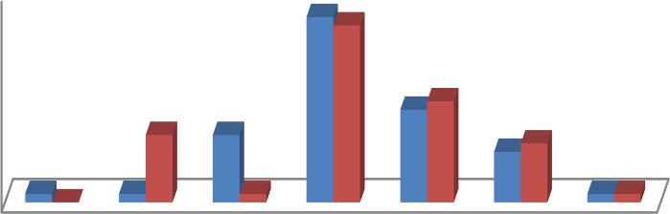
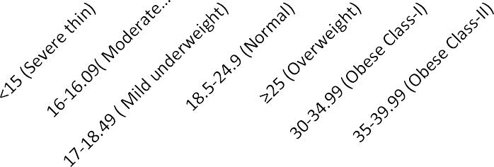
Figure 1: Body mass index of samples (n=100)
25
20
15
10
5
0
2221
1112
8
8
6 7
1 0
1
1
1 1
Institutionalized
Non-Institutionalized
Body Mass Index (BMI)

Dietary pattern: There were 69 non-vegetarians, and 25 were vegetarian with an almost identical proportion of Ova-Vegetarians (3 in both). 85% of the participants reported not skipping meals, and 15% of the subjects (institutionalized =6, non-institutionalized =9) skipped meals for psychiatric and financial reasons.
Regarding the intake of nutrients macro and micronutrient consumption is nearly identical in both groups except for calcium, which is deficient in the regimented group. On comparing Institutionalized and Non-institutionalized the intake of the latter was higher than the former (table 3)
Table 3. Nutrient intake of the samples (24 hours recall)
Category | Calories (Kcal) | CHO (g) | Protein  (g) | Fat(g) | Fiber (g) | Calcium  (mg) | Iron (mg)
Institutionalized | 1425 | 231 | 43.2 | 34.1 | 26.8 | 330.6 | 7.2
Non-Institutionalized | 1504 | 236 | 44.3 | 37.8 | 24.0 | 433.4 | 7.8
Sufficient/Deficient | -78.93 | -4.86 | -1.07 | -3.74 | -2.78 | -102.73 | -0.51

Health status: The majority of the subjects (61%), had health issues (28% were institutionalized and 33% were non-institutionalized), while 39% did not have any health issues Fig 2.
Figure 2: Types of health ailments noted in samples
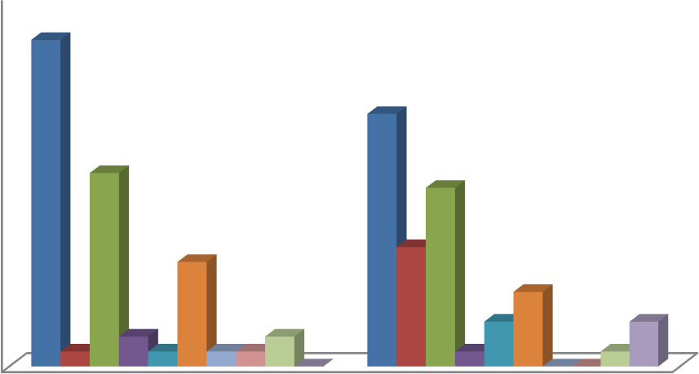
TYPES OF HEALTH AILMENTS
25
22
No Ailments
Diabetes
20
17
15
13
12
10
Blood pressure
Asthma Others
DM and BP
7
8
5
BP and Arthritis
5
1
2
3
3
1
1 1
2
0
1
0 0
1
0
DM,BP and CVD
DM and Arthritis DM and CVD
Institutionalized Non-Institutionalized

38% of subjects do not seek medical care, while 62% look for medical care in which 10% of institutionalized subjects consult physicians once a week. Around 31% of respondents have a medical exam once a month, while 7% and 6% have a medical check-up every three and six months, respectively.
Exercise, appetite, sleep- The majority 62% of the respondents did not engage in any type of exercise. Only 38% of the respondents participated and placed a high value on regular exercise. Normal appetite was seen in 78% of the respondents, 22% reported reduced appetite, and none reported increased appetite. 30% of the respondents reported having disturbed sleep, compared to 70% who did not show any sleep disruption.
Depression Status: Depression was seen in 38% of subjects with a marginal level of depression varying from mild to severe. About 16% of the subjects had mild depression, and 8% have moderate depression. Severe depression was evident in 14% of the subjects (Fig 3)
Figure 3: Depression status among the aged
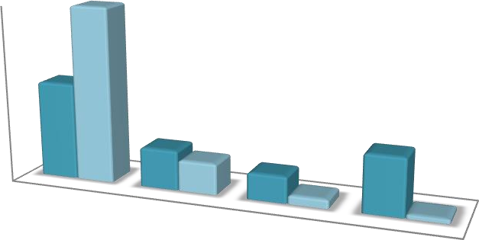
40
40
35
30
25
20
15
10
5
0
22
9
7
13
6
2
1
Normal (0-4
points) Mild
Moderate
Depression
(5-8 points) Depression
(9-11 Points)
Severe
Depression (12-15
Points)
Institutionalized
Non-Institutionalized

DISCUSSION
This study compared institutionalised and non-institutionalized elders nutritional and depressive health statuses. Numerous research on the frequency of malnutrition in different older communities yielded diverse results. Santosh et al studied that Mini nutritional assessment (MNA) done on 105 elderly people shows that 60.4% of them are at were potentially vulnerable for malnutrition and 29.4% of them are undernourished. Males (40.6%) had a considerably lower rate of malnutrition than females (59.4%). Age (p 0.001), family income (p 0.001), literacy level (p 0.001), decreased dietary intake (p 0.001), and meal consumption (p 0.001) were all independently linked to lower MNA scores ^{20, 22}. According to a comparative research, the elderly living at home had higher BMI and MNA scores, while 19.4% of respondents in old age home were undernourished and 57.4% of them at risk of malnutrition. The outcomes of this study show a substantial risk of malnutrition among residents in old age facilities²¹. In our study 19% of the subjects are malnourished (n=10% in institutionalized and 9% in non-institutionalized) and 38% of them were overweight and obese.
The bulk of individuals who entered the institution came from nuclear families and faced more societal difficulties, such as adaption in old age Homes. The elderly was sent to an old age centre mostly because of the son's and daughter-in-law's disrespect for their parents. Aside from that, elderly people moved to nurse homes due to a lack of care, ignorance, a lack of room in their homes, and a lack of mental support ^{23,24}. Our Study shows that of Institutional subjects (n=50) in which 60% were voluntarily joined in old age homes whereas 40% were forcefully joined in the home. The majority of Elderly people were suffering from health issues in which Female respondents were sicker than males. Some prevalent illnesses in residents were circulatory system disorders, hypertension, and diabetes ²⁵. Hypertension was seen in 25% of the subjects, 12% of the subjects have both diabetes & hypertension, 9% of them have diabetes, and 39% were free from disease.
About half (38%) of individuals in this study were determined to be depressed based on the GDS scores. Other studies conducted by Chauhan et al and Bishak et al showed the prevalence of depression among senior persons was 42.3% (14% had severe depression and 28.3% had mild depression) and 9.3%, respectively ^{26,27}. 92% of senior people have to spend their retirement years in an assisted living home ²⁸. Kumar et al discovered that one-half of the aged were struggling with mental health issues in which depression was more prevalent. It was significantly higher in city dwellers, females, the aged, and nuclear families, as well as those living alone and in old age homes, unemployed, illiterates, impoverished, functionally impaired, and cognitively impaired ^{29,30}.
CONCLUSION

When compared to non-institutionalized older persons, institutionalised elderly are much more prone to suffer from depression.

Depression was absent in 40% of noninstitutionalized patients and 22% of institutionalised respondents. Severe depressive episodes were reported in 13% of institutionalized elders and 1% of non-institutionalised older people.

The well-being of the elderly in society in India is under risk because of demographic changes, urbanisation, modernisation of Indian culture, and the breakdown of nuclear families. Without a robust social facility other than the family, an increasing number of senior citizens are on the edge of being homeless.

As parents get older, they experience physical or cognitive issues that make it difficult for them to care for themselves alone. That will lead to morbidity, mortality, hospitalisation, and poor functional status in older people due to prevalent mental illnesses. Thus, Family members should provide them with essential support and assist with their daily routine, healthcare, and psychological health needs.

LIMITATIONS

- Conclusive evidence on nutritional status and depression could not be drawn because of less sample size
- Time Constraint and feasibility did not permit us to carry on weighment method for finding out the actual nutrient intake.

REFERNCES
- Ageing - World Health Organization (WHO), https://www.who.int/health-topics/ageing
- Guigoz, Y.. Vellas, B., Garry, P.J., 1996: "Assessing the nutritional status of the elderly: The Mini Nutritional Assessment as part of the Geriatric Evaluation", Nutrition Surveys in the Elderly, Nutrition Reviews, 5A (1), p.559-565.
- (World Population Ageing 2020 Highlights- the United Nations, https://www.un.org/development/desa/pd/sites/www.un.org.development.desa.pd/files/undesa_pd-2020_world_population_ageing_highlights.pdf)
- Forman, D. E., Berman, A. D, McCabe, C. H, Baim, D. S, Wei, J. Y. (1992). “PTCA in the elderly: The “young-old” versus the “old-old”. Journal of the American Geriatrics Society. 40 (1): 19–22.
- MMWR. Public Health and Aging: Trends in Aging—United States and Worldwide. Available at: http://www.cdc.gov/mmwr/preview/ mmwrhtml/mm5206a2.htm. Last accessed on 03-06-2015 (.)
- Friedman B., Conwell Y., Delavan R. L. Correlates of late life major depression: a comparison of urban and rural primary care patients. // Amer. J. Geriatric. Psychiatry. 2007. Vol. 15(1). P. 28–41. 5.
- Kumar A., Lavretsky H. Clinically Significant Non-Major Depression in the Elderly: Clinical Impact Versus Diagnostic Uncertainty // Clin. Geriatrics. 2001. Vol. 9(11). P. 13–15
- Molton, I.R., Terrill, A.L. (2014). American Psychologist, 69(2), Feb-Mar, 197-207. 132.
- Khandelwal, D., Goel, A., Kumar, U., Gulati, V., Narang, R., &Dey, A. B. (2012). Frailty is associated with longer hospital stay and increased mortality in hospitalized older patients. The journal of nutrition, health & aging, 16(8), 732-735.
- Stek, M. L., Vinkers, D. J., Gussekloo, J., Van Der Mast, R. C., Beekman, A. T., & Westendorp, R. G. (2006). Natural history of depression in the oldest old: population-based prospective study. The British Journal of Psychiatry, 188(1), 65-69.
- Manju, P. et.al (2013). Elderly depression in India: An emerging public health challenge, Australian Medical journal, 6(3), 107-111
- Thirthahalli, C et.al (2014) The proportion and factors associated with depressive symptoms among elderly in an urban slum in Bangalore, Journal of Urban Health, 91(6): 1065-1075.
- Bergdahl, E., Gustavsson, J. M., Kallin, K., von HeidekenWågert, P., Lundman, B., Bucht, G., & Gustafson, Y. (2005). Depression among the oldest old: the Umeå 85+ study. International Psychogeriatrics, 17(4), 557-575.
- Bergdahl, E., Allard, P., Alex, L., Lundman, B., & Gustafson, Y. (2007). Gender differences in depression among the very old. International Psychogeriatrics, 19(6), 1125-1140.
- Blazer, I. I., & German, D. (1993). Depression in late life. CV Mosby Co.
- Minardi, H. A., & Blanchard, M. (2004). Older people with depression: pilot study. Journal of Advanced Nursing, 46(1), 23-32.
- Praveen Kumar, B. A., Udayar, S. E., Sravan, S., & Arun, D. (2016). Depression and anxiety among the elderly persons from institutional and noninstitutional settings in the field practice area of a tertiary-care institute, Andhra Pradesh: a comparative study. Int J Med Sci Public Health, 5(11), 1-4.
- heikh, JI & Yesavage, JA (1986) Recent evidence and development of a shorter version. Clinical Gerontology: A Guide to Assessment and Intervention, pp. 165–173 [Brink, TL, editor]. New York: The Haworth Press.

Full Body Sensor Body Composition Monitor and Scale
https://omronhealthcare.com/wp-content/uploads/hbf-510w-instruction-manual.pdf
- Santosh., Srinivas., et al., (2017). Geriatric Nutrition: Elderly at Risk of Malnutrition in Old Age Homes. National Journal of Community Medicine. 8(8):447-450
- Pai, M. K., (2011). Comparative study of nutritional status of elderly population living in the home for aged vs those living in the community. Biomedical Research, 22 (1), 120-126.
- Lahiri, S., Biswas, A., Santra, S., Lahiri, S.K., (2015). Assessment of nutritional status among elderly population in a rural area of West Bengal, India. International Journal of Medical Science and Public Health. 4(4).
- Akbar Shamsi, Ambrish Kumar, Rakesh Kumar Tripathi and Nisha Mani Pandey (2014): “Reason for Living of Elderly to in Old Age Home: An Exploratory Study”, The International Journal of Indian Psychology, Vol. 2, Issue 1
- Hemavathi, U. and Rani Sawroopa (2014): “Problems Faced by Elderly- A Comparative Study of (Institutionalized and NonInstitutionalized)”, International Journal of Science and Research, volume 3, issue 12.
- Tanuja Mohapatra (2009): “Living Arrangement of Elderly: An Empirical Study in Odisha”, The Indian Journal of Gerontology, Vol. XXI, No. I & II.
- Chauhan, K., Agarwal, A., Nair, P., (2013). Impact of Nutritional Health Education in Elderly Males as Change Agents for Aged. Journal of the Indian Academy of Geriatrics. 9(1):32-34
- Payahoo, L., Bishak, Y.K., Gargari, B.P., (2013). Assessment of Nutritional and Depression Status in Free-Living Elderly in Tabriz, Northwest Iran. Health Promotion Perspectives. 3(2):288-293
- Mukherjee, Mousumi (2019): “Social Life in the Old Age Homes in Kolkata”, Department of Sociology, University of Kolkata, Kolkata.
- Pardeep Kumar, Anindya Das and Urvashi Rautela (2012): “Mental and Physical Morbidity in Old Age Homes of Lucknow, India”, Delhi Psychiatry Journal, Vol. 5, No. 1.
- Sengupta, P., and Benjamin, A.I., (2015). Prevalence of Depression and Associated Risk Factors among the Elderly in Urban and Rural Field Practice Areas of a Tertiary Care Institution in Ludhiana. Indian Journal of Public Health. 59(1):1-8

