IOT based intelligent weather monitoring system
Mrs.Shuchita Mudgil Shri.Rohan Rajoriya
Lecturer IT Sr.Lecturer IT
Kalaniketan Polytechnic College Jabalpur Kalaniketan Polytechnic College Jabalpur

Abstract :-
The system proposed in this document is an advanced solution to monitor weather conditions in a specific location and make the information visible anywhere in the world. The technology behind it is the Internet of Things (IoT), an advanced and efficient solution for connecting things to the Internet and connecting the whole world of things in one network. Things like electronic devices, sensors, and electronic devices for automobiles can be here. The system monitors and controls environmental conditions such as temperature, relative humidity with sensors, sends the information to the website, and then records the sensor data as graphical statistics. The data updated by the implemented system can be accessed on the Internet from anywhere in the world.
Keywords- Internet of Things (IoT); Arduino Cloud, ESP8266
INTRODUCTION
The weather monitoring system is concerned with the collection and collection of various weather parameters in different locations, which can be analyzed or used for weather forecasting. The goal of this system is achieved through technologies such as Internet of Things (IOT) and cloud. The idea of ​​the Internet of Things is to connect a device to the Internet and other necessary connected devices. Using the Internet, the information of the IoT device can be easily transferred to the cloud and then from the cloud to the end user. Weather monitoring is an essential practical implementation of the concept of the Internet of Things, it involves collecting and recording various weather parameters and using them for alerts, sending notifications, setting devices accordingly and also for long-term analysis. Also, we will try to identify and display trends in parameters using a graphical representation. The Devices The devices used for this purpose are used to collect, organize and display information. The Internet of Things is expected to change the world by monitoring and controlling the environmental phenomenon by using sensors/devices capable of detecting, processing and transmitting weather parameters .Cloud is the availability of computer system resources such as data storage, computing power without direct active management of the user .
The collected data is transferred to the cloud so that the data can be further viewed. Also, the system consists of components such as the ESP8266 wifi module board, a microcontroller board consisting of 14 digital pins, a USB connector and everything used to support the microcontroller; DHT11 is a temperature and humidity sensor used to detect these mentioned parameters; The WIFI module is used to convert the data collected by the sensors and then send it to the web server. In this way, weather conditions in any location can be monitored from any remote location in the world. A web page is created that can access the cloud and display and organize the required results.
Litreature Survey :
IOT has grown to be a popular subject of interest for academic institutions, major tech firms, and undoubtedly users or customers as well. Many IOT-based concepts, such as smart wearable technology, smart homes, and smart cities, have attracted a lot of attention. Nearly all Internet of Things applications use transducers and sensors attached to microcontrollers with wireless or wired data transmission to a remote cloud service or local data storage that transforms the raw data into significant information that can be used in a variety of other applications. As we worked on this project, we came across some examples of successful smart application development employing inexpensive Arduino or Raspberry Pi devices.These boards were used to create the majority of applications, including smart city and other automation projects. "Places can be equipped with sensors and monitor environmental conditions, cyclists or athletes can find the most "healthy" trips, and the city can respond by adjusting traffic orby planting more trees in some areas," according to [1]. All citizens will have access to the data, encouraging the development of applications that provide inhabitants with real-time information. Therefore, it is safe to conclude that this weather monitoring system will also be useful in some smart city initiatives. The authors of [2][3] used a single sensor, a composite DHT11 sensor, to measure both humidity and temperature.In the past, persons who worked from home or were occupied with household duties were unaware of the environmental conditions outside their place of residence or employment. People are unaware of the outside temperature, its level of humidity, whether it is raining or not, or whether it is quite low, high, or normal. In [4], a particle photon, an IoT board that is compatible with Arduino, was used to construct a weather monitoring system. It will also send us wishes in the morning, evening, and at night because it is equipped with a light sensor.The fact that "by deploying sensor devices in the environment, we can bring the environment into real life" was highlighted by the authors in [5] is fantastic.
Design and Implementation:
Using the MQTT protocol, the nodemcu board, which serves as a client in this system, publishes the sensor data into the topic Arduino Cloud/DEVICE ID/state in the Arduino Cloud is a Message Broker. The published data will be instantly stored in the Arduino cloud and made accessible in the cloud platform's visualisation tool. The client must subscribe to the commands started using cloud workflow on the subject "Arduino Cloud /DEVICE ID/commands" in order to receive the stored data from the cloud MQTT broker.

- NodeMCU
The Arduino Uno WiFi module that we utilised is built within the Arduino Uno that we used.The board's ATmega328P processor and ESP8266 WiFi module combine with a TCP/IP protocol stack.The microcontroller must utilise a few AT commands in order to connect to the ESP8266 WiFi module and begin communicating.
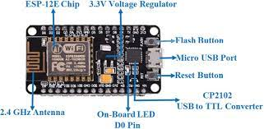
- DHT-11 Sensor :
A straightforward, incredibly affordable digital temperature and humidity sensor is the DHT-11. It measures the humidity in the air using a thermistor and a capacitive humidity sensor, and it outputs a digital signal on the data pin without the requirement for analogue input pins.
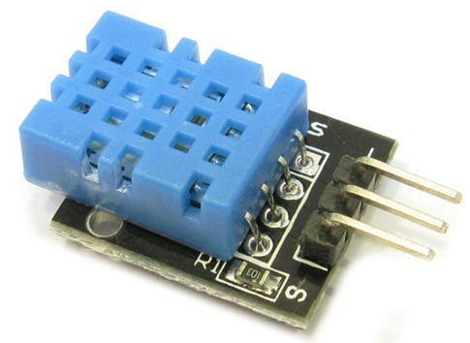

- Arduino IDE:

The Arduino IDE was the primary programme we used to programme our microcontroller board. It was created using C and C++.It offers a built-in library with several input and output options. Additionally, the programme is open source.The user code is flashed to Arduino code using the avrdude uploading tool by default.Sketches are the name for the programmes created in Arduino IDE. These are created in an editor and saved with the.ino file extension. It has a console where output, including error warnings and other data, is shown. This IDE supports the C and C++ programming languages by arranging the code according to some unique criteria.
Steps and Procedure for performing the Project
The "Arduino IOT Cloud platform" is the foundation of the entire project. Some of the main attributes of this IOT platform are listed below:
Things ,Dashboards, hardware, software, integrations, and templates
- Launch the browser, type ARDUINO IOT CLOUD into the search bar, and navigate to www.create.arduino.cc
Fig : Snapshot Of Arduino Cloud

- Each user can establish or sign up for their own account to utilise the capabilities of this IOT cloud platform, and the website holds all of their private information, including their Gmail address, password, and usernames. Users of "Create.arduino.cc" have a variety of alternatives for setting up an account. Option 1: Users can join up by selecting the CREATE ONE option, where they can enter all of their personal data, including Full Name, Date of Birth, Location, and so on. Option 2: Direct registration by choosing the Gmail option (no personal information is required).

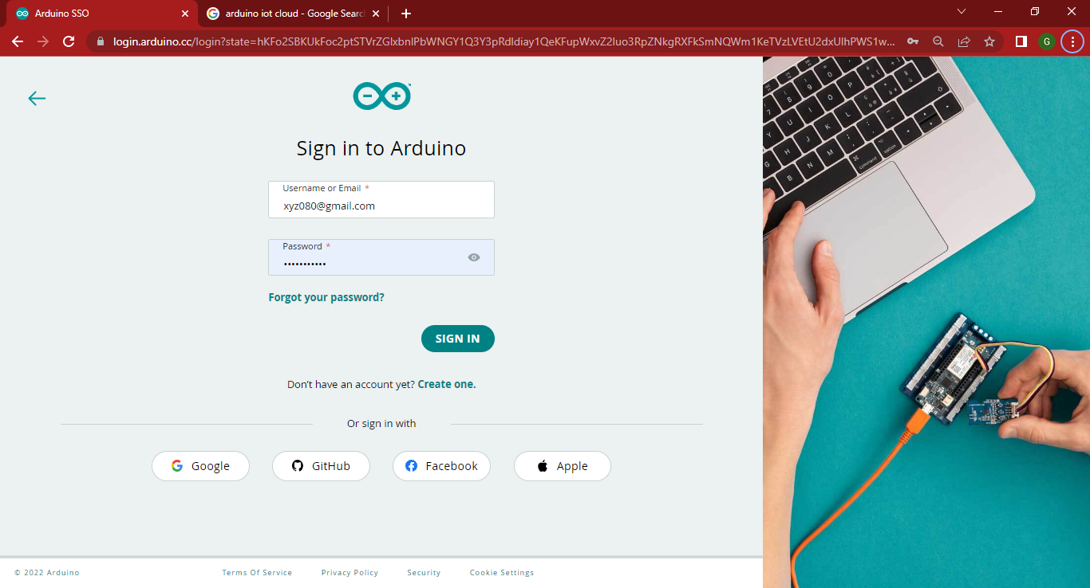
Fig : Signing in Arduino Cloud

- Develop "THINGS"

This option includes all the necessary data for running the project, such as humidity, LED, temperature, and network connectivity for pairing devices with one another to access the device through Bluetooth and WiFi.

SELECT -> Humidity – int humidity (integer type), LED – boolean type, and the Temperature – CloudTemperatureSensor.
- By entering the correct SSID and your WiFi password, you can pair your device.
- Develop "DASHBOARDS"
The Dashboard essentially provides a U.I (user interface) that allows users to connect with the IOT platform and is in charge of managing the overall Layout of the project. The following is a list of the widgets or parts that must be included in the dashboard for the device:
- LED Switch
- Temperature Gauge
- Humidity Value
- Temperature Chart

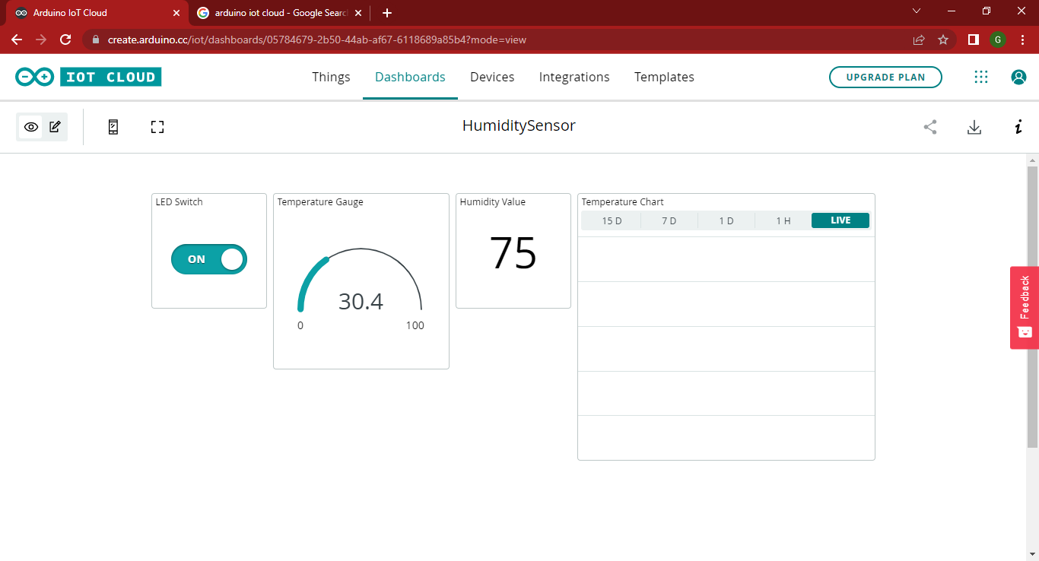
Fig : Dashboard Creation
- Develop "DEVICES"
This option includes all of the device (Hardware) configurations and data for the Esp8266 - Node MCU in the project mentioned above.
- Select “Set up a third party device”
- Search for Node MCU (1.0) module
- After completing the above steps successfully a Secret-Key will be generated and providing the right key is mandatory for pairing the device to access the Wifi and Bluetooth connectivity.
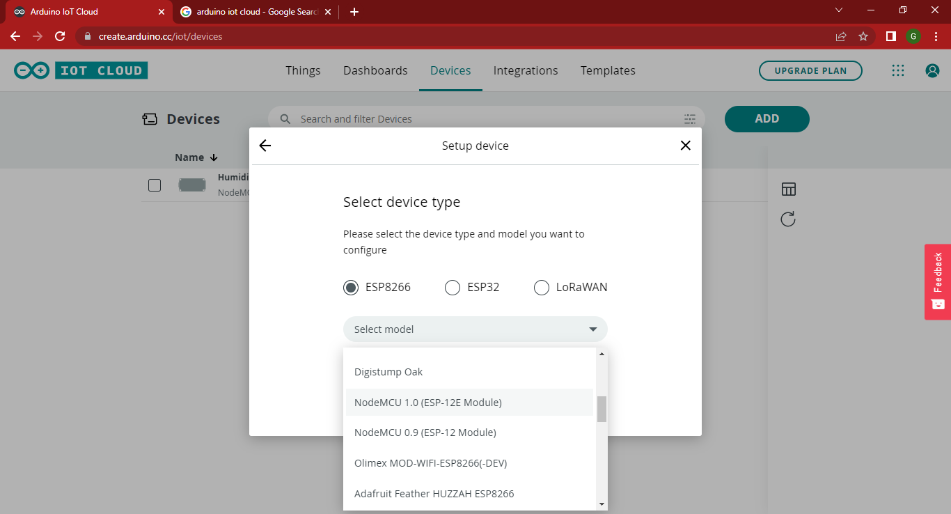
Note : The secret Key must be accurate.
- Produce a "SKETCH" and submit the CODES
"Sketch" is the brain of the entire project; it manages all the logical and programming aspects required to run the device and retrieve readings for the temperature and humidity of a specific area. maintaining the device's wireless and Bluetooth connectivity. The sketch functions as a carrier for all the code and programming necessary to run the gadget.
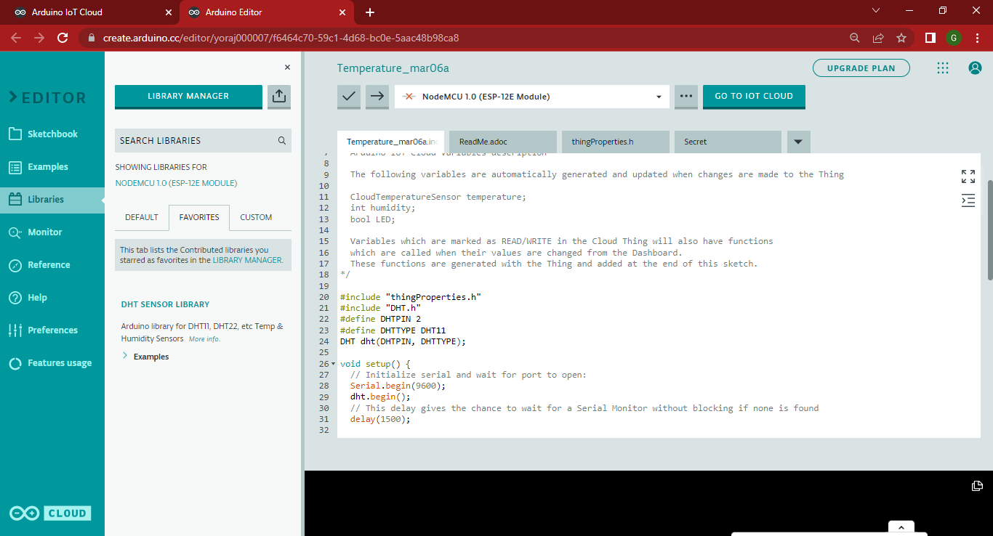
Fig: Sketch Code
- To record the humidity, import the "DHT SENSOR LIBRARY" library from the library manager.
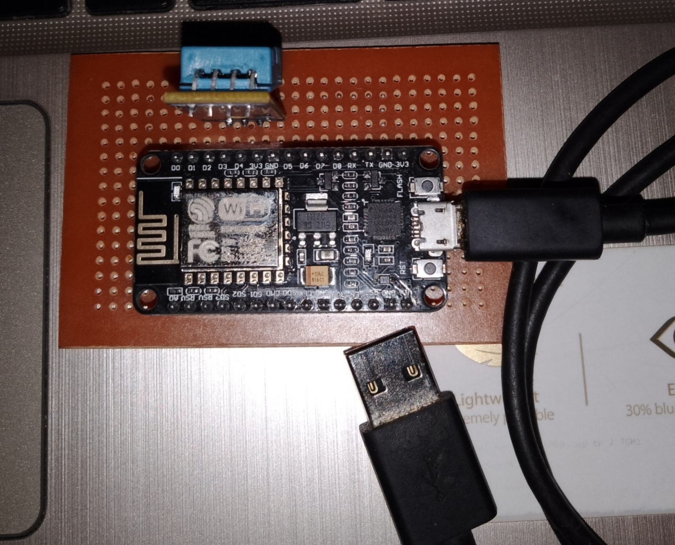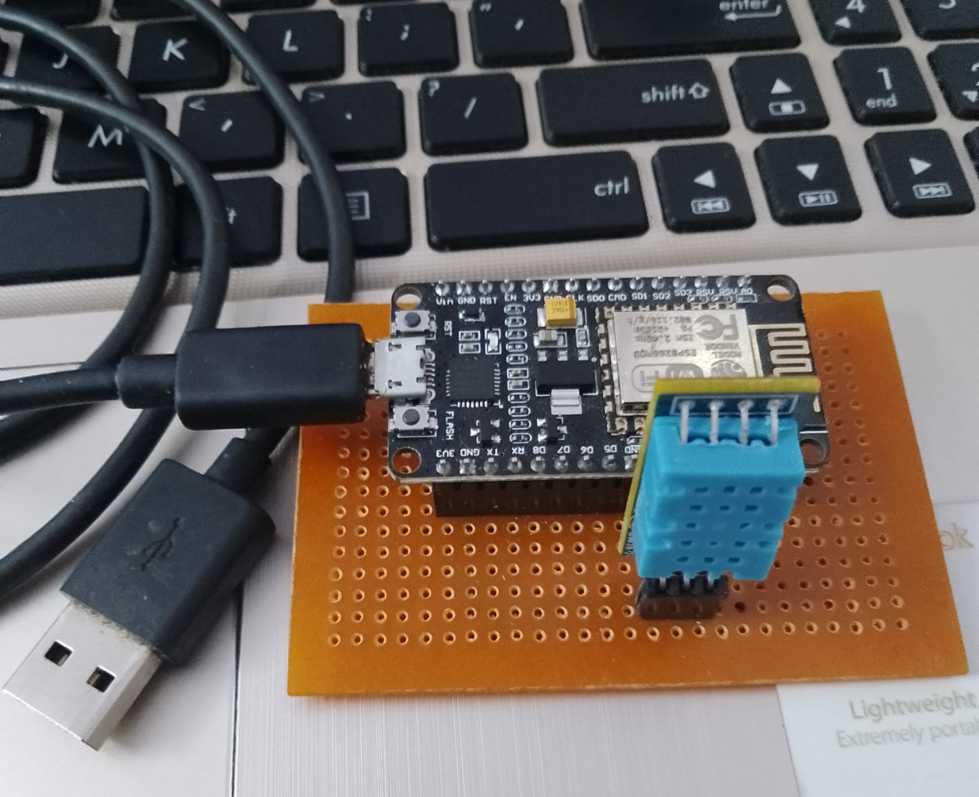

Result :

The numbers are analyzed when the sensor measurements are sent to the cloud, and the system is then alerted if a parameter's specific value deviates from its expected range. Additionally, a graph is drawn to display the trends.

Future Scope:
The suggested cloud-based and IoT-based weather monitoring system can be expanded to include a wide range of functions. We may also incorporate a GPS device into the design so that, in addition to the environment's other attributes, such as temperature, humidity, pressure, and light intensity, the user will also receive information on the environment's location by email or text message.For detecting several other weather characteristics, such as sun radiation and visibility, we can add more sensors. The system can also be changed so that all environmental parameters can be sent as a message or as a notification to a mobile phone or email address whenever a message is sent from a certain phone number or email address to the server. .Additionally, this weather monitoring system can be used for many other automation projects, such as smart city projects.

References :
[1] Hammi, B., Khatoun, R., Zeadally, S., Fayad, A., & Khoukhi, L. (2018). IoT technologies for smart cities. IET Networks, 7(1), 1-13. doi: 10.1049/iet-net.2017.0163
[2] S. Zafar, G. Miraj, R. Baloch, D. Murtaza, and K. Arshad, “An IoT Based Real-Time Environmental Monitoring System Using Arduino and Cloud Service”, Eng. Technol. Appl. Sci. Res., vol. 8, no. 4, pp. 3238-3242, Aug. 2018.
[3] S. D. Shewale, S. N. Gaikwad, “An IoT based real-time weather monitoring system using Raspberry Pi”, International Journal of Advanced Research in Electrical, Electronics and Instrumentation Engineering”, Vol. 6, No. 6, pp. 4242-4249, 2017
[4] K, H. (2020). IOT Based Weather Monitoring System Using Particle Photon. Retrieved 10 April 2020, from https://www.engineersgarage.com/contributions/iot-based-weather-monitoring-systemusing-particle-photon/
[5] Babu, R.Suresh & Thillainathan, Palaniappan & Anushya, K & Kowsalya, M & Krishnadevi, M. (2018). IoT Based Weather Monitoring System. [6] A Greenhouse Monitoring and Crop Prediction System Implemented using Iot, Arduino Uno and Nodemcu. (2020). International Journal Of Recent Technology And Engineering, 8(4S5), 1-4. doi: 10.35940/ijrte.d1001.1284s519.

[6] F. Meneghello, M. Calore, D. Zucchetto, M. Polese and A. Zanella, "IoT: Internet of Threats? A Survey of Practical Security Vulnerabilities in Real IoT Devices," in IEEE Internet of Things Journal, vol. 6, no. 5, pp. 8182-8201, Oct. 2019. doi: 10.1109/JIOT.2019.2935189
[7] N. Y. Parotkin and V. V. Zolotarev, "Information Security of IoT Wireless Segment," 2018 Global Smart Industry Conference (GloSIC), Chelyabinsk, 2018, pp. 1-7. doi: 10.1109/GloSIC.2018.8570144
[8] S. Siboni et al., "Security Testbed for Internet-of-Things Devices," in IEEE Transactions on Reliability, vol. 68, no. 1, pp. 23-44, March 2019. doi: 10.1109/TR.2018.2864536
[9] Y. Liu, Y. Kuang, Y. Xiao and G. Xu, "SDN-Based Data Transfer Security for Internet of Things," in IEEE Internet of Things Journal, vol. 5, no. 1, pp. 257-268, Feb. 2018 doi:10.1109/JIOT.2017.2779180
[10] P. Fremantle and P. Scott, “A survey of secure middleware for the Internet of Things,” PeerJ Computer Science, vol. 3, p. e114, May 2017

