Green Recycling: Sustainable Disposal of Computers and Digital Devices

Swati Gupta
Dev Bhoomi Uttarakhand University
Dehradun, India
swatig060@gmail.com

Saqib Salaria
Dev Bhoomi Uttarakhand University
Dehradun, India
Saqibsalaria14@gmail.com

ABSTRACT
The widespread use of computers and digital gadgets in an age marked by rapid technological growth and digital innovation has definitely changed the way we live, work, and interact. These technological wonders have improved convenience, connectivity, and efficiency by seamlessly integrating themselves into our daily lives. The rising tide of electronic garbage, or e-waste, is a challenge that demands our immediate attention and collective action in the midst of this incredible progress. An international environmental crisis that threatens the delicate balance of our world has been sparked by the growth of technological devices. Discarded smart phones, televisions, computers, and other digital devices all add to the growing stream of e-waste, which is full of both potential and danger. Beyond their sophisticated designs and cutting-edge features are dangerous elements, harmful compounds, and unavoidable ecological effects. The need for "green recycling" has arisen as a result of the pressing need to address this complex issue. This innovative strategy for managing e-waste calls for a paradigm shift away from traditional disposal techniques and towards a paradigm that is ecologically friendly and sustainable. Green recycling prioritizes resource conservation, pollution prevention, and the development of a circular economy in order to lessen the negative effects of electronic waste. This chapter, on the other hand, is meant to be a beacon of hope, a call to action, and a road map for change. With a strong focus on sustainability, green recycling presents a way out—a route to responsible e-waste management that protects the environment, saves priceless resources, and maintains the innovation legacy for future generations.

Keywords—E-Waste; Green Recycling; Sustainable Disposal; Electronic Devices

INTRODUCTION

The chapter emphasizes the pervasiveness of electronic gadgets in contemporary culture against the backdrop of a technical landscape that is continually expanding. Electronics have become a necessary part of daily life, influencing and reflecting how we live, work, and communicate, from smartphones to laptops, from home appliances to industrial machinery. The rise of e-waste, with its poisonous components and environmental risks, poses a serious threat to ecosystems, human health, and the health of the world as a whole. This digital revolution has, however, come at a price.The chapter emphasizes the main objective of green recycling, which is to develop eco-friendly, sustainable techniques for handling e-waste that minimize damage and maximize resource recovery. The chapter aims to highlight the need for rapid and coordinated action to address this issue by examining the complexities of e-waste composition and its possible risks.The chapter explores workable solutions while being driven by a sense of obligation to the environment and future generations. It provides information about cutting-edge recycling techniques, global best practices, and actual instances of nations leading the way in environmentally friendly recycling initiatives. With the help of these revelations, the chapter envisions a greener, more sustainable future where electronics are not only produced and used, but also managed with care, consideration, and a dedication to maintaining the delicate balance of our world.In essence, this chapter's background serves as a rallying call to recognize the urgency of the e-waste crisis and embrace the principles of green recycling as a means to effect positive change. It sets the stage for a comprehensive exploration of responsible e-waste management, inviting readers to delve into the multifaceted dimensions of this global challenge and to embrace the transformative potential of sustainable practices.

Electronic Waste (E-Waste)
Electronic waste, also referred to as e-waste, is a term used to describe discarded electrical and electronic devices that have reached the end of their useful life or are no longer required. E-waste includes a wide range of electrical items such as computers, laptops, smart phones, televisions, refrigerators, washing machines, and other consumer electronics. Because of technology improvements, wear and tear, or changes in consumer preferences, these products may be non-functional, outmoded, or undesired.
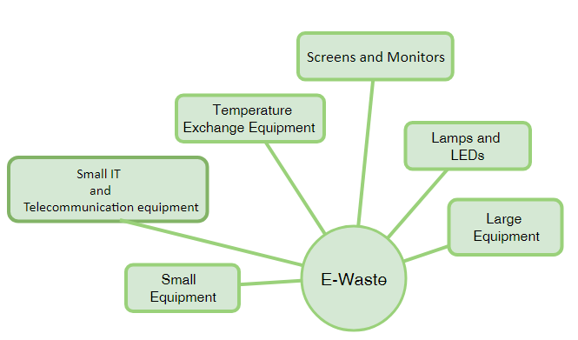
Figure 1: Composition of E-waste

The quantity and complexity of e-waste can range from small handheld gadgets to big household appliances and industrial equipment. It comprises products that are both functional and non-functional and incorporate electronic components, circuitry, and other elements.
To reduce the harmful effects on the environment and public health, proper e-waste management includes responsible recycling, refurbishing, and safe disposal techniques. Recycling e-waste allows valuable materials to be recovered, reduces demand for virgin resources, and contributes to a more sustainable and circular economy.

Hazards and Environmental Impact of E-Waste
Electronic garbage, or e-waste, offers substantial dangers and environmental implications owing to poor management, disposal, and recycling. E-waste is made up of abandoned electronic devices like computers, smart phones, televisions, and other electronic equipment. The presence of harmful compounds and components within these devices contributes to the hazardous character of e-waste. Here are some of the most serious risks and environmental consequences related with e-waste:
- Toxic Substances: Toxic substances found in e-waste include lead, mercury, cadmium, and brominated flame retardants. When e-waste is incorrectly disposed of in landfills or burnt, these compounds can leak into the soil and water. Human exposure to these substances can result in major health concerns such as neurological illnesses, reproductive troubles, and developmental defects.
- Pollution of the Air and Water: Incinerating e-waste can emit harmful gasses and particulates into the air, adding to air pollution. Furthermore, when e-waste is disposed of in landfills, harmful substances can seep into groundwater and contaminate water sources, damaging aquatic ecosystems and potentially entering the food chain.
- Soil Contamination: Improper e-waste disposal can result in soil contamination because dangerous compounds from electronic equipment can permeate the soil. This can have long-term implications on soil quality, impacting plant development and agricultural productivity.
- Resource depletion: E-waste contains valuable and limited resources such as precious metals (gold, silver, palladium) and rare earth elements. Improper disposal results in the loss of these resources, which necessitates more mining and extraction activities to meet demand, further depleting natural resources and contributing to environmental deterioration.
- Informal Recycling Practices: In many underdeveloped nations, e-waste is typically recycled in a dangerous and inefficient manner. This can include burning cables to recover copper, which emits dangerous gasses, or utilizing acid baths to remove valuable metals, which produces toxic waste.

THE ESCALATING E-WASTE CRISIS

Investigating the scale of the problem, this section highlights the alarming growth of e-waste worldwide and its implications for the environment and human health. The escalating e-waste crisis refers to the rapidly increasing problem of electronic waste around the world. E-waste includes discarded electronic devices, such as computers, Smart phones, televisions, and other consumer electronics, as well as electrical appliances and industrial equipment. The surge in technological advancements and the constant demand for new and upgraded devices have contributed to the significant growth of e-waste generation.

Factors contributing to the E-waste Crisis

- Rapid Technological Obsolescence: As technology evolves at a swift pace, electronic devices become outdated and replaced with newer models, leading to a high turnover rate of electronic products.
- Increased Consumerism: The rise in consumerism, coupled with aggressive marketing strategies, encourages people to replace their electronic devices frequently, even if the older ones are still functional.
- Short Product Lifespan: Some manufacturers design electronic products with planned obsolescence, making them difficult or costly to repair, encouraging consumers to replace rather than repair.
- Limited Recycling Infrastructure: Many regions lack proper recycling facilities and regulations for e-waste management, leading to improper disposal, including illegal dumping and incineration.

Environment Health Implications

The escalating e-waste crisis has significant environmental and health implications:

- Environmental Impact: Improper disposal of e-waste releases hazardous chemicals and metals into the environment, contaminating soil and water sources. This can harm ecosystems, wildlife, and plant life.
- Health Hazards: E-waste contains toxic substances like lead, mercury, cadmium, and brominated flame retardants. When not handled properly, these toxins can pose serious health risks to both humans and animals.
- Resource Depletion: Electronic devices contain valuable and finite resources like gold, silver, copper, and rare earth metals. Without proper recycling, these resources go to waste and increase the demand for new raw materials.
- Greenhouse Gas Emissions: E-waste that ends up in landfills or is incinerated contributes to greenhouse gas emissions, further exacerbating climate change.

Addressing the escalating e-waste crisis requires collective efforts from governments, manufacturers, consumers, and recycling industries. Implementing effective recycling programs, promoting product longevity, encouraging responsible consumption, and raising awareness about the environmental impact of e-waste are crucial steps toward a more sustainable and responsible management of electronic waste [3][5].

Global E-Waste Statistics

Global E-Waste Statistics" provides a concise and thorough look at the current global landscape of electronic waste (e-waste), addressing the prevalent issue of excessive e-waste generation. This statistical compilation highlights the growing issues posed by the growth of abandoned technological gadgets. The data emphasize the importance of adopting sustainable and ecologically responsible disposal methods by highlighting the vast magnitude of e-waste creation. The data emphasizes the crucial need for quick action to prevent the negative environmental and health impacts of inappropriate e-waste handling. In essence, this compilation serves as a stark reminder of the global urgency to shift toward more sustainable approaches in the processing and disposal of electronic trash [8].

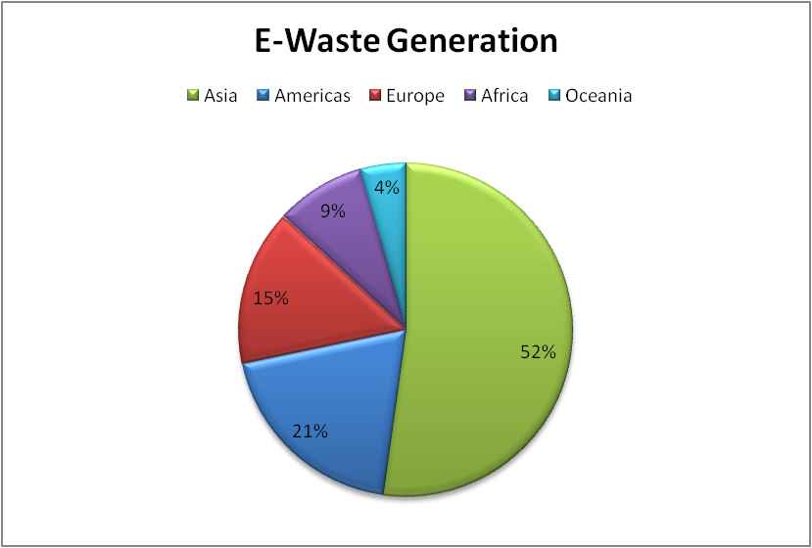
Figure 2: Global E-Waste Statistics

ENVIRONMENTAL IMPACT OF IMPROPER DISPOSAL

Improper disposal and management of electronic trash (e-waste) can have major and far-reaching consequences for human health, often resulting in the release of dangerous compounds and poisonous elements into the environment. Individuals living near e-waste disposal sites, as well as those active in informal recycling activities, and even consumers of products containing e-waste-derived components, may be affected by these health effects [4][5]. Some of the most serious environmental health consequences of inappropriate e-waste disposal include:

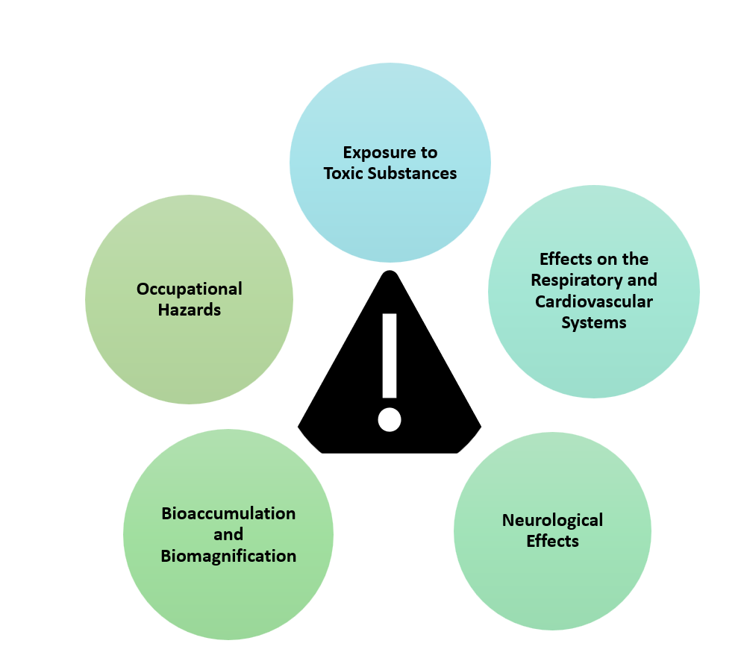
Figure 3: Improper Disposal Consequences
- Exposure to Toxic Substances: E-waste contains hazardous materials such as heavy metals (lead, mercury, and cadmium), brominates flame retardants, and other toxic chemicals. Through improper disposal practices, these substances can leach into soil, water, and air, leading to human exposure through direct contact, inhalation, or ingestion.
- Effects on the Respiratory and Cardiovascular Systems: Burning e-waste in open areas emits dangerous pollutants into the air, including particulate matter and poisonous gasses. Inhaling these pollutants can cause respiratory problems such as asthma and bronchitis, as well as worsening of pre-existing illnesses. Fine particulate particles might potentially cause cardiovascular issues.
- Neurological Effects: Heavy metals present in e-waste, such as lead and mercury, have been related to neurological diseases, developmental delays, and cognitive impairments, especially in children and pregnant women.
- Bioaccumulation and Biomagnifications: Hazardous compounds from e-waste can infiltrate the food chain and accumulate in organisms over time, resulting in bioaccumulation and biomagnifications. This process, known as bioaccumulation and biomagnifications, can result in higher tropic levels, including humans, having larger amounts of dangerous compounds.
- Occupational Hazards: Workers engaging in informal e-waste recycling activities suffer considerable health hazards due to direct exposure to dangerous materials, which are often done in unsafe conditions and without sufficient protective gear.
Proper management of e-waste is crucial to prevent the release of these toxic components into the environment. Responsible recycling and disposal processes involve the safe extraction and handling of these hazardous substances to minimize their environmental impact. Governments and environmental agencies around the world have introduced regulations and guidelines to ensure the safe recycling and disposal of e-waste, aiming to protect both the environment and human health from the hazards associated with toxic components found in electronic devices [6].

THE NECESSITY OF GREEN RECYCLING

The necessity of green recycling, especially in the context of electronic waste (e-waste), stems from the increasing environmental impact of discarded electronics and the urgent need to adopt sustainable waste management practices. Green recycling is an approach that prioritizes environmentally responsible and sustainable methods for recycling and disposing of electronic devices.
- Resource Conservation: Discussing the importance of recycling in conserving valuable resources like rare metals, minerals, and other materials used in electronics.
- Circular Economy Approach: Exploring the concept of a circular economy and its application in prolonging the lifespan of electronics through responsible recycling and refurbishment.

Environmental Protection through Green Recycling

Environmental protection through green recycling entails using sustainable and ethical waste management procedures, notably for electronic trash (e-waste). We can greatly reduce the negative environmental impacts associated with inappropriate disposal and resource extraction by promoting green recycling. Here's how green recycling helps to safeguard the environment.
- Resource Conservation: Green recycling is concerned with recovering valuable materials from discarded electronic devices. We eliminate the need for virgin resource extraction by recycling metals, polymers, and other components, saving precious natural resources and avoiding habitat harm.
- Landfill Waste Reduction: E-waste contributes significantly to landfill waste, occupying valuable land space and potentially leaching harmful elements into the environment. Green recycling diverts e-waste away from landfills, lessening the pressure on these sites while also eliminating soil and groundwater contamination.
- Toxic Release Avoidance: E-waste contains toxic substances such as heavy metals and dangerous chemicals. Green recycling ensures that these items are handled and processed properly, preventing their release into the environment and protecting ecosystems and human health.

Resource Conservation and Circular Economy Approach

The responsible and efficient use of natural resources to maintain their availability for future generations is referred to as resource conservation. Resource conservation in the context of e-waste management means minimizing the extraction of new raw materials and optimizing the use of existing materials through recycling, reuse, and responsible consumption.

Key Resource Conservation Principles:
- Extraction Reduction: We reduce the demand for virgin resources by recycling and repurposing elements from e-waste, which typically includes energy-intensive operations and environmental impact.
- Reducing Waste: Proper e-waste management decreases the amount of garbage transported to landfills, saving valuable landfill space and minimizing environmental damage.
- Energy Savings: Recycling e-waste uses less energy than making new items from raw materials, which helps to conserve energy and reduce greenhouse gas emissions.

SUSTAINABLE E-WASTE MANAGEMENT

Collection and Sorting: Investigating efficient methods for collecting, sorting, and categorizing electronic waste to streamline recycling processes.
Collection and sorting are essential steps in the management of electronic waste (e-waste) to ensure responsible disposal and recycling. Collection involves gathering electronic waste from various sources, including households, businesses, educational institutions, and government agencies. These steps are crucial for efficient and effective e-waste management systems. There are several methods of collection:

- Drop-off Centers: Many regions have designated drop-off centers where individuals and businesses can voluntarily bring their old or unwanted electronic devices for recycling. These centers are often managed by recycling companies or local governments.
- Curbside Collection: In some areas, e-waste may be collected alongside regular household waste through curbside pickup programs. However, curbside e-waste collection is less common and may be limited to specific items.
- Recycling Events: Recycling events organized by local authorities or recycling organizations, provide an opportunity for the public to bring their e-waste to a central location on designated dates for recycling.
- Producer Take-Back Programs: Some countries or regions have implemented extended producer responsibility (EPR) laws, which require manufacturers to take back and recycle their products at the end of their life cycle. This approach holds manufacturers accountable for the proper disposal of their electronic products.
- Sorting: After collection, e-waste undergoes sorting to categorize different types of electronic devices and components. Sorting serves several purposes:
- Identifying Recyclable Materials: Electronics contain various materials like metals (e.g., copper, aluminum), plastics, glass, and circuit boards. Sorting helps identify and separate these materials for recycling.
- Separating Hazardous Components: Some electronic devices may contain hazardous components like batteries and cathode ray tubes (CRTs). Proper sorting ensures that these components are isolated for safe and specialized recycling.
- Preparing for Disassembly: Sorting prepares e-waste for the disassembly process, where individual components are separated from the devices to extract valuable materials and facilitate further recycling.
- Data Security and Privacy Concerns: Addressing the critical issue of data destruction and privacy protection during the recycling process.
- Responsible Recycling Standards: Introducing international guidelines and certifications that ensure ethical and environmentally-friendly e-waste recycling practices [7].

The success of e-waste recycling largely depends on efficient collection and sorting practices. Proper collection methods encourage responsible disposal by making it convenient for individuals and businesses to recycle their electronic devices. Effective sorting ensures that materials are properly separated, and hazardous components are treated safely, minimizing environmental and health risks associated with electronic waste.

TECHNOLOGICAL INNOVATIONS IN GREEN RECYCLING

Technological advancements have been critical in the advancement of green recycling, particularly in the context of electronic waste (e-waste) management. These breakthroughs have transformed how we manage, process, and recover precious elements from discarded electronic gadgets. Here are a few major technological advancements in green recycling [6]:

- Automated Dismantling Systems: Manual dismantling of electronic equipment was labor-intensive and generally inefficient in traditional e-waste recycling. Robotics and artificial intelligence are used in advanced automated dismantling systems to deconstruct electronic gadgets more efficiently, segregating different components and materials for recycling.
- Shredding and Sorting Technologies: Cutting-edge shredding and sorting technologies allow electronic devices to be efficiently broken down into smaller components. Sensors and cameras are used in optical sorting systems to recognize and separate distinct materials depending on their qualities, hence increasing the recovery of valuable metals and polymers.
- Hydrometallurgical procedures: Hydrometallurgical procedures employ chemical processes to dissolve and recover valuable metals from electronic trash. These technologies are less harmful to the environment than older methods and can easily extract precious metals such as gold, silver, and palladium from electronic components.
- Bioleaching: It is the use of microorganisms to recover metals from electrical waste. Certain bacteria can naturally degrade electronic components and liberate metals, which can subsequently be recovered and processed. Bioleaching is seen as a more environmentally friendly alternative to typical extraction procedures.
- 3D Printing from E-trash: Some novel ideas involve employing recycled electronic trash as a source material for 3D printing, resulting in the creation of new goods and components while consuming fewer resources.

CORPORATE AND GOVERNMENT INITIATIVES

Corporate and government activities are critical in resolving electronic trash (e-waste) concerns and encouraging sustainable e-waste management. These programs include a variety of actions targeted at reducing e-waste generation, enhancing recycling procedures, and avoiding the environmental and health consequences of inappropriate disposal [4][7].

- Legislation and Regulations: Governments around the world have implemented laws and regulations that govern e-waste management. These regulations often include requirements for proper collection, recycling, and disposal of electronic devices. Examples include the Waste Electrical and Electronic Equipment (WEEE) Directive in the European Union and the Resource Conservation and Recovery Act (RCRA) in the United States [7].
- Extended Producer Responsibility (EPR) Laws: Many governments have established EPR laws that mandate manufacturers to take back and recycle their products. These laws hold producers accountable for the end-of-life management of their electronic devices.
- Subsidies and Incentives: Governments may offer financial incentives or subsidies to encourage businesses and consumers to participate in e-waste recycling programs. These incentives can include tax benefits, grants, or discounts on recycling services.
- Public Collection Programs: Governments often establish collection points or centers where citizens can drop off their e-waste for proper recycling. These programs make it convenient for individuals to dispose of their electronic devices responsibly.
- International Agreements and Collaborations: Some governments participate in international agreements and collaborations to address the global e-waste challenge. These efforts involve sharing best practices, technology transfer, and capacity-building in e-waste management.

Both corporate and government initiatives are vital components of the broader strategy to address the environmental and health impacts of e-waste and promote a more sustainable approach to electronic waste management.

REAL EXAMPLES: COUNTRIES ADOPTING GREEN RECYCLING

From September 2021, numerous countries around the world have been adopting green recycling practices to address electronic waste and promote sustainability [5]. Some of the leading countries known for their efforts in green recycling include:

Germany:

Germany is a notable example of proactive and effective green recycling policies in the handling of electronic trash (e-waste). The government has adopted comprehensive plans and legislation that serve as an example for safe e-waste disposal. Here are some significant elements of Germany's approach:
- Extended Producer Responsibility (EPR): Germany has built a solid EPR framework in which manufacturers are responsible for the whole life cycle of their products, including disposal. This has created a significant incentive for manufacturers to build items that are easily recyclable and environmentally beneficial.
- Waste Electrical and Electronic Equipment (WEEE) Directive: Germany has incorporated the European Union's WEEE Directive into domestic law. This directive establishes e-waste collection targets and regulations. It ensures that e-waste is collected, handled, and recycled properly
- Collection Infrastructure: The country has established a comprehensive network of e-waste collection stations, drop-off centers, and recycling facilities. This makes it easier for citizens to properly dispose of their technological devices.
- Deposit Refund System: Similar to the deposit system used for beverage containers, Germany has implemented a deposit system for electronic gadgets. When purchasing electronics, consumers pay a deposit, which is refunded when the gadget is returned for recycling. This encourages proper waste disposal and recycling.
- Recycling Efficiency: Germany uses innovative recycling technology that allows valuable materials to be recovered from e-waste. Extraction of precious metals such as gold, silver, and copper from circuit boards and other components is included.

Japan:
Japan is a shining example of smart and innovative e-waste management, displaying a dedication to green recycling procedures that has won international acclaim. This technologically advanced country has put in place extensive strategies and activities to address the difficulties posed by electronic trash, establishing a standard for responsible disposal and resource recovery. Here are some significant features of Japan's e-waste management strategy:

- Collaborative Legislation: Japan has built a comprehensive legal framework for e-waste disposal, focusing on collaboration among the government, industry, and consumers. The Home Appliance Recycling Law and the Act on the Promotion of Recycling of Small Waste Electrical and Electronic Equipment are critical pieces of legislation that govern e-waste disposal and recycling.
- Advanced Collection Infrastructure: Japan has a large network of collection centers and recycling facilities, making it easy for citizens to dispose of their electronic gadgets correctly. Collection stations are deliberately placed throughout the country to ensure easy access for both urban and rural residents.
- Consumer Education: Public awareness initiatives are important components of Japan's e-waste management plan. The government and commercial organizations work together to educate consumers about the necessity of recycling and safe disposal, establishing an environmental culture.
- Efficient Material Recovery: To extract valuable materials from e-waste, Japan uses cutting-edge technologies. Precious metals, rare earth elements, and other valuable resources are recovered from discarded electronic equipment using modern sorting and recycling methods.
- Research and Development: Japan invests in research and development to promote e-waste recycling methods. Innovations abound, from efficient dismantling techniques to novel approaches to collecting important elements with minimal environmental impact.

Sweden:
Sweden is a shining example of proactive and inventive e-waste management, exhibiting a strong dedication to sustainability and green recycling techniques. Sweden has effectively addressed the difficulties posed by electronic waste through a combination of strong legislation, modern technologies, and public engagement. Here are some major points about Sweden's approach to e-waste management.

- Legislation and Regulations: To oversee the collecting, recycling, and disposal of e-waste, Sweden has adopted severe rules and regulations. The Waste Electrical and Electronic Equipment (WEEE) Directive, which is part of the regulatory framework of the European Union, serves as the foundation for Sweden's e-waste management activities.
- Extended Producer Responsibility (EPR): Sweden's EPR system holds producers accountable for the whole lifecycle of electronic devices. This covers e-waste collection, recycling, and disposal. Manufacturers are incentivized to design items that are recyclable and to set up take-back procedures.
- Convenient Collection locations: Sweden has built a nationwide network of collection locations where citizens may simply drop off their e-waste. These collection terminals are frequently found in easily accessible locations, such as electronics retailers and recycling facilities.
- Recycling technology of the Future: The country has invested in innovative recycling technology such as automated dismantling systems, sorting technologies, and environmentally friendly processing processes. These technologies make it possible to recover valuable elements from e-waste in an efficient manner.

It's essential to note that the e-waste management process varies from country to country, and not all locations have well-established recycling facilities. Improper disposal of electronic waste can lead to environmental pollution and health hazards, making responsible e-waste recycling crucial for a sustainable future. Many countries are continuously working to improve their e-waste management practices and implement more efficient and environmentally friendly solutions to address this growing issue.

CONCLUSION

As society continues to embrace ever-evolving technology, it becomes paramount to address the mounting challenges of e-waste. This chapter emphasizes the urgency of adopting green recycling practices for computers and digital devices, illustrating the crucial role that sustainable e-waste management plays in safeguarding the planet's future. By implementing responsible recycling strategies, businesses, governments, and individuals can collectively contribute to a more environmentally conscious and technologically sustainable world.

CHAPTER SUMMARY

The chapter aims to achieve the following specific objectives:

- Educate and Inform: The chapter seeks to educate readers about the magnitude of the e-waste crisis, its environmental consequences, and the hazardous components present in electronic devices. It aims to provide a clear understanding of the urgency of adopting sustainable e-waste management practices.
- Highlight the Need for Sustainable Practices: Through a detailed exploration of the environmental impact of improper e-waste disposal, the chapter aims to emphasize the necessity of green recycling. It intends to underscore the importance of transitioning from conventional disposal methods to environmentally responsible recycling approaches.
- Showcase Best Practices: The chapter intends to showcase successful green recycling initiatives and practices implemented by countries and organizations. By highlighting real-world examples, it aims to inspire readers and demonstrate the feasibility and effectiveness of sustainable e-waste management.
- Promote Resource Conservation: One of the core objectives is to underscore the significance of resource conservation through recycling. The chapter aims to convey how green recycling can contribute to the preservation of valuable materials, reduce the demand for virgin resources, and minimize the ecological footprint of electronic devices.
- Advocate for Policy and Behavior Change: The chapter seeks to advocate for the adoption of policies and regulations that support green recycling practices. It aims to encourage readers to embrace responsible e-waste disposal and promote behavior change at both individual and societal levels.
- Empower Decision-Making: By providing insights into the benefits of green recycling, the chapter aims to empower individuals, businesses, and policymakers to make informed decisions that prioritize sustainable e-waste management and contribute to a cleaner environment.
- Contribute to Sustainability Dialogue: Ultimately, the chapter aims to contribute to the ongoing global dialogue on sustainability, waste reduction, and environmental protection. It aspires to be a valuable resource for researchers, policymakers, educators, and concerned individuals engaged in addressing the e-waste challenge.

REFERENCES

- Debnath, B., Roychoudhuri, R., & Ghosh, S. K. (2016). E-waste management–a potential route to green computing. Procedia Environmental Sciences, 35, 669-675.
- Agarwal, S., & Nath, A. (2011, June). Green computing-a new horizon of energy efficiency and electronic waste minimization: A global perspective. In 2011 International Conference on Communication Systems and Network Technologies (pp. 688-693). IEEE.
- Kurp, P. (2008). Green computing. Communications of the ACM, 51(10), 11-13.
- Taruna, S., Singh, P., & Joshi, S. (2014). Green computing in developed and developing countries. arXiv preprint arXiv:1406.2773.
- Kaur, A. (2014). Green computing: Emerging trends in information and communication technology. International Journal of Engineering Inventions, 3(9), 42-46.
- Radhakrishnan, S. (2016). Environmental implications of reuse and recycling of packaging. Environmental footprints of packaging, 165-192.
- Harmon, R. R., & Auseklis, N. (2009, August). Sustainable IT services: Assessing the impact of green computing practices. In PICMET'09-2009 Portland International Conference on Management of Engineering & Technology (pp. 1707-1717). IEEE.
[8] Ruth, S. (2009). Green it more than a three percent solution?. IEEE Internet Computing, 13(4), 74-78.

