Elephant Corridor for Movement and Identification Management Using Drone Camera in Deep Neural Network

Dr. ArunaRana, Professor in MSAE, MATS University, Raipur, Email: dr.aruna05@gmail.com
Dr. BhavnaNarain, Professor in MSIT, MATS University, Raipur, Email: narainbhawna@gmail.com
Mrs. BakhtawerShameem, Research Scholar in MSIT, MATS University, Raipur Email:saba7shameem@gmail.com
Mr. Jaideep Singh, Drone Expert, and UAV Manage in Flying Technologies Solution, Raipur Email: jaideep.s82@gmail.com

Abstract
Recently, it is seen that Chhattisgarh elephant human conflict is a major problem this major problem has resulted in big socio-economic problem. Various steps has been taken to organize elephants and corridor. Elephant identification and their behavioral analysis has been discussed in many research works. We have proposed an Elephant corridor searching model that can extract discriminative feature of elephant and their corridor. We can identify particular elephant by using a drone camera video and pictures, that represents a stout baseline for how elephants can be identified using a drone camera. Moreover, there is no need for separate scanning of deforest movement in the device because it uses a drone camera picture .Drone camera acquires the two type of data sets, first the map of elephant corridors and the second one is elephant movement beside highly recognized performance the proposed drone camera searching method also ensure simplicity and proficiency . The searching through drone camera achieves better recognition performance then estate of the art method for the collected elephant corridor detail. We have cross validated elephant movement data set using multiple dataset and acquired the average identification of elephant and corridor accuracy is 98.59%.The proposed elephant corridor identification network is a convolution neural network CNN based network structure. Comparison of all features of extraction and attention can be done by these models.
Keyword
Elephant Corridor, Corridor Map, Drone Camera, Convolutional Neural Network (CNN), Deep Learning.
- Introduction
Elephant movement in corridor is promising area of study with drone cameras in Chhattisgarh region. Various techniques are used for searching elephants in deep forests in the area of vision of computer and deep learning in recent years. The extracting features of discriminative by considering elephant corridor and elephant image processing trends, such as visual appearance and three-dimensional view for pattern recognition of Elephant in corridor (H. S. Kuhl et al., 2013, & S. Kumar et al., 2018). Accordingly, elephant corridor and movement have been applied systems in various Chhattisgarh forest areas for elephant corridor, and management analysis. The co-existence harmony between people and elephants and major conflicts are the coupled responsibility. Therefore the elephant corridor and movements system by using drone camera for managing the elephants and monitoring the other species of wild animals also. The several incidents allied with elephant corridors and movement can be significantly minimized through drone camera monitoring used for tracking of elephants, and reducing thieve. Moreover, by enabling successful elephant picture as data and a corridor map can be created and data can be collected from the Chhattisgarh forest to overcome the limitation imposed by inadequate elephant data set (S. Kumar et al., 2018, 2017).

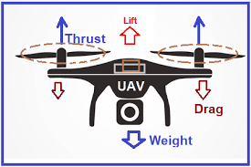
Fig. 1:Basic Features of Drone with Camera
This work has prominence on the efficiency improvement of the Chhattisgarh forest department and its elephant movements can be managed through drone cameras. There are various different techniques which reduce the elephant-human conflict. The sophistication of approaches are met in documentation of drone cameras those are used while searching an elephant herd and its moments. Today, drone cameras are not being used for searching the moment of the elephant in the Chhattisgarh forest. The use of drone camera monitoring for the elephant corridor and its movement may reduce elephant conflict. Previous work can greatly impact on elephant identification and its behavior. Today's requirement is to minimize human-elephant conflict and knowledge of elephant movement. Our drone work is very impressive in minimizing elephant-human conflict in the Chhattisgarh forest.
Fig. 1 shows the drones basic features. Chhattisgarh elephant corridor is very big and not possible the ground based searching techniques. But the use of drone camera minimizes the work of forest force. The early warning system may be derived through this handy device in deep forest.
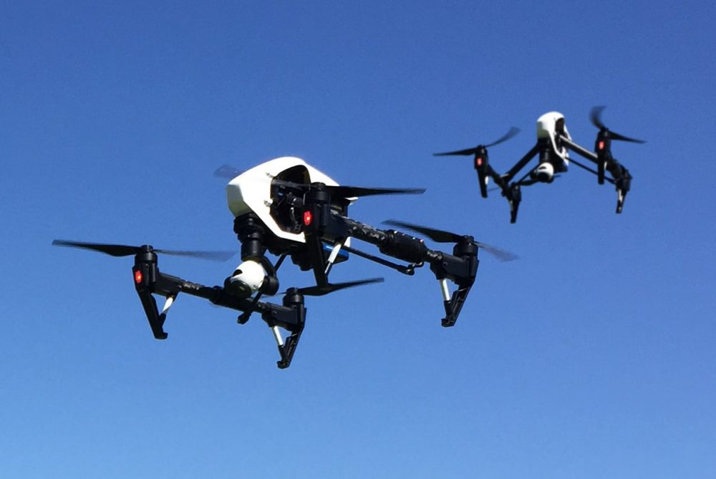
Fig. 2: Camera mounted Drone

- Size and Weight of Drone
Our addressing range position frequency is the integration of all information technology communication technologies. Robotics hunting, hurricanes, business operation, disaster operation, Timber Mapping, Timber conservation, guarding wildlife and delivery parcels are all work done by a drone. Better use of DOROTICS (drones and Robotics) to contribute to the development of an eco-efficient resource effective and competitive husbandry thought. One important new task that drones are presently Bing assigned chart mapping. Drone at a first glance is like an introduction model airplane that was designed only for recreational purposes. We have used drone to collect data for photography. The feather Light drones are now able to take thousands of digital images when serving geography. Each drawn of these images can also be collected to make complete and largely accurate 2D and 3D maps. Therefore, they suggest using the large drone for fixed-wing drones between 20 and 150 kg. Multi-rotor drones between 25 and 100 kg small drones are with fixed-wing drones up to 20 kg and multi-rotor drones up to 25 kg. In the category of small drones, it is suggested that by using a subcategory of mini drones. Mini drones can size and weigh from grams up to approximate kilograms. Always mini drones are mainly used for indoor application and recreational applications.
- Types of Drones can be used
We can consider five types of drones in our research work.
3.1. Multi-Rotor Drone
Multi-rotor drones are easiest and very cheap option for getting these drones.“Eye-in-the-Sky”is the other name for our major work is elephant corridor and moment monitoring. They are very effective in monitoring purposes and greater control offer over framing and position. Hence, they are perfect for forest area photography of elephants and surveillance.
3.2. Fixed-Wing Drones
These drones are designed to use for photography, easy camera mount for the research worthy work. It looks and works like an airplane and provide more lift and increase the battery endurance. This drone type is used to capture very fast and clear photographs in better than ground cameras. Energy needs to move forward and glide itself in the air.
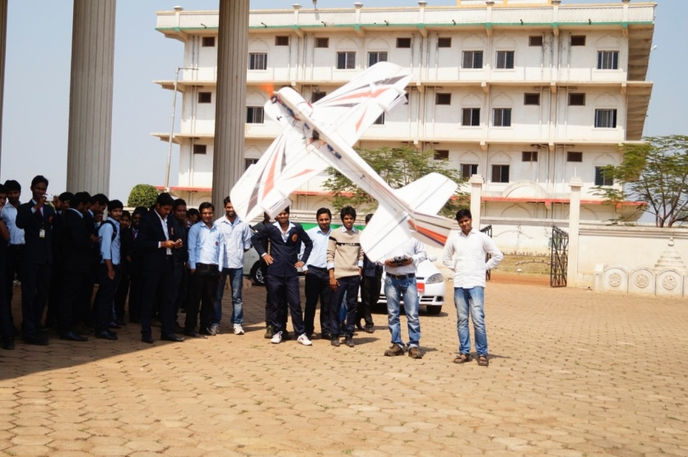
Fig. 3: Fixed-wing drones in MATS University
3.3 Single rotor drones
Single-rotor drones are very stronger and durable. It looks like to actual mini helicopters in the structure and in design. A single rotor drone has just one rotor which is like rotator wing plus a tail rotor to control direction and stability.
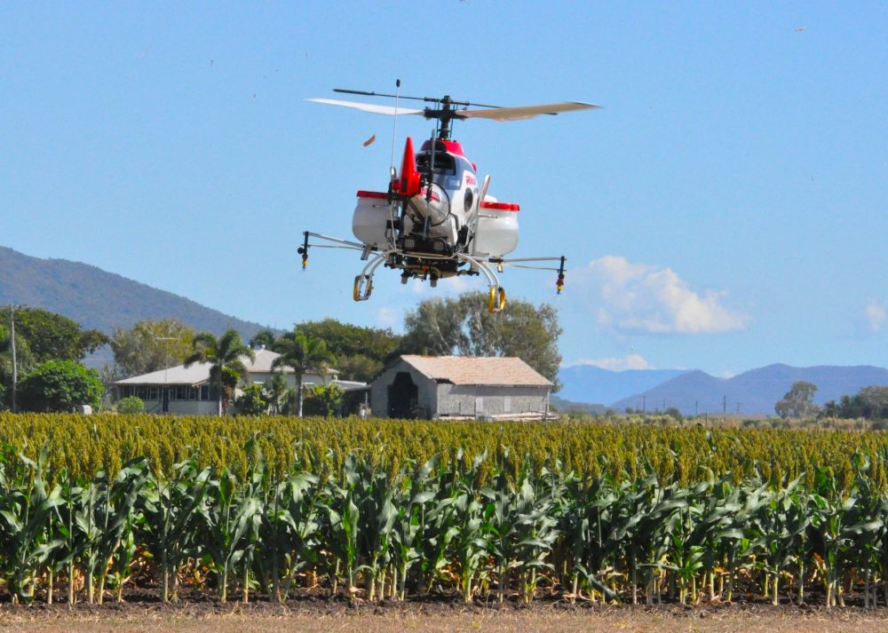
Fig. 4: single rotor drone/mini Helicopter
3.4. Fixed-wing hybrid VTOL
The hybrid VTOL drone is having a fixed wing and a quad fitted in wings, design is rotor-based. This drone type has attached rotors to the fixed wings allowing it to hover and take off vertically with the help of drone, it maps the land verifiably. This category is new hybrids technology which advances in market, this option can be very popular in the coming years. One example of a fixed hybrid model is in this photograph at MATS University.
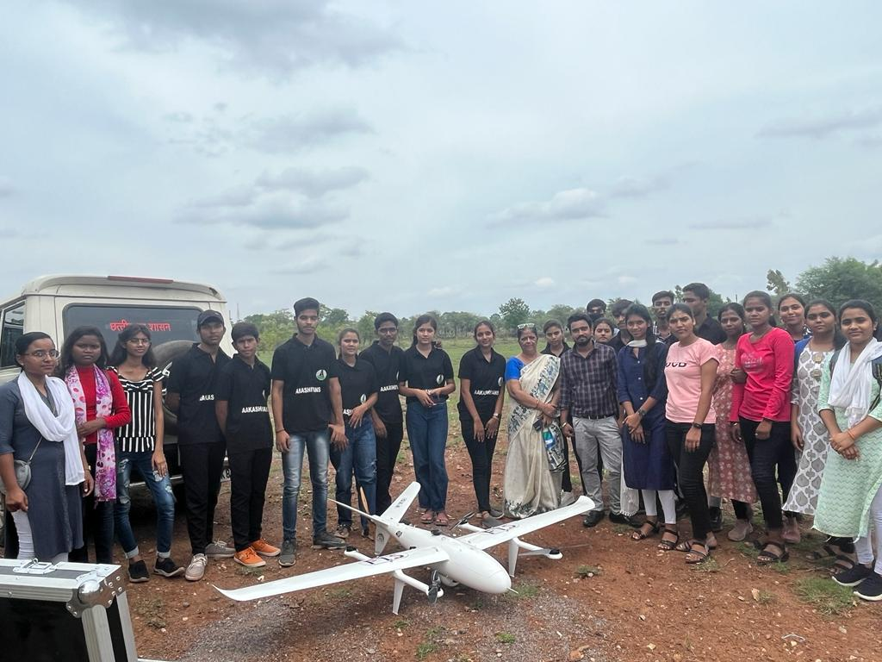
Fig. 5: Fixed-wings hybrid VTOL drone in MATS University
3.5. Broadcasting Drones
The use of broadcasters drones provides with an innovative way of capturing data the small and Nano technology allows the media to get footage of the action like never before. Use of technology to resolve human-animal conflict having proven fruitful for the forest department of affected states. officials successfully used the drones to monitor the movement of a herd of elephants back to the woods in Karnataka and as well used in Uttarakhand also. The Government further decided to extend the use of drone technology to find the location with in no time. keep an eye on the periphery of the forest. The machines based on other technology are beyond fulfilling their slated purpose. Tracking and monitoring elephant moment in thickly wooded areas its a very challenging job, more so when the terrain is hilly. But the use of drone has made this easier job in very less time.
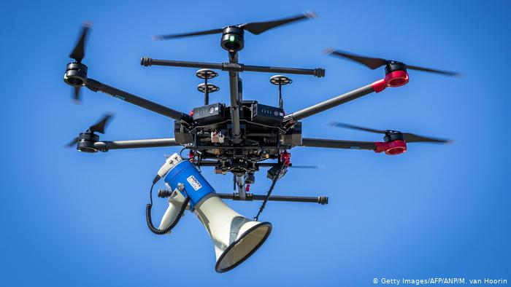Fig. 6: Broad Casting Drones-may be good assistant to the forest officers
4. Related Work
So many organizations are working on the problem at different platforms, the workshop organized to resolve the problem. The workshop presented in spanking sequential order and the sum of the merits and demerits of each work are stressed. The author (L. nam et al., 2016) propose an offline flight diary for a quad copter drone that calculates contents circles to ensure useful data for image mosaic. The present result parts the workshop using approximate cellular corruption with the size of each cell determined by the UAVs detector reading and the task implication between two success images, two Grace food processing of the data from image mosaicking. In (C. A. Kapoutsis et al., 2017) a grid mapping for multi-robot content path planning (MCPP) is presented. The crucial idea in this work is the multi-robot problem that can be answered efficiently by dividing the overall ROI into exclusive sub-reasons equal to the number of robots that will be employed for the content procedure and also working a typical CPP problem for each sub-reason. This work uses the algorithm of the divided area of optimal multi-robot coverage path planning (DARP) algorithm introduced in the area allocation procedure.
5. Proposed system
The proposed system for the Elephant corridor and movement monitoring for the Chhattisgarh forest has two main components, the first one is the drone searching all corridors and the second one is the monitoring elephant movement. These two components are very useful to reduce human-elephant conflicts and the identification of individual elephants in the overall system flow of the processing system.
5.1. Automatic detecting ground camera
Elephant’s corridor and moment monitoring for Chhattisgarh forest the process flow of automatic detection and cropping of the elephant images, for detecting the elephant. Firstly, we perform the interface differencing between two consecutive frames of the elephants and corridor field image in order to detect the elephant, then we transfer the interface differencing result into the binary image by using the predefined threshold, the equation of interface differencing method based binary image creating is described in equation (1) 1 if threshold 0 otherwise
$Mt\left(x\right)=\left\{\begin{aligned}1, if\left|It\left(x\right)-It-1\left(x\right)\right|≥Threshold \\ 0, otherwise\end{aligned}\right.$ (1)
Where,
M_{t}(x) is the result binary image of frame t,
I_{t}(x) is the cow’s image at frame t and
I_{t} – 1(x) is at the previous (t-1) frame
Then we use the white pixel occurrence (350 pixels) as a threshold in order to find the elephant corridor and movement monitoring. The horizontal history count is greater or less than the threshold v regard that elephant corridor location as a pole location. if the elephant image and Elephant corridor are two poles location detected be used the corridor location which is located near the previously detected pole, for image cropping. We use the cropping height and weight by the fixed value of 450 pixels and 850 pixels respectively because the distance between the two poles' location and the length of the pole are the same for all frames. After getting the pole location we check it for finding the cropped image direction. If the value of the y corridor of the detection pole plus the image cropped height threshold of 450 is less than or equal to the height of the original corridor or elephant image then cropping is performed over the lower 450 pixels’ area of the elephant corridor and elephant images otherwise the upper 450 pixels are his cropped. Count the frequency of the occurrence of image pixels in the horizontal direction of each point along the vertical axis. As a result, we get the horizontal histogram of the binary image. The size of each frame is 1024x768.
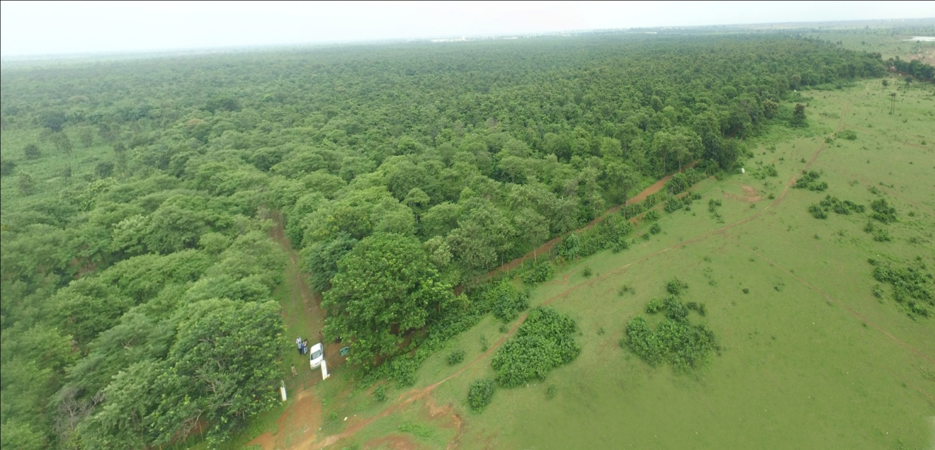Fig. 7: Panorama of Mohrenga forest Kharora Raipur

The feature map is original obtained through the channel with the concatenated first step are then axis for corridor each map obtained through the reshaped image and attention channel module in the second step, the final step is the attention model obtained through a fully connected (FC) layer. We used contrastive loss (R. Headseel et al., 2006) to optimize our model. The contrast we lost is calculated, check and apply the label of binary to appear positive negative elephant image and corridor image inputs. We also margin-based loss calculate and added additional (J. Deng et al., 2019) to extract the discriminative wedding vector of the elephant monitoring and corridor mapping CNN model. The loss is considered with the contrast your loss to optimize the elephant monitoring and corridor mapping CNN model. The experimental outcome indicates that the proposed elephant monitoring and corridor mapping CNN model framework superior reorganization illustrates performance to collected state-of-the-art methods for the elephant images data set. The contributions of our proposed elephant monitoring and corridor mapping CNN model framework is as follows
- The proposed elephant monitoring and corridor mapping CNN model method improves individual elephant corridor and Elephant movement managing systems perform through elephants based on techniques of Deep learning our method is the first step to identify an individual elephant based on Deep learning models. We provide a base line robust model through the elephant monitoring and corridor mapping CNN model method for individual elephant identification systems.
- We ensure table and discriminative feature extraction by integrating the elephant monitoring and corridor mapping CNN model modules into and to and training and combined objective functions to optimize the elephant monitoring and corridor mapping CNN network.
- We experimentally demonstrate the superior performance of our collected elephant data set compared to state-of-the-art methods. we acquired an average elephant identification and Elephant corridor map creating an accuracy of 98.59% with the rank one approach.
5.2. Deep Learning Feature-Based Methods
In vision of computer technology, deep learning for animal identification has become a key area of development. All approaches are popular to image recognize images and classification, image detection and image tracking of objects for drone cameras therefore elephant images and Elephant corridor images and identifications, recognition through deep learning. Tasks(B. Shameem et al., 2021, K. He et al., 2016, Krizhevsky et al., 2012). (Hansen et al., 2018) Animal identification system of the individual image is used in elephant monitoring and corridor mapping CNN model for training and testing with an artificially augmented data set from an unconstrained commercial form environment. (Deb et al., 2018) presented an animal face reorganization system called Prominent where a mobile application was used to directly obtained camera images of three families or species in the wild: lemurs, golden monkeys, and chimpanzees. (Hou et al., 2020) used elephant monitoring and corridor mapping CNN with deep learning to propose a new individual identification system for the giant panda; they ensure the effectiveness and reliability of the panda image identification model by considering multiple treatments under various conditions such as panda large face angle low brightness and highest saturation. (Wang et al., 2019) used an elephant monitoring and corridor mapping CNN with residual learning to study the unique panda facial feature for gender classification. (Kumar etal., 2018) approach using individual deep learning architecture such as an elephant monitoring and corridor mapping CNN and deep network brief (DNB) for individual identification of cattle. The muzzle identification of print approach was superior.

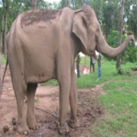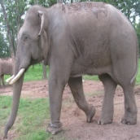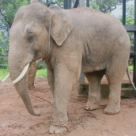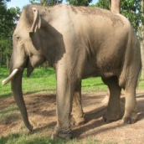
Fig. 8: Sample images of 13 elephants
6. Experiments
Comparative study can be done on both drone and ground cameras. The drone technology will be definitely fruitful to monitor and manage the corridors, it is efficient to give the early warning systems for herd of elephants and send them back into the woods.
7. Conclusion
This paper proposed an Elephant corridor and Elephant movement identified (CNN model) deep learning framework for individual elephant images. Our method of identification is the first attempt to elephant image patterns for elephant different body parts based on the deep learning models. The CNN model method aims to feature obtain robust and discriminative that can extract the unique patterns in elephant images. As ablation studies demonstrate the performance of combining objective functions for Elephant monitoring and corridor mapping optimization in CNN network with integrated modules that constitute elephant monitoring and mapping CNN model is more stable than using only body part of the elephant monitoring and mapping model unable more stable and feature of discriminative extraction to identify features using the images of elephant body part. Moreover, our experiment demonstrates that our proposed approach out performers state-of-the-art elephant monitoring and corridor mapping CNN methods on the collected elephant images data set. Consequently, the proposed elephant monitoring and corridor mapping CNN model can serve as a baseline repeat for individual elephant identification. In future work, we will discuss improvement in elephant identification and Elephant corridor monitoring by drone camera system by extending the elephant image data set. We also plan to obtain an elephant data set of images for an additional wild animal such as a tiger leopard etc. As previous studies noted in related elephant images are important extraction feature that distinguishes mild species characteristics. Therefore, we will apply it to the task of identifying elephants. Elephant image and corridor movement identification using the rehabilitation differencing and horizontal histogram-based method for automatically detecting and cropping of the elephant and corridor map for training and recognition of the elephant image. We also create the elephant image data set of 13 different elephant images and perform experiments on that data set. The proposed system got an accuracy of 96.8% for automatically detecting and cropping elephants and corridor map reason and 97.01% for Elephant identification.

REFERENCES
“Face recognition of cattle: can it be done?” Proceedings of the National Academy of Sciences, India Section A: Physical Sciences, vol. 86, no. 2, pp. 137–148, 2016.
A. I. Awad and M. Hassaballah, “Bag-of-visual-words for cattle identification from muzzle print images,” Applied Sciences, vol. 9, no. 22, p. 4914, 2019.
A. I. Awad, A. E. Hassanien, and H. M. Zawbaa, “A cattle identification approach using live captured muzzle print images,” in International Conference on Security of Information and Communication Networks. Springer, 2013, pp. 143–152.
A. Krizhevsky, I. Sutskever, and G. E. Hinton, “Imagenet classification with deep convolutional neural networks,” in Advances in neural information processing systems, 2012, pp. 1097–1105.
A. Noviyanto and A. M. Arymurthy, “Automatic cattle identification based on muzzle photo using speed-up robust features approach,” in Proceedings of the 3rd European Conference of computer science, ECCS, vol. 110, 2012, p. 114.
A. Noviyanto and A. M. Arymurthy, “Beef cattle identification based on muzzle pattern using a matching refinement technique in the sift method,” Computers and electronics in agriculture, vol. 99, pp. 77–84, 2013.
A. Paszke, S. Gross, S. Chintala, G. Chanan, E. Yang, Z. DeVito, et al., “Automatic differentiation in pytorch in Nips 2017 autodiff workshop: The future of gradient-based machine learning software and techniques,2017.”
A. Taha, A. Darwish, and A. E. Hassanien, “Arabian horse identification system based on live captured muzzle print images,” in International Conference on Advanced Intelligent Systems and Informatics. Springer, 2017, pp. 778–787.
A. Tharwat, T. Gaber, A. E. Hassanien, H. A. Hassanien, and M. F. Tolba, “Cattle identification using muzzle print images based on texture features approach,” in Proceedings of the Fifth International Conference on Innovations in Bio-Inspired Computing and Applications IBICA 2014. Springer, 2014, pp. 217–227.
A. Toshev and C. Szegedy, “Deeppose: Human pose estimation via deep neural networks,” in Proceedings of the IEEE Conference on computer vision and pattern recognition, 2014, pp. 1653–1660.
B. Klare, Z. Li, and A. K. Jain, “Matching forensic sketches to mug shot photos,” IEEE Transactions on pattern analysis and machine intelligence, vol. 33, no. 3, pp. 639–646, 2010.
B. Shameem, And BhavanaNarain, (2021), ‘An Elephant Identification By Trunk Using Digital Image Processing Using Convolution Neural Network’, Paper Presented in IEEE International Conference on Technology, Research, and Innovation for Betterment of Society (TRIBES - 2021), 17-19 Dec 2021,DOI: 10.1109/TRIBES52498.2021.9751664Raipur, Chhattisgarh, India.
B. Shameem, and BhavanaNarain, (2021), Identification of Elephant Age Using CNN Classification Model in Deep Learning, Paper Presented in 3rd International Conference on Innovative Research in Science Management and Technology (ICIRSMT 2021) Dee 27-28, 2021, Bilaspur, Chhattisgarh, India, India, Vol. 02, No. 01, January 2022, ISSN- 2767-1933, Https://Gjcet.Gkfusa.Org/Current-Issue/, Pp-60-67.
B. Shameem, BhavanaNarain, ‘Suitability of Location for Rehabilitation of Elephants in Chhattisgarh’, Paper Presented in International Conference on SPAST-2021Nov 2021, Japan.
B. Shameem, BhavanaNarain, Sanjay Kumar,” Recent Trends in Remote Sensing Image Processing”, All India Conference on Global Innovations in Computer Science & and Information Technology, April 12th & 13th, 2013 ChhatrapatiShivaji Institute of Technology, Shivaji Nagar, Kolihapuri, Durg. CG. India ISBN: 978-81-923288-1
C. Szegedy, S. Ioffe, V. Vanhoucke, and A. Alemi, “Inception-v4, inception-ResNet and the impact of residual connections on learning,” arXiv preprint arXiv:1602.07261, 2016.
C.-Y. Lin, Z. Tao, A.-S.Xu, L.-W.Kang, and F. Akhyar, “Sequential dual attention network for rain streak removal in a single image,” IEEE Transactions on Image Processing, vol. 29, pp. 9250–9265, 2020.
D. Crouse, R. L. Jacobs, Z. Richardson, S. Klum, A. Jain, A. L. Baden, and S. R. Tecot, “Lemurfaceid: A face recognition system to facilitate individual identification of lemurs,” Bmc Zoology, vol. 2, no. 1, p. 2, 2017.
D. Deb, S. Wiper, S. Gong, Y. Shi, C. Tymoszek, A. Fletcher, and A. K. Jain, “Face recognition: Primates in the wild,” in 2018 IEEE 9th International Conference on Biometrics Theory, Applications and Systems (BTAS). IEEE, 2018, pp. 1–10.
D. Deb, S. Wiper, S. Gong, Y. Shi, C. Tymoszek, A. Fletcher, and A. K. Jain, “Face recognition: Primates in the wild,” in 2018 IEEE 9th International Conference on Biometrics Theory, Applications and Systems (BTAS). IEEE, 2018, pp. 1–10.
D. G. Lowe, “Distinctive image features from scale-invariant keypoints,” International journal of computer vision, vol. 60, no. 2, pp. 91–110, 2004.
D. P. Kingma and J. Ba, “Adam: A method for stochastic optimization,” arXiv preprint arXiv:1412.6980, 2014.
G. Huang, Z. Liu, L. Van Der Maaten, and K. Q. Weinberger, “Densely connected convolutional networks,” in Proceedings of the IEEE Conference on computer vision and pattern recognition, 2017, pp. 4700–4708.
G. Koch, R. Zemel, and R. Salakhutdinov, “Siamese neural networks for one-shot image recognition,” in ICML deep learning workshop, vol. 2. Lille, 2015.
G. Mougeot, D. Li, and S. Jia, “A deep learning approach for dog face verification and recognition,” in Pacific Rim International Conference on Artificial Intelligence. Springer, 2019, pp. 418–430.
H. Hu, B. Dai, W. Shen, X. Wei, J. Sun, R. Li, and Y. Zhang, “Cow identification based on fusion of deep parts features,” Biosystems Engineering, vol. 192, pp. 245–256, 2020.
H. S. Kühl and T. Burghardt, “Animal biometrics: quantifying and detecting phenotypic appearance,” Trends in ecology & evolution, vol. 28, no. 7, pp. 432–441, 2013.
H. Wang, H. Su, P. Chen, R. Hou, Z. Zhang, and W. Xie, “Learning deep features for giant panda gender classification using face images,” in Proceedings of the IEEE International Conference on Computer Vision Workshops, 2019, pp. 0–0.
H. Zhang, I. Goodfellow, D. Metaxas, and A. Odena, “Self-attention generative adversarial networks,” in International Conference on Machine Learning. PMLR, 2019, pp. 7354–7363.
J. Deng, J. Guo, N. Xue, and S. Zafeiriou, “Arcface: Additive angular margin loss for deep face recognition,” in Proceedings of the IEEE Conference on Computer Vision and Pattern Recognition, 2019, pp. 4690–4699.
J. Duyck, C. Finn, A. Hutcheon, P. Vera, J. Salas, and S. Ravela, “Sloop: A pattern retrieval engine for individual animal identification,” Pattern Recognition, vol. 48, no. 4, pp. 1059–1073, 2015.
J. Fu, J. Liu, H. Tian, Y. Li, Y. Bao, Z. Fang, and H. Lu, “Dual attention network for scene segmentation,” in Proceedings of the IEEE Conference on Computer Vision and Pattern Recognition, 2019, pp. 3146–3154.
J. Hou, Y. He, H. Yang, T. Connor, J. Gao, Y. Wang, Y. Zeng, J. Zhang, J. Huang, B. Zheng et al., “Identification of animal individuals using deep learning: A case study of giant panda,” Biological Conservation, vol. 242, p. 108414, 2020.
J. Hu, L. Shen, and G. Sun, “Squeeze-and-excitation networks,” in Proceedings of the IEEE Conference on computer vision and pattern recognition, 2018, pp. 7132–7141.
J. Long, E. Shelhamer, and T. Darrell, “Fully convolutional networks for semantic segmentation,” in Proceedings of the IEEE Conference oncomputer vision and pattern recognition, 2015, pp. 3431–3440.
K. He, X. Zhang, S. Ren, and J. Sun, “Deep residual learning for image recognition,” in Proceedings of the IEEE Conference on computer vision and pattern recognition, 2016, pp. 770–778.
K. Mikolajczyk and C. Schmid, “A performance evaluation of local descriptors,” IEEE Transactions on pattern analysis and machine intelligence, vol. 27, no. 10, pp. 1615–1630, 2005.
K. Simonyan and A. Zisserman, “Very deep convolutional networks for large-scale image recognition,” arXiv preprint arXiv:1409.1556, 2014.
L. v. d. Maaten and G. Hinton, “Visualizing data using t-sne,” Journal of machine learning research, vol. 9, no. Nov, pp. 2579–2605, 2008.
M. F. Hansen, M. L. Smith, L. N. Smith, M. G. Salter, E. M. Baxter, M. Farish, and B. Grieve, “Towards on-farm pig face recognition using convolutional neural networks,” Computers in Industry, vol. 98, pp. 145– 152, 2018.
M. Favorskaya and A. Pakhirka, “Animal species recognition in the wildlife based on muzzle and shape features using joint cnn,” ProcediaComputer Science, vol. 159, pp. 933–942, 2019.
N. Coldea, “Nose prints as a method of identification in dogs,” Veterinary Quarterly, vol. 16, no. sup1, pp. 60–60, 1994.
Q. He, Q. Zhao, N. Liu, P. Chen, Z. Zhang, and R. Hou, “Distinguishing individual red pandas from their faces,” in Chinese Conference on Pattern Recognition and Computer Vision (PRCV). Springer, 2019, pp. 714–724.
R. Hadsell, S. Chopra, and Y. LeCun, “Dimensionality reduction by learning an invariant mapping,” in 2006 IEEE Computer Society Conference on Computer Vision and Pattern Recognition (CVPR’06), vol. 2. IEEE, 2006, pp. 1735–1742.
R. J. Wang, X. Li, and C. X. Ling, “Pelee: A real-time object detection system on mobile devices,” in Advances in Neural Information Processing Systems, 2018, pp. 1963–1972.
R. Kumar, M. Sharma, K. Dhawale, and G. Singal, “Identification of dog breeds using deep learning,” in 2019 IEEE 9th International Conference on Advanced Computing (IACC). IEEE, 2019, pp. 193–198.
S. Chakraborty, K. Karthik, and S. Banik, “Investigation on the muzzle of a pig as a biometric for breed identification,” in Proceedings of 3rd International Conference on Computer Vision and Image Processing. Springer, 2020, pp. 71–83.
S. Ioffe and C. Szegedy, “Batch normalization: Accelerating deep network training by reducing internal covariate shift,” arXiv preprint arXiv:1502.03167, 2015.
S. Kumar, A. Pandey, K. S. R. Satwik, S. Kumar, S. K. Singh, A. K. Singh, and A. Mohan, “Deep learning framework for recognition of cattle using muzzle point image pattern,” Measurement, vol. 116, pp. 1–17, 2018.
S. Kumar, S. K. Singh, A. I. Abidi, D. Datta, and A. K. Sangaiah, “Group sparse representation approach for recognition of cattle on muzzle point images,” International Journal of Parallel Programming, vol. 46, no. 5, pp. 812–837, 2018.
S. Kumar, S. K. Singh, R. S. Singh, A. K. Singh, and S. Tiwari, “Realtime recognition of cattle using animal biometrics,” Journal of Real-Time Image Processing, vol. 13, no. 3, pp. 505–526, 2017.
S. Kumar, S. Tiwari, and S. K. Singh, “Face recognition for cattle,” in 2015 Third International Conference on Image Information Processing (ICIIP). IEEE, 2015, pp. 65–72.
S. Ren, K. He, R. Girshick, and J. Sun, “Faster r-cnn: Towards real-time object detection with region proposal networks,” in Advances in neural information processing systems, 2015, pp. 91–99.
S. Taheri and Ö. Toygar, “Animal classification using facial images with score-level fusion,” IET computer vision, vol. 12, no. 5, pp. 679–685, 2018.
S. Woo, J. Park, J.-Y. Lee, and I. So Kweon, “Cbam: Convolutional block attention module,” in Proceedings of the European conference on computer vision (ECCV), 2018, pp. 3–19.
T. Chehrsimin, T. Eerola, M. Koivuniemi, M. Auttila, R. Levänen, M. Niemi, M. Kunnasranta, and H. Kälviäinen, “Automatic individual identification of saimaa ringed seals,” IET Computer Vision, vol. 12, no. 2, pp. 146–152, 2018.
U. “ TACTICAL EMPLOYMENT OF RADIO CONTROL MODEL FLYING SYSTEM” PhD thesis of Dr
Aruna Rana Pt Ravishankar University Raipur.

V. Nair and G. E. Hinton, “Rectified linear units improve restricted boltzmann machines,” in ICML, 2010.
W. Kusakunniran, A. Wiratsudakul, U. Chuachan, S. Kanchanapreechakorn, and T. Imaromkul, “Automatic cattle identification based on fusion of texture features extracted from muzzle images,” in 2018 IEEE International Conference on Industrial Technology (ICIT). IEEE, 2018, pp. 1484–1489.
W. M. Matkowski, A. W. K. Kong, H. Su, P. Chen, R. Hou, and Z. Zhang, “Giant panda face recognition using small dataset,” in 2019 IEEE International Conference on Image Processing (ICIP). IEEE, 2019, pp. 1680– 1684.
X. Wang, R. Girshick, A. Gupta, and K. He, “Non-local neural networks,” in Proceedings of the IEEE conference on computer vision and pattern recognition, 2018, pp. 7794–7803.
Y. Chen, Y. Kalantidis, J. Li, S. Yan, and J. Feng, “Aˆ 2-nets: Double attention networks,” in Advances in neural information processing systems, 2018, pp. 352–361.
Y.-C. Chen, S. C. Hidayati, W.-H.Cheng, M.-C.Hu, and K.-L. Hua, “Locality constrained sparse representation for cat recognition,” in International Conference on Multimedia Modeling. Springer, 2016, pp. 140– 151.
Nam, L.; Huang, L.; Li, X.J.; Xu, J.An approach for coverage path planning for UAVs. In Proceedings of the 2016 IEEE 14th
International Workshop on Advanced Motion Control (AMC), Auckland, New Zealand, 22–24 April 2016; pp. 411–416.
Kapoutsis, A.C.; Chatzichristofis, S.A.; Kosmatopoulos, E.B. DARP: Divide areas algorithm for optimal multi-robot coverage path planning. J. Intell. Robot. Syst. 2017, 86, 663–680.
Gabriely, Y.; Rimon, E. Spanning-tree based coverage of continuous areas by a mobile robot. Ann. Math. Artif.Intell.2001, 31, 77–98.

