Exploring the potential of phage therapy as an alternative against infections of antibiotic-resistant bacteria

Shirjeel Ahmad Siddiqui*¹, Sarah Ahmad Khan¹, Asghar Ali² and Iqbal Ahmad¹

¹Department of Agricultural Microbiology, Faculty of Agricultural Sciences, Aligarh Muslim University, Aligarh (UP), 202002, India.
² Department of Biochemistry, School of Chemical and Life Sciences, Jamia Hamdard, New Delhi-110062, India.
Corresponding author:shirjeelahmad786@gmail.com

ABSTRACT
The global damage caused by the phenomenon of antibiotic resistance and the continued threats looming thereof have necessitated the discovery and development of novel antimicrobial agents with equal to or enhanced efficacy compared to the currently available antibiotics. Active research is being conducted in this regard, with various novel alternatives being developed. Among the many frontiers being explored, the old yet unestablished concept of phage therapy is steadily gaining traction as an effective alternative against antibiotic-resistant bacterial infections. Considering the rapid strides being made in the field of phage engineering, this chapter attempts to provide valuable insights into the concept of phage therapy and the various biotechnological techniques being applied to confer on phages desirable anti-infective properties, along with an account of recent in-vitro, in-vivo and clinical studies that encourage therapeutic applications of this interesting technology in modern medicine.

Keywords: Antibiotic resistance, alternative medicine, phage therapy, gene editing,
INTRODUCTION
Antibiotic resistance has emerged as a significant public health crisis in the present times. Such intense is the development of resistance, that there exist resistant pathogens against every class of antibiotic discovered to date (1). The problem is not tame-more than 70% of clinically relevant bacteria are found to be resistant to at least one antibiotic, and ARBs have spread to every country across the globe, threatening clinical efficiency worldwide (2). Such is the extent of threats posed by these bacteria, that it is estimated that by the year 2050, antibiotic-resistant bacterial infections may become the leading cause of death globally (3,4). Such a critical situation warrants an urgent need for scientists to look for other alternatives in order to minimize the havoc of antibiotic resistance.

Various attempts have been made in the past decade at formulating novel drugs and technologies in this regard. Advancements in biology, including synthetic biology, high-throughput sequencing and availability of vast genomic and proteomic databases have profoundly impacted modern medicine and the development of suitable and effective therapies against a variety of human ailments, including infectious diseases. Among the several options being explored, the concept of phage therapy is quickly gaining interest of researchers for their advantages including target specificity and safety towards humans. Phages are naturally occurring viral entities that specifically infect bacterial cells only, and thus have the potential to be employed in the inconsequential treatment of recalcitrant bacterial infections (5). The rapid strides in the field of genetic engineering have further enhanced the development and application of highly specific phages to effectively kill the target pathogenic bacteria (6,7). Such synthetic engineering platforms allow for tailor-made, highly specific and effective phages to kill target bacterial pathogens (8).

This chapter discusses the potential of phage therapy in the present scenario of antibiotic resistance, in combating antibiotic-resistant bacteria (ARB’s,) and the prospects of using genetically engineered phages in a targeted approach against bacterial infections. It is expected that through this chapter the readers will gain perspective on the concept of phage therapy and its potential as a promising alternative to antibiotics in the near future.

- AN OVERVIEW OF PHAGES
Bacteriophages, or simply phages, are a group of bacteria-infecting viruses, known to either kill its bacterial host soon after infection or incorporate its DNA into the host’s genome, thus multiplying with the host through generations (9). According to most reports, there are more than 10³¹ phages in the environment, making them the most abundant biological assemblies on the planet, and it is widely believed that every strain of bacterium has at least one, and probably more than one phage associated with it (10)
Typically, phages may adopt one of two life cycles, namely, the lytic cycle, or the lysogenic cycle (Figure 1). The former involves identification of phage-specific receptors on a bacterial cell, infection of the bacterial host by the phage, followed by multiplication within the host cell and ultimately, lysis of the host cell via endolysins and holins, and release of resident phages into the surrounding environment. The phages (known as virulent phages) thus released can then further infect the bacteria in the surrounding environment (11). The lysogenic life cycle on the other hand involves integration of the viral genome with the bacterial genome, which results in the replication of the viral factor (known as the prophage) as the host cell multiplies. Typically, this will go on for hundreds or even thousands of bacterial generations, till an external stressor prompts the conversion of the prophage (aka temperate phage) to the lytic phase, following the expression of certain viral proteins (12).

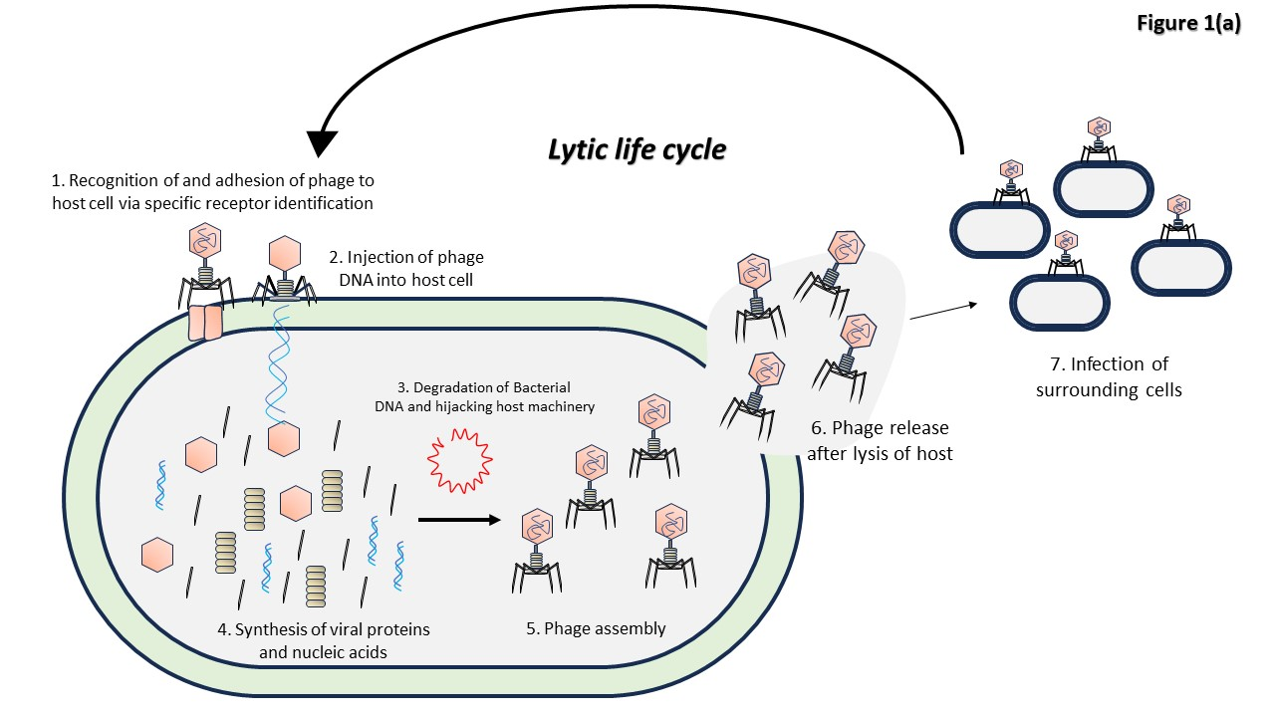[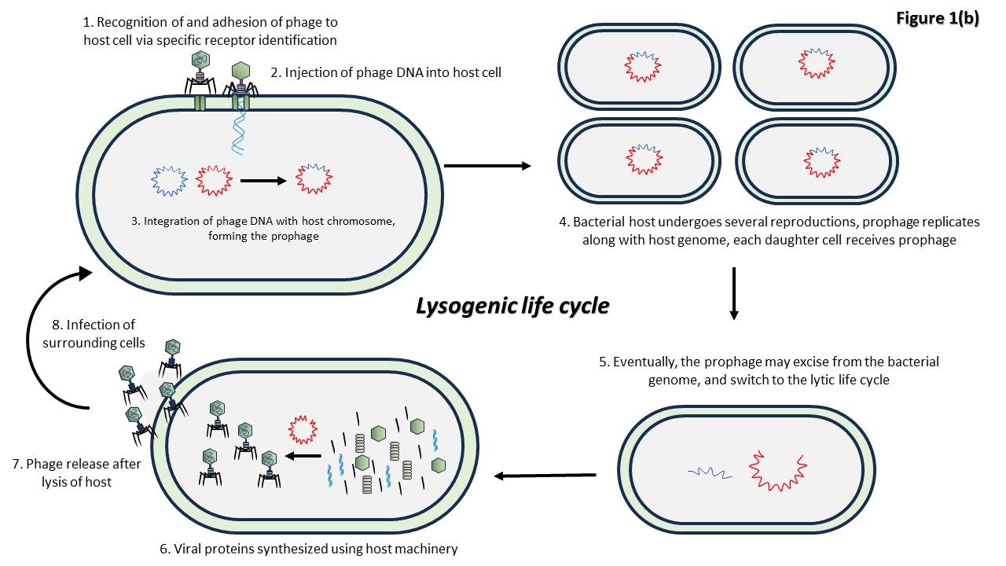
Figure 1: The lytic and lysogenic life cycles of bacteriophages

- PHAGE THERAPY: PHAGES AS ANTI-INFECTIVE BIOLOGICAL MACHINES?
The concept of phage therapy to treat bacterial infections was first introduced by d’Herelle in 1917. However, before the novelty of phage therapy could gain any significant momentum, it was overshadowed by the rapid discoveries and establishment of antibiotics and other drugs, which seemed to be the best option for combatting bacterial infections (9)
However, following the rapid spread of antibiotic resistance and the emergence of multidrug-resistant bacteria, focus has been shifted to the development of novel or repurposed alternatives to combat such resistant bacteria that are responsible for various recalcitrant infections. In such a scenario, bacteriophages have regained the interest of researchers, as natural killing machines that can be employed against different bacteria, as an effective alternative against drug-resistant pathogens (13)
For antibacterial phage therapy, lytic phages are employed, as they kill the host immediately after assembly (14). Among the various phages, the Caudovirales are the best-suited virulent phages for applications in phage therapy (15). Phages may be used alone in phage monotherapy, as a cocktail with other phages or in combination with conventional antibiotics, depending upon their intended spectrum of activity and intended use, with the aim of achieving a synergized antibacterial effect that may help in the successful inactivation of the resistant pathogen (16)

Since phages are a normal part of the human microbiome, they are well-tolerated by the immune system, thereby encouraging the idea of including phage therapy as a regular treatment option against recalcitrant bacterial infections (15).

- GENETICALLY ENGINEERED PHAGES IN ANTIBACTERIAL THERAPY
The fact that phages are essentially assemblies of nucleic acids and proteins, the phage genomes can be easily manipulated if their genetic make-up is well documented. The phage genomes are typically much smaller than the genomes of bacteria, enabling comparatively easier analysis of their genes and facilitating their genetic modification as well (17). Phages may be genetically engineered to integrate a gene, replace a gene, or mutate a gene within their genomic makeup. In antibacterial phage therapy, phages may be engineered for several purposes, with a common goal of improving the antibacterial properties of the phage. These include improved efficacy, expanded host range, increased antibiofilm action, or conversion of a temperate phage to a lytic one (17). Moreover, phages may be engineered to carry antibiotics, enzymes, bacteriocins, and CRISPR-Cas machinery in order to enhance their antibacterial and/or anti-biofilm potential. Additionally, genetically engineered phages can be used to our advantage in cases of phage resistance that may be exhibited by certain target bacteria as well (17). The phages may be equipped with CRISPR-Cas machinery designed to inactivate antibiotic-resistance genes in target bacteria, thereby rendering them susceptible to antibiotics (18). Furthermore, the tail genes of a phage may be engineered/ modified to expand the host range of the phage, enabling a single phage to target multiple bacterial strains causing an infection. The capsid of a phage can also be engineered to increase the host range and alternatively, conjugate with it an antibiotic, to increase the susceptibility of the bacterial pathogen to the antibiotic.
Some interesting strategies have been devised for the repurposing of phages through genetic engineering (Figure 2). The most commonly reported ones have been described below
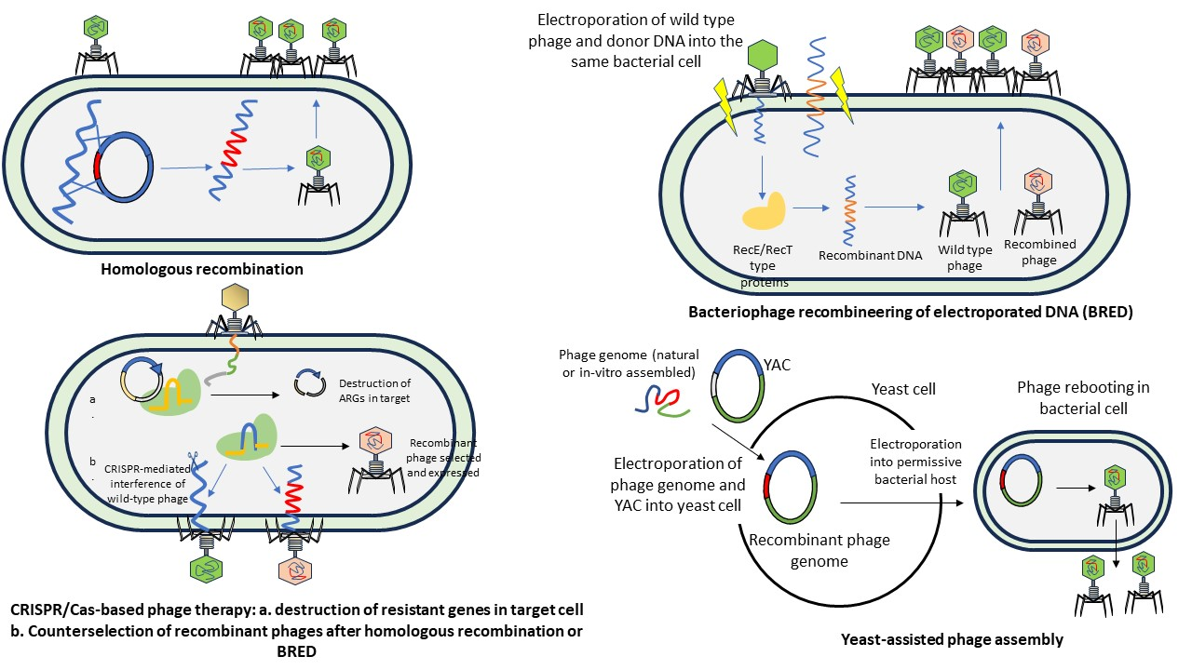
Figure 2: Strategies employed for phage engineering in developing alternatives against antibiotic resistance
- Homologous recombination: This technique involves recombination of desired gene sequences with the phage genome. The gene sequence to be inserted into the phage must be flanked by sequences homologous to that of the phage in question. This technique may involve genetic exchange between two phages (i.e., a “phage-cross”), or between a phage and a plasmid. Contrary to the former, the latter allows for specific modifications to be entered into the phage (19). The desired gene sequence is first incorporated into a replicative plasmid, which is then allowed to infect a bacterial host cell. Next, the phage is allowed to infect the bacterial cell carrying the donor plasmid. Interaction between the plasmid and the phage DNA results in homologous recombination between the plasmid and the phage, and the phage now carries the gene of interest (20). Following phage multiplication and assembly, the bacterial host cell lyses, releasing the genetically modified phages, which can be purified and applied for the specified purpose (Pires et al., 2016). Although a simple technique, the recombination rates here are typically in the range of 10⁻¹⁰ to 10⁻⁴, which is quite low, resulting in very few recombinant phages (20).

- Bacteriophage recombineering of electroporated DNA (BRED)
This technique is fundamentally similar to the above described homologous recombination approach but employs a phage-encoded recombination system instead. A linear DNA containing the gene of interest (and flanked by sequences homologous to the phage) is inserted into a bacterial host cell, along with lambda phage, through electroporation (21). The introduced DNA is then acted upon by phage-encoded recombination systems such as the Red system or the RecE/RecT-like system of the host cell, eventually leading to incorporation of the gene of interest from the donor DNA to the phage, producing the recombined (i.e., genetically modified) phage (19). One of the disadvantages or limitations of this technique is that the success of this procedure relies on the co-transformation of both, the phage DNA and the donor DNA in the same bacterial cell (18)

- CRISPR-Cas based engineering of phages
Clustered Regularly Interspaced Short Palindromic Repeats and the Cas proteins (i.e., the CRISPR-Cas system) are the components of the prokaryotic adaptive immune system, which protect the bacterial cells from viral genetic elements and plasmids as well (22). CRISPR-Cas has been recognized as an efficient tool in gene editing technologies, with applications extended to modern medicine and agriculture. Genes may be knocked out and knocked in, as desired, in the guide mRNA, and used to edit genes in the target bacteria or other cells and tissues (23).

The use of CRISPR-Cas in phage engineering was first demonstrated by Kiro et al. in 2014, wherein the E.coli T7 phage was engineered using the CRISPR/Cas system. Following homologous recombination, the wild type phages was separated and deactivated from the genetically modified phages, enabling the easier isolation of recombinant phages (24). Thus, CRISPR-Cas systems may be employed to efficiently select genetically modified, i.e., mutant phages from the wild-type after a genetic engineering procedure (25).

CRISPR/Cas may also be employed to target and deactivate antibiotic resistance-encoding genes in bacterial pathogens. In a study conducted by Park et al., (2017), CRISPR/ Cas machinery was packaged into a temperate phage’s (ϕSaBov) genome. This genetically modified phage carrying the gene-editing apparatus, was employed to remove virulence genes from the bacterial pathogenic target, namely, Staphylococcus aureus. Additionally, the phage was also genetically modified in its tail fibre proteins, using the broad-spectrum ϕ11 in order to expand the host range. Further experiments involved murine models, which demonstrated effective clearing of the skin infections and a two-fold reduction in the CFU (26).

- Yeast-based assembly of phages
In this approach, the yeast artificial chromosome (YAC) is employed to assemble the phage genome, in order to avoid any chances of toxicity to the bacterial cell. The phage genome may either be isolated from different sources or may be engineered in-vitro. Next, the engineered/ isolated phage and the YAC are electroporated together in a yeast cell, wherein the phage genome is recombined with YAC via the transformation-assisted recombination (TAR) system of the yeast cell. Once assembled, the recombinant phage genomes are then electroporated into a suitable (permissive) bacterial cell, wherein the phage is “rebooted” and recombinant phages are expressed (8). Alternatively, instead of using yeast cells, L-forms of bacteria may be employed to reboot the phages into the infectious form. L-forms offer better advantages over the intact gram-positive cells, especially since the latter exhibit lower competence for transformation (25).

- Cell-free engineering and rebooting of phages
The above described techniques have certain limitations of which the availability of a suitable host is most defining. Oftentimes, procuring a non-pathogenic, well-characterised host, which is free from lysogenic contamination, is challenging. Moreover, once the phage is rebooted, the process of purification of the phage is equally challenging (27). To circumvent such issue, cell-free bacteriophage synthesis (CFBS) may be employed. Such systems comprise a transcription-translation machinery (TXTL system), which is obtained from cell extracts, an energy buffer comprising of components to enable ATP production, and of course, a DNA template that carries the sequence of interest (28).

In an exemplary study conducted by (29), a novel phage engineering platform, “SpyPhage” was developed. This cell-free system involves the CRISPR-Cas mediated generation of a “bacteriophage scaffold”, which can serve to be genetically modified according to the interests of the researcher. Using this cell-free system, the capsid of phage K1 (which targets the E. coli K1 pathogen), was decorated with two proteins, namely, SpyCatcher-mCherry-EGF and SpyCatcher-mCherry-Rck. The EGF and Rck proteins, when ultimately expressed on the phage surface, facilitated the process of endocytosis of the phage by the epithelial cells of the urinary bladder in-vitro, suggesting a solution to counter multidrug resistant bacterial pathogens (29). The authors suggest that such cell-free systems could be the solution to the time taking and tedious processes of licensing novel genetic modifications.
All of the above-described techniques ultimately result in a common end-point, allowing desired genetic modification in a phage of choice, to enable selective therapeutic application, including anti-infective applications. Additionally, in this context, phages can also be described as delivery vectors, that can be theoretically employed to deliver any genetic material, since the basic biology of phage reproduction remains intact.

Table 1 enlists some recent studies conducted on the applications of phage therapy as a novel alternative against antibacterial-resistant pathogens. Although these studies are mostly in-vitro claims, some phage products are available in the market. Among the recently approved phage products for application as alternatives against conventional antibiotics are EcoActive (E. coli), Staphefekt (MRSA), and EcoShield (E.coli) (57; 30)
Table 1: Some recent studies conducted on the development of phage-based products against ARB
Priority level | Resistant bacteria | Phage product | Reference
Critical | MDR K. pneumoniae | ZCKP1 (Myoviridae) | (30)
High | MRSA | ɸ-SA012 | (31)
High | B-lactamase producing S. enterica Typhi | GE_vB_MG | (32)
Critical | MDR E. cloacae | MJ2 (Podoviridae) | (33)
High | MRSA | ɸ-MR003 | (34)
Critical | Carbapenem-resisatnt A. baumanii | SH-Ab15519 (Podoviridae) | (35)
High | Ampicillin-resistant S. enterica Enteriditis | PA13076 (Myoviridae) | (36)
High | MRSA | Sb-1 | (37)
Critical | Carbapenem-resistant K. pneumoniae | P545 (Myoviridae) | (38)
Critical | Ciprofloxacin/ceftriaxone-resistant E. coli | ɸ-WL-3 | (39)
High | MRSA | Sb-1 | (37)
Critical | Carbapenem-resistant K. pneumoniae | P545 (Myoviridae) | (38)
High | Vancomycin-resistant E. faecalis | SA14 (Siphoviridae) | (5)

In in a study conducted in 2017, phage tail fibres from different phages were swapped and a genetically modified T7 phage was created, which was able to target multiple pathogens, including those which are not natural hosts of the phage. This study successfully addressed the issue of tedious generation of host-specific recombinant phages and their selection, enabling genetic modifications to facilitate broad-spectrum activity (40)
In another study conducted by (26), CRISPR-Cas was delivered into a bacterial cell using the ϕSaBov temperate phage. The CRISPR system was integrated into the phage genome and ultimately transduced into S. aureus cells. Integration of the CRISPR system enabled targeted removal of the virulence genes in the host, further preventing transmission of virulence. Additionally, the phage tail proteins were also modified, which resulted in a broad-spectrum activity, effectively killing several lineages of S. aureus, contrary to the activity of the wild-type phage, which selectively kills only the CC151 lineage of S. aureus.
Phage engineering can be applied to treat intracellular infections as well. In a study conducted by (41), a phage, K1F, specific to E. coli K1 was genetically engineered to express the human epidermal growth factor (EGF). This genetic modification was mediated via the homologous recombination technique. Such modification readily enabled the in-vitro internalization of the phage by the human cell lines associated with K1 infection, via endocytosis into the cells. Additionally, higher rates of internalization were observed in the case of the phages which expressed the EGF. Furthermore, effective clearing of E. coli infection from the cells was observed (41).

- APPLICATION STRATEGIES OF PHAGES
With regard to the application of phages, there are four main strategies that are commonly explored and employed for favourable in-vitro and in-vivo studies. The most straightforward method involves the identification and selection of an appropriate phage that can be used to infect the pathogen in question (15). However, such monophage therapy is limited, owing to the fact that more often than not, a bacterial infection is the result of multiple strains of a particular pathogen, and phages usually are very strain-specific, therefore reducing the chances of off-target activity which may affect beneficial microbiota as well (42). In such cases, another commonly employed approach is that of phage cocktails, wherein more than one phage (usually about 10, depending on the requirement) is used to prepare a cocktail, with lytic activity extending to the entire spectrum of strains involved in the infection. Alternatively, instead of using entire phages as anti-infective agents, we may use purified phage lytic enzymes directly, to do the job (43). Lastly, phages and antibiotics may be used in combination under the phage-antibiotic synergy approach, whereby phages are administered either simultaneously, or sequentially after antibiotics, to enhance the activity of the antibiotics against resistant bacterial pathogens

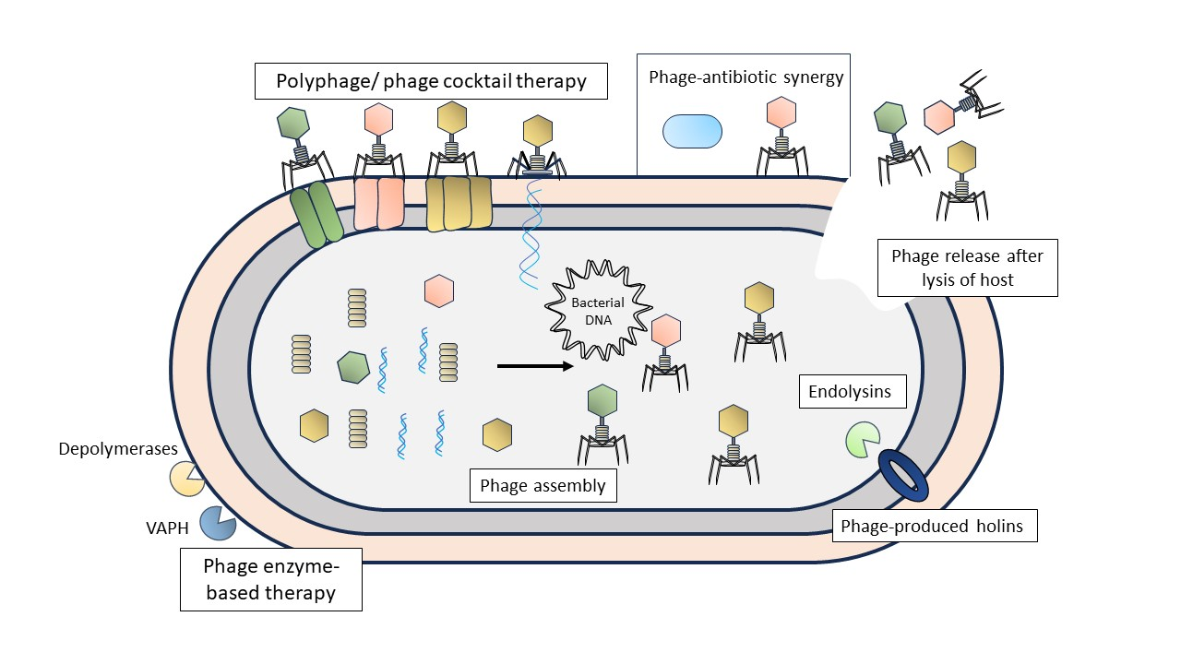

Figure 3: The application of phage therapy as an alternative to antibiotics against drug-resistant bacteria

- Phage cocktails
In the recent times, a “phage synergy” approach has been the focus of many novel researches. These attempts involve the development of a phage “cocktail” (polyphage therapy), a concoction comprising different phages, to be used against multi-drug resistant pathogens. For example, in a study conducted by (44), a phage cocktail comprising 6 phages was developed against ESBL-producing clinical isolates of E. coli and Klebsiella, employing the Direct Spot Test and Efficiency of Plating methods. Further assessment involved conducting a genomic analysis of the finally selected phages, to discard any possibility of lysogeny in bacteria or virulence to the human system. Although the final results didn’t exhibit the desired outcome, the cocktail was successful in killing 83% of the E. coli ST131 isolates, notorious for causing urinary tract-related infections (44). Polyphage therapy provides a better alternative compared to monophage therapy by employing more than one type of phage for targeting multiple species, or multiple strains of a single species. Additionally, polyphage therapy may help in countering any chance of resistance that may develop against one of the phages, by keeping the other phages on a “standby” (44). However, phage cocktail preparation is a more tedious and rigorous of process, involving precise assessment of the compatibility between the target bacteria and the phages used in cocktail preparation. These phages may be administered all at once, or sequentially, the latte probably being more effective, especially with regard to the development of resistance among the target strain, as the strain will not resist all the phages (33).
A more recent attempt was made to understand the therapeutic effects of a phage cocktail on Staphylococcal biofilms, responsible for recalcitrant bone and joint infections, when used alone, and in combination with vancomycin. Successful inhibition of the planktonic state and biofilms in a dose-dependent manner was observed when the cocktail was used alone (10⁷ PFU/mL), along with appreciable synergetic effects when used in combination with antibiotics. Such results indicate the possible use of bacteriophages in reducing the recalcitrance of biofilms to antibiotics. Further investigation involved assessing the activity of the phages in osteoblasts. Interestingly, phage internalization was found to occur only when the bone cells were infected with S. aureus, suggesting a trojan horse-type mechanism of action, and revealing an intracellular inactivity of the phages (46).

- Phage enzymes
Phage enzymes including depolymerases and lysins can be used to target pathogenic biofilms, resulting in their disruption, followed by further clearance of the pathogenic cells by phage lysins, or by exposing the individual cells to antibiotics, thereby increasing their susceptibility (32).
- Phage antibiotic synergy (PAS)
Administration of phages with antibiotics is considered as an efficient and targeted approach to combatting multidrug-resistant bacterial pathogens. Such phage-antibiotic synergy is a result of the combined action of the two fundamentally different antibacterial agents, which may be co-administered simultaneously, or sequentially. There are different mechanisms by which phages and antibiotics may exert a synergistic effect, including but not limited to degradation of bacterial cell wall by the phage enzymes which further allows antibiotics to diffuse into the bacterial cell, reduced occurrence of phage- and/or antibiotic-resistant mutants, increased plaque formation and phage replication, etc.( 47).

Phage-antibiotic synergy may work through one of a few ways- the phage may result in modification of efflux pump proteins, thereby rendering the efflux pump inactive, causing antibiotics to be within the cell matrix, or, the phage may inhibit antibiotic resistance elements present in the bacterial cell (48). In one study, commercially available Staphylococcal bacteriophages (Sb-1) were combined with antibiotics as an alternative to rifampicin-resistant strains of S.aureus, associated with bone infections. Five antibiotics, namely doxycycline, rifampin, linezolid, levofloxacin, and clindamycin, were combined with 10⁶ PFU/mL of Sb-1 phage. Appreciable synergy was found to occur between the phages and levofloxacin and doxycycline against all strains tested. Additionally, the combination of the phages with doxycycline resulted in a 100% inhibition in the biofilms of all the strains tested (39).

- PHAGES IN THE CLINICAL SCENARIO: RECENT ADVANCES
Although phage therapy has made it past clinical trials in Russia and Poland, it is still met with limitations in other parts of the world (14). A huge factor that determines successful clinical applications is the interactions of the phage molecules with the human host molecules, i.e., their pharmacokinetics and pharmacodynamics. Hence, extensive studies must first be conducted in this regard (15).
Recent advances in the inclusion of phage therapy at the clinical scenario have been steady. In 2008, USFDA approved the first clinical trials of phage therapy for the treatment of venous leg ulcers. In 2013, Phagoburn, a clinical-phase trial initiative, financed by the European Union, was launched to assess the efficacy of a cocktail of 12 lytic phages of P. aeruginosa (PP131) as a treatment of P. aeruginosa. However, the trials, conducted on a set of 27 patients terminated in 2017, since the phage cocktail at the concentrations tested, proved ineffective in the intended treatment. However, through this study, it became evident that the clinical study needed a larger number of patients, and a higher concentration of phages in the cocktail in order to decrease the bacterial wound as per the established standards (50).
In a ground-breaking study, (51), a 15-year-old patient suffering from cystic fibrosis was subjected to phage therapy involving a cocktail of three phages, named Muddy, ZoeJ, and Bps, following a lung transplant, which resulted in recalcitrant infections. The phages were genetically engineered to specifically kill the causative disseminated agent, namely Mycobacterium abscesses. This attempt involved preliminary identification of suitable phages after isolation of the causative strain from sputum samples of the patient, and their genetic modification into lytic phages using BRED technique described previously. Following intravenous administration of the engineered phage cocktail, favorable results were obtained, including phage multiplication as assessed in blood samples, and tolerance of the phage system by the body, resulting in healing of sternal wound, improved lung function, and healed skin lesions, 6 months post-treatment. Additionally, serum and sputum samples did not reveal the presence of any M. abscesses isolates following treatment (51).

Attempts made at clinical trials to validate the application of phage therapy as an established mode of treatment are limited in their approach due to some important reasons, including the lack of a control group in most studies, lack of uniformity in mode of administration, concentration of phage(s) administered, and the duration of treatment; pharmacokinetic and pharmacodynamic properties of phages, and interaction with other viruses and phages, and unstandardized use of phage susceptibility testing (PST) (Suh (52, 53). At present, there are no stringent or effective regulatory guidelines for the application of phage therapy at the clinical stage. An interplay of various factors including the nature of phage (lytic/lysogenic), stability, toxicity, possibility of bacterial resistance, sterility, etc, must be considered before any sort of therapeutic application (54). Elaborate studies on the overall effect of the immune responses of the host on the therapeutic efficacy of the phage must be conducted in order to determine the complete potential and safety issues of this novel alternative (55).

- ADVANTAGES AND LIMITATIONS OF PHAGE THERAPY
Phage engineering offers several advantages, including but not limited to: endowing phages with desired activity including efficient lysis of bacterial cells, or expression of desired proteins within target cell, developing genetically engineered derivatives of well-established phages to conserve time and resources, removal of undesired genes such as virulence-encoding sequences from phages to validate their inconsequential application, etc. (55)
Despite the theoretical and practical advantages posed by bacteriophages, there are certain limitations with regard to their full-fledged applications in the clinical scenario, including the development of phage resistance among target bacteria, possible immune reaction in the human host, chances of transduction in the bacterial host, making it more virulent/ resistant, and the inability of a phage to infect a mammalian cell (57, 58). An important factor to consider in phage therapy is the immune response of the host. It is highly likely that a complex interaction between the phages, the pathogen and the human host is bound to occur, in turn greatly determining the end effect of the intended therapy (59, 55).
An important hindrance in their application includes the polymeric nature of phages, which increases their susceptibility to degradation under environmental stress. In this regard, nanoencapsulation of phages into nanoliposomes has also been examined for their potential to increase the stability of phage stressful environments such as the acidic gastrointestinal juice, and also improve chances of cellular uptake of the phage, for effective killing of intracellular pathogens which are otherwise inaccessible to phages (54).

Table 2 weighs some advantages and disadvantages of phage therapy as an alternative against antibiotic-resistant bacteria. One of the most important advantages that phages offer phages is the evolutionary advantage over bacterial cells- they are bacterial killing machines that co-evolve with their bacterial hosts, thereby addressing the issue of the development of resistance among the target cells (53). Moreover, phages have the ability to self-multiply once administered into the body. This counters another issue presented by antibiotics- multiple doses/ improper dosage of antibiotics has led to increased selection pressure among pathogenic and commensal bacteria as well, exacerbating the issue of environmental AMR and transmission (60). Another advantage of using phages is the unique biochemical makeup that allows for a very target-specific approach, as opposed to the broad-spectrum antibiotics, which are now recognized to have significantly contributed to the rapid spread and establishment of AMR (42). Actually, the narrow-spectrum activity of phages is both an advantage and an impediment- although the selectivity allows for targeted killing and minimal chances of resistance development among bacteria, it also implies rigorous identification of bacterial-phage compatibility before application and reduced the number of target bacteria, which is both time and cost-consuming (31).
Table 2: A comparison of the advantages and disadvantages associated with therapeutic application of phage therapy against antibiotic-resistant bacteria
Advantages | Disadvantages
Self-limiting, ceases to function once the bacterial pathogen is killed | Phage enzymes may trigger immune reaction in human systems
They are bactericidal agents unlike some antibiotics which may be bacteriostatic | Possible transformation of host cell to make the bacterium pathogenic/ virulent (transduction)
Chances of cross-resistance with antibiotics is unlikely, as both agents exercise antibacterial effects via different modes of action(s) | Phage-mediated killing may potentially release bacterial toxins, inflicting unintended pathogenicity
Different phages may be mixed together to improve the antibacterial spectrum | Susceptible to thermal and chemical changes in the environment
Need only a single dose as they are able to multiply exponentially within the host cell, unlike antibiotics which require multiple doses and are washed out from the body over time | Evolution of bacteria to develop resistance against phages, inactivation of phages using the CRISPR-Cas system, or modification of phage receptors, etc.
Unlike antibiotics with side-effects, phages generally are safe for humans | May induce inflammatory reactions and other side effects
Species-specific activity | Broad-spectral, thereby increasing chances of resistance development in non-target species, which further leads to the dissemination of resistance in the environment
Concurrent evolution with the bacterial host, thereby solving the issue of bacterial resistance development | Intracellular pathogens are inaccessible to phage therapy

- CONCLUSIONS AND FUTURE PERSPECTIVES
Given the rapidly declining efficacies of currently available antibiotics, various novel alternatives are being explored in the current scenario, with a common aim of killing pathogenic bacteria and tackling the emergence and spread of ARB and their ARGs. Technological interventions are being explored rapidly for possible incorporation of antimicrobial activities. However, such studies lack in several aspects which limit our understanding of their complete potential as replacements of/ supplements for antibiotic treatment. Although significant progress is being made with regard to in-vitro applications, it must be stressed that any efforts in this regard will be fruitless unless backed by elaborate in-vivo experiments and subsequent clinical trials.
Amidst all the successful research conducted in-vitro, and the results obtained in the limited but encouraging in-vivo studies, the lack of randomized clinical trials is probably the most important impediment in the full-fledged therapeutic application of phage therapy as an effective alternative against antibiotic-resistant clinical pathogens. Despite the fact that phage resistance may develop among bacteria, studies demonstrate that the selection for phage resistance is much lower than that of resistance to antibiotics. Moreover, application of novel and effective phage-antibiotic synergetic combinations has the potential to not only combat bacterial infections, but also reduce the development of mutant strains among pathogenic bacterial populations. Their living/non-living status further complicates the formulation, implementation and establishment of medicinal regulations that are a pre-requiste for any novel therapeutic agent.
Acknowledgments
The authors (Shirjeel Ahmad Siddiqui and Iqbal Ahmad) are thankful to DBT (Department of Biotechnology, India) for supporting the research through Indo-UK collaborative research projects: ‘SELECTAR and ResPharm’.

References
- Larsson, D. J., & Flach, C. F. (2022). Antibiotic resistance in the environment. Nature Reviews Microbiology, 20(5), 257-269.
- CDC. Antibiotic Resistance Threats in the United States, 2019. Atlanta, GA: U.S. Department of Health and Human Services, CDC; 2019.
- O'Neill, J. (2016). Tackling drug-resistant infections globally: final report and recommendations.
- World Health Organization. (‎2014)‎. Antimicrobial resistance: global report on surveillance. World Health Organization. https://apps.who.int/iris/handle/10665/112642
- Ali, Z., Dishisha, T., El-Gendy, A. O., & Azmy, A. F. (2023). Isolation and phenotypic characterization of bacteriophage SA14 with lytic-and anti-biofilm activity against multidrug-resistant Enterococcus faecalis. Beni-Suef University Journal of Basic and Applied Sciences, 12(1), 1-10
- Pizarro-Bauerle, J., & Ando, H. (2020). Engineered bacteriophages for practical applications. Biological and Pharmaceutical Bulletin, 43(2), 240-249.
- Kilcher, S., & Loessner, M. J. (2019). Engineering bacteriophages as versatile biologics. Trends in microbiology, 27(4), 355-367.
- Mitsunaka, S., Yamazaki, K., Pramono, A. K., Ikeuchi, M., Kitao, T., Ohara, N., ... & Ando, H. (2022). Synthetic engineering and biological containment of bacteriophages. Proceedings of the National Academy of Sciences, 119(48), e2206739119.
- Brives, C., & Pourraz, J. (2020). Phage therapy as a potential solution in the fight against AMR: obstacles and possible futures. Palgrave Communications, 6(1), 1-11.
- Keen, E. C. (2015). A century of phage research: bacteriophages and the shaping of modern biology. Bioessays, 37(1), 6-9.
- Clokie, M. R., Millard, A. D., Letarov, A. V., & Heaphy, S. (2011). Phages in nature. Bacteriophage, 1(1), 31-45.
- Doss, J., Culbertson, K., Hahn, D., Camacho, J., & Barekzi, N. (2017). A review of phage therapy against bacterial pathogens of aquatic and terrestrial organisms. Viruses, 9(3), 50.
- Guo, D., Chen, J., Zhao, X., Luo, Y., Jin, M., Fan, F., ... & Liu, Z. (2021). Genetic and chemical engineering of phages for controlling multidrug-resistant bacteria. Antibiotics, 10(2), 202.
- Barron, M. (2022). Retrieved from https://asm.org/Articles/2022/August/Phage-Therapy-Past,-Present-and-Future
- Romero-Calle, D., Guimarães Benevides, R., Góes-Neto, A., & Billington, C. (2019). Bacteriophages as alternatives to antibiotics in clinical care. Antibiotics, 8(3), 138.
- Royer, S., Morais, A. P., & da Fonseca Batistão, D. W. (2021). Phage therapy as strategy to face post-antibiotic era: a guide to beginners and experts. Archives of microbiology, 203, 1271-1279.
- Gibb, B., Hyman, P., & Schneider, C. L. (2021). The many applications of engineered bacteriophages—An overview. Pharmaceuticals, 14(7), 634.
- Lv, S., Wang, Y., Jiang, K., Guo, X., Zhang, J., Zhou, F., ... & Teng, T. (2023). Genetic Engineering and Biosynthesis Technology: Keys to Unlocking the Chains of Phage Therapy. Viruses, 15(8), 1736.
- Chen, Y., Batra, H., Dong, J., Chen, C., Rao, V. B., & Tao, P. (2019). Genetic engineering of bacteriophages against infectious diseases. Frontiers in microbiology, 10, 954.
- Khambhati, K., Bhattacharjee, G., Gohil, N., Dhanoa, G. K., Sagona, A. P., Mani, I., ... & Singh, V. (2023). Phage engineering and phage‐assisted CRISPR‐Cas delivery to combat multidrug‐resistant pathogens. Bioengineering & Translational Medicine, 8(2), e10381.
- Marinelli, L. J., Piuri, M., Swigoňová, Z., Balachandran, A., Oldfield, L. M., van Kessel, J. C., & Hatfull, G. F. (2008). BRED: a simple and powerful tool for constructing mutant and recombinant bacteriophage genomes. PLoS One, 3(12), e3957.
- Tao, S., Chen, H., Li, N., & Liang, W. (2022). The application of the CRISPR-Cas system in antibiotic resistance. Infection and drug resistance, 4155-4168.
- Tyagi, S., Kumar, R., Das, A., Won, S. Y., & Shukla, P. (2020). CRISPR-Cas9 system: A genome-editing tool with endless possibilities. Journal of Biotechnology, 319, 36-53.
- Kiro, R., Shitrit, D., & Qimron, U. (2014). Efficient engineering of a bacteriophage genome using the type IE CRISPR-Cas system. RNA biology, 11(1), 42-44.
- Mahler, M., Costa, A. R., van Beljouw, S. P., Fineran, P. C., & Brouns, S. J. (2022). Approaches for bacteriophage genome engineering. Trends in Biotechnology.
- Park, J. Y., Moon, B. Y., Park, J. W., Thornton, J. A., Park, Y. H., & Seo, K. S. (2017). Genetic engineering of a temperate phage-based delivery system for CRISPR/Cas9 antimicrobials against Staphylococcus aureus. Scientific reports, 7(1), 44929.
- Wilding, K. M., Hunt, J. P., Wilkerson, J. W., Funk, P. J., Swensen, R. L., Carver, W. C., ... & Bundy, B. C. (2019). Endotoxin‐free E. coli‐based cell‐free protein synthesis: Pre‐expression endotoxin removal approaches for on‐demand cancer therapeutic production. Biotechnology journal, 14(3), 1800271.
- Brooks, R., Morici, L., & Sandoval, N. (2023). Cell Free Bacteriophage Synthesis from Engineered Strains Improves Yield. ACS Synthetic Biology.
- Liyanagedera, S. B., Williams, J., Wheatley, J. P., Biketova, A. Y., Hasan, M., Sagona, A. P., ... & Kulkarni, V. (2022). SpyPhage: a cell-free TXTL platform for rapid engineering of targeted phage therapies. ACS Synthetic Biology, 11(10), 3330-3342.
- Taha, O. A., Connerton, P. L., Connerton, I. F., & El-Shibiny, A. (2018). Bacteriophage ZCKP1: a potential treatment for Klebsiella pneumoniae isolated from diabetic foot patients. Frontiers in microbiology, 9, 2127.
- Iwano, H., Inoue, Y., Takasago, T., Kobayashi, H., Furusawa, T., Taniguchi, K., ... & Tamura, Y. (2018). Bacteriophage ΦSA012 has a broad host range against Staphylococcus aureus and effective lytic capacity in a mouse mastitis model. Biology, 7(1), 8.
- Kakabadze, E., Makalatia, K., Grdzelishvili, N., Bakuradze, N., Goderdzishvili, M., Kusradze, I., ... & Chanishvili, N. (2018). Selection of potential therapeutic bacteriophages that lyse a CTX-M-15 extended spectrum β-lactamase producing Salmonella enterica serovar typhi strain from the democratic republic of the Congo. Viruses, 10(4), 172.
- Jamal, M., Andleeb, S., Jalil, F., Imran, M., Nawaz, M. A., Hussain, T., ... & Das, C. R. (2019). Isolation, characterization and efficacy of phage MJ2 against biofilm forming multi-drug resistant Enterobacter cloacae. Folia Microbiologica, 64, 101-111.
- Peng, C., Hanawa, T., Azam, A. H., LeBlanc, C., Ung, P., Matsuda, T., ... & Tanji, Y. (2019). Silviavirus phage ɸMR003 displays a broad host range against methicillin-resistant Staphylococcus aureus of human origin. Applied microbiology and biotechnology, 103, 7751-7765.
- Hua, Y., Luo, T., Yang, Y., Dong, D., Wang, R., Wang, Y., ... & He, P. (2018). Phage therapy as a promising new treatment for lung infection caused by carbapenem-resistant Acinetobacter baumannii in mice. Frontiers in microbiology, 8, 318476.
- Bao, H., Zhou, Y., Shahin, K., Zhang, H., Cao, F., Pang, M., ... & Wang, R. (2020). The complete genome of lytic Salmonella phage vB_SenM-PA13076 and therapeutic potency in the treatment of lethal Salmonella Enteritidis infections in mice. Microbiological research, 237, 126471.
- Kebriaei, R., Lev, K., Morrisette, T., Stamper, K. C., Abdul-Mutakabbir, J. C., Lehman, S. M., ... & Rybak, M. J. (2020). Bacteriophage-antibiotic combination strategy: an alternative against methicillin-resistant phenotypes of Staphylococcus aureus. Antimicrobial agents and chemotherapy, 64(7), 10-1128.
- Li, M., Guo, M., Chen, L., Zhu, C., Xiao, Y., Li, P., ... & Du, H. (2020). Isolation and characterization of novel lytic bacteriophages infecting epidemic carbapenem-resistant Klebsiella pneumoniae strains. Frontiers in Microbiology, 11, 1554.
- Wang, L., Tkhilaishvili, T., Andres, B. B., Trampuz, A., & Moreno, M. G. (2020). Bacteriophage–antibiotic combinations against ciprofloxacin/ceftriaxone-resistant Escherichia coli in vitro and in an experimental Galleria mellonella model. International journal of antimicrobial agents, 56(6), 106200.
- Yosef, I., Goren, M. G., Globus, R., Molshanski-Mor, S., & Qimron, U. (2017). Extending the host range of bacteriophage particles for DNA transduction. Molecular cell, 66(5), 721-728.
- Williams, J., Kerven, J., Chen, Y., & Sagona, A. P. (2023). Genetic Engineering of Bacteriophage K1F with Human Epidermal Growth Factor to Enhance Killing of Intracellular E. coli K1. ACS Synthetic Biology.
- Pires, D. P., Cleto, S., Sillankorva, S., Azeredo, J., & Lu, T. K. (2016). Genetically engineered phages: a review of advances over the last decade. Microbiology and Molecular Biology Reviews, 80(3), 523-543.
- Love, M. J., Bhandari, D., Dobson, R. C., & Billington, C. (2018). Potential for bacteriophage endolysins to supplement or replace antibiotics in food production and clinical care. Antibiotics, 7(1), 17.
- Haines, M. E., Hodges, F. E., Nale, J. Y., Mahony, J., Van Sinderen, D., Kaczorowska, J., ... & Clokie, M. R. (2021). Analysis of selection methods to develop novel phage therapy cocktails against antimicrobial resistant clinical isolates of bacteria. Frontiers in Microbiology, 12, 613529.
- Gordillo Altamirano, F. L., & Barr, J. J. (2019). Phage therapy in the postantibiotic era. Clinical microbiology reviews, 32(2), 10-1128.
- Kolenda, C., Josse, J., Medina, M., Fevre, C., Lustig, S., Ferry, T., & Laurent, F. (2020). Evaluation of the activity of a combination of three bacteriophages alone or in association with antibiotics on Staphylococcus aureus embedded in biofilm or internalized in osteoblasts. Antimicrobial agents and chemotherapy, 64(3), 10-1128.
- Łusiak-Szelachowska, M., Międzybrodzki, R., Drulis-Kawa, Z., Cater, K., Knežević, P., Winogradow, C., ... & Górski, A. (2022). Bacteriophages and antibiotic interactions in clinical practice: What we have learned so far. Journal of Biomedical Science, 29(1), 23.
- Luong, T., Salabarria, A. C., & Roach, D. R. (2020). Phage therapy in the resistance era: where do we stand and where are we going?. Clinical therapeutics, 42(9), 1659-1680.
- Wang, L., Tkhilaishvili, T., Andres, B. B., Trampuz, A., & Moreno, M. G. (2020). Bacteriophage–antibiotic combinations against ciprofloxacin/ceftriaxone-resistant Escherichia coli in vitro and in an experimental Galleria mellonella model. International journal of antimicrobial agents, 56(6), 106200
- Jault, P., Leclerc, T., Jennes, S., Pirnay, J. P., Que, Y. A., Resch, G., ... & Gabard, J. (2019). Efficacy and tolerability of a cocktail of bacteriophages to treat burn wounds infected by Pseudomonas aeruginosa (PhagoBurn): a randomised, controlled, double-blind phase 1/2 trial. The Lancet Infectious Diseases, 19(1), 35-45.
- Dedrick, R. M., Guerrero-Bustamante, C. A., Garlena, R. A., Russell, D. A., Ford, K., Harris, K., ... & Spencer, H. (2019). Engineered bacteriophages for treatment of a patient with a disseminated drug-resistant Mycobacterium abscessus. Nature medicine, 25(5), 730-733.
- Suh, G. A., Lodise, T. P., Tamma, P. D., Knisely, J. M., Alexander, J., Aslam, S., ... & Antibacterial Resistance Leadership Group. (2022). Considerations for the use of phage therapy in clinical practice. Antimicrobial agents and chemotherapy, 66(3), e02071-21.
- Huang, Y., Wang, W., Zhang, Z., Gu, Y., Huang, A., Wang, J., & Hao, H. (2022). Phage products for fighting antimicrobial resistance. Microorganisms, 10(7), 1324.
- Ling, H., Lou, X., Luo, Q., He, Z., Sun, M., & Sun, J. (2022). Recent advances in bacteriophage-based therapeutics: Insight into the post-antibiotic era. Acta Pharmaceutica Sinica B, 12(12), 4348-4364.
- Melo, L. D., Oliveira, H., Pires, D. P., Dabrowska, K., & Azeredo, J. (2020). Phage therapy efficacy: a review of the last 10 years of preclinical studies. Critical reviews in microbiology, 46(1), 78-99.
- Łobocka, M., Dąbrowska, K., & Górski, A. (2021). Engineered bacteriophage therapeutics: rationale, challenges and future. BioDrugs, 35(3), 255-280.
- Kaur, G., Agarwal, R., & Sharma, R. K. (2021). Bacteriophage therapy for critical and high-priority antibiotic-resistant bacteria and phage cocktail-antibiotic formulation perspective. Food and Environmental Virology, 13(4), 433-446.
- Hatfull, G. F., Dedrick, R. M., & Schooley, R. T. (2022). Phage therapy for antibiotic-resistant bacterial infections. Annual Review of Medicine, 73, 197-211.
- Van Belleghem, J. D., Dąbrowska, K., Vaneechoutte, M., Barr, J. J., & Bollyky, P. L. (2018). Interactions between bacteriophage, bacteria, and the mammalian immune system. Viruses, 11(1), 10.
- Saha, D., & Mukherjee, R. (2019). Ameliorating the antimicrobial resistance crisis: phage therapy. IUBMB life, 71(7), 781-790.

