“Unlocking the Potential of Novel Frontiers in Chitosan Oligomers Research”

Dhanishta Vilas Attarde¹ and Neelu Nawani¹*
¹Microbial Diversity Research Centre, Dr. D. Y. Patil Biotechnology & Bioinformatics Institute,
Dr. D. Y. Patil Vidyapeeth, Pimpri, Pune, Maharashtra, India.
Email ID: dhanishta.attarde@dpu.edu.in

Abstract:

Chitosan, a biopolymer derived from chitin, has garnered attention for its biocompatibility and eco-friendly attributes. The depolymerization or partial degradation of chitosan resulting in Chitosan oligomers, with their shorter chains, offer enhanced solubility and bioactivity, rendering them valuable for various applications. It delves into the methods of chitosan oligomer production, including enzymatic, chemical approaches, and radiation-based approaches, highlighting their structural features and physicochemical properties that contribute to their efficacy and their role as natural preservatives and antimicrobial agents in the food industry and their potential in controlled drug delivery systems for pharmaceuticals. In the realm of agriculture, chitosan oligomers exhibit promises as biostimulants and in agriculture. They showcase a range of innovative findings and applications for chitosan oligomers across diverse fields Their applications extend to eco-friendly materials, including biodegradable plastics and wound-healing dressings, contributing to sustainable material development. It also underscores their utility in water treatment technologies due to their pollutant adsorption and heavy metal chelation capabilities. chitosan oligomers hold tremendous potential to contribute to a more environmentally friendly and technologically advanced future.
Keywords: chitosan oligomers, structural properties, biomaterials, applications

- Introduction:
The evolution from chitin to chitosan, and further to chitosan oligomers, encompasses a captivating journey of polysaccharide transformation with wide-ranging implications. Chitosan, emerging from chitin, takes a prominent stance within the polysaccharide realm, securing the second position in abundance after cellulose. Chitin, composed of N-acetyl-D-glucosamine units linked via β-1,4 glycosidic bonds, exerts its structural influence across diverse life forms like fungi, diatoms, sponges, corals, and arthropods (Ngo, D. H., et. al., 2015). However, chitin's constitution renders it insoluble in water, setting the stage for a remarkable alteration through deacetylation, resulting in the soluble chitosan, especially in acidic conditions (Aranaz, I. et al., 2021).
The historical tapestry expands with Charles Rouget's pioneering work in 1859, which involved concentrated potassium hydroxide and dilute organic acid solutions, leading to the transformation of chitin into soluble chitosan. This pivotal insight into chitin deacetylation was termed "modified chitin," and the moniker "chitosan" was later coined by Felix Hoppe-Seyler in 1894. The solubility of chitosan hinges on factors like acetylation degree and molecular weight. In acidic pH environments, protonation of chitosan's amine group facilitates solubility. This phenomenon intertwines with acetylation intricacies, allowing certain chitin components to persist within the chitosan structure (Cord-Landwehr et al., 2020). This narrative resonates in chitosan oligomers, arising from chitosan but sporting shorter chains due to molecular weight reduction. While inheriting chitosan's qualities, chitosan oligomers offer distinct attributes that open doors to versatile applications (Jeon, Y. J. et al., 2000).
From antimicrobial potential to immunomodulation, and controlled drug release to intricate interactions with biological systems, chitosan oligomers perpetuate the journey of natural polymer exploration. This trajectory culminates in a contemporary understanding, that chitosan oligomers encompass shorter chitosan chains acquired through depolymerization or partial degradation. Deacetylation of chitosan eliminates acetyl groups, generating chitosan oligomers with reduced chain lengths and sugar units. The degree of polymerization within chitosan oligomers can span from 2 to approximately 20 units (Cord-Landwehr et al., 2020; Riaz Rajoka, M. S. et al., 2019).

Fig.1: Chemical structures of Chitosan and Chitosan Oligomer.
The transition from chitin's rigidity to chitosan's adaptability, and eventually to the nuanced realm of chitosan oligomers, illustrates the dynamic trajectory of scientific discovery. This journey seamlessly connects molecular modifications with practical applications across scientific and industrial landscapes, underscoring the profound impact of nature's polymers in shaping innovation (Riaz Rajoka, M. S. et al., 2019).

I.A Key characteristics of chitosan oligomers include:
Chitosan oligomers possess a range of beneficial attributes that make them valuable in various applications. With their reduced molecular weight, these oligomers showcase enhanced solubility in water, attributed to their shorter chains. This feature translates to greater interactions with water molecules, allowing them to readily disperse and interact effectively in aqueous solutions (Dzung, N. A., et al., 2011).

Fig. 2: Various characteristics of Chitosan Oligomers

This property plays a pivotal role in facilitating their utilization in different scenarios. A key attribute lies in their biodegradability, paralleling the chitosan polymer from which they originate (Ngo, D. H., et al., 2015The Fig. 2 has suggested, this biodegradation process involves the cleavage of glycosidic bonds, leading to the making of smaller fragments. These fragments can be efficiently metabolized by microorganisms, effectively modifying environmental concerns and addressing issues related to the accumulation of non-degradable waste. The realm of biomedicine is significantly impacted by the pronounced biocompatibility of chitosan oligomers. This compatibility is deeply rooted in their origin as natural biomolecules and their structural resemblance to endogenous compounds (Dzung, N. A., et. al., 2011).
Consequently, their integration into living organisms occurs seamlessly, minimizing the likelihood of evoking adverse immune reactions in biomedical applications. This is of paramount importance, particularly when considering their potential applications in drug delivery and tissue engineering (Ho, T. T. P. et al., 2021).
Notably, their status as non-toxic substances reinforce their viability across various sectors, particularly in the strictly regulated realms of food and pharmaceuticals. This non-toxic nature not only aligns with stringent safety standards but also underscores their potential as safe, viable components in diverse applications (Je, J. Y., & Kim, S. K., 2012).
Exploring further, chitosan oligomers reveal dynamic interactions with biological systems. Their antimicrobial efficacy arises from their capability to interact with microbial cell membranes, leading to membrane disruption and thus rendering them effective against a wide spectrum of microorganisms. This attribute is particularly promising in applications necessitating effective microbial control (Je, J. Y., & Kim, S. K., 2012).
Moreover, chitosan oligomers exhibit noteworthy antioxidant properties due to specific amino and hydroxyl groups within their structure. These functional groups enable them to interact with and neutralize free radicals and reactive oxygen species, thereby suggesting potential benefits in mitigating oxidative stress-related conditions. Interestingly, chitosan oligomers exhibit immunomodulatory effects. These effects manifest through interactions with immune cells and the ability to influence cytokine profiles. As a result, their potential applications span wound healing, tissue engineering, and even vaccine adjuvant, where modulation of immune responses is a critical factor (Li, Y., et al., 2021).
On the other hand, their film-forming capacity holds relevance in contexts such as wound dressings and controlled drug delivery systems. Additionally, their interactions with biological molecules and cells hold significance in tissue engineering, where augmented cellular adhesion and proliferation contribute to enhanced regenerative capabilities. Their controlled-release properties offer promise in pharmaceutical formulations. By encapsulating drugs within chitosan oligomers, controlled and gradual release of therapeutic agents can be achieved, optimizing treatment outcomes while minimizing potential adverse effects (Ho, T. T. P. et al., 2021).
The chitosan oligomers encapsulate a rich attribute grounded in solubility enhancement, biodegradability, biocompatibility, antimicrobial and antioxidant efficacy, immunomodulation, and controlled drug delivery potential. This multifaceted nature positions them as materials with vast scientific keystones, across numerous fields, and advancing the boundaries of scientific innovation (Singh, A. et al., 2023).
Their versatile properties, combined with their potential to promote sustainability, have made chitosan oligomers a subject of growing interest in research and development efforts aimed at addressing contemporary challenges in multiple fields (Cord-Landwehr et al., 2020).

I.B Structural Properties of Chitosan Oligomers:
Chitosan oligomers exhibit a diverse array of structural characteristics that intricately shape their properties and functions. Beginning with their chain length, these oligomers are composed of shorter chains of sugar units compared to the original chitosan polymer, typically encompassing 2 to about 20 sugar units (Kasaai, M. R., et al., 2013).
Fig. 3 shows that the degree of polymerization (DP), defines their structure, representing the number of sugar units within each chain. This parameter indicated as DP 2 for dimers, DP 3 for trimers, and so on, imparts uniqueness to each chitosan oligomer, endowing them with varying properties and functionalities (Cord-Landwehr et al., 2020).
The degree of acetylation (DA) plays a pivotal role, reflecting the proportion of acetyl groups on the sugar units. A higher DA signifies increased acetylation, while a lower DA implies more glucosamine units. This degree significantly dictates solubility, reactivity, and bioactivity, underpinning their performance across applications. The distribution of acetyl groups along the chain, whether random or blocky, adds another layer of complexity, potentially affecting interactions and functions (Zhou, J., et al., 2021).
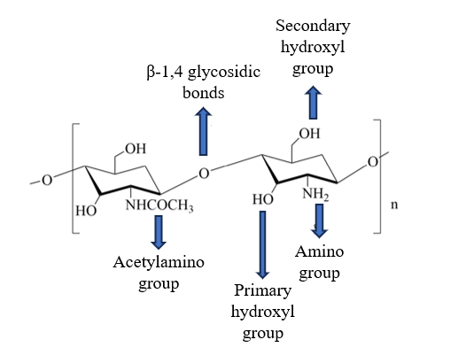
Fig. 3: Structural properties of chitosan oligomers

The presence of polydispersity leads to varying chain lengths within an oligomer sample, influencing uniformity. Intriguingly, conformational shifts occur based on environmental conditions like pH and temperature, further interactions, and applications (Kasaai, M. R., et al., 2013). Chitosan oligomers' subtle structural attributes intricately create their behaviour, rendering them versatile players across a spectrum of applications, from biomedicine to environmental remediation and beyond (Zhou, J., et al., 2021).
The ability to modify and tailor these properties through synthesis methods allows researchers to design chitosan oligomers with specific characteristics. Understanding the structural properties is vital for optimizing the use of chitosan oligomers in different applications and developing innovative solutions to address societal challenges (Sabu, S. et al., 2023).
I.C Synthesis Methods of Chitosan Oligomers:
The synthesis of chitosan oligomers involves the depolymerization or partial degradation of the chitosan polymer to obtain shorter chains with reduced molecular weight. Several methods have been developed to produce chitosan oligomers (Schmitz, C. et al., 2019).
As shown in fig. 4 Acid Hydrolysis: Acid hydrolysis is a widely used approach to create chitosan oligomers, which are abbreviated chains of chitosan molecules. This method involves controlled chitosan degradation through acid treatment, leading to the development of chitosan oligomers with reduced degrees of polymerization. By capitalizing on the vulnerability of glycosidic bonds in chitosan to acid-triggered cleavage, this process severs the connections between N-acetylglucosamine (GlcNAc) units within chitosan polymers, ultimately giving rise to truncated chains known as chitosan oligomers (Ailincai, D. et al., 2022).
Enzymatic Hydrolysis: Enzymatic hydrolysis is a method that utilizes specialized enzymes like chitosanases or chitinases to break down chitosan into oligomers. This approach is known for its selectivity and gentleness, distinguishing it from chemical methods. Enzymatic hydrolysis retains the biological activity of the generated oligomers, making it a preferred choice in certain applications (Zhou, J., et al., 2021).

Physical Degradation
Chitosan
Enzymatic Hydrolysis
Acid Hydrolysis
Use of specific enzymes such as chitosanases or chitinases
Use of physical methods such as Ultrasound-Assisted Degradation, Radiation Degradation, Microwave-Assisted Degradation, etc.
Use of acids such as Strong acids such as hydrochloric acid, sulfuric acid, or nitrous acid

Fig. 4: Methods for synthesis of chitosan oligomers
Physical assisted degradation: Various innovative techniques have emerged for the controlled synthesis of chitosan oligomers, each harnessing distinct energy sources to achieve tailored degradation. Ultrasound-assisted degradation involves subjecting chitosan to high-frequency ultrasound waves, which imparts mechanical energy, disrupting its chains and yielding shorter oligomeric chains. Microwave-assisted degradation capitalizes on localized heating effects generated by microwave irradiation, enabling the depolymerization of chitosan chains into oligomers (Pandit, A., et al., 2021).
Additionally, radiation degradation introduces ionizing radiation, such as gamma irradiation, prompting chain scission within chitosan molecules to produce chitosan oligomers. This method's versatility is evident in its capacity for tunable degradation, adjusting the radiation dose to modify oligomer properties, either in the presence or absence of crosslinkers. These innovative ways underscore the dynamic possibilities in chitosan oligomer synthesis, catering to a range of applications across diverse domains (Pandit, A., et al., 2021).
It is essential to note that the choice of synthesis method can influence the characteristics and properties of the resulting chitosan oligomers, including their chain length, polydispersity, and functional groups. Additionally, factors such as the reaction conditions, such as temperature, pH, and reaction time, play a crucial role in tailoring the final oligomer product (Schmitz, C. et al., 2019).

- Developments of various Chitosan oligomers-based biomaterials:
Table 1 has provided information showcasing a range of recent innovative findings and applications for chitosan oligomers across diverse fields.
Table 1: Recent chitosan oligomers-based biomaterials in various fields
Biomaterials | Applications | Findings | References
chitosan oligomers–hydroxyapatite–carbon  nitride | Postharvest Fruit Protection | Eco-friendly options to traditional fungicides for controlling postharvest plant diseases. | Santiago-Aliste, A, et. al., 2023.
Chitosan oligomers (COS) solution | Improved crop productivity | COS-treated plants as an excellent alternative crop for saline lands. | Mukarram, M., et. al., 2023.
Chitosan oligosaccharides (COS) | Prevention of acute kidney injury and renal interstitial fibrosis | Attenuates I/R-induced AKI and maintains glomerular filtration function by inhibiting oxidative stress, mitochondrial damage, and excessive endoplasmic reticulum stress. | Yin, S., et. al., 2023.
COS–Secondary Metabolites (Streptomyces spp.) Conjugate Complexes | The Quality and Improves the Shelf Life of Table Grapes from Botrytis cinerea | Conjugate complexes as coatings preserve grape firmness and delay pathogen onset. This offers a promising, sustainable gray mold control method. | Buzón-Durán, L., et. al., 2023.
Polyurethane foams obtained from the polyols synthesized from the chitosan oligomer | Obtaining Polyurethane Foams | It has low thermal conductivity, enhanced thermal resistance, dimensional stability, low water uptake, and high compressive strength, and it grows remarkably upon thermal exposure. | Strzałka, A., et. al., 2023.
Chitosan oligomer and monomer | Root rot disease treatment | Chitosan oligomer and monomer shows significant improvement compared to chemical fungicide | Vatcharakajon, P., et. al., 2023.
G. lucidum extract with chitosan oligomers complex | Antimicrobial Activity against phytopathogens | Alternative to synthetic fungicides for controlling plant diseases caused by oomycetes and fungi. | Sánchez-Hernández, E., et. al.,2023.
Chitosan Oligomers N-Conjugated with Asparagine and Glutamine | Battling against HIV-1 infection | It possesses HIV-1 entry inhibition activity. | Karadeniz, F., 2023.
Magnetic chitosan oligomer-sulfonate-stearic acid | Cisplatin carrier for site-specific targeted on MCF-7 cancer cells | Good applicants for thermotherapy in cancer treatment in the future. | Akkaya, B., et. al., 2023.

In the field of agriculture, chitosan oligomers combined with hydroxyapatite and carbon nitride offer an environmentally friendly approach for safeguarding postharvest fruits from diseases, presenting an alternative to conventional fungicides (Santiago-Aliste, A, et. al., 2023). Moreover, these oligomers have demonstrated their efficacy in improving crop productivity, particularly in saline lands, suggesting a potential solution for enhancing agricultural yields (Mukarram, M., et. al., 2023).
Chitosan oligosaccharides (COS) exhibit promise in the medical field as well. Their ability to mitigate acute kidney injury and renal interstitial fibrosis by counteracting oxidative stress, mitochondrial damage, and endoplasmic reticulum stress is noteworthy (Yin, S., et. al., 2023). Similarly, chitosan oligomers, when combined with secondary metabolites from Streptomyces spp., have been shown to extend the shelf life of table grapes by preserving their firmness and delaying the onset of Gray Mold, contributing to sustainable pathogen control (Buzón-Durán, L., et al., 2023.).
The versatility of chitosan oligomers extends to material science, with applications such as obtaining polyurethane foams that possess exceptional properties like low thermal conductivity, high thermal resistance, and dimensional stability (Strzałka, A., et al., 2023). These oligomers also prove effective in combating root rot diseases, outperforming chemical fungicides and offering a promising solution for managing such plant health issues (Vatcharakajon, 2023).
Furthermore, the combination of chitosan oligomers with an extract from Ganoderma lucidum demonstrates antimicrobial activity against phytopathogens, suggesting an alternative to synthetic fungicides in agricultural disease control (Sánchez-Hernández, E., et al.,2023.).
In medicine, chitosan oligomers, when modified with asparagine and glutamine, exhibit the potential to inhibit HIV-1 entry, offering a novel angle in the battle against HIV infections (Karadeniz, F., 2023). Lastly, the development of magnetic chitosan oligomer-sulfonate-stearic acid complexes presents a promising avenue for targeted delivery of cisplatin to cancer cells, holding future prospects for thermotherapy in cancer treatment (Akkaya, B., et al., 2023).
Overall, these studies highlight the multifaceted nature of chitosan oligomers, showcasing their capacity to revolutionize agriculture, medicine, and material science with their eco-friendly and versatile applications.
- Versatile Applications of chitosan oligomers include
- Biomedical Applications:
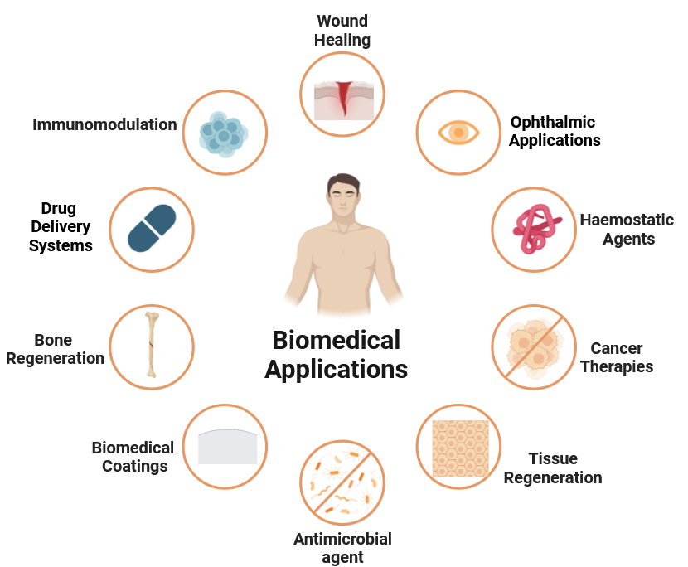
Fig. 5: Role of chitosan oligomers in various biomedical applications
Chitosan oligomers have garnered significant attention for their remarkable potential in various realms of regenerative medicine and biomedical engineering. These compounds, derived from chitosan through controlled degradation processes, possess structural features resembling both sugar and amino acid residues. This structural resemblance endows them with the capacity to mimic the biological molecules present in the human body, such as proteins and growth factors. This mimicry, in turn, triggers essential physiological responses crucial for processes like wound healing and tissue regeneration (Ho, T. T. P. et al., 2021). When applied in wound dressings and tissue engineering scaffolds, chitosan oligomers act as analogues, accelerating wound healing by promoting cell proliferation and orchestrating the restructuring of tissue within wounds (Santiago-Aliste, A. et al., 2022). This dynamic functionality aligns well with the principles of regenerative medicine, fostering an environment conducive to cellular regeneration and tissue rejuvenation (Riva, R. et al., 2011).
Furthermore, chitosan oligomer’s adaptability extends to drug delivery systems, where their controlled-release properties prove invaluable. By encapsulating therapeutic agents, drugs, or growth factors, these oligomers facilitate enhanced drug bioavailability while enabling targeted delivery to specific tissues or cells. This feature holds great promise for improving treatment efficacy while minimizing potential side effects (Abdelhamid, H. N. et al., 2022).
Notably, the antimicrobial potential of chitosan oligomers presents an additional facet of their utility. Demonstrating robust activity against a range of microorganisms, including bacteria, fungi, and certain viruses, these oligomers are harnessed in various applications such as antimicrobial coatings, wound dressings, and topical formulations (Ho, T. T. P. et al., 2021). This application is particularly relevant in preventing infections and promoting healing, especially given the increasing challenges posed by antimicrobial resistance (Qian, J. et al., 2023).
Beyond these applications, chitosan oligomers exhibit a capacity for immunomodulation, rendering them valuable candidates for adjuvants in vaccines and immunotherapies (Tsvetkov, Y. E., et al., 2020). They have also found a place in the development of biomedical coatings, serving to enhance the biocompatibility of medical devices and mitigate inflammation responses (Şenel, S., & McClure, S. J., 2004).
Expanding into the realm of cancer therapy, chitosan oligomers hold promise as carriers for anticancer drugs and agents used in photodynamic therapy. Their capability to target tumor cells and facilitate drug uptake contributes to the efficacy of cancer treatments (Akkaya, B., et al., 2023). Additionally, in the context of bone regeneration, these oligomers have been applied in tissue engineering scaffolds, stimulating bone formation and fostering the repair of bone defects and fractures (Riva, R. et al., 2011).
The versatility of chitosan oligomers extends even to ophthalmic applications, where they are being explored for ocular drug delivery and the development of contact lens materials with enhanced biocompatibility and prolonged drug release properties (Klausner, E. A. et al., 2010). Furthermore, their haemostatic properties make them valuable tools in surgical and emergency settings, aiding in the promotion of blood clotting and control of bleeding (Harugade, A. et al., 2023).
Their ability to modulate cellular responses, facilitate targeted therapy, and enhance various biomedical interventions positions them as pivotal components in advancing modern healthcare solutions and improving patient outcomes. The medical applications of chitosan oligomers continue to expand as researchers explore their potential in various therapeutic approaches (Harugade, A. et al., 2023). Their unique combination of properties makes them attractive candidates for innovative medical technologies, offering safer and more effective solutions in the fields of wound healing, drug delivery, regenerative medicine, and more. However, it is essential to conduct further research and clinical trials to fully harness their potential and ensure their safe and effective use in medical settings (Santiago-Aliste, A. et al., 2022).
- Food Industry:
Chitosan oligomers have found numerous applications in the food industry due to their unique properties, which offer several benefits for food preservation, safety, and quality enhancement (Singh, A., et al.,2023).
Chitosan oligomers present an array of applications in the realm of food science have shown in fig. 6, driving both innovation and sustainability. Their inherent antimicrobial properties offer a natural avenue for food preservation and extended shelf-life. Whether integrated into food packaging materials or directly applied to food surfaces, they serve as potent inhibitors of spoilage and pathogenic microorganisms, effectively elongating the lifespan of food products. This dual role aligns seamlessly with sustainability efforts, curbing food waste and reducing the environmental impact associated with production and disposal (Singh, A., et al.,2023).
Moreover, chitosan oligomers-based packaging materials serve as guardians against moisture and oxygen, bolstering food quality and safety over time.

Food Preservation
Shelf-life Extension
Antioxidant activity
Fat Reduction in Foods
Chelating Agents for Metal Ions
Food Preservation

Fig. 6: Applications of chitosan oligomers in the food industry
Their biodegradability and ability to combat wastefulness position them as a greener alternative in the persistent struggle against plastic waste. Their role in antioxidant and nutraceutical applications contributes to sustainability by prolonging food quality and reducing the need for premature disposal. As fat substitutes in low-fat foods, they enhance sensory experiences while promoting healthier dietary choices (Zhou, J., et. al., 2021).
Furthermore, their function as chelating agents for metal ions contributes to safer food consumption. In the era of sustainable practices, chitosan oligomers stand as a versatile and eco-conscious solution, harmonizing human well-being with environmental health. (Kumar, P. et al., 2023).
- Environmental Applications:
Chitosan oligomers have emerged as a valuable component in environmental remediation due to their ability to interact with various pollutants and contaminants, offering eco-friendly and sustainable solutions (Dey, A., et al., 2021).
Chitosan oligomers emerge as a multifaceted and sustainable arsenal in environmental remediation. Their adoption spans a wide spectrum of applications, ranging from water purification through natural coagulation and heavy metal chelation, to innovative solutions for oil spill cleanup and the removal of emerging contaminants like pharmaceuticals and microplastics (Issahaku, I. et al., 2023).
Their potential extends even to air pollution control and the pursuit of greener alternatives to single-use plastics, as they offer an avenue for biodegradable packaging. These solutions, rooted in nature-inspired processes, hold promise in addressing pressing pollution challenges (Hsu, Y. F. et al., 2021).
While their real-world scalability demands further investigation, research, and integration with existing technologies, the rising importance of environmental sustainability positions chitosan oligomers as a pivotal tool in the protection and restoration of ecosystems (Dey, A., et al., 2021).
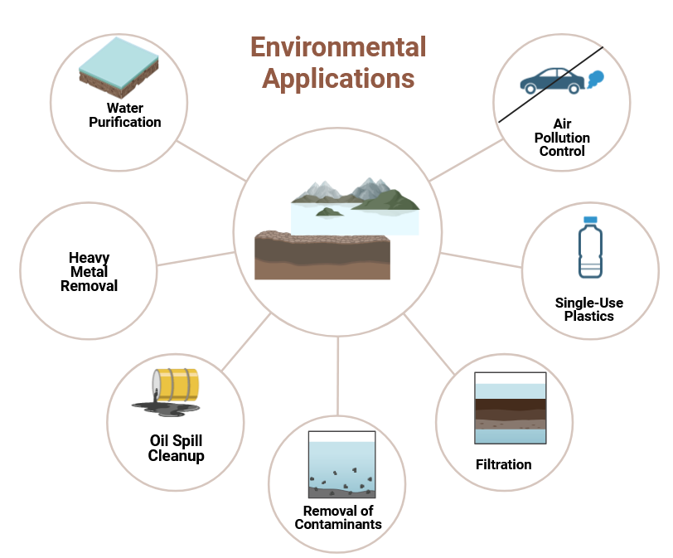
Fig. 7: Various environmental applications of chitosan oligomers
Chitosan oligomers represent a cornerstone of sustainable agriculture and crop protection practices. Their myriad advantages, spanning from fortifying seeds for improved germination to fortifying plants against environmental stresses, extending post-harvest shelf life, countering nematode pests, and remediating soil pollution, underscore their eco-friendly significance (Kumar, P. et al., 2023).
By leveraging their biodegradability, harmlessness to non-target organisms, and ability to bolster plant resilience, these oligomers champion environmentally conscious farming and mitigate reliance on traditional chemical pesticides. However, meticulous attention to their application methods and dosages is imperative to optimize efficacy while upholding ecological integrity (Ameen, H. H., et al., 2013). In encompassing these diverse applications, chitosan oligomers emerge as a pivotal sustainable asset, fostering agricultural practices that harmonize productivity with long-term environmental well-being (Coelho, N. et al., 2022).
- Industrial Applications:
Chitosan oligomers have found diverse applications in various industrial sectors, owing to their unique properties and eco-friendly nature. Their versatility makes them valuable biomaterials for enhancing processes and products in different industries (Tharanathan, R. N., & Kittur, F. S., 2003).
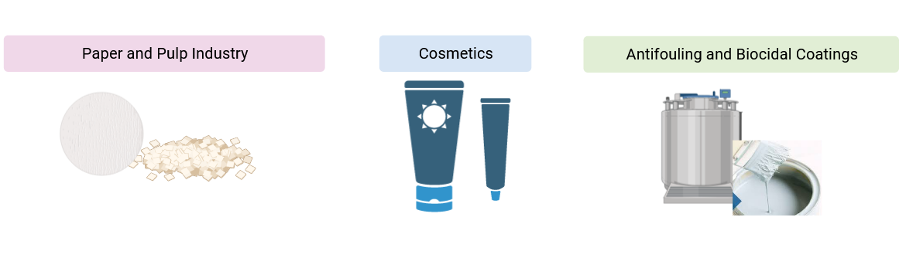
Fig. 8 Role of chitosan oligomers in industry
Chitosan oligomers have found diverse applications that extend into multiple industries. In the paper and pulp sector, these oligomers are explored as additives to bolster paper strength, ink absorption, and water retention. Additionally, their introduction into paper production processes enhances recyclability and reduces the ecological footprint of paper manufacturing (Zhu, Q. et al., 2023).
In the realm of cosmetic and personal care products, chitosan oligomers contribute their film-forming attributes and hair-strengthening qualities, thereby enhancing product stability and overall effectiveness in formulations like shampoos, conditioners, and lotions (Tharanathan, R. N., & Kittur, F. S., 2003).
Furthermore, chitosan oligomers offer a solution in the development of antifouling and biocidal coatings for industrial equipment and structures, as they exhibit the ability to impede the attachment and proliferation of biofouling organisms (Kulka, K. et al., 2023). This dual functionality reduces maintenance expenses and extends the operational life of industrial assets (Singh, T., & Singh, A. P., 2012).

- Challenges in Large scale production of chitosan oligomers
While chitosan oligomers offer multifaceted potential, their utilization comes with a spectrum of challenges that demand thoughtful consideration. Controlled synthesis to tailor specific properties proves intricate, and enhancing the efficiency and scalability of synthesis methods is paramount for facilitating large-scale production and eventual commercialization (Zhou, J., et al., 2021).
Notably, the variations inherent in chitosan oligomers, arising from diverse sources and synthesis routes, encompass properties like chain length, degree of acetylation, and polydispersity. Addressing this variability through standardization emerges as a prerequisite, ensuring consistent performance across the gamut of applications (Thambiliyagodage, C., et al., 2023).
However, the cost of chitosan oligomers presents a hurdle, particularly when compared to conventional industry materials. Navigating this challenge necessitates the development of cost-effective production techniques and strategic sourcing of chitosan raw materials, critical for enhancing their competitiveness and broader adoption. Moreover, while chitosan oligomers exhibit promising attributes, their exact mechanisms of action in various applications remain, at times, enigmatic. Unraveling these mechanisms requires comprehensive research efforts to optimize their utility effectively. Intricate aspects like formulation and stability come to the fore when incorporating chitosan oligomers into pharmaceuticals, cosmetics, and beyond (Aranaz, I., et. al., 2021).
Ensuring their stability across diverse environments is essential for preserving their functional efficacy. While the biodegradability of chitosan oligomers aligns with sustainability, evaluating their post-use persistence and environmental impact remains imperative. Rigorous studies on their degradation in varying environmental contexts are essential to comprehend long-term ramifications. Ultimately, the pursuit of reliable outcomes hinges on the attainment of high levels of purity and consistency in chitosan oligomer sample applications (Thambiliyagodage, C., et al., 2023).
Contaminants or molecular variations have the potential to considerably influence experiment results and practical applications, reinforcing the significance of meticulous quality control measures. In navigating these challenges, the path toward harnessing the transformative potential of chitosan oligomers is underscored by the need for scientific innovation and strategic solutions (Kumar, P. et al., 2023)

V. Conclusion and Future Perspectives:
The future of chitosan oligomers holds immense potential for driving sustainability across diverse sectors (Thambiliyagodage, C., et al., 2023). These versatile molecules derived from chitin, found in crustacean shells, offer numerous of applications that can revolutionize industries. From agriculture to biomedical fields, chitosan oligomers exhibit remarkable biocompatibility, biodegradability, and antimicrobial properties (Cord-Landwehr, S, et al., 2020).
Their potential to enhance crop growth, replace synthetic additives in food, aid in water treatment, and contribute to biodegradable polymers underscores their pivotal role in fostering eco-friendly practices (Ameen, H. H., et al., 2013). As pioneers in sustainable solutions, chitosan oligomers are poised to pave the way for a greener and better future.

References:
  - Cord-Landwehr, S., Richter, C., Wattjes, J., Sreekumar, S., Singh, R., Basa, S., ... & Moerschbacher, B. M. (2020). Patterns matter part 2: Chitosan oligomers with defined patterns of acetylation. Reactive and Functional Polymers, 151, 104577.
  - Aranaz, I., Alcántara, A. R., Civera, M. C., Arias, C., Elorza, B., Heras Caballero, A., & Acosta, N. (2021). Chitosan: An overview of its properties and applications. Polymers, 13(19), 3256.
  - Jeon, Y. J., Shahidi, F., & Kim, S. K. (2000). Preparation of chitin and chitosan oligomers and their applications in physiological functional foods. Food Reviews International, 16(2), 159-176.
  - Sabu, S., Sasidharan, A., & Venugopal, V. (2022). Influence of isolation conditions on the physicochemical and biological properties of chitosan and chitosan oligosaccharides from marine crustacean shell wastes. In Chitooligosaccharides: Prevention and Control of Diseases (pp. 333-352). Cham: Springer International Publishing.
  - Ailincai, D., Rosca, I. R. I. N. A., Ursu, L., & Dascalu, A. N. D. R. E. I. (2022). Chitosan Oligomers—Synthesis, Characterization, and Properties. Cellul. Chem. Technol, 56, 767-776.
  - Schmitz, C., González Auza, L., Koberidze, D., Rasche, S., Fischer, R., & Bortesi, L. (2019). Conversion of chitin to defined chitosan oligomers: current status and future prospects. Marine drugs, 17(8), 452.
  - Riaz Rajoka, M. S., Zhao, L., Mehwish, H. M., Wu, Y., & Mahmood, S. (2019). Chitosan and its derivatives: synthesis, biotechnological applications, and future challenges. Applied microbiology and biotechnology, 103, 1557-1571.
  - Singh, A., Mittal, A., & Benjakul, S. (2023). Chitosan, chitooligosaccharides and their polyphenol conjugates: preparation, bioactivities, functionalities and applications in food systems. Food reviews international, 39(4), 2297-2319.
  - Qian, J., Wang, X., Chen, Y., Mo, C., Liang, C., & Guo, H. (2023). The correlation of molecule weight of chitosan oligomers with the corresponding viscosity and antibacterial activity. Carbohydrate Research, 530, 108860.
  - Coelho, N., & Romano, A. (2022). Impact of chitosan on plant tissue culture: recent applications. Plant Cell, Tissue and Organ Culture (PCTOC), 1-13.
  - Abdelhamid, H. N. (2022). Chitosan‐Based Nanocarriers for Gene Delivery. Nanoengineering of Biomaterials, 91-105.
  - Santiago-Aliste, A., Sánchez-Hernández, E., Langa-Lomba, N., González-García, V., Casanova-Gascón, J., Martín-Gil, J., & Martín-Ramos, P. (2022). Multifunctional Nanocarriers Based on Chitosan Oligomers and Graphitic Carbon Nitride Assembly. Materials, 15(24), 8981.
  - Harugade, A., Sherje, A. P., & Pethe, A. (2023). Chitosan: A review on properties, biological activities and recent progress in biomedical applications. Reactive and Functional Polymers, 105634.
  - Kumar, P., & Korat, H. (2022). Mass Production Methods, Markets, and Applications of Chitosan and Chitin Oligomer as a Biostimulant. In Industrial Microbiology Based Entrepreneurship: Making Money from Microbes (pp. 265-285). Singapore: Springer Nature Singapore.
  - Kulka, K., & Sionkowska, A. (2023). Chitosan Based Materials in Cosmetic Applications: A Review. Molecules, 28(4), 1817.
  - Hsu, Y. F., Chuang, C. Y., & Yang, S. (2021). Evaluation of the bioaerosol inactivation ability of chitosan-coated antimicrobial filters. International Journal of Environmental Research and Public Health, 18(13), 7183.
  - Tharanathan, R. N., & Kittur, F. S. (2003). Chitin—the undisputed biomolecule of great potential.
  - Singh, T., & Singh, A. P. (2012). A review on natural products as wood protectant. Wood Science and Technology, 46, 851-870.
  - Issahaku, I., Tetteh, I. K., & Tetteh, A. Y. (2023). Chitosan and chitosan derivatives: Recent advancements in production and applications in environmental remediation. Environmental Advances, 100351.
  - Zhu, Q., Tan, J., Li, D., Zhang, T., Liu, Z., & Cao, Y. (2023). Cross-linked chitosan/tannin extract as a biodegradable and repulpable coating for paper with excellent oil-resistance, gas barrier and UV-shielding. Progress in Organic Coatings, 176, 107399.
  - Dey, A., Dhumal, C. V., Sengupta, P., Kumar, A., Pramanik, N. K., & Alam, T. (2021). Challenges and possible solutions to mitigate the problems of single-use plastics used for packaging food items: A review. Journal of Food Science and Technology, 58(9), 3251-3269.
  - Zhou, J., Wen, B., Xie, H., Zhang, C., Bai, Y., Cao, H., ... & Su, Z. (2021). Advances in the preparation and assessment of the biological activities of chitosan oligosaccharides with different structural characteristics. Food & Function, 12(3), 926-951.
  - Singh, A., Mittal, A., & Benjakul, S. (2023). Chitosan, chitooligosaccharides and their polyphenol conjugates: preparation, bioactivities, functionalities and applications in food systems. Food reviews international, 39(4), 2297-2319.
  - Pandit, A., Indurkar, A., Deshpande, C., Jain, R., & Dandekar, P. (2021). A systematic review of physical techniques for chitosan degradation. Carbohydrate Polymer Technologies and Applications, 2, 100033.
  - Ho, T. T. P., Doan, V. K., Tran, N. M. P., Nguyen, L. K. K., Le, A. N. M., Ho, M. H., ... & Nguyen, T. H. (2021). Fabrication of chitosan oligomer-coated electrospun polycaprolactone membrane for wound dressing application. Materials Science and Engineering: C, 120, 111724.
  - Riva, R., Ragelle, H., des Rieux, A., Duhem, N., Jérôme, C., & Préat, V. (2011). Chitosan and chitosan derivatives in drug delivery and tissue engineering. Chitosan for biomaterials II, 19-44.
  - Şenel, S., & McClure, S. J. (2004). Potential applications of chitosan in veterinary medicine. Advanced drug delivery reviews, 56(10), 1467-1480.
  - Tsvetkov, Y. E., Paulovičová, E., Paulovičová, L., Farkaš, P., & Nifantiev, N. E. (2020). Synthesis of biotin-tagged chitosan oligosaccharides and assessment of their immunomodulatory activity. Frontiers in Chemistry, 8, 554732.
  - Akkaya, B., Akkaya, R., & Nazlim, A. (2023). Magnetic chitosan oligomer‐sulfonate‐stearic acid triple combination as cisplatin carrier for site‐specific targeted on MCF‐7 cancer cells: Preparation, characterization and in vitro experiments. Chemical Biology & Drug Design.
  - Ameen, H. H., Osman, H. A., Lashein, A. M., Hasabo, S. A., & Koura, F. H. (2013). Control of root knot nematode Meloidogyne arenaria on potato in Egypt with plant defence elicitors, bioagents and inorganic fertilizers. International Journal of Nematology, 23(2), 167-174.
  - Dzung, N. A., Khanh, V. T. P., & Dzung, T. T. (2011). Research on impact of chitosan oligomers on biophysical characteristics, growth, development and drought resistance of coffee. Carbohydrate polymers, 84(2), 751-755.
  - Je, J. Y., & Kim, S. K. (2012). Chitosan as potential marine nutraceutical. Advances in food and nutrition research, 65, 121-135.
  - Li, Y., Ma, Z., Yang, X., Gao, Y., Ren, Y., Li, Q., ... & Zeng, R. (2021). Investigation into the physical properties, antioxidant and antibacterial activity of Bletilla striata polysaccharide/chitosan membranes. International Journal of Biological Macromolecules, 182, 311-320.
  - Ngo, D. H., Vo, T. S., Ngo, D. N., Kang, K. H., Je, J. Y., Pham, H. N. D., ... & Kim, S. K. (2015). Biological effects of chitosan and its derivatives. Food hydrocolloids, 51, 200-216.
  - Kasaai, M. R., Arul, J., & Charlet, G. (2013). Fragmentation of chitosan by acids. The Scientific World Journal, 2013.
  - Thambiliyagodage, C., Jayanetti, M., Mendis, A., Ekanayake, G., Liyanaarachchi, H., & Vigneswaran, S. (2023). Recent Advances in Chitosan-Based Applications—A Review. Materials, 16(5), 2073.
  - Klausner, E. A., Zhang, Z., Chapman, R. L., Multack, R. F., & Volin, M. V. (2010). Ultrapure chitosan oligomers as carriers for corneal gene transfer. Biomaterials, 31(7), 1814-1820.
  - Santiago-Aliste, A., Sánchez-Hernández, E., Buzón-Durán, L., Marcos-Robles, J. L., Martín-Gil, J., & Martín-Ramos, P. (2023). Uncaria tomentosa-Loaded Chitosan Oligomers–Hydroxyapatite–Carbon Nitride Nanocarriers for Postharvest Fruit Protection. Agronomy, 13(9), 2189.
  - Mukarram, M., Khan, M. M. A., Kurjak, D., & Corpas, F. J. (2023). Chitosan oligomers (COS) trigger a coordinated biochemical response of lemongrass (Cymbopogon flexuosus) plants to palliate salinity-induced oxidative stress. Scientific Reports, 13(1), 8636.
  - Yin, S., Liu, J., Zhao, X., Dong, H., Cao, Y., Zhang, S., ... & Wang, Z. (2023). Chitosan oligosaccharide attenuates acute kidney injury and renal interstitial fibrosis induced by ischemia-reperfusion. Renal Failure, 45(1), 2238831.
  - Buzón-Durán, L., Sánchez-Hernández, E., Sánchez-Báscones, M., García-González, M. C., Hernández-Navarro, S., Correa-Guimarães, A., & Martín-Ramos, P. (2023). A Coating Based on Bioactive Compounds from Streptomyces spp. and Chitosan Oligomers to Control Botrytis cinerea Preserves the Quality and Improves the Shelf Life of Table Grapes. Plants, 12(3), 577.
  - Strzałka, A., Lubczak, R., & Lubczak, J. (2023). Chitosan Oligomer as a Raw Material for Obtaining Polyurethane Foams. Polymers, 15(14), 3084.
  - Vatcharakajon, P., Choengpanya, K., Susawaengsup, C., & Dangtungee, R. (2023). Chitosan oligomer and monomer (COAMs) benefit and its application in innovative organic method for root rot disease treatment in durian crops. Materials Today: Proceedings, 77, 1033-1038.
  - Sánchez-Hernández, E., Teixeira, A., Pereira, C., Cruz, A., Martín-Gil, J., Oliveira, R., & Martín-Ramos, P. (2023). Chemical Constituents and Antimicrobial Activity of a Ganoderma lucidum (Curtis.) P. Karst. Aqueous Ammonia Extract. Plants, 12(12), 2271.
  - Karadeniz, F. (2023). In Vitro Anti-HIV-1 Activity of Chitosan Oligomers N-Conjugated with Asparagine and Glutamine. BioTech, 12(1), 18.
  - Akkaya, B., Akkaya, R., & Nazlim, A. (2023). Magnetic chitosan oligomer‐sulfonate‐stearic acid triple combination as cisplatin carrier for site‐specific targeted on MCF‐7 cancer cells: Preparation, characterization and in vitro experiments. Chemical Biology & Drug Design.

