TOPIC

Integration of Technology in Culture: Digital Adaptation of Folktales

Submitted by

Neha Bhushan (Assistant Professor II)
Amity School of Communication
Amity University
Noida (UP), India

Integration of Technology in Culture: Digital Adaptation of Folktales

Neha Bhushan (Assistant Professor II)
Amity School of Communication
Amity University
Noida (UP), India

Storytelling is one of the essential parts of our life. For generations, folklores and folktales have helped in preserving culture and traditions. All the different states of India have fascinating folktales as a great source of entertainment and enlightenment. Folktales help our young generations learn moral values along with entertainment. As technology has redefined the way of communication in our lives, traditional folktales are now making their presence on digital platforms. Some of the YouTube channels like Folktales of India, Story Circus, and Devdutt Myth, Geethanjali produce great audio-visual and animated content, admired by many subscribers. The presence of folktales on digital platforms like YouTube has created various opportunities and challenges. In this paper, the researcher will attempt to analyze some of the Indian YouTube channels producing audio-visual content on folktales and their popularity among viewers. This study will discuss the various opportunities and challenges involved in the digital adaptation of folktales as an art of storytelling from the content producers' and viewers' points of view.

Keywords: Digital, Folktales, Storytelling, YouTube.

Introduction
Folktales are traditional stories about ordinary people of any particular region. It is one of the most effective mediums to express cultural beliefs and values. Folktales have been a part of our culture even when no written means of communication were available. As a part of oral traditions, folktales play an essential role in preserving culture and teaching moral values. With its vast cultural diversity, India is the world's richest source of Folktales. All the different states of India have fascinating folktales as a great source of entertainment and enlightenment. The documentation of folktales in books and audio format is not a new concept. It helps preserve oral tradition and provides an opportunity for the masses to read folktales. Compared to any other literature in the world, Indian literature has played an essential role in documenting and propagating the oral traditions of folktales. Various authors and publishing houses have documented folktales in multi-lingual books. Adaptation of folktales on television and movies is also popular. A recent example of folktale adaptation in the song is Tejimola, an Assamese folktale, which received colossal popularity when sung by Joi Barua, the famous Assamese singer. Betal Pacheechi screened from 1997 to 1998 on D.D. Metro is a classic example of folktales cited through television. Now, as technology has redefined the way of communication in our lives, our valuable oral tradition is making its presence on digital platforms to avoid the risk of extinction. The presence of folktales on digital platforms like YouTube has created various opportunities and challenges. Some of the YouTube channels like Folktales of India, Story Circus, Geethanjali, and Devdutt Myth produce great audio-visual and animated content, admired by many subscribers. In this paper, the researcher has analyzed some Indian YouTube channels creating rich audio-visual content on Indian folktales and their popularity among viewers. A narrative methodology, an interpretive approach, has been used to analyze the Youtube channels’ videos and discuss the various opportunities and challenges involved in the digital adaptation of folktales as an art of storytelling from the content producers' and viewers' points of view.

Importance of Storytelling
Since the beginning of civilization, storytelling has been a very integral part of the culture. Stories can arouse emotions and connect with the listener. When fabricated with exciting characters, dry information about the past adds meaning and value to an individual's life. Richard Kearney, a philosopher, and literary critic, stated, 'Storytelling gives us a shareable world .'Before the time when mass entertainment mediums were available, storytelling in the form of oral communication entertained and fascinated the masses throughout the generations. Through storytelling, knowledge, information, experiences, and moral values can be transmitted to future generations. Storytelling is a universal practice among human beings. It is a common practice across all the cultures and traditions throughout countries. With their creativity, storytellers provide a timeless connection of our present with glorious past cultures, customs, and traditions. As a sophisticated form of communication, storytelling provides an opportunity for young generations to learn about their traditions. Stories have the unique ability to build empathy, compassion, and trust.
With its diverse culture and traditions, India follows a different storytelling style. Every state and region in India has a storytelling tradition in local languages. Like, Katha is one of the forms of religious storytelling which narrates moral values and the consequences of human actions. Katha is further classified into three major traditions. Purana-Pravachana is a lecture on a religious theme from an Indian epic where storytellers recite the scriptures providing its meaning from different angles and its significance. Kathakalakshepa is the stories of ancient text often told in Sanskrit, Tamil, and Hindi, where storytellers narrate the story interweave with music to the ordinary people. The third one is folk narratives which are folktales with moral values to avoid theft, lies, and ill manners. These are the stories about the King, Queen, and brave hunters. Every region has different stories traditionally narrated by parents and grandparents at home for their children. In Southeast India, Andhra Pradesh, Folk Narratives are known as Burra Katha, and in Southern India, Tamil Nadu, folk narratives are called Villu Paatu.
Stories have been documented in various forms in the past. During the Covid era, storytellers have made their presence on online platforms to reach out to kids and adults with entertainment and talk therapies in the difficult time of the pandemic. It is also true that the present generation is more comfortable with digital devices for learning and entertainment. So, online can be the best medium to preserve the oral tradition of storytelling and folktales.

Folktales in India
Folktales are the traditional tales about the common folk of a particular region. It is a part of oral tradition in every culture. These are the simple, quickly understood stories that have been transmitted from one generation to another through oral communication. The folktale tradition consists of traditional tales, which could be oral, or in permanent form, written or audio-visual format, of the people in a particular community that could have passed through generations (Choudhury, 2013). According to Olajide (2006), folktale practice has been a potent agent of socialization and moral values, especially among the young ones. These folktales include Epics, fables, mythological stories, stories praising Kings, and glorified stories of local heroes. The purpose of these tales is entertainment and to instill moral values in people. All the folktales contain a moral lesson at the end of the story. These stories are usually based on humans, heroic characters, animals, birds, or imaginary characters. Folktale in India plays a vital role in maintaining Indian cultural identity and unity. India is a country with heterogeneous traditions and a rich cultural heritage. Every state and region in India possesses different folktales in local and vernacular languages. The Ramayana and the Mahabharata are the two greatest epics of India. There are various folktales based on the characters of these two epics in society. Indian folk heroes like Rama and Krishna are even famous worldwide. Panchatantra, Akbar-Birbal, Tales of Tenaliraman, Baital Pachis, Hitopadesha Tales, and Jataka tales are some of the most famous folktales of India. The Panchatantra, initially composed in the 2nd century B.C., is a collection of short stories from India believed to be written by Vishnu Sharma and many other scholars. The composition of Panchatantra was to implant moral values in the young sons of the king. The Hitopadesha tales had their origin around a thousand years ago, which is similar to Panchatantra, a short story compilation by Narayana Pandit. The Jataka Tales had their origin in 300 B.C., originally written in the Pali language. These are Buddhist tales that have been translated into different languages worldwide. These folktales are available in various interpretations and adaptations in the form of books, audio formats, and television series. These stories are a significant part of our collective Indian culture. Historians have traced the evidence of these stories from the wall paintings and scriptures almost 2500 years ago. During the British period, to understand the Indian values system for administrative purposes, proper research was conducted on Indian Folklore. After independence, many scholars and authors began to take reference from traditional folktales to identify our local identity. In an attempt to preserve cultural identity and languages, various Indian universities and academic institutes have also established departments to study Folktales from 1970 onwards. Notable scholars like Chitrasen Pasayat, Vivek Rai, Jawaharlal Handoo, Sadhana Naithani, P. Subachary, Molly Kaushal, Shyam Sundar Mahapatra, M. D. Muthukumaraswamy, and P. C. Pattanaik have contributed towards the studies of Indian Folklore. Some major publishing houses like Penguin Random House India, Geico Publishing house, and Harpers Children's have published books on Indian Folktales written by famous authors like Sudha Murthy, Pratibha Nath, Amrita Bharati, Pika Nani, and Deepa Aggarwal.

Folktales in Digital Era
Digital communication refers to digital technologies, production, storage, transmission, and reception of information. Digital media are rooted in computer and computer-related technologies like electronics, satellite technologies, digitalized media equipment, and mobile phones. (Nweke, 2001; Ufuophu-Biri and Ojoboh, 2017). Folktales as oral tradition are an excellent tool for cultural preservation in the country. Due to the fear of being extinct, these tales have been documented in books, audio files, and television programs. The inclination of the present generation towards digital platforms is creating a new opportunity for folktales to show their presence online. Digital technologies have redefined means of entertainment, but they need to instill moral education in the young generation, and adults are still the same. Digital mediums are highly effective in preserving and promoting oral traditions. During the pandemic, the entire media and entertainment industry have inclined towards Over the Top (OTT) platforms. Tales in the form of television cartoons from the westernized culture are already popular among children. The adaptation of folktales on digital platforms like YouTube allows the audience to easily access the medium and learn about our traditions. The most significant benefit of digital technology is its speed. In the form of smartphones, it is available at the fingertips of the audience. With the help of rich audio-visual and animated content, digital technology can grab the attention of the young generation and adults. Some of the YouTube channels like Folktales of India, Story Circus, and Devdutt Myth, Geethanjali produce great audio-visual and animated content, admired by many subscribers. The digital medium can provide new hope for the preservation and propagation of folktales in the present and future. Although, Apuke and Dogari (2017) stated that the digital adaptation of folktales can shift the audience's full attention to the entertainment and digital technology, which may harm the folklore practice.

Methodology and Analysis of Youtube Channels Content
The researcher has analyzed four YouTube channels, namely Folktales of India, Story Circus, Devdutt Myth, and Geethanjali. A narrative methodology, an interpretive approach, has been used to analyze the Youtube channels’ videos and discuss the various opportunities and challenges involved in the digital adaptation of folktales as an art of storytelling. Out of the four main methodological approaches of narrative research (Kohler Riessman), Structural analysis has been used. With the help of structural analysis, the researcher paid attention to the narrative genre, which is the Folklore genre where stories are passed from generation to generation orally, its digital adaptation in the form of rich audio-visual content and linguistic form. In this paper the investigator tries to present a bird’s-eye view of the Youtube channel’s content narration and the opportunities and challenges involved in its digital adaptation.

Popular Indian Folktales YouTube Channels
Folktales of India
India has a large body of heroic ballads and folk tales in various languages, stored in oral and written tradition. Folktales of India is a YouTube channel that uniquely encompasses many folk tales of India. It showcases a variety of folktales from different states covering the diverse culture of India. It uses the art of storytelling in the English and Hindi language and in the form of animation and graphics content that reaches the masses in India and also attracts foreigners. The channel has a follower base of 4.7k.
The folktales have been categorized state-wise with enriching content covering the most famous tales of the states. It has a beautiful and fascinating narration with perfect graphics resulting in one's indulgence in the tales and their culture.
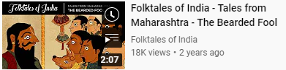
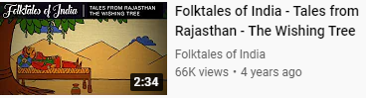

Story Circus
The art of storytelling through folk tales has got another platform on digital media in the form of Story Circus. Story Circus is a family entertainment channel with "Explore India with Folktales" as one of its significant content contributors. Through that, the channel makers have attempted to contribute to enhancing the reach of India’s rich culture of folktales.
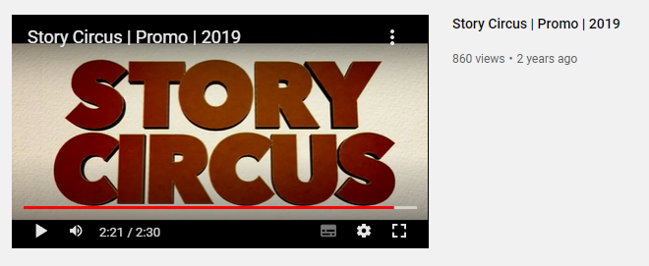
The narration has got the beautiful voice of Dr. Ulka Mayur, and the tales are in the form of animation and attractive graphics.
The tales are categorized state-wise, covering folk tales of the most popular state. The channel has a subscriber base of 1.4k.
Devdutt Myth
India possesses a rich history of folk tales, some of which are also embedded in our mythology. Devdutt Pattanaik, a famous Indian mythologist, speaker, and author, through his YouTube channel DevduttMyth, has worked towards spreading the rich mythology through folk tales in the modern digital era.
The stories are in the form of narration by him and have covered various mythologies and cultural influences in society.
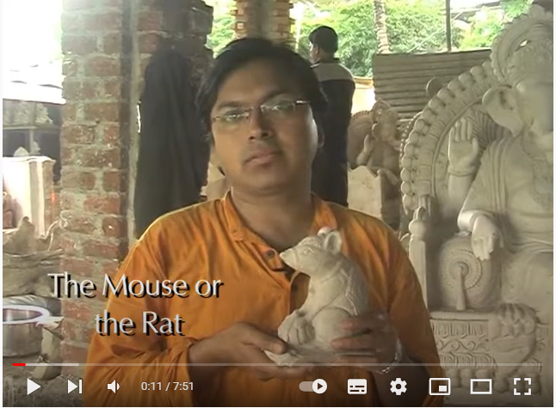
His videos on the YouTube channel cover various Folk tales related to Mythology, symbolic associations with Hindu Gods, and cultural influences. He has a subscriber base of 78.1K.
Geethanjali
Folk tales are also popular in our rich mythology, part of our Indian culture. Geethanjali – Cartoons for Kids has attempted to teach the younger generation about folk tales in an animated form of storytelling through the YouTube channel.
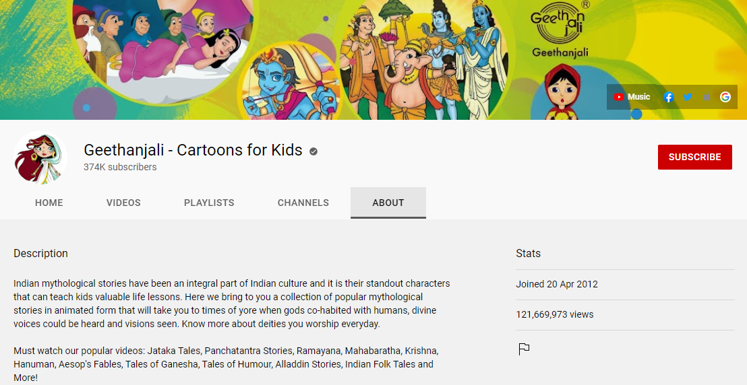
One can find a collection of popular tales on the channel. The narration is in the English language, making it attractive in the form of graphics that attract a large audience. The content includes many animated tales covering Panchatantra, Hitopadesha, Sanskrit Fables, and mythological tales. The channel's popularity is evident from the subscriber base of 374k.
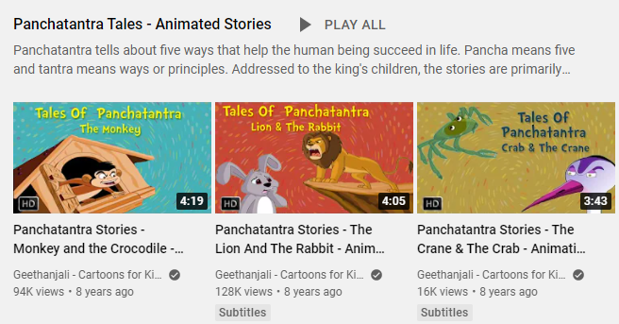
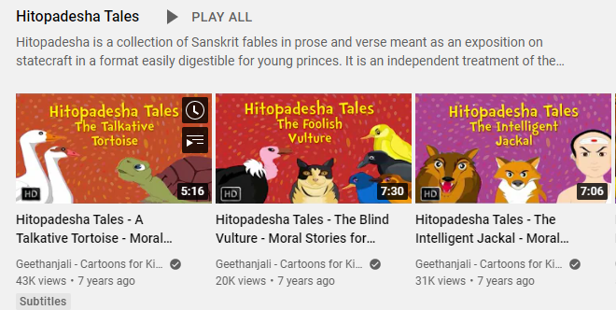

Opportunities in Digital Adaptation of Folktales
For the tech-savvy young generation, the digital adaptation of folktales provides an excellent opportunity to learn moral values and preserve the country's culture. The foremost advantage of the digital medium is its capability to include all arts of communication in a single medium. On this platform, the oral tradition of folktales can be presented with rich audio-visual, animated content.
- The inclination of Children toward Digital Media
In a critical growing stage, parents, grandparents, and elders in the family used to narrate stories to the children. These stories are primarily folktales with moral lessons in the end. The digital platforms have taken the place of the story narrator as a grandparent or parent. YouTube is a new 'Babysitter' for children. Studies show that young children spend more time on YouTube than on television or reading. A YouTube kid is a trendy digital platform for parents and kids in India. Children's inclination towards this platform provides an excellent opportunity for digital folktales creators to popularise Indian folktales.

- Rich Audio-Visual Content
Digital media is capable of providing visually rich content. Immersive audio-visual experience with the help of digital technology like 3D graphics and animations can grab the audience's attention in storytelling. Paid OTT platforms and YouTube premium services also provide ad-free content to consumers.
- Digital Convergence
Converged computer-mediated communication is possible by combining all the features of text, pictures, audio, music graphics, and animation on digital media. Digital platforms can include all arts of communication in a single medium. Folktales in narration, animation, pictures, and text can be found on the digital platform.
- Language
Language is no barrier on the digital platform. Stories from any part of the country can be narrated on the digital channel. YouTube channels like Folktales of India are creating episodes on the tales of different states of India in the English language, which is a universal language understood mainly by the urban audience. Similarly, many other YouTube channels create Hindi and other regional languages content.

Challenges in Digital Adaptation of Folktales
The Digital adaptation of Folktales is gaining importance with the arrival of new digital media in handy internet assets and platforms. Television, which had a limited bandwidth during the 1990s, is now accessible easily on a mobile phone. D.D. network, which we use to access through antennae, now has a dedicated TV-On-Go Doordarshan application that can be downloaded on mobile phones and can be watched anytime and anywhere with access to the internet. The History of storytelling of our tradition, culture, and popular ragas through Folktales dates back to the 1980s and 1990s when Doordarshan showcased many folktales like the tale of Panchatantra Vikram Betal and Kartha Sagar. However, with the development comes the era of digitalization where the art of storytelling through Folktales has gained importance. Various social media and OTT platforms have facilitated a medium for its showcase. Content creators, distributors, and promoters face many challenges in promoting their channels. It is evident from the number of subscribers they enjoy at the moment. In this paper, the researcher has analyzed various challenges in the Digital adaptation of Folktales during present times. Some of these challenges have been discussed in the following paragraphs.
- Rural Reach
As per census data, the rural population formed 68.84% of the total population in India, with the urban population constituting 31.16%. With the infrastructure under development in the rural areas, the internet connectivity and the reach of the cellular network are not at par, and hence the reach of the OTT and other digital platforms like YouTube, where channels are operating, is limited. As per the report by survey companies, according to the inputs from the Telecom Regulatory Authority of India (TRAI), 93% of urban India is connected to internet broadband compared to 29.3% of rural India. Further, this gap worsens with digital development technology such as payment wallets and A.I. The significant challenges in increasing the internet service connectivity in rural areas are unreliable electricity, lack of initiative for low-cost connectivity, local challenges, language barriers, and cultural reservations.
- Digital Literacy
Another challenge in promoting folktales through digital media is the lack of digital literacy in the country, especially in rural India. Even in the areas well connected by low-cost internet, people are not digitally literate to use the platforms. They are devoid of the information and knowledge on using the digital medium to enjoy the offered benefits and comfort. Based on the surveys done by several agencies, only 38% of Indian households are digitally literate. In Urban areas, it is 61%; however, it is only 25% in rural India. This shows the lack of understanding of the platform and utilizing the same.
According to the survey conducted in 2015 by the Internet and Mobile Association of India, about 75% of the rural residents responded that they were not aware of the internet and hence did use it.
- Affordability
Affordability in owning internet-connected devices in the country still holds a common consensus even when the internet providers are thriving towards providing cheap internet. As per a recent study, 75% of the population earns less than 5000 rupees per month. Even if they try to purchase second-hand and less expensive devices, the adaptability to rapidly changing technology creates issues such as the non-accessibility of specific platforms, the non-compatibility of applications, and continuous streaming problems.

- Lack of Promotion
Another major challenge in the digital adaptation of folktales is less or completely lacking channel promotion. It is also evident by looking at the less number of subscribers most of the channels own. The audience's inclination towards programs based on western culture is a hurdle in promoting channels with Indian Folktales, which are mostly region and tradition specific. Less interest of the advertisers and marketers in the channel's content is also one of the reasons for its poor promotion. Unfortunately, folktale channels are not gaining popularity because of their engaging storytelling but only because of the involvement of any celebrity, singer, or blogger. This is evident by the example where Folktale adaptation in the song of Tejimola, an Assamese folktale, received colossal popularity when it was sung by Joi Barua, the famous Assamese singer.
- Misinterpretation of Stories
Apuke and Dogari (2017) stated that the digital adaptation of folktales could shift the audience's full attention to entertainment and digital technology, harming the folklore practice. The diverse culture of India has folktales from different geographical and religious regions in multiple languages. The digital adaptations of these tales may require translation in various languages, resulting in misinterpretation of culture-based stories.

Conclusion
India has the world's oldest oral tradition in the form of Folktales. Folktales are an essential tool for cultural preservation and instilling moral values in the young generations and adults. Different mediums of mass communication like print, television, films, and radio adapted folktales in different formats. As Prasad (2013) stated, the digital era includes all arts of communications in a single medium. Digital adaptation of folktales can be a potent tool to preserve and popularise folktale culture in India. In this paper, the researcher has discussed four YouTube channels based on their rich and attention-grabbing content and subscribers. The first channel, Folktales of India, categorized tales state-wise and presented enriched content. It has a beautiful and engaging narration with perfect graphics resulting in one's indulgence in the tales and their culture. Another channel, Geethanjali – Cartoons for Kids, has attempted to teach the younger generation about folk tales in an animated form of storytelling. Story Circus is a family entertainment channel with "Explore India with Folktales" as one of its significant content contributors. Devdutt Pattanaik, a famous Indian mythologist, speaker, and author on his YouTube channel DevduttMyth, has worked towards spreading the rich mythology through folktales. The stories are in the form of narration by him and have covered various mythologies and cultural influences in society. A few challenges of digital platforms include lack of digital literacy, rural-urban gap, and affordability. However, for the tech-savvy young generation, the digital adaptation of folktales provides an excellent opportunity to learn moral values and preserve the country's culture. Future research should be conducted on the reach and feasibility of these YouTube folktale channels in the audience.

References
- Cigay, D. T., (2009). Preserving our Folktales, Myth, and Legends in the Digital Era. Storytelling, Self, Society, vol 6. no.1 pp 19-38.

- Chandra, T., (2016). India’s folk tales -Thriving in a digital age https://www.businessinsider.in/Indias-folk-tales-Thriving-in-a-digital-age/articleshow/56138981.cms

- Prasad, N., (2013). Folk Media: An Active Media for Communication Campaigns in Digital Era. Global Media Journal-Indian Edition. (4)3. https://caluniv.ac.in/global-mdia-journal/COMMENTARY-DEC%202013/Commentary_1_Neeru_Prasad.pdf

- Rural-Urban Distribution. (2011). https://www.censusindia.gov.in/census_Data_2001/India_at_glance/rural.aspx

- Santhanam, K., (2010). Documenting the folk tales of Tamil Nadu - The Hindu https://www.thehindu.com/books/Documenting-the-folk-tales-of-Tamil-Nadu/article16203856.ece

- Storytelling traditions across the world: India. All Good Tales. https://allgoodtales.com/storytelling-traditions-across-the-world-india/

- The tale of 2020: How Indian storytellers are taking their art online. The Hindu https://www.thehindu.com/entertainment/art/indian-storytellers-take-their-art-online/article32011533.ece

- Taiwo, A., (2019).New Media, Old Artistry: The Adaptation of Yorùbá Folktale Narrative Strategies in Video Films. Afrika Focus 32(1). DOI: https://doi.org/10.21825/af.v32i1.11783

