Vidya-Mitra-an Integrated E-content portal with special reference to Physical & Basic Sciences: a critical appraisal

Dr. Md. Alamgir Khan
Librarian, Chandidas Mahavidyalaya affiliated to the University of Burdwan Khujutipara.Birbhum.W.B.
E-mail- alamgir.cm@gmail.com

ABSTRACT

Information & communication technology has immense potential to upgrade today’s educational system. E-learning system is one of them and the product of e-learning is e-content. Vidya-mitra is an online learning portal. It is meant for all the e-content projects developed under the NME-ICT (National Mission on Education through Information and Communication Technology), MHRD. This portal facilitates searching and browsing of all hosted content. As a result, a learner can easily be provided with the desired material such as, audio/ video learning materials, textual materials, multimedia-enriched materials etc. through a single interface. In last few years, a remarkable evolution and growth in education have been experienced by Vidya-mitra. This study emphasizes on the online learning resources especially UG courses in physical & basic sciences groups and also focuses on subject and e-content wise distribution in UG courses. It also lay emphasis on the latest status of UG courses, status of institute wise contribution and users’ pattern of UG courses.

Keywords: E-content, Institutes, NME-ICT, UG courses, Vidya-Mitra

1. Introduction

World-wide educational system is undergoing increasing pressure to use the new information and communication technology. The purpose is to acquaint students with the required knowledge and information. To develop a knowledge society, it is essential to integrate ICT at all levels of education system (Mishra, Patel and Doshi July 2017). It has changed the entire concept of education. With the advancement of internet technology, web-based e-learning systems are becoming popular. As the systems are online, they provide an opportunity to learn any course/subject from any corner of the world at any time. They may help to save resource in terms of time, money, paper and so on. This will improve the accessibility to the course instructors as well as students. In consideration with the changing trends in information communication technology and scarcity of time, the role of e-learning has increased. Once the course contents are digitized using some content management system and the same are made available on the web, they can be effectively used by researchers, instructors and students anywhere at any time (Khan, Khan and Das 2020).
In contemporary education system, E-content has become a very precious and powerful instrument of education. It is the newest method of instruction. It can be used to create an information rich society where everyone, irrespective of caste, religion, race, region, gender etc., are empowered to create, receive, share and utilize information for their economic, social, cultural and political upliftment. Mode of teaching has been transformed by the use of E-content in several ways. Learning can be engaging and even addictive for social network and Google generation students (Kingston 2017).
.

Electronic content (e-content) or digital content suggests to the information delivered over network based electronic devices. This is made available using computer networks. The soul object of e-content development is to create an information rich society. Everyone in the society is empowered to create, receive, share and utilize information for their advancement. Developed, well designed and validated e-content will impart access to high quality meaningful digital content. At the same time, it will serve as an effective virtual teacher (Khan, Khan and Das 2020).

Several e-content development programs have been introduced by Ministry of HRD, Government of India. They are National Programme on Technology Education Learning (NPTEL), SWAYAM, Vidyamitra and so on. Vidya mitra is an e-content project. It is initiated by MHRD, under its National Mission on Education through ICT (NME-ICT) for development of e-content from secondary to postgraduate level. It aims to provide with high quality, curriculum-based, interactive content in different subjects across all disciplines of social sciences, arts, fine arts and humanities, natural and mathematical sciences, linguistics and languages. It is implemented by INFLIBNET centre with the support of University Grants Commission.

2. OBJECTIVES

In this study, the prime objectives are as follows:

- To find out the latest status of UG Courses in physical & basic sciences group offered in Vidya-Mitra
- To assess the status of subject and e-content wise distribution of UG courses in Vidya-Mitra
- To identify the latest status of Institute-wise contribution of UG courses in Vidya-Mitra

- To know the status of users’ pattern in Vidya-Mitra

3. Limitations
There are some limitations in this study. The limitations are:
1. Consider only UG courses
2. Consider only physical and science groups
3. Data has been collected till 11th September, 2023

4. Methodology

For this study, Vidya-Mitra, an integrated e-content portal has been consulted for this purpose. Data has been taken from the above sources up to the 11th September, 2023. Vidya-Mitra is an integrated online e-content portal. It covers all the e-content projects developed under the NME-ICT (National Mission on Education through Information and Communication Technology), MHRD. This portal facilitates searching and browsing of all hosted content. As a result, a learner can easily be provided with the desired materials, such as, audio/video learning materials, textual materials, multimedia-enriched materials etc. through a single interface. Portal provides e-contents to the users of wide ranges (i.e., from secondary to PG level).

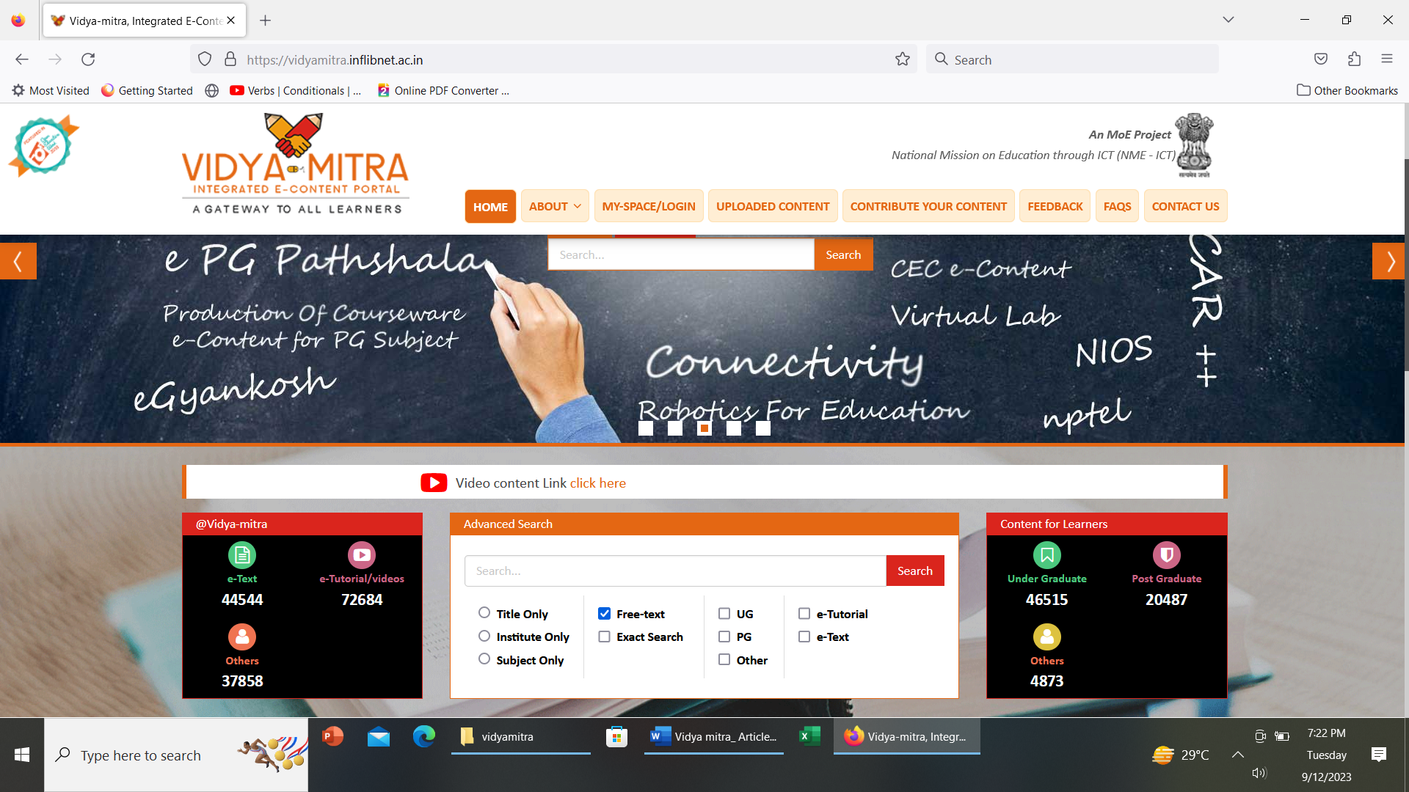

Snapshot of Vidya-Mitra

5. Data Analysis of Physical and Basic Sciences Group

5.1 UG Courses Offered

Four subjects are being offered in UG courses in physical & science groups in Vidya-mitra. These are Biochemistry (no. of courses offered18), Mathematics (no. of courses offered163), physics (no. of courses offered 156) and statistics (no. of course offered 21).

Table 1: UG courses offered in physical and basic sciences group in Vidya-mitra

Courses offered (UG) | No. of courses | Percentage
Biochemistry | 18 | 5.02
Mathematics | 163 | 45.53
Physics | 156 | 43.57
Statistics | 21 | 5.86
Total | 358 | 99.98=100

The Table 1 shows that maximum UG courses are being offered in mathematics 163 (45.53%) followed by physics 156 (43.57%), followed by statistics 21(5.86%) and then biochemistry 18 (5.02%). This may be represented by the following Figure 1.

Figure 1: UG courses offered in physical and basic science groups in Vidya-mitra

5.2 Subject-wise number of E-Resources

Electronic resources are the mines of information. These information preserved through modern ICT devices, refined and redesigned and more often stored in the cyber space in the most compact form. They can be accessed simultaneously from infinite points by a great number of audiences. For UG level students e-resources play vital role for their day-to-day learning process. Subject wise distribution of e-resources has been shown in the Table 2.
Table 2: Subject wise number of E-resources in UG courses in
Physical and basic sciences group in Vidya-mitra
Subject-wise Distribution (UG) | No. of E-Resources | Percentage
Biochemistry | 421 | 5.75
Mathematics | 4624 | 63.18
Physics | 1797 | 24.55
Statistics | 477 | 6.52
Total | 7319 | 100

The Table 2 shows that the maximum number of E-resources of UG courses is available in Mathematics subject 4624 (63.18 %), followed by Physics subject 1797 (24.55%), then statistics 477 (6.52 %), and lowest number of subject wise e-resources is available in biochemistry 421 (5.75 %). This can be represented by the following Figure 2.

Figure 2: Subject & Percent wise number of E-resources in UG courses
in Physical and basic sciences group in Vidya-mitra

5.3 E-content-wise Distribution

There are different types of e-resources available for UG courses in Vidya-Mitra. These are Web-references, e-Tutorial, e-Text, Web-resources, Self- assessment, e-PUB. With the help of these resources learners can prepare their study and able to self -assess themselves.
Table 3: Type of e-resources in physical & science groups in Vidya-mitra
E-content-wise Distribution | No. of E-Resources | Percentage
Web –references | 62 | 0.66
e- Tutorial | 5743 | 61.50
e-Text | 2285 | 24.47
Web-resources | 933 | 9.99
Self- assessment | 251 | 2.69
e-Pub | 64 | 0.69
Total | 9338 | 100

The Table 3 shows that highest number of material available in e-tutorial format 5743 (61.50%), followed by e-text 2285 (24.47%), web-resources 933 (9.99%), self- assessment 251 (2.69%), e-pub 64 (0.69%) and minimum number of materials available in web references 62(0.66%). It can be represented by following Figure 3.

Figure 3: Type of e-resources in physical & science groups in Vidya-mitra

5.4 Institute-Wise Contribution

There are different types of institutes in India such as IITs, NITs, IGNOU, NIOS, INFLIBNET, Central Universities, State Universities, Deemed Universities and colleges for offering different types of courses for different levels of learners in Vidya-mitra. In the case of physical and science groups 33 institutes are offering the undergraduate course in the subjects of Biochemistry, Mathematics, Physics and statistics.

Table 4: Institute-wise contribution of UG courses in Physical & basic sciences group in Vidya-mitra
Name of Institutes | Subject (UG) | No. of Institute Contributed | Percentage
CEC, New Delhi, IIT Bombay, IIT Delhi, IIT Gandhinagar and Christ College, Rajkot, IIT Gandhinagar and Navrachna University | Biochemistry | 5(five) | 15.15
CEC, New Delhi, IGNOU, New Delhi, IIT Guwahati, IIT Kanpur, IIT Kharagpur, IIT Madras, IIT PAL, IIT Roorkee, Institute of Mathematical Science, Chennai, NCERT, NIOS, New Delhi and University of Calcutta | Mathematics | 12(twelve) | 36.36
CEC, New Delhi, Chitkara University, Punjab, IISc Bangalore, IIT Bombay, IIT Delhi, IIT Guwahati, IIT Kanpur, IIT Kharagpur, IIT Madras, IIT PAL, NCERT, NIOS, New Delhi, University of Delhi | Physics | 13(thirteen) | 39.39
Indira Gandhi National Open University (IGNOU),NIT Patna and  University of Calcutta | Statistics | 3(three) | 9.09
Total |  | 33 | 99.99=100

The Table 4 shows that 33 institutes have contributed subject wise materials to vidya-mitra. Some cases the database club more than one institute but it is treated as a single institute at the time of submission of e-content. Out of which, the thirteen institutes have contributed physics subject related e-material (i.e.39.39%), followed by twelve institutes have contributed mathematics subject related e-content (i.e. 36.36%), followed by five institutes have contributed Biochemistry related e-content (i.e.15.15%) and three institutes have contributed Statistics related e-content (i. e.9.09%). It can be represented by the Figure 4.

Figure 4: Institute-wise contribution of UG courses in Physical
& basic sciences group in Vidya-mitra

5.5 Users Pattern of UG courses in physical & basic sciences group
Different categories of users use the Vidya-mitra for their different types of courses. These users belong to secondary, high secondary, senior secondary, undergraduate and postgraduate level.

Table 5: Users Pattern of UG Courses in physical & basic sciences group
Users pattern of UG Courses | No. of Users | Percentage
Secondary/High Secondary | 43 | 0.60
Senior Secondary | 387 | 5.44
Under Graduate | 4452 | 62.56
Post Graduate | 2091 | 29.38
Other including multidisciplinary | 143 | 2.01
Total | 7116 | 99.99=100

This study highlights different types of courses in physical and basic sciences group but it shows that learners who are using this type of materials belong to different levels of user category such as secondary to PG. The maximum number of users belongs to UG level 4452(62.56%) followed by PG 2091 (29.38%), senior secondary 387 (5.44%), other including multidisciplinary 143 (2.01%) and Secondary/high secondary 43 (0.60%). It may be represented by the following Figure 5.

Figure 5: Users Pattern of UG Courses in physical & basic sciences group

Findings
- Up to 11th September 2023, the maximum number of UG courses in physical and basic sciences group is offered in Mathematics (163) and physics (156) and twenty-one courses is offered in statistics & lowest number of courses is offered in Biochemistry (18).
- The study shows that Maximum number of e-resources of UG courses in physical and basic sciences group is available in mathematics subject (4624) and lowest number of E-resources of UG courses in physical & basic sciences group is available in biochemistry subject (421).
- Maximum number of e-resource materials available in e-tutorial format (5743) for UG courses in physical and basic sciences group and minimum number of e-resources available in web-resources (62) for UG courses in physical and basic sciences group.
- Materials/e-contents in Physics subject is offered by thirteen institutes, then Materials/e-contents in Mathematics subject is offered by twelve institutes and materials/e-contents in Biochemistry is offered by five institutes and materials in Statistics is offered by three institutes.
- It is also found from this study that 62.56 % of learners belong to the UG level.

Suggestions
- More UG courses in physical and basic sciences group may be introduced in statistics and biochemistry.
- More number of E-resources should be available in Biochemistry subject.
- More numbers of e-content should be available in web-references and e-pub form.
- More number of institutes should be involved to upload e-content in Vidya-mitra
- Awareness programmes may be arranged in secondary, high secondary and senior secondary level, so that learners may get acquainted with these facilities available free of cost and available in 24X7 modes.

Conclusion and Recommendations
E-content has become a very valuable and powerful modern tool of education. It is the heart of teaching learning process and it plays a key role in e-learning (Sinha and Sahay n.d.). Globally, integrated E-content portal plays an important role in higher education system. In India the Government of India has taken new initiatives to develop the online learning through National Mission on Education through Information and Communication and Technology (NMEICT) with providing quality educational content to all the learners in India. It is also suggested that in general, the coverage of the content may be based on the syllabus of major Indian Universities and which can help the student community to acquire the quality education in India. This new way will be helpful for teachers and learners like promotion for in service teachers and jobs, admission to higher classes by learners.

References:

Govt. of India. Ministry of Human Resouurce Development. e-content. n.d. https://mhrd.gov.in/e-contents (accessed May 19th, 2020).
Govt. of India. SWAYAM. NPTEL. 2019. https://swayam.gov.in/nc_details/NPTEL (accessed May 19th, 2020).
INFLIBNET Centre. Vidya-mitra. 2020. http://vidyamitra.inflibnet.ac.in/ (accessed May 11th, 2023).
Khan, B, M A Khan, and A K Das. "Vidya-mitra-an Integrated E-content Portal with special reference to Arts, Humanities and Languages: A Critical Appraisal." PEARL - A Journal of Library and Information Science 14, no. 1 (2020): 71-76.
Kingston, R. "E-Learning and E-Content Creation in India through Blended Learning." International Journal of Humanities, Arts, Medicine and Sciences (BEST: IJHAMS) 5, no. 07 (2017): Pp. 63-70.
Mishra, U, S Patel, and K Doshi. "E- Content: An Effective Tool for Teaching and Learning in a Contemporary Education System." IJRIIE 2, no. 1 (July 2017).
Sinha, Bhawna, and Shanker Sahay. "eContent: An Effective Tool For Blended Learning." www.researchgate.net. n.d. https:// www. researchgate.net / publication/ 330650968 _e- Content _An_Effective_Tool_For_Blended_Learning (accessed May 19th, 2020).

E-content development is the heart of teaching learning process. Although content development plays a key role in e-learning,

