Unlocking the Potential of Cancer Treatment: Examining Targeted Therapy, Immunotherapy, Epigenetics and Gene Editing.
Sandhanam K¹, Arunkumar Subramanian¹, Nisma Rahman¹, Swetha S¹, T. Tamilanban^{1*}
¹Department of Pharmacology, SRM College of Pharmacy, SRM Institute of Science and Technology, Kattankulathur, Chengalpattu, Tamil Nadu - 603203, India.

*Corresponding author: Dr. T. Tamilanban,
Associate Prof.,
Dept. of Pharmacology,
SRM College of Pharmacy,
SRM Institute of Science and Technology
India.
tamilant@srmist.edu.in

Abstract:
The abstract addresses the global concern of cancer, with a focus on nonmelanoma skin cancer in specific regions associated with aging and unhealthy lifestyles. Innovative approaches are being explored to combat this challenge effectively. Targeted therapy is a groundbreaking approach, concentrating on specific genes and proteins crucial for cancer growth and survival, enabling personalized and more effective treatments tailored to individual cancer characteristics. Immunotherapy utilizes the body's immune system to recognize and attack cancer cells, leading to remarkable success in various cancer types. Immune checkpoint inhibitors and CAR T-cell therapy have shown promising results with long-lasting responses in some patients. Epigenetic modifications play a crucial role in cancer development, altering gene expression without changing the DNA sequence. Researchers are investigating methods to reverse these changes, potentially inhibiting cancer growth and restoring normal cellular function. Epigenetic drugs like DNA methyltransferase inhibitors and histone deacetylase inhibitors hold promise as therapeutic targets for certain cancers. Gene editing technologies, particularly CRISPR-Cas9, have opened new possibilities in cancer research and treatment. These tools allow targeted DNA modifications, potentially correcting genetic mutations involved in cancer development. While gene editing is still in early stages for cancer treatment, promising results from preclinical and early clinical trials offer hope for more precise and efficient therapies in the future. The continuous research and development in these areas are expected to revolutionize cancer treatment, providing personalized and effective solutions to improve patient outcomes. By combining the power of targeted therapy, immunotherapy, epigenetic modification, and gene editing, oncologists and healthcare professionals can offer tailored treatments based on individual patients' specific cancer profiles. This patient-centric approach will undoubtedly lead to enhanced therapeutic responses and better quality of life for cancer patients worldwide. With ongoing research and collaboration in these fields, the future of cancer treatment holds great promise, driving us closer to the ultimate goal of eradicating this devastating disease.

Keywords: Targeted therapy, Gene editing, immunotherapy, Cancer research

Graphical abstract:
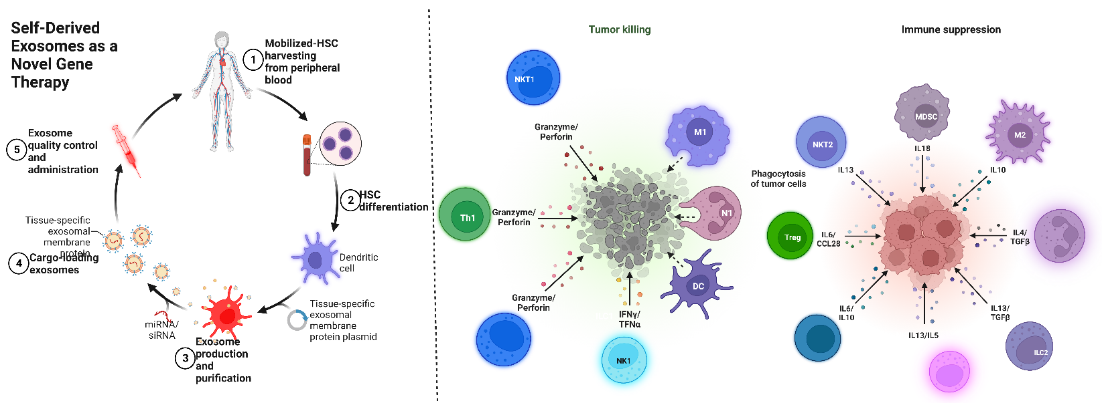
Various cancer treatment strategies in the future

- INTRODUCTION
Cancer poses a global concern, with 18 million new cases and 10 million deaths in 2018 alone. Projections indicate that there will be over 1,000,000 new cases and 65,000 deaths worldwide, with the incidence rate in males roughly double that of females. Nonmelanoma skin cancer (NMSC) is the most prevalent form of cancer in North America, Australia, and New Zealand, which also happen to have the highest incidence rates for both men and women. The increase in cancer cases in these regions has been associated with factors such as ageing and adopting unhealthy lifestyles. Moreover, the incidence of cancer continues to rise due to environmental changes and the adoption of modernized, unhealthy lifestyles. The most commonly diagnosed cancers globally are lung and breast cancer, and they also account for the majority of cancer-related deaths in both men and women.
The risk of developing cancer can be influenced by various factors, including external elements like cigarette smoke, chemicals, radiation, and infectious diseases, as well as internal factors. As we strive to address this global challenge, understanding and managing these risk factors play a crucial role in combating the spread and impact of cancer. The advancements in biology and immunological therapies, as well as the significant advancements in modern medication design and production, have made the development of a cancer cure a realistic goal. Many human malignancies have already been cured or given a longer life expectancy, including lymphomas, testicular cancer, and juvenile lymphoblastic leukemia. Targeted therapy is one kind of cancer therapy. The medication targets certain genes and proteins that support the survival and expansion of cancer cells. Targeted therapy may go after specific cancer-related cells, such as blood vessel cells, or it may change the tissue environment that supports the growth of cancer cells. (1)
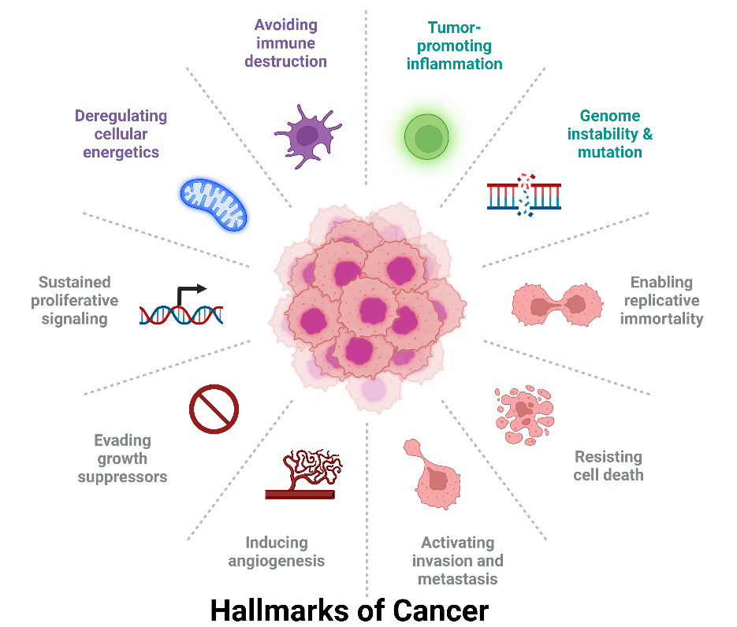
Fig 1: Various risk factors for developing Cancer.
Targeted therapy has emerged as a promising treatment option for various types of cancer. It can be used alone or in combination with other treatments, like chemotherapy. While not all cancers can presently be treated with targeted therapies, the field is rapidly advancing, and numerous state-of-the-art targeted medications are undergoing clinical trials. Immunotherapy, another cutting-edge approach, harnesses the body's immune system to identify and eliminate cancer cells. Several immunotherapies have shown great promise in clinical research and are currently under development, such as immune checkpoint inhibitors, CAR-T cell therapy, and cancer vaccines. Gene editing techniques, notably CRISPR-Cas9, hold tremendous potential to revolutionise cancer treatment by allowing researchers to modify genes, correct mutations, or deactivate genes linked to cancer development. Although still in its early stages, this technology requires further research and development. In this book chapter, we will focus on some of the leading research areas, including the impact of targeted therapy, immunotherapy, epigenetic modification, and gene editing on cancer cells. These cutting-edge approaches offer new hope in the fight against cancer and have the potential to transform the landscape of cancer treatment in the future.
- EPIGENETIC MODIFICATION

Epimutations, such as hypermethylation and epigenetic silencing of tumour suppressor genes, play a crucial role in the development of human malignancies. Epigenetic processes govern the regulation of genetic information, leading to permanent, inheritable, and reversible DNA and histone alterations. These alterations involve covalent modifications of DNA base residues and specific amino acids in histones. DNA methyltransferases, a group of enzymes, methylate DNA at the carbon-5 position of cytosine residues. Methyl-binding proteins act as bridges between methylated DNA and chromatin-modifying enzymes like histone deacetylases and histone methyltransferases. This interaction attracts histone-modifying enzymes to methylated DNA regions, resulting in the formation of chromatin structures that suppress gene transcription. Covalent histone modifications, such as methylation of lysine at position 9 in histone H3 and deacetylation of lysine at position 16 in histone H4, are examples of changes associated with gene silencing. The interplay between DNA methylation and histone modifications significantly impacts the epigenetic regulation of gene expression patterns and may thus play a vital role in the initiation of cancer. Understanding these epigenetic mechanisms could offer valuable insights into cancer development and potentially lead to novel therapeutic approaches. DNA methylation is a crucial mechanism for controlling epigenetic regulation. Compared to the complex pattern of histone modifications, DNA methylation exhibits a relatively simple binary pattern, distinguishing between methylated and nonmethylated bases. This simplicity makes it particularly amenable to experimental analysis. The process of DNA methylation leads to chromatin reorganization, which is facilitated by methyl-binding proteins. In the context of cancer, all studied cancer cells display alterations in the pattern of DNA methylation. These alterations can manifest as either increased methylation (hypermethylation) or reduced methylation (hypomethylation). Moreover, it has been observed that genetic mutations in human cancer cells can induce epigenetic changes. For example, the fusion protein PML-RAR, associated with leukemia promotion, may attract DNA methyltransferases to specific target genes, resulting in epigenetic silencing.
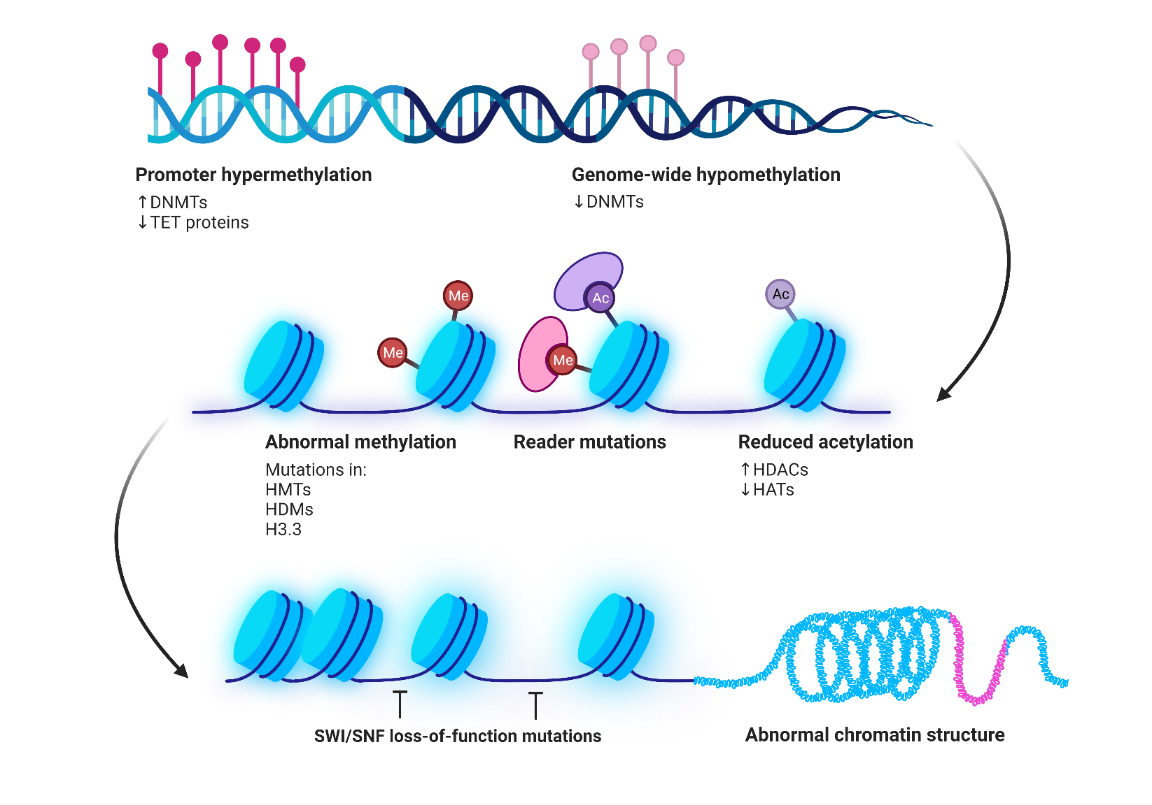
Fig 2: Mechanism for Epigenetic Methylated Cancer Formation
These findings highlight that cancer involves a collaboration between genetic and epigenetic factors. The interplay of genetic mutations and epigenetic modifications contributes to the development and progression of cancer, emphasizing the importance of studying both aspects for a comprehensive understanding of the disease. Epigenetic changes present attractive targets for therapeutic interventions due to their reversible nature. Unlike genetic mutations, which are passively inherited through DNA replication, epigenetic mutations require active maintenance. This active nature opens up possibilities for directly modifying gene expression patterns and related cellular characteristics through pharmacological suppression of specific epigenetic alterations. By doing so, it may be possible to restore proper modification patterns and potentially correct aberrant cellular behavior. Research on histone methyltransferase inhibitors is currently in the early stages of preclinical development. (2)
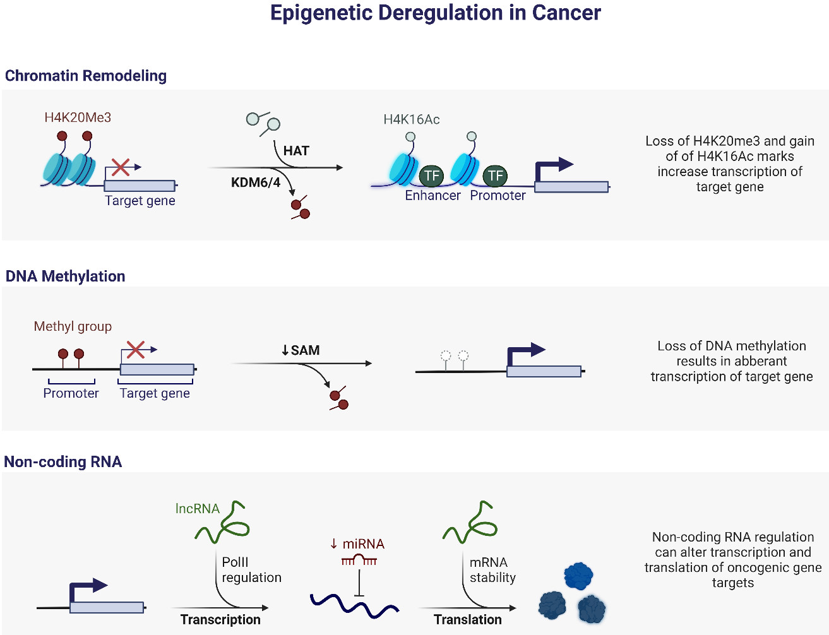
Fig 2: Cancer epigenetic dysregulation
Clinical studies are being conducted to test histone deacetylase inhibitors, but it's worth noting that their growth-suppressing effects might be attributed to changes in histone acetylation patterns or alterations in signalling pathways that control cell proliferation. DNA methyltransferase inhibitors, on the other hand, have undergone extensive testing in phase I–III clinical trials and are in a more advanced stage of clinical development compared to inhibitors of histone deacetylases or histone methyltransferases. Notably, the Food and Drug Administration (FDA) has approved Vidaza, a prototype DNA methyltransferase inhibitor, as an anticancer drug for the management of myelodysplastic syndrome. The effects of DNA methyltransferase inhibitors can be directly assessed at the DNA level, and their impact on DNA methyltransferase activity has been found to significantly influence tumour progression. These findings highlight the potential of DNA methyltransferase inhibitors as a promising avenue in cancer treatment due to their advanced clinical development and specific mechanism of action targeting the DNA level.(3)

III. IMMUNOTHERAPY
Immunotherapy is a cancer treatment that boosts the body's immune system to find and eliminate cancer cells. It can be used alone or in combination with other therapies. Cancer can evade the immune system's defenses, leading to its spread. Immunotherapy works in diverse ways, either stopping cancer growth, aiding in cancer cell destruction, or preventing its spread. This promising approach offers new possibilities in cancer treatment.(4)
The different types of immunotherapies include:
- Monoclonal antibodies and immune checkpoint inhibitors
- Oncolytic virus therapy
- T-cell therapy
- Cancer vaccines
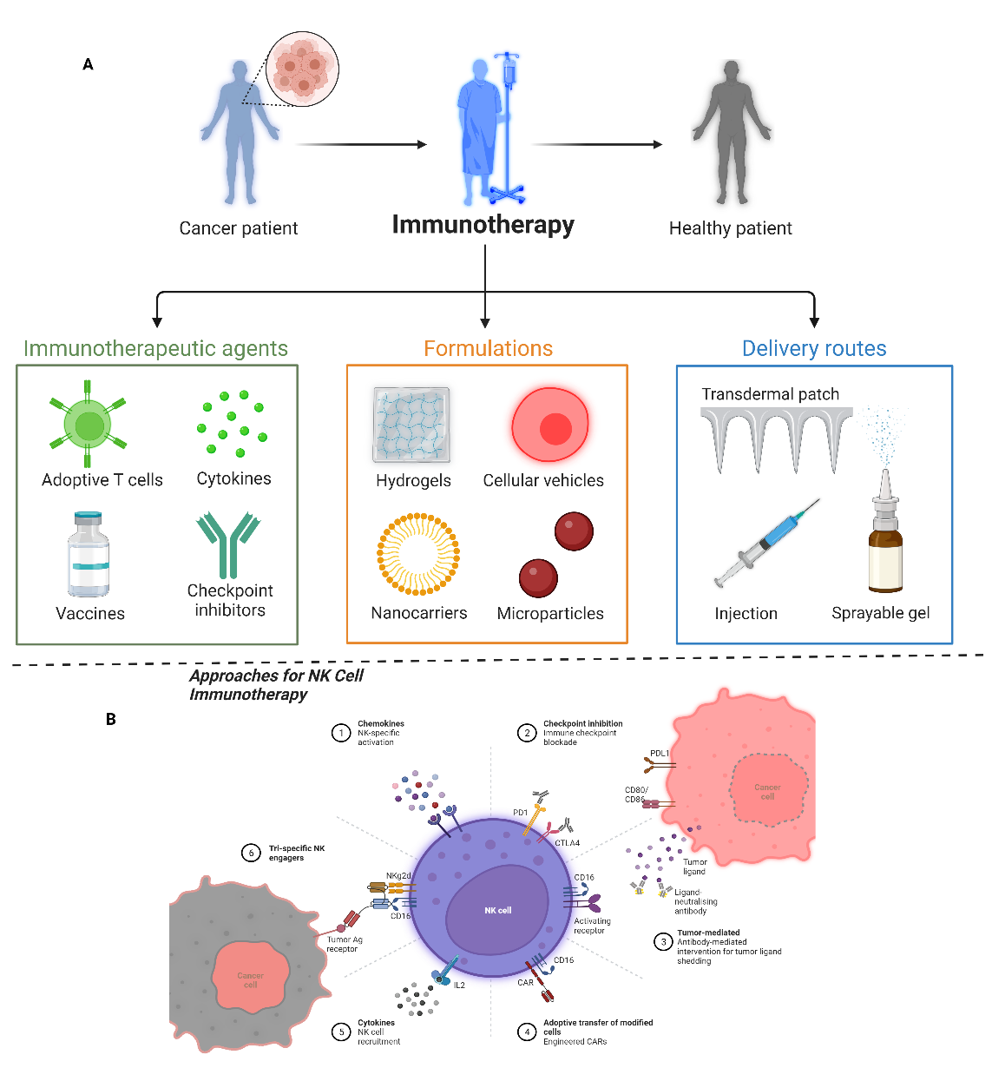
Fig 3(A): Novel approach to Immunotherapy for cancer patients via Immunotherapeutic agents, Formulations, and delivery routes. (B): Approaches for Natural Killer cells in Immunotherapy.

- Monoclonal antibodies and Immune Checkpoint inhibitors:

When the immune system detects a threat, it produces antibodies that bind to antigens to fight infections. In laboratories, monoclonal antibodies are created to supplement or replace the body's own antibodies. Monoclonal antibodies can be valuable in the fight against cancer in several ways. They can be used to hinder abnormal proteins in cancer cells from functioning correctly, a form of targeted therapy that specifically targets the genes, proteins, or tissue environment that support tumour growth and survival.(5)
Some monoclonal antibodies function by blocking immunological checkpoints, thus boosting the immune system. Immunological checkpoints are mechanisms that automatically halt immune responses, preventing the immune system from attacking healthy cells. Cancer cells can activate these checkpoints to evade immune detection. By using checkpoint inhibitors, cancer cells can no longer suppress the immune system. Commonly targeted pathways include PD-1/PD-L1 and CTLA-4 checkpoints. These approaches hold promise for enhancing the immune system's ability to combat cancer effectively.(6)

- Oncolytic Virus Therapy:

Oncolytic viral treatment, also known as virus therapy, utilises genetically modified viruses created in a laboratory to target and destroy cancer cells. These modified viruses are injected into the tumor, where they replicate themselves inside the cancer cells, causing them to rupture and die. As the cancer cells die, they release proteins that trigger the immune system to recognise and attack other cancer cells in the body with similar proteins. Importantly, healthy cells remain unaffected by the virus.

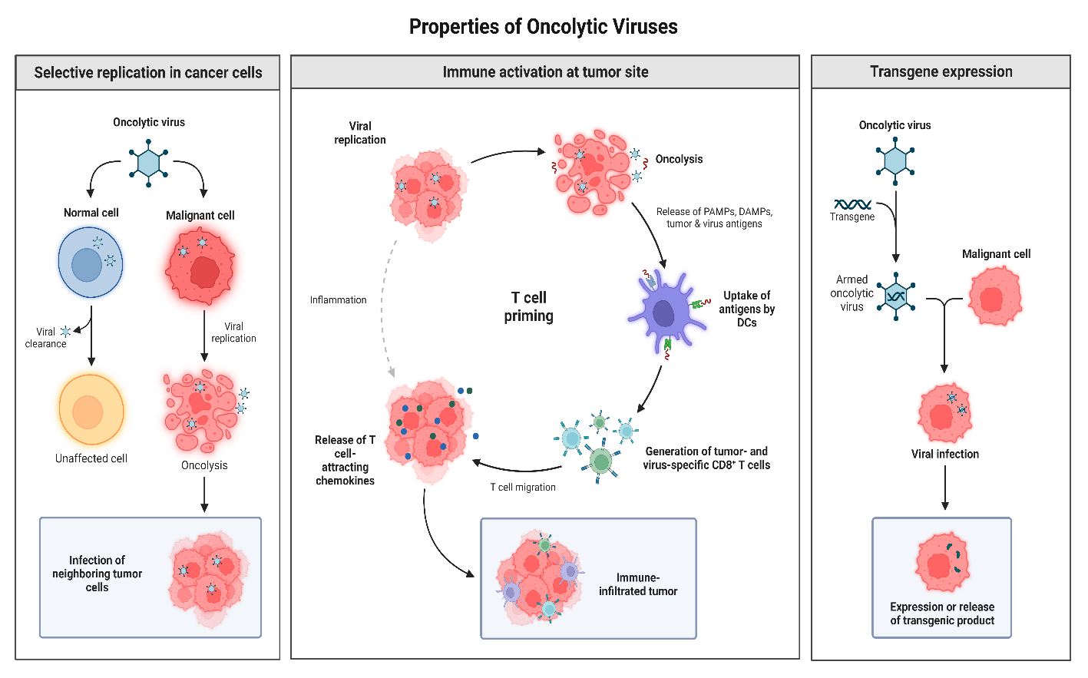
Fig 4: Mechanism of Oncolytic Viruses

One specific type of oncolytic viral treatment is currently authorised for cancer treatment in the United States. Talimogene laherparepvec, also known as T-VEC or Imlygic, is an oncolytic viral treatment authorised for the treatment of advanced melanoma that cannot be surgically removed. It is commonly used by individuals who either cannot or choose not to undergo other prescribed therapies. T-VEC is a modified form of the herpes simplex virus, typically responsible for cold sores. The treatment involves the direct injection of T-VEC into one or more melanoma tumors. Some side effects of oncolytic virus treatment include pain at the injection site and flu-like symptoms.(7)

T-Cell therapy:
T-cell treatment harnesses the power of immune cells called T cells to fight infection. The process involves drawing T cells from the patient's blood and modifying them in the laboratory with specific receptors, which enable them to recognize cancer cells. Once modified, these T cells are infused back into the patient's body.
This type of treatment is known as CAR T-cell therapy. The modified T cells can then locate and eliminate cancer cells effectively. However, there may be some side effects, including fever, disorientation, low blood pressure, and, in rare cases, seizures. Despite the potential side effects, CAR T-cell therapy offers a promising approach to combat cancer by utilizing the body's own immune system.
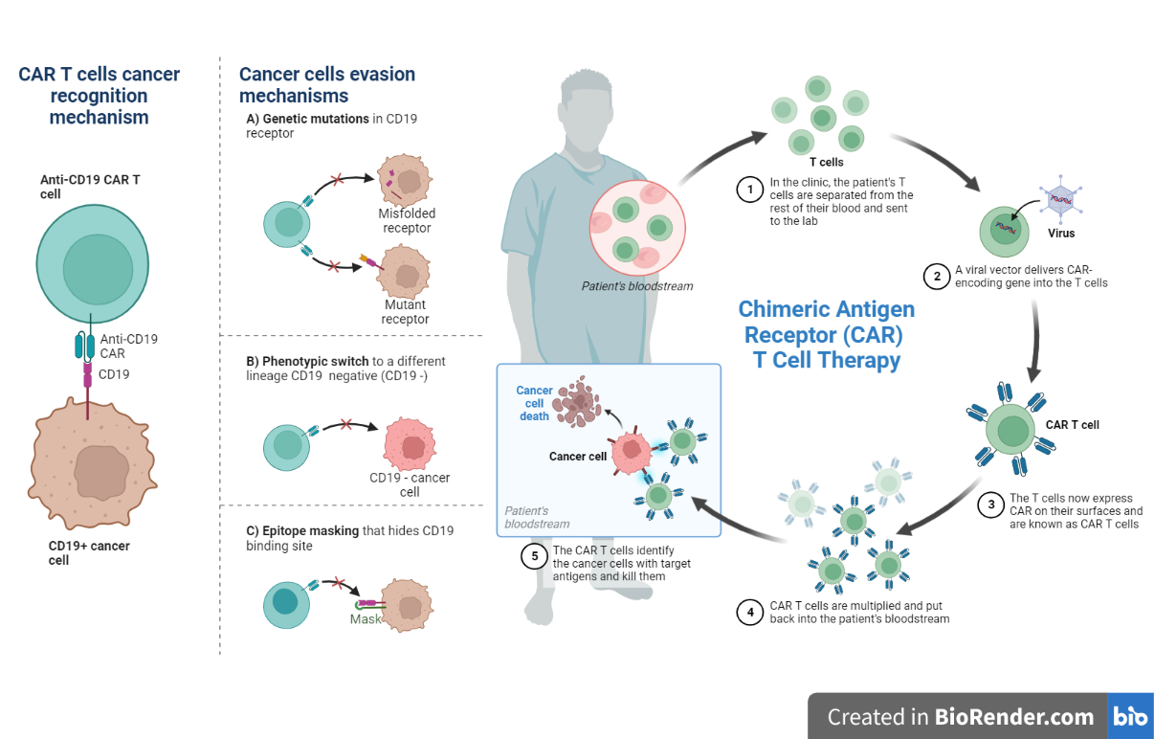
Fig 5: CAR T cells cancer evasion and recognition mechanism and Chimeric antigen receptor (CAR) T Cell Therapy

CAR T-cell therapy shows promise as a treatment for specific blood malignancies. Researchers are actively studying this approach and other methods of modifying T cells to treat cancer.(8)

Cancer Vaccines
Cancer vaccinations can be beneficial for the body's immune system. Through vaccination, the immune system is exposed to an antigen, a foreign protein, which triggers the immune response to identify and eliminate that specific antigen or associated compounds. There are two types of cancer vaccines: preventive vaccines and therapeutic vaccines.
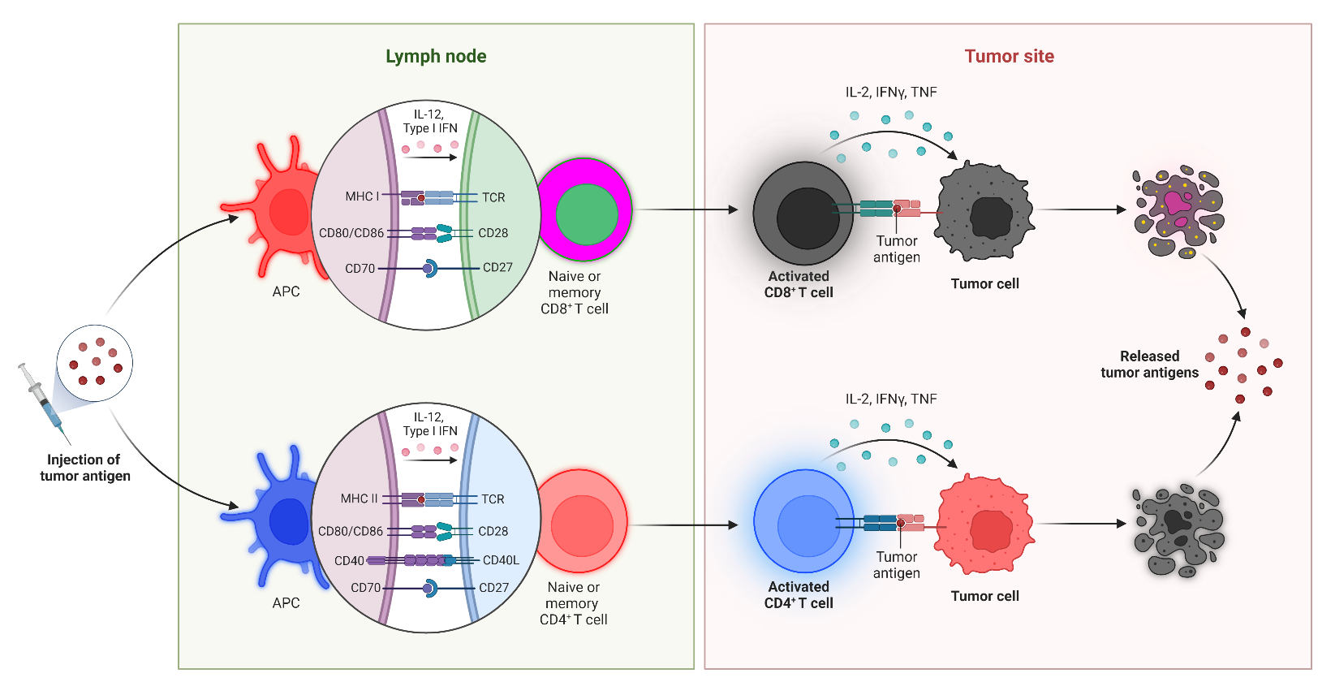

Fig 6: Overview of Cancer Vaccines
An example of a cancer prevention vaccine is Gardasil, designed to protect against the human papillomavirus (HPV), which can lead to certain types of cancer. As for therapeutic vaccines, spuleucel-T (Provenge) is used to treat advanced prostate cancer that does not respond to hormone therapy. T-VEC (mentioned earlier) is also considered a cancer vaccine. Both therapeutic vaccines may cause flu-like symptoms as side effects. Cancer vaccinations hold promise in aiding the immune system's fight against cancer and can be used for prevention or as part of cancer treatment protocols.
IV. TARGETED CANCER THERAPY
Targeted therapy is a specific type of cancer treatment that utilizes drugs to precisely target the genes and proteins responsible for supporting the growth and survival of cancer cells. It can alter the tissue environment in which cancer cells thrive or focus on cells associated with cancer development, such as blood vessel cells.
Targeted therapy is effective against many different types of cancer and can be used in combination with other treatments like chemotherapy. While not all cancers can currently be treated with targeted therapy, this field of research is rapidly expanding, with several novel targeted medications undergoing clinical trials. In the body, various cell types exist, each with specific functions, such as skin, brain, and blood cells. In cancer, certain genes that are normally present in healthy cells undergo changes, becoming abnormal and contributing to the development of the disease. These changes are referred to as "genetic mutations" or "alterations." Targeted therapy holds promise as a precise and effective approach to combat cancer by directly addressing these specific genetic changes in cancer cells.
Genes play a vital role in instructing cells to produce proteins that maintain their proper functioning. However, when gene mutations occur, these proteins can be altered, leading to abnormal cell division and survival. The affected cells may divide excessively and persist longer than normal, ultimately resulting in the uncontrolled growth of a tumor. To combat this, researchers are diligently working to identify the specific genetic changes that support tumor growth and progression. These targeted alterations are referred to as the "drug's target." Ideally, an ideal target for therapeutic treatment would be a protein abundant in cancer cells but absent or scarce in healthy cells. Once such a target is identified, researchers develop pharmacological therapies designed to attack it specifically, providing tailored and precise treatments to combat the tumor's growth and evolution.

Targeted treatments have a variety of effects on the cancer cells they aim to treat:
- Turn off or block the signals that instruct cancer cells to proliferate and grow
- Avoid letting the cells live longer than they should.
- obliterate cancer cells
Similar to other treatments, targeted therapies can have adverse effects. Therefore, it is essential for your doctor to carefully select the appropriate therapy and dosage specifically tailored to your tumor. The optimal dosage of targeted treatment is determined based on various factors, such as your body weight and the likelihood of experiencing severe side effects. Your health care team considers these variables to ensure the treatment is effective and safe for you. If you have any questions or concerns about the recommended dose, it's essential to have an open conversation with your health care team to understand their rationale and make informed decisions about your treatment.(9)

A. Different types of targeted therapy:
Targeted treatment is available in diverse forms, with the two most common categories being small-molecule medications and monoclonal antibodies.

Monoclonal antibodies.

Monoclonal antibodies are specialized medications designed to target specific sites on the surface of cancer cells. They can focus on the area surrounding the cancer cells or deliver cytotoxic agents directly to the cancer cells. For example, they can enhance the penetration of chemotherapy and radiation treatment into cancer cells. Some monoclonal antibodies are considered a form of immunotherapy, while others may not fall under this category.

Small-molecule drugs.
Small-molecule medications are effective in halting the growth and spread of cancer cells. Among these targeted treatments are angiogenesis inhibitors, which play a crucial role in the process of angiogenesis, the creation of new blood vessels. Since blood vessels provide nourishment to tumors, angiogenesis inhibitors work by starving the tumor, preventing the growth of new blood vessels in the surrounding tissue. Other forms of targeted treatment include apoptosis inducers, which initiate cell death, and various immunotherapies. These treatments offer diverse strategies to combat cancer cells and can be valuable additions to the arsenal of targeted therapies against cancer.
V. EPIGENETIC GENE SILENCING
Epigenetic gene silencing plays a crucial role in both the development and prevention of cancer. Epigenetics refers to reversible changes in gene expression patterns that occur without altering the DNA sequence itself. These changes, such as DNA methylation and histone modifications, can lead to the silencing of tumour suppressor genes or the activation of oncogenes, contributing to the development and progression of cancer. Understanding and studying these epigenetic alterations is vital to comprehend the mechanisms of cancer and potentially developing targeted therapies to combat the disease.
DNA methylation is one of the well-known epigenetic alterations linked to gene silencing in cancer. This process involves the addition of a methyl group to the DNA molecule, primarily occurring at cytosine residues within CpG dinucleotides. When CpG islands, which are regions near gene promoters with a high density of CpG sites, undergo hypermethylation, it can lead to the silencing of genes. CpG island hypermethylation is frequently observed in cancer cells and is associated with the inactivation of tumour suppressor genes that typically play crucial roles in regulating cell growth, DNA repair, and apoptosis. Understanding these epigenetic mechanisms helps shed light on the molecular changes underlying cancer development and may pave the way for targeted therapies to reverse such alterations and potentially treat cancer more effectively. Histone modifications also play a significant role in epigenetic gene silencing in cancer. Histones are proteins that aid in compacting DNA into a structure called chromatin.
Different chemical modifications, such as methylation, acetylation, phosphorylation, and ubiquitination, can occur on histone proteins. These modifications impact the accessibility of DNA to transcription factors and other regulatory proteins, thereby influencing gene expression. Changes in histone modifications can lead to gene silencing or activation, and abnormalities in histone modification patterns have been observed in cancer cells. Understanding these altered histone modifications provides valuable insights into the epigenetic mechanisms that contribute to cancer development and may potentially guide the development of targeted therapies to address such modifications and manage cancer more effectively. Epigenetic gene silencing plays a significant role in cancer-related cellular processes. When tumor suppressor genes are silenced, it disrupts the normal cell cycle control mechanisms and apoptosis, leading to uncontrolled cell growth and the development of tumors. Moreover, the activation of oncogenes through epigenetic means drives cancer progression by promoting cell proliferation, angiogenesis, and metastasis. Exploring the epigenetic mechanisms involved in gene silencing in cancer has opened up promising therapeutic possibilities. Drugs designed to target DNA methylation, like DNA methyltransferase inhibitors such as azacitidine and decitabine, can reverse abnormal DNA methylation patterns and reactivate silenced tumor suppressor genes. Similarly, histone deacetylase inhibitors like vorinostat and romidepsin can modify histone acetylation patterns and restore normal gene expression. In conclusion, epigenetic gene silencing is a critical mechanism in cancer development and regulation. Abnormal DNA methylation and histone modifications can lead to the silencing of tumor suppressor genes or the activation of oncogenes, resulting in uncontrolled cell growth and malignancy. Understanding and targeting these epigenetic alterations offer promising avenues for clinical diagnosis, prognosis, and treatment in the fight against cancer.(10)
- CONCLUSION
The future of advanced cancer research shows great promise with the development and application of targeted therapy, immunotherapy, epigenetic modification, and gene editing. These innovative approaches are revolutionizing cancer treatment by offering personalized and effective solutions. Targeted therapy involves drugs or substances that specifically target cancer cells' unique characteristics or genetic mutations, leading to more precise treatment with reduced harm to healthy cells and fewer side effects. Immunotherapy harnesses the immune system's power to fight cancer and has shown remarkable success with treatments like immune checkpoint inhibitors and CAR T-cell therapy. Ongoing research aims to improve immunotherapies' efficacy and broaden their applicability for more patients. Epigenetic modifications play a crucial role in cancer development, and researchers are exploring ways to reverse these changes and inhibit cancer growth. Epigenetic drugs, like DNA methyltransferase inhibitors and histone deacetylase inhibitors, show promise in certain cancers. Gene editing technologies, like CRISPR-Cas9, hold potential for personalized medicine by modifying cells' DNA to correct genetic mutations or enhance their ability to fight cancer. While gene editing is still in early development for cancer treatment, it has shown promise in preclinical and early clinical trials. Overall, ongoing research and collaboration in these fields offer new avenues for efficient and personalized cancer treatments, ultimately improving patient outcomes and quality of life.

REFERENCES

1. Li Z, Zou J, Chen X. In Response to Precision Medicine: Current Subcellular Targeting Strategies for Cancer Therapy. Advanced Materials (2023) 35: doi: 10.1002/adma.202209529
2. Pickles OJ, Wanigasooriya K, Ptasinska A, Patel AJ, Robbins HL, Bryer C, Whalley CM, Tee L, Lal N, Pinna M, et al. Abstract 2989: Colorectal cancer displays three patterns of tumor-specific MHC-II inducibility and dynamics, with implications for combining epigenetic therapy with immunotherapy. Cancer Res (2023) 83:2989–2989. doi: 10.1158/1538-7445.AM2023-2989
3. Gungabeesoon J, Gort-Freitas NA, Kiss M, Bolli E, Messemaker M, Siwicki M, Hicham M, Bill R, Koch P, Cianciaruso C, et al. A neutrophil response linked to tumor control in immunotherapy. Cell (2023) 186:1448-1464.e20. doi: 10.1016/j.cell.2023.02.032
4. Li J, Lu W, Yang Y, Xiang R, Ling Y, Yu C, Zhou Y. Hybrid Nanomaterials for Cancer Immunotherapy. Advanced Science (2023) 10:2204932. doi: 10.1002/advs.202204932
5. Liu Y, Xun Z, Ma K, Liang S, Li X, Zhou S, Sun L, Liu Y, Du Y, Guo X, et al. Identification of a tumour immune barrier in the HCC microenvironment that determines the efficacy of immunotherapy. J Hepatol (2023) 78:770–782. doi: 10.1016/j.jhep.2023.01.011
6. Merino A, Maakaron J, Bachanova V. Advances in NK cell therapy for hematologic malignancies: NK source, persistence and tumor targeting. Blood Rev (2023) 60:101073. doi: 10.1016/j.blre.2023.101073
7. Ma R, Li Z, Chiocca EA, Caligiuri MA, Yu J. The emerging field of oncolytic virus-based cancer immunotherapy. Trends Cancer (2023) 9:122–139. doi: 10.1016/j.trecan.2022.10.003
8. Yang Y, Huang J, Liu M, Qiu Y, Chen Q, Zhao T, Xiao Z, Yang Y, Jiang Y, Huang Q, et al. Emerging Sonodynamic Therapy‐Based Nanomedicines for Cancer Immunotherapy. Advanced Science (2023) 10:2204365. doi: 10.1002/advs.202204365
9. Lee PY, Yeoh Y, Low TY. A recent update on small‐molecule kinase inhibitors for targeted cancer therapy and their therapeutic insights from mass spectrometry‐based proteomic analysis. FEBS J (2023) 290:2845–2864. doi: 10.1111/febs.16442
10. Zulfiqar S, Farooq MA, Zhao T, Wang P, Tabusam J, Wang Y, Xuan S, Zhao J, Chen X, Shen S, et al. Virus-Induced Gene Silencing (VIGS): A Powerful Tool for Crop Improvement and Its Advancement towards Epigenetics. Int J Mol Sci (2023) 24:5608. doi: 10.3390/ijms24065608

