SUSTAINABLE MATERIALS AND RECYCLED BRICK AGGREGATES IN 3D CONCRETE PRINTING

Yashash Gowda S
20222BCT0010
Master in technology
Building construction and technology
Presidency University
Bengaluru, India

Dr. Jagdish H Godihal
Professor- CIV
Deputy Dean- Academic Research
School of engineering
Presidency University
Bengaluru, India

ABSTRACT
Three-dimensional concrete printing (3DCP) has become recognized and alternative to conventional concrete in building construction, mainly due to its potential increase in productivity and reduces the environmental impact of the construction industry. An existing mixture is used by adjusting and recycling by 64% of its natural aggregate in RBA. The potential of sustainability in building sector by automation construction and demolition waste is addressed, where construction with brick remains as popular option. The different types of RBA for demolition project can be considered in various mix designs containing Type-01 RBA, Type-2 RBA and combined RBA. To arrive water absorption and porosity of each RBA types are first tested to determine the estimated additional water requirement in each concrete mix design. The results of mechanical characterization test shows replacement of 64% natural aggregate with RBA in mix can be reduces the compressive cube strength by 25%, compressive 3DCP by 14% and 20% with different direction respectively.
Keywords: 3D concrete printing recycled brick aggregate, construction and demolition waste, strength comparison and sustainability.

- INTRODUCTION:
The construction building sector can be divided into various phases like the construction phase, the operational phase and demolition phase. This is mainly to create more sustainable buildings should be considered. The high levels of carbon dioxide produced by the building sector and large energy associated with construction, there are strong drive to adapt the materials used and method of production as the world becomes more aware of environmental impact of anthropogenic carbon dioxide emission. The mechanical characterization test is carried out on specimen cuts from 3DCP regular section of preferred RBA-3DCP mix design and compressive cube strength test were performed on cast sample of preferred RBA-3DCP mix as result from reference the façade section of different layer is printed [01].

- EXPERIMENTAL PROCEDURE
  - Preparation of recycled brick aggregates
The portion of the sand should be replaced with RBA in the new RBA-3DPC mix and the locally sourced sand that was available in the laboratory had a very ﬁne-grading and it was discovered that a combination of this ﬁne sand with carefully selected fractions of RBA would produce a grading curve. The grading of the RBA‐3DPC mix could therefore achieve optimal packing density. The volume ratios of sand to RBA would be 36% to 64%. Two types of RBA from local demolition projects, each type was crushed and sieved into two or more fractions to obtain the grading of RBA. The ratios of the fractions retained on the different sieve sizes as mentioned. Microscopic images revealing the difference in colors and texture the microscopic images show a signiﬁcant variations between types of RBA from different sources can be. Type 2 RBA was notably redder in colors and contained a larger amount of ﬁne dust stuck to the outside of its particles. [02]
2.2. Water absorption and density of recycled brick aggregate
The water absorption, bulk density and apparent density are the different types of RBA each type of RBA was tested. The results indicate that Type 2 RBA has water absorption 1.9 times that of Type1 RBA. It is determined that the RBA with higher water absorption would need additional water in the mix design in order to achieve similar ﬂow ability, pump ability and printability to the reference mix. A value for the open porosity of the RBA can be calculated based on the assumption of the open pores in a sample were entirely saturated with water. An equation was developed to calculate open porosity, ∅ (%), from bulk density, BD (kg/m3), and water absorption, WA (%), with the density of water, ρw (kg/m3)
∅=WA.BD/ρw [03]

Table 1
Grading of RBA and sand combination

Sieve size(mm) | Sand(% of passing) | RBA(% of passing) | Combination(% of passing)
4.75 | 99.9 | 100 | 99.7
2.36 | 99.7 | 97.3 | 96.0
1.18 | 99.4 | 60.5 | 75.2
0.6 | 97.2 | 29.2 | 54.9
0.3 | 78.5 | 0 | 29.7
0.15 | 19.7 | 0 | 7.5
0.075 | 1.4 | 0 | 0.5
0 | 0 | 0 | 0

Table 2
Fractions of RBA included in concrete mixes

Sieve size (mm) | % mass retained on sieve
2.000-4750 | 6.3
1.000-2.000 | 33.2
0.600-1.000 | 31.3
0.425-0.600 | 14.5
0.300-0.425 | 14.7

∅=100 (1-BD/AD) [03-04]

  - Development of RBA-3DCP
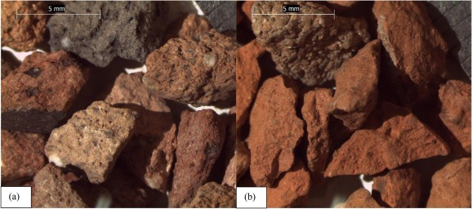
The mold is filled with concrete, the concrete is compacted into two layers, and then the mold is gently lifted so that the concrete lies on the flow table. The impact load is then applied to the concrete by a falling motion of the flow panel to the bottom support at a height of 12.7 mm. The falling motion is performed 15 times, then the spreading diameter is measured. A flow table diameter of 150-165mm should be aimed for printable mixing. Three mix designs were developed for 3DPC containing RBA Type 1, RBA Type 2, and a combination of RBA 3DPC Type 1 and Type 2. The 3DPC mix was adjusted by replacing 64% of the sand volume with RBA and water. Additional water is added to the mixture to meet the additional water requirement of RBA due to its porous nature. RBA Type 2 has a significantly higher water absorption capacity than RBA Type 1, explaining the increase in required additional water from 6% to 12% for RBA-3DPC Mix 1 and RBA-3DPC Mix 2 respectively. The amount of additional water required by Type 2 RBA is twice that of Type 1 RBA and can be connected to the water absorption capacity of Type 2 RBA, which is 1.9 times higher than Type 1 RBA. RBA-3DPC Mix 3 contains 33 wt% RBA type 1 and 67 wt% RBA type 2, and requires an additional 11 wt% RBA water to achieve acceptable printability [05, 06, and 07].
Fig. 1: 2 – 4.75 mm fractions of (a) Type 1 and (b) Type 2 RBA

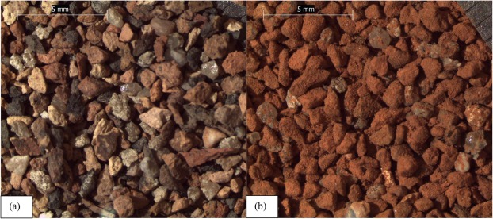
Fig.2: 0.6 – 1 mm fractions of (a) Type 1 and (b) Type 2 RBA

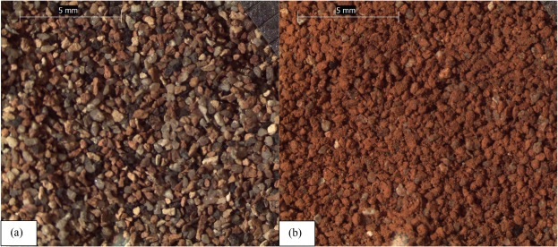
Fig.3: 0.3 – 0.425 mm fractions of (a) Type 1 and (b) Type 2 RBA

The mixing process is as follows:
- Add the RBA to the pan, followed by the ﬁne aggregate passed through a sieve to remove large impurities.
- Weigh off the amount of ﬁne aggregate not passing through the sieve and replace this mass in the mix.
- Mechanically mix for 2 min, then manually mix the sand and RBA to ensure there is no RBA remaining at the bottom of the pan.
- Add the ﬂy ash, silica fume and cement to the pan, also through the sieve, to ensure no larger lumps of material are added to the mix.
- Mechanically mix for 2 min, then manually mixes all dry ingredients again, checking for an even mix.
- Add the VMA and superplasticizer to the water restart mechanical mixing, and add the liquids to the mix slowly over 2 min.
- Over the next 2 min, add the ﬁbers to the mix slowly in handfuls. After mixing for 5 min from when all constituents have been added, extract a sample of concrete for a mini‐slump cone test.
- Repeat mini‐slump cone tests after 10, 15 and 20 min of mixing after all constituents have been added.

The development of the three mix designs was useful in understanding water requirements of concrete mixtures containing RBA and the relationship between these water requirements and the water absorption capacity of RBA. RBA-3DPC Mix 2 was chosen as the mixture used to determine mechanical properties [8, 9, 10]

Table 3
Density and water absorption of Type 1 and Type 2 RBA
 |  | Type 1 RBA | Type 2 RBA
Bulk/dry density (kg/m3) |  | 1982 | 1811
Apparent/true density (kg/m3) |  | 2448 | 2708
Water absorption (%) |  | 9.6 | 18.2
Open porosity (%) |  | 19.03 | 33.12
Open porosity (%) |  | 18.98 | 33.02

- MECHANICAL CHARACTERISATION
The ﬁrst comparison was of the 28‐day compressive cube strength, which was performed on cast samples of the concrete mixes. The second comparison was of the 28‐day tensile 3DPC strength and the third comparison was of the 28‐day compressive 3DPC strength [11]

3.1. Compressive Cube strength tests:
Cube compressive strength tests were conducted on cast samples. of the 3DPC Mix and RBA‐3DPC Mix 2, which had been cured in a climate‐controlled for 28 days. The density of the cubes used for compressive strength testing was also recorded.
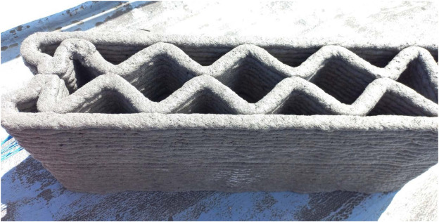
Fig. 04: Rectangular section to be saw cut for DTT and UCT tests with axes showing testing directions

3.2. Tensile and compression 3DPC strength testing:
Direct tensile testing (DTT) and uniaxial compression testing (UCT) were performed on 3DPC Mix and RBA-3DPC Mix-2 samples cut from 3D printed rectangular sections. A 3D printed rectangular section of the 3DPC mix is ​​shown in Figure 05. The rectangular sections were printed with a layer height of 10 mm, a printing speed of 60 mm/s, and a path length of 1200 mm. For a part height of 200 mm, 20 layers are printed. After 21 days of printing, six samples were cut from each rectangular section in direction 3 (D3 - alternating direction). Then, a cut 3.5 mm wide and 5 mm deep was made on one side of the sample, and the T-shaped profile was glued to the steel with epoxy resin and allowed to dry for 6 days. [12, 13, 14]
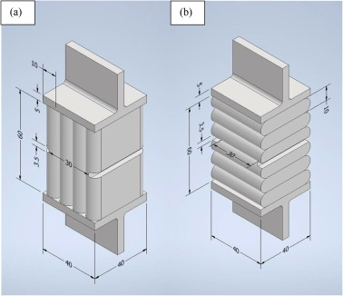
Fig. 05: (a) D1 specimen for DTT (interlayer) (b) D3 specimen for DTT (interlayer)

- RESULTS

4.1 compressive cube strength:
The density of fours cube cast from RBA-3DCP mix 1 and 3DCP mix 2 which water reduced 25% and increase the porosity brought about by addition of porous RBA to concrete mix significantly.
Compressive Strength (MPa) | RBA-3DPC Mix2 | 3DPC Mix
Cube 1 | 38.6 | 47.9
Cube 2 | 39.1 | 55.6
Cube 3 | 42.0 | 53.6
Average | 39.9 | 53.1
Cov % | 3.8 | 6.7

4.2 DTT results for 3DPC Mix and RBA-3DPC Mix 2
DTT results for samples printed with 3DPC Mix and RBA-3DPC Mix 2 are shown in the table. The average interlinear tensile strength of the RBA-containing mixture was 20% lower than the average interlinear tensile strength of the reference 3DPC mixture − 1.37 MPa compared to − 1.72 MPa [15, 16]
 | RBA-3DPC Mix 2  D1 | RBA-3DPC Mix 2  D3 | 3DPC Mix
Specimen 1 (MPa) | 2.62 | 1.52 | 1.59
Specimen 2 (MPa) | 2.54 | 1.14 | 2.07
Specimen 3 (MPa) | 2.53 | 1.49 | 1.87
Specimen 4 (MPa) | 2.66 | 1.18 | 1.53
Specimen 5 (MPa) | 2.72 | 1.49 | 1.87
Specimen 6 (MPa) | 2.38 | 1.41 | 1.42
Average | 2.58 | 1.37 | 1.72
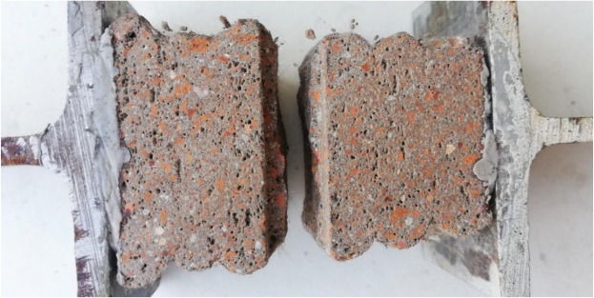
Top view of specimens after UCTs (Direction 1) – RBA-3DPC Mix 2 (left) and 3DPC (right) [17, 18]

CONCLUSION

The addition of RBA to 3DCP which increases the water requirement of the mix design related to water absorption and allows grading of mix to maximum packing density, strength of concrete decreasing with increase in porosity to replacement of 64% natural aggregate in 3DCP mix with RBA which reduces the compressive strength of cube by 20% and compressive by 14-20%. The tension and compression is dependent and lack of fusion between printing layers, which decreases the interlayer tensile strength and reduces the compression and influence the environmental and materials test factor.

REFERENCES

[01] Y. Weng et al. “Comparative economic, environmental and productivity assessment of a concrete bathroom unit fabricated through 3D printing and a precast approach 2020.
[02] S. H. Ghaffar, J. Corker, and M. Fan. “Additive manufacturing technology and its implementation in construction as an eco-innovative solution.” Autom. Constr. Vol. 93. No. October 2017. 1–11-2018.
[03] Jha, K., 2012. FORMWORK FOR CONCRETE STRUCTURES. Tata McGraw Hill, New Delhi. S. C. Paul, G. P. A. G. Van Zijl, M. J. Tan, and I. Gibson. “A review of 3D concrete printing systems and materials properties : current status and future research prospects,” no. July 2018
[05] Agustí-Juan, I., Müller, F., Hack, N., Wangler, T., Habert, G., 2017. Potential beneﬁts of digitalfabricationforcomplex structures:Environmental assessmentofarobotically fabricated concrete wall. J. Clean. Prod. 154, 330–340. https://doi.org/10.1016/j. jclepro.2017.04.002. [06] Bester, F.A., van den Heever, M., Kruger, P.J., Zeranka, S., Van Zijl, G.P.A.G., 2019. BENCHMARK STRUCTURES FOR 3D CONCRETE PRINTING. Concr. – Innov. Mater. Des. Struct. 2016, 305–312.
[07] Cho, S., Kruger, P.J., Zeranka, S., van Zijl, G.P.A.G., 2019. 3D PRINTABLE CONCRETE TECHNOLOGY AND MECHANICS. Concr. Soc. no. c, 11–18.
[08] Kruger, J., Zeranka, S., van Zijl, G., 2019. An ab initio approach for thixotropy characterisation of (nanoparticle-infused) 3D printable concrete. Constr. Build. Mater. 224, 372–386. https://doi.org/10.1016/j.conbuildmat.2019.07.078.
[09] Cho, S., Kruger, J., Bester, F., van den Heever, M., van Rooyen, A., van Zijl, G., 2020. “A Compendious Rheo-Mechanical Test for Printability Assessment of 3D Printable ConcreteCement”,2ndRILEMInt.Conf.Concr.Digit.Fabr.3, 1–10.https://doi.org/ 10.1007/978-3-030-49916-7_20. Germann Instruments. “ICAR Plus Rheometer.” http://germann.org/products-byapplication/rheology-of-concrete/icar-rheometer (accessed Jun. 15, 2020).
[10] Baker, I. (Ed.), 2018. Fifty Materials That Make the World. Springer International Publishing, Cham. Behera, M., Bhattacharyya, S.K., Minocha, A.K., Deoliya, R., Maiti, S., 2014. Recycled aggregate from C&D waste & its use in concrete – A breakthrough towards sustainability in construction sector: A review. Constr. Build. Mater. 68, 501–516. https://doi.org/10.1016/j.conbuildmat.2014.07.003.

