MALLA REDDY UNIVERSITY SCHOOL OF AGRICULTURALA SCIENCES
DEPARTMENT OF AGRONOMY
M SC.AGRONOMY
D Swathi, SHANTHI B, THAMMINANA JYOTSNA, Y. Durga Venkat Hemu
ARTIFICIAL INTELLIGENCE IN AGRICULTURE
Abstract
A major issue on every continent is artificial intelligence. One of the most practical ways to manage food shortages and adjust to the needs of increased population is use with AI in farming.Despite his best efforts, the farmer was unable to live up to the demands using the standard approach. The synthetic intelligence approach will then be included. Many people now have the opportunity to work and obtain the daily food they require thanks to this. A parallel agricultural revolution is being driven by artificial intelligence in agriculture. Many people now have the opportunity to work and obtain the daily food they require thanks to this. In this period, a number of concerns, including population growth, climate change, labor market challenges, and concerns regarding. the key problem The purpose of the document is to confirm the numerous Agriculture artificial intelligence applications include Irrigation, weeding, and spraying are all examples of maintenance activities. which are combined contains sensors and other instruments used in robotics and drones. By using less water, using fewer pesticides, and maintaining soil fertility, these advances can help save money. They can also help increase productivity, better utilize human resources, and deliver higher-quality services. To automate weeding in agricultural structures, robotics and drones are used. According to the information now available, it is widely acknowledged that the use of artificial intelligence in agriculture the United States has led to significant breakthroughs. Crop productivity, price, and disease detection are three areas where AI has proven to be quite useful. It has also helped farmers make informed decisions on all three areas of agriculture by supplying information about the best growing conditions and utilizing price prediction models to analyze data collected using a variety of approaches.
INTRODUCTION
Because of because of its tremendous technical growth and breadth variety artificial intelligence is one of the applications primary fields of research in computer science. The foundation of artificial intelligence is the hypothesis that individual intelligence can be defined such a way that a computer can easily replicate and perform duties ranging from the most basic to the most complex.The main issue and new condition around the world is agriculture automation. Agriculture is one of the most important areas where AI is critically essential. Artificial intelligence is having a huge impact. on all business sectors. one among the oldest and most significant vocations throughout the world is agriculture and farming. Agronomist Agriculture must be accepted as their principal source of revenue because it takes a lot of time and effort to develop acceptable crops. Farmers, however, must deal with loss and decline in financial situations due to poor revenue and, on occasion, no gain from land due to weather conditions or resource scarcity, which eventually leads to suicide due to depression. Artificial intelligence has prompted a revolution in agriculture. The crop output has been obtained impacted by a variety of variables this generation, incorporating the populace growth, employment problems, and issues with nourishment safety and climate change. using in artificial intelligence agricultural in order to irrigate, weeding, and inculde spraying of robots also drones have sensors and other technology built in. These Technology reduces the need for further applications water, insecticides, and herbicides while maintaining soil fertility allowing for more effective use of human labor, increasing output, and raising the standard of living. It is essential to the economic sector. Numerous programs exist. Using AI to increase crop quality and accuracy can really help farmers develop their agricultural intelligence. Plant illnesses, insect pests, and weeds can all be found using AI sensor targets. The solution is cooperative agricultural robots with farmers. Large and swift plants are gathered by the robot. Farmers can use spraying as a means to employ Drones can perform tasks five times faster than traditional machinery. There was a time during the Blue River era when existed A weed-controlling farm robot. The agriculture calculator that allows farmers to choose appropriate crops as well as determine near pricing at a lesser price is one of the intelligent programs included in agriculture can increase the productivity of farmers all over the world.
1) WHY ARTIFICIAL INTELLIGENCE IS IMPORTANT IN AGRICULTURE ?
- Artificial intelligence (AI) has the potential to be used across disciplines and to fundamentally alter the way we now view farming.
- Artificial intelligence-powered solutions will not only help agronomist work higher efficiently with fewer money, but they will furthermore enable them to increase their harvest as a consequence of growing use of excessive technology in certain regions such as government, healthcare, and education.
- Agriculture is the industry that has been most affected by artificial intelligence because of its emphasis on efficiency and ease of use. The application of AI in agriculture must be improved for low cost as well as simple processing.
- The all industries, agriculture is the most heavily impacted because artificial intelligence is focused on efficiency and smart working.
- Artificial intelligence should be employed to improve agricultural regions minimal cost.
- There are several ways in artificial intelligence to increase crop production rates and harvest quality, such as the introduction of indoor farming.
- There are numerous AI packages available to genuinely assist farmers, including those that analyze farm statistics with the goal of increasing the quality and accuracy of the flora, detect weeds using sensors, and discover pests and other ailments in the flora.
- AI addresses issues related to labor, As a result of the fact that Fewer individuals are entering this industry, and farmers are struggling. labor shortfall and a lack of personnel. Agriculture robots, who will work alongside farmers, are a solution to these issues.
- Aerial spraying with drones is five times faster than traditional machinery, which is another benefit of crop spraying technology for farmers.
- AI can also performs diagnostic examination similar to weather satellites forecasting as well as crop sustainability, which will be very beneficial for farmers if they already had a general understanding of the weather. changes. Agri-ECalculator, which enables farmers to select appropriate and less expensive flora by calculating its price, is one of the smart farming packages offered by AI. There are many better products on the market, but the drawback is that they come with expensive prices and challenging instructions. In plain English, we may state that the application of AI to agriculture is enhancing the productivity of farmers worldwide.
2) AGRICULTURAL LIFECYCLE :
We can categorize the agricultural process into various components.
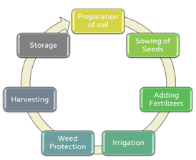
1.soil preparation: Farmers prepare the soil for planting planting seeds During the earliest stage of farming. Large dirt clumps must be broken up, and debris such as sticks, pebbles, and roots must be removed. Depending on the type of crop, you can also add organic matter and fertilizers to create the ideal atmosphere for crops.
2.seed planting: At this stage, it is critical to evaluate the space between seeds as well as the depth at which they should be planted. At this phase, climate parameters such as temperature, humidity, and rainfall are important.
3.Boost Manure: Maintaining soil fertility is critical for farmers to be able to grow nutritious and robust crops.Fertilizers Farmers employ them because they give plant nutrients such as nitrogen, phosphate, and potassium.. Fertilizers are simply fertilizers planted and added to agricultural regions to supplement the minerals already present in the soil. The quality of the crop is also determined at this stage.
4.Water management: This phase contributes to the preservation of humidity and soil moisture. Crop growth can cause problems underwatering or overwatering, which, if done incorrectly, can result in crop damage.
5.Prevention against weeds: Weeds are unwanted plants. typically appear at the edge of farms or next to crops. Weeds reduce yields, drive up production expenses, impede and harvest degrade crop yield, hence they must be considered when planning for crop production.
6.Harvesting: It is the procedure for gathering harvests from the fields that are ripe. This activity is labor- intensive since it necessitates numerous workers. Additionally, postharvest handling activities like cleaning, categorizing, etc. packing, and refrigeration are provided stage.
7. Storhouse: During this stage of the post-harvest system, products are stored to provide food security outside of agricultural seasons. Crop Packing and shipping are also included.
3) AI IMPACT IN FARMING
Farming is a business. $5 trillion global AI technology and industries can help with a diverse range of agricultural- duties associated with the entire food supply chain, including managing insect control, soil and growth condition monitoring. preparing information Farmers benefit from less workload and yielding more healthy crops. However, under this setting, the $204 million Indian Agri-tech market has only reached one percent of that estimated $ 24 billion in capacity. Large Agricultural Information Resources India offers a fantastic opportunity for AI and information scientists Because of the variety of soil types, climate, and geography, professionals are needed to build cutting-edge AI tools and solutions for agriculture. For the time being, ndian farms and farmers supply good and abundant information to assist in the development of AI solutions. Not just the United States, but the entire planet. That is one of the aspects that distinguishes Indian agriculture's adoption of AI from that of other countries.

4) ARTIFICAL INTELLIGENCE APPLICATIONS IN AGRICULTURE
Artificial intelligence technology are expected to assist the sector. promote healthier results crops, control Pests, soil and growth conditions are monitored, data is organized for farmers, workloads are reduced, and a range of agriculture-related occupations are improved along the way. entire food distribution network .agri-related activities throughout the entire food supply chain.
1.USE OF WHEATHER FORCASTING: Farmers find it challenging to decide when to plant seeds due to climate change and rising pollution. With the aid of artificial intelligence, farmers can analyze weather conditions using weather forecasting to help them plan the type of crop that can be grown and when should seeds be sown.

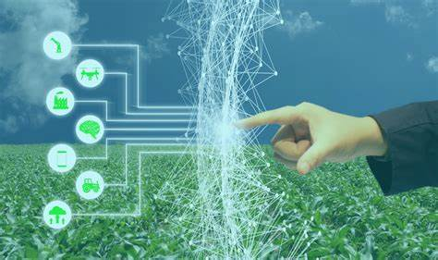
2. Farming Robotics:
- AI companies are developing robots that can easily perform a range of tasks in farming settings. This type of robot is programmed to control weeds and harvest crops faster and in higher quantities than humans.
- These robots have been trained to pick and pack crops while also assessing crop quality and weed presence.
- These robots can also deal with issues that agricultural laborers face.
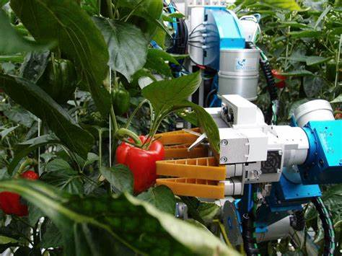
3.Monitoring system for soil and plant health:
- Soil quality is deteriorating as a result of growing deforestation, making assessment harder.
- A technology begin with a German base PEAT has developed Plantix, an AI-based technology that can detect nutritional deficiencies in soil as well as pests and illnesses. that affect plants, providing farmers with the knowledge they need to use fertilizer to improve the quality of their crops harvest. Image recognition-based technology is employed by this app.
- Using smartphones, the owner of the land The plants can be photographed. Through concise films on this program, we may look at soil restoration techniques along with suggestions and other fixes. Similar to others, Trace Genomics is a machine learning company that helps farmers with soil analysis.
- With the aid of these kinds of apps, farmers can monitor the quality of their soil and crops, resulting in more productive and sustainable agriculture healthy yield.

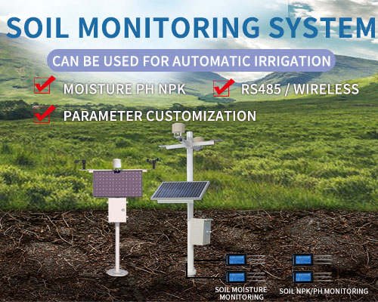
4. Using drones to assess crop health
- Ariel imaging systems are used for drones SkySqurrel Technologies has released to track the health of crops. This technology uses a drone to collect data from fields, which is then sent to a computer via USB drive for expert analysis.
- This company analyzes the images it has taken using algorithms, and then offers a detailed report on the farm's state. By identifying Farmers, pests and germs can make use of pest control technologies as well as other timely measures to take the necessary steps.

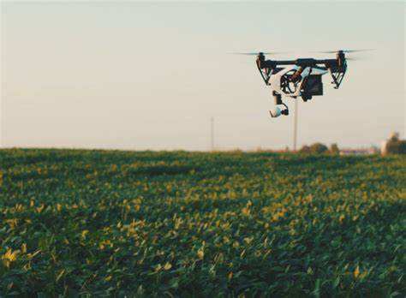

5. Accurate Agriculture:
- The use AI (artificial intelligence) in agriculture has resulted in the creation of technologies and programs that help farmers perform accurate and regulated farming by providing them with the right advice concerning water management, crop rotation, timely harvesting, and crop type, optimal planting, pest attacks, and nutrition management.
- AI-enabled technologies forecast weather conditions, analyze crop sustainability, and evaluate farms for the presence of diseases or pests and inadequate nourishment for plants using information such as temperature, precipitation, wind speed, and solar radiation in conjunction with images taken Satellites and drones are used to do this.
- Farmers who do not have internet connection can already benefit as a result of AI thanks to equipment as fundamental as an capable phone as well as the Sowing App. Farmers with Wi-Fi connectivity can utilize AI apps to get a constantly AI-tailored prepare for their farms, in the meantime.
6.Monitoring plant maturity
- Manual inspection of wheat head growth is a labor-intensive activity. phases is classified as precisely the one Precision agriculture can benefit from AI.
- The researchers were able to build a "two-step coarse-to-fine wheat ear." detection mechanism" by taking images of wheat over three years under various lighting situations at various "heading" stages.
- Farmers no longer required to go out into the fields on a daily basis to inspect their crops because of this. computer vision The model could then detect wheat growth stages more precisely than human observation.
7. Determining Plant and insect pests
- Using deep learning-based image recognition technology, we can now detect plant ailments and pests automatically.
- This functions by way of picture classification, detection, and an The ability to manually eliminate Weeds not only saves time but also money. the farmer a large number of labor but also lessens the requirement for chemicals, making the entire farming process much more sustainable and environmentally benign.Using picture segmentation techniques, models for "keeping an eye" on plant health are created.
8.Identifying bugs with code
Additionally, computer vision systems for insect detection can tell you not only whether your crops are infested with pests but also how many there are.
9.Automatic weeding
- Not all artificial intelligence (AI) is involved in weeding, well, weeding. Other computer vision Robots are eradicating unwanted plants in more direct ways. In comparison to computer vision's capacity to detect bugs, weed detection does not save the farmer any time or effort.
- The capacity to manually eliminate Weeds not only saves time but also money. the farmer a large number of labor but also lessens the requirement for chemicals, making the entire farming process much more sustainable and environmentally benign.
10.Robots in the weeds
- All of this serves to present BoniRob, an agricultural robot that searches for Weed detection using a camera and image recognition technologies before removing via means of hammering a bolt into the ground.
- It learns to discriminate between weeds and crops by visual training on leaf size, shape, and color..

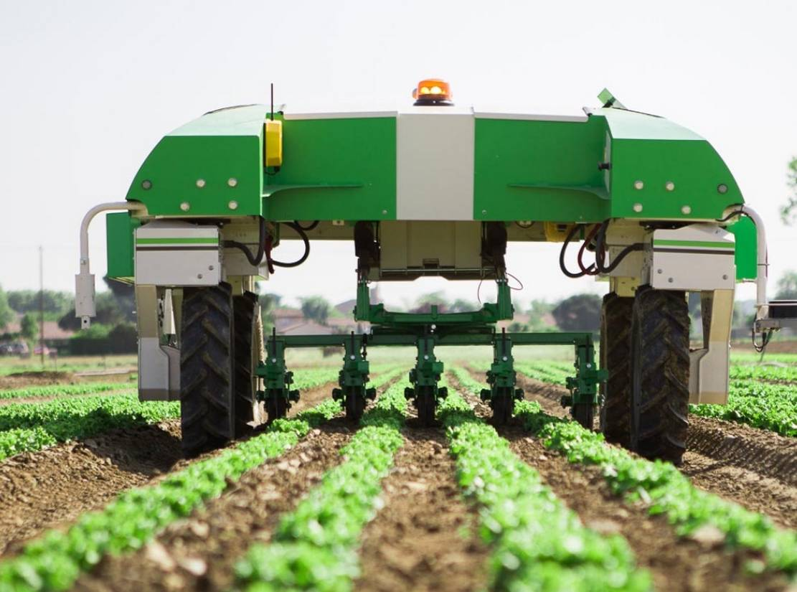
11.Produce grading and sorting
- Last but not least, AI computer vision can assist farmers even after the crops have been harvested. Algorithms for imaging can be used to distinguish "good" They can distinguish defective or ugly product in the same way that they can recognize faults, disease, and pests while the plants are growing.
- Computer vision has the potential to automate the grading, sorting procedure with accuracy rates and speed that are far higher than even those of a qualified professional by examining the size, shape, color, and volume of fruit and vegetables.
5) Agriculture AI Challenges
After learning about the benefits of AI for sustainable farming, farmers may feel compelled to adopt this technology. However, as we all know, there are still some huge challenges ahead of us.
1.Insufficient knowledge of emerging technologies
- For developing countries, implementing AI and cutting-edge agricultural technologies can be difficult.
- Selling such technologies in areas where they are not currently used in agriculture will be extremely difficult.
- Farmers in such cases places require help in order to use these automation.
2.Privacy and security issues
- As there are still unclear rules and guidelines for using AI, it may lead to a number of legal problems. Additionally, there can be certain privacy and security risks like cyberattacks and data leaks as a result of the use of software and the internet.
- For farm owners or farmers, all of these problems could be very problematic.

6) ADVANTAGES OF AI IN AGRICULTURE:
1.AI decreases the labor shortage:
- The agricultural sector has long struggled with a labor deficit. This problem of farming automation can be resolved by AI.
- Farmers may execute duties without the need of additional personnel. members thanks to AI and automation. Driverless tractors are one example. intelligent irrigation and fertilization systems, intelligent spraying, vertical farming software, and AI-powered harvesting robots.
2.AI improves decision-making:
- The agriculture sector greatly benefits from predictive analytics. It aids farmers in overcoming the major difficulties they face in farming, including analyzing market demand, price prediction, and calculating the optimal time to plant and harvest a crop.
- Additionally, AI-powered equipment can assess soil and crop health, recommend fertilizer treatments, track weather, and evaluate crop quality. Because of all of the benefits of AI in agriculture, farmers may make better judgments and practice more successful farming.

3. AI leads to cost savings:
- Precision farming with AI-enabled machinery enables farmers to produce more crops with fewer inputs and expenses. Farmers have the ability to make informed decisions made at every farming stage as a result of the instantaneous insights.
- There will be reduced product and chemical waste as a result of this prudent decision. more effective use of both time and money. It also allows farmers to locate the specific areas that require pesticide application., fertilization, and Irrigation reduces the amount of chemicals used on the crop. All of these factors add up to less herbicide use, greater crop quality, and higher profits with fewer resources.
7) FUTURE SCOPE
Future developments in artificial intelligence are difficult to forecast. Enhancing research and development was the main purpose of artificial intelligence in the 1990s, but would that still be the case in the future? Research focuses on comparing robots or machines that resemble humans. Humans' roles will undoubtedly alter if machines start undertaking human labor. Researchers' perseverance may one day pay off, and we may find that machines do our work and that a robot walks alongside .the future, we will observe Worker robots in agriculture fields, producing more yields of higher quality.
CONCULSION
Agricultural yields and quality must be increased while using fewer resources. AI not possible only assist farmers in automating their activities while also assisting them in transitioning to precise harvesting techniques. The advancement of unmanned aircraft and self-driving cars will result in scientific breakthroughs. advancements, more practical applications, and will aid in the resolution of food supply challenges brought as a result of population growth. Because of crop peak as well as harsh weather conditions, agricultural sector faces a number of challenging problems, including the loss of efficient irrigation systems, weeds, and issues with plant monitoring. However, with the help of the generation resource, the performance may be increased and these issues may be resolved. Farmers faced the problem of precision weeding methods eliminated the significant quantity of crops destroyed during the process of weeding process. Aside from that, this, Farmers could utilize to use drones efficiently Pesticides and herbicides are sprayed on their crops. and tracking plants is no longer a bother. First and foremost, the resource of artificial brain electricity in agribusiness difficulties can be used to understand shortages of assets and jobs. In traditional methods, a lot of labor was needed to purchase crop attributes including soil, plant height texture, and substance. As a result, manual testing was place. became tiresome. The different options studied allow for quick and non-destructive high-throughput phenotyping with the advantages of flexible and advantageous interest and on-demand gain access. to spatial goals and data.
REFERNCES
1. Kataoka T, Murakami A, Bulanon D M, et al. Estimating Apple Fruit Locations for Manipulationby Apple Harvesting Robot[J]. Ifac Proceedings Volumes, 2000, 33(29):67-7
2.Bak T, Jakobsen H. Agricultural Robotic Platformwith Four Wheel Steering for Weed Detection[J]. biosystems engineering, 2004, 87(2):125-136.
3. Aitkenhead M J, Dalgetty I A, Mullins C E, et al. Weed and crop discrimination using imageanalysis and artificial intelligence methods[J]. Computers & Electronics in Agriculture, 2003,39(3):157-171.
4. Albattah, Waleed, Ali Javed, Marriam Nawaz, Momina Masood, and Saleh Albahli. 2022. “Artificial Intelligence-Based Drone System for Multiclass Plant Disease Detection Using an Improved Efficient Convolutional Neural Network.” Frontiers in Plant Science 13 (June). https://doi.org/10.3389/fpls.2022.808380.
5. Kumar, Parasuraman, Srinivasan Raghavendran, Karunagaran Silambarasan, Kaliaperumal Senthamarai Kannan, and Nallaperumal Krishnan. 2022. “Mobile Application Using DCDM and Cloud-Based Automatic Plant Disease Detection.” Environmental Monitoring and Assessment 195 (1). https://doi.org/10.1007/s10661-022-10561-3.
6. [1] Figueredo, A. J. and Wolf, P. S. A. (2009). Assortative pairing and life history strategy -a cross-cultural study. Human Nature, 20:317–330.
7.Tanha Talaviya, Dhara Shah, Nivedita Patel, Hiteshri Yagnik, Manan Shah, Implementation of artificial intelligence in agriculture for optimisation of irrigation and application of pesticides and herbicides,Artificial Intelligence in Agriculture,Volume 4,2020
8. Muangprathub, Jirapond & Boonnam, Nathaphon & Kajornkasirat, Siriwan & Lekbangpong, Narongsak & Wanichsombat, Apirat & Nillaor, Pichetwut. (2019). IoT and agriculture data analysis for smart farm. Computers and Electronics in Agriculture. 156. 467-474. 10.1016/j.compag.2018.12.011.
9. Gray, Leslie & Morant, Philippe. (2003). Reconciling indigenous knowledge with scientific assessment of soil fertility changes in southwestern Burkina Faso. Geoderma. 111. 425-437. 10.1016/S0016-7061(02)00275-6.
10.Vijai Singh, Namita Sharma, Shikha Singh,A review of imaging techniques for plant disease detection,Artificial Intelligence in Agriculture,Volume 4,2020.
11.Vijayanand, Chinnusamy. (2018). Artificial Intelligence (AI) in Agriculture. International Journal of Current Microbiology and Applied Sciences. 7. 2122-2128. 10.20546/ijcmas.2018.712.241
12.Das, Swarup & Ghosh, Indrajit & Banerjee, Gouravmoy & Sarkar, Uditendu. (2018). Artificial Intelligence in Agriculture: A Literature Survey.
13.“Intelligent data mining and agriculture [2]
Artificial Intelligence for Agriculture book.
14. Sharma S.K., K. R. Singh "An Expert System for diagnosis of diseases in Rice Plant." International Journal of Artificial Intelligence
15. The fourth age By Byron Reese.
16.McCarthy J, Minsky ML, Rochester N and Shannon CE 1955 A Proposal for the Dartmouth Summer Research Project on Artificial Intelligence 27 12-12
Google Scholar.

16.Banerjee G., Sarkar U., Das S. and Ghosh I. 2018 Artificial Intelligence in Agriculture: A Literature Survey[J] International Journal of Scientific Research in Computer Science Applications and Management Studies 7 1-6
Google Scholar.

17.Michael C and Fuetc 2016 Google DeepMind's AlphaGo[J] Or/ms Today
Google Scholar.

18."Hunger and Food Insecurity." Food and Agriculture Organization of the United Nations, Food and Agriculture Organization of the United Nations, 2020, www.fao.org/hunger/en/ Google Scholar

dcdc

