A study on the impact of ChatGPT among college students (APA 7)

Niveditha Nair Heera J David
Department of Economics Department of Economics
Marian College Kuttikanam Marian College Kuttikanam
Kuttikanam, India Kuttikanam, India

Adhalia Chinnu Bino
Department of Economics
Marian College Kuttikanam
Kuttikanam, India

Abstract
The introduction of ChatGPT marks a breakthrough in intelligence that has revolutionized education and had a huge impact on college students. To evaluate the impact of ChatGPT on learning, we conducted both quantitative and qualitative study focusing on students from different colleges. The collection of raw data is very useful and shows the unique impact of ChatGPT on learning. This research produced tables and graphs showing the effectiveness of ChatGPT in improving the knowledge and skills of college students. This study shows the enormous potential of ChatGPT in shaping the future of education, making it an important tool for effective education.
Keywords- Education, ChatGPT, Impact, College Students, Intellectual Growth
- Introduction
Human reactions to artificial intelligence have been varied since its inception. However, with recent advances in AI, questions and concerns about its potential influence have grown dramatically. People are now asking whether AI has the potential to drastically change the world as we know it. Despite inventors' promises that AI will ultimately benefit humanity, a lack of empirical evidence has left many unconvinced. ChatGPT is one such AI tool that is making a significant impact especially in the education sector. Teachers fear for the future of children's education due to the possibility of fraudulent practices using ChatGPT. Proponents, on the other hand, argue that this innovation can actually be beneficial. As a result, it is important to thoroughly research and understand the impact of ChatGPT on students to avoid any harmful consequences in the educational sphere.
- Statement of the Problem
The incorporation of artificial intelligence (AI) and natural language processing (NLP) technology into educational contexts has led to the development of new learning aids such as ChatGPT. ChatGPT is an AI chatbot that can lead dynamic discussions and answer questions, making it a potentially effective educational resource. This research aims to analyze whether ChatGPT has a positive or negative impact on the academic performance and learning experience of university students.
- Objectives
The aim of this study is to evaluate the impact of ChatGPT on the academic performance, critical thinking, decision-making, and overall learning experience of undergraduate students to understand the potential advantages and disadvantages of incorporating AI-based chatbots into higher education
- Literature Review
The impact of Chat GPT, an AI-assisted writing tool, on students' writing abilities is examined in this article. Students can get writing prompts from Chat GPT, get feedback and recommendations for revisions, and get writing help. The article presents instances of how Chat GPT is used in education and explores the advantages and potential disadvantages of utilizing it to improve students' writing abilities. These examples include the AI writing instructor M-Write from the University of Michigan and AI-powered writing. (The impact of ChatGPT on student’s writing skills: an exploration od AI assisted writing tools, 2023)
The world has seen a significant transformation in recent decades and is still changing. Researchers and educators are among the stakeholders in academia most affected by Chat GPT speculation (Biswas, 2023). A natural language processing (NLP) model called Chat GPT was created by OpenAI and uses a large data set to generate text responses to students' questions, comments and challenges (Gilson et al., 2023). Providing feedback, solving problems, and offering help can mimic dialogues with students (OpenAI, 2023). It could help students stay interested in the course subject matter and feel more connected to their learning experience. The rapid adoption of sophisticated NLP models such as OpenAI's Chat GPT or Google's Bard also presents several challenges. In this post, I will address the various issues facing higher education, as well as the opportunities and difficulties. I then draw conclusions that will hopefully highlight gaps in knowledge, inspire new lines of research, and finally advance the conversation about NLP in higher education. (Exploring the opportunities and challenges of NLP models in higher education: is Chat GPT a blessing or a curse? n.d.)
The inventive growth of intelligent technologies enters a new historical stage thanks to the next generation of artificial intelligence represented by Chat GPT (Generative Pre-trained Transformer). This technology fundamentally transforms society and humanity itself, in addition to having a fundamental impact and shaping the production, living and communication practices of the entire society (Hill-Yardin et al., 2023). Powered by Artificial Intelligence Generated Content (AIGC) technologies, chatbots have been evolving and evolving since Eliza first appeared. This development process has now entered a historic phase that is spiraling upward thanks to chatbots such as Microsoft Xiaoice and Google Siri, as well as continuous technological advances such as Chat GPT (Rahaman et al., 2023). Future developments in technology may change the design of our Chatbots and the way people talk to us to improve user experience. Key differences between Chatgpt and other similar products sometimes known as AIGC products, is that they have established criteria for content production. Deeply embedded in how people live their daily lives, these products can deeply connect with each user, dramatically changing people's behavior patterns and inspiring continuous innovation in learning strategies. On November 30, 2022, Chat GPT was introduced and was considered a technological revolution without parallels. The chatbot concept created by OpenAI has attracted more than 1 million users in just 5 days and has generated a lot of interest and discussion around the world. After the release of Chat GPT, not only companies in the technology and Internet industries, but also brick-and-mortar and brick-and-mortar companies all joined the organization to develop various application products based on Chat GPT. Microsoft has just announced its new Chat GPT search engine and Edge browser, which will integrate with all aspects of business operations, including Bing, Office, GitHub and Azure. To improve the user experience, Google also launched its Bard chatbot service and partnered with AI startup Anthropic to create the Cloud AI Assistant (Strowel, 2023). ERNIE Bot, a product of the Chinese Internet giant Baidu, completed internal testing in March 2023 and is now available to some users (Stokel-Walker, 2022). This series of product and application development shows the rapid adoption and use of Chat GPT technology and the continuous advancement of AI technology in various fields. (Reflection on whether Chat GPT should be banned by academia from the perspective of education and teaching, n.d.)
Artificial intelligence is a system that has human-like intelligence and can learn, adapt, solve problems, make decisions, and interpret human speech. In the field of education, artificial intelligence offers many advantages, including the use of technologies such as virtual teachers, voice assistants, new teaching materials, smart classrooms, independent assessment and personalized learning. On the one hand, the ChatGPT system is an artificial intelligence-based chatbot that can generate texts in various formats such as formal, informal, and creative writing and provide educational challenges. ChatGPT easily processes information from text inputs and makes your work less novel and uncreative. Chat-GPT's ability to understand human language makes it very easy to write creative writing such as poetry, short stories, novels and other human-quality writing. By studying the theory of creative writing, this article examines the ChatGPT system and its effect on the lack of creativity in student writing. This article analyzes scientific journals and other related publications using qualitative approaches and library survey data collection techniques. (The use of artificial intelligence based ChatGPT and its challenges for the world of education; from the view point of the development of creative writing | Shidiq | proceedings of international conference on education, society and humanity, n.d.)
Since late November 2022, development in the chatbot space has progressed at breakneck speed. You see that there is a lot of news every day. Amidst an AI arms race and money rush, a chatbot race is raging. Millions of students and academics are starting to use bots like ChatGPT, Bing Chat, Bard, and Ernie for various purposes, and these rapid changes are impacting higher education. This article introduces some of the most promising chatbots in English and Chinese, along with company origins and a brief history. We discuss benchmarking strategies, conduct up-to-date academic literature reviews in Chinese and English, and then systematically evaluate selected chatbots in multidisciplinary examinations of higher education. Despite the hype and controversial accusations to the contrary, our test results show that there are currently no A or B students in this group of bots. The much-hyped AI still doesn't seem that smart. GPT-4 and its predecessors performed best, while Bing Chat and Bard were comparable with at-risk children with mean F scores. We conclude our study with four recommendations for key higher education stakeholders. (1) evaluation professors; (2) teaching and learning; (3) students; and (4) higher education institutions. (War of the chatbots: Bard, Bing Chat, ChatGPT, Ernie and beyond. The new AI gold rush and its impact on higher education | Journal of Applied Learning and Teaching, n.d.)
- Research Design
The researcher's goal is to comprehend how ChatGPT has changed the academic and personal lives of higher education students. A case study was in quantitative and qualitative aspects. The study's population consisted of 62 students from higher education institutions or students at the graduate level from 28 different colleges in India. The probability sampling methodology was employed by the researcher, and the data was obtained using a self-structured questionnaire method. The sample size for this study is n students from various colleges. Because the researcher was interested in this topic, the data was meticulously collected and is quite reliable and valid.
IV. Analysis
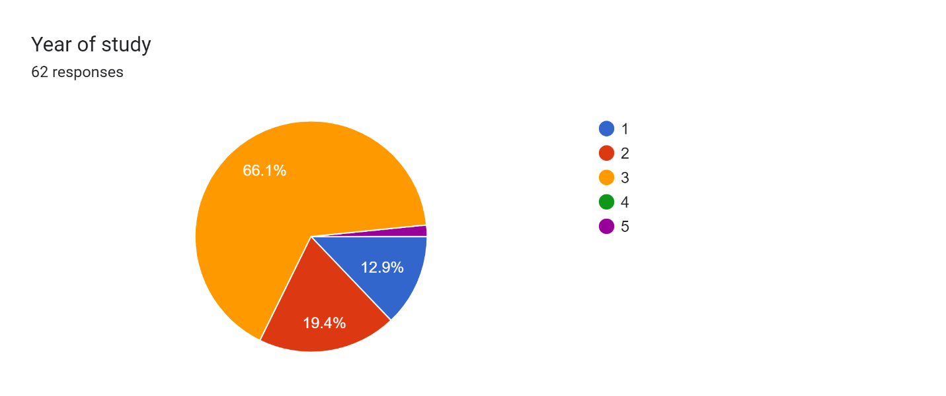
The information gathered includes information about the academic year of 62 college students. More than half of these students are in their third year of a degree program. A small number of students are in the fifth year, with the remainder divided between the first and second years. Notably, the data show that a considerable majority of responders are from the third year, indicating a greater response rate from this group.

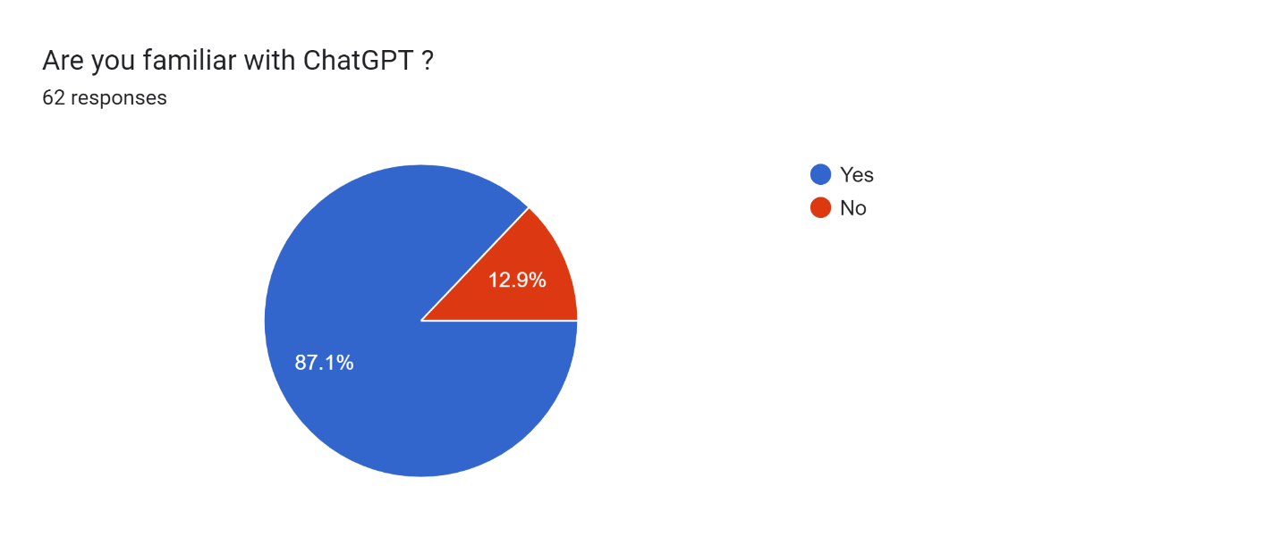
The acquired data set of 62 students reveals that a vast majority, accounting for 81.7% of the respondents, are familiar with ChatGPT. In contrast, 12.9% of interviewees stated that they were unaware of ChatGPT technology. These data indicate that ChatGPT is well-known and recognized among the assessed student population.
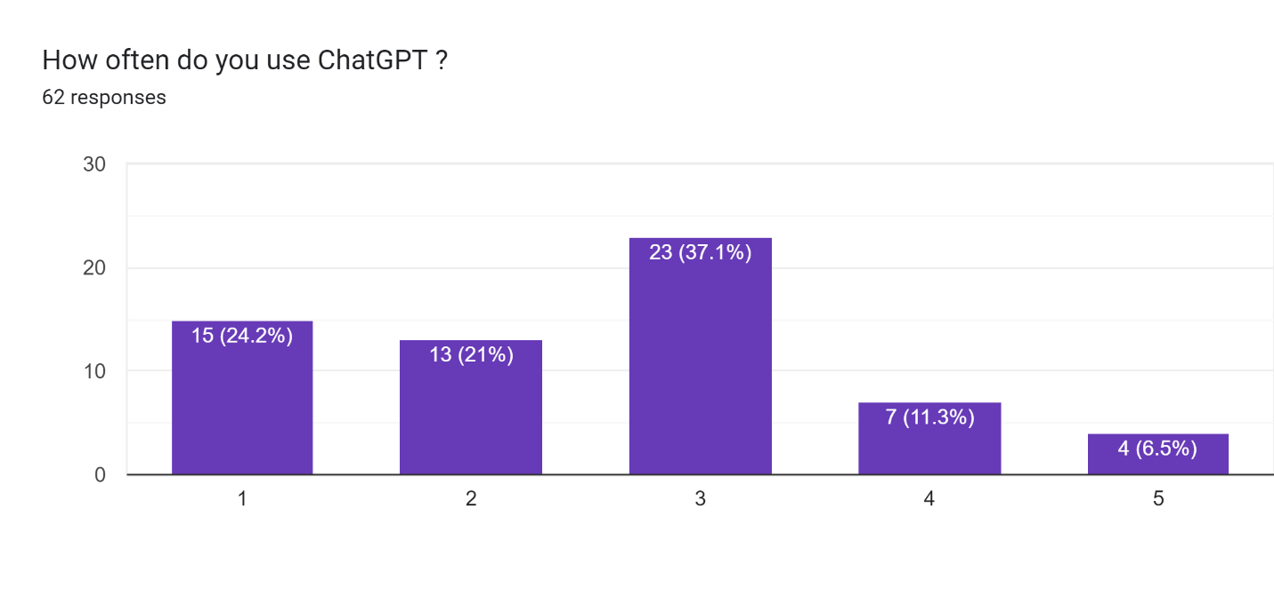
According to the data supplied, the majority of students, roughly 37.1%, have a neutral degree of engagement with chatGPT. A significant proportion of students, approximately 24.2%, are infrequent users, while only a small percentage, exactly 6.5%, are regular users of chatGPT. As a result, it can be deduced that chatGPT usage among students for various purposes is rather low.
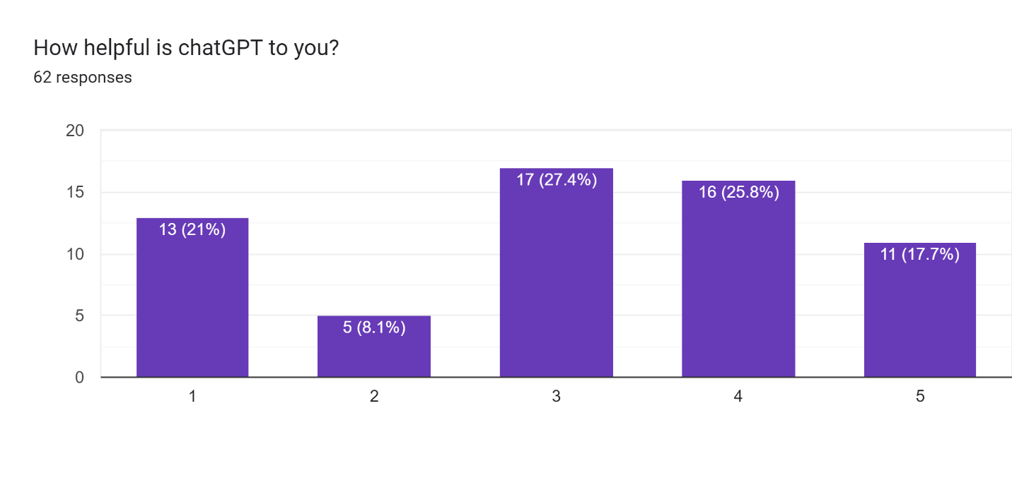
Based on the statistics, it is clear that students' perspectives on the utility of ChatGPT differ. About 27.4% of students are neutral, while 21% say ChatGPT is not beneficial for them. ChatGPT, on the other hand, is extremely valuable to 17.7% of students. As a result, the majority of pupils perceive ChatGPT to be moderately or almost useful for their needs.
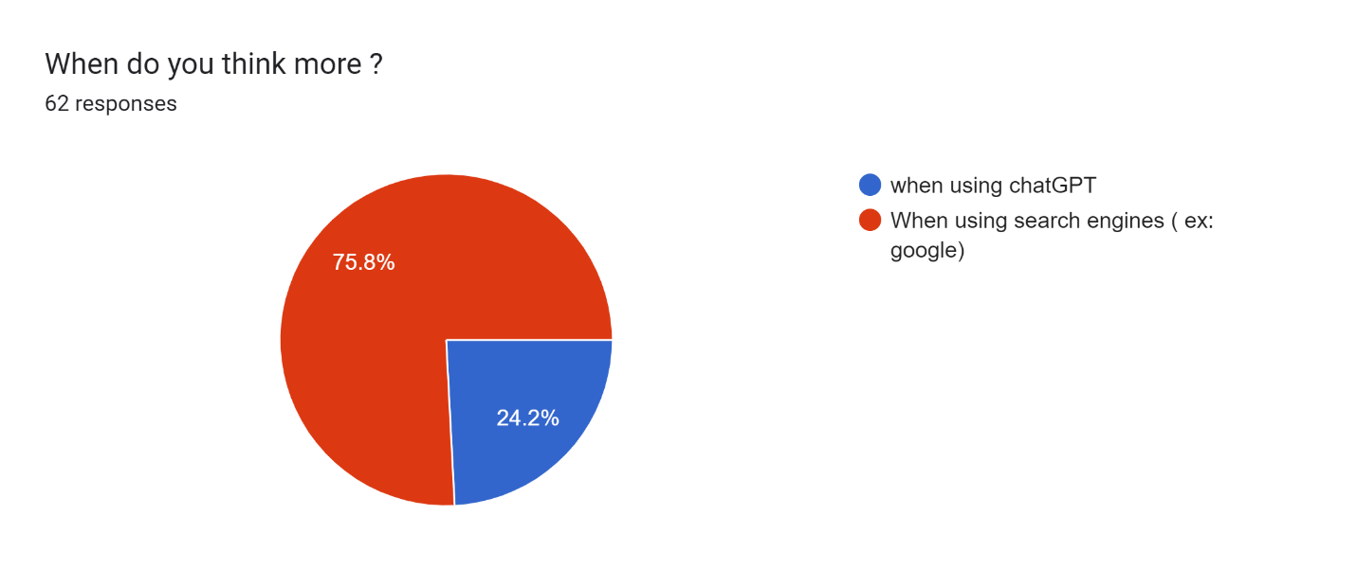
According to the data, a considerable majority of students (75.8%) engage in more critical thinking while utilizing alternative search engines such as Google. However, a lesser minority of students (24.2%) appear to depend on ChatGPT material without further consideration or questioning. This indicates that the majority of students are less likely to question the information they receive via ChatGPT.
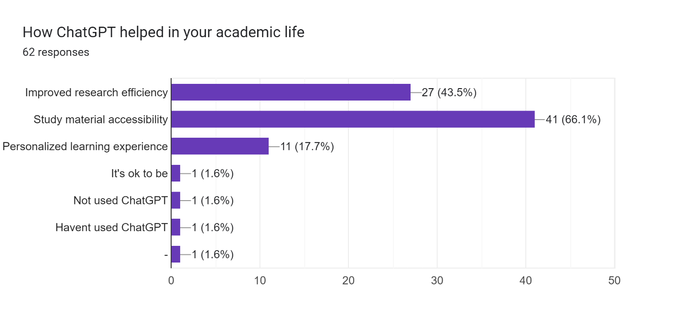
According to the results, a large majority of students (66.1%) felt that ChatGPT helped to provide them with easy access to study materials. Furthermore, ChatGPT has helped 43.5% of students improve their research efficiency. Furthermore, 17.7% of students stated that the AI model had improved their individualized learning experience. It should be noted that there is a subset of students who have not used ChatGPT for these objectives.
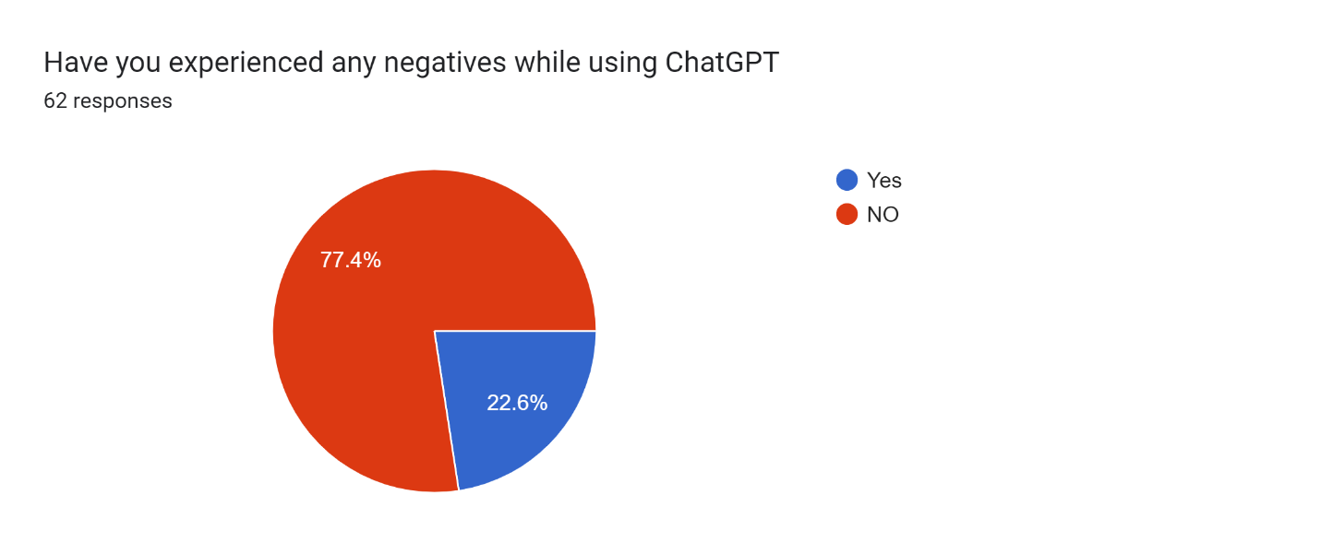

Based on the statistics presented, it is clear that the vast majority of students, about 77.4%, have had no unpleasant experiences while utilizing ChatGPT. However, a lesser proportion of students, 22.6%, reported having some unfavorable experiences while utilizing the site.
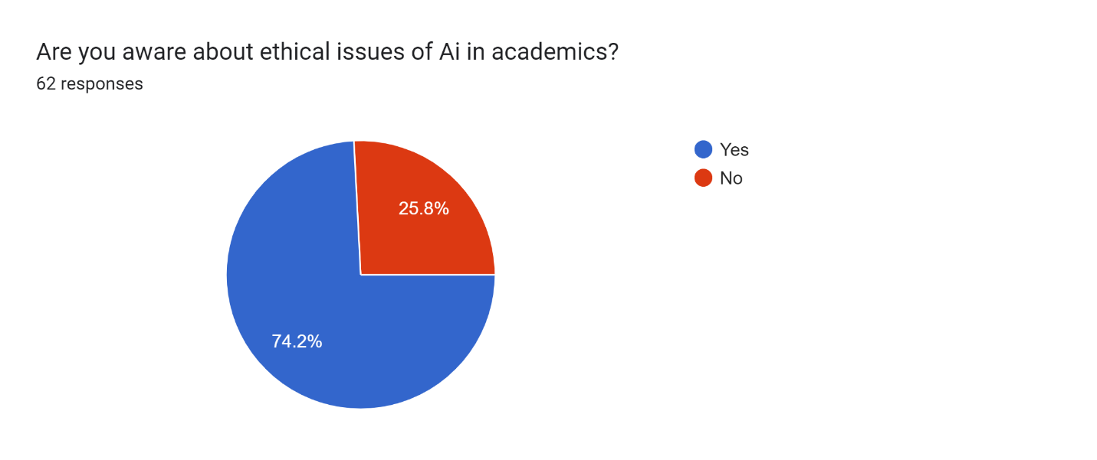
According to the data supplied, roughly three-quarters (74.2%) of students are aware of the ethical considerations linked to using ChatGPT in academics. In contrast, nearly a quarter (25.8%) of students are unaware of these ethical concerns.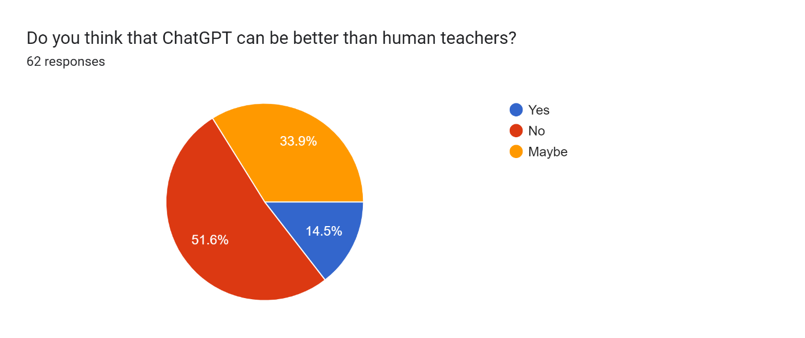
According to the results, a majority of students, around 51.6%, believe that human teachers are superior to ChatGPT. Meanwhile, around 33.9% of pupils are skeptical about the future and if ChatGPT can surpass human teachers. However, 14.5% of pupils agree that ChatGPT is superior to real lecturers.
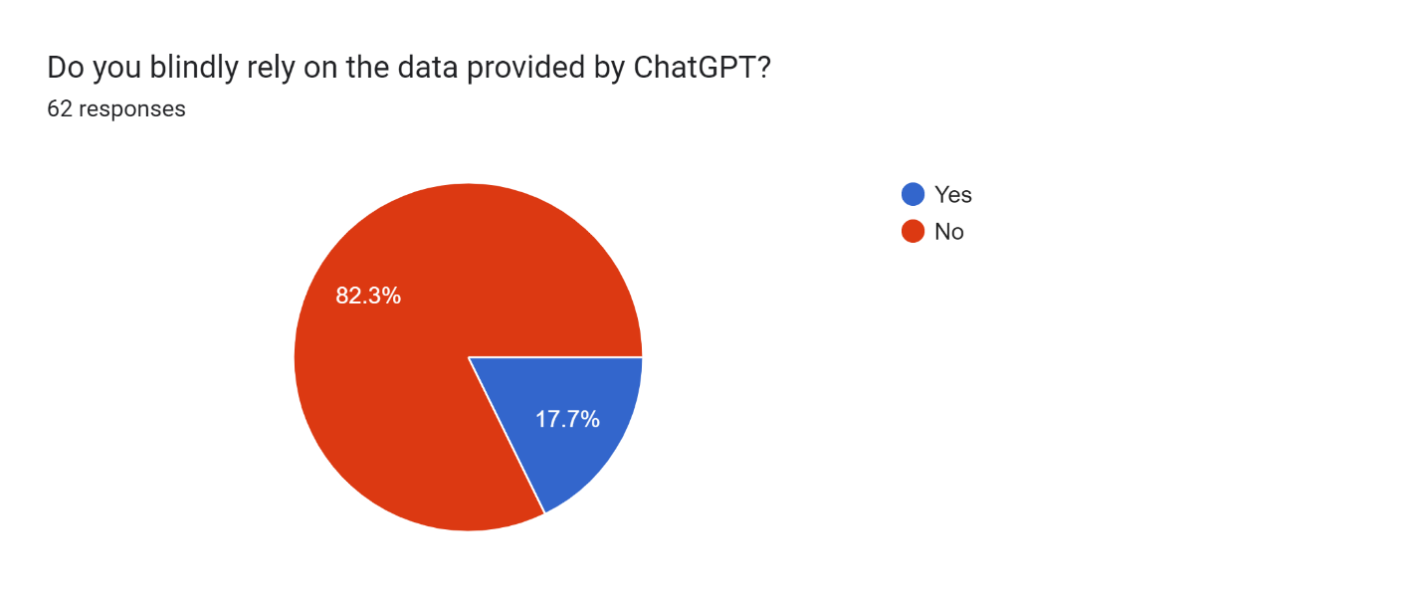
Based on the statistics presented, we can conclude that the majority of students do not have complete faith in the information provided by ChatGPT. Instead, individuals tend to double-check or cross-check information from multiple sources before accepting it as true. However, a tiny number of pupils depend entirely on the information provided by ChatGPT without further verification. In short, most pupils exercise caution by double-checking the facts, while a few students rely only on ChatGPT's responses.
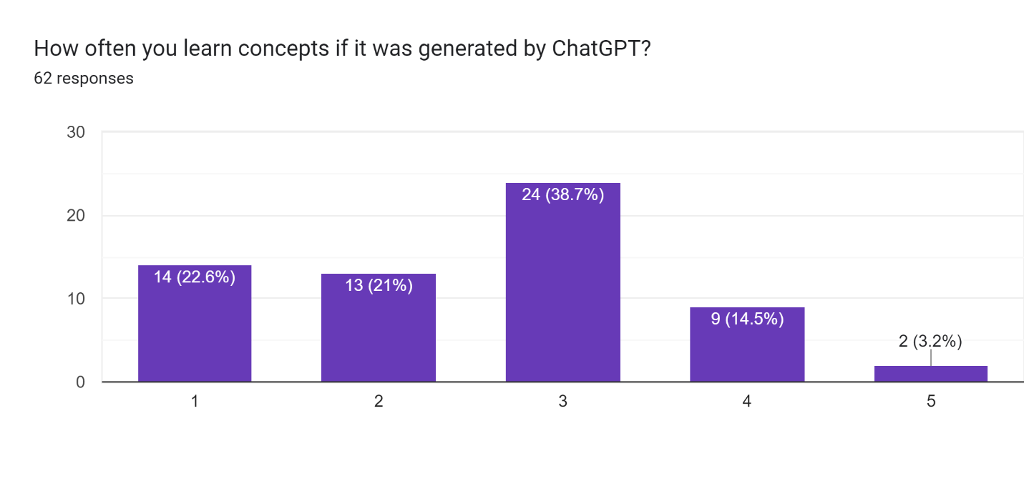
According to the findings, a substantial fraction of pupils, roughly 22.6%, do not understand the concepts taught by chatGPT. The percentage of students that understand the ideas is significantly low. On the other hand, around 38.7% of pupils show an uneven response, sometimes understanding the concepts created by chatGPT and other times struggling. In short, the data shows that a significant part of students struggle to learn from chatGPT, while a reasonable percentage has different levels of success learning the concepts.
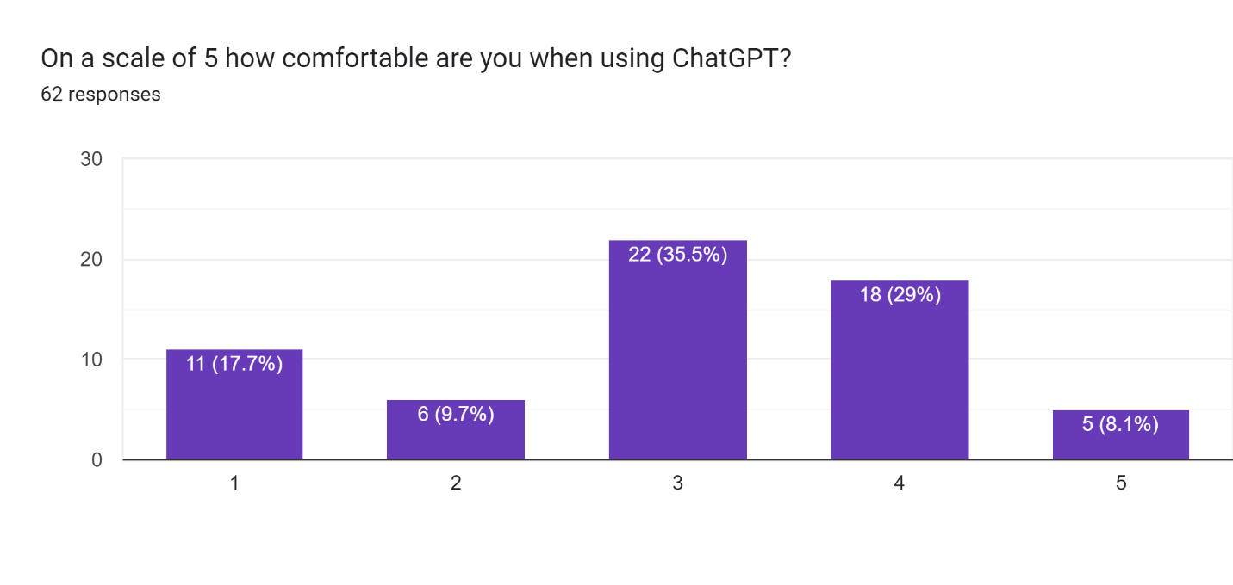
According to the research, a considerable proportion of students, roughly 17.7%, feel uneasy when utilizing chatGPT. Conversely, just a small percentage, approximately 8.1%, are comfortable utilizing chatGPT. The majority of students have a neutral impression, indicating that they are either not very comfortable or are not at all comfortable with technology.
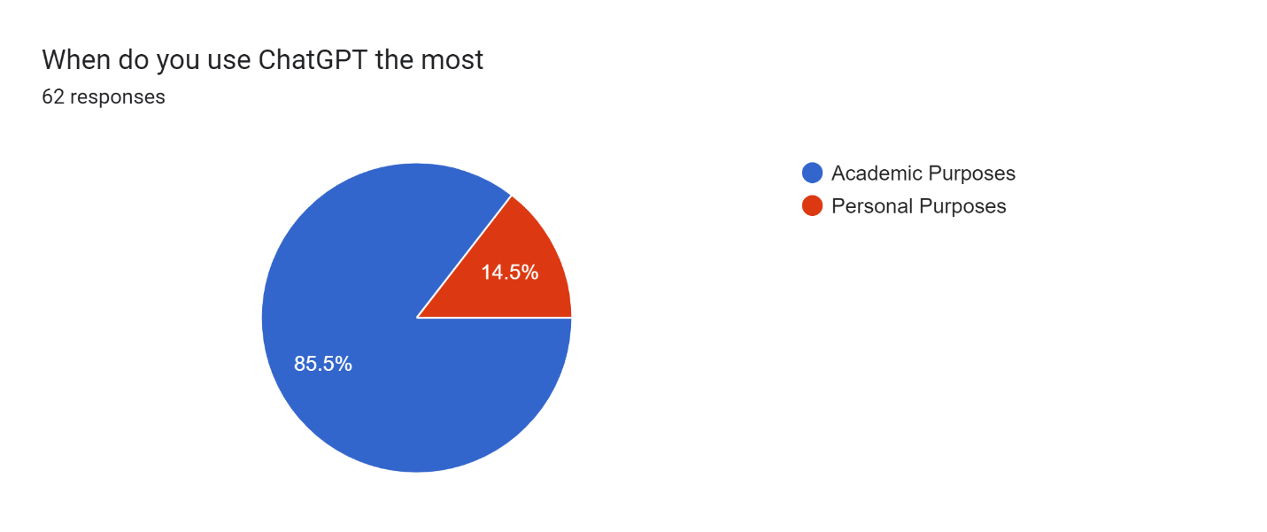
Based on the data supplied, it is clear that a considerable majority of students use chatGPT for academic purposes, while just a handful use the technology for personal reasons.

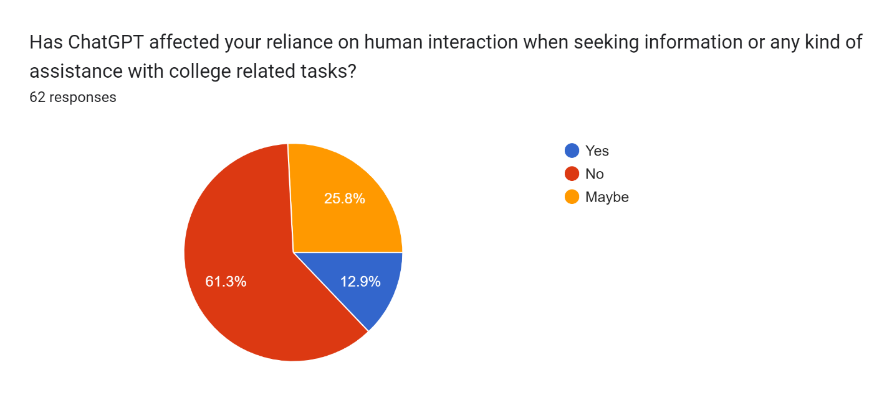
According to the findings, more than half of the students (more than 50%) say ChatGPT has had little effect on their reliance on human connection while seeking information. A quarter of the students (25.8%) are doubtful whether ChatGPT has affected their human interaction in this way. On the other hand, around 12.9% of students are certain that ChatGPT has had an impact on their human interaction while seeking guidance or help with college-related chores.
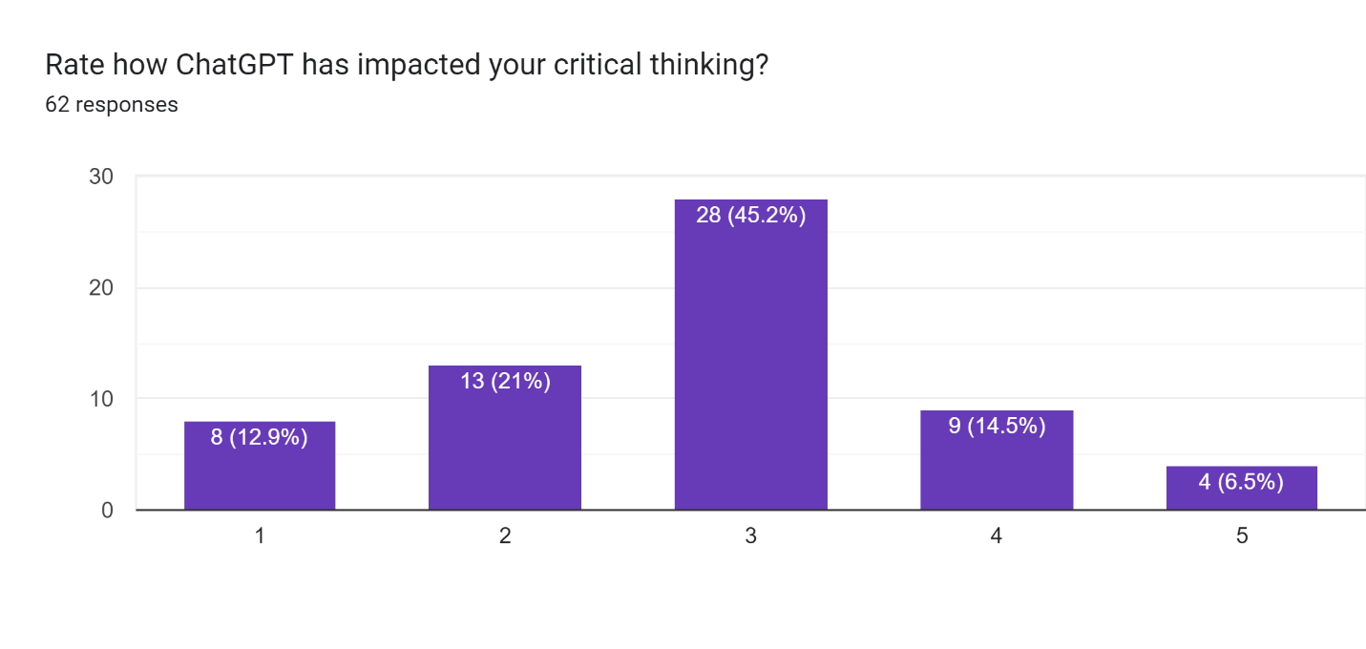

The majority of pupils, or about 45.2%, have a neutral influence on their critical thinking abilities, which means the impact might be either beneficial or bad, according to the statistics. About 12.9% of pupils indicate that using ChatGPT has a detrimental effect on their ability to think critically, while 6.5% of pupils report that using ChatGPT has had an advantageous effect. 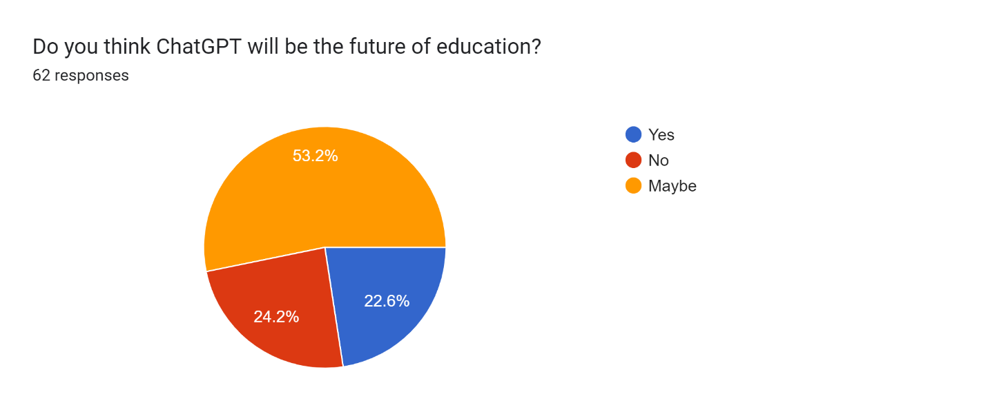
According to the findings, it is clear that a sizable majority of students (53.2%) believe ChatGPT will shape the course of education in the future. A significant 22.6% of this group strongly agrees that ChatGPT will unquestionably influence the next phase of education, whereas 24.2% have some misgivings and question its efficacy.
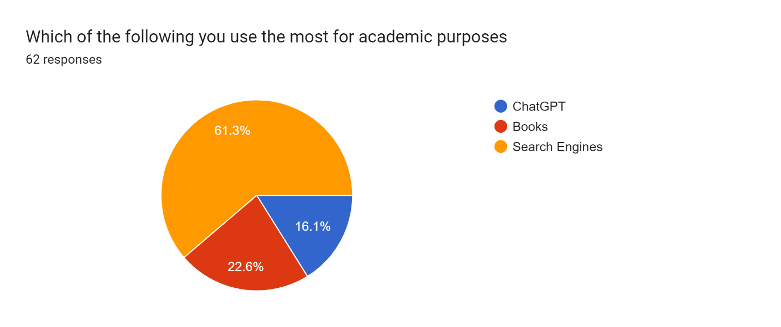
Examining the data supplied, it is clear that most students, or 61.3%, use Google and other alternate search engines for academic purposes. On the other hand, just 16.1% of users use ChatGPT for academic objectives. The other pupils complete their academic needs by using conventional literature.

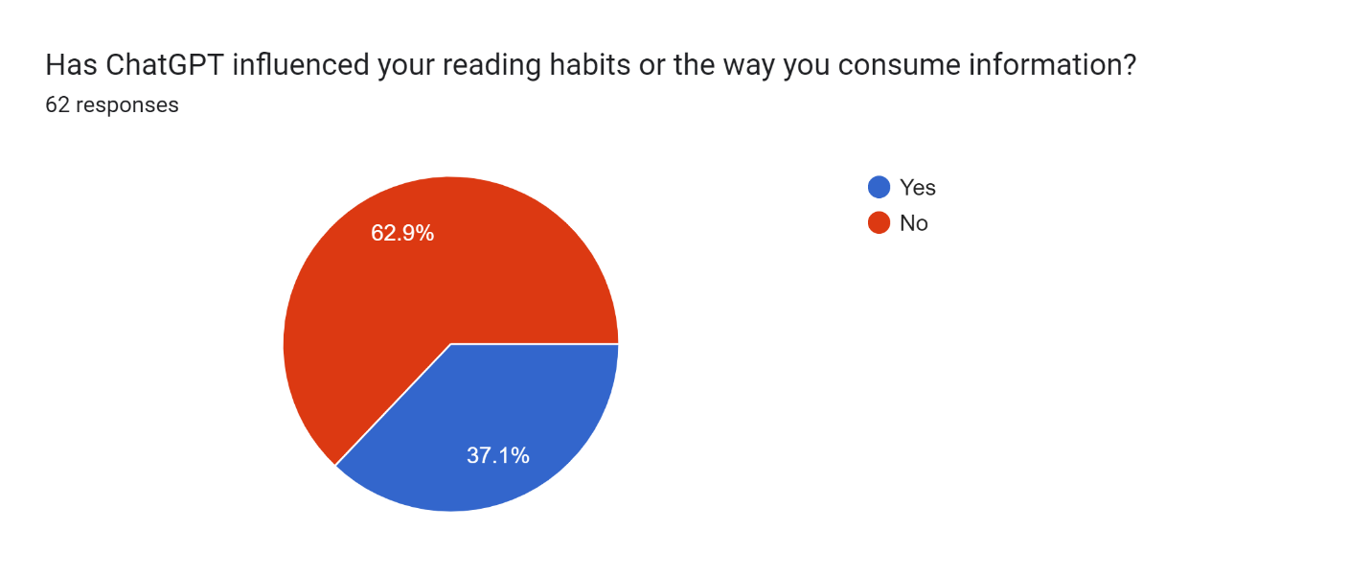
According to the data, it's clear that a sizable majority of students (62.9%) say ChatGPT hasn't changed how they acquire information or how often they read. On the other hand, the remaining students agree that ChatGPT has changed the way they read and approach material.

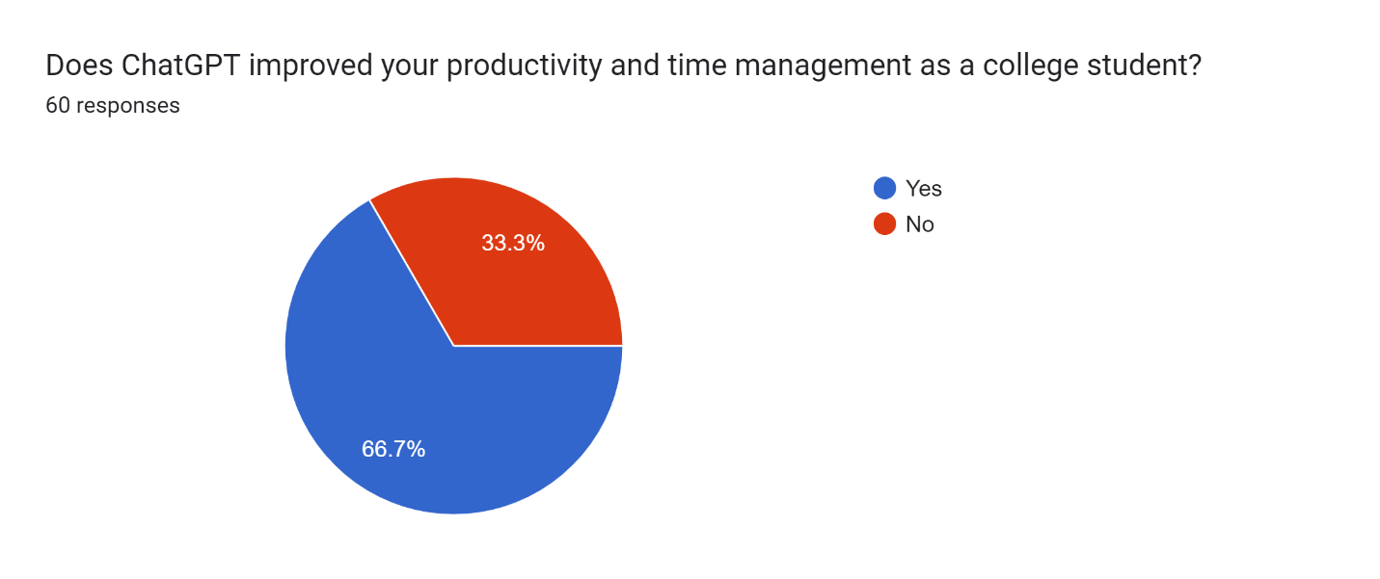
Under the analysis, more than two-thirds of the students (66.7%) think ChatGPT has improved their ability to organize their time as undergraduates. On the other hand, 33.3% of the pupils disagree with this assessment and believe that it hasn't led to any gains in these areas.
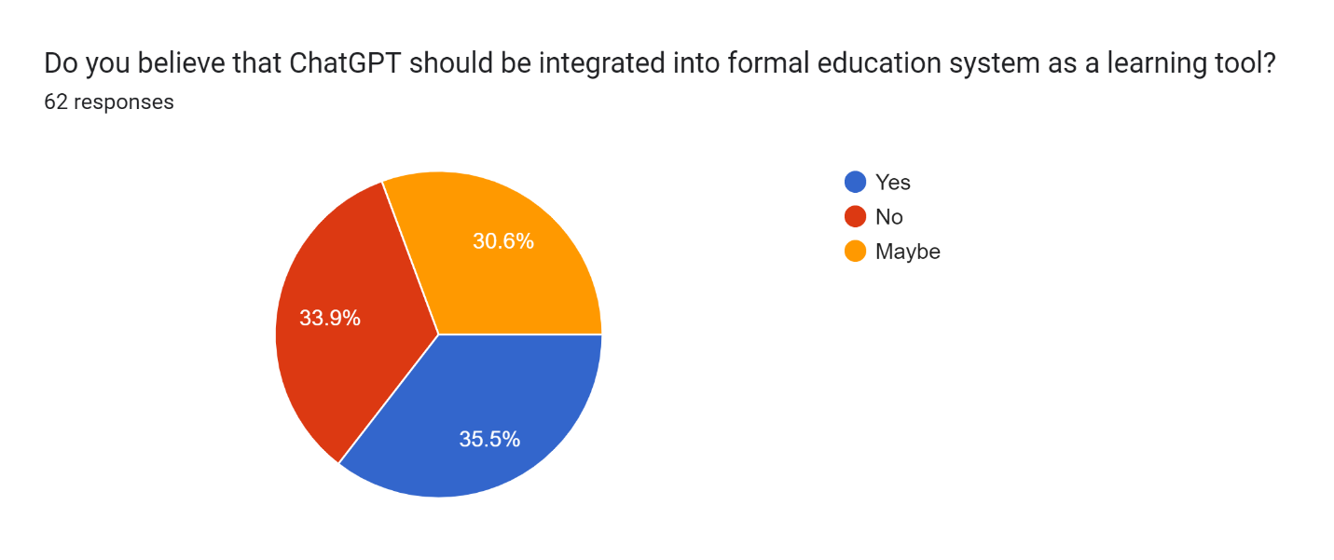
About 30.6% of the students support integrating ChatGPT as a teaching tool into the traditional educational system, based on the data that is currently accessible. 33.9% of pupils think ChatGPT will be incorporated into the established educational system. However, roughly 35.5% of the pupils think ChatGPT can't be employed as a learning tool in the conventional educational system.
- Results
Breakdown by academic year: The majority of pupils (more than 50%) are enrolled in the 3rd year, followed by the second and first year for the remaining students.
Awareness and recognition of ChatGPT: The majority of students (81.7%) have heard of ChatGPT, indicating that the AI model is well known and widely accepted in the student population that was assessed. However, 12.9% of students claimed to be unfamiliar with ChatGPT technology.
ChatGPT Engagement Levels: Most students (37.1%) are moderately engaged with ChatGPT. While only a handful of students (6.5%) use ChatGPT regularly, the vast majority (24.2%) of students are occasional users. This shows that pupils generally do not use ChatGPT for many different reasons.
Perceived usefulness of ChatGPT: Most students believe that ChatGPT is somewhat or almost useful for their needs. 21% of students feel that ChatGPT does not help them while 27.4% are neutral. However, ChatGPT is useful for 17.7% of pupils.
Critical thinking and reliance on ChatGPT: When using other search engines such as Google, a significant majority of students (75.8%) engage in more critical thinking, while a much smaller minority (24.2%) rely solely on ChatGPT content without further thought or inquiry .
Academic assistance and research efficiency: According to 66.1% of students, ChatGPT is useful because it gives them instant access to study resources. In addition, it contributed to better learning for 17.7% of pupils and improved research efficiency for 43.5% of pupils.
Adverse experiences: The majority of students (77.4%) reported that they had no adverse experiences using ChatGPT, while 22.6% reported that they had several.
Adverse experiences: Many students (77.4%) reported that they had no adverse experiences using ChatGPT, while 22.6% reported that they had several.
Awareness of ethical considerations: About three-quarters (74.2%) of students are aware of the ethical considerations associated with using ChatGPT in academics, while 25.8% are not aware of these concerns.
Comparison of ChatGPT with human teachers: Most students (51.6%) think that human teachers are better than ChatGPT, while 33.9% doubt the future and think that ChatGPT will not be able to compete with human teachers. Only 14.5% of respondents agree that ChatGPT is better than live professors.
Verifying Information: Most students try to cross-check or double-check information from multiple sources, which shows that they do not have complete confidence in the content of ChatGPT.
Concept understanding and comfort of ChatGPT: A significant minority of students (about 22.6%) do not understand the topics taught through ChatGPT. About 8.1% of pupils are comfortable with using ChatGPT.
Impact on human interaction: More than 50% of students say ChatGPT has little impact on how much they rely on interpersonal relationships to learn. 12.9% of students believe that ChatGPT has changed the way they connect with others.
Impact on Critical Thinking Skills: For most students (about 45.2%), using ChatGPT had little impact on their critical thinking skills. About 12.9% of students report that using ChatGPT harms their ability to think critically, while 6.5% report that it has a positive impact.
The future of ChatGPT in education: A large majority of students (53.2%) think that ChatGPT will affect education in the future. While 24.2% have some reservations about the effectiveness of ChatGPT, roughly 22.6% strongly believe that it will have a major impact on education.
Use for academic purposes: Only 16.1% of students use ChatGPT for academic purposes, compared to the majority of students (61.3%) who use Google and other search engines.
Time management and information retrieval: More than two-thirds of students (66.7%) think that ChatGPT has helped them manage their time better as college students.
Integration into the educational system: About 30.6% of students are in favor of including ChatGPT as a learning tool in the established educational system, while 33.9% believe it will happen and 35.5% believe it cannot be used as a learning tool in an established system.
- Discussion
Most students find ChatGPT beneficial in improving their writing skills. The program helps students improve the quality and style of their writing by providing writing prompts, comments, and editing suggestions. Students at many academic levels and majors can benefit from this improvement in writing. Because ChatGPT is fast, free and easy to use, it is used by the vast majority of students. Students who want immediate help with their writing assignments find it interesting because of its availability and accessibility. This shows that ChatGPT can also be used as a practical and affordable writing resource. Although ChatGPT offers quick access to study materials, many students cross or double check information from different sources. This shows that students are still using critical thinking skills by independently confirming the material even though they are not completely dependent on ChatGPT. A significant proportion of students are aware of the moral issues associated with using ChatGPT in the classroom. This knowledge is crucial because it allows students to understand the limitations and potential biases of artificial intelligence (AI)-generated content and to consider the moral implications of using such technologies. Most students believe that ChatGPT has minimal effect on how much they rely on social interactions for learning. This means that even when students use AI-based writing tools, they still place a high priority on interpersonal relationships. There have been concerns about the potential impact of ChatGPT on the originality of pupils' writing. Most students believe that ChatGPT has minimal effect on how much they rely on social interactions for learning. This points to the need to ensure that pupils continue to expand their uniqueness and creativity in writing assignments. The debate about the inclusion of ChatGPT in the current education system is contentious. While some students are receptive to this idea, others question its value as a teaching tool in the context of conventional education. This requires careful thought and investigation into the use of artificial intelligence tools in formal education. A significant proportion of students believe that ChatGPT will significantly influence education in the future. This expectation highlights the need for continued analysis of the effectiveness of artificial intelligence tools and their implications for the future, concluding that while students find ChatGPT useful, the balance between using technology to provide support and maintaining student autonomy in learning and writing. processes are needed. Students use ChatGPT in a variety of ways, with some using it frequently and others less frequently. Understanding these variations can help instructors provide the right resources and support to different groups of students.
- Conclusion
In conclusion, the study shows that ChatGPT is recognized and familiar among college students, and most of them believe that it is somewhat or almost useful. The impact on critical thinking, understanding ideas and verifying information is not well understood and not widely used. While some students find it useful for time management and academic support, others still prefer traditional search engines and human tutors. The potential impact of ChatGPT on education is still controversial; some students think it will have a big impact, while others are skeptical.
- Reference
THE IMPACT OF CHAT GPT ON STUDENT'S WRITING SKILLS: AN EXPLORATION OF AI-ASSISTED WRITING TOOLS. (2023, April 28). Zenodo. https://zenodo.org/record/7876800
Exploring the opportunities and challenges of NLP models in higher education: is Chat GPT a blessing or a curse? (n.d.). Frontiers. https://www.frontiersin.org/articles/10.3389/feduc.2023.1166682/full
Reflection on whether Chat GPT should be banned by academia from the perspective of education and teaching. (n.d.). Frontiers. https://www.frontiersin.org/articles/10.3389/fpsyg.2023.1181712/full
THE USE OF ARTIFICIAL INTELLIGENCE-BASED CHAT-GPT AND ITS CHALLENGES FOR THE WORLD OF EDUCATION; FROM THE VIEWPOINT OF THE DEVELOPMENT OF CREATIVE WRITING SKILLS | Shidiq | PROCEEDING OF INTERNATIONAL CONFERENCE ON EDUCATION, SOCIETY AND HUMANITY. (n.d.). E-Journal UNUJA. https://ejournal.unuja.ac.id/index.php/icesh/article/view/5614
War of the chatbots: Bard, Bing Chat, ChatGPT, Ernie and beyond. The new AI gold rush and its impact on higher education | Journal of Applied Learning and Teaching. (n.d.). Future Home of journals.sfu.ca. https://journals.sfu.ca/jalt/index.php/jalt/article/view/771

