CARDIC BIOENGINEERING IN RECENT TIMES
Manisha Majji¹, Praveen Kumar Nagadesi²
¹Department of Botany, Kakaraparti Bhavanarayana College (Autonomous), Kothapeta, Vijayawada-520 001.Andhra Pradesh, India.
²Department of Botany, School of Life Sciences, St. Joseph’s University, 36, Lalbagh Road, Bengaluru, Karnataka, India.
Abstract:
Cardiovascular diseases are responsible for approximately one-third of deaths around the world. Among cardiovascular diseases, the largest single cause of death is ischemic heart disease. Ischemic heart disease typically manifests as progressive constriction of the coronary arteries, which obstructs blood flow to the heart and can ultimately lead to myocardial infarction. This adversely affects the structure and function of the heart. Conventional treatments lack the ability to treat the myocardium lost during an acute myocardial infarction. Stem cell therapy offers an excellent solution for myocardial regeneration. Stem cell sources such as adult stem cells, embryonic and induced pluripotent stem cells have been the focal point of research in cardiac tissue engineering. The adult human heart has a limited regenerative capacity. Heart failure occurs through multiple mechanisms centered on the loss of functional.Despite the plethora of available medical and surgical therapies, the body’s inability to regenerate myocardium poses a significant ongoing risk to heart failure patients.Stem cell therapy is a promising approach to myocardial regeneration that has been extensively studied by researchers. The concept of replacing cells lost in myocardial infarction with new stem cell-derived cardiomyocytes has captivated many researchers and research organizations. Many cell types ranging from adult stem or progenitor cells to embryonic or induced pluripotent stem cells (iPSCs) are currently being investigated for treatment purposes.Cell attrition due to poor cell engraftment of the transplanted cells into the host native myocardium is a major obstacle that needs to be addressed in cardiac tissue engineering (CTE).
INTRODUCTION :
Heart failure is the end-stage of many cardiovascular diseases—such as acute myocardial infarction—and remains one of the most appealing challenges for regenerative medicine because of its high incidence and prevalence. Patients with progressive cardiac dysfunction show a high risk of sudden death and, despite substantial advances in recent years, cardiac function is only fully reestablished after heart transplantation (although its use is limited by the scarcity of donors and the possibility of complications). Acute myocardial infarction occurs when the blood supply to the heart is interrupted, causing irreversible myocardial ischemia, loss of cardiac muscle cells (cardiomyocytes), and formation of a noncontractile scar. Consequently, there is a need to develop therapeutic strategies that can promote rapid reconstruction of the affected tissue and efficient renewal of its contractile capacity.
Cardiovascular engineering encompasses a wide range of biomedical and engineering projects targeted at understanding the mechanisms, treatments and detection of cardiovascular health, disease, and regeneration. This includes the following
- Engineering sciences of fluid dynamics and solid mechanics integrated with biology and diseases of the heart, heart valves, vasculature, and lymphatics in adult and pediatric cardiovascular diseases.
- Cardiovascular regeneration or repair using up-to-date technologies including gene, drug, and cellular therapies and their delivery technologies, biomaterials, bio 3D printing, and nanotechnologies.
- Using experimental and computational approaches asking questions spanning the genes and small molecules to cellular and organ levels that, in most cases, are integrative and multi-scale.
- Fluid dynamics and mechanics of blood studied in the heart, heart valves, blood and lymphatic vessels and vascular grafts, and using in vitro, in vivo, multi-scale “OMICS” and in silico approaches, with the latter becoming increasingly prominent.
- The department’s research associated with mechanical heart valves, new bioprosthetic designs, and polymeric trileaflet valve prostheses is internationally recognized, as is research in arterial hemodynamics, endothelial cell biology, and their roles in atherosclerosis and arterial remodeling.
- Biomechanical evaluation of the heart failure in adult and pediatric cardiac lesions using swine and ovine models and its translation to clinical use with cardiac MRI is being pursued.

CELLULAR CARDIOMYOPLASTY :
Need for cell cardiomyoplasty
Cardiomyoplasty has evolved from “dynamic” to “cellular cardiomyoplasty”. The term dynamic cardiomyoplasty is referred to a surgical procedure developed in 1987 [to wrap the heart with the latissimus dorsi muscle, aiming to support the heart beating and limit the remodeling. Nevertheless, the obtained results were not as good as expected. With the advances in cell therapy, cellular cardiomyoplasty appeared as a promising therapeutical approach. This name encloses the therapies that use the injection of cells, from different origins, directly into the heart to try to obtain an improvement in the reduced heart function after an ischemic insult .Cells With Cardiac Regeneration Potential
An ideal source of cells would: expand in vitro on a large scale
b) integrate with damaged tissue, and
c) differentiate into new cardiomyocytes electromechanically coupled with the host tissue
Cell type | Advantages | Disadvantages
Skeletal myoblasts | Easily isolated High rate of proliferation Hypoxia-resistant Autologous | High incidence of arrhythmias
Bone marrow-derived stem cells Endothelial progenitor cells Hematopoietic stem cells Mesenchymal stem cells | Autologous Easily isolated Multipotent Low immune response | Limited availability Cases of bone or cartilage formation in the myocardium
Adipose tissue-derived stem cells | Easily isolated High availability Multipotent Low immune response | Low survival
Cardiac stem cells | Multipotent Autologous | Limited availability
Embryonic stem cells | Pluripotent Easy to expand | Teratogenic Limited availability Host immune response Ethical problems
iPSC | Pluripotent Easy to expand Good availability Autologous | Potentially teratogenic Possible oncogenic potential
Fetal cardiomyocytes | Cardiomyocyte phenotype | Limited availability Low survival
It was long thought that mammal hearts lacked any self-regenerating capacity. This view has been discounted, partly due to the discovery of cardiac stem cells, residing in the heart, which are self-replicating and capable of generating cardiomyocytes, endothelial cells and cardiac fibroblasts.
As an alternative, embryonic stem cells have been tested because of their strong capacity for expansion and subsequent differentiation into cardiomyocytes, endothelial cells and cardiac fibroblasts.To avoid using this type of nonautologous cell and the consequent need for immunosuppression therapy, induced pluripotent stem cells have been developed from somatic human tissue.Like embryonic stem cells, induced pluripotent stem cells have limited replication and ample capacity for differentiation. Cardiomyocytes of fetal origin are another cell type that has been used. These cells are capable of surviving, proliferating and forming intercalary discs with host myocardial tissue.
The aim of cardiac cell therapy is to heal the damaged infarcted tissue by the implantation of cells into or onto the pathologic myocardium by different techniques. In tissue engineering strategies, different types of cells have been combined with materials and with bioactive molecules if necessary to again try to recover the injured tissue. The employed materials will support cells, provide them 3D organization, protect them, stimulate and guide its growth, maintain them in the site of interest, etc.; in sum, they will act as an artificial extracellular matrix during the regeneration process. But the use of materials either injectable, or ex vivo conformed (gels –patches- or scaffolds) has an additional and important effect: the implantation of a material in the scarred ventricular wall, increases its thickness and by Laplace’s law, this increase leads to a reduction in the wall stress. This side-effect could be by itself very positive, even although regeneration did not arrive to happen, to limit ventricular remodeling and improve the quality of life of cardiac patients
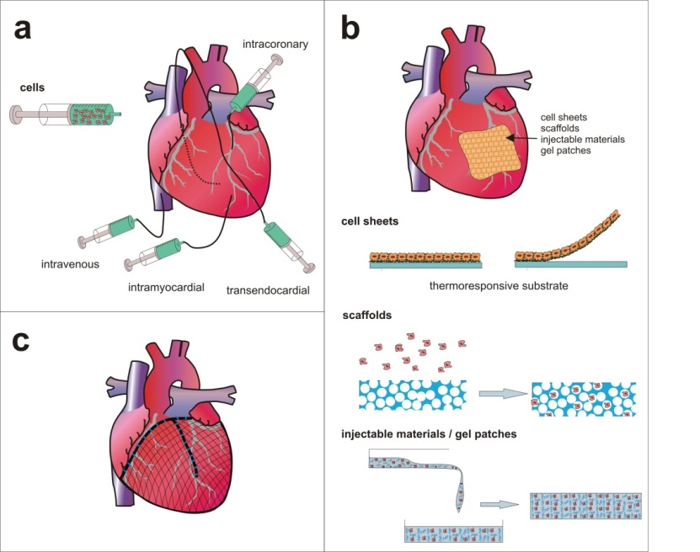
Limitations :
Studies in animal models based on the above-mentioned use of cells and routes of delivery indicate that cardiomyoplasty is a feasible, safe and beneficial technique. Nonetheless, although a viable therapy in the clinical setting, the extent to which infarcted myocardium is regenerated and cardiac function improved is highly limited. Basically, cells implanted under mechanical forces show poor survival, and recipient tissue hypoxia prevents them from providing any therapeutic effect. Moreover, very few cells differentiate into new cardiomyocytes and, because they lack any electromechanical properties, the regenerated muscle tissue is dysfunctional. For example, the high incidence of arrhythmias due to the lack of electromechanical coupling has undermined the use of myoblasts to treat patients with cardiac dysfunction. Furthermore, the status of indifferentiation of embryonic stem cells generates their uncontrolled proliferation, giving rise to the formation of teratomas,whereas obtaining induced pluripotent stem cells entails using viral infections that could also promote unwanted oncogenic activity.
CARDIAC IMPLANTABLE ELECTRONIC DEVICES
Permanent implantable electronic devices have been used in cardiology for many decades—at first cardiac pacemakers, then implanted cardiac defibrillators (ICDs) and cardiac resynchronization therapy devices (CRT-Ds). The most straightforward approach to remote monitoring (RM) is to acquire data from an already implanted device via a transmitter (provided for the patient) and communication technology that allows remote data transfer. Recently, a smartphone functionality has been developed that enables communication with implanted devices via Bluetooth. For many years such data acquisition has been used to detect technical problems such as low battery level, electrode dysfunction, or insulation defects. At present, the device may also be used to assess patients’ clinical status, such as changes in heart rate (including the onset of arrythmias), respiration rate, or physical activity. RM may lead to the further optimization of implantable cardioverter-defibrillator leads and lower chances of inappropriate shock .
In theory, remote monitoring strategies might result in fewer hospital or clinic visits (only when necessary vs. according to schedule) and in the timely detection of adverse events Consequently, RM should result in a lower cost of care and in higher survival rates or, at least, in a better quality of life. Most experts agree that such transmissions should take place every 3 months, which is more often than recommended follow-up visits The type of data transmitted and the frequency of transmission depend on the type of device, the indications for its implantation (secondary vs. primary prevention), and patient’s clinical status.
Results from several clinical studies seem to support this concept. The IN-TIME trial is one of the few that demonstrated actual clinical benefits to remotely monitored patients (lower mortality). The patients who benefited the most were those with a history of atrial fibrillation; indeed, an onset of atrial fibrillation was the event that most frequently led to medical intervention .In a meta-analysis of patients with heart failure (HF) and an ICD with telemonitoring function, all-cause mortality and hospitalizations were significantly reduced Similar results were provided by ALTITUDE and EFFECT studies In accordance with the above findings, the remote monitoring of implantable devices is indicated in cases of suspected AF, in patients with heart failure and low ejection fraction, and when there are known technical problems with the device or any of its components.
Remote monitoring was also found to result in lower costs without compromising patient survival .This finding in itself is a very important one given the ever-increasing number of HF patients and the amount of human and economic resources necessary to diagnose and treat them. Any solution that might lead to lower costs or better resources allocation would result in enormous savings on a regional or country level The standardization of the data recorded by devices from different manufacturers is a persisting issue. It is necessary to allow uncomplicated access to the data for all treating physicians as the inability of some health professionals to acquire certain data may compromise patient safety
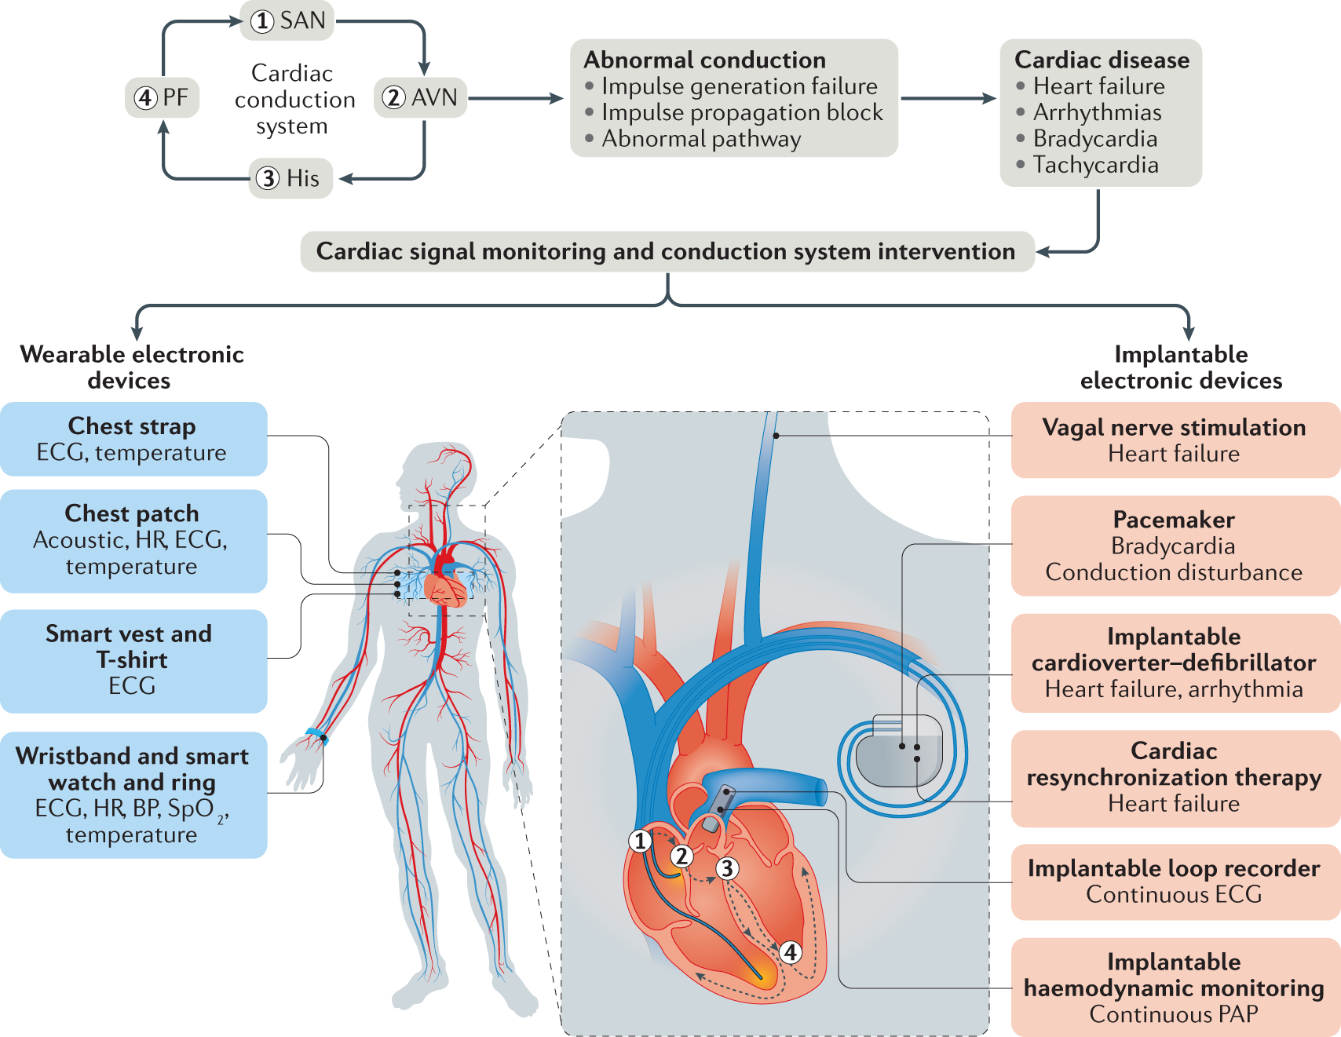

A small number of transplantation recipients undergo implantable cardioverter-defibrillator (ICD) placement for primary or secondary prevention of malignant ventricular arrhythmia and sudden cardiac death (SCD). The use of primary prevention ICDs in transplantation recipients is derived from the original ICD trials of patients without transplantation who had reduced left ventricular ejection fraction (LVEF) and symptomatic heart failure .It is not clear that the conclusions of SCD-HeFT (Sudden Cardiac Death in Heart Failure Trial) guidelines can be applied to HT patients. SCD occurs in approximately 10% of patients following HT, with only 10% of such deaths attributed to ventricular fibrillation (VF) . In this review, we provide a comprehensive analysis of the existing literature regarding the role for PPMs and ICDs in this population, including leadless PPMs and subcutaneous ICDs, as well as special considerations and future directions.
CD: Implantable Cardioverter-Defibrillator (ICD)
ICD stands for Implantable cardiovascular-defibrillator. It is a battery-operated device that tracks the heartbeat. It is placed under the skin and is connected with the heart through wires. This device is designed to detect the abnormal heartbeats and to deliver an electric shock to restore the normal heartbeat.
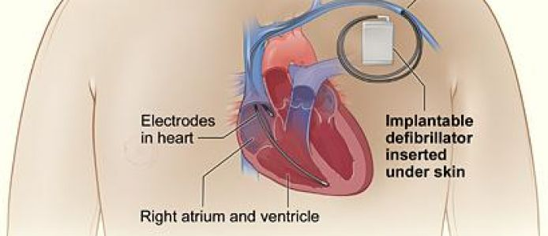
This device is surgically placed under your skin below the left collarbone of a person. It continuously monitors your heartbeat and delivers an electric shock through wires connected to the heart through your veins. This device helps prevent sudden death due to sustained ventricular tachycardia or fibrillation.
ICD is required if a person's suffering from ventricular tachycardia (fast heartbeat) or a chaotic heartbeat that indicates ventricular fibrillation in which the heart is not able to supply enough blood to different parts of the body.
You may have seen doctors in hospitals giving electric shocks to an unconscious person using electric paddles. The ICD performs the same function but internally and automatically when it detects an abnormal heartbeat. However, it is different from a pacemaker, which is also a device that helps control the abnormal heartbeat.
Most ICDs are capable of delivering 4 types of therapy for your heart.
If your heart goes too slowly:
- the ICD can act as a pacemaker to prevent your heart dropping below a certain rate
- If your heart is going too quickly:
- the ICD can deliver a sequence of very fast paced beats or “Anti-Tachycardia Pacing” (ATP)
- the ICD can deliver a low energy shock or “Cardioversion”
- the ICD can deliver a high energy shock or “Defibrillation”

Working of ICDS :
During rapid or abnormal heartbeat the wires that are attached to heart send signals to the ICD. The ICD on receiving the signals generates and sends electrical pulses to regulate the heartbeat. However, a subcutaneous ICD has one lead that is placed in the tissue to the left of the breastbone instead of the heart.
Section snippets :
Vascular grafts
Vascular grafts are conduits that can support blood flow, withstand the pressures exerted by blood flow, and, ideally, have the capability to grow, remodel, and self-repair in vivo The first engineered vascular graft was proposed by Bell and colleagues in the 1980’showever, it took nearly 20 years for engineered vascular grafts to be implanted in humans [9]. The first engineered vascular graft implanted in humans was generated using autologous cells isolated from explanted
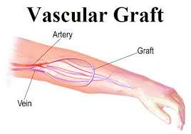
Cardiac scaffolds
Cardiac scaffolds (or cardiac patches) are in vitro engineered constructs that can provide mechanical support to promote endogenous repair and regeneration of the ischemic tissue, or otherwise act as a vehicle to deliver therapeutic cargo to the ischemic tissue. Many of these types of scaffolds have the potential to maintain the cellular microenvironment, support cellular differentiation and organization.Cardiac scaffolds can be built upon natural or synthetic. For the decellularization-based construction strategy, human or animal donorderived hearts undergo the process of decellularization to obtain decellularized whole heart scaffolds with preserved macroarchitecture. Regenerative cells (e.g., myocardial cells and endothelial cells) are seeded onto decellularized scaffold through perfusion. Repopulated scaffolds are placed under 3D culture condition in a bioreactor, yielding tissue-engineered whole heart with overall structure and vasculature of heart. For the cell sheet-based construction strategy, 3D construct was produced by layering 2D myocardial cell sheets, leading to formation of myocardial tissue. For the synthetic/natural materials-based construction strategy, cells (e.g., myocardial cells), scaffolds (e.g., collagen), and growth factors are combined in vitro to produce myocardial tissue
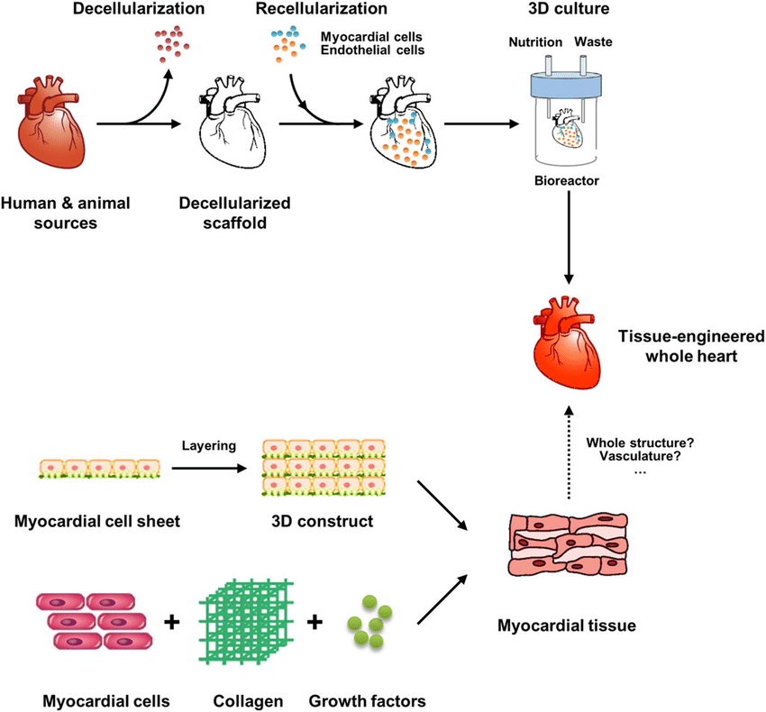

Nano-featured and bioactive scaffolds
Scaffolds serve as temporary, artificial extracellular matrices to accommodate cells and support three-dimensional tissue regeneration. Therefore, it is often beneficial to mimic certain features of a natural extracellular matrix in scaffold design. It is now well known that many biologically functional molecules, extracellular matrix components, and cells interact at the nanoscale. Hence, nano-featured synthetic scaffold design is one of the exciting new areas in tissue engineering.

Nano-fibrous scaffolds
Collagen is a major natural extracellular matrix component, and possesses a fibrous structure with fiber bundles varying in diameter from 50-500 nmTo mimic the nano-fibrous architecture, a few technologies have been developed to engineer nano-fibrous scaffolds.

Electrospinning
Electrospinning was first introduced in early 1930s¹²⁶ to fabricate industrial or household nonwoven fabric products. The technique has been rejuvenated over the past decade to process biodegradable and/or biocompatible polymers (macromolecules) into fibrous fabrics with an average fiber diameter at micrometer or nanometer scales for tissue engineering scaffolds. To form such fibers using electrospinning, a polymer solution is forced through a capillary, forming a drop of polymer solution at the tip. A high voltage is applied between the tip and a grounded collection target. When the electric field strength overcomes the surface tension of the droplet, a polymer solution jet is initiated and accelerated towards the collection target. As the jet travels through the air, the solvent evaporates and a nonwoven polymer fabric is formed on the target. To generate preferential orientation or/and tubular structure, an electrically grounded rotating drum is used as the collection target.

ii)Bioactive scaffolds

The ideal tissue engineering scaffold should positively interact with cells, including enhanced cell adhesion, growth, migration, and differentiated function. To achieve these positive cell-scaffold interactions, surface or bulk modifications of the polymers are often employed.The surface properties can be varied by either bulk or surface modification. Bulk modification is typically realized by copolymerization or functional group attachment to the polymer chains before scaffold fabricationand usually changes the mechanical and processing properties of the polymers. Surface modification can be carried out after a porous scaffold has been fabricated. For example, plasma treatment alone or followed by chemical modification has been used to modify polymer thin films and porous scaffolds
Injectable hydrogels
Hydrogels are the most commonly used cellular scaffolds. These 3D hydrophilic polymer networks are formed through molecular interactions between the different functional groups present on the base polymers.
Injectable hydrogels are water-swollen networks of crosslinked polymers composed of natural and/or synthetic polymers and are mostly classified based on chemical or physical crosslinking mechanisms.
Naturally derived polymers are typically considered prime candidates for regenerative hydrogels given their derivation from native ECM or ECM-like components. They have excellent biocompatibility, biodegradability and have been extensively studied in bone, cartilage, skin, nerve and cardiac regeneration .Some of the commonly employed natural polymers in CTE discussed in this review include chitosan, collagen, gelatin, fibrin, alginate and other 3D decellularized tissues. These polymers can be used independently or in combination with each other to synthesize an ideal injectable hydrogel for cardiac regeneration .
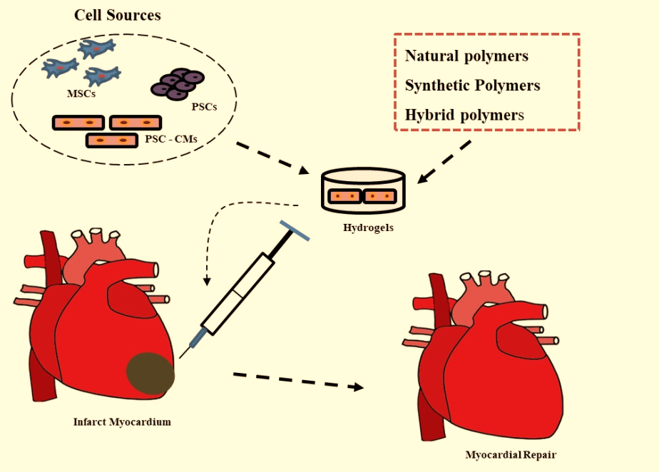

CONCULSION:
Cardiac Bioengineering has the power to improve cardiac health globally by engineering diagnostic, treatment and disease monitoring platforms that function in diverse settings and to enhance the chances to save patient health upto some time.

REFERENCES:
https://canberraheartrhythm.com.au/services/procedures/cardiac-devices/233-implantable-cardiac-defibrillator-icd.html
(Asghari et al., 2017; Boni et al., 2018; Brovold et al., 2018; Fakoya et al., 2018; LogithKumar et al., 2016; Malafaya et al., 2007; Van Vlierberghe et al., 2011).
(Hasan et al., 2015; Peña et al., 2018).
https://www.melbourneheartrhythm.com.au/learn/procedures/62-implantable-cardioverting-defibrillator-icd?showall=1
https://www.revespcardiol.org/en-cardiac-tissue-engineering-bioartificial-heart-articulo-S1885585713000248
https://www.intechopen.com/chapters/44656

