ROCKY MOUNTAIN SPOTTED FEVER

Introduction
Rocky Mountain spotted fever (RMSF) is a bacterial disease which spread because of the bite of an infected tick. Most commonly seen symptoms in infected persons are fever, headache, and rash. RMSF can be lethal if not treated early with the correct antibiotic. It is also an acute febrile disease, caused by Rickettsia rickettsiae, and the reservoir for the same is the ticks and rodents. Man is only an accidental host. Disease is transmitted by the bite of tick, all stages in its life cycle is infective.

Transmission
As already mentioned, Rocky Mountain spotted fever is a severe tick-borne infection which can be lethal if not treated early, spread by several species of ticks in the United States, includes:
- The American dog tick (Dermacentor variabilis)
- Rocky Mountain wood tick (Dermacentor andersoni)
- The brown dog tick (Rhipicephalus sanguineus)
RMSF is most commonly seen in parts of the southwestern United States and Mexico. The cases of RMSF occur throughout the United States, but are most commonly reported from North Carolina, Tennessee, Missouri, Arkansas, and Oklahoma.
November 2013, in India four confirmed cases belonging to ‘’spotted fever’’ group were diagnosed, which includes tick borne agents Rickettsia rickettsii, R. conorii and mite transmitted R. akari. All the cases were from rural areas within 100 km of Lucknow (district- Hardoi, Raebareli, Sultanpur and Sitapur).

Signs and Symptoms
Early signs and symptoms are not very precise to RMSF as it includes general symptoms like fever and headache. However, the illness can rapidly progress to a serious and life-threatening illness. Immediately one must contact his/her healthcare provider if one become ill after having been bitten by a tick, having been in the forest areas or in areas with high brush where ticks commonly live.
Common signs and symptoms are:
- Fever
- Headache
- Rash
- Nausea
- Vomiting
- Stomach pain
- Muscle pain
- Lack of appetite

Late stage Rash
Rashes are commonly seen in people who are sick with RMSF. Rash typically develops 2-4 days after fever begins. The appearance of the rashes can differ widely over the course of illness. Some rashes can look like red splotches and some look like pinpoint dots. While almost all patients with RMSF will develop a rash, it often does not appear early in illness, which can make RMSF difficult to diagnose.
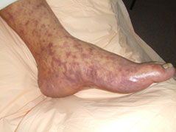

Long-term Health Problems
- RMSF does not result in chronic or persistent infections.
- Some patients who recover from severe RMSF may be left with enduring damage, including amputation of arms, legs, fingers, or toes (from damage to blood vessels in these areas); hearing loss; paralysis; or mental disability. Any permanent damage is caused by the acute illness only and does not result from a chronic infection.

Diagnosis and Testing
- The signs and symptoms of RMSF are comparable to those of many other diseases. One must contact the healthcare provider if any of the signs or symptoms of RMSF is developed.
- Be sure that one must provide the history to the healthcare provider in case of any tick bite followed by subsequent illness or have spent time in areas where ticks may be found.
- The healthcare provider may order certain blood tests to look for evidence of RMSF.
- The results of these tests can take weeks. On the basis of physical examination and history, if the healthcare provider provisionally diagnoses the illness to be RMSF, he or she should recommend antibiotic treatment before test results are available.

Treatment
- Initial treatment with the antibiotic doxycycline can prevent death and severe illness.
Doxycycline is the recommended antibiotic treatment for RMSF in adults and children of all ages.

Prevention
- There is no vaccine for the prevention of RMSF. It can be prevented by preventing tick bites, preventing the development of ticks on pets, and preventing ticks in the yard.
- Ticks live in grassy, brushy, or wooded areas, or even on animals, so spending time outside camping, gardening, or hunting will bring in close contact with ticks.
- Tick exposure can occur all the year-round, but ticks are active mostly during warmer months (i.e. April-September). Explore the type of tick that is common in your area.
- Treat clothing and gear with products containing 0.5% permethrin. Permethrin can be used to treat boots, clothing and camping gear. It remains protective even after several washings.
- Avoid Contact with Ticks by avoiding wooded and brushy areas with high grass and leaf litter.
- Check the clothing for ticks after visiting any area where tics can be present and take Shower soon after being outdoors.
- Check your body for ticks after being outdoors. Inspect your body after returning from possibly tick-infested areas, including your own backyard. Use a hand-held or full-length mirror to view all parts of your body. These parts of the body must be checked for ticks:
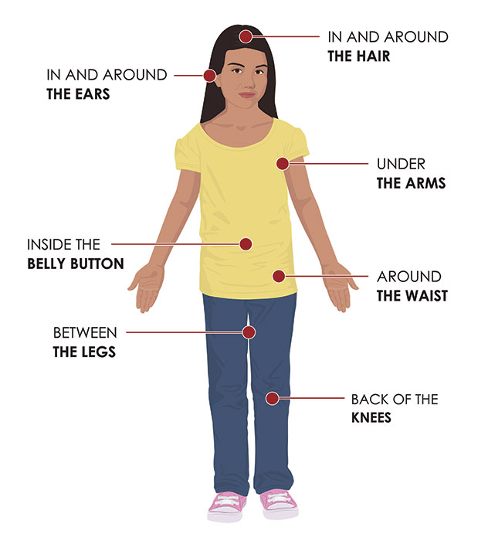
- Under the arms
- In and around the ears
- Inside belly button
- Back of the knees
- In and around the hair
- Between the legs
- Around the waist

Conclusion:
Rocky Mountain spotted fever is a potentially lethal disease that is usually caused by the bite of a tick infected with rickettsia group bacteria. RMSF symptoms include a fever with headache, Rash (may occur later in illness) and stomach upset. Recommended treatment for suspected RMSF in children and adults is Doxycycline.

References
- https://www.cdc.gov/rmsf/index.html
- https://www.ncbi.nlm.nih.gov/pmc/articles/PMC4418163/#ref1
- Mahajan SK. Rickettsial diseases. J Assoc Physicians India. 2012;60:37–44.
- Shah V, Vaidya V, Bang V, Shah I. Spotted fever in a child in Mumbai, India. J Vector Borne Dis. 2009;46:310–2.
- Chaudhry D, Garg A, Singh I, Tandon C, Saini R. Rickettsial diseases in Haryana: not an uncommon entity. J Assoc Physicians India. 2009;57:334–7.

