ARTIFICIAL INTELLIGENCE IN HEALTHCARE

Induni Nayodhara Weerarathna
Department of Biomedical Sciences, Datta Meghe Institute of Higher Education and Research,
Sawangi Meghe Wardha, Maharashtra, India.442001
Weerarathnainduni5@gmail.com

ABSTRACT
The application of Artificial Intelligence (A.I.) in healthcare has led to significant advancements and transformative developments in various areas. Medical imaging and diagnostics benefit from A.I.'s ability to analyze and interpret complex imaging data, enabling more accurate and timely diagnoses. Electronic health records (E.H.R.) are streamlined through A.I., facilitating efficient data management and retrieval for better patient care. In robot-assisted surgery, A.I. enhances surgical precision and safety, improving surgical outcomes. AI-driven disease prediction and risk assessment models aid in identifying potential health risks early, enabling proactive interventions and preventive measures. Additionally, A.I.'s involvement in drug discovery and development accelerates the search for new medications and treatment options, promising advancements in the pharmaceutical industry. Virtual assistants and chatbots equipped with A.I. capabilities provide personalized support, answering medical queries and offering guidance to patients and healthcare providers. Precision medicine is furthered through A.I.'s capability to analyze genetic data and match patients with tailored treatment options. Moreover, remote patient monitoring is made feasible with A.I., enabling real-time tracking and management of patient health, especially for those with chronic conditions. Overall, the integration of A.I. in healthcare is paving the way for more efficient, precise, and patient-centric medical practices.
Keywords: Artificial intelligence, medical imaging; electronic records; drug discovery; robots; chatbots;
ABBREVIATIONS:
A.I. Artificial Intelligence
E.H.R. Electronic Health Record
CT Computed Tomography
M.R.I Magnetic Resonance Imaging
CAD Computer-Aided Diagnosis
Q.S.P.R Quantitative Structure-Property Relationship
C.F.D. Computational Fluid Dynamics
H.I.V. Human Immune Deficiency Virus
D.N.A. Deoxyribonucleic Acid
R.P.M. Remote Patient Monitoring
I.T. Information Technology
HIPAA Health Insurance Portability and Accounting Act

I INTRODUCTION
A.I.'s rapid expansion is revolutionizing medicine and various aspects of our lives. A.I. plays a crucial role in aiding doctors through sophisticated algorithms and machine learning techniques. It allows them to make more accurate diagnoses, identify potential health hazards, and provide tailored treatment strategies for individual patients. Utilizing extensive data, A.I. revolutionizes the healthcare sector, offering the potential for enhanced patient results and a more streamlined healthcare system. However, responsible implementation, privacy protection, and ongoing collaboration between A.I. experts and medical professionals remain crucial for maximizing A.I.'s benefits and ensuring ethical medical practices. A.I. holds the capacity to transform healthcare by presenting streamlined and impactful solutions to vital challenges in the medical field. By harnessing extensive medical data, including imaging scans and laboratory findings, A.I. can identify subtle patterns that might evade human observation. Consequently, this enables healthcare professionals to provide more accurate diagnoses and customized patient treatments. The fast-evolving realm of artificial intelligence utilizes sophisticated algorithms and machine learning methods, revolutionizing the medical landscape with improved diagnostic precision, the early detection of potential health hazards, and personalized therapeutic strategies for individual patients. A.I. can revolutionize healthcare, offering streamlined and potent solutions to the sector's critical challenges. By analyzing extensive medical data, such as imaging scans and lab results, A.I. can identify patterns that human observation might miss. This ability enables doctors to achieve greater precision in diagnoses and provide more personalized treatments to patients, ultimately enhancing healthcare's overall effectiveness and efficiency. Artificial intelligence in medicine traces back to the 1950s when researchers started investigating how computers could be applied to analyze medical data and aid in making diagnostic decisions. As time passed, A.I. technology advanced with the introduction of sophisticated algorithms and machine learning techniques, enabling computers to manage increasingly complex medical data. In the 1990s, A.I. became more widely utilized in medicine, encompassing tasks like analyzing medical images and streamlining drug discovery procedures.
In the early 2000s, a remarkable breakthrough occurred in A.I. with the introduction of deep learning algorithms, completely transforming the field. These algorithms allowed computers to learn and adapt to new data in a highly sophisticated way, leading to the rise of AI-driven medical systems capable of analyzing massive amounts of medical data and making accurate predictions. Today, A.I. is extensively utilized across various medical domains, including diagnosis, treatment planning, and health monitoring. We expect even more astonishing developments in integrating A.I. within healthcare as technology advances.
A.I. aims to mimic human cognitive abilities, triggering a significant transformation in the healthcare sector. This change is driven by the growing abundance of healthcare data and the rapid progress in analytical methods. A.I. is utilized for analyzing structured and unstructured healthcare data, with classical support vector machines, neural networks, and contemporary deep learning methods being prominent A.I. techniques for structured data. Additionally, A.I. leverages natural language processing for handling unstructured data. In healthcare, A.I. has significantly advanced in three major disease areas: cancer, neurology, and cardiology. These developments have triggered a lively discussion on A.I. doctors' potential to replace human physicians eventually. While it is unlikely that machines will completely replace human physicians in the foreseeable future, the integration of A.I. has shown significant potential to enhance healthcare. A.I. can assist physicians in making improved clinical decisions and may even take over certain aspects of healthcare, such as radiology, where A.I. has demonstrated successful applications. The progress in A.I.'s implementation in healthcare has been facilitated by the growing accessibility of healthcare data and the rapid advancements in big data analytics.
Here we have discussed some selective areas in that artificial intelligence is used in health care. There are;
- Medical imaging and diagnostics
- Electronic health records (E.H.R.)
- Robot-assisted surgery
- Disease prediction and risk assessment
- Drug discovery and development
- Virtual assistants and chatbots
- Precision medicine
- Remote patient monitoring

- MEDICAL IMAGING AND DIAGNOSTICS

The potential of artificial intelligence in radiology shows great promise and is expected to grow alongside technological advancements. A.I. can detect patterns and anomalies that human observation might miss by employing deep learning algorithms to analyze medical images like computed tomography (C.T.) or magnetic resonance imaging (M.R.I.) scans. This heightened accuracy has the potential to significantly assist radiologists in making more precise diagnoses and providing targeted treatments for patients. Furthermore, A.I.'s role in creating personalized treatment plans by analyzing a patient's medical history and relevant data holds tremendous potential for improving treatment effectiveness and minimizing complications. As A.I. progresses, it can revolutionize healthcare by offering more efficient and effective solutions to critical challenges, particularly in oncology, where it can enhance diagnostic precision and enable personalized treatment approaches for patients.

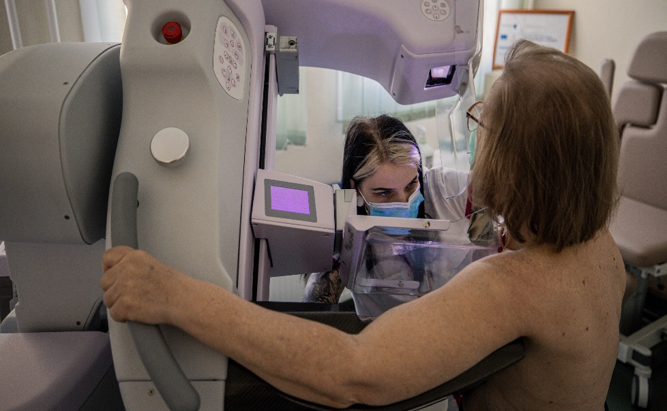
Fig: 1. A.I. imaging diagnostic for detecting spot cancer
Computer-Aided Diagnosis (CAD) systems use A.I. algorithms to aid in interpreting medical images. They analyze images and provide diagnostic suggestions to radiologists or other healthcare professionals. CAD can be handy in the early detection of diseases and abnormalities, increasing the chances of successful treatment. It can streamline radiology workflows by automating tasks such as image sorting, annotation, and measurement. This allows radiologists to focus more on complex cases and make quicker and more accurate diagnoses and techniques like deep learning can be used to enhance image quality and improve the visibility of fine details in medical images. It helps reduce image noise, improve resolution, and enhance image contrast, leading to more accurate interpretations.
It can automate the analysis of histopathology slides, which are traditionally examined under a microscope. By analyzing digital pathology images, A.I. algorithms can assist pathologists in diagnosing cancers and other diseases, reducing the need for manual examination and improving efficiency.
Fig: 2 A.I. and Digital pathology
A.I. systems can provide real-time decision support to healthcare professionals during image acquisition and interpretation. For example, A.I. algorithms can help optimize image acquisition parameters, ensure image quality, and provide immediate feedback on potential issues.
B. ELECTRONIC HEALTH RECORDS
AI holds great promise as a valuable tool in primary care, and one of its potential applications involves using deep learning algorithms to analyze medical data, including imaging scans, lab results, and vital signs. A.I. systems can efficiently identify patterns and anomalies that human observation might overlook, empowering doctors to make more accurate diagnoses and provide targeted treatment. Another possible application is the creation of personalized care plans. By utilizing A.I. to evaluate a patient's medical history and pertinent data, healthcare practitioners can develop tailored treatment plans based on the individual's specific needs and preferences. This approach shows potential for enhancing treatment effectiveness and reducing the risk of complications.
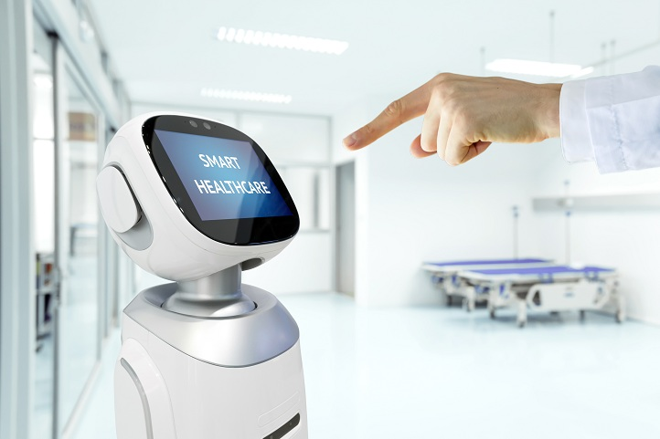
Fig: 3.A.I. in Electronic health record through fingerprint scanning
C. ROBOT-ASSISTED SURGERY
Robotic surgical assistants have transformed healthcare by incorporating artificial A.I. into surgical procedures. These advanced systems combine automated technology's precision and agility with A.I. algorithms' intelligence and decision-making capabilities. As a result, a powerful tool is created that improves surgeon skills and patient outcomes, allowing complex procedures to be performed with greater efficiency and accuracy. Robotic surgical assistants are typically robotic arms outfitted with specialized surgical instruments and a high-definition camera. These arms are operated by surgeons from a console, using intuitive hand movements and controls. The A.I. component comes into play during the procedure by providing real-time feedback and analysis, assisting the surgeon in making informed decisions. Robot assistants help the surgeon in many surgeries, such as; Rectal surgery, bladder-related surgery, cardiovascular surgery etc.
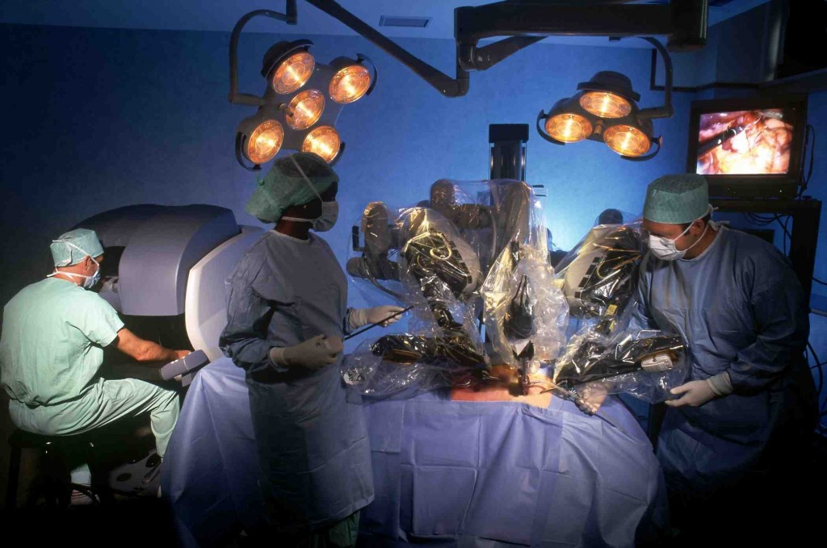
Fig: 4 A.I. in Rectal surgery through Robot-Assisted surgery
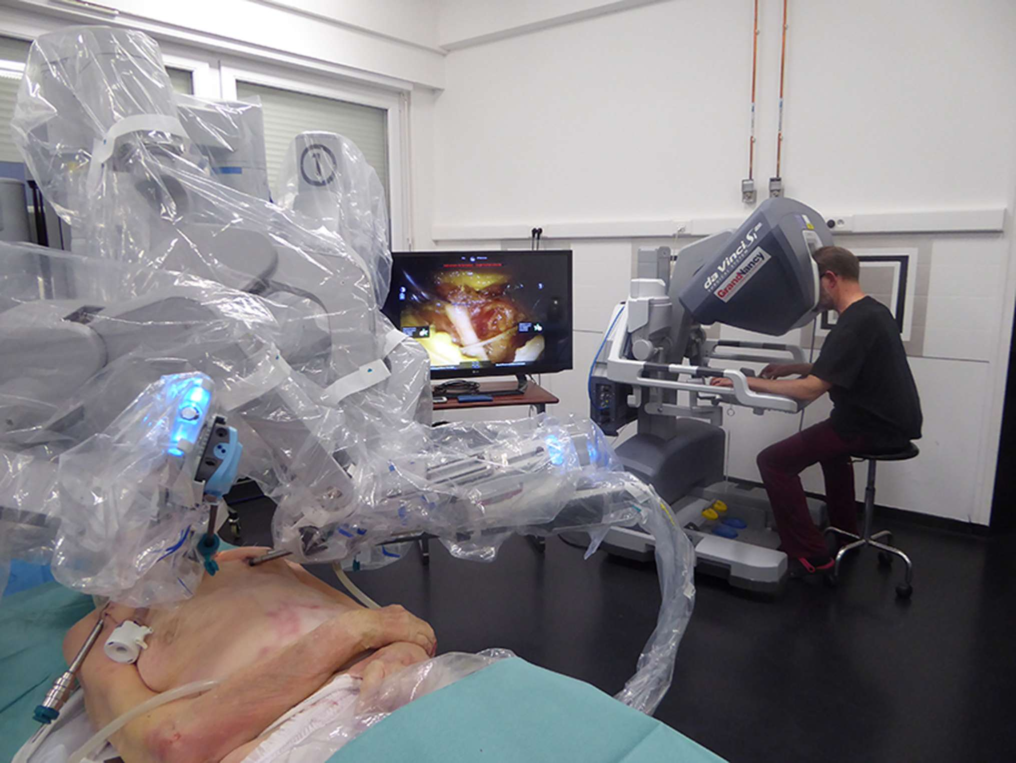
Fig: 5.A.I. Robot-assisted machine in cardiovascular surgery
A key advantage of robotic surgical assistants is their capacity to conduct minimally invasive procedures. By inserting robotic arms and instruments through small incisions in the patient's body, surgeons can access hard-to-reach areas that would be challenging to approach using traditional open surgery. The A.I. algorithms in the robotic system aid in improving visualization, reducing hand tremors, and providing precise movements, resulting in better surgical outcomes and shorter recovery times for patients. Robots possess the unique capability to mimic exact movements, which proves particularly advantageous in hair transplant surgeries. In these procedures, the robot effectively extracts hair follicles and strategically implants them in designated areas of the scalp. Advanced force sensing technology is integrated into the robot, ensuring it maintains the desired force during harvesting and implantation. Moreover, abdominal surgical robots can be controlled using an eye-tracking camera, where surgeons can control the robot's movements by simply moving their eyes. The system also incorporates haptic feedback, enabling surgeons to sense the forces experienced by the robotic arms during the operation.
Robotics-assisted surgery, defined as "the use of a mechanical device to assist surgery in the place of a human being or a human-like manner," rapidly influences many standard general surgical procedures, particularly minimally invasive. In surgery, three types of robotic systems are used:
- Active systems execute predetermined tasks while being supervised and controlled by the operating surgeon.
- Semi-active systems enable surgeons to complement the pre-programmed components of the system with their inputs and interventions.
- Master-slave systems operate without autonomous elements and rely entirely on the surgeon's actions. During laparoscopic surgery or teleportation, the system transmits the surgeon's hand movements to surgical instruments, which faithfully replicate those actions.
Surgeons can benefit from navigation systems that assist in spatial localization and provide answers regarding anatomical orientation. Modern surgical navigation systems, equipped with an infrared-emitting stereoscopic camera and real-time marker tracking, can accurately determine the 3D position of prominent anatomical structures.
Furthermore, A.I. algorithms can analyze massive amounts of medical data, such as patient records, images, and research papers, to help surgeons with pre-operative and intraoperative decision-making. Using this knowledge, the A.I. can provide suggestions and recommendations based on patterns and evidence, allowing surgeons to make more informed decisions during surgery. Robotic surgical assistants have the potential to democratize access to specialized healthcare. They can remotely transmit surgical expertise, allowing surgeons in different locations to collaborate and perform procedures together. This capability provides training, consultation, and improved access to quality healthcare, particularly in underserved areas.
A.I. can drive the evolution of robot-assisted surgery towards cognitive surgical robotics. Current surgical robots used in clinical settings primarily function as telemanipulators without autonomous capabilities. However, in research, there have been advancements in the development of robots designed for situation-aware automatic needle insertion. Using a porcine bowel model, a different system demonstrated superior performance compared to humans in bowel anastomosis. Despite this, even the most advanced robotic systems cannot comprehend the surgical scene or adapt to the surgical workflow. Therefore, it becomes crucial to develop and validate surgical workflow analysis and scene understanding to a degree where they can become dependable sources of information for cognitive surgical robots. The successful establishment of these capabilities is a prerequisite for enabling cognitive robots to proficiently perform auxiliary tasks, including controlling the laparoscopic camera, manipulating tissue, and executing more intricate surgical procedures like anastomosis. An AI-powered cognitive robot will be able to understand its environment and potentially learn from previous experiences, leading to continuous improvements in its performance over time.
Finally, incorporating artificial intelligence into robotic surgical assistants has dramatically altered the healthcare landscape. These cutting-edge systems provide surgeons with increased precision, decision-making assistance, and access to vast medical knowledge. As technology advances, robotic surgical assistants are expected to play a growing role in improving patient outcomes and advancing healthcare.

D. DISEASE PREDICTION AND RISK ASSESSMENT
AI has become a potent tool in the healthcare sector, specifically for disease prediction and risk assessment. A.I. systems can use advanced algorithms and machine learning techniques to analyze extensive patient data to identify patterns indicating disease development or heightened risk. These algorithms process data from various sources, including electronic health records, medical imaging scans, genetic profiles, and wearable devices, enabling them to detect subtle correlations that human observers might overlook. The early detection of diseases like cancer, cardiovascular disorders, and diabetes through A.I.'s predictive capabilities allows healthcare professionals to swiftly intervene and implement preventive measures or treatment plans, leading to improved patient outcomes.

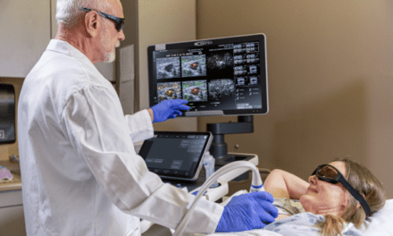
Fig: 6. Used of A.I. in diagnosing Breast Cancer
The potential of artificial intelligence in cancer therapy is far-reaching, spanning drug discovery, drug development, and clinical validation. A recent study focused on various adaptable machine-learning algorithms capable of detecting lung cancer with connections to the Internet of Things. Additionally, it is worth noting that Diabetes Mellitus, commonly known as diabetes, is the primary cause of high blood sugar levels. A.I. is a low-cost method of reducing diabetes-related ophthalmic complications and avoidable blindness. Researchers have demonstrated that artificial intelligence can help to streamline chronic disease care. As a result, various machine learning algorithms are being developed to identify patients at high risk of developing chronic disease. According to researchers, artificial intelligence can predict when heart disease patients will die.
Consequently, various algorithms have been employed to forecast the heart rate's severity and diagnose potential conditions. A.I. is being considered as a possible remedy for tuberculosis. Researchers found that the A.I. system can identify stroke indications in medical images if it suspects a stroke in a patient. Additionally, A.I. can diagnose hypertension by analyzing input data such as blood pressure, demographics, and other relevant factors. A team of researchers has created an artificial intelligence system designed to accurately categorize cutaneous skin issues, offering valuable support to clinicians in enhancing their diagnostic precision. Moreover, researchers have found that A.I. has the potential to identify and treat liver disease at an early stage, thereby improving the prognosis and recovery rate for affected individuals.
One key advantage of A.I. in disease prediction and risk assessment is its ability to learn and improve its performance continually. As more data becomes available and new patterns are discovered, A.I. algorithms can adapt and refine their predictions, enhancing their accuracy and reliability over time. This iterative learning process allows A.I. systems to keep pace with emerging research and medical advancements, ultimately improving patient care and outcomes. Furthermore, A.I. can help address healthcare resource allocation challenges. By accurately predicting disease risks individually, healthcare providers can allocate resources more efficiently, ensuring that those at higher risk receive appropriate interventions while reducing unnecessary procedures and treatments for individuals at lower risk. This targeted approach optimizes resource utilization and enhances overall healthcare system efficiency.
E. DRUG DISCOVERY AND DEVELOPMENT
Artificial intelligence (A.I.) has recently begun to ramp up its application in various sectors of society, with the pharmaceutical industry leading the way. A.I. algorithms can rapidly analyze massive databases of chemical compounds to predict their ability to bind to specific drug targets. This enables virtual screening, where potential drug candidates are identified based on their predicted interactions with target molecules, saving time and cost compared to traditional methods.
Fig: 7. A.I. Robotic Drug Discovery machine

Molecules. By learning from existing compounds and their interactions, A.I. models can generate novel structures with desired properties, optimizing efficacy, safety, and bioavailability. It can help identify novel drug targets by analyzing vast biological data, including genomics, proteomics, and medical literature. By uncovering disease-related patterns and relationships, algorithms can pinpoint potential therapeutic targets that were previously unknown or underexplored.
A.I. algorithms can analyze patient data to identify suitable participants for clinical trials. By considering a range of factors such as medical history, genetics, and demographics, A.I. can optimize trial design, patient recruitment, and outcome prediction, resulting in more efficient and adequate clinical trials. It can accelerate identifying existing drugs that could be repurposed for new therapeutic uses. By analyzing large-scale data, including gene expression profiles, protein interactions, and disease databases, A.I. algorithms can identify potential drug candidates already approved or tested for other indications. A.I. can analyze patient data and electronic health records to identify patterns indicating possible adverse events associated with specific drugs. By detecting signals of safety issues earlier, A.I. can help researchers and regulators make informed decisions regarding drug safety and can assist in optimizing drug formulation and delivery methods. By analyzing drug solubility, stability, and pharmacokinetics data, A.I. algorithms can help design formulations that enhance drug efficacy and patient compliance.
A.I. can potentially revolutionize discovering new drug molecules by replacing the traditional trial-and-error approach. Through computational tools like Quantitative Structure-Property Relationship (Q.S.P.R.), A.I. can effectively address formulation design challenges related to stability, dissolution, porosity, and more. Decision-support systems, driven by rule-based A.I., select appropriate excipients based on the drug's physicochemical properties and continuously adapt the process through feedback mechanisms. As manufacturing processes become more complex and demand for efficiency and product quality rises, modern manufacturing systems aim to transfer human knowledge to machines, reshaping manufacturing practices. The integration of A.I. into pharmaceutical manufacturing processes offers significant advantages. For instance, Computational Fluid Dynamics (C.F.D.), which employs Reynolds-Averaged Navier-Stokes solvers, enables the automation of various pharmaceutical operations by studying agitation and stress levels in equipment like stirred tanks. Additionally, sophisticated methods like direct numerical and extensive eddy simulations address intricate manufacturing flow challenges, showcasing A.I.'s potential to optimize pharmaceutical production.
Nanorobots are highly advanced miniature devices incorporating integrated circuits, sensors, power supplies, and secure data backup. These robots are designed to operate precisely, avoiding collisions and identifying and attaching to specific targets within the body. They can be safely excreted after fulfilling their intended purpose. Recent Nano/micro-robot technology advancements have enabled these devices to navigate through the body based on physiological factors like pH, enhancing their effectiveness while minimizing potential side effects. The development of implantable Nano robots has opened up new possibilities for controlled drug and gene delivery, involving parameters such as dose adjustment and sustained and controlled release. A.I. tools, such as neural networks, fuzzy logic, and integrators, are utilized to automate and optimize drug release from microchip implants within the body. Nanomedicines, which combine nanotechnology and medicine, offer promising approaches for diagnosing, treating, and monitoring complex diseases like Human immunodeficiency virus (H.I.V.), cancer, malaria, asthma, and inflammatory conditions. Integrating nanotechnology and AI can solve formulation development challenges and significantly accelerate the drug discovery and development process, reducing costs and increasing success rates in bringing new drugs to market. However, it is crucial to recognize that while A.I. is a valuable tool, it should complement rigorous scientific research and human expertise rather than replace them entirely.
F.VIRTUAL ASSISTANTS AND CHATBOTS

AI has played a crucial role in developing virtual assistants and chatbots in the healthcare sector. These intelligent systems are designed to engage users, offer information, and assist with various healthcare tasks. While chatbots have been widely used in online retail, their integration into healthcare is gradually becoming more prominent. Well-designed chatbots have the potential to enhance customer retention, attract new users, and provide excellent customer service. With the growing trend of healthcare consumerism, which aims to make healthcare delivery more efficient and convenient, there is a need for better connections with members and patients. Fortunately, the healthcare industry possesses a wealth of plan information and extensive data from digital health records, enabling enriched consumer interactions. AI-enabled virtual assistants tailored for payers, providers, and members can contribute to simplifying and personalizing user experiences throughout the healthcare domain.
Virtual assistants and chatbots can offer personalized support and education to patients. They can answer common health-related questions, provide medication information, explain medical procedures, and offer general health advice. A.I. enables these systems to understand user inquiries, retrieve relevant information from medical databases, and deliver accurate responses. Virtual assistants and chatbots can help users assess their symptoms and determine the appropriate action. By asking questions about symptoms and medical history, AI-powered systems can provide preliminary assessments and triage recommendations, such as suggesting self-care measures, advising a doctor's visit, or indicating the need for urgent medical attention. Driven virtual assistants can assist users in scheduling appointments with healthcare providers. By integrating with scheduling systems, these assistants can check availability, propose suitable appointment slots, and facilitate booking. This automation saves time for both patients and healthcare staff.

Virtual assistants and chatbots can help individuals manage their medications. They can send reminders for medication doses, provide information about drug interactions and side effects, and assist in medication adherence. A.I. algorithms can personalize reminders based on individual schedules and preferences and enable virtual assistants to support remote monitoring and telehealth initiatives. They can collect and analyze data from connected devices like wearable or home sensors to track vital signs, activity levels, or sleep patterns. These assistants can offer insights and alerts to users and their healthcare providers, facilitating remote healthcare management. In addition, it can provide mental health support and interventions. They can offer coping strategies for stress, provide resources for managing mental health conditions, and engage in conversations to alleviate loneliness or anxiety. A.I. algorithms can continuously learn from user interactions and personalize the support provided, and powered virtual assistants and chatbots can help bridge language barriers in healthcare settings. They can translate medical information, instructions, and conversations between patients and healthcare providers, facilitating communication and ensuring better understanding. It is important to note that while virtual assistants and chatbots in healthcare offer valuable support, they should not replace professional medical advice or clinical judgment. These systems should be designed and continuously improved in collaboration with healthcare professionals to ensure data accuracy, privacy, and ethical use.

G. PRECISION MEDICINE

The integration of artificial intelligence (A.I.) and precision medicine holds the promise of transforming healthcare. Precision medicine techniques aim to identify patient phenotypes with unique treatment responses or specific healthcare needs. A.I. contributes to this revolution by employing advanced computation and inference, enabling the system to learn and reason effectively. The result is augmented intelligence that empowers clinicians with valuable insights, enhancing their decision-making capabilities.

A.I. algorithms are used to analyze large-scale genomic data, including deoxyribonucleic acid (D.N.A.) sequencing, gene expression, and genetic variations. By identifying patterns and associations within this data, A.I. can assist in identifying genetic biomarkers, predicting disease risks, and determining the most effective treatments tailored to an individual's genetic profile. It cans integrate patient-specific data, including medical records, imaging results, and genomic information, to provide clinicians with evidence-based recommendations, and algorithms can assist in diagnosing complex diseases, predicting treatment outcomes, and suggesting personalized treatment plans based on patient characteristics.

A.I. is vital in accelerating precision medicine's drug discovery and development process. Machine learning models can analyze vast amounts of biological data to identify potential drug targets, optimize drug candidates, and predict drug response based on individual characteristics. A.I. can also facilitate the repurposing of existing drugs for specific genetic subsets of patients. Precision medicine integrates diverse data sources, including electronic health records, wearable devices, and biomedical research. A.I. techniques, such as natural language processing and data mining, can analyze and extract meaningful insights from these heterogeneous data sources, enabling a comprehensive understanding of patient health and treatment options.

A.I. can analyze patient data to identify individuals at high risk of developing certain diseases. A.I. algorithms can predict disease risks and enable early interventions by considering genetic predisposition, environmental exposures, and lifestyle choices. This allows for preventive measures and personalized interventions to mitigate or delay the onset of diseases, and it can enhance the design and execution of clinical trials in precision medicine. By leveraging A.I. algorithms, researchers can identify suitable patient cohorts based on specific genomic or phenotypic characteristics for clinical trials. A.I. can also aid in monitoring and analyzing trial data, enabling more efficient and precise evaluation of treatment efficacy. The integration of A.I. in precision medicine holds great promise for improving patient outcomes, optimizing treatment strategies, and advancing our understanding of complex diseases. However, it is essential to ensure that A.I. systems are developed ethically, with robust validation and rigorous evaluation, and in collaboration with healthcare professionals to ensure patient safety and privacy.

H. REMOTE PATIENT MONITORING

A.I. has significantly impacted healthcare remote patient monitoring (R.P.M.), transforming patient data collection, analysis, and utilization. R.P.M., or Remote Patient Monitoring, involves using technology to observe patients' health from a distance, enabling healthcare providers to monitor their conditions beyond conventional healthcare facilities. A.I. enhances R.P.M. by improving data analysis, enabling early detection of health issues, and facilitating personalized care.

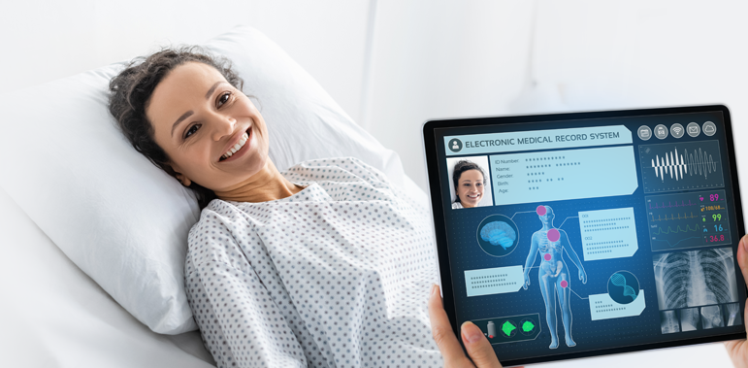
Fig: 8. RPM in Artificial Intelligence
To identify patterns, trends, and anomalies, A.I. algorithms can analyze large volumes of patient data, including vital signs, medical history, and patient-reported symptoms. By leveraging machine learning and predictive analytics, A.I. can provide healthcare professionals with valuable insights and support in making accurate diagnoses and treatment decisions. Powered wearable devices like smart watches or fitness trackers can continuously monitor vital signs and other health parameters. These devices use A.I. algorithms to process the collected data, detecting abnormalities or significant changes in the patient's health status. Real-time monitoring enables early intervention, timely alerts, improved patient outcomes, and predicts potential health risks or complications by analyzing patient data. By applying predictive models to R.P.M. data, A.I. algorithms can identify patients at high risk of developing specific conditions or experiencing adverse events. This enables healthcare providers to intervene proactively and provide targeted interventions to mitigate risks.
It can analyze individual patient data and generate personalized care plans based on their unique health profile. By considering medical history, genetics, lifestyle, and environmental factors, A.I. algorithms can recommend tailored interventions, medication adjustments, or lifestyle changes to optimize patient health outcomes. AI-powered tools can facilitate remote diagnostics by analyzing images like X-rays, CT scans, or pathology slides. Deep learning algorithms can be trained to detect and interpret patterns indicative of diseases, assisting healthcare professionals in making accurate diagnoses remotely. AI-powered chatbots or virtual assistants can interact with patients, answer questions, provide educational materials, and offer essential medical advice. These conversational A.I. platforms can help patients feel supported, informed, and connected to healthcare professionals, even when physically distant.
Overall, AI in remote patient monitoring holds great potential to improve healthcare outcomes, enhance patient experiences, and optimize healthcare resource utilization. It enables timely interventions, early detection of health issues, and personalized care, ultimately leading to more efficient and effective healthcare delivery. Nonetheless, it is crucial to prioritize ethical concerns, safeguard data privacy, and adhere to regulatory requirements when integrating A.I. into healthcare environments.
II.CHALLENGERS FOR ARTIFICIAL INTELLIGENCE IN HEALTH CARE

Various organizations' increasing adoption of A.I. in healthcare brings challenges that demand immediate attention. These challenges revolve around ethical and regulatory concerns, remarkably unique to the healthcare sector. Paramount among them is the issue of data privacy and security. A.I. systems gather vast amounts of personal health data, requiring stringent measures to prevent potential misuse or unauthorized access. Patient safety and accuracy are of utmost importance in healthcare A.I. applications. To guarantee the reliability and safety of AI-generated decisions, conducting comprehensive validation and maintaining transparency in the decision-making process is essential. Moreover, training algorithms to effectively recognize patterns in medical data is a complex task that demands diverse and representative datasets while actively addressing biases.

Integrating A.I. with existing I.T. systems smoothly is another pressing challenge. Seamless integration is crucial to maximizing the benefits of A.I. while minimizing disruptions to established workflows. Gaining the trust and acceptance of physicians is vital for successful A.I. implementation. Proper education and communication can alleviate concerns and demonstrate the advantages of A.I., ultimately leading to its practical use in healthcare settings. Adhering to federal regulations, such as the health insurance portability and accountability act (HIPAA), is non-negotiable when dealing with healthcare data. Strict compliance is necessary to protect patient privacy and prevent legal consequences. Incorporating robust security measures is essential to safeguard sensitive patient data from potential exploitation for malicious purposes when utilizing A.I. in healthcare. Patient safety and accuracy are:

- Paramount concerns in A.I. implementation.
- Requiring A.I. systems to be proficient in recognizing patterns in medical data.
- Understanding relationships between diagnoses and treatments.
- Providing precise, personalized recommendations for each patient.

Integrating A.I. with existing I.T. systems can introduce complexities for medical providers, necessitating a comprehensive understanding of the current technology to ensure seamless operation. However, A.I. automation can potentially replace specific job roles, leading to unemployment or changes in employment opportunities in specific sectors or professions. To address this, reskilling or upskilling the workforce may become necessary to adapt to emerging roles in AI-driven healthcare.

Incorporating A.I. techniques into healthcare delivery poses distinctive challenges beyond the technical limitations that exist compared to human capabilities in vision, language processing, and context-specific reasoning. Healthcare professionals have historically been cautious about adopting new technologies, often preferring established methods for providing clinical care. Even with proper regulatory approval, introducing AI-enabled applications will likely encounter resistance and opposition within the healthcare industry.

Precise clinical diagnostics face ongoing challenges that demand continuous improvement to combat emerging illnesses and diseases effectively. Despite significant advancements, medical professionals acknowledge the obstacles that must be surmounted before AI-driven diagnostics can reliably predict conditions and associated symptoms. Doctors' scepticism towards AI-based approaches stems from uncertainties about their accuracy in disease detection. Therefore, substantial efforts are necessary to train A.I. systems and enhance the precision of disease diagnosis. In the years to come, AI-based research should be conducted with full awareness of these constraints, fostering a collaborative partnership between A.I. and clinicians to enhance patient outcomes. Furthermore, adopting a decentralized, federated learning approach can facilitate the development of a unified training model for disease datasets in remote locations, assisting in the early detection of illnesses.

Finally, gaining medical providers' acceptance and trust is critical for successfully implementing A.I. in healthcare. Physicians must trust the reliability of A.I. systems and their ability to provide accurate guidance. Transparency becomes crucial as physicians need to understand how the A.I. system arrives at decisions, ensuring it relies on valid and current medical research. Additionally, adherence to federal regulations is essential to ensuring the ethical use of A.I. systems and safeguarding patient safety and well-being.

III.CONCLUSION
Integrating A.I. in basic healthcare facilities is poised to reduce costs, making essential healthcare more affordable and accessible. With the rise of communicable and non-communicable diseases and new virus infections, A.I. will be crucial in swift disease detection and more effective patient care. The increasing population is straining healthcare staff, leading to sleep deprivation and mental exhaustion, adversely affecting patient treatment. However, rapid advancements in A.I. research, backed by government and industry support, make it highly probable that A.I. will be widely adopted in healthcare delivery, offering substantial cost savings and improved service quality. AI-smart robots will assist healthcare staff in providing more efficient patient care, alleviating their burden. Empowering individuals with AI-powered intelligent watches and bands will enable them to detect minor ailments, saving time and money otherwise spent on hospital visits. The vast potential of artificial intelligence continues to grow, promising significant assistance to humanity through ongoing innovations.
However, challenges such as data quality, bias, ethical considerations, human-AI collaboration, and technical limitations must be addressed. Furthermore, responsible A.I. practices and regulatory frameworks must mitigate potential adverse effects of A.I. in healthcare, such as job displacement, bias and discrimination, security and privacy risks, and ethical concerns. By navigating these challenges and responsibly deploying A.I. in healthcare, we can harness its full potential to improve patient care, optimize treatment outcomes, and enhance the healthcare experience. A.I., when implemented ethically and in collaboration with healthcare professionals, can be valuable in advancing healthcare delivery and positively impacting global well-being.

REFERENCES:

[1] Topol, E. J. (2019). High-performance medicine: the convergence of human and artificial intelligence. Nature medicine, 25(1), 44-56.

[2] Chen, J., & Asch, S. M. (2017). Machine learning and prediction in medicine: beyond the peak of inflated expectations. New England Journal of Medicine, 376(26), 2507-2509.

[3] Davenport, T., & Kalakota, R. (2019). The potential for artificial intelligence in healthcare. Future healthcare journal, 6(2), 94.

[4] Fig 1.1 Source: Choi, J. W., & Kim, H. C. (2018). Artificial intelligence in medical imaging: Current advances and future directions. Pre cision and Future Medicine, 2(3), 115-121.

[5] Fig 1.2 Source: Sharma, A., & Mishra, S. (2020). Artificial Intelligence and Its Application in Pathology. Journal of Oral and Maxillofacial Pathology, 24(3), 442.

[6] Wang, D., & Khosla, A. (2021). Artificial Intelligence in Primary Care: A Scoping Review. Primary Care: Clinics in Office Practice, 48(2), 359-376.

[7] Fig 2 Source: Sharma, A., & Mishra, S. (2020). Artificial Intelligence and Its Application in Pathology. Journal of Oral and Maxillofacial Pathology, 24(3), 442.

[8] Fig 3.1 Source: Al-Jabir, A., Kerwan, A., Nicola, M., Alsafi, Z., Khan, M., Sohrabi, C., & Amawi, H. (2020). Impact of the Coronavirus (COVID-19) pandemic on surgical practice-Part 2 (surgical prioritisation). International Journal of Surgery, 79, 233-248.

[9] Fig 3.2 Source: Zhou, S., Liao, H., Nie, Z., He, Y., Hu, Y., Wu, W., ... & Chen, Y. (2019). Novel design and fabrication of a soft robotic hand for minimally invasive surgery. Soft Robotics, 6(1), 123-135.

[10] Oprea, A. D., Talpos-Niculescu, C., Rusu, M. C., Vaida, C., & Oprea, G. (2020). Advances in robotic technology and artificial intelligence in surgery. Journal of Mind and Medical Sciences, 7(2), 224-230.

[11] Fig 3.3 Source: Noh, Y. (2021). Image-guided surgery using augmented reality and artificial intelligence. Journal of the Korean Medical Association, 64(9), 647-656.

[12] Fig 3.4 Source: Davenport, T., & Kalakota, R. (2019). The potential for artificial intelligence in healthcare. Future healthcare journal, 6(2), 94.

[13] Fig 4 Source: Gholami, M., & Salimi, M. (2020). Application of Artificial Intelligence for Breast Cancer Diagnosis: A Comprehensive Review. Breast Cancer: Targets and Therapy, 12, 157.

[14] Guntaas, S., Paul, R. S., Kaur, H., & Gupta, A. (2021). Application of Artificial Intelligence and Machine Learning in Predicting and Diagnosing Various Diseases: A Review. Journal of Big Data, 8(1), 1-13.

[15] Lundberg, S. M., & Lee, S. I. (2017). A unified approach to interpreting model predictions. In Advances in neural information processing systems (pp. 4765-4774).

[16] Minaee, S., Kalchbrenner, N., Cambria, E., Nikzad, N., & Chenaghlu, M. (2021). Deep learning in drug discovery and medicine; Scratching the surface. Computational and Structural Biotechnology Journal, 19, 2951-2975.

[17] Fig 5 Source: Colasanti, R., & Bovo, E. (2021). Artificial intelligence and the drug discovery process: challenges and perspectives. European Journal of Medicinal Chemistry, 219, 113419.

[18] Xu, Y., & Wang, X. (2018). Drug discovery: AI to the rescue?. Science, 360(6385), 478-479.

[19] Tian, F., Zhang, H. H., Zhang, J. G., Huang, Y. P., & Pan, L. L. (2021). A systematic review of artificial intelligence in drug discovery. Expert Opinion on Drug Discovery, 16(1), 17-31.

[20] Prajapati, K. D., Patel, K., Modi, H., & Patel, M. (2014). Artificial intelligence techniques in formulation development: A review. Asian Journal of Pharmaceutical Sciences, 9(4), 163-170.

[21] Chatbots in healthcare: Where are we now? (2018). Healthcare IT News.

[22] Abd-Alrazaq, A. A., Rababeh, A., Alajlani, M., Bewick, B. M., Farran, B., Househ, M., & Shah, Z. (2020). Artificial Intelligence Chatbot Application as a Tool to Address the COVID-19 Pandemic: Development and Implementation Study. Journal of Medical Internet Research, 22(8), e20420.

[23] Restifo, A., Narayan, A., Malkani, S., Uppal, J., Chu, S. K., & Vawdrey, D. K. (2020). Using virtual health assistants and chatbots in clinical practice: Systematic review. Journal of Medical Internet Research, 22(10), e20246.

[24] Esteva, A., & Topol, E. J. (2019). Reinventing clinical trials with artificial intelligence. JAMA, 322(20), 1901-1902.

[25] Kumar, P., Sharma, M., & Patel, S. K. S. (2021). AI and Precision Medicine in Oncology: A Need of Present and Future. Frontiers in Pharmacology, 12, 11.

[26] Fig 6 Source: Gao, R., Ai, J., Cui, Y., & Li, J. (2021). The Role of Remote Patient Monitoring in Chronic Disease Management. Frontiers in Medicine, 8, 13.

[27] Khoja, S. (2020). Artificial intelligence in remote patient monitoring. Journal of the American Medical Association, 323(23), 2380.

[28] Dixon, B. E., & Cassel, C. K. (2020). AI and the future of medicine. Annals of Internal Medicine, 173(1), 59-60.

[29] Ong, S. L., & Koh, J. W. K. (2018). AI in healthcare: The end of physicians? Annals of the Academy of Medicine, Singapore, 47(11), 477-478.

