Mathematical Modelling for Radial Overcut on Mechanical Micro drilling of CFRP-Ti6Al4V Stack Composite by Response Surface Methodology

Mr. Rahul Raju Kundiya
Assistant Professor, Dept. of Mechanical Engg.
VPM’s MPCOE, Velneshwar
Guhagar, India
rahulkundiya1999@gmail.com/rahul.kundiya@vpmmpcoe.org

Dr. P. V. Jadhav
Professor, Dept. of Mechanical Engg.
Bharati Vidyapeeth (Deemed to be University)
Pune, India
pvjadhav@bvucoep.edu.in

Mr. Swanand Joshi
Assistant Professor, Dept. of Mechanical Engg.
VPM’s MPCOE, Velneshwar
Guhagar, India
swanand.joshi@vpmmpcoe.org

ABSTRACT

Response surface approach is used in this work to estimate radial overcut in the mechanical micro drilling process for CFRP-Ti6Al4V stack composite. To investigate the radial overcut, spindle speed, feed rate, and MQL flow rate are used as input process parameters. The central composite design (CCD) approach was used to plan the tests. A mathematical model was constructed after 20 tests to link the impacts of various machining factors with radial overcut. ANOVA at the 5% level of significance yielded the significant coefficients. Based on the data, it was discovered that spindle speed has a substantial influence on radial overcut. The projected findings based entirely on established models are found to be in good agreement with the expected values, with the coefficient of determination 0.7482 for radial overcut fitting the experimental data relatively well.

Keywords—Mechanical micro drilling, Radial overcut, CFRP/Ti6Al4V, Central composite design, Response surface methodology

INTRODUCTION
In aerospace, CFRP-Ti6Al4V stack composite is utilised for engine cowlings, wing connections, wing panels, and nacelles. A 0.8 mm to 1.25 mm thick sheet of CFRP/Ti alloy is utilised for the cowling of the high performance engine of the 757 Dreamliner, Falcon 900 business jet, Airbus A320, and F-16XL aircraft.

Modern composite materials like CFRP/Ti stack, which have amazing structural properties including a high strength-to-weight ratio, precise corrosion resistance, high layout flexibility, and others, are widely used in the aircraft industry today. The stacked composite may provide the combined structural benefits of each stacked phase while minimising their individual weaknesses since it is made up of two different elements, CFRP and Ti alloy. For instance, the Ti alloy displays strong strength-to-weight ratio, excellent fracture resistance, isotropic behaviour, and exhibits good reparability whereas the CFRP composite exhibits high specific stiffness, superior corrosion resistance, and remarkable fatigue strength. While the lack of low impact energy and repairable difficulties of composites are often avoided, the lack of fatigue strength and corrosion resistance of metals are frequently addressed by the metal alloy-to-composite alliance in a layered composite structure. [1-3]

Mechanical micro drilling is capable of producing minute holes as long as the tool's surface is tougher than the workpiece. This method involves repeatedly inserting and removing the drill from the hole, which creates a hole. The technique's potential may be seen in its ability to drill holes as small as 50 micrometres in metals, plastics, and polymers. Drill bits are used to cut holes in soft metals such as brass and copper. These drill bits are made of high-speed steel, tungsten, and other hard materials. Because more tiny and micro gadgets are being used, there is a growing demand for micro drilling, or creating holes that are smaller than 1 mm in diameter. miniature drilling is most commonly used in the automotive, aeronautics, electronics, and therapeutic domains. [4-5]

Several studies looked on mechanical micro-drilling of challenging materials. According to a study by R Landge et al., mechanical micro-drilling of brass material was evaluated experimentally using speed, feed, hole depth, and machining time as input machining parameters. The mathematical models for the MRR response were developed using response surface techniques. [6]

A work on the optimisation of mechanical micro-drilling of CFRP employing spindle speed, feed rate, and drill diameter as input machining parameters was written by K. Shunmugesh et al. Mathematical models for the circularity and cylindricity errors were developed using the Taguchi technique. Low feed rate and high spindle speed are used to reduce circularity and cylindricity errors. [7]

In order to create, enhance, and optimise processes, the Response Surface Methodology (RSM) combines several input variables and analyses how their intricate connections affect the performance of the response variables as a whole. [10-11]. RSM creates the version utilising a statistical layout of test techniques, such the central composite design, and then mounts ANOVA checks to measure the performance of the recommended model. To observe how input variables impact responses, 3D response graphs can be employed. The RSM technique has been used extensively in studies to assess the effectiveness of industrial processes. [8-9], [12-13]

The literature study found no published research on the mechanical micro-drilling of CFRP-Ti6Al4V stack material. In order to produce a mathematical radial overcut using input parameters like spindle speed, feed rate, and MQL flow rate, the response surface technique is used in this study. The suitability of the developed model was assessed using an ANOVA test, and the impact of machining parameters on radial overcut was investigated via 3D response graphs.

EXPERIMENTAL DETAILS

The studies were carried out on an Interface design associates private limited, India, SMD10B CNC micro drilling machine. The machine's aerostatic spindle has a capability of 6001 rpm to 60000 rpm. Lubricant oil was a brown transparent emulsified oil. CFRP and Ti6Al4V grade 5 workpieces were employed in the trials. The mechanical characteristics of Ti6Al4V and CFRP are shown in Tables 1 and 2.

Table 1. Mechanical properties of Ti6Al4V
Workpiece (Young’s modulus) | Density(kg/m3) | Hardness HV | Yield strength  (MPa) | Tensile strength (MPa) | Thermal conductivity  (W/m K)
Mechanical properties  Ti-6Al-4V (120 GPa) | 4420 | 349 | 880 | 950 | 6.7

Table 2. Mechanical Properties of CFRP
Properties | value
Density, g/cm^3 | 1.9
Young's Modulus, GPa | 250
Shear Modulus, GPa | 110
Uniform Elongation, % | 1.9
Poisson's Ratio | 0.33

CFRP and Ti6Al4V were stacked using Araldite AW134 Epoxy resin. T5401 grade - TiN coated tungsten carbide (coating thickness 0.2-0.5 micron) was employed for the current investigation. For the purposes of this investigation, a micro drill with a diameter of 0.4 mm and a point angle of 140 degrees was used..

Figure 1 shows the diameter of holes generated in the work material measured using an optical microscope (ALICONA Infinite focus). The Radial overcut is described by Veenaraja et al. (2013) as half the difference between the diameter of the hole created and the diameter of the tool.[15]

$Radial overcut= \frac{d_{jt }- d_{t}}{2}$ (1)

Here, dt denotes the tool's diameter whereas djt denotes the size of the hole the tool left in the workpiece.

EXPERIMENTAL DESIGN AND PARAMETER SELECTION

The response surface methodology (RSM), which investigates how the performance of the response variables is influenced by the extensive interconnections of the input variables, is an excellent tool for building, improving, and optimising processes. The response surface is often characterised by the following equation [14]:

$Y=β_{0}+\sum_{i=1}^{s}{}β_{i}χ_{i} +\sum_{i=1}^{s}{}β_{i}χ_{i}+\sum_{i=1}^{s}{}β_{ii}χ_{i}^{2}+\sum_{i=j}^{s}{}β_{ij}χ_{i}χ_{j}+ ε$ (2)
Table 3. Selected machining parameter and its levels
Name | Units | Lowest | Low | Centre | High | Highest
Spindle Speed | rpm | 26591 | 30000 | 35000 | 40000 | 43408
Feed Rate | mm/min | 1.03 | 1.2 | 1.45 | 1.7 | 1.87
MQL flow rate | ml/hr | 99 | 150 | 225 | 300 | 351

RSM creates the model using statistical design of experiments methodologies such as the central composite design (CCD), and then uses ANOVA tests to assess how well the proposed model works. The trials were built using the experimental design method known as the CCD approach. The coefficients of the regression model may be calculated from the experiment results using the statistical tool Design Expert 13.0. Based on the literature on mechanical micro drilling study and the operating characteristics of the selected machine, spindle speed, feed rate, and MQL flow rate were chosen as the machining parameters for this work. Table 3 shows the selected machining parameters and their levels.

Table 4. CCD design layout and experimental results

 | Factor 1 | Factor 2 | Factor 3 | Response
Run | A:Spindle speed | B:Feed rate | C:MQL flow rate | Radial overcut
 | RPM | mm/min | ml/hr
1 | 30000 | 1.2 | 150 | 3.45
2 | 40000 | 1.2 | 150 | 28.24
3 | 30000 | 1.7 | 150 | 12.6
4 | 40000 | 1.7 | 150 | 15.7
5 | 30000 | 1.2 | 300 | 9.21
6 | 40000 | 1.2 | 300 | 11.13
7 | 30000 | 1.7 | 300 | 17.6
8 | 40000 | 1.7 | 300 | 20.8
9 | 26591 | 1.45 | 225 | 3.35
10 | 43408 | 1.45 | 225 | 32.25
11 | 35000 | 1.02955 | 225 | 25.51
12 | 35000 | 1.87045 | 225 | 20.11
13 | 35000 | 1.45 | 98.8655 | 2.36
14 | 35000 | 1.45 | 351.134 | 7.21
15 | 35000 | 1.45 | 225 | 5.12
16 | 35000 | 1.45 | 225 | 11.56
17 | 35000 | 1.45 | 225 | 8.35
18 | 35000 | 1.45 | 225 | 0.11
19 | 35000 | 1.45 | 225 | 8.35
20 | 35000 | 1.45 | 225 | 19.56

EXPERIMENTAL RESULT AND DISCUSSION

A total of 20 experimental runs for the CCD were performed, according to the input data in Table 4. As illustrated in Fig. 1, an optical microscope (ALICONA) may be used to measure the diameter of machined holes on work materials. The output response, or radial overcut, is then calculated for each run and reported in Table 4.

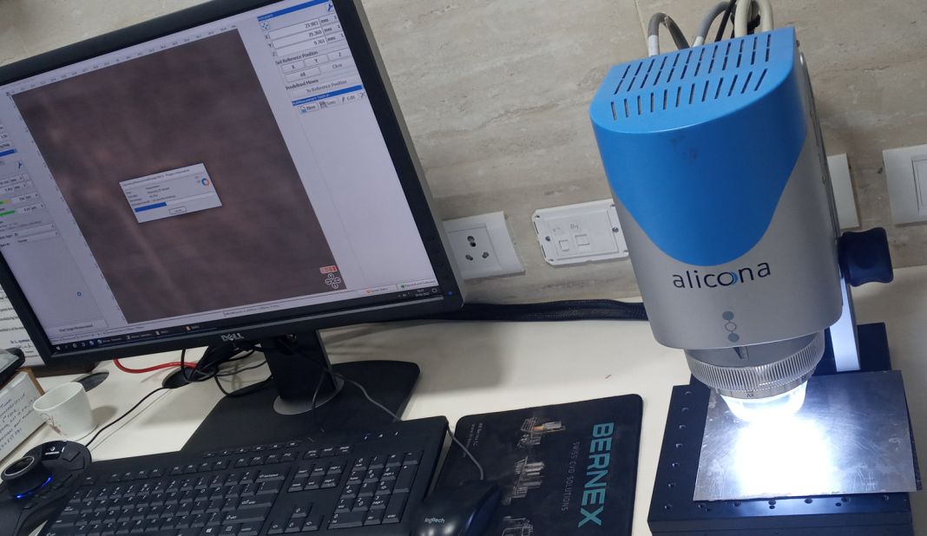
Fig.1 Measuring diameter of machined micro holes on work material by ALICONA optical microscope.

- Development of Mathematical model for radial overcut and ANOVA

The Design Expert software and the pertinent experimental data from Table 4 were used to create the mathematical model, which was used to relate how the machining settings affected the size of the radial overcut. The quality of fit of the model must be assessed before data analysis may proceed. The tests for the regression model's significance, the significance of the model coefficients, and the test for poor fit are all a part of the model adequacy checking. Analysis of variance (ANOVA) is used to achieve this goal. The quadratic model is statistically significant for radial overcut analysis, according to the fit summary. ANOVA Table 5 presents the findings of the quadratic model for radial overcut.

The model appears remarkable based on its Model F-value of 3.30. Just 0.01% of the time may noise cause a "Model F-Value" of this size. Table 5's "Prob > F" values indicate that model terms with 95% confidence intervals less than 0.05 are significant. A, AB, and B2 were significant model variables in this situation. The model terms are not significant if the value is greater than 0.1000. If your model has many unnecessary words (apart from those necessary to maintain hierarchy), model reduction may help it.

The "Lack of Fit F-value" of 0.8510 indicates that there is no statistically significant difference between the Lack of Fit and the pure error. A "Lack of Fit F-value" this high might be due to noise with a 56.81% possibility. It also displays the R-Squared and corrected R-Squared values for the model. The better the response model matches the experimental data, the closer R2 is to unity. According to the calculated R-Squared value of 0.7482, the model explains around 74.82% of the ROC variance. A fair agreement can be drawn between the "Pred R-Squared" value of 0.4624 and the "Adj R-Squared" value of 0.5215. Furthermore, the "Adeq Precision" score of 5.5638 for this model suggests a sufficient signal and is higher than 4. Utilise the design space's navigational tools.

Table 5. Analysis of variance for radial overcut model
Source | Sum of Squares | df | Mean Square | F-value | p-value
Model | 1170.52 | 9 | 130.06 | 3.30 | 0.0383 | significant
A-Spindle speed | 487.63 | 1 | 487.63 | 12.38 | 0.0056
B-Feed rate | 2.29 | 1 | 2.29 | 0.0581 | 0.8144
C-MQL flow rate | 3.50 | 1 | 3.50 | 0.0888 | 0.7719
AB | 52.07 | 1 | 52.07 | 1.32 | 0.0421
AC | 64.81 | 1 | 64.81 | 1.64 | 0.2286
BC | 57.51 | 1 | 57.51 | 1.46 | 0.2548
A² | 131.91 | 1 | 131.91 | 3.35 | 0.0972
B² | 331.59 | 1 | 331.59 | 8.42 | 0.0158
C² | 35.80 | 1 | 35.80 | 0.9086 | 0.3630
Residual | 393.99 | 10 | 39.40
Lack of Fit | 181.14 | 5 | 36.23 | 0.8510 | 0.5681 | not significant
Pure Error | 212.85 | 5 | 42.57
Cor Total | 1564.51 | 19
R² | 0.7482
Adjusted R² | 0.5215
Predicted R² | 0.4624
Adeq Precision | 5.5638

Backward elimination is used to remove non-significant terms from the fitted quadratic model before it is adjusted for ROC. The following is how the final ROC quadratic model is arrived at:
$ROC=8.86+10.05A-7.21AB+13.54B^{2}$

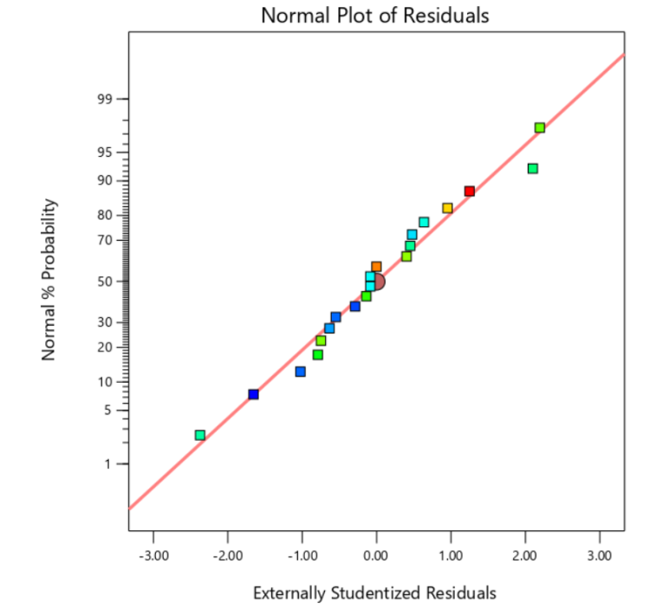
Fig. 2. Normal probability plot for radial overcut

When the data's underlying assumptions about normality are tested, it can be seen in Fig. 2 that every point on the normal plot is nearly straight.

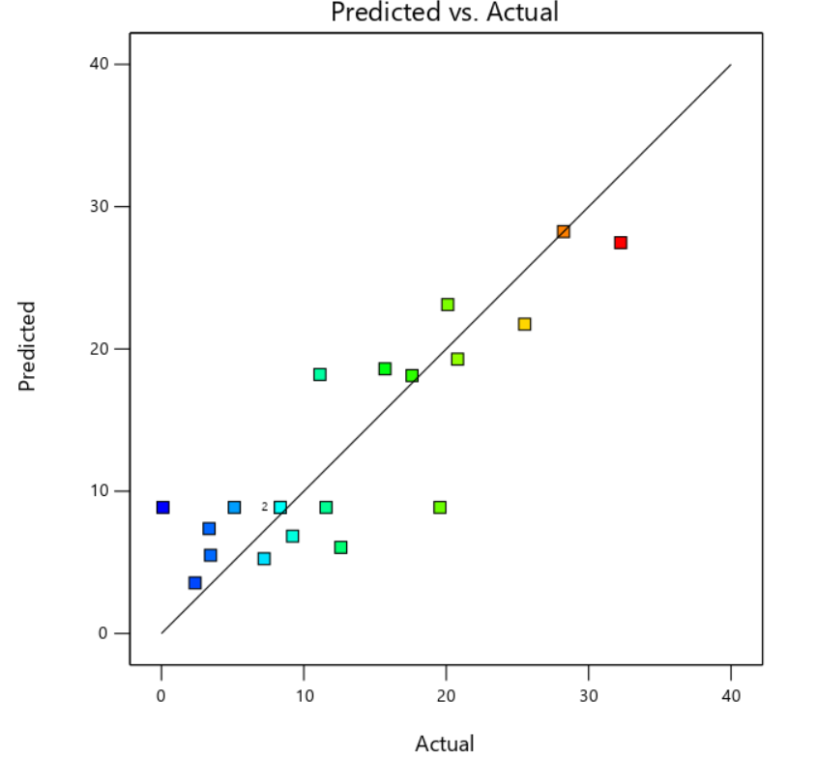
Fig. 3. Comparison with predicted radial overcut with experimental data

Additionally, each experimental data set is contrasted with the projected data derived from the model and shown in Fig. 3. It is evident that the expected values for the radial overcut reasonably match the experimental results.

- Effect of machining parameters on the radial overcut

Radial overcut is an intrinsic characteristic of the micro drilling process that cannot be avoided, even when appropriate compensations are supplied at the tool design. Overcut should be kept to a minimum in order to obtain improved precision in the mechanical micro drilling process. As a result, the parameters impacting the radial overcut must be identified. Figure 4 depicts how spindle speed and feed rate affect radial overcut. Minimum radial overcut occurs with a medium spindle speed and a medium feed rate. It can be seen that the medium level of feed rate is optimum for reducing radial overcut.

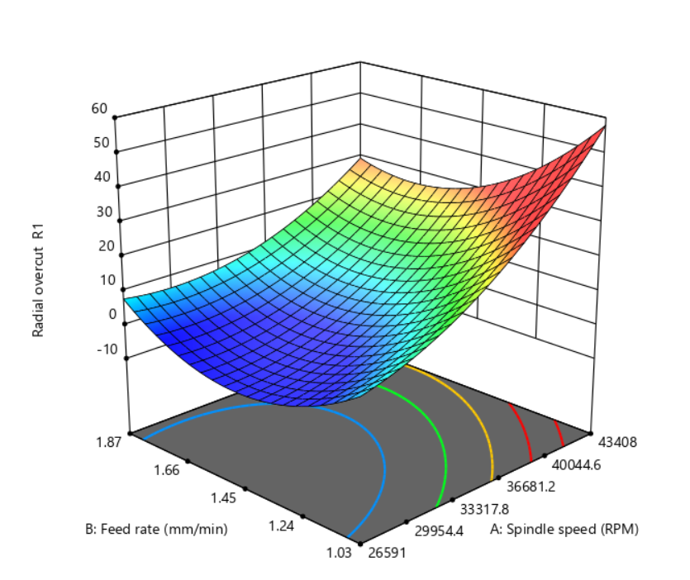
Fig. 4. Response surface plot for radial overcut Vs spindle speed and feed rate

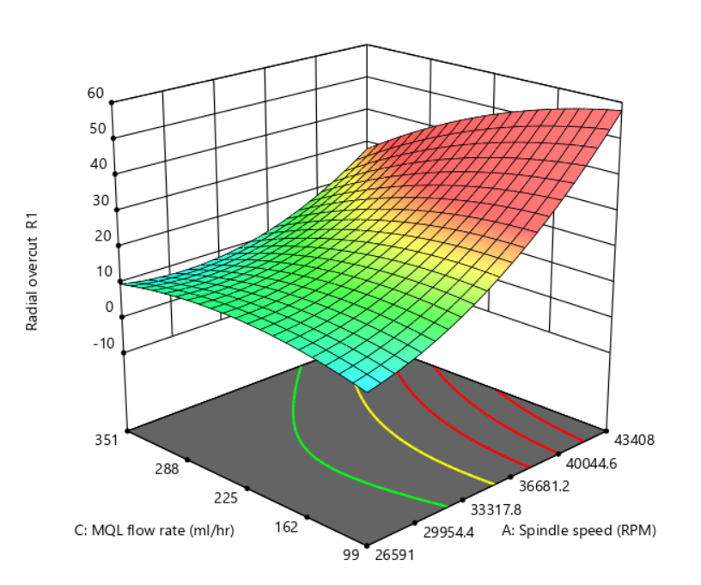

Fig. 5. Response surface plot for radial overcut Vs spindle speed and MQL flow rate

Figure 5 depicts the expected surface response for radial overcut in relation to spindle speed and MQL flow rate. It can be seen that lowest radial overcut occurs at a low MQL flow rate and at the middle spindle speed. It can be seen that increasing the spindle speed increases the radial overcut.

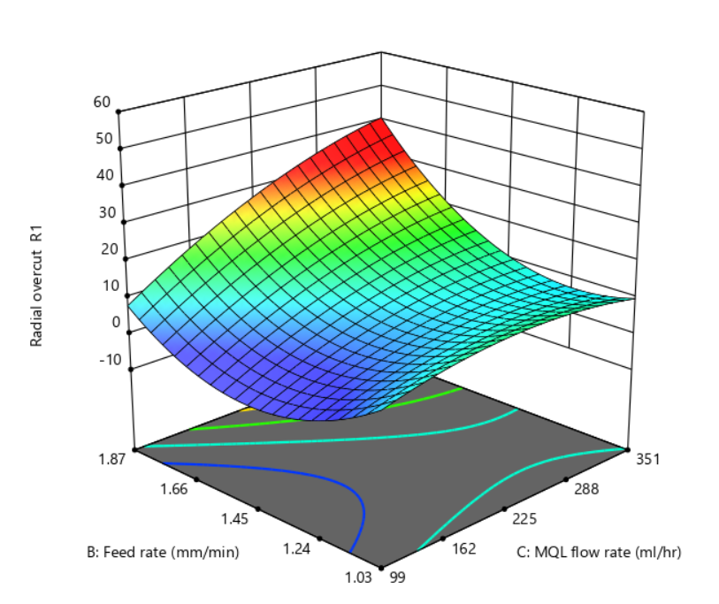
Fig. 6. Response surface plot for radial overcut Vs feed rate and MQL flow rate
The influence of feed rate and MQL flow rate on radial overcut is depicted in Figure 6. It is evident that the smallest radial overcut occurs for feed rates around the middle of the range and flow rates near the middle of the range, as well as spindle speeds near the centre of the range. It is obvious that MQL flow rate influences radial overcut more than feed rate and spindle speed.

Spindle speed is directly related to the centrifugal force acting on the lubricating fluid contained in the gap between tool and workpiece, which contains debris particles, according to graph trends. As a result, increasing the spindle speed somewhat reduces radial overcut. greater feed rate increments with rapid increases in spindle speed are attributable to greater friction between tool and work piece. As a result of the increased heat generation and wear, a bigger radial overcut occurs.

CONCLUSION

An effort was made in this work to use response surface methods to forecast radial overcut in mechanical micro drilling of CFRP-Ti6Al4V stack composite material. Twenty tests were successfully carried out for three input parameters at five levels using the central composite design (CCD) approach. Using the experimental data, the mathematical model for radial overcut was constructed on the basis of RSM. ANOVA findings demonstrate that spindle speed is a very significant parameter, whereas feed rate and MQL flow rate are non-significant parameters when radial overcut reaction is taken into account. With a coefficient of determination of 0.7482 for radial overcut, the projected values match the experimental data quite well. According to the response surface plots, the intermediate level of spindle speed and feed rate significantly reduces radial overcut. The results of this study show that response surface approach can be utilised to successfully simulate the input machining parameters of the mechanical micro-drilling process for CFRP-Ti6Al4V stack composite. The findings can be expanded in the future to build models for additional reactions such as hole taper and delamination factor.

REFERENCES
[1] Jinyang Xu, Mohamed El Mansori.Experimental study on drilling mechanisms and strategies of hybrid CFRP/Ti stacks, Composite Structures 157 (2016) 461–482, Elsevier

[2] Isbilir, Ozden and Ghassemieh, Elaheh. (2013). Comparative study of tool life and hole quality in drilling of CFRP/titanium stack using coated carbide drill. Machining Science and Technology.

[3] Islam Shyha, Sein Leung Soo, David K. Aspinwall, Sam Bradley, Stuart Dawson, Cornelius J. Pretorius, 2010, Drilling of Titanium/CFRP/Aluminium Stacks, Key Engineering Materials ISSN: 1662-9795, Vols. 447-448, pp 624-633.

[4] Hasan, M., Zhao, J. and Jiang, Z. (2017). A review of modern advancements in micro drilling techniques. Journal of Manufacturing Processes, 29 343-375.

[5] Heinemann, R., et al., The performance of small diameter twist drills in deep-hole drilling. Journal of manufacturing science and engineering, 2006. 128(4): p. 884-892.

[6] R. landge, A. borade, 2017. Analysis of Micro-Drilling Process Using Response Surface Methodology., International Journal of Applied Engineering Research ISSN 0973-4562 Volume 12, Number 20 (2017) pp. 9570-9574

[7] K shunmugesh, K pannerselvam, 2018. Multi purpose optimisation of micro drilling using taguchi technique based on membership function., Indian Journal of Engineering and Material science, pp. 383-390.

[8] Djoudi, Aissani-Benissad, F., Bourouina-Bacha, 2007. Optimization of copper cementation process by iron using central composite design experiments. Chemical Engineering Journal 133, 1–6.

[9] Gopalakannan, S., Senthilvelan, T., 2013. EDM of cast Al/SiC metal matrix nanocomposites by applying response surface method. International Journal of Advance Manufacturing Technology 67, 485–493.

[10] Lin, Y.C., Tsao, C.C., Hsu, C.Y., Hung, S.K., Wen, D.C., 2012. Evaluation of the characteristics of the micro electrical discharge machining process using response surface methodology based on the central composite design. International Journal of Advance Manufacturing Technology 62, 1013–1023.

[11] Natarajan, U., Periyanan, P.R., Yang, S.H., 2011. Multiple-response optimization for micro-end milling process using response surface methodology. International Journal of Advance Manufacturing Technology 56, 177–185.

[12] Sohani, M.S., Gaitonde, V.N., Siddeswarappa, B., Deshpande, A.S., 2009. Investigations into the effect of tool shapes withsize factor consideration in sink electrical discharge machining (EDM) process. International Journal of Advance Manufacturing Technology 45, 1131–1145.

[13] Tsao, C.C., 2008. Comparison between response surface methodology and radial basis function network for core-center drill in drilling composite materials. International Journal of Advance Manufacturing Technology 37, 1061–1068.

[14] Sameh, S.Habib., 2009. Study of the parameters in electrical discharge machining through response surface methodology approach. Applied Mathematical Modelling 33, 4397–4407.

[15] Veenaraja, D., Muthukumar, V., Venkatasamy, R., Dharmendhirakumar, M., Sureshbabu, A., Senthilkumar, N., 2013. “Impact of Machining Parameters on the EDM Process Responses: A Taguchi Approach for Al-SiC MMC,” 4th Nirma University International Conference on Engineering. Ahmedabad, India, paper#2251.

