AI IN CARS FOR FUTURE INNOVATION WITH MACHINE LEARNING
PAVANA A B, AKILA S D, SHONA R, SIVA PRAKASH D,
II M.Sc. Computer Science,
Department of Computer Science, Dr.N.G.P.Arts and Science College, Coimbatore-48

Abstract
Artificial intelligence is the one of the top most growing sectors as the technology grows faster the machine jumps learning faster the machine starts learning the day to day process known as the machine learning by using the stored information the Artificial intelligence is grown as quicker the technology grows. Some statistical information says that the AI market is expected to reach a net worth of 190 billion American dollars by 2025 and worldwide 75% enterprise apps will use Artificial intelligence with machine learning for their improvement. AI is the future world as it has the ability to record, analyze and act upon the situation. This is our upcoming, “Let's get into the future through AI”. The AI can sense the current situation using the sensors like humidity, temperature, rain and so on. This can be implemented using the IoT sensors that can sense the environment day to day and make them as a routine. This can be the future.

Keyword
AI-Technology-machine learning-IoT-future-growing technology-innovation-future technology.

Introduction
The AI is the future here we say because of the machine learning the technology grows as well as the machine starts learning nowadays has the ability to learn that are called as the artificial intelligence that learn by the daily routine of the human or anything else.
When the machine starts learning the human resource is reduced as well as the CNC that stands for Computer Numerical Control machine that can be programmed several times as we need them to do this is a human controlled machine as now the machine starts learning for example if we have our home automation a fully automated Home if it is rain outside the machine sense the rain and control the speed of the fan if else the temperature is high it makes the room cool by increasing the speed of the fan or air conditioner this is how the machine learn by them self .

AI in the current technology world
“AI - Artificial intelligence” was named at Dartmouth College in 1956.
The technology grows and years passed it has experienced several difficulties and it is optimized
Artificial intelligence that include the advanced web search engines like Google the recommendation systems that shows the recommendation when we used to see some related search and also the YouTube amazon and Netflix has their own ai the can understand the user and show their recommendations and the ai which respond to us by understanding human speech such as Siri and Alexa and Google assistant now the tech grows as the self-driving cars like Tesla.These are the artificial intelligence(artificial brain) that think like a human brain

AI in cars
Today the artificial intelligence has a major impact on the robotic cars and also in some car sensors like ultrasonic sensor for the distance from the car to the next object to the car that sense the object and make a alert to us by some signals that can be productive for our car

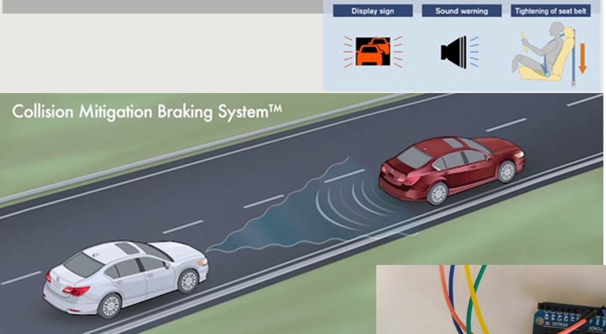
THE CMBS
The CMBS is a radar or a sensor that is placed in the front-facing camera located behind the rearview mirror or in the front grill that detects the vehicles in front of and the pedestrians on the road ahead .at the situation it depends on the situation, the CMBS shows us a visual alerts, audio alerts (beeps sounds ), and may automatically that can apply the brake to help you avoid a collision in the road

Smart Cruise Control
Smart Cruise Control (SCC) in the cars that enables an essential self-driving feature in today's cars and core technology for ADAS

What is meant by ADAS?
Advanced driver assistance systems (ADAS) mainly focused on collision avoidance technologies for example, lane departure warning and blind-spot applications. These are the real time examples and some like night vision, driver alertness and adaptive cruise control. The main focus is on maintaining distance from the vehicle to the vehicle in front of our vehicle while traveling at the speed selected by the driver is called Cruise control. SCC-ML combines AI and SCC into a system that learns the driver's patterns and habits on its own and starts implementing them on the road.
Here I have given the list of top 10 algorithms that are used as the common ML. and they are
- Linear regression
- Logistic regression
- Decision tree
- SVM algorithm
- Naive Bayes algorithm
- KNN algorithm
- K-means
- Random forest algorithm
- Dimensionality reduction algorithms
- Gradient boosting algorithm and AdaBoosting algorithm

The most common ML algorithm is Linear Regression
It is an ML algorithm based on supervised learning. It performs a regression task. Regression models a target prediction value based on independent variables. It is used to find the relationship between the variables and the forecasting. The different regression models differ on the basis of the type of relationship between the dependent and independent variable, and they are considering the number of independent variables getting used.
Conclusion
Here we come to know that AI is a part of human life in the future as they can also help us to do our work in future by passing some commands. Now in our hands we have an AI called Google Assistant or Alexa or and Siri that can be more interactive to humans as well. They can understand many languages that are spoken in the world. Thus the AI can do nowadays and the IoT sensor can also help the AI to sense the environment like humidity of the air or speed of wind or the temperature of the atmosphere and the luminosity of the environment

Reference
1.I. Dincer and A. Abu-Rayash, "Fundamental aspects of energy environment and sustainability", Energy Sustain., pp. 1-18, Jan. 2020.
2. "Emissions - Global Energy & CO2 Status Report 2019 - Analysis - IEA", Global Energy & CO2 Status Report 2019 2019, [online] Available: https://www.iea.org/reports/global-energy-c02-status-report-2019/emissions.
3. I. K. Nti, M. Teimeh, O. Nyarko-Boateng and A. F. Adekoya, "Electricity load forecasting: a systematic review", J. Electr. Syst. Inf. Technol. 202071, vol. 7, no. 1, pp. 1-19, Sep. 2020.

