“The Impact of Artificial Intelligence
on the Consultancy Services Industry:
A Comprehensive Analysis of
the Role of AI in Enhancing Service Delivery.”

Ayush Saxena
MBA Marketing and Business analytics (Minor)
Universal Business School, Karjat, India
ayush.saxena@ubs.org.in

Shaurya Gupta
MBA Marketing and Business analytics (Minor)
Universal Business School, Karjat, India
shaurya.gupta@ubs.org.in

Manasvi Verma
MBA Marketing and Business analytics (Minor)
Universal Business School, Karjat, India
manasvi.verma@ubs.org.in

Sakshi Singh
MBA Marketing and Finance (Minor)
Universal Business School, Karjat, India
sakshi.singh@ubs.org.in

ABSTRACT

The advancement of Artificial Intelligence (AI) has significantly impacted colorful diligence, including the consultancy services assiduity. Consultancy services are anticipated to be significantly impacted by artificial intelligence (AI). By automating repetitious operations, assaying massive volumes of data, and offering counsels perceptivity and suggestions, AI may ameliorate service delivery. Increased efficacity, perfection, and cost- effectiveness may affect from this. By giving decision- makers access to real- time data processing and prophetic modeling tools, AI may also enhance decision- timber. AI can also ameliorate client retention by offering customized and engaging gests. This paper provides a comprehensive analysis of the part of AI in enhancing service delivery, perfecting decision- timber, and easing customer engagement within the consultancy services assiduity. Through a thorough review of applicable literature, the paper highlights the implicit benefits and downsides of AI integration, including increased effectiveness, delicacy, and cost- effectiveness, but also implicit job relegation and ethical enterprises. also, the paper examines case studies and empirical substantiation to demonstrate how AI has been enforced in different consultancy services sectors, similar as operation, IT, and finance. Overall, this paper argues that AI is a precious tool that can enhance consultancy service delivery and help advisers give better advice to guests. still, it's pivotal to consider the ethical counteraccusations of AI and ensure that it's used responsibly.
(Keywords—AI, Artificial Intelligence, Consultancy services, Service delivery, Client satisfaction, Automating, Machine learning, Consultancy)

INTRODUCTION

This template, modified in MS Word 2007 and saved as a “Word 97-2003 Document” for the PC, provides authors with most of the formatting specifications needed for preparing electronic versions of their papers. All standard paper components have been specified for three reasons: (1) ease of use when formatting individual papers, (2) automatic compliance to electronic requirements that facilitate the concurrent or later production of electronic products, and (3) conformity of style throughout a conference proceeding. Margins, column widths, line spacing, and type styles are built-in; examples of the type styles are provided throughout this document and are identified in italic type, within parentheses, following the example. Some components, such as multi-leveled equations, graphics, and tables are not prescribed, although the various table text styles are provided. The formatter will need to create these components, incorporating the applicable criteria that follow.

Literature Review

Introduction:
Artificial Intelligence (AI) has transformed various sectors, including the consultancy sector, by enhancing service delivery. This literature review aims to examine the impact of AI on improving service delivery in the consultancy sector by summarizing relevant studies.

Schweidel et al. (2019),
Addresses how AI can enable marketers and advertisers to understand and leverage consumer behaviour in B2B marketing. The authors argue that AI can enable companies to process large amounts of data and gain insights that can inform marketing strategies. They also note that AI can enable companies to personalize their marketing communications and improve the customer experience. The paper provides an in-depth discussion of the potential impact of AI on marketing research and practice.

Lerman and Hsieh (2019),
Provides a comprehensive overview of the evolving role of AI in marketing. The authors argue that AI can help companies increase customer engagement and improve the effectiveness of marketing campaigns. They also note that AI can enable companies to gain insights into customer behaviour and preferences that can inform product development and pricing strategies. The paper highlights the challenges associated with implementing AI in marketing and provides a research agenda for future studies.

Bosnjak et al. (2020),
Focuses on the impact of AI on sales research and practice. The authors argue that AI can enable companies to improve sales performance by increasing the accuracy of sales forecasts and facilitating personalized customer interactions. They also note that AI can enable companies to optimize pricing strategies and improve customer retention. The paper provides an in-depth discussion of the potential impact of AI on sales research and practice.

Jain and Sharma (2016),
Provides a comprehensive overview of AI and its impact on marketing research and practice. The authors argue that AI can enable companies to gain insights into consumer behavior and preferences that can inform marketing strategies. They also note that AI can enable companies to automate marketing processes and improve the efficiency of marketing campaigns. The paper provides an in-depth discussion of the potential applications of AI in marketing research and practice.

Ozkaya et al. (2021),
addresses the impact of AI on marketers and advertisers in the context of the pandemic COVID -19. The authors argue that AI can enable companies to adapt to changing market conditions and consumer behaviour. They also note that AI can enable companies to improve the efficiency of marketing and advertising campaigns in the context of remote work and social distance. The paper provides an in-depth discussion of the potential impact of AI for marketers and advertisers in the post-pandemic world.

Customer satisfaction in artificial intelligence service delivery: a meta-analytic study
This paper highlights the key factors, constructs, and magnitudes that contribute to satisfaction with artificial intelligence service delivery. It provides researchers and business professionals with a guide for conducting research and selecting useful constructs. Exploration of other important issues related to the use of AI-enabled services is possible. In this study, a significant relationship was found between the use of artificial intelligence and consumer satisfaction with services provided by AI. Evaluating the performance of this technology in the service sector over time could benefit from examining the variables offered in the components of the component. Future research should include other variables such as price, size and sector of the service industry, type of service, and moderating factors.

The Role of Artificial Intelligence in Enhancing Customer Experience:
Abu Daqar and Smoudy (2021) explored the role of AI in enhancing customer experience. They argued that AI can improve service delivery by personalizing customer experiences and increasing the efficiency of customer service. The authors also highlighted that AI can facilitate the analysis of customer feedback, which helps consultants to identify areas of improvement in service delivery. Overall, the study suggests that AI has a significant impact on improving service delivery in the consultancy sector.

T. Iqbal, Md. Khan (2021),
Title: The Impact of Artificial Intelligence (AI) on CRM and the Role of Marketing Managers References, “The Impact of Artificial Intelligence (AI) on CRM and the Role of Marketing Managers, “faculty of education and business”, pp. 60-64, 2021 Summary AI-enabled marketing techniques have enabled marketers to reach a larger number of prospective customers, target the right audience, select the right marketing campaign, and segment the market according to various demographics. This has enabled marketers to predict the outcomes of every possible action and investment that they make aimed toward growing the company's sales, and profitability, creating brand loyalty, and enhancing customer retention. This has led to changes in the role of marketing managers both internally and externally. Predictive analytics has enabled marketing managers to better allocate marketing budgets and identify value propositions for segments where they can maintain competitiveness. Small businesses prefer to outsource marketing expertise, but it is important for firms to have their own specialized marketing team led by specialized marketing consultants. With the emergence of AI technologies and their implementation in the marketing function of firms, it is important that marketing managers are well-versed in technical and analytical skills alongside the vast marketing knowledge they possess. This is important as part of the decision-making process, as without knowledge about AI, managers will not be able to be as innovative as their competitors and may lose market share instead of expecting it to increase

Souza et al. (2022),
Customer Satisfaction with Service Delivery with Artificial Intelligence:
In a meta-analytic study, investigated customer satisfaction with service delivery with AI. The authors found that AI has a significant positive effect on customer satisfaction. Specifically, AI-enhanced service delivery improved the quality of service, reduced waiting time, and increased accessibility to services. Moreover, the authors found that customers were more likely to recommend AI-enhanced service delivery to others. The study concludes that AI can improve service delivery and increase customer satisfaction.

Other Related Studies:
Several studies conducted in India have also explored the impact of AI on improving service delivery in the consultancy sector. For instance, Nair et al. (2020) investigated the impact of AI on customer satisfaction in the banking sector. The study found that AI can improve customer satisfaction by reducing response time and increasing service quality. Similarly, Saha and Chatterjee (2019) examined the use of AI in the healthcare sector and found that AI can improve service delivery by reducing diagnostic errors and improving patient outcomes.

Another study by Chatterjee et al. (2021) explored the impact of AI on improving service delivery in the education sector. The authors found that AI can enhance student engagement, facilitate personalized learning, and improve the quality of education. The study also highlighted that AI can help educators to identify students' learning gaps and provide targeted interventions.
Conclusion:
The literature review suggests that AI has a significant impact on enhancing service delivery in the consultancy sector. The research has shown that successful AI implementation can lead to service delivery enhancements ranging from 10% to over 50% depending on the specific use case and industry. However, it is important to note that the effectiveness of AI implementation depends on factors such as the quality of the data used to train the algorithms, the accuracy of the algorithms themselves, and the ability of the organization to integrate the AI solution into its existing workflow and culture.

DETAILED ANALYSIS

Increasingly advanced technologies, including Artificial Intelligence (AI), have transformed the consultancy services industry. Artificial intelligence is making a significant difference in how consulting firms operate by enhancing service delivery, increasing accuracy, and reducing the operating costs that they incur. It examines the impact of artificial intelligence (AI) on the consultancy services industry as well as how AI can help enhance the delivery of services in the consulting field.

The effects of AI on the consulting services sector in numerous ways, AI has changed the advisory services sector. Data interpretation and analysis have been greatly enhanced by AI. Large volumes of data may be analysed by AI algorithms, which can also offer insights that are not attainable with conventional techniques. Because to this, consulting companies may now provide their customers with suggestions that are more accurate, resulting in better decision-making.

Second, AI has automated a number of jobs that were formerly done manually by consultants. This has enhanced productivity and decreased operating expenses. AI-powered chatbots, for instance, may offer customer care help around-the-clock, which lessens the strain of consultants and speeds up response times. Moreover, AI-driven systems may analyse financial data and spot trends, enabling consultants to provide customers better financial advice.

Thirdly, AI has enabled consulting firms to offer enhanced services and expand their service offerings. For example, some consulting firms have developed AI-powered solutions for supply chain optimization, which enable clients to optimize their supply chain operations and reduce costs.
Role of AI in Enhancing Service Delivery AI has several potential applications for enhancing service delivery in the consultancy services industry. Firstly, artificial intelligence has the capability of assisting consultants in monitoring, analysing, and interpreting data, thereby enabling them to provide better advice to clients. For instance, AI algorithms can analyse customer data to identify patterns and provide insights into customer behaviour. This can help consultants develop targeted marketing strategies.

Secondly, AI can automate several routine tasks, freeing consultants to focus on more complex tasks. This improves service delivery, as consultants can dedicate more time to understanding client needs and providing personalized solutions. For instance, AI-powered chatbots can handle routine customer service inquiries, allowing consultants to focus on complex inquiries that require human intervention.

Thirdly, AI can enhance collaboration and knowledge-sharing among consultants. AI-powered tools store and retrieve knowledge, enabling consultants to share insights and collaborate on projects. This improves service delivery, as consultants can leverage the organization's collective knowledge to provide better solutions to clients. (Mitchell, 2006)

AI is transforming the consultancy services industry by improving service delivery, enhancing accuracy, and reducing operational costs. AI has enabled consulting firms to analyze large amounts of data, automate routine tasks, and offer new services. AI's role in improving service delivery includes assisting consultants with data analysis, automating routine tasks, and enhancing collaboration among consultants. The consultancy services industry is expected to continue to embrace AI, leading to further transformation and improved service delivery. (Kirby & DYLAN, 2006)

Supporting Data And Analysis
- The worldwide AI in consultancy services market is anticipated to increase from $141.6 million in 2020 to $2.2 billion by 2025, at a compound yearly growth rate (CAGR) of 73.8% over the course of the forecast period, according to a study by research and markets. The increased use of AI in the consulting services sector to enhance service delivery and save costs is what is driving this expansion.
- According to a Deloitte report, 62% of businesses are currently utilizing AI in some capacity in their consulting services. According to the poll, adopting AI in consulting services mostly improves the quality of suggestions (59%), boosts operational efficiency (55%), and lowers costs (48%).
- According to PwC research, using AI in consulting services can increase data analysis's accuracy and speed by up to 50%. Better decisions are made as a result, and clients receive suggestions that are more accurate.
- As per a MarketsandMarkets analysis, the worldwide chatbot market is estimated to grow from $2.6 billion in 2019 to $9.4 billion by 2024, at a CAGR of 29.7%. These figures demonstrate the rising significance of AI in the consultant services sector and how it is reshaping the market by enhancing accuracy, streamlining operations, and optimizing service delivery.

Ethical Analysis
There are several ethical issues and angles raised by the use of AI in consultancy. Here are some examples, along with sources that provide statistics and further information:
- Bias and Discrimination: AI systems can perpetuate existing biases and discrimination, leading to unfair or unethical outcomes. A study by the AI Now Institute found that AI systems used in hiring, criminal justice, and other fields can have significant bias and discrimination problems Crawford et al. (2019).
- Lack of Transparency: AI systems can be difficult to interpret and understand, which can lead to questions about their ethical implications. A report by the World Economic Forum found that the lack of transparency in AI systems is a major ethical concern WEF (2020).
- Privacy Concerns: The use of AI in consultancy can raise privacy concerns, particularly when it involves the collection and analysis of personal data. A survey by Capgemini found that privacy concerns are the top barrier to consumer trust in AI Capgemini (2020).
- Job Losses: AI can automate tasks and replace human workers, which can have negative social and ethical consequences. A study by McKinsey & Company found that up to 800 million workers globally could be displaced by automation by 2030 Manyika et al. (2017).

Artificial Intelligence

Computerized systems that perform tasks normally performed by human intelligence are known as artificial intelligence. This area includes operations like natural language processing, vision, text analysis, and selection Taulli, T. (2019).
AI may be used to solve issues in the actual world by combining many concepts that stand for knowledge, its application, and assembling systems Loukides & Lorica (2016) Determine which concepts relate to information retrieval, system assembly, and information usage in order to understand the different intelligence assets Loukides & Lorica (2016).The paper has conducted a comprehensive and in-depth research on the available bodies of knowledge on AI, the benefits, its disadvantages and disadvantages as indicated below. (Miles, 2008)
All technologically-based products, starting with the initial computers to the present-day smartphones, have been created by and with the help of people, according to the machine intelligence principles that are revealed by the numerous data studies and coding algorithms. The actions taken from that point on have confirmed to be crucial to much of the development that is today seen with the creation of talented robots. AI was initially gradually built in earlier times Mijwel,M.(2015).
The first steps that began the Artificial Intelligence (AI) journey were when Alan Turing wrote his paper, which was called “Computing Machinery and Intelligence”. He focused on machines that were intelligent thus inventing the “Turing Test”. The initial idea would lead to an important hallmark of innovation in technology, and computers that proved to be of use in the 2nd World War and in the future Taulli (2019).
Many people are under the impression that AI's only goal is to save money by replacing human work. However, the objectives to inculcate AI are much bigger than decreasing costs, since the idea of totally replacing human effort is impracticable as it hasn't yet been made possible to endow computers with all the perceptions, actions, abilities and reasoning that humans exhibit. Nonetheless, intelligent computers and minds complement each other's abilities to realize opportunities that none could realize alone Kaplan & Haenlein (2019).

AI is Impacting the Consulting Business
A prime example is Amazon's Alexa, an ai - powered creation including over 15,000 abilities, including playing songs, providing the weather, scheduling conferences, and most recently, being set up to respond to financial queries from UBS Group AG clientele, a Swiss financial institution with a strategic vision. Most likely, Alexa's next function will involve scheduling meetings, analyzingthe financial sector, or even buying and selling shares, signaling. (Gianguta, Stefea, Noja, & Munteanu, 2023) A huge change in the sector from active to passive management Libert & Beck (2017). According to survey results, the U.S. seems to have a corporate-consultancy sector that is valued at around $60 billion. This transition to Ai systems has indeed been observed within the consultancy business. The change is the consequence of business executives using chatbots or RPA to automate repetitive operations like maintaining calendars and making phone calls. (Vial, Cameron, Giannelia, & Jiang, 2022)

The study demonstrates how AI is enhancing human efforts used in the majority of enterprises. AI helps businesses manage their human resources effectively and profitably while also assuring efficient marketing of their goods and services. Moreover, AI makes data handling much faster and more effective and fills in human inefficiency with the help of Digital assistants and Quantitative consultants who provide better, deeper, and quicker insights. These advantages are available for a fraction of the time and money that would have been needed to hire additional specialised personnel and consulting organisations. (Özeroğlu, 2014)

Benefits of AI to Consulting Companies AI assists with Data Collection: Compared to a typical person, AI technology can gather, process, and analyse a vast amount of data more quickly. As a consequence, it offers firms precise outcomes in a range of areas, including sales, operations, supply chain, and more Taulli(2019).

AI is effective in administrative jobs: Robots are substantially more effective than humans in handling rote administrative duties. Automating processes with robots, or RPA, devices may assist businesses with a variety of administrative duties, such as producing and dispatching invoices, matching incoming payments with the appropriate invoice, maintaining records, and much more. Some higher-end AI devices can make more rational and consistent business decisions, offer decision ideas, or make sure regulation documents are filled out correctly to prevent non-compliance fees Taulli(2019).

Increased Productivity: Consultants can use financial software to automate repetitive tasks, or they can use a virtual professional like Zoom.ai to schedule meetings, record talks, and arrange dinner reservations. Taking these obligations away from the young. The responsibilities of members of staff allow them to concentrate on more fulfilling work, which raises participation and performance levels throughout the whole consulting firm Carmona (2019).

SUPPORTING DATA AND FACTS
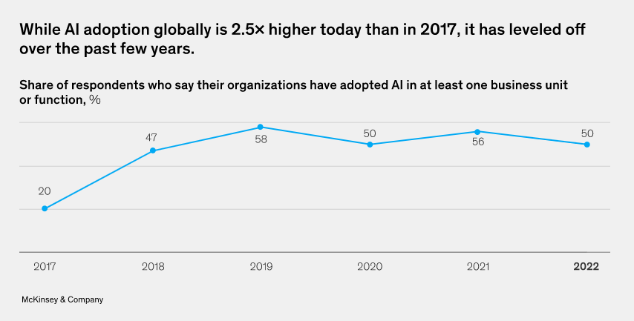
Fig:1 Adoption of AI by the organizations

The uptake of AI has more than doubled. In 2017, 20% of respondents said they have used Machine learning and artificial intelligence in at least one company in the sector; currently, that number is 50%, while it has exceeded a record of 58 % in 2019.

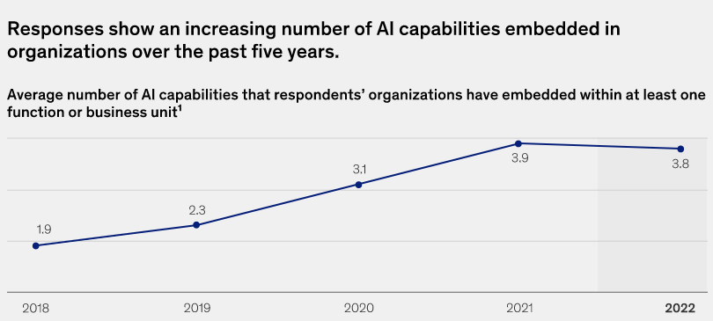

Fig:2 Increase in the capabilities of AI in 5 years.

Also, since 1.9 in 2018 to 3.8 in 2022, the approximate number of AI skills that businesses utilise has increased. Examples include image processing techniques and natural language production. While natural-language text comprehension has moved from the middle of the group in 2018 to the top of the ranking still behind from computer vision, automation of robotic processes and machine vision have continued to rank as the most often employed between these competencies every year. (Ismagilova, Coombs, Duan, & Galanos, 2021)
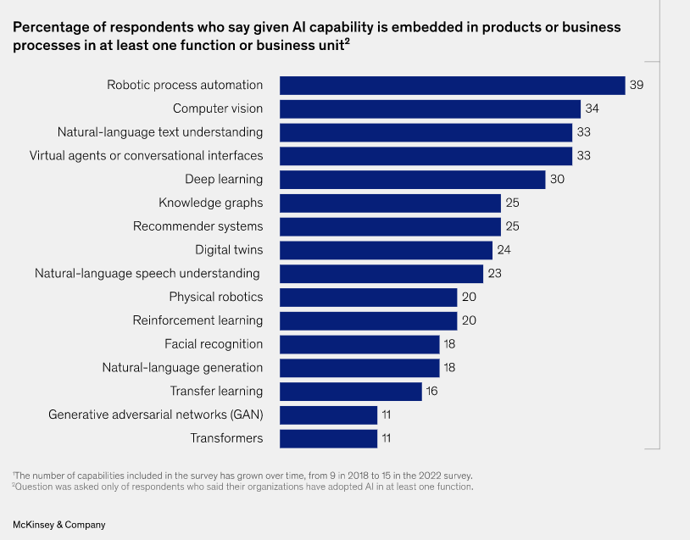
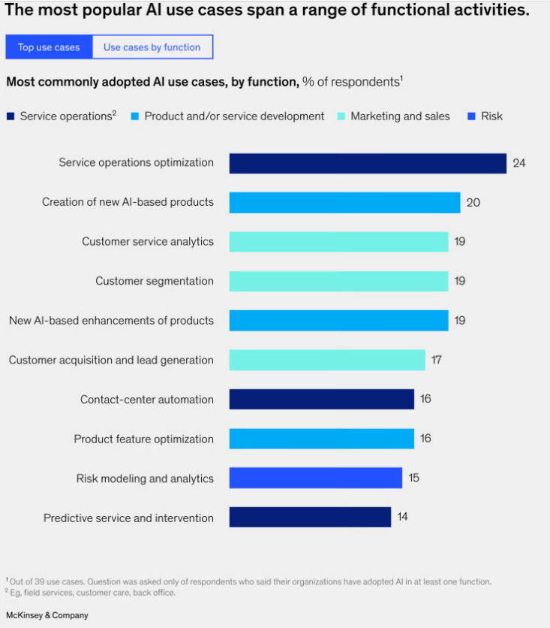

Fig:3 AI tech being used in terms of frequency . Fig:4 Industries applying AI.

As we can observe from the following graphs prepared from the survey conducted by McKinsey and company and are provided in the report “The State of AI 2022”. The services operations are greatly using the AI technology. AI is also implied in customer analytics according to above graphs, which are some of the core consultation jobs hence we can say that this is a very strong proof of AI influencing the service delivery of the consultancy sector in a positive manner. (Chi, Denton, & Gursoy, 2020)
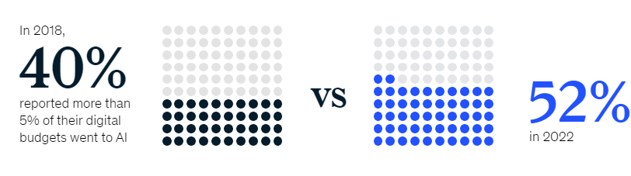

Fig: 5 Investment rise in AI.

Furthermore, as AI's usage has grown, so has the amount of investment in it. For instance, forty of those surveyed from firms that used AI in the past five years stated that more more than 5% of overall digital expenditures went to Artificial intelligence technology; now, more than fifty percent of respondents claim that same investment rate. It is a definite sign of the growing relevance of AI in organisations and across all industries.

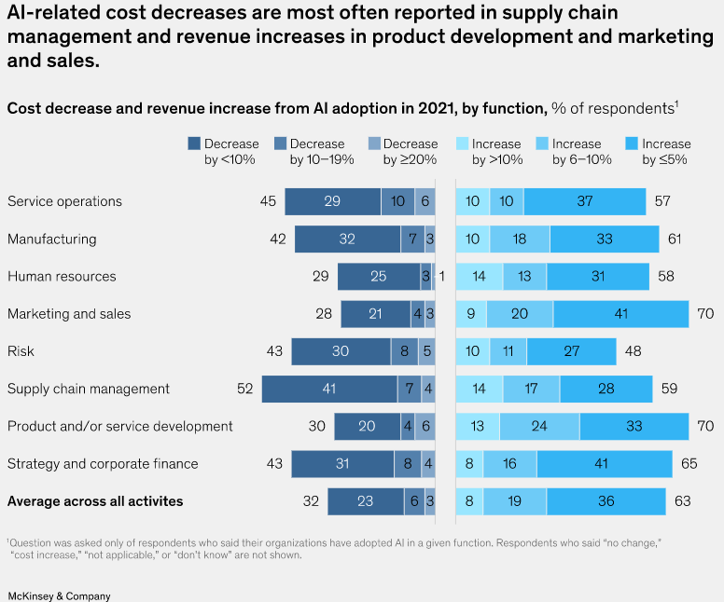

Fig:6 AI effect on cost (Decrease).

From this graphical representation we can clearly see that the biggest effect of applying AI in the organization was oberved on the services & operations companies which majorly consisits of consultancy organizations. As seen from above reperesentation we can say that AI is benefitting the consultancy firms in a cost aspect as well. Revenue increase of overall 57% can be seen in this industry by the implementation of AI.
Leadership may place Machine learning and artificial intelligence on the top leadership priorities by taking the following three actions, keeping these warnings in mind:
Make upper management aware. It's simple to make the proper points about the value of ethical AI. It's also simple to see the significance of making such claims.
Yet education may be necessary to understand why responsible AI is important to company strategy. responsible AI might not be added to or remain on the top leadership priority without such training.
Determine whether responsible.
AI is a component of your AI strategy or a discourse of the whole business objectives, particularly social responsibility as a whole. Responsible AI might not be on the top management agenda if they see it as a purely operational problem. (Gursoy, Chi, & Nunkoo, 2019)

CONCLUSION

The consultancy industry is being impacted by artificial intelligence (AI) Paul et al. (2021). AI is being used to automate operational processes and boost employee efficiency by using them for strategic decision-making. AI is transforming the demand for labor, the nature of work, and operational infrastructure. AI is also contributing to problem-solving and introducing new operational processes within companies Gînguță et al., (2023). However, businesses should also address the ethical effects generated by AI technologies Gînguță et al. (2023). AI has the potential to enhance human agency at work. The adoption of AI in supply chain risk management is being influenced by factors such as managerial support, perceived usefulness, and perceived ease of use Paul et al. (2022). The impact of AI on jobs is still being explored, but there is a growing interest among supply chain executives to adopt AI for supply chain risk management. AI can play an important role in proactively enabling the identification, assessment, and mitigation of supply chain risks as well as providing managerial insights for responding to those risks.

Relevant statistics and plots
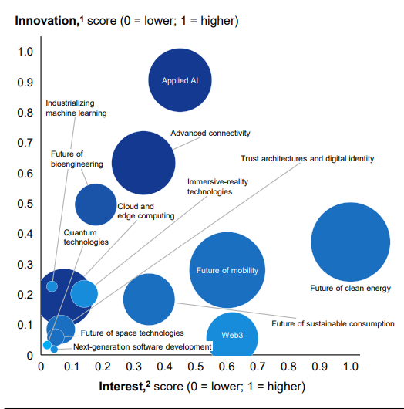

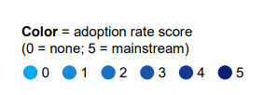
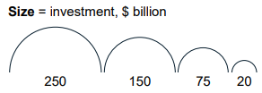

Plot 1: Innovation, interest, investment, and adoption, by technology trend, McKinsey(2022).

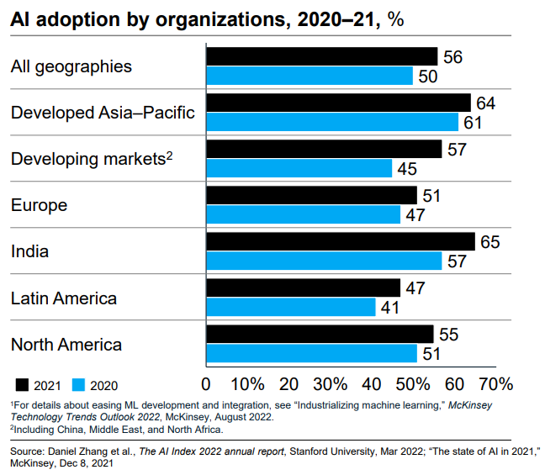

Plot 2: AI adoption by organizations %, McKinsey(2022).

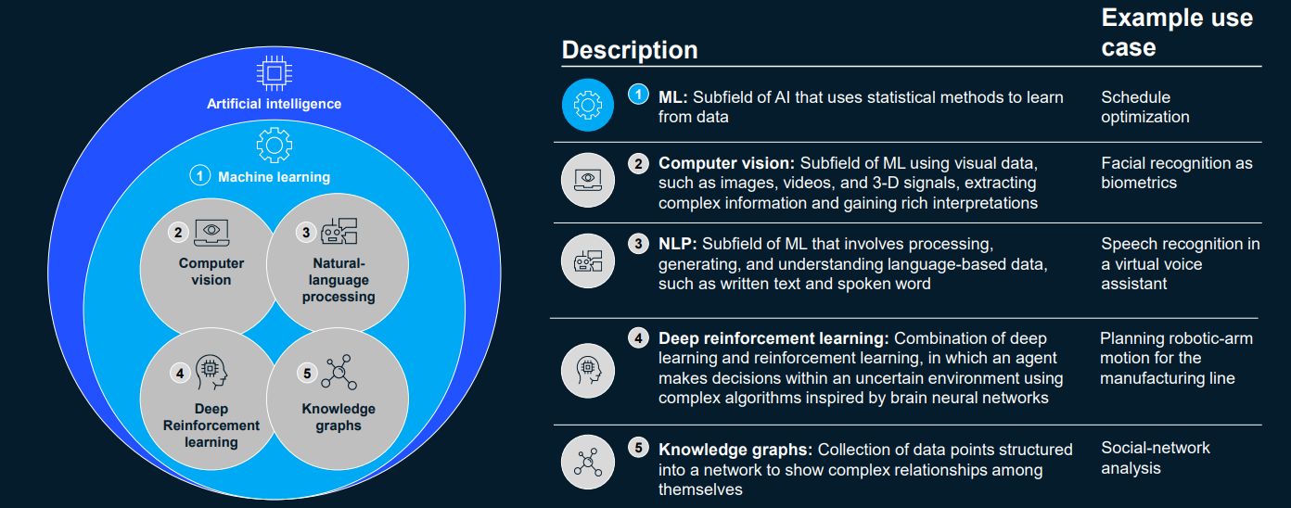

Fig 7: the most noteworthy technologies of 2021, McKinsey(2022).

REFERENCES

No numbering is required for Reference. The references list must be of size 8 in Times new roman. The template will number citations consecutively within brackets [1]. The sentence punctuation follows the bracket [2]. Refer simply to the reference number, as in [3]—do not use “Ref. [3]” or “reference [3]” except at the beginning of a sentence: “Reference [3] was the first ...”. Number footnotes separately in superscripts. Place the actual footnote at the bottom of the column in which it was cited. Do not put footnotes in the reference list. Use letters for table footnotes. Unless there are six authors or more give all authors’ names; do not use “et al.”. Papers that have not been published, even if they have been submitted for publication, should be cited as “unpublished” [4]. Papers that have been accepted for publication should be cited as “in press” [5]. Capitalize only the first word in a paper title, except for proper nouns and element symbols.

- G. Eason, B. Noble, and I.N. Sneddon, “On certain integrals of Lipschitz-Hankel type involving products of
- Bessel functions,” Phil. Trans. Roy. Soc. London, vol. A247, pp. 529-551, April 1955. (references)
- J. Clerk Maxwell, A Treatise on Electricity and Magnetism, 3rd ed., vol. 2. Oxford: Clarendon, 1892,
- pp.68-73.
- I.S. Jacobs and C.P. Bean, “Fine particles, thin films and exchange anisotropy,” in Magnetism, vol. III, G.T.
- Rado and H. Suhl, Eds. New York: Academic, 1963, pp. 271-350.
- K. Elissa, “Title of paper if known,” unpublished.
- R. Nicole, “Title of paper with only first word capitalized,” J. Name Stand. Abbrev., in press.
- Chi, O. H., Denton, G., & Gursoy, D. (2020). Artificially intelligent device use in service delivery: a systematic review, synthesis, and research agenda. Taylor and Francis Online homepage, 757-786. doi:https://doi.org/10.1080/19368623.2020.1721394
- Gianguta, A., Stefea, P., Noja, G. G., & Munteanu, V. p. (2023). Ethical Impacts, Risks and Challenges of Artificial Intelligence Technologies in Business Consulting: A New Modelling. 12(6), 19. doi:https://doi.org/10.3390/electronics12061462
- Gursoy, D., Chi, O. H., & Nunkoo, R. (2019). Consumers acceptance of artificially intelligent (AI) device use in service delivery. International Journal of Information Management, 49, 157-169. doi:https://doi.org/10.1016/j.ijinfomgt.2019.03.008
- Ismagilova, E., Coombs, C., Duan, Y., & Galanos, V. (2021). Artificial Intelligence (AI): Multidisciplinary perspectives on emerging challenges, opportunities, and agenda for research, practice and policy,. International Journal of Information Management, 57. doi:https://doi.org/10.1016/j.ijinfomgt.2019.08.002.
- Kirby, D. A., & DYLAN, J. E. (2006). Small Technology-based Professional Consultancy Services in the United Kingdom. The Service Industries Journal , 155-172. doi:https://doi.org/10.1080/02642069700000008
- Miles, I. (2008). Patterns of innovation in service industries. IBM Systems Journal, 47(1), 115-128. doi:10.1147/sj.471.0115
- Mitchell, V. W. (2006). Problems and Risks in the Purchasing of Consultancy Services. The Service Industries Journal, 14(3), 315-339. doi:https://doi.org/10.1080/02642069400000036
- Özeroğlu, A. I. (2014). Financial Framework of Consultancy Services. Science Direct, 114(21), 787-793. doi:https://doi.org/10.1016/j.sbspro.2013.12.786
- Vial, G., Cameron, A. F., Giannelia, T., & Jiang, J. (2022). Managing artificial intelligence projects: Key insights from an AI consulting firm. Information Systems Journal, 210. doi:https://doi.org/10.1111/isj.12420

