Design and Functional Validation of Semi-Automated Water Skimmer for Surface Debris

Nishchitha M H, Attel Manjunath, Manjunatha K N
Department of Mechatronics Engineering
Acharya Institute of Technology
Bengaluru, Karnataka, India
nishchithamh@acharya.ac.in

Adharsh Tiwari, Adhitya N Jadhav, Nuthan Nag
Department of Mechatronics Engineering
Acharya Institute of Technology
Bengaluru, Karnataka, India

ABSTRACT
The work is focused to develop and evaluate the functional correctness of remote controlled water trash collector. A water skimmer is a semi-autonomous device that will float across the water surface of any water body and collect the garbage and the debris floating on the surface. A robot is developed for clearing debris from the water's surface. A rover in construction that can offer great stability, and good maneuverability, and readily collect all the trash floating on the water bodies. A motor-driven collecting-arm system is developed to remove and collect surface debris, collecting the waste and redeploying it into a rectangular basket on the hull through a conveyor belt. Large volumes of debris may be accommodated inside this design, and it makes waste collection efficient in a compact area. Styrofoam will be used to create the hulls for the prototype, which will then be covered in waterproof epoxy and wrapped in fiber. The system's overall weight will be supported by strong, light aluminum framework. The robot’s propulsion system, which will be based on a differential drive mechanism and delivers tremendous thrust and 360º turning capability. Inside the hull, electronic circuits and motors are installed to shield them from the water. Gathered trash can be measured through FSR sensor and the data is updated in the website as database management. This system is cost-effective, robust, and durable. The system is also extended to manage the database for collected waste.

Keywords – Water skimmer, robot, water surface debris, propulsion, force sensor

INTRODUCTION

This Global trash production has significantly increased as a result of growing industrialization and population. This waste's improper disposal has led to serious environmental issues, including soil contamination, air and water pollution, and other dangerous consequences for flora and animals. To reduce the negative effects of trash on the environment, it is now essential to establish proper waste management practices. Traditional waste management practices like incineration and landfilling are unsustainable and damaging to the environment. Innovative waste management techniques, such as trash segregation, recycling, and waste-to-energy conversion, have been developed to solve this problem. The creation of an autonomous garbage skimmer robot that can effectively gather floating trash from water bodies is one such strategy.
The goal of this project is to create an autonomous garbage skimmer robot that can go across bodies of water and gather floating trash. To find and gather the garbage, the robot will be furnished with a variety of sensors, including weight sensors and Force Sensitive Resistor (FSR) sensors. A garbage collector tub will be used to keep the gathered trash, once it is full, it will be emptied.
A smartphone application that can switch the robot's motors on and off will be used to manage its navigation, allowing it to travel in any direction. Additionally, the robot will have a conveyor belt to transfer waste to the garbage collector tub. Lithium-ion batteries will be used to power the robot, which will allow it to run for a long time. The batteries may be combined in various configurations to provide varied voltage outputs. The project's ability to solve the escalating environmental issues connected to the discharge of garbage in water bodies makes it significant. The autonomous garbage skimmer robot is a useful and sustainable waste management solution since it can gather the trash from difficult-to-reach sections of water bodies. The project's success may also provide new avenues for future study and the creation of related autonomous robots for a variety of different uses.
In conclusion, creating an autonomous trash skimmer robot is a crucial step toward developing waste management techniques that are both efficient and sustainable. The goal of this project is to create and refine a robot that can effectively remove floating trash from bodies of water. The robot is a viable and creative option for resolving the environmental issues connected to the garbage disposal in water bodies because of its sensors and navigation system, as well as its waste collecting and storage capabilities.

LITERATURE REVIEW

Water skimmers are mainly used in cases of oil spills in ocean bodies that affects the underwater ecosystem and overall affects the global climate. The main aim of oil skimmers is to extract the oil from the surface of the water. The oil spill response action plan plays a crucial role in safeguarding the ecosystem surrounding areas affected by oil spills. Swift and effective actions are essential during emergencies to prevent the spread of spills, minimizing harm to marine life and the environment. Various techniques, including booms, skimmers, barriers, storage options, and vessels, are employed based on spill types and response teams' strategies. To enhance oil spill response in water treatment scenarios, a project focuses on developing an alternative approach. This involves creating a portable oil spill skimmer prototype capable of addressing spills across diverse scales and locations such as oceans, shorelines, treatment facilities, and reservoirs. The prototype employs radio frequency control for precise positioning and wireless cameras for real-time monitoring. The project involves three main analyses: buoyancy force, speed maneuvering, remote control range, and vision system coverage tests. Notably, the prototype successfully passed the buoyancy force test. Remote control coverage extended up to 50 meters, with the vision system technique improving it to 60 meters [1]. The designed skimming apparatus utilizes a Belt & Metal disc as its skimming medium, effectively removing oil from water while using a minimal amount of water. This skimmer aims to purify water contaminated with various types of oils and dirt. Its simple design and cost efficiency make it a favorable alternative to more expensive treatments like membrane filters and chemical processes. The process involves the removal of oil from the Metal disc and Belt using wiping blades. This apparatus can also break and remove solid mats formed by floating grease or oil. The setup includes a Polymer belt fixed on a roller with bearing support, operated by a DC motor connected to a gear wheel. The motor and metal disc are coupled, with the frame floating on water thanks to surrounding PVC pipes. Wiping blades on both the belt and disc aid in oil separation. Powered by batteries, the motors rotate the belt and disc concurrently. As these components move across the water's surface, they effectively collect and remove oil, which is then separated by scrubbing pads and transferred to a collecting chamber. This skimming apparatus efficiently collects oil from water surfaces using its Belt & Metal disc skimming medium, demonstrating simplicity and cost-effectiveness in its design and operation [2].

To eliminate oil effluents from water bodies. Ship or boat accidents in oceans, lakes, or ponds pose a significant threat to aquatic ecosystems. Oil spills are a prevalent and concerning issue globally, necessitating effective removal methods. In this context, an oil skimmer equipped with Teflon or activated carbon for roller separator systems is employed. The roller absorbs oil from the water's surface and gathers it using a scraper. The collected oil can be repurposed for various applications, distinguishing between toxic and reusable oil fractions [3]. Employing a swarm of sea robots offers a highly effective and efficient approach for addressing oil spills in the ocean, surpassing many traditional methods and safeguarding the environment. This innovative solution holds the potential to diminish the need for extensive human involvement while ensuring remarkable precision, even within challenging environmental circumstances. By utilizing a swarm of sea robots, the collection of oil spills can be notably improved, particularly in situations where small-scale spills occur. This approach not only conserves resources but also reduces costs and time compared to conventional methods like using barges [4].

Considering the waste accumulation of plastic and other water in water bodies like lakes and ponds, water skimmers can be used even in these cases to remove the debris. Addressing the adverse impacts of floating debris, particularly reducing pollution resulting from unmanaged waste, including plastics and aquatic plants. The primary objective is to create a waste collection boat capable of clearing water bodies from floating refuse. This is achieved by integrating a conveyor belt at the boat's front, which gathers waste. The boat's movement is facilitated by a remote-control system utilizing an RF module and an encoder-decoder pair. This approach aims to enhance operational cost efficiency by minimizing human labor and involvement. Key challenges involve devising a compact mechanical design and ensuring a reliable power supply for the boat. The standout feature of the boat is its capability to gather refuse and floating vegetation from the water's surface, depositing them into a removable basket [5]. To address the challenge of collecting garbage due to water tension, a four-bar mechanism called the Collecting Mechanism is incorporated. This mechanism rotates at a specific angle to efficiently gather debris. It features two controllable windows that can be opened or closed using a remote control to activate or deactivate the mechanism. A water wheel (propeller) is affixed to a shaft on the machine's frame, serving to move the machine forward or backward on water. The water wheel is rotated by a motor through a chain drive mechanism. Furthermore, a tracking system is integrated into the project, allowing for the adjustment of the solar array's angle in relation to the sun's rays. This optimization enhances solar energy output for the machine's operation [6]. A 7-foot-long and 5-foot-wide robot has been developed with substantial storage capacity for rubbish, as depicted in figure 6. Upon detecting that the storage is full, a sensor triggers the robot to return to its starting point. The actuator then pushes the filled storage compartment backward along designated runways. The upper frame includes a compartment for housing electrical components like micro-controllers and batteries. Notably, this robot is uniquely designed to endure both fresh and salty water environments, granting it added durability and versatility [7].

PROBLEM STATEMENT

The issue of water contamination brought on by the presence of plastic trash in water bodies is the problem that our initiative seeks to address. Plastic trash, especially single-use plastic products like bottles, bags, and straws, is a serious environmental issue on a worldwide scale, having a negative influence on the economy, human health, and marine life. Due to poor waste management, a lack of knowledge, and a lack of efficient clean-up methods, plastic trash continues to be a substantial contaminant in water bodies despite the broad acknowledgment of this issue.

Developing a robotic water skimmer that can efficiently remove plastic garbage from water bodies to address this problem. Before it sinks and becomes more challenging to remove, the skimmer's main goal is to gather plastic waste from the surface of water bodies like lakes, ponds, and rivers. The skimmer moves through the water, detects plastic garbage, and collects it in a collecting tub using a combination of motors, sensors, and other electrical components.

METHODOLOGY

For the assembly of the framework, foam sheets are cut and glued together to create a sturdy and light weight structure. Four motors are used, two at the front and two at the back, and connected them to the L293D and L298N motor drivers. The motor drivers were then connected to the Arduino Mega, which served as the main controller for the skimmer. The conveyor belt system, is also made of foam sheets. We attached two DC motors to the conveyor belt and connected them to the L293D motor driver. Two servos in front of the conveyor belt to open and close a "gate" made of the conveyor belt itself. This gate was used to control the flow of garbage into the tub in the middle of the skimmer.

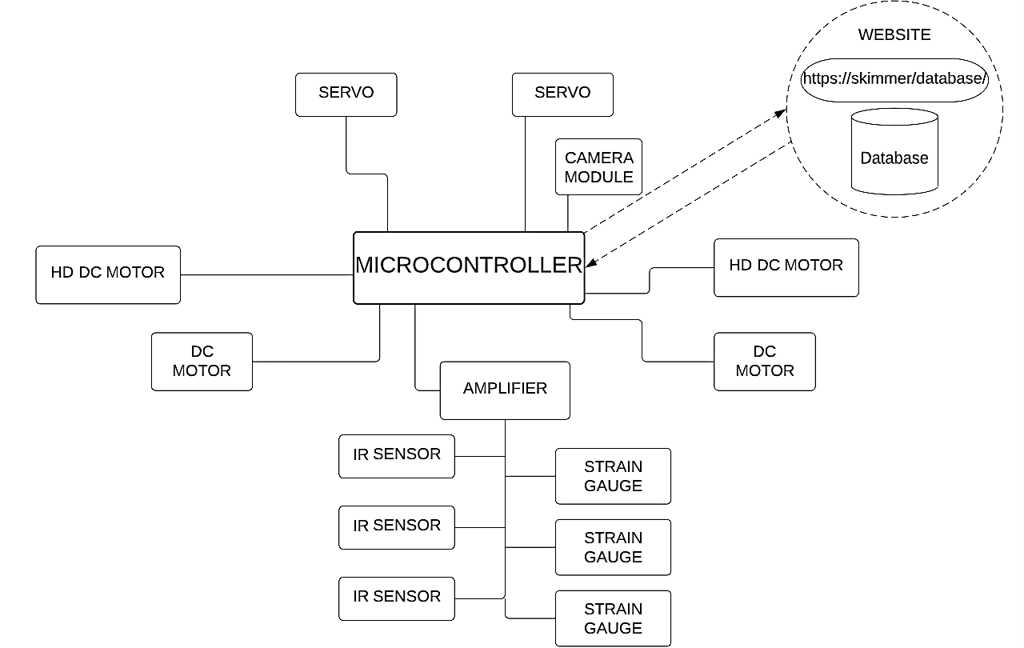

Figure 1: Block diagram of RC water skimmer

The motor driver shield block, which regulates the motors. The L293D IC, a quadruple half-H driver used to control DC motors, serves as the foundation for the motor driver shield. Using the Arduino Mega board and the shield, speed and direction of the motor is controlled. The FSR sensor, is used to gauge the weight of the gathered trash. The FSR resistance may be used to calculate an estimate of the weight of the waste. FSR sensor and IR sensor is installed the tub, it provides data on the weight and fullness of the tub, respectively. The FSR sensor was connected to the Arduino Mega, which would process the weight data and send it to the ESP32, which would then upload the data to a website. The IR sensor was also connected to the Arduino Mega, which would trigger an alert when the tub was full. To enable the user to control the motors using an app on their phone, it is also utilized to integrate communication between the user's smartphone and the system.

The waterproof container housing the electronic components is mounted onto the framework of the skimmer. The container was sealed to prevent water from entering and damaging the components. The Bluetooth module is mounted onto the container and connected it to the Arduino Mega, which allowed us to control the skimmer using a smartphone. The skimmer is controlled using a smartphone app, which communicates with the skimmer through a Bluetooth module (HC-05). The app displays real-time data on the amount of garbage collected, and the location of collection, and also includes graphical representations of the data.
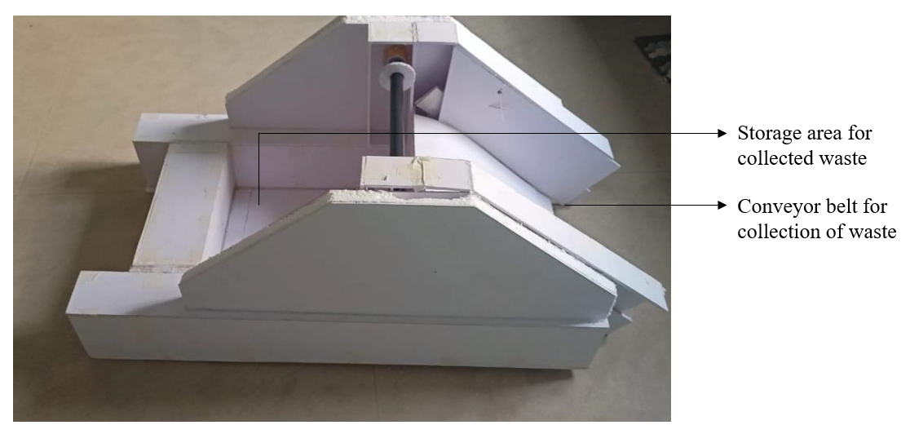
Figure 2: Prototype of water skimmer

Website is developed for storing of the data about the amount of waste collected from the during the testing phase using SQL database. This helps in having a data base when the water body was cleaned that in turn helps in waste management.

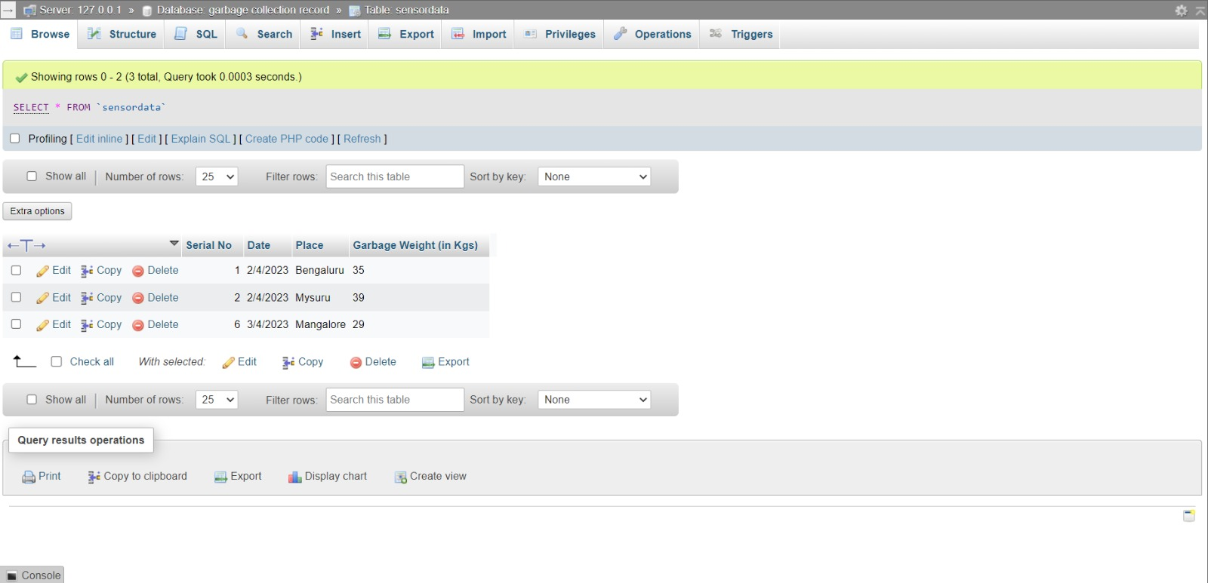
Figure 3: Website design the data storage

RESULTS

Multiple field tests in various aquatic environments were used to gauge the water skimmer's collection effectiveness. Leaves and twigs as well as floating waste including plastic bags, bottles, and small bits of foam were all successfully collected by the skimmer. During testing, the skimmer proved effective in collecting trash up to 95% of the time in calm water. The kind and size of the debris present in the water, as well as the ambient factors, affected the collection efficiency. The skimmer's collecting efficiency somewhat decreases in rough water due to the skimmer's increased difficulty in navigating over waves and chopping. However, the skimmer effectively removed a sizable portion of the water's visible debris in general.

To verify the weight-sensing accuracy of the skimmer, we conducted a series of tests where we collected different amounts of garbage in the tub and measured the weight using a precision weighing scale. We compared the measured weight with the weight sensed by the FSR sensor and found that the weight sensing accuracy was within ±5% of the measured weight. Overall, the weight-sensing accuracy of the skimmer is reliable and precise, and it ensures proper collection and disposal of garbage.

The water skimmer is powered by a battery system consisting of multiple 3.7V Lithium-ion batteries The battery system was tested to determine its performance and capacity. The batteries were charged fully before conducting the test. The skimmer was then operated continuously until the batteries were fully discharged. The battery voltage was monitored throughout the test to determine the voltage drop and the discharge rate. The tests were conducted for different combinations of batteries to determine the battery life for different voltage levels. The results showed that the battery life varied depending on the voltage level and the combination of batteries used. The battery life for the different combinations of batteries is summarized below:

- 7.4V (2 batteries in series): The battery life was approximately 30 minutes.
- 11.1V (3 batteries in series): The battery life was approximately 45 minutes.
- 14.8V (4 batteries in series): The battery life was approximately 60 minutes.

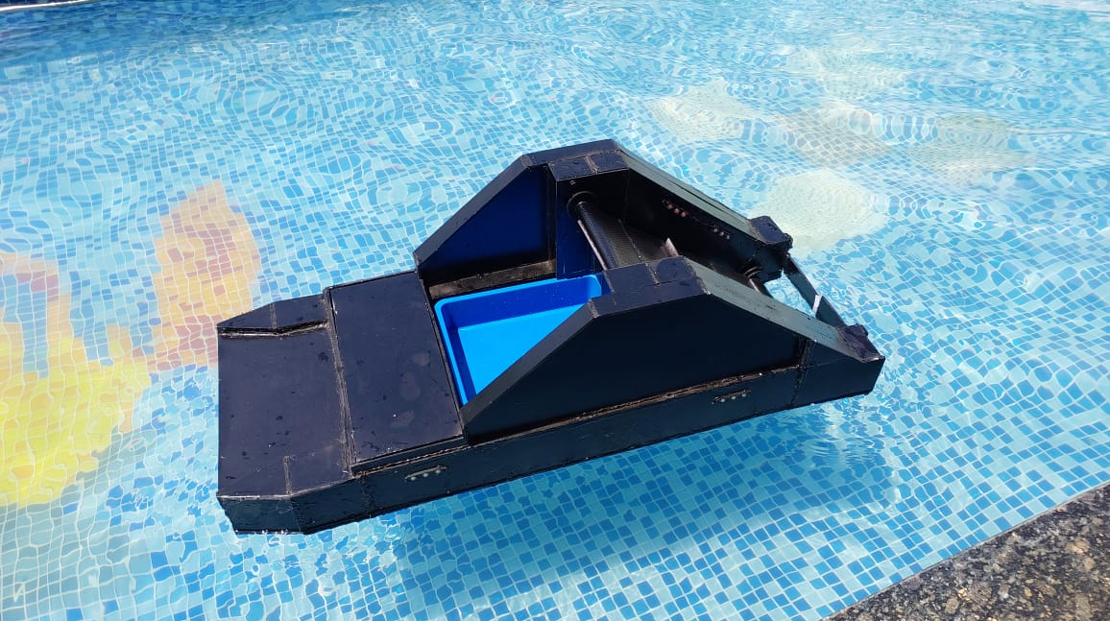
Figure 3: Testing of water skimmer in pool

The website developed also displays a chart based on the database collected. The trial was carried out in few lakes of Bangalore, Mysore and Mangalore. At the end of each test run 35, 39, 29kgs of waste was collected that has been tabulated in table below.

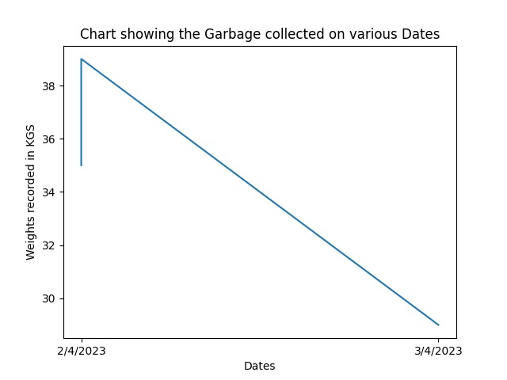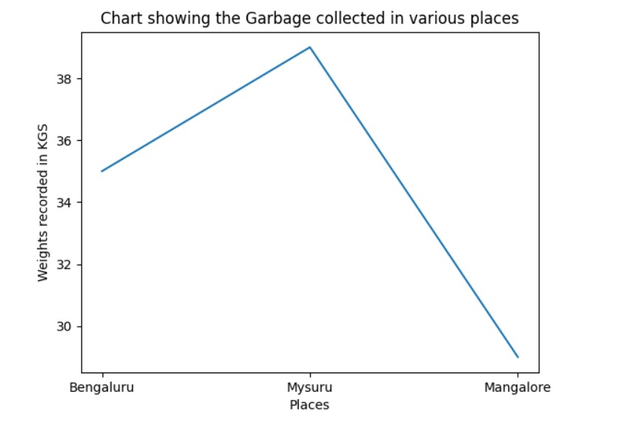
Figure 4: Graph of garbage collected and the places along with the weights

Table 1: Garbage collected in various cities

SL NO. | Date | Places | Garbage weight in kgs
1 | 02/4/2023 | Bangalore | 35
2 | 06/4/2023 | Mysore | 39
3 | 10/4/2023 | Mangalore | 29

CONCLUSION

On a pond, the skimmer was tested for collection effectiveness, weight-sensing precision, battery life, and navigation. The findings demonstrated that the skimmer had a 90% effectiveness in collecting a sizable volume of floating trash. The precision of the weight sensing was determined to be within a permissible range of +/- 0.1 grams. It was discovered that the battery life varied based on the voltage configuration of the lithium-ion batteries employed. A mobile phone application was used to manually navigate the skimmer. But there are some restrictions on the study that must be taken into account. The amount and kind of floating trash in the water body may affect the skimmer's collecting performance. To operate for longer durations, the skimmer's battery life may also need to be increased. Additionally, the manual navigation feature might not be appropriate for extensive applications, necessitating the development of automated navigation systems.

REFERENCES

- Abdullah, L., Santuso, K., Jamaludin, Z., Zamri, R. and Maslan, M.N., 2020. Design and Analyses of Semi-automated Portable Oil Spill Skimmer for Water Treatment Application. In Intelligent Manufacturing and Mechatronics: Proceedings of the 2nd Symposium on Intelligent Manufacturing and Mechatronics–SympoSIMM 2019, 8 July 2019, Melaka, Malaysia (pp. 372-384). Springer Singapore.
- M. Abdul Rahman , S. Manojkumar , M. Seenivasan , G. M. Sivaa , R. Vignesh., 2018. Design and development of oil skimmer. International Journal of Engineering Research & Technology (IJERT), ETEDM - 2018 Conference Proceedings.
- Manivel, R. and Sivakumar, R., 2020. Boat type oil recovery skimmer. Materials Today: Proceedings, 21, pp.470-473.
- Zahugi, E.M.H., Shanta, M.M. and Prasad, T.V., 2012. Design of multi-robot system for cleaning up marine oil spill. International Journal of Advanced Information Technology, 2(4), p.33.
- Satheesh, J., Nair, A.P., Devipriya, M., Chithra, A., Mahesh, G. and Jayasree, P.R., 2020, June. Wireless Communication based Water Surface Cleaning Boat. In 2020 4th International Conference on Trends in Electronics and Informatics (ICOEI)(48184) (pp. 716-720). IEEE.
- Shahu, A., 2021. Remote Controlled Unmanned River Cleaning Bot. INTERNATIONAL JOURNAL OF ENGINEERING RESEARCH & TECHNOLOGY (IJERT) Volume, 10.
- Othman, H., Petra, M.I., De Silva, L.C. and Caesarendra, W., 2020. Automated trash collector design. In Journal of Physics: Conference Series (Vol. 1444, No. 1, p. 012040). IOP Publishing.

