Biofuels: Renewable energy for a sustainable world
Abdul Moin¹, Umaimah Nuzhat Iqbal¹, and Masrure Alam¹*

¹ Microbial Ecology and Physiology Lab, Department of Biological Sciences, Aliah University, IIA/27 New Town, Kolkata 700160, West Bengal, India.

* Correspondence: Masrure Alam
Email: alam_micro@aliah.ac.in
Contact No: +91-9432183459

Abstract:
The exponential increase in the use of non-renewable natural resources, with the increase in world population, and modernization of human livelihood, it is expected that there will be a scarcity of fossil fuels very soon, and future generations will encounter a dearth of energy resources. In addition, the combustion of non-renewable fuels, such as natural gases, petroleum, and coal, results in the production of substantial quantities of detrimental gases, such as CO₂, NO₂, hydrocarbons, etc. Thus, the search for alternative renewable energy sources is underway across the world. Biofuels are found to be very promising, as well as important renewable and alternative energy sources for the energy-craving world in the near future. The most common and promising biofuels used nowadays are – bioethanol, biodiesel, and biogas. In this chapter, we have discussed various aspects of biofuels, such as types of biofuels, feedstocks used for, and processes of production of the main biofuels, their properties, and their advantages and disadvantages.

Keywords: Biofuels; Bioethanol; Biodiesel; Biogas, Biohydrogen

1. Introduction
Biofuels are the fuels that can be produced from biomass materials, or feedstocks, such as plants, algae, animals, and genetically modified organisms, over a short period of time, in comparison to the fossil fuels, such as oil, which are produced through very slow natural processes. The first biofuels were likely used by humans thousands of years ago when they burned wood and other plant materials for heat and light. Some common, modern biofuels include bioethanol, biodiesel, biogas, biohydrogen, and bio-ethers. Till now, we are mainly dependent on fossil fuels, such as coal, crude oil, and natural gases, which have been formed through natural processes over millions of years. For example, coal is formed from the remains of plants buried in swamps and other low-lying areas over millions of years through processes called coalification (Marsh and Rodríguez-Reinoso, 2006). Crude oil is formed from the remains of dead organisms, mostly zooplankton and algae, that lived millions of years ago in marine environments, buried under layers of sediments, and subjected to prolonged heat and pressure. The heat and pressure caused the organic matter to change, first into a waxy material known as kerogen, and then with more heat into liquid and gaseous hydrocarbons via a process known as catagenesis (Wong et al., 2015). Natural gases, on the other hand, are formed from the decomposition of organic matter, especially from marine microorganisms under high pressure and heat over millions of years (Clennell et al., 1999). The significant advantages of fossil fuels are their low price, ease of use, and high energy content.
However, the exponentially increased use of fossil fuels in the last century, with the increase in global population and their increased need, it is expected that fossil fuel reserves will be exhausted very soon. Thus, the search for alternative, renewable energy sources is underway across the globe. Towards this direction, biofuels happened to be very promising and important for the energy-craving world in the near future. Some of the most common types of biofuels used nowadays are – ethanol, biodiesel, and biogases. Ethanol is a two-carbon alcohol that is produced from fermentation of sugars or starches from plants by yeast, and can be used directly as a fuel in vehicles and can also be blended with gasoline. Biodiesel is a fuel produced from the transesterification of vegetable oils or animal fats, and can be used in vehicles that are designed to run on diesel fuel. Whereas, biogases are a type of fuel that is produced from the anaerobic digestion of organic matter, which can be used as vehicle fuel or converted into electricity. Currently, hydrogen biogas is extensively used as fuel in different industries (De Vrieze et al., 2020).
In India, the first ethanol blending program was launched in 2003 with the aim to reduce petrol and diesel-burning-related pollution. India's Ministry of Petroleum and Natural Gas published its “National Policy on Biofuels” in 2018, and further amended it in June 2022. The policy's objective is to reduce the import of petroleum products by the development of domestic biofuel production and aims to blend petrol with 20% bioethanol by 2026.

2. History of biofuels
In the year 1875, a Dutch farmer named Wouter Sluys used methane for the first time for illumination (Khoiyangbam et al., 2011). England recovered biogas from sewage in the year 1895 which was used to light the street lamps. In India, the first biogas plant was constructed in 1897 in Bombay. Bowsel in the 1930s made a scientific breakthrough by developing biogas technology by combining different organic wastes with manure as substrate. Not only he identified the anaerobic bacteria for methane production but also their optimal growth condition (Abbasi et al., 2012). In 1937, G. Chavanne was granted a Belgium patent for an ethyl ester of palm oil which is today known as biodiesel. The first commercial biofuel plant was built in the United States in 1937. During World War II, when petroleum supplies were scarce, many countries started utilizing biofuels as an alternative fuel. Han Gaffron, in the year 1939, discovered hydrogen production method from green algae. In his studies, Gaffron observed that Scenedesmus obliquus when subjected to anaerobic condition can either use H₂ as an electron donor in the CO₂ fixation process in the dark and in light can evolve H₂ (Melis and Happe, 2004). In 1997, Professor Anastasios Melis found that when sulfur is scarce, algae start to produce hydrogen (Melis and Happe, 2001). Currently, the major countries that produce biofuels are given in Table 1.
Table 1: List of major countries which produce biofules.*
Country Name | Energy produced (TWh$)
United state | 452
Brazil | 254
Indonesia | 108
China | 41
Germany | 38
Argentina | 28
India | 27
Netherlands | 24
France | 22
Thailand | 22
Spain | 19
United Kingdom | 7
* Data have been obtained from Ourworldindata.org (Weblink: Biofuel production by region (ourworldindata.org))
$ TWh = TeraWatt-hours

3. Types of biofuels on the basis of feedstock
3.1. First-generation biofuels
Conventional biofuels or first-generation biofuels are fuels that have been derived from traditional crop-based feedstocks, such as corn, sugar, vegetable oil, starch, wheat, etc. mainly by fermentation (Rulli et al., 2016). Major plants used in biofuel production are jatropha, corn, sugarcane, switchgrass, palm tree, canola, etc. The advantage of first-generation biofuel is its less complex pretreatment method to breakdown large sugar polymers to small fermentable sugar monomers. Their energy yield is also high. The main disadvantage is the competition with food, land and fresh water (Rulli et al., 2016).

3.2. Second-generation biofuels
Advanced biofuels or second-generation biofuels are those that are produced by non-feedstocks, such as plant materials and animal wastes. Lignocellulosic materials and waste vegetable oils are the sources of second-generation biofuels (Sims et al., 2010).

3.3. Third-generation biofuels
Third-generation biofuels, also known as algae biofuels, are mainly derived from lower-plant algae and some other microorganisms. There are many different algae species that have been investigated for biofuel production. Some of the most promising algal species include–Chlorella sp., which is a unicellular green alga that is known for its high oil content, and can be grown in a variety of conditions, including freshwater, saltwater, and wastewater; Nannochloropsis sp., which is a unicellular green alga that has a high oil content and is also known for its ability to grow rapidly in a variety of conditions; Botryococcus sp., which is a multicellular green alga that can accumulate high levels of oil and is found in freshwater and saltwater environments; Dunaliella sp., which is a unicellular green alga that is known for its high carotenoid content that can be used to improve the fuel properties of biofuels; and Haematococcus sp., which is a unicellular green alga that can accumulate high levels of astaxanthin, which is a carotenoid that can be used to improve the colour and stability of biofuels.

3.4. Fourth generation biofuels
Fourth-generation biofuels are not fully developed yet and is in the developmental and experimental stage, and is mainly produced by genetically modified organisms and nanotech algal biomass.

4. Types of biofuels on the basis of their physical state
4.1. Liquid biofuels
4.1.1. Ethanol
Ethanol can be produced by microbial fermentation of different sugar sources and can be used as fuel. Nowadays, many countries blend engine fuel with ethanol to reduce car engine pollution. Details of bioethanol is discussed later.

4.1.2. Other bio-alcohol
Butanol is considered to be the most advanced biofuel and can be used directly to the existing car engines without any modification. Yet it is not used because of its high production cost by the fermentation of acetone-butanol-ethanol (ABE) fermentation (Xue et al., 2013).

4.1.3. Biodiesel
Biodiesel is a renewable and clean-burning diesel fuel that can be produced primarily from vegetable oils, animal fats, or recycled eatery grease. Chemically it is parallel to diesel and can be used in unmodified current engines. More details about biodiesel are discussed later.

4.1.4. Green diesel
It is a second-generation alternative form of energy, similar to petroleum diesel, but provide better diesel property. The production of green diesel needs hydrotreating of triglycerides present in vegetable oil with hydrogen. Hydrotreating has three main processes, hydrodeoxygenation (HDO), decarbonylation (DCO) and decarboxylation (DCO₂), which removes oxygen, carbon monoxide and water, and carbon dioxide respectively (Kittisupakorn et al., 2016).

4.1.5. Straight vegetable oil
In this case, the edible unmodified oil used as biofuel and can be used in diesel engine too. The chemical nature of vegetable oil is triglycerides which have a three-carbon backbone and three fatty acyl chains attached by ester bond. Soybean oil, palm oil can be used as fuel in engines directly, or after little modification to the engine (Misra and Murthy, 2010).

4.1.6. Bioethers
Ethers are class of chemical compounds which has ether group. Bioethers can be made from sugar beet, wheat and waste glycerol by biodiesel industry. Ether can be used as blending component in fuel industry. It is added to petroleum to burn it completely and cleanly to enhance the engine performance. In 1970s fuel ethers were first introduced to replace a toxic compound lead. The mostly used fuel ethers are MTBE (methyltertiary-butyl-ether) and ETBE (ethyl-tertiary-butyl-ether).

4.1.7. Aviation fuels
Aviation fuels refer to fuels that power aircraft. It is mainly made from petroleum-based fuels. Aviation fuels are one of the leading causes of greenhouse effect. So, to reduce greenhouse effect we need to think of alternate fuel source. Aviation biofuels or bio-jet fuels or bio-aviation fuels (BAF) are promising in this case. All aviation fuels have to meet a standard before that can be considered as aviation fuel. ASTM D1655 and DEF STAN 91-91 are the standards governed by the American Society for Testing and Materials in USA and British Ministry of Defence (MOD) respectively as the most commonly used standards for aviation fuel (Rumizen, 2021). Aviation biofuels are the mixtures of conventional jet fuels with bio-based fuels, but not 100% bio-based fuels. ASTM D7566-18 has defined five different kinds of synthesised paraffinic kerosene (SKP) which can be used as a bio-jet fuel by blending it with conventional jet-fuels. For example, Fischer-Tropsch synthesised paraffinic kerosene (FT-SKP) can be blended with conventional jet-fuel by 50% (Meurer and Kern, 2021). Hydro-processed esters and fatty acids (HEFA) can also be blended in 50:50 ratio. FT-SPK plus Aromatics (FT-SPK/A) is also used by 20% blending. Synthesized iso-paraffins (SIP) can also be used but by only 10% blending with conventional jet-fuel. Alcohol-to-jet (ATJ) is another type of chemically-alcohol bio-jet-fuel (Yang et al., 2019).

4.2. Gaseous biofuels
4.2.1. Biogas
Biogas is a mixture of gases which include mainly methane (47%-70%) and carbon dioxide (32%-43%),carbon monoxide, nitrogen (<1% to 17%), oxygen (<1%), ammonia, water vapour, volatile organic compounds (such as organic silicon compounds- siloxanes, silanes), halogenated compounds,sulphur compounds (such as H₂S, mercaptans, sulphides) etc. (Calbry-Muzyka et al., 2022; Rasi, 2009).These gases are formed by the anaerobic digestion of biomass (agricultural wastes, animal wastes, crop residues, forest residues etc.) by microorganisms. Different types of microorganisms are found in biogas plants for different types of gas formation. The microorganisms are methanogenic (such as Methanobacterium formicicum, Methanospirillim spp., Methanosaeta spp.etc.), acetogenic (Clostridium spp., Syntrophomonus wolfei, Syntrophomonus wolinni), acidogenic (Lactobacilllus spp., E. coli, Sarcina spp.,Veollonella spp.,Desulfobacter spp. etc.), and hydrolysing (Proteus vulgaris, Peptococcus spp., Bacteriodes spp., Clostridium spp. etc.) (Velmurugan et al., 2014).

4.2.2. Biomethane
Methane is one of the major greenhouse gases in the atmosphere, and this gas can be used as fuel for combustion. There are different sources of methane, like agriculture, oil and gas industries, waste land etc. Different prokaryotic microorganisms, mainly archaea, are methanogenic and produce methane gas by anaerobic digestion of different organic matters. Biomethanation is the general term used to define the conversion of biomass to methane by anaerobic process. Fermenting bacteria, organic acid oxidizing bacteria, and methanogenic archaea are the three main types of microorganisms for this process. These methanogenic organisms are strict anaerobes and cannot grow in the presence of O₂. For methanogens the terminal electron acceptor is not oxygen but carbon dioxide and acetate. Methanogens are of two types based on the substrate they use. The type I produces methane and carbon dioxide from acetate, and includes species of Methanosaeta and Methanosarcina. Whereas, the type II, which includes species of Methanobacterium, Methanobrevibacterium, Methanoplanus, and Methanospirilum reduces carbon dioxide with hydrogen to produce methane (Adnan et al., 2019).

4.2.3. Syngas
Synthesis gas or syngas is primarily a mixture of hydrogen and carbon monoxide, which is highly combustible. The syngas contains no, or very less methane. Syngas basically synthesised from gasification of biomass and wastes in a dual fluidised bed gasifier (DFBG). This syngas can be used as automotive biofuel production and biodegradable plastic production (Göransson et al., 2011).

5. Bioethanol
Currently, bioethanol, because of its environment-friendly characters, is considered as a potential alternative of conventional gasoline. On the basis of feedstocks, first-generation bioethanol can be produced mainly from food sugar crops, such as corn, sugarcane, sugar beet, and sweet sorghum (Zandoná Filho et al., 2022). The feedstock of second-generation bioethanol includes non-food feedstocks, like lignocellulosic biomass and starchy biomass. These materials could be sugarcane trash, corn stover, wheat straw, rice straw, rice hull, waste papers and paper products, cotton stocks, cereal straw, etc. The development of second-generation bioethanol production may not be as advanced as first-generation production. First generation and second-generation bioethanol production has some important drawbacks, such as competition with food product, land and the pretreatment cost. For this, third-generation bioethanol production methods have been developed which is mainly produced from algal biomass.

5.1. First-generation bioethanol production from corn
First generation bioethanol means ethanol produced from edible feedstock, such as sugar cane, corn, wheat, sugar beets etc. Corn (Zea mays) is the major raw material for bioethanol production in United States (Lin et al., 2023). Corn contains a good amount of starch in it, whose monomer is used as substrate for the fermentation by the yeasts to produce ethanol. Corn has mainly four parts: endosperm (83%), pericarp (5%), germ (11%) and tip cap (1%). Corn kernel’s chemical composition contains starch, protein, lipid, fibre and ash.
The steps of formation of ethanol from corn are:
- Separation of corn kernel from corn cob: the first step is to separate the lignocellulosic corn cob from starchy corn kernel.
- Separation of impurities: remaining dirt stones are separated and the corn kernel is cleaned.
- Conversion of complex feedstock to fermentable sugars.
- Fermentation
- Purification
Methods of first-generation bioethanol production are mainly of two types - dry milling and wet milling.

5.1.1. Dry milling
In this process the entire corn kernel is grind into flour, then the starch present in the flour is converted to ethanol by fermentation. In dry milling process, there are mainly five steps - grinding, cooking, liquefaction, saccharification, and fermentation. A brief outline of the dry milling is shown in Figure 1, left panel. In grinding step there is no special process to separate the starch from corn kernel. The entire corn kernel is smashed and grind into flour in a hammer-mill, and then mixed with water to form a slurry. Corn kernel endosperm contains insoluble partially crystalline granular starch. Starch has α-1,4 glycosidic bond in its linear form called amylose; while, the α-1,6 glycosidic bond is present in branching points called amylopectin. 27% normal corn starch is amylose, whereas rest is amylopectin. Yeast cannot metabolise this complex molecule to ethanol. Before fermentation, it must be converted into six carbon molecules (glucose) by α-amylase. A thermostable α-amylase breaks down α-1,4 glycosidic bond to produce dextrins from starch polymer. Cooking at high temperature above 100°C in a jet-cooker, along with mechanical shearing, helps break the starch molecules. Pumping the corn mash through a holding tube that has a backpressure valve allows the temperature to be maintained there for a number of minutes. Then the temperature is permitted to drop to 80–90°C while the mash flows from the holding tube into the flash tank. In the liquefaction process the mash is liquefied by addition of more α-amylase and incubation for at least 30 minutes. Liquefaction helps to reduce the size of large starch molecules. In the next step this dextrinized mash is cooled down; pH is adjusted to 4.5; and the enzyme glucoamylase is added. This liquefied starch is converted to glucose by the enzyme glucoamylase.

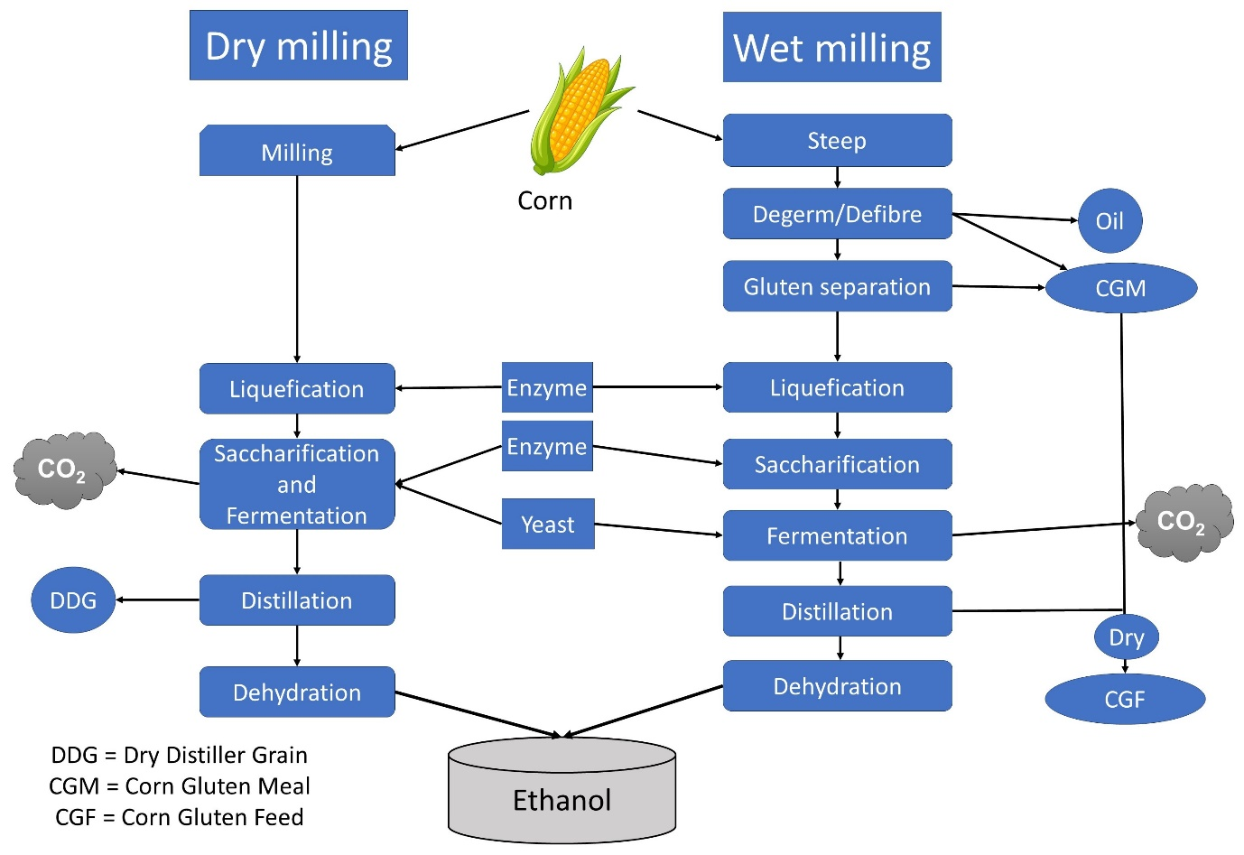
Figure 1: Basic steps of dry-milling and wet-milling. Details of the processes are discussed in the text.

This cooked mash is cooled to 32°C and transferred to a fermenter, most commonly a batch fermenter. Inoculum of the yeast Saccharomyces cerevisiae is then added. For maximum yield, Saccharomyces cerevisiae 3013 and Zymomonas mobilis ZMA7-2 is added (Senatore et al., 2020). For optimal growth of yeasts, urea or ammonium sulfate is added as the source of nitrogen. Addition of protease enzyme is also sometimes useful as the enzyme breaks down proteins into amino acids, which can additionally serve as source of nitrogen for yeasts. Fermentation for about 48-72 hour is carried out which yields 10 to 12% of ethanol concentration. During fermentation the pH of the fermenter is kept below pH 4. This low pH is important for glucoamylase activity and also inhibit growth of other unwanted bacteria. Saccharifying the liquefied starch at 65 °C prior to fermentation can reduce amount of glucoamylase used in the fermenter. Simultaneous saccharification and fermentation (SSF) gives some advantages in the yield. Which include, lowering the contamination by unwanted microorganisms, lowering the osmotic stress of yeast, and providing more energy efficiency. This process may provide 8% more yield of ethanol per lot of grain.
In distillation process the ethanol is separated from solid and water in mash. The vaporization temperature of ethanol and water is 78 °C and 100 °C respectively (at sea level). Difference in the vaporization temperature helps to separate ethanol from water by heating in a distillation column. By conventional distillation, or rectification, 95% pure ethanol can be produced, and farther heating cannot separate any ethanol from water. The remaining 5% water is removed by molecular sieve method to produce 100% pure ethanol.
Beside bioethanol, in this process two very useful by-products are formed - distiller grain, which can be used as livestock feed, composting, baking etc., and CO₂ which is used in different food industries. Whole stillage refers to the remaining solid and liquid fractions after distillation. This whole stillage can contain oil, fibre, protein components of grain and remaining non-fermented starch. This product is also very useful for poultry, livestock and fish culture (Bothast and Schlicher, 2005).

5.1.2. Wet milling
In wet milling the kernel is pretreated with water and sulfurous acid for 24-48 hours to separate the kernel components (starch, fibre, germ and gluten). The process of separation contains six main courses (Ramirez et al., 2008). A brief outline of the wet milling is shown in Figure 1, right panel.
- Grain handling: Grains stored in a silo must be cleaned, small and large dirt particles have to be removed to avoid clogging of the screens, which may cause the process to become vicious, lowering the quality of the product.
- Steeping: Diluted SO₂ solution is used to soak the cleaned corn under controlled temperature. In this process the protein matrix is disintegrated to liberate the starch granules, allowing them to be separated during the next milling. Steeping is used to aid in the separation process by softening the kernel, increasing the moisture content of the grains, and eliminating soluble debris. Steeping is very much important and the efficiency of wet milling depends on this.
- Germ separation and washing: Germ is an oil rich content in corn kernel. Steeped swollen kernel is ground and by using four sets of hydrocyclones the germ is separated from the starchy slurry.
- Fibre separation and recovery: It is run through the grit screen to separate the fibre, bound starch, and gluten from the water and loose starch and gluten (mill starch). To completely disperse the starch the remaining solids which contain fibre and bound starch and gluten are finely ground. This milling breaks up the fibre and frees the starch. The ground slurry is then rinsed and sorted in a succession of tanks and washed the fibres. This processed water from gluten thickener is sent to the final stage of separation.
- Gluten separation and recovery: In a disk stack centrifuge, density differences separate the gluten from the starch. Prior to separation, the mill starch is de-gritted to remove any extraneous particles like sands, rust, or pipe scales that might interfere with the centrifuges later in the process. Then it is centrifuged to concentrate it. The thickened mill starch stream is sent to the first centrifuge, which separates the less dense gluten from the starch. The primary centrifuge's goal is to get high-quality gluten in the overflow. The starch, gluten, and other contaminants in the underflow are transferred to the starch washing process. Following that, the gluten is dewatered using a centrifuge, a rotary vacuum belt filter, and a ring dryer to a final moisture content of 10%.
- Starch washing and recovery: The crude starch is washed in a counter current method in a succession of tiny hydrocyclones organized in stages. In the last washing stage, where the starch left the process, the wash water enters the system. Now, this separated starch is used to farther treatments described above in dry milling process to get bioethanol.

5.2. Second-generation biofuel production
Second generation biofuel is derived from non-edible feedstock mainly lignocellulosic compound. Lignocellulose is made up of cellulose (40%-60%), hemicellulose ( 20%-40%) and lignin (10%-25%) (Chen, 2014). Other feedstocks for second generation biofuels are agricultural residues like leaves, stovers, straws; agrowastes, like solid cattle manure; forest waste like saw dust, wood chips; forest biomass like cedar, spruce; industrial and municipal wastes like chemical pulps, food waste, krafts paper etc (Carriquiry et al., 2011; Hirani et al., 2018; Su et al., 2020). For lignocellulosic biomass there are some dedicated plants like Echhornia crassipes an aquatic plant and Phalaris arundinacea, Panicum virgatum, Miscanthus spp. are some perennial grasse (Govil et al., 2020).
Process of second-generation bioethanol production includes the following steps:
- Collection of lignocellulosic biomasses: Biomasses are collected from the source to the bioreactor factory. Here the high transportation cost makes it economically unfavourable. On the basis of feedstock pre-processing steps, such as grinding and milling, to get an easy to transport material are followed.
- Pretreatment: In pretreatment method the lignocellulosic components can be separated by different pretreatment processes (Tabe 2) to cellulose, hemicellulose, and lignin as they formed a complex called lignin-carbohydrate complex (LCC) which is hard to break without pretreatment. From this pretreated component cellulose and hemicellulose go for hydrolysis process.

Table 2: Different pretreatment methods of lignocellulosic biomass.
Type of method | Agents/reagents used | References
Physical | Fragmentation, sonication, pyrolysis, extrusion, liquid hot water, irradiation. | (Aguilar-Reynosa et al., 2017; Su et al., 2020; Subhedar and Gogate, 2013; Yang et al., 2008)
Chemical | Acid, alkali, salts, solvolysis, hydrotropes | (Dharmaraja et al., 2023; Klein-Marcuschamer et al., 2011; Mosier et al., 2005; Travaini et al., 2016; Yin et al., 2021)
Physicochemical | Microwave assisted pyrolysis, ultraviolet assisted chemical pretreatment, ammonia fiber explosion. Steam explosion | (Jung et al., 2008; Kumari and Singh, 2018; Mussatto and Dragone, 2016; Teymouri, 2005)
Biological | Enzymes (Hemicellulose, Cellulase, Pectinase, Laccase), Microorganism (Brown rot fungi, White rot fungi, Bacterial cell) | (Sharma et al., 2019)

In pretreatment method the breakdown of lignocellulosic compounds forms some byproducts which are inhibitory or toxic for the enzymes and microorganisms used in the next steps. Detoxification is an important step for second-generation biofuel production. These toxic products include sugar acids, formic acid, acetic acid, levulinic acid and furfural. These toxic products come mainly from the breakdown of hemicellulose and lignin (Guo et al., 2022). Different biological and physiochemical approaches have been used to treat this problem, like modified fermentative strategies. However, the advancements in lignocellulose hydrolysate detoxification techniques have led to a large loss of sugars after purification. To avoid this inhibition and improve sugar recovery hydrolysis of myco-LB (LB after fungal pretreatment) is a good approach (Chandel et al., 2013).
- Hydrolysis: In this process cellulose and hemicellulose substrates are converted into fermentable simple 6-C or 5-C sugars, such as D-glucose and D-xylose. This step is very important as the fermenting enzyme can’t digest cellulose or hemicellulose directly during fermentation to form alcohol. Hydrolysis can be performed by either enzymatic method or by acid hydrolysis. Acid hydrolysis includes H₂SO₄ and HCL and it can be divided into concentrated and diluted acid treatment. Concentrated acid treatment requires less time but sugar recovery from high acid is cumbersome and it can degrade mono-sugars too. Dilute acid treatment requires high temperature and low acid concentration. Enzymatic hydrolysis process is very much efficient and gives high sugar recovery. The optimum conditions of enzyme hydrolysis are 45° - 50° C of temperature and pH of 4.8 - 5. There are three major types of cellulase enzymes used in this process endo-1-4-β-glucanases, cellobiohydrolases, and β-glucosidases. The main problem with these enzymes is their high cost, that makes the fuel economically unfavourable (Edeh, 2020).
- Fermentation: This is the main step where microorganisms utilize sugar molecules to form ethanol by fermenting the mono-sugar with the production of gases as byproduct.
Fermentation
C₆H₁₂O₆ + yeast 2C₂H₅OH + 2CO₂
The major microorganism used in this process is Saccharomyces Cerevisiae, also known as Brewer’s yeast. Saccharomyces Cerevisiae 3013 (Ji et al., 2012) and Saccharomyces Cerevisiae BY4742 (Zeng et al., 2014) are the two strains that are used for this fermentation process. Other than yeast, bacteria like Zymomonas Mobilis, and fungi Aspergillus oryzae 694 and Rhizobium javanicus 2871 have also been reported to be used in bioethanol production (Skory et al., 1997).
- Product recovery: Ethanol is recovered from fermenter using distillation process, or distillation combined with adsorption process.

6. Biodiesel
The exponential increase in population is widely recognized as the primary factor contributing to the depletion of natural resources. The current scarcity is resulting in increased prices, hence exacerbating the hardships faced by marginalized communities. In addition to this, the process of combusting non-renewable fuels, namely natural gas, petroleum, and coal, results in the production of substantial quantities of detrimental gases such as CO₂, NO₂, hydrocarbons and particulate matters (Ng et al., 2010; Qadeer et al., 2021). It is anticipated that future generations would encounter a dearth of energy resources, notably petroleum. Researchers are now developing sustainable alternative fuel sources with a specific focus on the challenges that humanity are anticipated to encounter in the future. Biodiesel is considered to be among the various alternative fuels available. As to the definition provided by the Brazilian Biodiesel Programme, biodiesel refers to a blend including alkyl ester derived from vegetable oil, animal fat, and fossil diesel, combined in varying quantities (Pinto et al., 2005).
In 1893, Rudolf Diesel, the inventor of the engine, employed peanut oil as a fuel source for operating his engine (Lin et al., 2011). The output of biodiesel has surpassed 9.378 million metric tons globally. The European Union (EU), which contributes 61% of the industry’s total production, is the first-place producer of biodiesel, followed by the United States, which produces 1.510 million metric tons. Malaysia, China, Indonesia, Brazil, and Argentina are important additional nations that produce significant amounts of biodiesel (Ng et al., 2010). Biodiesel synthesis can be achieved through the utilization of many raw substrates, including soybean oil, sunflower oil, palm oil, coconut oil, castor oil, rapeseed oil, canola oil, triglycerides, animal fats (tallow), and crude oil (Lin et al., 2011). Methanol is the preferred alcohol for the transesterification process of oil or fat in the manufacturing of biodiesel. Although ethanol can also be utilised, its efficiency is comparatively lower than that of methanol. Additional sources of biodiesel production include jatropha, barley, camelina, almond copra, groundnut, karanja, oat, poppy seed, fish oil, sesame, okra seed, rice bran, wheat, and sorghum (Lin et al., 2011). One of the disadvantages of vegetable as fuel is incomplete combustion of the fat and gum formation. High gum formation makes the diesel thick and more lubricating (Ma and Hanna, 1999). The land area necessary for cultivating crops for oils and fats appears to be insufficient in meeting the demands of the global population. In order to address this particular circumstance, microbes can assume the role of biofuel generation. Microalgae have gained attention as a promising and rising alternative for the generation of biodiesel. Numerous species of microalgae have the capacity to synthesise diverse varieties of lipids, serving as viable feedstocks for the transesterification procedure (Chisti, 2007). The production process of any specific product is influenced by several critical variables in addition to the raw material. These variables include temperature, the alcohol-to-vegetable oil ratio, the types of raw substrates employed, the catalyst utilized, and the quantity of catalyst involved (Marchetti et al., 2007). The different catalysts which can be used for the transesterification are NaOH, KOH, H₂SO₄, sulfonic acid, and lipase (Chiaramonti et al., 2007). It is evident that biodiesel has superior fuel qualities in comparison to diesel, as indicated by its greater cetane number, elevated flash point, and enhanced lubrication capabilities (Lin et al., 2011).

6.1. Composition of biodiesel
Biodiesel is a monoalkyl-ester of fatty acids produced by the transesterification reaction of the fatty acids, triacylglyceride, and alcohol (Knothe and Razon, 2017). Different substrates used for biodiesel formation contain different amounts and types of fatty acids. Fatty acids can be classified into two categories: saturated and unsaturated fatty acids. In saturated fatty acids, there is no double bond, whereas in unsaturated fatty acids, there are one or more double bonds. Unsaturated fatty acid-containing fats remain liquid at room temperature, and saturated fatty acid-containing fats remain solid at room temperature. In beef tallow, 50% of the fatty acids are saturated in nature. Vegetable oil and animal fat both contain some amount of free fatty acids (Ma and Hanna, 1999). The difference in bonds causes a difference in the properties of fatty acids. The crop-derived oil used for biodiesel production contains fatty acids with a longer chain, usually more than 8 carbons. Carbon-18 fatty acids are more prominent in plant-based oils, and the fatty acids of algae are usually saturated and mono-unsaturated with carbon chain lengths of 16 to 18 (Gaurav et al., 2013). The chemical composition of biodiesel formed from soybean is: saturated fatty acid C14 (0.1), C16 (10.7), C18 (4.3), C20 (0.4), C24 (0.4), unsaturated fatty acid C18:1 (23.7), C18:2 (53), C18:3 (7.2), and C20:1 (0.2). Biodiesel formed from chicken fat contains C14 (0.5), C16 (19.4), C17 (0.4), C18 (6.1), and C21 (0.3) saturated fatty acids, as well as C16:1 (3.6), C18:1 (32.2), C18:2 (32.8), and C18:3 unsaturated fatty acids (Manaf et al., 2019).

6.2. Properties of biodiesel
The most important and studied properties of fatty acid methyl esters (FAME) are viscosity, flash point, cetane number, iodine value, heating value, density, clod filter plugging point, pour point, specific gravity, sulfur value, acid value, peroxide value, lubricity, oxidative stability, and cloud point (Hoekman et al., 2012; Knothe and Razon, 2017; Singh et al., 2019). Properties of biodiesel produced from different feedstocks are summarized in Table 3.

6.2.1. Viscosity
The viscosity of biodiesels obtained from different raw substrates shows variation, but most of the biodiesel shows a narrow range of 4-5 mm²/s. The viscosities of camelina oil and coconut oil-derived biodiesel have values of 3.8mm²/s and 2.75mm²/s respectively (Hoekman et al., 2012). The viscosity of biodiesel is higher than other biofuels (Alptekin and Canakci, 2008; Ejim et al., 2007; Singh et al., 2019). Biodiesel generated from spirulina-based oil shows maximum viscosity of 17.14 mm² /s, whereas plastic pyrolysis shows the minimum value of viscosity 1.91 mm²/s. Viscosity shows an inversely proportional relationship with the density of the biodiesel and the degree of unsaturation of the fatty acids. Higher density reduces the viscosity, and similarly, high numbers of double bonds also decrease the viscosity (Singh et al., 2019).
Table 3: Properties of biodiesel produced from different feedstock
Feedstock oil | Cetane number | Viscosity at 40 °C | Flash point | Density at 15 °C | Iodine number | Acid value | References
Palm oil | 60.21 | 4.53 | 176.7 | 870 | 50.5 | 0.2 | (Moser and Vaughn, 2010)
Mahua | 55 | 4.77 | 129.5 | 895 | 74.2 | 0.41 | (Godiganur et al., 2009; Puhan et al., 2005; Saravanan et al., 2010)
Soybean oil | 44.7 | 4.15 | 140.1 | 882 | 117.7 | 0.18 | (Mihaela et al., 2013; Moser and Vaughn, 2010; Ramadhas et al., 2005; Sarin et al., 2007)
Cotton seed oil | 48.1 | 4.19 | 210 | 887 | 120 | 0.5 | (No, 2011; Ramadhas et al., 2005)
Rapeseed oil | 48.25 | 4.4 | 169.5 | 879 | 112 | 0.26 | (Mihaela et al., 2013; Ramadhas et al., 2005)
Jatropha | 55.43 | 4.52 | 175.5 | 865 | 95.75 | 0.24 | (Chauhan et al., 2010; Ganapathy et al., 2011; Kumar Tiwari et al., 2007; Sarin et al., 2007)

6.2.2. Density
The density of biodiesel ranges from 860 - 900 kg/m³, which is specified only in EN 14214. Density shows a linear relationship with degree of unsaturation; highly unsaturated fatty acids possess higher density, and higher density results in low viscosity. The density of biodiesel is higher than petrol-based diesel. It also shows a correlation with the chain length of the fatty acid; a high chain length decreases the density (Hoekman et al., 2012; Knothe and Razon, 2017).
6.2.3. Cetane value (CV)
Ignition delay is a key phase of fuel, which is the time gap between fuel discharge into the combustion chamber and the start of ignition. Biodiesel shows a higher cetane value because of its higher oxygen content and overall higher combustion efficiency (Sakthivel et al., 2018). The Cetane value is specified by EN ISO 5165, ASTM D613, and ISO 5156/P9. The minimum value of Cetane set by ASTM is 47 and by EN ISO is 51. The biodiesel produced from Spirulina platensis microalgae and linseed oil shows the highest (70) and lowest (34.6) CV respectively (Singh et al., 2019). CV is an indicator of the ignition behaviour and quality of biodiesel; a higher CV value indicates a lower ignition delay, which means the fuel can ignite quickly. The CV value shows a linear relationship with carbon chain length. A decrease in chain length causes a reduction in CV value, and vice versa (Knothe and Razon, 2017).
6.2.4. Flash point (FP)
The flash point is the lowest temperature at which a fuel ignites when it comes into contact with a source of fire. Biodiesel has a higher value of FP (150 °C) than other conventional fuels (55–60 °C). The evaluation of FP value is governed by EN ISO 3679, ASTM D93, and P21. The minimum value of FP is 55 °C, which is for biodiesel of neem oil, and the maximum value of FP is 241 °C, which is possessed by biodiesel of linseed oil (Knothe and Razon, 2017). The residue of methanol in alkylester decreases the flash point significantly (Hoekman et al., 2012).
6.2.5. Iodine value (IV)
The iodine value is a measure of the degree of unsaturation. The IV is specified by EN 14214. The maximum IV specified by EN14214 is 120 mg I₂/100 g. Rapeseed biodiesel and coconut-derived biodiesel show maximum (just below 120) and minimum (19) iodine values respectively (Hoekman et al., 2012; Knothe and Razon, 2017).

6.3. Substrate or feedstock
Different oils extracted from crops, animal fats, and waste cooking oil can be used for biodiesel production. The common vegetable oils used for this purpose are rapeseed oil (used in the EU), soybean oil (used in the US), cottonseed oil, peanut oil (used in tropical countries), sunflower oil (dominant in the EU), palm, olive, and corn. The advantages of vegetable oil selection for the process are renewability, easy availability, low sulfur content, high biodegradability, and low aromatic compound content. But, there are also some disadvantages, which include high viscosity, highly reactive hydrocarbons, and low volatility. Non-edible crop oils can also be used for biodiesel production; the common sources of such oils are microalgae, jatropha tree, karanja, rice bran, neem, rubber seed tree, tobacco seed, and mahua. The substrates of animal origin include tallow, lard, yellow grease, and chicken fat, where tallow is the most commonly used fat substrate of animal origin (Balat and Balat, 2010; Hoekman et al., 2012). The first generation of biodiesel is made from edible oils like soybean oil, the second generation from non-edible oils like jatropha oil, the third generation from waste oil, and the fourth generation from solar energy (Singh et al., 2019).

6.4. Biodiesel synthesis
Pyrolysis and oil cracking are the traditional processes for generating biodiesel. Pyrolysis is the degradation of materials using heat (without oxygen). Numerous studies on the pyrolysis of vegetables have been conducted ever since World War I. Through pyrolyzing, tung oil, the first diesel fuel with a trace amount of kerosene and gasoline was created (Ma and Hanna, 1999). The primary component of biodiesel’s chemical makeup is a monoalkyl ester, which can be either methyl-, or ethyl-ester and is often generated from long-chain fatty acids found in either animal or plant-based lipids. Alcohol, the catalyst, and the substrate oil are stirred in a bioreactor for one hour at 60˚C to produce biodiesel from vegetable oil (Gerpen, 2005). Enzymatic catalysis, which catalyzes the conversion of fatty acids into esters (transesterification), is the most ideal way of the synthesis of biodiesel. This process can be carried out using an organic solvent system, such as a lipase-mediated reaction, or in a solvent-free system (alcohol should be added). An ideal water concentration guarantees a
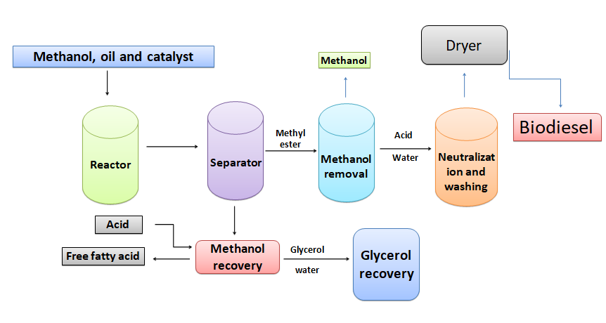
Figure 2: Flowchart of biodiesel production.

greater number of transesterification reactions and a better biodiesel output (Szczęsna Antczak et al., 2009). The temperature required for the reaction ranges between 20 and 60 °C. After the transesterification step, glycerol accumulates in the lower phase and biofuel floats in the upper phase, which can be easily separated. Lipase is an enzyme obtained from plants, animals, and microorganisms that possesses both hydrolytic and synthetic properties. Commercially available lipases are isolated from microorganisms. The fatty acid specific lipase acts on the carboxyl ester bond of a specific triglyceride to produce fatty acids (Luna et al., 2016). It also catalyzes the transesterification reaction. The key factors of a lipase-mediated reaction are temperature, pH, water activity, concentration of substrate, and selection of organic solvent (Szczęsna Antczak et al., 2009). As a result of triglyceride transesterification, a mixture of glycerol, alcohol, esters, catalyst, and tri-, di-, and monoglycerides are formed. Ester separation is not easy because of the various impurities. The suitable content of free fatty acids for biodiesel production should be below 0.5%. Microemulsion is a colloidal equilibrium dispersion that possesses a dispersed-phase particle with a very low diameter. It is also known as hybrid fuel. Problem with high viscosity of vegetable oils can be solved by the formation of microemulsion with immiscible liquids, such as ethanol, methanol, and non-ionic or ionic amphiphilic substances. The microemulsion decreases the viscosity and improves the spray pattern by increasing the amount of 1-butanol (Balat and Balat, 2010). The downstream processing of biodiesel formation includes the removal of catalyst, alcohol, glycerine, and the complete esterification of free fatty acids. Glycerol and alcohol can be recovered by centrifugation and used as commercial products. The lower value of specific gravity indicates the completion of the process and the removal of glycerol. The desired chemical product that is formed by the above process is alkyl ester, known as biodiesel (Balat and Balat, 2010).

6.5. Advantages and disadvantages of biodiesel
By reducing the generation of greenhouse gases and CO₂ emissions, biodiesel benefits the environment. Because biodiesel contains less sulfur than other fuels, it produces less sulfur oxides and, as a result, has a negative impact on acid rain (Ng et al., 2010). Its biodegradability and non-toxicity are additional characteristics that make it environmentally benign. It does not explode as much as petrol-diesel. Higher combustion efficiency, mobility, renewability, and a lower proportion of aromatic compounds are further benefits (Knothe and Razon, 2017; Ma and Hanna, 1999). In comparison to petroleum-based diesel, biodiesel has a higher flash point (432 K), a higher cetane number (50), and an oxygen concentration of 10-11% (Balat and Balat, 2010). In comparison to diesel based on gasoline, storage and handling risk is also minimal (Demirbas, 2007).
The main disadvantages of biodiesel include its high viscosity, increased nitrogen oxide emissions, cold start issues at lower temperatures, lower energy content, engine compatibility at lower engine speeds, high corrosion, poor calorific value, and, most crucially, its high cost. The high viscosity of biodiesel results in poor fuel spray and reduces the fuel injector’s precision (Balat and Balat, 2010; Singh et al., 2019). A major aspect in the development of the biodiesel sector is consumer acceptability. More research can be done to make biodiesel more affordable for human usage by examining how the general population feels about it.

7. Hydrogen biofuel
Hydrogen is believed to be the fuel of future as it is environment-friendly. It produces zero emission; rather, its combustion emits pure drinkable water. The global company Toyota is the major company producing and developing hydrogen fuelled cell cars. Toyota Mirai is existing hydrogen fuelled cell car since 2014. Beside that other global companies like Honda and Hyundai also entered in this market and investing for the development of the hydrogen fuelled cell cars. NASA has been searching hydrogen fuel cell to generate electricity in its space capsule from 1960s (Cook, 2002). In addition, hydrogen is also used in planes, trains and heavy-duty industries for energy production. Nowadays almost half of the H₂ is produced from natural gas by gasification and thermos-catalytic process, which is still fossil fuel dependent. So, we need to develop biological processes to get hydrogen. There are mainly five processes by which biohydrogen can be produced.
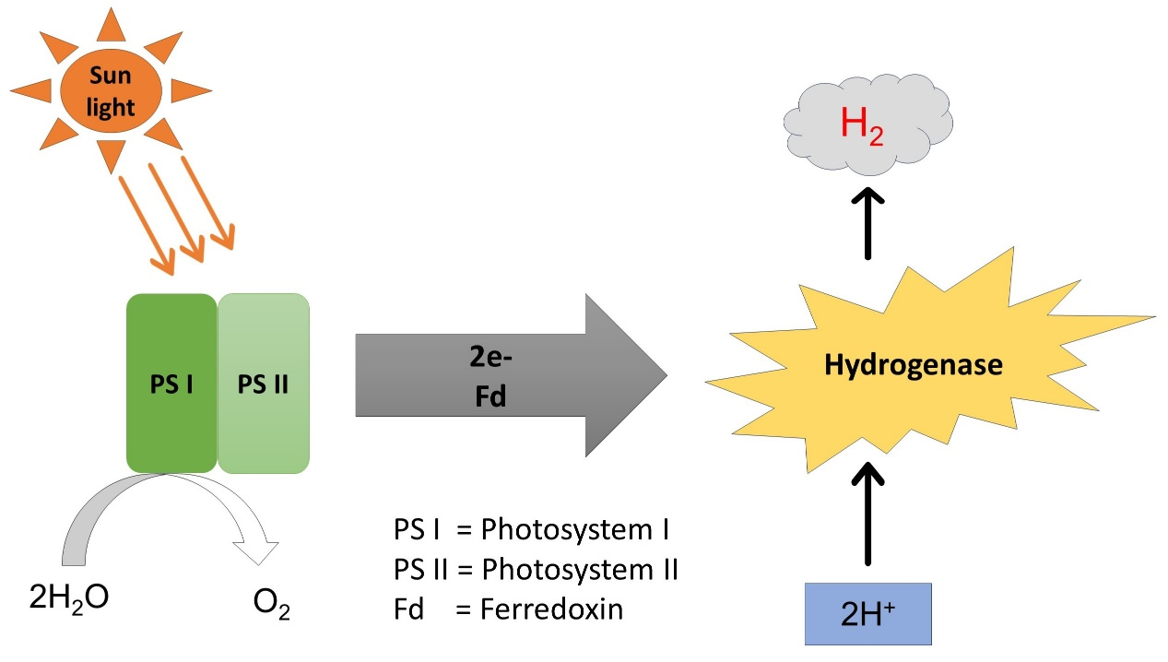
Figure 3. The process of direct biophotolysis. Photosystem I (PS I) and photosystem II (PSII), with the help of light, excite electrons and transfer them to ferredoxin (Fd). Hydrogenase accepts electrons from Fd and produces hydrogen.

- Direct biophotolysis: Biohydrogen can be generated from plants by bio-photolysis of water using microalgae, fermentation of organic compounds, and photodecomposition of organic compounds by photosynthetic bacteria (Figure 3).
The general reaction for this process is:

2H₂O 2H₂ + O₂
Light

The light energy absorbed by PSII and PSI raise the energy level of electrons and transferred to ferredoxin. Then the enzyme hydrogenase accepts the electrons from ferredoxin to produce hydrogen. Hydrogenase is an enzyme that catalyzes the reversible oxidation of molecular hydrogen. Hydrogenase enzymes are of three different types, iron-iron hydrogenase, nickel-iron hydrogenase and iron hydrogenase (Vignais and Billoud, 2007). Hydrogenase enzyme is sensitive to O₂.
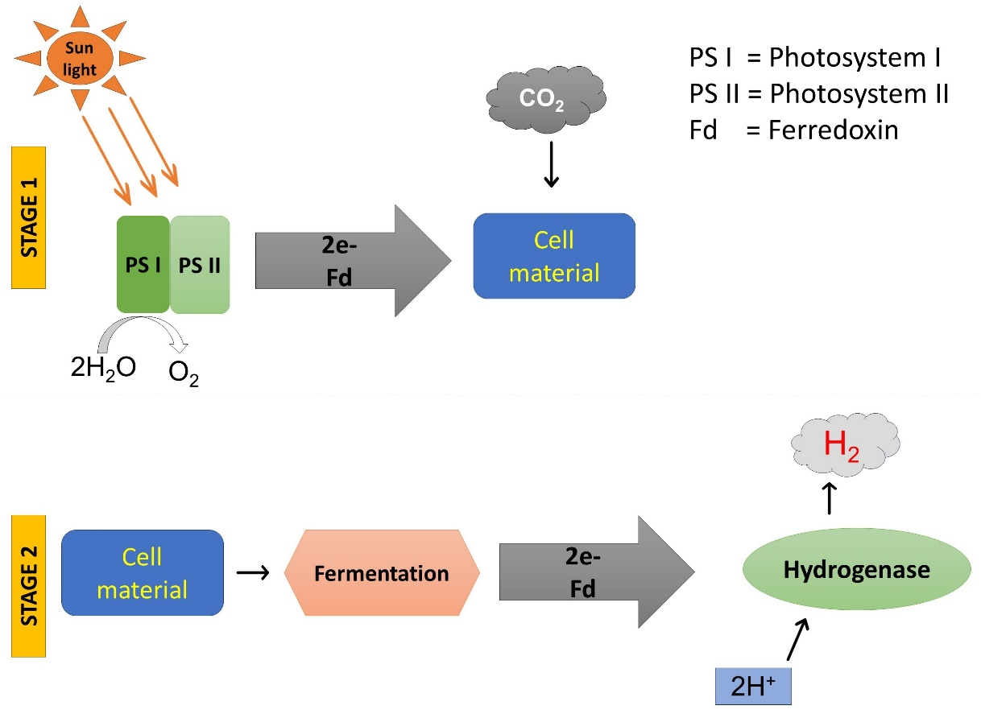
Figure 4. Indirect biophotolysis. In step one with the help of light plants do photosynthesis to produce cellular material. In the second step by fermenting the cellular material gets converted to hydrogen with the help of the enzyme hydrogenase by accepting electrons from ferredoxin (Fd).

- Indirect biophotolysis: It is a two-step process by which hydrogen is produced (Figure 4). Cyanobacteria and microalgae are used to produce hydrogen by this process by using starch and glycogen as substrates. In the first step of this process, light energy is used to form carbohydrate molecules (starch and glycogen), and in the second step these carbohydrate molecules are utilised to form hydrogen by metabolic pathways in a dark and anaerobic condition. In this anaerobic phase carbohydrates first get converted into acetate in the dark, then in a photobioreactor acetate is converted into H₂ and CO₂. This process is advantageous over direct photobiolysis, as the byproduct of light reaction of photosynthesis oxygen, which is toxic for the enzyme hydrogenase, is separated from the system.
The reactions for indirect biophotolysis are:
Light
6H₂O + 6CO₂ C₆H₁₂O₆ + 6CO₂
C₆H₁₂O₆ + 2H₂O 4H₂ + 2CH₃COOH + 2CO₂
Light
2CH₃COOH + 4H₂O 8H₂ + 4CO₂
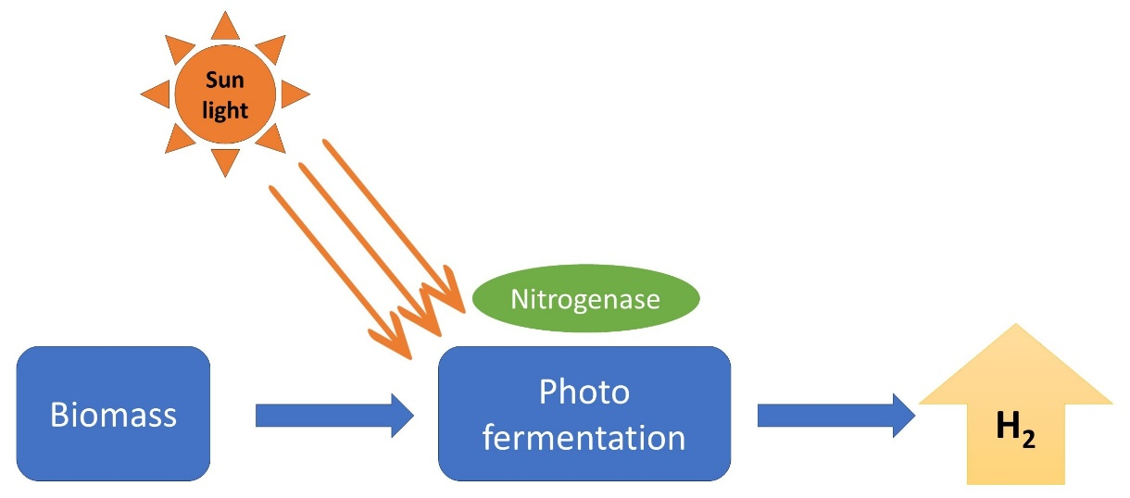
Figure 5. Photo-fermentation. Diverse groups of photosynthetic bacteria produce hydrogen by fermenting organic biomass by the enzyme nitrogenase, in nitrogen deficient condition, using light as an energy source.

- Photo-fermentation: From different crop residues we can produce hydrogen by photo-fermentation process using diverse groups of photosynthetic bacteria (Figure 5). These microorganisms, in nitrogen deficient condition, produce hydrogen by the enzyme nitrogenase from reduced compounds using light as an energy source. Rhodobacter sphaeroides SH2C is a type of purple non-sulphur bacteria which is used to produce hydrogen from small molecular fatty acids (Redwood et al., 2009). Many other photosynthetic bacteria, like Chromatium, Chlorobium, Halobacterium, Rhodopseudomonas, Rhodobater, and Rhodospirillum have been reported to produce hydrogen gas by the help of oxygen sensitive enzyme nitrogenase (Singh and Sarma, 2022). They use diverse substrates to produce hydrogen; for example, carbohydrates, like glucose, fructose, and organic acids, like malate and acetate.
The reaction for photo-fermentation is:
Light
C₆H₁₂O₆ + 12H₂O 12H₂ +CO₂

- Dark fermentation: As the name suggests, dark fermentation does not require light source for fermentation reaction. It is the process by which microorganisms produce hydrogen by the process of heterotrophic fermentation (Figure 6). Substrates used in this fermentation process are glucose, cellulose, starch and sucrose. In dark fermentation we get organic acids as byproduct. By the process of hydrolysis, the complex matters get converted into simple molecules. Then these simple compounds go to acidification process in presence of enzymes secreted by fermentative bacteria. Next, the acid produced are converted into biohydrogen and acetate in acetogenesis process (Kucharska et al., 2019). Facultative and anaerobic bacteria such as E. coli, E. cloacae, Clostridium sp., etc. are used for fermentation process (Cao et al., 2022).
The reaction for dark-fermentation is:
C₆H₁₂O₆ + 2H₂O 4H₂ +CO₂ + 2CH₃COOH
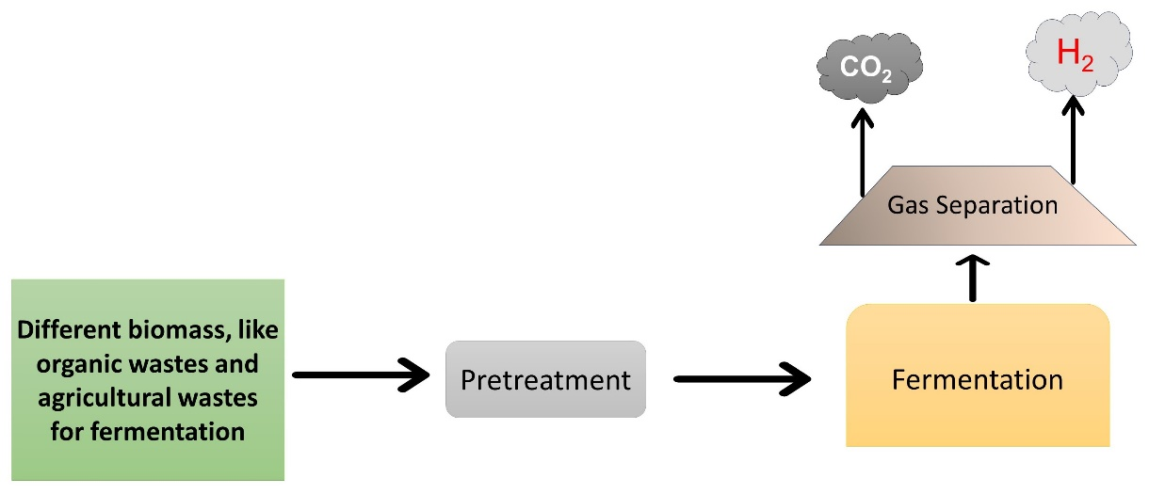
Figure 6. Dark fermentation. Wide variety of microorganisms produce hydrogen by the process of dark fermentation or heterotrophic fermentation.

- Microbial electrolysis cell (MEC): It is a novel technique used to produce hydrogen from organic matter, including renewable resources and wastewater. Electrochemically active bacteria oxidize organic materials in a MEC, producing CO₂, electrons, and protons (Figure 7). The bacteria donate electrons to the anode while releasing protons into the solution. The electrons then move through a wire to a cathode, where they mix with the liberated protons in solution. This, however, does not happen on its own. Under ordinary biological circumstances, a cathode potential of at least -0.414 V is required to create hydrogen at the cathode from the combination of these protons and electrons. If we consider acetate as substrate, in anode the reaction would be:
CH₃COO⁻ + 4H₂O 2HCO³⁻ +9H⁺ +8e-
In cathode the reaction would be:
8H⁺ + 8e- 4H₂.
The standard condition for this reaction is pH 7, temperature 25 °C and 1 atmospheric pressure (Kadier et al., 2014).
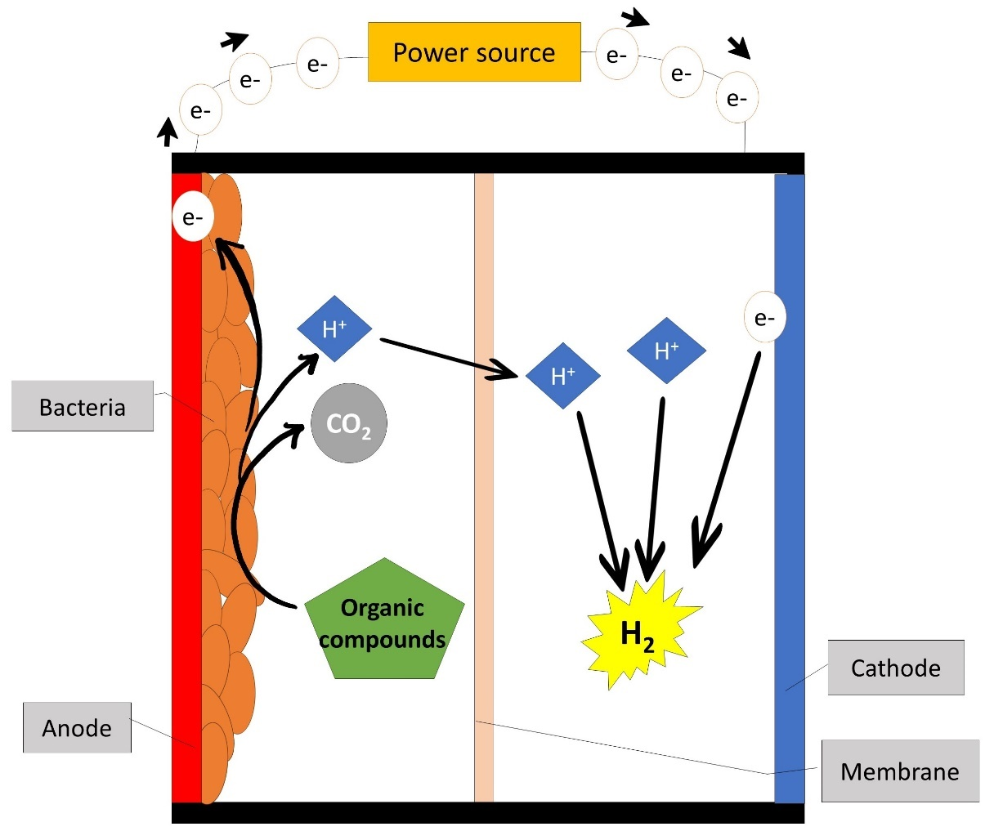
Figure 7: Mechanism of microbial electrolysis cell

8. Problems in the biofuel industry
Despite being marketed as a greener and more sustainable alternative to fossil fuels, there are a number of drawbacks to biofuels that make their broad use unsettling. These drawbacks, as discussed below, cover economic, social, and environmental issues.
- Land use and deforestation: The substantial quantity of land needed for the development of biofuels is one of the main drawbacks. Deforestation and habitat damage may result from this, especially in areas with a high biodiversity. For instance, the spread of oil palm and soybean plantations for the manufacture of biofuels has been connected to deforestation and the loss of important ecosystems in Southeast Asia and South America (Fargione et al., 2008).
- Food vs. fuel debate: The conflict between biofuel crops and food crops for arable land is a major concern. Especially in vulnerable countries, the growth of commodities like corn and sugarcane for the production of biofuels may increase food costs and worsen food shortages (Taheripour et al., 2010).
- Resource intensive: Biofuel production frequently necessitates large amounts of energy, water, and fertilizer. Because the energy balance of biofuels can be relatively low, especially for certain feedstocks like maize ethanol, this can negate some of the environmental benefits. Excessive water use can also contribute to water scarcity in areas where biofuel crops are grown (Hill et al., 2006).
- Greenhouse gas emissions: Although the use of biofuels is encouraged as a way to cut greenhouse gas emissions, these benefits are occasionally outweighed by the emissions linked to their production and changes in land use. For instance, the conversion of grasslands or forests to biofuel crops may result in the release of substantial quantities of carbon dioxide into the atmosphere (Searchinger et al., 2008). Biodiesel production causes an increased emission of oxides of nitrogen (Balat and Balat, 2010).
- Monoculture farming: Large-scale biofuel crop production may result in monoculture farming techniques, which may be harmful to the health of the soil, raise the danger of insect outbreaks, and lessen the diversity of agriculture as a whole (Foley et al., 2011).
- Infrastructure and technological challenges: Significant infrastructure and transportation system improvements, including the creation of new distribution and refuelling networks, are also necessary to accommodate the widespread use of biofuels. It can take a lot of money and effort to do this (Perlack, 2005).

9. Conclusion
During the last few decades, biofuels, such as bioethanol, biodiesel, and biogas, have emerged as a potential alternative to the exhaustible natural resources, and shown a ray of hope as a cleaner and more sustainable energy sources that can be used in the energy-craving future world. Unlike fossil fuels, biofuels are obtained from renewable feedstocks, such as food crops, non-crop plants, and algae, which also absorb carbon dioxide, a greenhouse gas, during their growth. Biofuels emit little toxic gases into the environment in comparison to natural fuels, which might be a promising solution to reduce greenhouse gas emissions. By substituting traditional gasoline, petrol and diesel-based fuels with biofuels, or blending those natural fuels with some amount of biofuels, substantial reduction in emissions may be achieved. Biofuels are also biodegradable in nature. Biofuels can be produced locally, reducing the dependence on other countries for oil, making a country self-dependent.
However, the biofuel industry also faces challenges. Of which, land-use competition with the crop plants is a major concern. Large-scale biofuel production will lead to competition for cultivable lands, displacing food crops and exacerbating food security issues. This may also lead to deforestation, destroying the biodiversity, to increase the cultivable land for growing the feedstocks. Keeping the right balance between biofuel production and food production needs extensive planning and policies. Thus, to really get the benefits of biofuels, it is important to produce that through second, third, or fourth-generation technologies that utilize non-food feedstocks, such as agricultural residues or wastes, and non-food crops. Furthermore, research into use algae-based, or genetically engineered microorganisms as substrates may provide high yields with minimal land use.
In conclusion, biofuels offer the promise of reducing greenhouse gas emissions, and enhancing future energy security, but their acceptance and use must overcome the challenges, like land-use competition and food security. Drawbacks highlight the significance of careful thinking and planning, as well as adoption of sustainable methods in both their production and use. The challenge of balancing the potential advantages of biofuels with the environmental and social problems caused by the biofuels demands for continued research and judicious management. To harness the full potential of biofuels, government policy makers, scientists, and industries must work hand-in-hand to develop and promote advanced technologies while ensuring responsible and sustainable production practices.

Acknowledgments
We express our sincere thanks to Aliah University, and MA & ME Dept., Govt. of West Bengal for financial help. AM and UNI received SVMCM fellowship, GoWB. We sincerely thank Dr. Wriddhiman Ghosh, Bose Institute, Kolkata, for his critical review of the manuscript and valuable suggestions.

Conflict of Interests
The authors declare that they do not have any conflict of interest.

References:
Abbasi, T., Tauseef, S.M., Abbasi, S.A., 2012. A Brief History of Anaerobic Digestion and “Biogas,” in: Abbasi, T., Tauseef, S.M., Abbasi, S.A. (Eds.), Biogas Energy, SpringerBriefs in Environmental Science. Springer, New York, NY, pp. 11–23. https://doi.org/10.1007/978-1-4614-1040-9_2
Adnan, A.I., Ong, M.Y., Nomanbhay, S., Chew, K.W., Show, P.L., 2019. Technologies for Biogas Upgrading to Biomethane: A Review. Bioengineering 6, 92. https://doi.org/10.3390/bioengineering6040092
Aguilar-Reynosa, A., Romaní, A., Ma. Rodríguez-Jasso, R., Aguilar, C.N., Garrote, G., Ruiz, H.A., 2017. Microwave heating processing as alternative of pretreatment in second-generation biorefinery: An overview. Energy Conversion and Management 136, 50–65. https://doi.org/10.1016/j.enconman.2017.01.004
Alptekin, E., Canakci, M., 2008. Determination of the density and the viscosities of biodiesel–diesel fuel blends. Renewable Energy 33, 2623–2630. https://doi.org/10.1016/j.renene.2008.02.020
Balat, M., Balat, H., 2010. Progress in biodiesel processing. Applied Energy 87, 1815–1835. https://doi.org/10.1016/j.apenergy.2010.01.012
Bothast, R.J., Schlicher, M.A., 2005. Biotechnological processes for conversion of corn into ethanol. Appl Microbiol Biotechnol 67, 19–25. https://doi.org/10.1007/s00253-004-1819-8
Calbry-Muzyka, A., Madi, H., Rüsch-Pfund, F., Gandiglio, M., Biollaz, S., 2022. Biogas composition from agricultural sources and organic fraction of municipal solid waste. Renewable Energy 181, 1000–1007. https://doi.org/10.1016/j.renene.2021.09.100
Cao, Y., Liu, H., Liu, W., Guo, J., Xian, M., 2022. Debottlenecking the biological hydrogen production pathway of dark fermentation: insight into the impact of strain improvement. Microbial Cell Factories 21, 166. https://doi.org/10.1186/s12934-022-01893-3
Carriquiry, M.A., Du, X., Timilsina, G.R., 2011. Second generation biofuels: Economics and policies. Energy Policy, Special Section: Renewable energy policy and development 39, 4222–4234. https://doi.org/10.1016/j.enpol.2011.04.036
Chandel, A.K., da Silva, S.S., Singh, O.V., 2013. Detoxification of Lignocellulose Hydrolysates: Biochemical and Metabolic Engineering Toward White Biotechnology. Bioenerg. Res. 6, 388–401. https://doi.org/10.1007/s12155-012-9241-z
Chauhan, B.S., Kumar, N., Du Jun, Y., Lee, K.B., 2010. Performance and emission study of preheated Jatropha oil on medium capacity diesel engine. Energy 35, 2484–2492. https://doi.org/10.1016/j.energy.2010.02.043
Chen, H., 2014. Chemical Composition and Structure of Natural Lignocellulose, in: Chen, H. (Ed.), Biotechnology of Lignocellulose: Theory and Practice. Springer Netherlands, Dordrecht, pp. 25–71. https://doi.org/10.1007/978-94-007-6898-7_2
Chiaramonti, D., Oasmaa, A., Solantausta, Y., 2007. Power generation using fast pyrolysis liquids from biomass. Renewable and Sustainable Energy Reviews 11, 1056–1086. https://doi.org/10.1016/j.rser.2005.07.008
Chisti, Y., 2007. Biodiesel from microalgae. Biotechnol Adv 25, 294–306. https://doi.org/10.1016/j.biotechadv.2007.02.001
Clennell, M.B., Hovland, M., Booth, J.S., Henry, P., Winters, W.J., 1999. Formation of natural gas hydrates in marine sediments: 1. Conceptual model of gas hydrate growth conditioned by host sediment properties. J. Geophys. Res. 104, 22985–23003. https://doi.org/10.1029/1999JB900175
Cook, B., 2002. Introduction to fuel cells and hydrogen technology. Engineering Science &amp; Education Journal 11, 205–216. https://doi.org/10.1049/esej:20020601
De Vrieze, J., Verbeeck, K., Pikaar, I., Boere, J., Van Wijk, A., Rabaey, K., Verstraete, W., 2020. The hydrogen gas bio-based economy and the production of renewable building block chemicals, food and energy. New Biotechnology 55, 12–18. https://doi.org/10.1016/j.nbt.2019.09.004
Demirbas, A., 2007. Importance of biodiesel as transportation fuel. Energy Policy 35, 4661–4670. https://doi.org/10.1016/j.enpol.2007.04.003
Dharmaraja, J., Shobana, S., Arvindnarayan, S., Francis, R.R., Jeyakumar, R.B., Saratale, R.G., Ashokkumar, V., Bhatia, S.K., Kumar, V., Kumar, G., 2023. Lignocellulosic biomass conversion via greener pretreatment methods towards biorefinery applications. Bioresource Technology 369, 128328. https://doi.org/10.1016/j.biortech.2022.128328
Edeh, I., 2020. Bioethanol Production: An Overview, in: Bioethanol Technologies. IntechOpen. https://doi.org/10.5772/intechopen.94895
Ejim, C.E., Fleck, B.A., Amirfazli, A., 2007. Analytical study for atomization of biodiesels and their blends in a typical injector: Surface tension and viscosity effects. Fuel 86, 1534–1544. https://doi.org/10.1016/j.fuel.2006.11.006
Fargione, J., Hill, J., Tilman, D., Polasky, S., Hawthorne, P., 2008. Land clearing and the biofuel carbon debt. Science 319, 1235–1238. https://doi.org/10.1126/science.1152747
Foley, J.A., Ramankutty, N., Brauman, K.A., Cassidy, E.S., Gerber, J.S., Johnston, M., Mueller, N.D., O’Connell, C., Ray, D.K., West, P.C., Balzer, C., Bennett, E.M., Carpenter, S.R., Hill, J., Monfreda, C., Polasky, S., Rockström, J., Sheehan, J., Siebert, S., Tilman, D., Zaks, D.P.M., 2011. Solutions for a cultivated planet. Nature 478, 337–342. https://doi.org/10.1038/nature10452
Ganapathy, T., Gakkhar, R.P., Murugesan, K., 2011. Influence of injection timing on performance, combustion and emission characteristics of Jatropha biodiesel engine. Applied Energy 88, 4376–4386. https://doi.org/10.1016/j.apenergy.2011.05.016
Gaurav, K., Srivastava, R., Singh, R., 2013. Exploring Biodiesel: Chemistry, Biochemistry, and Microalgal Source. International Journal of Green Energy 10, 775–796. https://doi.org/10.1080/15435075.2012.726673
Gerpen, J.V., 2005. Biodiesel processing and production. Fuel Processing Technology 86, 1097–1107. https://doi.org/10.1016/j.fuproc.2004.11.005
Godiganur, S., Suryanarayana Murthy, C.H., Reddy, R.P., 2009. 6BTA 5.9 G2-1 Cummins engine performance and emission tests using methyl ester mahua (Madhuca indica) oil/diesel blends. Renewable Energy 34, 2172–2177. https://doi.org/10.1016/j.renene.2008.12.035
Göransson, K., Söderlind, U., He, J., Zhang, W., 2011. Review of syngas production via biomass DFBGs. Renewable and Sustainable Energy Reviews 15, 482–492. https://doi.org/10.1016/j.rser.2010.09.032
Govil, T., Wang, J., Samanta, D., David, A., Tripathi, A., Rauniyar, S., Salem, D.R., Sani, R.K., 2020. Lignocellulosic feedstock: A review of a sustainable platform for cleaner production of nature’s plastics. Journal of Cleaner Production 270, 122521. https://doi.org/10.1016/j.jclepro.2020.122521
Guo, H., Zhao, Y., Chang, J.-S., Lee, D.-J., 2022. Inhibitor formation and detoxification during lignocellulose biorefinery: A review. Bioresource Technology 361, 127666. https://doi.org/10.1016/j.biortech.2022.127666
Hill, J., Nelson, E., Tilman, D., Polasky, S., Tiffany, D., 2006. Environmental, economic, and energetic costs and benefits of biodiesel and ethanol biofuels. Proceedings of the National Academy of Sciences 103, 11206–11210. https://doi.org/10.1073/pnas.0604600103
Hirani, A.H., Javed, N., Asif, M., Basu, S.K., Kumar, A., 2018. A Review on First- and Second-Generation Biofuel Productions, in: Kumar, A., Ogita, S., Yau, Y.-Y. (Eds.), Biofuels: Greenhouse Gas Mitigation and Global Warming: Next Generation Biofuels and Role of Biotechnology. Springer India, New Delhi, pp. 141–154. https://doi.org/10.1007/978-81-322-3763-1_8
Hoekman, S.K., Broch, A., Robbins, C., Ceniceros, E., Natarajan, M., 2012. Review of biodiesel composition, properties, and specifications. Renewable and Sustainable Energy Reviews 16, 143–169. https://doi.org/10.1016/j.rser.2011.07.143
Home | Statistical Review of World Energy [WWW Document], n.d. URL https://www.energyinst.org/statistical-review (accessed 9.5.23).
Ji, H., Yu, J., Zhang, X., Tan, T., 2012. Characteristics of an immobilized yeast cell system using very high gravity for the fermentation of ethanol. Appl Biochem Biotechnol 168, 21–28. https://doi.org/10.1007/s12010-011-9280-5
Jung, H., Yoon, H.G., Park, W., Choi, C., Wilson, D.B., Shin, D.H., Kim, Y.J., 2008. Effect of sodium hydroxide treatment of bacterial cellulose on cellulase activity. Cellulose 15, 465–471. https://doi.org/10.1007/s10570-007-9190-4
Kadier, A., Simayi, Y., Kalil, M., Abdeshahian, P., Hamid, A., 2014. A review of the substrates used in microbial electrolysis cells (MECs) for producing sustainable and clean hydrogen gas. Renewable Energy 71, 466–472. https://doi.org/10.1016/j.renene.2014.05.052
Khoiyangbam, R.S., Gupta, N., Kumar, S., 2011. Biogas technology: towards sustainable development. The Energy and Resources Institute, New Delhi.
Kittisupakorn, P., Sae-ueng, S., Suwatthikul, A., 2016. Optimization of Energy Consumption in a Hydrotreating Process for Green Diesel Production from Palm Oil, in: Kravanja, Z., Bogataj, M. (Eds.), Computer Aided Chemical Engineering, 26 European Symposium on Computer Aided Process Engineering. Elsevier, pp. 751–756. https://doi.org/10.1016/B978-0-444-63428-3.50130-2
Klein-Marcuschamer, D., Simmons, B., Blanch, H., 2011. Techno-economic analysis of a lignocellulosic ethanol biorefinery with ionic liquid pre-treatment. Biofuels, Bioproducts and Biorefining 5, 562–569. https://doi.org/10.1002/bbb.303
Knothe, G., Razon, L.F., 2017. Biodiesel fuels. Progress in Energy and Combustion Science 58, 36–59. https://doi.org/10.1016/j.pecs.2016.08.001
Kucharska, K., Cieśliński, H., Rybarczyk, P., Słupek, E., Łukajtis, R., Wychodnik, K., Kamiński, M., 2019. Fermentative Conversion of Two-Step Pre-Treated Lignocellulosic Biomass to Hydrogen. Catalysts 9, 858. https://doi.org/10.3390/catal9100858
Kumar Tiwari, A., Kumar, A., Raheman, H., 2007. Biodiesel production from jatropha oil (Jatropha curcas) with high free fatty acids: An optimized process. Biomass and Bioenergy 31, 569–575. https://doi.org/10.1016/j.biombioe.2007.03.003
Kumari, D., Singh, R., 2018. Pretreatment of lignocellulosic wastes for biofuel production: A critical review. Renewable and Sustainable Energy Reviews 90, 877–891. https://doi.org/10.1016/j.rser.2018.03.111
Lin, L., Cunshan, Z., Vittayapadung, S., Xiangqian, S., Mingdong, D., 2011. Opportunities and challenges for biodiesel fuel. Applied Energy 88, 1020–1031. https://doi.org/10.1016/j.apenergy.2010.09.029
Lin, T.-S., Kheshgi, H.S., Song, Y., Vörösmarty, C.J., Jain, A.K., 2023. Which crop has the highest bioethanol yield in the United States? Frontiers in Energy Research 11.
Luna, C., Luna, D., Calero, J., Bautista, F.M., Romero, A.A., Posadillo, A., Verdugo-Escamilla, C., 2016. Biochemical catalytic production of biodiesel, in: Handbook of Biofuels Production. Elsevier, pp. 165–199. https://doi.org/10.1016/B978-0-08-100455-5.00007-2
Ma, F., Hanna, M.A., 1999. Biodiesel production: a review1Journal Series #12109, Agricultural Research Division, Institute of Agriculture and Natural Resources, University of Nebraska–Lincoln.1. Bioresource Technology 70, 1–15. https://doi.org/10.1016/S0960-8524(99)00025-5
Manaf, I.S.A., Embong, N.H., Khazaai, S.N.M., Rahim, M.H.Ab., Yusoff, M.M., Lee, K.T., Maniam, G.P., 2019. A review for key challenges of the development of biodiesel industry. Energy Conversion and Management 185, 508–517. https://doi.org/10.1016/j.enconman.2019.02.019
Marchetti, J.M., Miguel, V.U., Errazu, A.F., 2007. Possible methods for biodiesel production. Renewable and Sustainable Energy Reviews 11, 1300–1311. https://doi.org/10.1016/j.rser.2005.08.006
Marsh, H., Rodríguez-Reinoso, F., 2006. Production and Reference Material, in: Activated Carbon. Elsevier, pp. 454–508. https://doi.org/10.1016/B978-008044463-5/50023-6
Melis, A., Happe, T., 2004. Trails of green alga hydrogen research - from hans gaffron to new frontiers. Photosynth Res 80, 401–409. https://doi.org/10.1023/B:PRES.0000030421.31730.cb
Melis, A., Happe, T., 2001. Hydrogen Production. Green Algae as a Source of Energy. Plant Physiology 127, 740–748.
Meurer, A., Kern, J., 2021. Fischer–Tropsch Synthesis as the Key for Decentralized Sustainable Kerosene Production. Energies 14, 1836. https://doi.org/10.3390/en14071836
Mihaela, P., Josef, R., Monica, N., Rudolf, Z., 2013. Perspectives of safflower oil as biodiesel source for South Eastern Europe (comparative study: Safflower, soybean and rapeseed). Fuel 111, 114–119. https://doi.org/10.1016/j.fuel.2013.04.012
Misra, R.D., Murthy, M.S., 2010. Straight vegetable oils usage in a compression ignition engine—A review. Renewable and Sustainable Energy Reviews 14, 3005–3013. https://doi.org/10.1016/j.rser.2010.06.010
Moser, B.R., Vaughn, S.F., 2010. Evaluation of alkyl esters from Camelina sativa oil as biodiesel and as blend components in ultra low-sulfur diesel fuel☆. Bioresource Technology 101, 646–653. https://doi.org/10.1016/j.biortech.2009.08.054
Mosier, N., Hendrickson, R., Ho, N., Sedlak, M., Ladisch, M.R., 2005. Optimization of pH controlled liquid hot water pretreatment of corn stover. Bioresource Technology, Coordinated Development of Leading Biomass Pretreatment Technologies 96, 1986–1993. https://doi.org/10.1016/j.biortech.2005.01.013
Mussatto, S. I., Dragone, G.M., 2016. Chapter 1 - Biomass Pretreatment, Biorefineries, and Potential Products for a Bioeconomy Development, in: Mussatto, Solange I. (Ed.), Biomass Fractionation Technologies for a Lignocellulosic Feedstock Based Biorefinery. Elsevier, Amsterdam, pp. 1–22. https://doi.org/10.1016/B978-0-12-802323-5.00001-3
Ng, J.-H., Ng, H.K., Gan, S., 2010. Recent trends in policies, socioeconomy and future directions of the biodiesel industry. Clean Techn Environ Policy 12, 213–238. https://doi.org/10.1007/s10098-009-0235-2
No, S.-Y., 2011. Inedible vegetable oils and their derivatives for alternative diesel fuels in CI engines: A review. Renewable and Sustainable Energy Reviews 15, 131–149. https://doi.org/10.1016/j.rser.2010.08.012
Perlack, R.D., 2005. Biomass as Feedstock for a Bioenergy and Bioproducts Industry: The Technical Feasability of a Billion-Ton Annual Supply (No. ORNL/TM-2005/66, 885984). https://doi.org/10.2172/885984
Pinto, A.C., Guarieiro, L.L.N., Rezende, M.J.C., Ribeiro, N.M., Torres, E.A., Lopes, W.A., Pereira, P.A. de P., Andrade, J.B. de, 2005. Biodiesel: an overview. J. Braz. Chem. Soc. 16, 1313–1330. https://doi.org/10.1590/S0103-50532005000800003
Puhan, S., Vedaraman, N., Ram, B.V.B., Sankarnarayanan, G., Jeychandran, K., 2005. Mahua oil (Madhuca Indica seed oil) methyl ester as biodiesel-preparation and emission characterstics. Biomass and Bioenergy 28, 87–93. https://doi.org/10.1016/j.biombioe.2004.06.002
Qadeer, M.U., Ayoub, M., Komiyama, M., Khan Daulatzai, M.U., Mukhtar, A., Saqib, S., Ullah, S., Qyyum, M.A., Asif, S., Bokhari, A., 2021. Review of biodiesel synthesis technologies, current trends, yield influencing factors and economical analysis of supercritical process. Journal of Cleaner Production 309, 127388. https://doi.org/10.1016/j.jclepro.2021.127388
Ramadhas, A., Jayaraj, S., Muraleedharan, C., 2005. Biodiesel production from high FFA rubber seed oil. Fuel 84, 335–340. https://doi.org/10.1016/j.fuel.2004.09.016
Ramirez, E., Johnston, D., McAloon, A., Yee, W., Singh, V., 2008. Engineering process and cost model for a conventional corn wet milling facility. Industrial Crops and Products 27. https://doi.org/10.1016/j.indcrop.2007.08.002
Rasi, S., 2009. Biogas composition and upgrading to biomethane. Jyväskylä studies in biological and environmental science.
Redwood, M.D., Paterson-Beedle, M., Macaskie, L.E., 2009. Integrating dark and light bio-hydrogen production strategies: towards the hydrogen economy. Rev Environ Sci Biotechnol 8, 149–185. https://doi.org/10.1007/s11157-008-9144-9
Rulli, M.C., Bellomi, D., Cazzoli, A., De Carolis, G., D’Odorico, P., 2016. The water-land-food nexus of first-generation biofuels. Sci Rep 6, 22521. https://doi.org/10.1038/srep22521
Rumizen, M.A., 2021. Qualification of Alternative Jet Fuels. Frontiers in Energy Research 9.
Sakthivel, R., Ramesh, K., Purnachandran, R., Mohamed Shameer, P., 2018. A review on the properties, performance and emission aspects of the third generation biodiesels. Renewable and Sustainable Energy Reviews 82, 2970–2992. https://doi.org/10.1016/j.rser.2017.10.037
Saravanan, N., Nagarajan, G., Puhan, S., 2010. Experimental investigation on a DI diesel engine fuelled with Madhuca Indica ester and diesel blend. Biomass and Bioenergy 34, 838–843. https://doi.org/10.1016/j.biombioe.2010.01.028
Sarin, R., Sharma, M., Sinharay, S., Malhotra, R.K., 2007. Jatropha–Palm biodiesel blends: An optimum mix for Asia. Fuel 86, 1365–1371. https://doi.org/10.1016/j.fuel.2006.11.040
Searchinger, T., Heimlich, R., Houghton, R.A., Dong, F., Elobeid, A., Fabiosa, J., Tokgoz, S., Hayes, D., Yu, T.-H., 2008. Use of U.S. Croplands for Biofuels Increases Greenhouse Gases Through Emissions from Land-Use Change. Science 319, 1238–1240. https://doi.org/10.1126/science.1151861
Senatore, A., Dalena, F., Basile, A., 2020. Chapter 19 - Novel bioethanol production processes and purification technology using membranes, in: Basile, A., Centi, G., Falco, M.D., Iaquaniello, G. (Eds.), Studies in Surface Science and Catalysis, Catalysis, Green Chemistry and Sustainable Energy. Elsevier, pp. 359–384. https://doi.org/10.1016/B978-0-444-64337-7.00019-7
Sharma, H.K., Xu, C., Qin, W., 2019. Biological Pretreatment of Lignocellulosic Biomass for Biofuels and Bioproducts: An Overview. Waste Biomass Valor 10, 235–251. https://doi.org/10.1007/s12649-017-0059-y
Sims, R.E.H., Mabee, W., Saddler, J.N., Taylor, M., 2010. An overview of second generation biofuel technologies. Bioresource Technology 101, 1570–1580. https://doi.org/10.1016/j.biortech.2009.11.046
Singh, D., Sharma, D., Soni, S.L., Sharma, S., Kumari, D., 2019. Chemical compositions, properties, and standards for different generation biodiesels: A review. Fuel 253, 60–71. https://doi.org/10.1016/j.fuel.2019.04.174
Singh, N., Sarma, S., 2022. Chapter 21 - Biological routes of hydrogen production: a critical assessment, in: Sahay, S. (Ed.), Handbook of Biofuels. Academic Press, pp. 419–434. https://doi.org/10.1016/B978-0-12-822810-4.00021-X
Skory, C.D., Freer, S.N., Bothast, R.J., 1997. Screening for ethanol-producing filamentous fungi. Biotechnology Letters 19, 203–206. https://doi.org/10.1023/A:1018337003433
Su, T., Zhao, D., Khodadadi, M., Len, C., 2020. Lignocellulosic biomass for bioethanol: Recent advances, technology trends, and barriers to industrial development. Current Opinion in Green and Sustainable Chemistry 24, 56–60. https://doi.org/10.1016/j.cogsc.2020.04.005
Subhedar, P.B., Gogate, P.R., 2013. Intensification of Enzymatic Hydrolysis of Lignocellulose Using Ultrasound for Efficient Bioethanol Production: A Review. Ind. Eng. Chem. Res. 52, 11816–11828. https://doi.org/10.1021/ie401286z
Szczęsna Antczak, M., Kubiak, A., Antczak, T., Bielecki, S., 2009. Enzymatic biodiesel synthesis – Key factors affecting efficiency of the process. Renewable Energy 34, 1185–1194. https://doi.org/10.1016/j.renene.2008.11.013
Taheripour, F., Hertel, T.W., Tyner, W.E., Beckman, J.F., Birur, D.K., 2010. Biofuels and their by-products: Global economic and environmental implications. Biomass and Bioenergy 34, 278–289. https://doi.org/10.1016/j.biombioe.2009.10.017
Teymouri, F., 2005. Pretreatment of switchgrass by ammonia fiber explosion (AFEX. Applied Biochemistry and Biotechnology.
Travaini, R., Martín-Juárez, J., Lorenzo-Hernando, A., Bolado-Rodríguez, S., 2016. Ozonolysis: An advantageous pretreatment for lignocellulosic biomass revisited. Bioresource Technology, Pretreatment of Biomass 199, 2–12. https://doi.org/10.1016/j.biortech.2015.08.143
Velmurugan, S., Deepanraj, B., Jayaraj, S., 2014. Biogas Generation through Anaerobic Digetsion Process – An Overview. RESEARCH JOURNAL OF CHEMISTRY AND ENVIRONMENT 18, 80–94.
Vignais, P.M., Billoud, B., 2007. Occurrence, Classification, and Biological Function of Hydrogenases: An Overview. Chem. Rev. 107, 4206–4272. https://doi.org/10.1021/cr050196r
Wong, S.F., Lim, J.S., Dol, S.S., 2015. Crude oil emulsion: A review on formation, classification and stability of water-in-oil emulsions. Journal of Petroleum Science and Engineering 135, 498–504. https://doi.org/10.1016/j.petrol.2015.10.006
Xue, C., Zhao, X.-Q., Liu, C.-G., Chen, L.-J., Bai, F.-W., 2013. Prospective and development of butanol as an advanced biofuel. Biotechnol Adv 31, 1575–1584. https://doi.org/10.1016/j.biotechadv.2013.08.004
Yang, C., Shen, Z., Yu, G., Wang, J., 2008. Effect and aftereffect of γ radiation pretreatment on enzymatic hydrolysis of wheat straw. Bioresource Technology 99, 6240–6245. https://doi.org/10.1016/j.biortech.2007.12.008
Yang, J., Xin, Z., He, Q. (Sophia), Corscadden, K., Niu, H., 2019. An overview on performance characteristics of bio-jet fuels. Fuel 237, 916–936. https://doi.org/10.1016/j.fuel.2018.10.079
Yin, X., Wei, L., Pan, X., Liu, C., Jiang, J., Wang, K., 2021. The Pretreatment of Lignocelluloses With Green Solvent as Biorefinery Preprocess: A Minor Review. Front. Plant Sci. 12, 670061. https://doi.org/10.3389/fpls.2021.670061
Zandoná Filho, A., Lorenci Woiciechowski, A., Letti, L.A.J., Zevallos Torres, L.A., Valladares-Diestra, K.K., Soccol, C.R., 2022. Feedstocks for First-Generation Bioethanol Production, in: Soccol, C.R., Amarante Guimarães Pereira, G., Dussap, C.-G., Porto de Souza Vandenberghe, L. (Eds.), Liquid Biofuels: Bioethanol, Biofuel and Biorefinery Technologies. Springer International Publishing, Cham, pp. 13–27. https://doi.org/10.1007/978-3-031-01241-9_2
Zeng, Y., Zhao, S., Yang, S., Ding, S.-Y., 2014. Lignin plays a negative role in the biochemical process for producing lignocellulosic biofuels. Current Opinion in Biotechnology, Energy biotechnology • Environmental biotechnology 27, 38–45. https://doi.org/10.1016/j.copbio.2013.09.008

