Chapter 6: IoT in Smart Home

Padmavathi M Dr.Jagadish H Godihal

Assistant Professor, Professor

Dayanandasagar College of Engineering Presidency University

Padmavathim-ece@dayanandasagar.edu drjagdishgodihal@presidencyuniversity.in

Abstract
Home automation is a subject that is growing becoming increasingly common due to its numerous advantages. By simply connecting electrical household appliances to the internet or cloud storage, one can achieve home automation. Network enabled automation for homes is in high demand right now due to its cost and simplicity, which recently reached a peak. Platforms built on cloud computing make it possible to get connected to the objects that are all around us, making it simple to access anything and everything at any time, from anywhere, in a user-friendly manner via portals that have been specially designed. Cloud serves as a front end to access IOT as a result. Technology for automating the home that allows an individual total control over all remotely controlled features in the house. A central host PC, the internet, as well as a packet PC running a Windows Mobile application will all be able to remotely access and operate the automation system.
1. Introduction
Smart Homes, an integral part of the Internet of Things (IoT) revolution, represent the future of modern living. A smart home is a residential environment equipped with interconnected devices and appliances that can communicate with each other and be controlled remotely through the internet. This interconnectedness enables a seamless and intelligent automation of various tasks, providing residents with unprecedented convenience, comfort, and efficiency.
The concept of smart homes has evolved over the years, propelled by the rapid growth of IoT technologies. With the proliferation of IoT devices and the increasing availability of high-speed internet, smart homes have become more accessible and practical for a broader range of consumers. In this paradigm, everyday objects and appliances are equipped with sensors, actuators, and computing capabilities, transforming them into smart devices that can collect and process data, respond to user commands, and adapt to changing conditions.
The integration of IoT in smart homes brings a plethora of benefits, such as energy efficiency, enhanced security, and improved quality of life. However, it also presents challenges related to data security, interoperability, and privacy concerns, which must be carefully addressed to ensure a seamless and secure smart home experience. The key components of a smart home ecosystem include various smart devices like thermostats, lighting systems, security cameras, smart appliances, entertainment systems, and more.
These components work in harmony, connected by a centralized hub or gateway that facilitates communication and coordination among them. As IoT continues to advance, smart homes are poised to become an integral part of modern living, enhancing convenience and transforming the way we interact with our living spaces.
Ensuring seamless communication and data exchange between these diverse components is essential for achieving integrated operations and effective data analytics. Standardized IoT protocols and interfaces facilitate this interoperability, allowing for a unified and interconnected system.
2. Fundamentals of IoT
The fundamentals of the Internet of Things (IoT) lay the foundation for a connected and intelligent world. IoT refers to a vast network of physical devices, objects, and sensors embedded with electronics, software, and connectivity capabilities that enable them to collect, exchange, and act upon data. At its core, IoT operates on the principle of interconnectivity, where these smart devices communicate with each other or centralized systems over the internet. This connectivity facilitates the exchange of data and enables seamless integration with various applications and services.
IoT communication protocols and technologies play a crucial role in enabling effective data exchange among IoT devices. These protocols dictate how devices communicate and establish standards for data transmission, ensuring interoperability and seamless integration within the IoT ecosystem. Common IoT communication protocols include Wi-Fi, Bluetooth, Zigbee, Z-Wave, and LoRaWAN, each with its strengths and weaknesses depending on the specific use case and requirements.
IoT hardware and sensor technology are the backbone of any IoT deployment. These components include various sensors (e.g., temperature, humidity, motion, light), microcontrollers, and communication modules that enable devices to collect data from the surrounding environment. The data collected by these sensors serves as the foundation for smart decision-making and automation within the IoT system.
Cloud computing and data analytics are integral to IoT's data-driven functionality. IoT devices generate vast amounts of data, and cloud computing provides the necessary infrastructure to store, process, and analyze this data. The cloud enables real-time data processing and provides scalable storage solutions, allowing IoT applications to efficiently handle data from a multitude of devices. Data analytics in IoT involves the use of advanced algorithms and machine learning models to derive insights from the collected data, enabling predictive and prescriptive actions to optimize device behavior and improve overall system performance.

3. Smart Home Infrastructure
A robust smart home infrastructure is essential to ensure seamless communication and coordination among IoT devices within a smart home ecosystem. This infrastructure comprises various components that enable connectivity, data exchange, and centralized control.
• Networking Infrastructure for Smart Homes: A reliable and high-speed networking infrastructure is the backbone of a smart home. Common networking technologies used in smart homes include Wi-Fi, Bluetooth, Zigbee, Z-Wave, and Ethernet. Wi-Fi is widely used for high-bandwidth applications, such as video streaming and smart home assistants. Bluetooth is suitable for short-range connections, while Zigbee and Z-Wave are commonly used for low-power, mesh networking of smart devices. Ethernet provides stable and secure wired connectivity for devices that require a more reliable connection.
• Gateways and Hubs: Connecting IoT Devices: Gateways and hubs play a vital role in smart home infrastructure by acting as intermediaries between different IoT devices and the central control system. These devices facilitate communication among devices that may use different communication protocols, enabling interoperability within the smart home ecosystem. They also serve as a central point for data aggregation, allowing users to monitor and control multiple devices from a single interface, such as a mobile app or a smart home hub with a touch screen.
• Security and Privacy Considerations in Smart Homes: As smart homes gather and process sensitive data about occupants and their activities, security and privacy become paramount. Encryption protocols and secure communication channels must be employed to protect data transmission between devices and the central hub. Secure user authentication mechanisms, such as passwords, biometrics, or two-factor authentication, should be implemented to prevent unauthorized access to the smart home system. Regular software updates and patches are crucial to address potential vulnerabilities in IoT devices. Privacy concerns should also be addressed, and users should have control over the data collected and shared by the smart home devices.

4. IoT Devices in Smart Homes

Smart Thermostats and Climate Control Systems: Smart thermostats are IoT-enabled devices that provide precise control over a home's heating, ventilation, and air conditioning (HVAC) systems. They use sensors and algorithms to learn occupants' preferences and adjust temperature settings accordingly, optimizing energy usage and reducing utility bills. Users can remotely control these thermostats through mobile apps or voice assistants, allowing them to set schedules and monitor their home's climate from anywhere.
Smart Lighting and Energy Management: Smart lighting systems utilize IoT technology to control lighting fixtures efficiently. They can be programmed to turn on and off based on occupancy, time of day, or natural light levels. Some smart bulbs can change color and intensity to create desired ambiance or improve sleep patterns. Energy management features allow users to monitor electricity consumption, identify energy-hungry appliances, and make informed decisions to reduce energy usage and costs.
IoT-Enabled Security and Surveillance Systems: Smart home security systems integrate various IoT devices, such as smart cameras, door and window sensors, motion detectors, and smart locks. These devices work together to enhance the security of a home. Users can monitor their property remotely, receive real-time alerts for suspicious activities, and even grant access to visitors remotely. The integration of AI and machine learning enables more advanced features like facial recognition and behavioral analysis to identify potential threats.
Smart Appliances and Home Automation: IoT-enabled smart appliances bring automation and convenience to daily household tasks. These appliances, such as smart refrigerators, ovens, washing machines, and robotic vacuum cleaners, can be controlled and monitored remotely through smart phones or voice commands. Home automation systems allow users to create scenarios where multiple devices work together based on specific triggers or schedules, optimizing efficiency and saving time.
Entertainment and Multimedia in Smart Homes: Smart homes offer enhanced entertainment experiences with IoT-enabled multimedia devices. Smart TVs, audio systems, and streaming devices can be controlled through mobile apps or voice commands, providing seamless access to a wide range of content. Integration with smart lighting and climate control allows users to create immersive home theater experiences with personalized settings for movie nights.
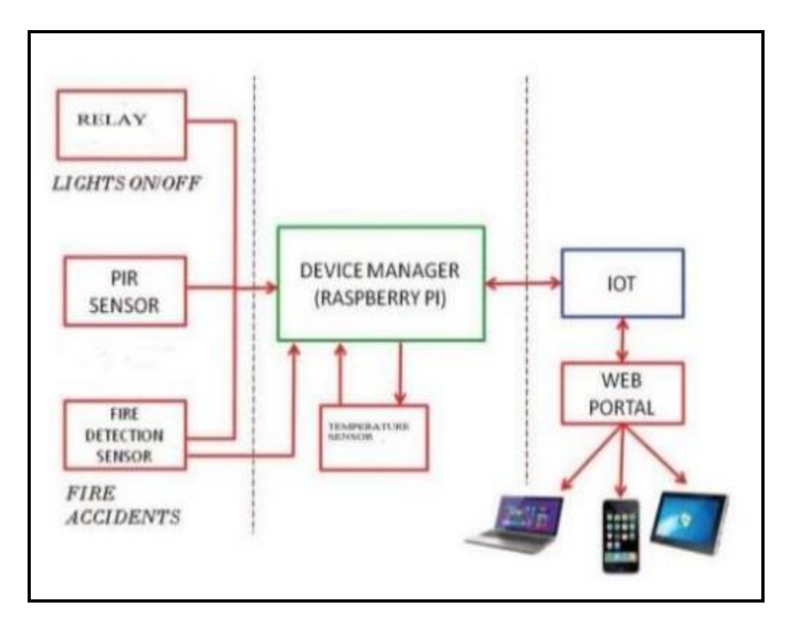
Fig1: Block diagram of IoT

5. Connectivity and Integration

Interoperability is a critical aspect of IoT adoption in smart homes, as it ensures that various IoT devices from different manufacturers can communicate and work together seamlessly. Standardization plays a key role in achieving this interoperability. Standards define common protocols, data formats, and communication interfaces that enable devices to understand and interact with each other. Organizations like the Open Connectivity Foundation (OCF), the Zigbee Alliance, and the Thread Group work towards creating unified standards for IoT devices.
Smart Home Protocols (Z-Wave, Zigbee, Wi-Fi, Bluetooth, etc.):
Various communication protocols are used in smart homes to facilitate the connectivity of IoT devices. Each protocol has its advantages and use cases:
Z-Wave: Z-Wave is a low-power, mesh networking protocol primarily used for smart home devices. It offers strong interoperability and is known for its reliability and long-range capabilities, making it ideal for larger homes.
Zigbee: Zigbee is another low-power, mesh networking protocol designed for low-cost and low-data-rate applications. It is commonly used in smart lighting, smart locks, and sensor networks due to its energy efficiency and scalability.
Wi-Fi: Wi-Fi is a widely used communication protocol in smart homes. It provides high data rates, making it suitable for devices that require a high bandwidth connection, such as smart TVs, cameras, and voice assistants.
Bluetooth: Bluetooth is commonly used for short-range connections between devices. Bluetooth Low Energy (BLE) is especially prevalent in smart home devices like wearable's, smart locks, and sensors due to its low power consumption.

6. Data Management and Analytics

Smart homes rely on data collection from various IoT devices and sensors to understand the environment and occupants' preferences. These devices continuously gather data related to temperature, humidity, occupancy, energy consumption, security events, and more. The collected data is then transmitted to a centralized data storage system, often in the cloud, where it can be securely stored and processed.
Data Analysis and Real-time Insights:
Once the data is stored, smart home systems utilize data analysis techniques to extract valuable insights. Data analysis involves processing and interpreting the collected information to identify patterns, trends, and anomalies. Real-time analysis allows smart homes to respond quickly to changing conditions and make data-driven decisions for automation and optimization. For example, data analysis can determine occupancy patterns to adjust lighting and climate control automatically or identify potential security threats for immediate action.
Machine Learning and AI Applications in Smart Homes:
Machine learning and artificial intelligence (AI) play a pivotal role in enhancing smart home capabilities. Machine learning algorithms can be trained on historical data to make predictions and adapt to user preferences. AI-powered systems can learn and understand occupants' habits and preferences over time, enabling personalized automation and tailored experiences. For instance, smart thermostats can learn the temperature preferences of different family members and adjust settings accordingly.
Personalization and Adaptive Systems:
Smart homes leverage data-driven personalization to create adaptive and intuitive experiences. As users interact with their smart devices and use various applications, the system learns their preferences and behavior. Over time, the smart home ecosystem adapts to suit individual needs, providing a more personalized and comfortable living environment. Adaptive systems can adjust lighting, entertainment choices, and even automate daily routines based on each occupant's preferences.
7. User Experience and Interfaces

Smart homes offer various user interfaces that allow residents to interact with their IoT devices and control their living environment. These interfaces cater to different user preferences and accessibility needs. Some common user interfaces in smart homes include:
- Mobile Apps: Mobile apps are widely used as user interfaces for smart homes. They allow users to control their smart devices remotely through their smartphones or tablets. With a mobile app, users can adjust thermostats, lighting, security cameras, and other connected devices from anywhere with an internet connection.
- Touchscreens: Smart home touchscreens are often installed in central locations within the house, such as on the walls or mounted on home hubs. These touchscreens provide a dedicated interface for controlling and monitoring various smart devices in the home. They offer a more interactive and intuitive experience for residents.
- Voice Control: Voice assistants, such as Amazon Alexa, Google Assistant, and Apple's Siri, enable hands-free control of smart home devices. Users can issue voice commands to turn on lights, adjust temperatures, play music, and perform various other tasks. Voice control enhances accessibility for people with mobility challenges and provides a convenient, natural way to interact with smart home devices.User Experience Design for Smart Home Applications:
- Effective user experience (UX) design is crucial for smart home applications to ensure user satisfaction and ease of use. Key principles for UX design in smart home applications include:
- Intuitive Navigation: Smart home apps should have straightforward and intuitive navigation to enable users to access various features and devices easily. Clear labels, icons, and menus should guide users through the app's functionalities.
- Consistency and Familiarity: The user interface should follow consistent design patterns to create a familiar experience for users. Consistency in layout, colors, and interactions reduces confusion and increases user confidence.
- Feedback and Alerts: Providing feedback and real-time alerts helps users understand the status of their actions and the devices they are controlling. Visual and auditory cues inform users about successful commands, device statuses, and potential issues.
- Personalization: Smart home apps should allow users to personalize their experience by customizing device names, room settings, and automation routines. Personalization enhances user engagement and satisfaction.
8. Security and Privacy
Common Security Threats and Vulnerabilities in Smart Homes:
- Weak Passwords: Many smart home devices come with default or weak passwords, making them vulnerable to brute force attacks.
- Outdated Firmware and Software: Failure to update the firmware and software of smart devices leaves them exposed to known security vulnerabilities.
- Insecure Communication: Lack of encryption or the use of weak communication protocols can lead to unauthorized access and data interception.
- IoT Botnets: Smart devices with weak security can be compromised and added to IoT botnets, which can launch DDoS attacks or other malicious activities.
- Inadequate Authentication and Authorization: Weak authentication mechanisms and insufficient authorization checks can allow unauthorized access to devices and systems.
- Physical Security Risks: Smart devices with physical interfaces (e.g., smart locks, cameras) can be tampered with or physically compromised.
- Cloud-Based Security Issues: Data stored in the cloud may be at risk due to cloud service provider vulnerabilities or data breaches.
- Best Practices for Securing IoT Devices:

Strong Passwords and Authentication: Use unique, strong passwords for each smart device, and enable two-factor authentication whenever possible.
Frequent Firmware Updates: Regularly update firmware and software to patch security vulnerabilities and protect against emerging threats.
Secure Communication: Employ strong encryption protocols for data transmission and communication between devices and central hubs.
Network Segmentation: Segment your home network to isolate smart devices from other critical systems, limiting the impact of potential breaches.
Disable Unnecessary Features: Disable unused features and services on smart devices to reduce potential attack surfaces.
Vetted Devices and Manufacturers: Choose reputable manufacturers and well-reviewed smart devices with a track record of security updates.
Privacy Settings: Review and configure privacy settings on smart devices to control data collection and sharing.
9. Future Trends and Emerging Technologies
Increased Integration and Interoperability: Smart home IoT devices are becoming more interconnected and easier to integrate with each other, leading to a more seamless and comprehensive smart home experience.Voice Control and Natural Language Processing: Voice assistants have become a central part of smart homes, allowing users to control various devices using natural language commands, enhancing convenience and accessibility.
Energy Efficiency and Sustainability: Smart home IoT solutions are increasingly focused on energy management and conservation, helping users optimize their energy usage, reduce carbon footprints, and lower utility bills.
Smart Security and Surveillance: Enhanced security features, including facial recognition, advanced motion detection, and real-time alerts, make smart homes more secure and provide homeowners with greater peace of mind.
Home Health and Wellness Monitoring: Smart home devices are being used to monitor health and wellness aspects, such as sleep patterns, air quality, and home environment, contributing to improved living conditions and well-being.
10. Conclusion
In conclusion, the integration of IoT technology in smart homes has ushered in a new era of convenience, efficiency, and personalization for homeowners. The combination of various IoT devices and applications in smart homes allows residents to control and automate their living spaces, creating a seamless and interconnected ecosystem. With voice assistants, mobile apps, touch screens, and more, users can effortlessly interact with their smart devices and tailor their living environment to their preferences. Moreover, the advancement of machine learning and AI applications empowers smart homes to adapt and anticipate user needs, further enhancing the overall user experience.
However, along with these remarkable advancements come important considerations. Security and privacy must be prioritized to safeguard user data and protect against potential threats and vulnerabilities. Best practices for securing IoT devices, transparency in data collection, and compliance with privacy regulations are essential to build trust among users. Additionally, accessibility and inclusivity considerations ensure that smart home technology remains accessible to people of all abilities and backgrounds
References:
1. Majid Al Kuwari, Abdulrahman Ramadan, et. al., “Smart-Home Automation using IOTbased Sensing and Monitoring Platform”, IEEE 12th International Conference on Compatibility, Power Electronics and Power Engineering, 2018.
2. Kishore. P. T. Veeramanikandasamy, K. Sabbath and S. Veerakumar , “Internet of Things based Low-Cost Real-Time Home Automation and Smart Security System”, International Journal of Advanced Research in Computer and Communication Engineering, Volume 6, Issue 4, 2017 .
3. Smart Security System”, International Journal of Advanced Research in Computer and Communication Engineering, Vol. 6, Issue 4, April 2017.

