ONLINE PHARMACIES: THE GAME CHANGER IN RETAIL PHARMACY

Bhupinder Pratap Aggarwal^{1,2}, Neelima Dhingra¹
1 University Institute of Pharmaceutical Sciences, Panjab University, Chandigarh
2 Indian Institute of Foreign Trade, New Delhi, India

Abstract

Over the last one decade , internet has been developed as a first-line information source in different l aspects of life of an ordinary people. Interest in procuring products online has equally augmented, including medicines. HealthCare industries are not seizing their chance to modernize a commonplace function by prescribing and dispensing medicine. Online pharmacies are offering advantages over traditional pharmacy by shipping the product overnight, by avoiding the delay of regular mail, while maintaining the privacy of customer . The expansion of online pharmacies has provoked the monitoring and regulatory actions at the professional association and organization levels. Present chapter is an overview of online pharmacies, their advantages, major players and the regulation involved.

Kewords : Internet pharmacy; online pharmacy, e health, future medicine, e- prescription

Corresponding author :
Dr Neelima Dhingra
National Award Winner
MNASc.MPASc, MIABMS, MPASc
M.Pharm, Ph.D ((Pharmaceutical Chemistry)
Assistant Professor
University Institute of Pharmaceutical Sciences
UGC Centre of Advanced Study (UGC-CAS)
Panjab University, Chandigarh 160014
01722534117 (O)
neelimad08@gmail.com;neelimad08@pu.ac.in

Introduction
Pharmaceuticals represent a group of promising organic compounds that have contributed to improve the quality of human life and pharmaceutical industries are accountable for the production, development, and marketing of generic and branded pharmaceuticals. Worldwide total revenue generated by the pharmaceutical was more than 1 trillion US dollars for the first time in 2014 and 2017 onwards market grown at an annual rate of 5.8% ¹. Globally, the India’s pharmaceutical sector is the third (3rd) largest in terms of volume and the thirteen (13th) biggest in terms of value² . The retail pharmaceutical market of India was approximately USD24 billion in 2018 and its rapidly growing. But, the retail sector is facing numerous challenges due to small industrial margins, increasing price burden, noncompliance with law, lack of paper records and tracking, and many others prevailing issues. There is need of technical solutions to overcome these challenges of retail sector and to improve the efficiency ³. To meet the specific and lifelong learning needs of an individual pharmacists, technology driven learning solutions can be employed that ultimately will improve the patient and public health outcomes. For the unique problems faced in India with considering the unavailability of drugs in rural areas. Pharmacies and pharmacists are doing a noble job by providing medicine and health care services to population at large. And the implementation of pioneering technology models will enable the entire process reliable, robust, efficient and transparent⁴.
The internet has changed our lives dramatically and has become an important part of our daily lives. Thus it is not a surprise that with these changing times, more pharmacies have started to move to online platform. Over the last decade, internet has become a first-line information source in all phases of life that has augmented the interest in purchasing products online including medicine and healthcare products. Online pharmacy is one of the evolving technology and post pandemic situation pushed the world and country’s pace towards digitalization where the online pharmacy seems to be a game changer.

Online Pharmacy : a concept

An e-pharmacy is an online based business that sells medicines with or out without prescription. It is a pharmacy that operates over the internet and provides services including supply of medicines, including repeated prescriptions, sale & supply of other health care products, diagnostic services, information about medicines, advice about symptoms, and online support services etc⁵ . Online pharmacies utilize different forms of technology to extend and enhance their site functionality⁶ . Patients/customer can use their medical prescriptions to order their medicines via use of these e-pharmacies and receive them at their doorstep. The e-pharmacy could be either a online website or a mobile based application. The customers/patients log into the app, they enter the medicines required and the quantity in the search bar, which are then added to the cart. They also have to upload their prescription before confirming their orders. After confirmation and authentication of prescription by a registered pharmacist, the customer/patient proceeds with the payment and address where the order is to be delivered. As the order is accepted the pharmacy store or the inventory is notified and the shipment process begins⁷. Many of the online pharmacies have their own inventory but some procurement is done through stores as well. Most of these legal stores working with an online pharmacy are having a drug verification process. And such stores demand a prescription from a personal doctor and the drug delivery is started after completing a questionnaire related to the patient health status. Finding these questionnaires duly approved by a doctor, finally medicines are being distributed to the patients for use. The store or inventory personnel verify the orders and pack the items . The order is shipped to the customer at the indicated location. Upon receiving the order, the user can rate the overall service of the online pharmacy⁸. Figure 1 shows an overview of the online pharmacy supply chain. A Consumer Medicine Information (CMI) leaflet is also provided to the patient with provision of advice to patients about safe dosage, administration, frequency, side effects, diet controls, and interaction of medicines they asked for. Similar to any other business, the success of an online pharmacy hinges on the satisfaction it provides to its customers for viability of the business⁸.

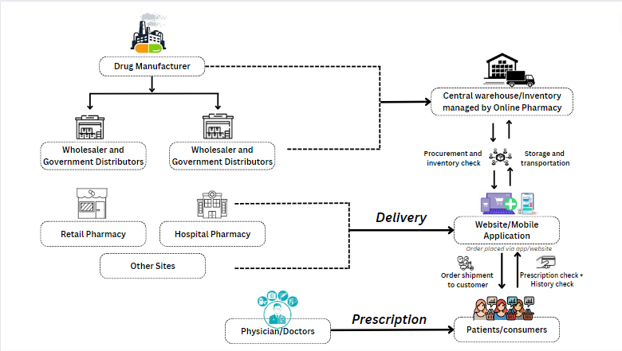
Figure 1: Supply chain of online pharmacy

Brick and Mortar v/s Online Pharmacy
In earlier times, the best way of communication for physician and doctors in decision relating to medication with patients was hand written prescriptions and to distribute dispense the medicines using brick mortar approach for pharmacist⁹. India’s retail pharmacy segment is a porous system that suffers from systemic hardships and the ills that are prevalent in the retail pharmacy systems are abundant to count. To begin with, the lack of trained pharmacist has not only been well documented, but also witnessed by the courts in several states, such as UP, where the number of drugstores out-numbers the number of registered pharmacists in the state. Published reports by Outlook India in 2017 highlighted the Allahabad High court’s Lucknow bench statement that preventive measure taken by government are yet not effective as compared to the wrong practices like large number of unqualified persons or either fictitious or usage of one registration certificate in several shops and looking after such shops. Additionally, ‘renting’ of a registered pharmacist license to the shops without having a certified pharmacist degree, assuming that dispensing is regular standard and acceptable practice in brick and mortar pharmacies³ .
Online pharmacies on the other hand, are systematic approach in applying pharmacist for certifying the prescriptions and distributing medicines in tamper proof containers as per Pharmacy act of 2015. The medicines sale without prescription is a known fact and has been observed by the bureaucrats and judiciary too. All we need is just to visit a retail pharmacy, or ask driver to get the medicines home easily with no prescription required. The honorable Delhi High Court in 2019 had directed the Governments at Center and State level to take action against those pharmacies selling medicines without prescription. In contrast, the online pharmacies systematically record each prescription digitally and deliver medicines only after valid prescription is provided. They have offered to the government to be audited by any competent regulatory body. India has the most scattered and fragmented pharmaceutical market around the world which makes availability of fresh medicines a challenge that retains their full potency. India falls under the WHO zone 4 for storage and stability of medicines, so drugs must be stored below 30*C along with relative humidity 70% to retain the efficacy & potency over the entire shelf life. This requires constant and good air conditioning, considering temperatures variations across the country. But unfortunately, most of the brick and mortar pharmacies are not air conditioned, and pushed the stability at risk. But, online pharmacies are possibly the ones that following WHO guidance for storage and transport’ of medicines and ensuring that patients are receiving medicines with intact integrity at their places safely. An online pharmacy provides with much wider range of options offer great advantages to the patients than traditional pharmacy. Further, it is not possible to find all brands or drug in one brick and mortar pharmacy of a particular area, but there are many more drug options available in general big drug stores and one needs to travel much further^{10,11}. Majority of brick and mortar retailers do not provide invoice bearing accurate batch numbers & expiry dates, payable amount mentioned on the back of the envelope and generally contact payment is being made. Law requires that not only the details of batch, expiry, and quantity received but also the signature of pharmacist is necessary, which is possible only if he is present at the pharmacy. On the other hand, online pharmacies scrupulously record all details like batch number, expiry date, amount received of each unit as it proceeds in the logistics chain, protecting the customer³.
In 2018, the Government of India released draft regulations which were well received by the pharmaceutical sector. The drafted guidelines allowed the DCGI to regulate the e-pharmacies and online retailers in the country to sell drugs and medicines using a single license

Merits of an Online Pharmacy

An online medicine delivery app is a game changer in the health sector that enabled patients to order and get doorstep delivery of medicine and other pharmacy products. Until the arrival of these applications, there wasn’t any substitute to purchasing medicine from the brick and mortar pharmacies¹². It is quite simple and easy to order prescription drugs through an online pharmacy. The people who are staying far away from traditional retail pharmacy stores, the elderly, the disabled persons, and those with intensive work lifestyle, this system is not only effortless but also a fast method of obtaining medicine (Figure 2). One can order medications within minutes and get their medicines hassle-free. One of the most important advantages of an online pharmacy is the cost effectiveness. Studies have shown that ordering drugs online can save about a one third of their money in total by saving their travel cost from remote areas to brick and mortar pharmacies¹⁰. Further, consumers can quickly find an alternative i.e. more competitively priced generic drugs for their costly prescription medications while being sitting on net at their places. Another benefit offered by online pharmacy is confidentiality and privacy¹². This is of quite great suitability particularly for those who are anxious of talking face to face with pharmacists and doctors. In addition, persons are able to order medications without any hesitation on special matters such as adolescence or sexuality which may turn out to be a source of awkwardness. Some e- pharmacies also provide additional useful facts and figures about the medicines and the illness. Customers can browse thoroughly for detailed instructions, side effects, and interactions with food. An online pharmacy may also provide scheduled notification making sure users don’t run out of medicines and forget to refill their prescription. Users can make instant secure payments and also receive delivery updates¹² .

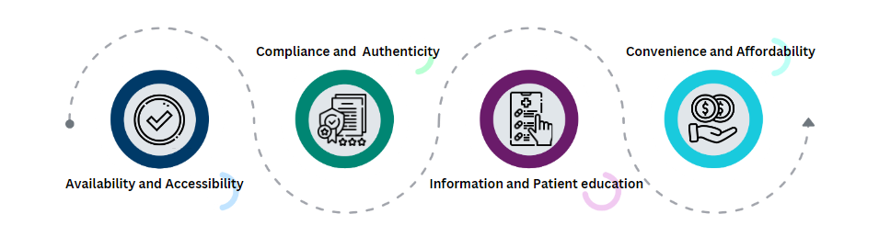
Figure 2: Merits

Competitive landscape in E-Pharmacy sector

The global ePharmacy market size in 2022 was valued at USD 60.0 billion and expected to grow at a compound annual growth rate of 20.4% from 2023 to 2030. The largest market share of the E-pharmacy market is being hold by North America holds (Figure 3) and is expected to witness the same trend over the forecast period. Increasing consumer inclination for online purchases with a great focus on convenience is helping in sustained growth. Further, the growing adoption of digital tools & knowledge and e-commerce in the healthcare sector is expected to push its overall growth. Therefore, owing to the above-mentioned key factors, the market for e-pharmacy is expected to grow in this region¹³
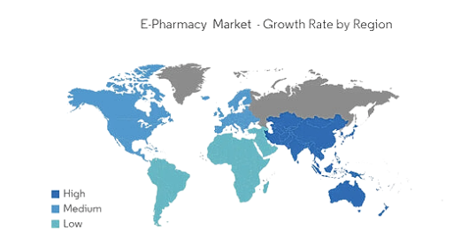
Figure 3: Growth of E-Pharmacy by Region¹⁴

Indian online pharmacies, that mostly emerged nearby in 2015, have changed the traditional scenario and added traction swiftly. There are nearly 60 major E-Pharmacies in India and it was estimated that in 2019 the market size was close to $0.5billion, which was approximately 2 to 3% of total Indian pharmacy sale. The market is predictable to grow at a compounded rate of 44 % to reach $4.5billion by 2025. In addition to the rise in customer adoption, a secular growth in investor’s interest for online pharmacies with the sector gathering $700 million was observed in 2020 alone . Approximately 85% of the E-pharmacy market is being dominated by four major players namely, PharmEasy, Netmeds, 1mg by Tata and Medlife (Figure 4).
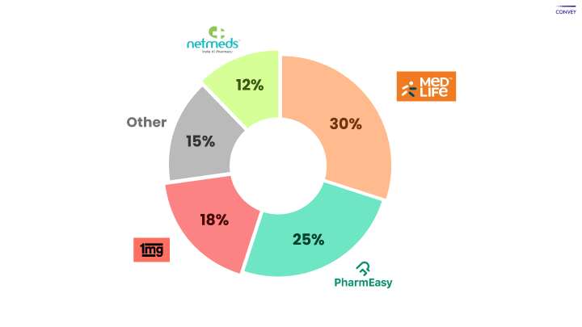
Figure 4: Market share of some major E-Pharmacies in India

There are also some key other players such as SastaSundar, Truemeds, Apollo Pharmacy, Practo, MedsOnWay, Healthkart, Myra, Lifcare, mChemist and many more. They have major presence in the metro and tier1 cities in India but are rapidly expanding to tier2, tier3 and the rural urban regions of India³ . These players provide wonderful offers reward and cash-back schemes to customers which benefits them getting recurring orders from the customers. Some key players are shown in Table 1.
TABLE 1
NAME | BASIC INFORMATION | MARKET REVENUE | SERVICES PROVIDED | LOGO | BRAND AMBASSADOR  AND TAGLINE
Pharm  Easy | Founded in 2014 by Dharmil Sheth and Dr Dhaval Shah. In 2020 it merged with API Holding, ( parent company). It acquired Medlife and Thyrocare in 2021 | It reported revenue of Rs 637 crore  ( US$ 91 Million) in 2020 | Selling online medicines, diagnostics, telehealth, online doctor consultation. | 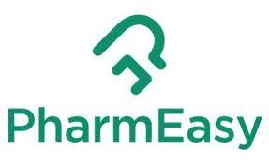 | Various actors  (Take it easy-PharmEasy)
Tata 1mg | Founded in 2015 by Gaurav Aggarwal Prashant Tandon, , and Vikas Chauhan. It is based in Gurgaon. Acquired Homeobuy in 2017 and named as 1mgAyush. | Reported revenue of 1mg was worth Rs 357.9 crore for 2019-20 and Rs 266 crore in one year 1April2020 to 31 January 2020. | Online pharmacy, lab blood tests, online doctor and E-consultation,  Diagnostic services. |  | Mr. Pankaj Tripathi  (Genuine medicine right at your doorstep)
Netmeds | In 2010, the Pradeep Dhadha group founded netmeds along with co founder Bruce Schwack. It was acquired by Reliance Industries and is based in Chennai. | It reported revenue of $1.03 million in FY20 and was valued at $125 million in September 2021. | Online medicines, supplements, health products, orthopedic devices, personal care products, automated refill reminders. |  | Mr. M.S.Dhoni, Mrs. Kareena Kapoor khan  (India ki pharmacy)
Medlife | Founded in 2014 by Prashant Singh and Tushar Kumar. It merged with PharmEasy in 2021. It is based in Bangalore and delivers to 29 states. | It reported a revenue of  Rs 363.4 crore ( US$ 48 million) in FY2019. | Prescription medicines, OTC products, online doctor, e-consultation, lab blood tests |  | Mr. Boman Irani, Mr. Varun Sharma  (Health comes Home)
Practo | Founded in 2008 by Shashank ND and Abhinav Lal. It has over 2lakh healthcare providers on its platform. | Practo reported a revenue of 124.3 crore in 2020 , while its net worth is valued at $500 in 2021. | Medicine delivery, online consultation, medical directory, online appointment and health plans. | 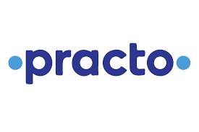 | Mr. Rahul Dravid  (Your home for health)

Role of consumers

The pharmaceutical market is categorized mainly into two segments - chronic and acute therapy. Till 2020, revenue generated by the chronic therapy segment was 63.42% of total market but it is expected to dominate during the 2021-2026 period as patients with chronic ailments require long term treatment with repeated need for medication. The acute therapy section have less revenue as of now, but its market share is anticipated to grow from 35% in 2020 to 46% till 2026.
The customers in the market are already price sensitive and increasing operational cost, low per-capita healthcare expenses, lack of stringent regulations and dearth of infrastructure has further lead to the low infiltration of pharmacy retail in India. Consumers expects lower rates; anticipates an advanced level of services, , convenience, innovation and personalization. The desire of the customers to increase the ability to choose where and when to receive digital service is increasingly continuously . When it comes to consumer experience, they start comparing the pharmacies with another firm regardless of industry, such as Amazon and Flipkart which themselves are investing in potential e-Pharmacies in India. This challenges pharmacists to provide a positive consumer experience in person, and through digital channels . India’s population is said to be a young population but E-services are not just being adopted by the young, but also people aged 50 or above as well. Retail pharmacies and customers have a great imperative to invest in e-commerce^{15,16} .
Growing consumer needs in this digital era and especially COVID-19 has made e-pharmacy, further a vital part to the health care delivery system. More than a year after the COVID -19 pandemic, customers started expecting all retail businesses, including pharmacies to deliver fast and mostly free online services & shipping. Safe home delivery turned out to be a boon for the customers amid COVID-19 pandemic and onset of the further waves helped online pharmacy to catch pace. Creating alliances with local pharmacy retailers enabled key players to address the gaps in their last-mile deliveries¹⁷.

Future prospects

Globally, health care sector has evolved rapidly over the years. The industry of internet pharmacy is heading toward unprecedented progress in developing and developed economies, and the US, France, the UK, , Germany, Spain, Italy, China, Japan are the key growth potential markets. The worldwide online pharmacy market size is expected to cross profits of over $131 billion by the end of 2025 with a CAGR growing rate of about 20%. Though the online pharmacy retail market in India is in the nascent stage but its popularity is growing with the increased ease of accessibility of medicines to the customers. In 2020, internet pharmacy market was worth Rs INR 50.71 billion and estimated to reach INR 458.14 billion by 2026 with a compound annual growth rate (CAGR) of approximately 44.99% in 2021-2026 period.
In past few years, increased usage of smartphones and penetration of internet, the incidence of lifestyle-related disorders, the Covid-19 pandemic, and various government initiatives have fueled the growth of online pharmacies. Further, social media platforms have fueled its popularity, and made it comfortable for individuals to get more information on medications and relevant data about toxicity or contradictions, therefore ordering pharmaceuticals using online platforms. Discounts impacting profitability, pharmacovigilance, data breaches & cybercrime and bottleneck in supply chains are some of the factors that impede the growth of these online merchants. Pharmacies fulfill number of roles, many of which are linked to other parts of the health service, and a sustainable future for pharmacy includes an online platform The government policies and regulation are favorable too as the e-pharmacy sector is positive about laws that are likely to come into effect.. Ongoing local and the global trends pointing towards positive and promising future of e pharmacy.

References
- Omar Israel González Peña, Miguel Ángel López Zavala, and Héctor Cabral Ruelas. "Pharmaceuticals Market, Consumption Trends and Disease Incidence Are Not Driving the Pharmaceutical Research on Water and Wastewater." Int. J. Environ. Res. Public Health [Online]. DOI: 10.3390/ijerph18052532. Published Online: March 4, 2021. (Accessed: 4th August 2021)

- "Pharmaceutical Companies in India, Indian Pharma Industry- IBEF." India Brand Equity Foundation (IBEF). URL: https://www.ibef.org/industry/pharmaceutical-india. (Accessed: 4th August 2021)

- "E-pharmacies in India: global and local trends point to a positive future." Analyse Mason. URL: https://www.analysysmason.com/globalassets/x_migrated media/media/analysys_mason_e-pharmacy_quarterly_oct19.pdf. (Accessed: 3rd August 2021)

- "E-Pharmacies V. Retail Pharmacies: The Honest Truth." ET HealthWorld: Pharma. URL: https://health.economictimes.indiatimes.com/news/pharma/e-pharmacies-v-retail-pharmacies-the-honest-truth/79502206. (Accessed: 4th August 2021)

- G. Prashanti, S. Sravani, Saleha Noorie. "E-Pharmacy in India." IOSR Journal of Pharmacy and Biological Sciences (IOSR-JPBS), Volume 12, Issue 3, Ver. IV (May – June 2017), PP 32-34. URL: www.iosrjournals.org. (Accessed: 3rd August 2021)

- Dcruz AC, Mokashi VN, Pai SR, Sreedhar D. "The rise of E-pharmacy in India: Benefits, challenges, and the road ahead." Indian J Pharmacol. 2022 Jul-Aug;54(4):282-291. PMID: 36204812, PMCID: PMC9804119 DOI: 10.4103/ijp.ijp_445_21.
URL: https://www.ncbi.nlm.nih.gov/pmc/articles/PMC9804119/.(Accessed: 20th August 2021)

- "Last Mile Access to Medicines." Indian Bar Association. URL: https://www.indianbarassociation.org/wp-content/uploads/2019/05/E-Pharmacy-in-India-Last-Mile-Access-to-Medicines_v6.pdf. (Accessed: 2nd August 2021)

- Rathwa, V.; Paswan, A.; Thakor, A.; Mahla, K.; Patel, D. "Review Article on E-Pharmacy." International Journal of Innovative Science and Research Technology, Volume 7, Issue 4, April – 2022. URL: www.ijisrt.com. (Accessed: 19th August 2021)

- Chordiya, S. V.; Garge, B. M. "E-Pharmacy vs Conventional Pharmacy." IP Int J Compr Adv Pharmacol 2018;3(4):121-123. (Accessed: 20th August 2021)

- "Advantages and Disadvantages of E-Pharmacy." Tiga Healthcare Technologies. URL: https://www.tigahealth.com/advantages-and-disadvantages-of-e-pharmacy/.(Accessed: 3rd August 2021)

- Fittler A, Vida RG, Káplár M, Botz L. "Consumers Turning to the Internet Pharmacy Market: Cross-Sectional Study on the Frequency and Attitudes of Hungarian Patients Purchasing Medications Online." J Med Internet Res. 2018 Aug 22;20(8):e11115. DOI: 10.2196/11115. (Accessed: 10th August 2021)

- "Medicine Delivery App Development: How Your Pharmacy Can Sell Online." SteelKiwi. URL: https://steelkiwi.com/blog/medicine-delivery-app-development/.(Accessed: 3rd August 2021)

- "E-Pharmacies: Bridging the Gap in Indian Healthcare." Invest India. URL: https://www.investindia.gov.in/team-india-blogs/e-pharmacies-bridging-gap-indian-healthcare. (Accessed: 1st August 2021)

- "ePharmacy Market." Mordor Intelligence. URL: https://www.mordorintelligence.com/industry-reports/epharmacy-market.(Accessed: 4th August 2021)

- "Schaftlein, S., & Hanna, R. (2021). Is e-commerce the prescription for the future of pharmacies?" EY. URL: https://www.ey.com/en_us/life-sciences/why-e-commerce-may-be-the-future-of-pharmacies. (Accessed: 3rd August 2021)

- Vikesh Rathwa, Avnish Paswan, Anand Thakor, Keshav Mahla, Dhrutika Patel. "Review Article on E-Pharmacy." International Journal of Innovative Science and Research Technology, Volume 7, Issue 4, April – 2022. URL: www.ijisrt.com

- Jairoun, A.A., Al-Hemyari, S.S., Abdulla, N.M. et al. "Online medication purchasing during the Covid-19 pandemic: A pilot study from the United Arab Emirates." J of Pharm Policy and Pract 14, 38 (2021). DOI: 10.1186/s40545-021-00320-z. (Accessed: 7th August 2021)

