**Preparation of Some Liquid Crystalline Polyamides of Diaminodibenzo-18-crown-6**

**Nawal M. Suleman**

**Chemistry Department, Faculty of Education ,University of Khartoum ,Omdurman ,Sudan**

**Abstract**

Crown ethers are very important compounds in the extraction of alkali, alkaline earth, and transition metal ions that by formation of complexes with these ions .Crown ether polymers may have more ability of extraction compared with their monomers .In addition these polymers may be less poisonous, inexpensive, and can be used as catalysts. This study had been aimed for preparation of four models, and seven polyamides of dibenzo-18-crown-6.First step in this preparation was the nitration of dibenzo-18-crown-6,followed by reduction of the nitro group .Then the polymerization was carried out in an atmosphere of nitrogen gas .The prepared compounds have been characterized using ( IR ) spectra ,and ( CHN ) mass spectra. The cis and trans diaminodibenzo-18-crown-6 have been analyzed using the proton magnetic resonance spectra ( 1HNMR ) .These results have been in agreement with the expected structure of these products. The inherent viscosity of these polymers was measured, and was found to have intermediate molecular weight .The liquid crystalline properties of these polymers was also studied using Differential Scanning Calorimeter( DSC ), and hot-stage microscope .The polymers of the trans isomer give a semectic, while those of the cis one did not give any liquid crystalline properties .

**1. Introduction**

In the last few years, after the discovery of crown ethers, polymeric crown compounds became very important in the chemical research. These compounds have valuable properties compared

1

with the monomeric ones; like that they may be less toxic, less

expensive, so this work aims to the synthesis of new models, and polyamides containing crown ethers. It was 1967 that Pedersen (Pedersen, 1967) published the first report on crown compounds, that were obtained unexpectedly. Crown compounds are, generally described (Hiraoka, 1982) as macrocyclic compounds , having hetero- atoms such as O, N, or S as electron donor atoms .Prior to 1971 ,Pedersen reported on a series of complexes crystals (Pedersen, 1970) ,nine kinds on novel crown compounds(Pedersen, 1970), nine kinds of macrocyclic polyether sulfides (Pedersen, 1971) having sulphur atoms in addition to oxygen atoms . Pedersen synthesized a number of aromatic and alicyclic crown ethers(Pedersen, 1967), and discovered that they are capable of complexation with salts of various metal cations comprising all of group1a, almost all of group 1b metal ions, and some of 11b,111a,1Vb metal ions (Li+,Na+,K+,Rb+,Cs+,Ag+,Au+, Ca2+, Sr2+,Ba2+,Cd2+,Hg2+,Ce3+,Ti2+,Pb2+)and with NH4+, and RNH3+ salts. The extraction of picrate ion with alkali metal ions, by some crown ethers was reported (Cheristensen (1974).Frensdroff, (1971). Danesi, (1975). Danesi, (1974) and, Tusek (1975). 4,4'-diaminodibenzo-18-crown-6 was prepared (Feigenbaum and Mickel(1971). Polyamides were prepared using cis-4, 4'-diaminodibenzo-18-crown-6(Shchori and Jagur-Grodzinski, 1976). The mobility of Na+ andRb+ in poly (dibenzo-18-crown-6) has been studied Beer, Crane, andDrew, 1991).The first example of main chain liquid-crystalline polymers containingdibenzo-18-crown-6 was reported (Percec and Rodenhouse 1989). The EDTA dianhydride was used in the reaction with diazacrown ethers to obtain the water-soluble EDTA-diazacrown ether polymers( Jian etel.2005).

**2. Experimental**

2.1. Chemicals and Techniques

All chemicals used are of high purity (98 % or more ). Techniques

2

used :the melting point measurement apparatus was designed by

Electro- Thermal Company .Infra –red was recorded using Pye-Unicame IR spectrophotometer model SP1025 ,and Perkin-Elemer model1310.1HNMR were recorded in deuterated dimethylsulphoxide (10%wt/v)on Hitachi R24-60MHz spectrophotometer. Elemental Analysis(CHN) was performed by 240C Perkin-Elemer Elemental Analyzer .All DSC measurement were with DSC-7 of Perkin Company .Texture observations were carried out using Olympus Polarizing Microscope equipped with photo micrographic system type PM-10AD .Hot-stage type HTM600 supplied by Meter Company (Switzerland)was used for heating the sample placed between glass slide and overslip.

**2.2. Procedures:**

2.2.1 Preparation of dinitrodibenzo-18-crown-6

In 500 ml two-neck round flask equipped with reflux condenser, and dropping funnel ;6.41g(17mmol)DB18C6,and 130ml chloroform were placed .After dissolution of the polyether by stirring using a magnetic stirrer ,96.5 ml glacial acetic acid was added ,then nitrated with solution consist of 5ml (78.9mmol ) , concentrated nitric acid in 13ml acetic acid .The later was added drop wise over 30 minutes. After refluxing for 4 hours, the reaction mixture was filtered giving 4.38 g oftrans-dinitrodibenzo-18-crown-6 .On standing the mother liquor was left for more than 5 days 3.04 of the cis isomer was collected .The products were recrystallized from DMF. To the suspension of 2.5g(5.6 mmol)oftrans or cis –DNDB18C6 in 38 ml of HCl and 60 ml of 1-butanol ;7.5 g often metal powder was added and refluxed for 4 hours .Two additional portions of HCl and tin were added and the reaction mixture was refluxed for 6 hours and for overnight respectively .The trans or cis-DADB18C6 were collected after addition of NaOH , followed by recrystallization from ethanol.2.2.2 Preparation of the acid chloride Excess thionyl chloride was added to the appropriate quantity of the acid; the reaction mixture was refluxed for one hour and then followed by distillation under vacuum.2.2.3 Preparation of the

3

model compounds and the polyamides ofdiaminodibenzo18-crown-6These compounds were prepared (Salh,1990) under dry nitrogen atmosphere by adding dropwise the appropriate acid or diacid chloride(3 mmole) to 0.59g (1.5mmol), and 1.2g (3mmol) of DADB18C6 in a mixture of 5ml of DMAC, and 5ml of TEA. The reaction mixture was stirred over night at room temperature ,then poured into cold water(100ml).The precipitate was separated by filtration ,washed with0.1 M HCl solution, saturated solution of sodium bicarbonate and then distilled water .Finally dried under reduced pressure at 500C .   
**3. Results and Discussion**

**3.1 Cis – and trans-dinitrodibenzo-18-crown-6(DNDB18C6)**

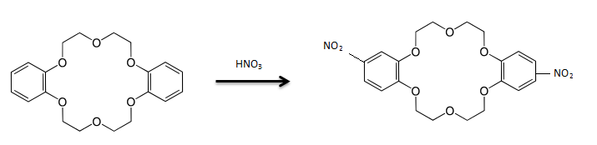 The two derivatives are characterized by IR spectroscopy and elemental analysis .The spectra of trans –DNDB18C6 clearly shows the C-N stretching in at 758-859 cm-1 ,symmetric –NO2 at stretching 1295-1385 cm-1 ,and asymmetric –NO2 at stretching 1540-1609cm-1 . The elemental analysis data and melting points are in agreements with calculated values (Table 3.1).

(Table 3.1) CHN data, m.p., and yield % for DNDB18C6

|  |  |  |  |  |  |  |  |  |
| --- | --- | --- | --- | --- | --- | --- | --- | --- |
| Compound | Calculated | | | Found | | | m.p.OC | Yield % |
| C% | H% | N% | C% | H% | N% |
| Trans-DNDB18C6 | 53.33 | 4.92 | 6.22 | 53.10 | 4.79 | 6.11 | 235-245 | 40 |
| Cis-DNDB18C6 | 53.33 | 4.92 | 6.22 | 53.13 | 4.82 | 6.06 | 235-245 | 45 |

4

**3.2 Cis and trans –diaminodibenzo-18-crown-6(DADB18C6)**

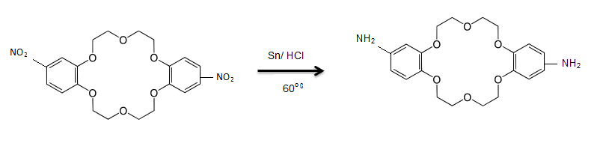

Cis and trans -(DADB18C6) were obtained by reduction of cis and trans-(DNDB18C6) respectively .The structure of these two isomers were verified by IR and 1HNMR spectroscopy in addition to the( CHN) .The IR spectra of trans isomer shows five characteristics bands ,1300 cm-1 ,for C-N stretching ,1645 cm-1(N-H bending),3450-3660 cm-1 (N-H stretching) , 1075 cm-1 (C-O-C sym stretching) , and 1247 cm-1 (C-O-C asymmetric stretching). for IR spectra of cis-(DADB18C6) .The 1HNMR for trans- (DADB18C6) displayed the following chemical shift , ᵟ (1.5-2.0),s,4H(NH2), , ᵟ (3.0-4.5),m,16 H (-CH2O-),and , ᵟ (6.0-6.5),m,6H(C6H3). The 1HNMR for cis- (DADB18C6) shows the following chemical shift , ᵟ (2.8-3.3),s,4H(NH2), , ᵟ (3.5-4.0),m,16 H (-CH2O-),and , ᵟ (6.0-6.5),m,6H(C6H3). The melting points and elemental analysis (Table3.2) are in good agreement with the literature (Feigenbaum W.H. and Michel, 1971).

**(Table 3.2) CHN data, m.p., and yield % for DADB18C6**

|  |  |  |  |  |  |  |  |  |  |
| --- | --- | --- | --- | --- | --- | --- | --- | --- | --- |
| Compound | Calculated | | | Found | | | m.p.OC | | Yield % |
| C% | H% | N% | C% | H% | N% |
| Trans-DADB18C6 | 61.53 | 6.71 | 7.17 | 61.32 | 6.59 | 7.09 | 199-205 | | 20 |
| Cis-DADB18C6 | 61.53 | 6.71 | 7.17 | 61.25 | 6.62 | 7.05 | | 179 | 21.6 |

**3.3 Model Compounds**

Four model compounds were prepared , and characterized by IR spectroscopy ,and elemental analysis .The IR spectra of these products give three characteristics bands, 1500 cm-1 (amide

5

11),1580-1640 cm-1 (amide 1),and 3130 cm-1 for N-H stretching. The elemental analysis data (Table3.3)are in good agreement with the calculated values.

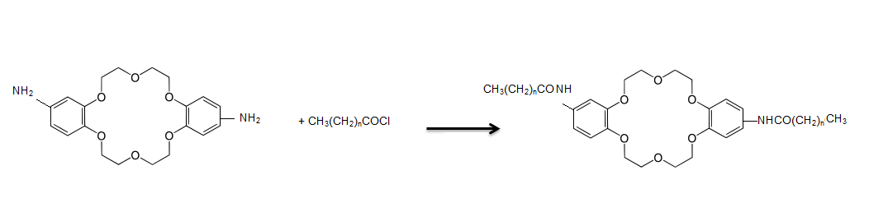

**(Table 3.3) CHN data, and yield % for model compounds of DADB18C6**

|  |  |  |  |  |  |  |  |  |
| --- | --- | --- | --- | --- | --- | --- | --- | --- |
| No | Modle | Calculated | | | Found | | | Yield % |
| C% | H% | N% | C% | H% | N% |
| 1 | C5H11-CO-NH-Trans*-NH-CO—C5H11 | 65.51 | 6.87 | 4.77 | 65.39 | 6.73 | 4.68 | 33.0 |
| 2 | C7H15-CO-NH-Trans-NH-CO—C7H15 | 67.66 | 7.53 | 4.36 | 67.34 | 7.29 | 4.18 | 46.6 |
| 3 | C5H11-CO-NH-Cis*-NH-CO—C5H11 | 65.51 | 6.87 | 4.77 | 65.38 | 6.69 | 4.63 | 28.6 |
| 4 | C7H17-CO-NH-Cis-NH-CO—C7H15 | 67.66 | 7.53 | 4.36 | 67.46 | 7.34 | 4.22 | 20.0 |

Trans*and Cis*means trans-DADB18C6 and cis-DADB18C6

**3.4 Polymers of diaminodibenzo-18-crown-6**

These polymers were synthesized by solution polymerization of cis or trans-DADB18C6, with diacid chlorides in DMA .Trimethylamine was used as acid acceptor. The structures of the synthesized polymers were verified by elemental analysis and IR spectroscopy. The (CHN) are in good agreement with calculated values based on repeating unit , see Table (3.4), together with yield %of these polymers .The IR spectra shows characteristics absorption bands ,at 1500cm-1 (amide 11), 1580-1640cm-1 (amide 1),and 3130cm-1 (NH stretching). Measurements of inherent viscosity had been made for the polymers solutions, in phenol/1,1,2,2-tertrachloroethane solvent mixtures (volume ratio 60/40 at 30oC ).These polymers expected to have moderate molecular weight , and this was well reflected by the relatively moderate inherent

6

viscosities obtained for all polymers ,which are varying from 0.3-0.9 dl/g.

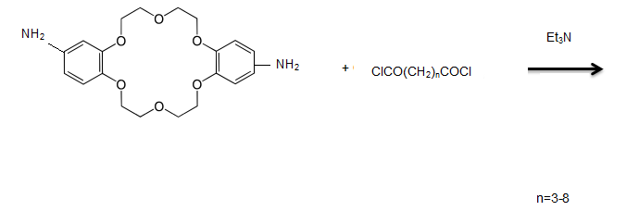

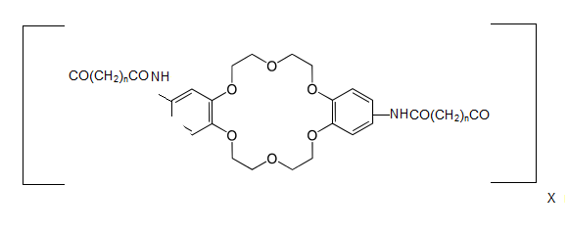

**Table (3.4) CHN data, m.p., yield %, and inherent viscosities for polyamides of DADB18C6**

|  |  |  |  |  |  |  |  |  |  |
| --- | --- | --- | --- | --- | --- | --- | --- | --- | --- |
| No | Modle | Calculated | | | Found | | | Yield % | h  dl/g |
| C% | H% | N% | C% | H% | N% |
| 5 | [CO(CH2)3-CO-NH-trans-NH-]n- | 61. 72 | 6.22 | 5.88 | 61. 88 | 6.22 | 5.76 | 83.9 | 0.8 |
| 6 | [CO(CH2)4-CO-NH-trans-NH-]n- | 62.39 | 6.22 | 5.29 | 62.19 | 6.22 | 5.60 | 76.5 | 0.4 |
| 7 | [CO(CH2)7-CO-NH-trans-NH-]n- | 63.95 | 6.22 | 5.01 | 63.89 | 6.22 | 5.14 | 71.4 | 0.9 |
| 8 | [CO(CH2)8-CO-NH-trans-NH-]n- | 64.50 | 6.22 | 5.89 | 64.38 | 6.22 | 5.01 | 99.2 | 0.6 |
| 9 | [CO(CH2)3-CO-NH-cis-NH-]n- | 61. 72 | 6.22 | 5.62 | 61. 60 | 6.22 | 5.76 | 98.7 | 0.3 |
| 10 | [CO(CH2)4-CO-NH-cis-NH-]n- | 62.39 | 6.22 | 5.34 | 62.01 | 6.22 | 5.60 | 17.5 | 0.4 |
| 11 | [CO(CH2)8-CO-NH-cis-NH-]n- | 64.50 | 6.22 | 4.92 | 64.39 | 6.22 | 5.01 | 83.3 | 0.3 |

**3.5 Chemotropic Liquid Crystalline Properties of the polymers**

The phase transition temperatures obtained from DSC thermos grams were confirmed by hot –stage polarizing microscope

7

observations and were in agreement with each other .The

temperature given refers to the peak temperature of the endoderm observed upon heating the sample at 20 K/min .The phase transition temperature accompanying the transition of the sample to the liquid crystalline state is designed tlc ,and that to the isotropic phase ti while tg refers to the glass transition temperature of polymer samples. The phase transition of all models and polymers are listed in Table (3.5). All polymers derived from trans-DADB18C6 moiety exhibited liquid crystalline behavior .The DSC thermograms of two models (1and2) show two phase transitions (Fig 3.1).The first one is related to the melting point of a crystalline phase, while the second transition indicates the existence of a liquid crystalline phase .Optical observations under the hot –stage polarizing microscope indicates that both models display nematic liquid crystalline in the biphasic region. Figures (3. 2 and 3. 3) showed thread –like nematic texture of both model compounds (1and2) respectively, which is on further heating goes to nematic droplet texture characteristics of nematic liquid crystalline phase. polymers (5-8) are shown in Fig.(3. 4)in which one can realize three transition endothermic peak, the first one is a second order transition due to the glass transition temperature ,while the other two are the liquid crystalline and isotropic phases respectively .The Liquid crystalline phases were recognized by their optical texture which showed the existence of what is called nematic worm texture (Graziano and Mackley, (1988).,which is usually obtained by freeze in the liquid crystalline state by quenching the polymer down to room temperature .Typical example of worm texture of polymer (5) is shown in Fig(3. 5).Another point of interest is the absence of smectic liquid crystalline phase for both models and polymers. The bulky sized of the crown ether moiety could be responsible for the disappearance of this phase. This bulkiness reduces the formation of closed –packed layer structure ,which is normally accompanying the smectic phase .Consequently forms randomly paralleled fashion arrangement might be formed ,which is favorable by the nematic phase .All models and polymers

8

derived cis-DADB18C6 moiety do not show liquid crystalline behavior ,but simply changed from crystalline state to the isotropic phase of specified temperature indicated in Table (3.5).The molecular structural criteria for liquid crystallinity are characterized normally by rigidity ,rod shape and polarizability. Any departure from linearity (Gray, 1989) of the polymer chain may cause complete loss of ability to form liquid crystalline state. The introduction of the cis- isomer of DADB18C6 moiety in the molecular backbone of polymers may cause significant deviation from linearity leading to a decrease in mesophase stability.

**Table (3.5) Phase transition temperature of models and polymers derived from cis-and trans- DADB18C6**

|  |  |  |  |  |
| --- | --- | --- | --- | --- |
| Designation | TgOC | TucOC | TIOC | Remarks |
| C5H11-CO- NH-trans*-NH-CO-C5H11 |  | 175 | 209 | L.C. |
| C7H15-CO- NH-trans*-NH-CO-C7H15 |  | 177 | 219 | L.C. |
| [CO(CH2)3-CO-NH-trans-NH-]n- | 119 | 296 | 297 | L.C. |
| [CO(CH2)4-CO-NH-trans-NH-]n- | 117 | a | 282 | L.C. |
| [CO(CH2)7-CO-NH-trans-NH-]n- | 93 | 260 | 279 | L.C. |
| [CO(CH2)8-CO-NH-trans-NH-]n- | a | 233 | 250 | L.C. |
| C5H11-CO- NH-cis*-NH-CO-C5H11 |  |  | 173b | L.C Not |
| C7H15-CO- NH-cis*-NH-CO-C7H15 |  |  | 175b | L.C Not |
| [CO(CH2)3-CO-NH-cis-NH-]n- | a |  | 282 | L.C Not |
| [CO(CH2)4-CO-NH-cis-NH-]n- | a |  | 270 | L.C Not |
| [CO(CH2)8-CO-NH-cis-NH-]n- | 87 |  | 202 | L.C Not |

a : difficult to detect b: decomposes



Fig 3.1 : The DSC thermograms of two models (1and2)

9



Fig 3.2: Thread –Like nematic texture of model compound( 1)



Fig 3.3: Droplet –Like nematic texture of model compound( 2)

10



Fig 3.4 : The DSC thermograms of two polyamides (5-8)



Fig 3.5: Worm –Like nematic texture polyamide( 5 )

**11**

**Conclusion**

1. Solution polymerization is a good method for the synthesis of polyamides of diaminodibenzo-18-crown-6. 2. All polymers are of moderate molecular weight. 3. All models and polymers derived from trans-DADB18C6 moiety exhibited liquid crystalline properties, while those derived from cis-DADB18C6 did not show any liquid crystalline properties.

**References:-**

1. Beer P.D, Crane C.G., andDrew.M.G**.J.Chem.Soc**. Dalton Trans., 3235(1991).

2. Cheristensen, J.J., Etaughand Izatt R.M.**Chem.Revs**., 79,531(1974). 3. Danesi, P.R., Meider-gorican, H., Chiarizia, R.and Scibona, G. **Int.Solvent.Extr.Conf**., 2, 1761(1974).

4. Danesi, P.R., Meider-gorican, H., Chiarizia, R.and Scibona, G. **J.Inorg.Nucl.Chem**., 37, 1479(1975).

5. Feigenbaum W.H. and Mickel R.H. **J. Polymer Sci**., A1, 9,817(1971) 6**.** Frensdroff, H.K**., J.Am.Chem.Soc**. 93, 4684(1971). 7. Graziano D., and Mackley M.R., **Mol. Crystal Liq. Crystal**, 126, 123, (1988).

8. Gray G.W., **Thermotropic Liquid Crystal**, Academic Press, London (1989).

9. Hiraoka, M. **Crown Compounds their Characteristics and Applications**, Elsevier Publishing Company, Amsterdam-Oxford-New York (1982).

10. Jian Z. L., Chun H. H., and Sheng Y. Q., **Chinese Chem**. Letters 16, No. 1, 27-30, (2005) .

11. Pecec, V.and Rodenhouse, **R.Macromolcules**, 22, 2043, (1989).

12. Pedersen, C.J**., J.Am.Chem.Soc**. 89, 2495(1967).

12

13. Pedersen, C.J**., J.Am.Chem.Soc**. 89, 7017(1967).

14**.** Pedersen, C.J**., J.Am.Chem.Soc**. 91,386(1970).

15. Pedersen, C.J**., J.Am.Chem.Soc**. 92,391(1970).

16. Pedersen, C.J**., J.Org.Chem**. 36,254(1971).

17. Salh, H.K. **Preparation of New Liquid Crystalline Monomers and Polymers, and Studying their Properties**, MSc. Thesis, Collage of Ibn Al-Haitham, University of Bagdad, 1990.

18. Shchori E. and Jagur-Grodzinski J**., J.App.Polymer Sci**.20, 1665, (1976)

19. Shchori E. and Jagur-Grodzinski J**., J.App.Polymer Sci**.20, 773, (1976).

20. Tusek, L., Danesi, and Chiarizia, R**., J.Inorg.Nucl.Chem**. 37, 1538(1975).

13