**“YouTube & Facebook as a Medium of Advertisement and its Effectiveness   
in North Gujarat Region”**

Author

Dr. Chanduji P. Thakor

Assistant Professor

S. K. School of Business Management

Department of Commerce and Management

Hemchandracharya North Gujarat University, Patan

Mob: 9879214586

Email: [chthakor@gmail.com](mailto:chthakor@gmail.com)

**ABSTRACT**

This research is based on the investigation of the effects of Facebook, YouTube and Instagram advertisements on consumers’ buying behaviours. For this purpose, a representative face to face survey has been conducted North Gujarat Region of 201 active users of Facebook, YouTube. SPSS program has been used for frequency, reliability and ANOVA analyses. I found that the variable most effective on consumers’ behaviour is informativeness motivation, trustworthiness and economic benefit variables follow informativeness respectively. So, companies should value these variables, giving a priority to informativeness.

Keywords: OTT platforms, Awareness and Usage, Respondents Profile

**INTRODUCTION**

The Internet has brought about a kind of revolution in human lives. It has brought consumers from all corners of the world closer together and has introduced a new online medium of advertising, which is quite different in comparison to other advertising media. Advertisers and brand managers are attracted to the online platforms as a communication medium, because these platforms are more interactive and have the ability to stimulate one-to-one interaction in a better way as compared to traditional advertising. Hence, social media marketing has emerged as the most popular and effective tool of marketing and communication. Popular social media sites, Facebook and YouTube, offer different ways to advertise brands. Facebook gives advertisers options such as promoted posts, sponsored stories, page post ads, Facebook object (like) ads, and external website (standard) ads. Advertising on YouTube there are branded channels, promoted videos, an in-video advertising. Among a variety of different phenomena, which have triggered change in the 21st century marketing thought, are higher advertising saturation levels, more fragmented media (recall rates for advertisements are dropping due to advertisement intensity and they are in fact not able to fulfil their basic missions any longer) and insufficient consumer attention to commercial advertisements as a result of consumer selectivity (both for products and advertisements) (Gegez, 2009: 26).

Increased online penetration powered by mobile phones. 73% of Indians citizens watch online videos. India has the 3rd largest online user based following U.S. and China. Facebook account for 67% of total online advertisement spend in India. 60.5 million social networking users in India. That’s equal to the entire population of Italy. YouTube and Facebook accounted for the largest penetration, at nearly 89 percent and 76 percent respectively as of the January 2021**.**

**LITERATURE REVIEW**

The trustworthiness of an advertisement is also affected by the trustworthiness of the organization itself (Goldsmith et al. 2000: 304). Advertising credibility is a key factor that affects the attitude and behavior of consumers (Ling, Piew and Chai, 2010 in Vestraten, 2015: 16). Hence, advertising credibility has a positive influence on attitude towards advertising and this then affects purchase intentions of consumers (MacKenzie, Lutz and Belch, 1986 in Verstraten, 2015: 16). It has been shown in the literature that trustworthiness has an important role for relationships in terms of ambiguity/uncertainty, solidarity and concerns about opportunism**.**

An advertisement can explain the value of a brand for its customers. The percentage of the budget devoted to advertisements affects the value of a brand in consumers’ eyes. However, it is highly difficult to say how much every little penny actually contributes to a brand’s value (Peltekoğlu, 2010: 123). Advertisements can contribute to the consumption of every possible type of product (Peltekoğlu, 2010: 126).

According to study By Harinadh Karimikonda in MEDIA ADVERTISING -A STUDY ON ADVERTISING ON SOCIAL MEDIA in November 2019 social media is the "BOOM" of 21st

century. It is not only used for chatting (or) communication purposes between two individuals but can also be used as an excellent marketing tool. Since, there are greater than three (3) billion people who are using social media applications across the globe and the number is increasing by approximately 9% every year. So, this is considered as new age marketing style and is

**RESEARCH METHODOLOGY**

**Research Design:**

The research design employs descriptive methods because descriptive explains the study and the aims of analytic study of You Tube and Facebook as Medium of Advertisement in North Gujarat Region. The basic information is obtained through the survey method by administering a questionnaire.

**Research Objective:**

* To identify the advertisement effectiveness on you tube and face book.
* To identify various parameters to measure the advertisement effectiveness on you tube and Face book.
* To study various demographic variable to check advertisement effectiveness on you tube and face book.
* To measure the reliability and validate of advertisement on you tube and face book.

**Research Hypothesis:**

* H1:There is a significant relationship between Age and Music parameter for advertisement effectiveness
* H1: There is a significant relationship between age and Tone parameter for advertisement effectiveness
* H1: There is a significant relationship between age and Actor Physical appearance parameter for advertisement effectiveness.
* H1: There is a significant relationship between age and body movements parameter for advertisement effectiveness.
* H1: There is significant relationship between age and facial expression parameter for advertisement effectiveness.

**Data Collection:**

* **Primary data**: This study is thoroughly based on the survey method. The primary data has been collected from the field directly based on structured Questionnaire presented to respondents.
* **Secondary data**: Besides the primary data, we collect the secondary data from various journals, articles, books, magazines, publish/unpublished research papers, authenticated website etc.

**Sample Size:**

* Total sample size of **201** respondents is selected into this research study.

**Data Collection Techniques:**

* The Primary data would be collected based on structured close ended Questionnaire.

**Data Analysis Tools:**

* Collected data would be analyzed by Reliability statistics, frequency distribution, cross tabulation, ANOVA test through SPSS software.

**Limitations of the study**

* Geographical Constraint is another limitation because Data collected in North Gujarat district only for this research.
* Responded Bias is a constraint because some of the respondents will not agree to fill the questionnaire and may be some of the respondents don’t attempt all the questions present in questionnaire.

**DATA ANALYSIS AND INTERPRETATION**

**Reliability Statistics:** The Cronbach Alpha value is 0.947 which is higher than 0.700. Therefore, collected data by researcher is more valid and reliable and its shows consistency.

**Frequency Distribution:** It is an organized tabulation/graphical representation of the number of individuals in each category on the scale of measurement. It allows the researcher to have a glance at the entire data conveniently. A frequency distribution is used to display the number of observations within a particular interval.

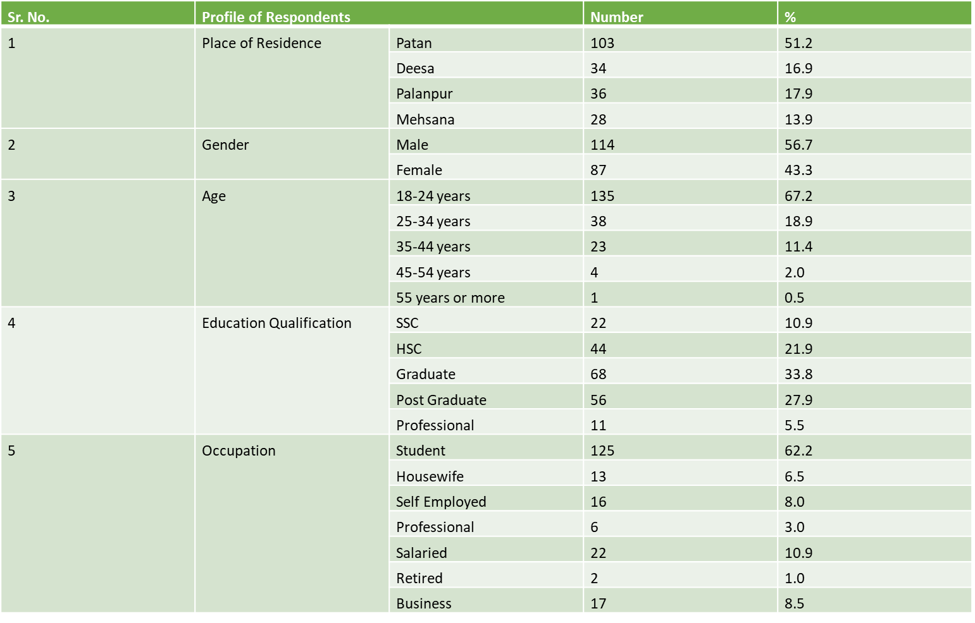

**Cross tabulation Analysis:** It is a method to quantitatively analyse the relationship between multiple variables. Also known as contingency tables or cross tabs, cross tabulation groups variables to understand the correlation between different variables. It also shows how correlations change from one variable grouping to another.



**ANALYSIS OF VARIANCE (ANOVA):** It is an analysis tool used in statistics that splits an observed aggregate variability found inside a data set into two parts: systematic factors and random factors. The systematic factors have a statistical influence on the given data set, while the random factors do not.



**Findings**

* 18-24 age are 67.2% (135 respondents) and 55years and above are 0.5% (1 respondents) that means youngest are watching more advertisement.
* 33.8% (68 respondent) of graduation, 5.5% (11 respondents) of professionals in Research paper it means that graduated are more interested in watching advertisement.
* 62.2% (125 respondents) are Students, 1% (2 respondents) of retired respondents in this Research paper student watch more advertisement.
* All most more than 56.22% (113 respondents) liked watching the advertisement 43.78% (88 respondents) do not like watching the advertisement in this Research paper.
* More than 76.12% are aware about the brand launch in the advertisement 23.88% (48 respondents) do not about the brand launch in the advertisement in this Research paper.
* The factor that affects the advertisement are Music, Tone, Body movement, Actor Physical Appearances

**SUGGESTIONS**

* They should improve the factors of advertisements to attract the viewers towards the advertisement.
* They should bring interesting advertisement so that they do not skip the advertisement.
* They should make the advertisement keeping in mind the all-age group of people.
* The advertisement should be clearly showing message about product and service in advertisement.
* Advertisement showing time should be proper and effective

**CONCLUSION**

The results in this study have demonstrated that multiplicity of cues are needed for an advertisement to be more effective. Individuals tend to engage with the communication channels that provide more cues because it facilitates the understanding of the message and leaves less chance for misinterpretations. Communication has not changed over the years, people are still selecting the channels that they feel better satisfy their needs; therefore, it is crucial for companies to not only identify those needs but also to comprehend what cues the advertisement should provide in order for it to be effective. At the same time, this study showed that when it comes to advertising, consumers do not feel the need to give feedback. In a social media site such as YouTube, where the most important cues are music, individuals tend to better comprehend the message, and therefore, not feel the need to comment or give feedback. Understanding these factors is helpful for companies to determine where their advertisement investments will be most profitable, and where the message will be better received and understood. This study has contributed to existing research, but with a new perspective that can be applied to other social media sites.

**REFERENCES**

Chowdhury, H.K., Parvin, N., Weitenberner, C. and Becker, M. (2006). "Consumer attitude toward mobile

advertising in an emerging market: An empirical study", International Journal of Mobile Marketing, Vol. 1, No.

2, pp. 33-42.

Chowdhury, H.K., Parvin, N., Weitenberner, C. and Becker, M. (2006). "Consumer attitude

toward mobile advertising in an emerging market: An empirical study", International Journal of Mobile Marketing, Vol. 1, No.2, pp. 33-42.

Farquhar, H. P. (1995). Strategic Challenges for Branding. Marketing Management. 3(2), pp.

8-15

Kim, B.H., Han, S., Yoon, S. (2010). Advertising creativity in Korea: scale development and

validation. Journal of Advertising, 39 (2), 93-108.

Lutz, R. J. MacKenzie, S. B., & Belch, G. E. (1983). Attitude toward the ad as a mediator of

advertising effectiveness: Determinants and consequences. Advances in consumer research, 10(1), 532-539.

Mehta, A. (2000). Advertising Attitudes and Advertising Effectiveness. Journal of Advertising

Research, 40(3), 67-72.

Shimp, T. A. (1981) Attitudes toward the ads as a mediator of consumer brand choice, Journal

of Advertising, 10(2), 9-15.

Verstraten, R. (2015). The effect of advertising credibility: could it change consumers’ attitude

and purchase intentions? Research about different advertising formats on the relationship between advertising credibility and consumers’ attitude and purchase intentions.