A SURVEY ON SMART PARKING SYSTEM USING IOT

¹Prof. Boban Mathews, ²Dr.K Chenna Reddy, ³Prof.Venkatesh S N, ⁴Dr.Thippeswamy M N
¹Assistant Professor, Department of Electronics and Communication Engineering.
²Associate Professor & HoD, Department of Electronics and Communication Engineering.
³Assistant Professor, Department of Electronics and Communication Engineering.
⁴Professor & HoD, Department of CS&E (AI&ML and Cyber Security).
^{1,2,3}Brindavan College Of Engineering-560063
⁴MS Ramaiah Institute of Technology 560054
¹bobanmathews05@brindavancollege.com

Abstract

Most major cities have parking issues for those with cars, especially during rush hour. The problem stems from not knowing where the available parking spaces are at the moment. Even if this information is available, many vehicles may still chase after a limited number of parking places, which in turn causes major traffic congestion. This study focuses on various smart parking techniques created to address the aforementioned issue using wireless sensor networks and delivering real-time data analysis from the sensors. Other studies include systems based on resource allocation and parking lot reservations that have a number of issues with effectively achieving the objectives. For the study of various guided parking and information strategies and algorithms, the provided article will be helpful for new scholars.
Keywords: Smart parking techniques, Wireless sensor networks, Real time data analysis, Parking lot reservations, Resource allocation.

Introduction

After the Internet, the internet of things (IoT) is seen as the next big technological and financial development in the global information business. It has a wide range of applications, including smart grid, healthcare, agriculture, and home and industrial automation. advancing the idea of the smart city One of the key Internet of Things applications is the smart parking system.
Additionally, as it satisfies the stringent needs of public services in order to actualize the so-called Smart Cities, this application of the Internet of Things concept to the urban situation is becoming more and more intriguing. In this regard, the Internet of Things can make a substantial contribution to the creation of a smart system that can respond to user requests regarding the effectiveness of the transportation network and social sustainability. 30 percent of traffic, on average. Parking solutions are crucial due to the expanding urban population and deteriorating traffic congestion. Numerous sources demonstrate that towns all throughout the world are addressing parking issues. We can enhance city parking conditions with a variety of applications thanks to information and communication technologies. It

means that thanks to contemporary technologies and the Internet of Things (IoT), parking difficulties no longer require the construction of new parking places in addition to better utilizing those that already exist . Smart devices are becoming more prevalent in daily life as a result of technological advancement. Smart city designs have been influenced by the creation of gadgets that can connect to the Internet and transfer data.
The inability to locate unoccupied parking spaces is a problem that frequently arises in our cities.
People who commute to work spend time looking for a place to park because of the parking difficulty. Cities now account for more than 80% of emissions, 75% of energy use, and more than 75% of garbage generation. About 20% of the CO2 emissions in Europe are due to road traffic, of which 40% are due to urban mobility. According to estimates, 30% of the daily traffic jams in a downtown urban area are brought on by drivers looking for free parking places. Building smart cities require a solid foundation, which intelligent parking applications provide. Intelligent parking solutions can enhance the municipal transportation system despite the high percentage of car travel in

Slovak cities. Therefore, some drivers may decide to switch to using public transportation as a result of the developed parking options. A driver will go less distance if they can get a parking spot right away. There is a ton of other literature that discusses smart parking technologies, or that also explains new system proposals and their algorithm.

Literature Review
Smart Parking is one of the most crucial infrastructures for IoT-based Smart cities. The identification of whether the parking space is occupied is the essential component of that, which drives the entire system. In addition to providing a summary of the detecting technologies, this paper delves deeper into the magnetometer and infrared sensor real-world performance. Additionally, an analysis of power usage and battery life is offered, which is essential for the deployment of sensors [1]. With the development of the Internet of Things and the growing interest in the idea of smart cities, it is now possible to realize these ideas and put them into practice. A lot of work is being done to improve the dependability and productivity of the infrastructure in urban areas. Traffic congestion, the scarcity of parking spots, and the time wasted looking for these scarce parking spaces are the main issues in urban areas. IoT systems can be used to solve these issues. The authors of this research did a survey of the existing parking management systems and described the key approach employed in each of the systems discussed. In addition to the primary results of the survey, we have also developed the solution using our engineering knowledge [2]. The Internet of Things (IoT) is crucial in bridging the gap between everyday objects and networking systems and makes it simple to access all non-internet objects from any location. For humans, adaptation to the expansion of current trends is inevitable. With all the technological innovation, finding a specific spot to park our car has become a frustrating problem. In our work, we developed a Smart Car Parking System (SCPS), which allows drivers to locate the closest parking space and displays the number of open spots in that specific parking zone, with the aid of an infrared sensor and a database based on IoT application. This philosophy mainly focuses on reducing the time needed to find a
parking spot and also reduces the needless journey through occupied parking spaces in a parking arena. As a result, gasoline usage will decline, lowering our environment's carbon imprint [3]. Urban traffic congestion is a significant issue, particularly in developing nations. To address this, numerous models of the traffic system have been put out by various academics. The traffic system can be made smarter, more dependable, and more resilient in a variety of ways. This essay discusses the numerous methods used to improve the global traffic system. The intelligent traffic system (ITS) appears as a significant application field following a comparative assessment of various possible research areas. Each study's important findings are highlighted, and their importance is assessed based on how well they might be implemented in developing nations like India. Additionally, a model is put forth that employs intelligent traffic monitoring through the use of infrared proximity sensors, a centrally located microcontroller, and vehicle length along a length [4]. One of the most troublesome topics at the moment is traffic signal management. In such situations, even when there is heavy traffic on the road, each signal receives 60 seconds of timing at regular intervals. According to the proposed model in this article, the number of vehicles on a certain roadside will alone determine the time interval of the traffic signal, which will be optimized. The main benefit of this technology is that it can reduce the amount of time drivers must wait at traffic lights to cross the street. We are utilizing a clustering algorithm model in this model that is based on the KNN method. Using this approach, a new model will be able to calculate predicted timing based on the signal's inputs, which are the number of cars. These systems' input is the number of vehicles on each side of the road as determined by the crossing signal. And how much time must be given will determine this input. "To determine the efficacy of the proposed model, case studies on this system are traffic network and real-time traffic sub-networks are organized [5]. Monitoring and controlling traffic congestion has become a significant concern due to the rapid rise of the population. The number of vehicles increases several issues, including time and fuel waste, air and noise pollution, and even fatalities from emergency vehicles being stuck. This study suggests a real-time traffic management system (TMS) that makes use of data analytics and the

Internet of Things (IoT). The traffic density is measured using ultrasonic sensors. After examining the sensor data, the system controller adjusts the timing of the traffic signal using a traffic management algorithm and also transmits data via a Wi-Fi module to a cloud server. The suggested approach is able to forecast potential traffic congestion at the intersection. If an emergency vehicle is found, precedence is given, and a long signal duration is used to pass the intersection. The system can identify the car in the event of a signal infraction, and a fine is assessed that must be paid via the Traffic Wallet smartphone app. This suggested system is affordable, incredibly quick to build, and simple to maintain [6]. Smart Cities services include anything from intelligent road lighting and water treatment to public health and mobility management. To achieve a foundation of zero customer dissatisfaction for the general public is the main goal. According to the World Health Organization's (WHO) Road Safety Report (2013), India's estimated GDP loss as a result of street car accidents is roughly 3%. The high prevalence of accidents in India can be attributed to the hazardous conditions on the streets. According to WHO data for 2012, 84,674 deaths were accounted for in India alone out of the 11.8 lakh street disasters that occurred around the world. The number of street mishap passings increased to 92,618 in India in 2014. Given the severity of the situation, it is generally agreed that purposeful action is necessary to reduce this extraordinary level of accident deaths and injuries through improved security measures and movement management. The proposed framework aims to strengthen the movement administration and overcome its weaknesses. The framework provides information about blocked streets, the ability to govern the flow of activities, and crisis vehicle practice exits. The ability of the suggested framework to reduce human intervention and improve the nature of activity administration is further enhanced by the Internet's ability to interface with real-world existent movement instruments [7]. Recently, controlling traffic has become one of the most important issues in a big city. The Internet of Things (IoT) can help us increase traffic efficiency. In this essay, we discuss methods for effective traffic control via the Internet. The main issue in recent decades has been
the growth of the population and the number of automobiles, which has resulted in considerable traffic congestion, noise, and increased travel times. Every day, there is heavy traffic because of this pollution. By keeping an eye on the volume of traffic, we can control the traffic signals and prevent gridlock on the roads. This is done by network communication between the server and hardware module. The biggest issue now is traffic awareness. Basically, the architecture is broken down into modules like GSM-GPS, RFID, and wireless sensor networks [8].

Problem Identification

On average, People squander between 3.5 and 12 minutes waiting for a spot in urban parking lots, which is a significant amount of time.
Increased gasoline is used when idling or driving through parking lots, which results in more CO2 emissions.
Accidents could happen as a result of too many moving automobiles in a cluttered parking lot. It can be challenging for drivers to find a parking space in most major cities, especially during rush hour.
Unavailability of real-time parking space information: A smart parking system using IoT can help provide real-time information on available parking spaces, reducing the time and effort spent on searching for a spot.
Inefficient management of parking lots: IoT-based smart parking systems can help improve the management of parking lots by providing data on usage patterns, occupancy rates, and revenue generation.
High parking costs: IoT-based smart parking systems can help optimize pricing strategies by adjusting prices based on demand, reducing the cost of parking for users.
Unauthorized parking: IoT-based smart parking systems can help enforce parking rules and regulations by using sensors to detect unauthorized parking and provide enforcement officers with
real-time information.
Traffic congestion due to parking-related issues: Smart parking systems using IoT can help reduce traffic congestion by providing real-time information on available parking spaces and optimizing parking management strategies.

Environmental impact: IoT-based smart parking systems can help reduce carbon emissions by reducing the time and distance spent searching for parking, promoting carpooling, and reducing idle.

Objectives
Smart parking makes use of low-cost sensors, real- time data, and applications that show users which parking spaces are available and unavailable. By automating the process, less time will be spent manually locating the ideal parking floor, spot, or even lot. Some solutions provide a comprehensive variety of services, such as online payments, alerts of the end of the parking period, and even car locating tools for very large lots. A parking solution might be very beneficial for the user and the lot owner.
Optimized parking: Users find the best place, conserving resources, time, and labor. The parking lot soon fills up, enabling companies to effectively utilize the space that is available. Less traffic: As fewer cars are required to search for parking places, traffic flow increases.
Reduced pollution – While people search for parking, one million barrels of oil are burned every day. The optimum parking arrangement will drastically cut down on travel time, which will lessen daily automobile emissions and, in turn, the world's environmental effects.
Increased Safety - Real-time lot data is available to employees and security officers at parking lots, which can be utilized to prevent parking violations and shady conduct. Relevant information can be gathered by cameras that can read license plates.
Additionally, fewer drivers scouring the streets for parking spaces can reduce accidents caused by the distraction of parking.
Decreased Management Costs – By increasing automation and reducing manual labor, labor expenses, and resource depletion can be decreased. Enhanced User Experience - A smart parking system will combine the entire user experience into a single action. The process of getting to the destination is smoothly integrated with the payment of the driver, location searches, spot recognition, and time notifications.

System Architecture

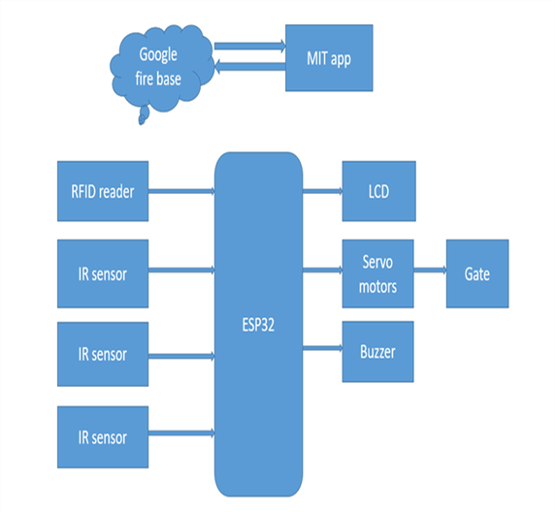
Figure 1: Block Diagram of Smart Parking System

The RFID scanner at the entry IN gate will read the card information of the user and the vehicle as soon as the automobile enters the parking area, and the gate will be opened after validating the record. If the record is incorrect, the gate will stay locked. The parking space's availability is determined by IR sensors, which also send notifications to an app and rotate a servo motor to open the gate if it is accessible.
The entrance side will operate in the same way as the exit side. The RFID sensor that is located before the OUT gate will identify the passing vehicle through its card as it is leaving the parking lot, and the gate will automatically open.
An LCD monitor used to show the status of ongoing processes, such as data verification, parking your car, etc., will be located in front of the parking lot. Additionally, a mobile app that displays time and a cardholder's remaining balance that is maintained in Google Fire Base.

Proposed Flowchart and Algorithm

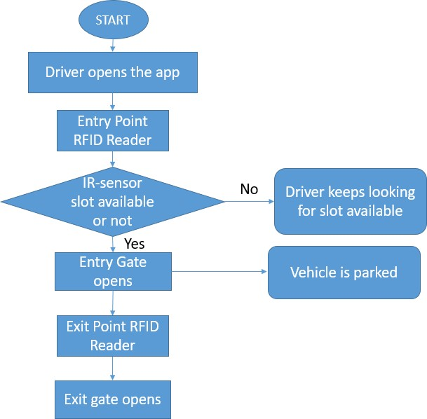

Figure 2. Smart parking system of flowchart and algorithm.

Conclusion

It can be concluded from this research that the proposed system provides a very efficient and easily way of dealing with parking traffic that people are facing every day in their life and also to saving both time and money. Further the application can be enhanced to become more accurate in the future and the possibility of booking car parking over the other features can be added to the system easily.

References

- IoT-based Smart Parking and Traffic Management System for Middle East College,
Aisha Rashid Masoud, Syed Imran Ali Kazmi IEEE 2019
- System Architecture based on IoT for Smart Campus Parking Lots Mohamed A. Ahmed; Abdulaziz S. Alsayyari; Young-Chon Kim 2019 2nd International Conference on Computer Applications & Information Security (ICCAIS) Year: 2019 | Conference Paper | Publisher: IEEE
- IoT-based Smart Vehicle Presence Sensor SPIN-V for Smart Parking System David A. Michel Torres; Luis F. Luque-Vega; Emmanuel Lopez-Neri; Miriam A. Carlos-Mancilla; Luis E. Gonzalez-Jiménez 2019 14th Annual Conference System of Systems Engineering (SoSE) Year: 2019
| Conference Paper | Publisher: IEEE
- Mattern, F., & Floerkemeier, C. (2010). From the Internet of Computers to the Internet of Things. In from active data management to event- based systems and more (pp. 242-259). Springer, Berlin, Heidelberg.
- Weber, R. H., & Weber, R. (2010). Internet of things (Vol. 12). Heidelberg: Springer.
- Jadeja, Y., & Modi, K. (2012, March). Cloud computing concepts, architecture, and challenges. In Computing, Electronics and Electrical Technologies (ICCEET), 2012 International Conference on (pp. 877-880). IEEE.
- Deshmukh, S. (2018). Importance of cloud computing -. Retrieved from https://www.esds.co.in/blog/importanceof-cloud- computing/#sthash.4SSZW4kP.dpbs
- Cloud Computing – Types of Cloud -. (2018). Retrieved from https://www.esds.co.in/blog/cloud- computingtypes cloud/#sthash.GJcX7GW9.Wjce m1zL.dpbs
- Types of Cloud Computing: Private, Public, and Hybrid Clouds | Technology Services - University of Illinois at Urbana-Champaign. (2018). Retrieved from https://cloud.illinois.edu/types-of-cloud- computingprivate-public-and-hybrid-clouds/
- IR Proximity Sensor Philippines | Makerlab Electronics. (2018). Retrieved from https://www.makerlabelectronics.com/product/ir- proximity-
sensor/

