PHYTOCHEMICAL SCREENING AND SPECTRAL ANALYSIS OF SESBANIA GRANDIFLORA AND AMARANTHUS VIRIDIS

P.Perumal¹, B.Vignesh Babu², S. Manimegalai³ G.Kanthimathi ⁴ ,A.Prrithiba ⁵

^{1,2 ,3} Post Graduate and Research Department of Chemistry, Arulmigu Palaniandavar College of Arts & Culture, Palani-624601, Tamilnadu, India.
⁴ Department of Chemistry, Ramco Institute of Technolgy, Rajapalayam 626117, Tamilnadu, India
⁵ Avinashilingam Institute for Home Science and Higher Education for Women, Coimbatore, Tamilnadu, India.

- Introduction:
In ancient times, plant compounds have been a component of phytomedicines. These include barks, leaves, flowers, roots, fruits, and seeds. Understanding the chemical components of plants is desirable since it will be useful for synthesizing complicated chemical molecules. Tropical nations frequently plant Sesbania grandiflora (Linn), a member of the Leguminosae family, for its tasty blooms and pods. It is mostly found growing in hot, humid climates around the world and is thought to have originated in either India or Southeast Asia. Sesbania is found in populated areas at low and medium altitudes from Northern Luzon to Mindanao. There is no doubt that it was brought to the Philippines. This tree grows wild from India to the Mascarene Islands, via Malaya, to tropical Australia, as well as in other tropical nations where it is cultivated. Slender amaranth or green amaranth are two common names for the worldwide plant Amaranthus viridis, which belongs to the botanical family Amaranthaceae.Fast-growing herb often known as "Chowlai" is Amaranthus viridis L. (Amaranthaceae), which is grown primarily in Asia, Africa, and Latin America. In south India, it is typically consumed as a leaf vegetable. This pseudocereal has garnered as a significant food item because of resistivity towards to pests, drought, and hot climates, as well as the fact that it requires little maintenance for growing. The usage of amaranth has increased during the past ten years, not only in the average diet but also in the diets of those who have celiac disease or allergies to conventional cereals. Amaranthus viridis (Amaranthaceae) is a plant that is extensively dispersed around the world, in all weather conditions, and has been used traditionally in Ayurveda. Whole plants and their preparations are utilised in Ayurveda to cure a variety of illnesses and disorders. For its antibacterial, anthelmintic, anti-tumor, and contraceptive characteristics, Sesbania grandiflora is used as an herbal medication. It also has some unusual medical effects.
Fig. 1 Sesbania grandiflora leaves, flower, bark and seeds contains water, carbohydrate, proteins,fats, fibres, minerals ( Iron calcium, sodium and potassium),vitamins and essential amino acids. The roots contains isoflavonids, isovestitol,medicarpin and sativan. Leucocyanidin and cyaniding are the active ingredients of Agati seeds¹.
Fig. 2: Amaranthus viridis is taken in the form of cooked vegetable or green in various cultures. The leaves are very nutrient-rich. Protein, fibre content, vitamins A, C, riboflavin (Vit-B2), thiamin (Vit-B1), iron, calcium, and magnesium, as well as amino acids are all present in the leaf. Proteins and lipids are present in the seeds. Due to its outstanding nutritional content, A. viridis received a lot of interest¹.

The leaves have purgative, febrifuge, and diuretic effects. The leaf sap has vermifuge, filaria-fighting, emmenagogue, and heart-relieving properties. Fresh or as dried powder used for various diseases.
Based on the above medicinal properties, the phytocompounds obtained from the butanol and aqueous extracts of plant leaves is used in the present study for the experimentation.

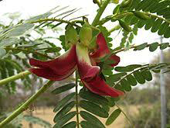
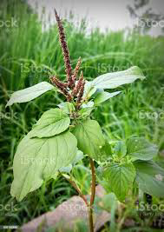
Fig.1: Sesbania grandiflora .L Fig.2: Amaranthus vidiris
2. Methodology
2.1Collection of plant material
The plants- Akathikeerai and kuppaikeerai were purchased from Ulavar Sandhai, Palani, Dindigul District. Plant specimen was authenticated in Department of Botany, Arulmigu Palaniandavar College of Arts & culture, Palani, Dindigul District, Tamilnadu.
2.2Processing of Plant material
The obtained plant material was cleaned three times with tap water and sterilised once with 70% ethanol spray. The sterilised plant material was drained at room temperature due to its high water content to avoid chemical changes, and it was frequently examined for potential fungal infection. The plant parts were then darkened, dried, and ground into a fine powder before being placed in airtight containers. By using the Soxhlet extraction method, the fine powder of the plant materials was gathered and used to extract the crude medicine in various solvents.
2.3Extraction of Phytoconstituents by Soxhlet method
Each plant material's 100g of powder, from which the extract must be extracted, is placed inside the Soxhlet equipment. The round bottom flask is filled with the solvent, which is then heated to a controlled temperature of 60 to 80 °C to extract condensation under reduced pressure. The primary jar is used to simultaneously collect and extract the materials, as evidenced by the solvent's colouring as a compound of substance dissolves in it. Consequently, the plant components' crude extract was obtained.
It takes 7-8 hours to completely extract all of the phytochemicals from the plant, using butanol and other high volumes of organic solvents. Dark green extract was produced when the solvent was completely evaporated; it is kept in the cold storage box to carry out the phytochemical analysis of Sesbania grandiflora (Akathikkerai) and Amaranthus viridis (Kuppaikeerai).
2.4Extract preparation
By dissolving 10 gm of each extract in 100 ml of distilled water and n-butyl alcohol, 10% of each extract was created. These extracts were shaken in an orbital shaker at 60–70 rpm for 24 hours at 40 °C. After incubation, the extracts were filtered using Whatman No. 1 filter paper and used for further investigation.

2.5Phytochemical Screening
(i)Test for Alkaloids
Mayers reagent, 1 ml of extract, and a few drops of iodine solution were combined. Yellow precipitate formation was interpreted as proof of alkaloids.
(ii)Test for Terpenoids
After being heated for two minutes, 1 ml of the crude extract was combined with 1 ml of the concentrated H₂SO₄. The presence of terpenoids is indicated by a developed greyish tint.
(iii)Test for Phenol and Tannins
1 ml of the FeCl₃ solution was mixed with 1 ml of the crude extract. The presence of tannins was shown by the production of blue-green or black precipitate.
(iv)Test for reducing Sugar
1 ml of the extract was boiled for 2 to 4 minutes along with 1 ml each of Fehling's A and B solutions. The development of a crimson tint confirms the presence of sugar.
(v)Test for Saponins
A test tube containing distilled water and 1 or 2 ml of extract was forcefully shaken. Shaken thoroughly, and a stable foam layer measuring 1 cm thick was considered a sign of saponins.
(vi)Test for Flavonoids
In a test tube, a few pieces of magnesium ribbon were introduced together with 1 ml of extract and a few drops of strong HCl, drop by drop. For 2 to 3 minutes, incubate. The emergence of pink scarlet after a short while indicated the presence of flavonoids.
(vii)Test for Quinines
1 ml of educe was mixed with 1 ml of 1% NaOH solution and mixed well properly. Developed the blue green or red indicates the presence of Quinines.
(viii)Test for Protein
Few drops of nitric acid was added to 1 ml of elicit and the test tube was allow to without disturbance for few seconds. Formation of yellow color indicates the presence of protein.
(ix)Test for Steroids
1ml of extort was mixed with equal amount of chloroform followed by added concentrated H₂SO₄ and allowed to develop red color ring. A red color was ring at the lower layer of chloroform indicates the presence of steroids ^{2-4.}
2.6UV-VIS spectrum analysis
Both plant extracts were centrifuged for 10 minutes at 3000 rpm before being filtered using Whatmann No. 1 filter paper. With the same solvent, the samples were diluted to a ratio of 1:10. Using a Perkin Elmer Spectrophotometer, the extracts were scanned at wavelengths ranging from 200 to 1100 nm, and the distinctive peaks were found. The UV-VIS peak values were recorded⁵.
2.6FT-IR analysis
Fine grain powder (butanolic extract) of test plants were used for FT-IR analysis⁶.1 mg of the dried powder of both the plants were confined in 10 mg of KBr pellet, in order to prepare translucent sample discs. The pellet samples were ground into powder and placed onto a Shimadzu FT-IR spectroscope (Japan), which has a scan range of 400 to 4000 cm⁻¹ and a resolution of 4 cm⁻¹.
3.RESULTS AND DISCUSSION
3.1Qualitative phytochemical analysis of Sesbania grandiflora & Amaranthus viridis
The results of qualitative phytochemical analysis of Sesbania grandiflora & Amaranthus viridis are tabulated in Table 1.
Phytochemical screening of water and n-butyl alcohol medium extracts confirms the presence of presence of alkaloids, terpenoids, phenols, sugars, saponins, flavanoids and quinines in Sesbania grandiflora plant extracts is shown in Fig.3,4,5.
Table 1: Quality assessment of the selected plant extracts' phytochemical composition
Phyto constituents | Extract used
 | Sesbania grandiflora |  | Amaranthus viridis
 | Water | n-Butyl alcohol | Water | n-Butyl alcohol
Alkaloids | + | + | - | +
Terpenoids | + | + | + | +
Phenol | + | + | + | -
Sugar | - | + | - | +
Saponins | + | - | + | -
Flavanoids | + | - | - | +
Quinines | - | + | - | +
Protein | - | - | - | +
Steroids | - | - | - | -

NOTE: ‘+’ Indicates the presence ‘-‘ Indicates the absence of phyto constituents
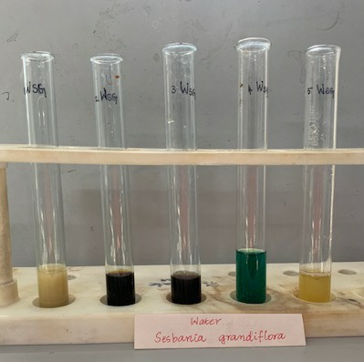

Fig.3.Aqueous extract of Sesbania grandiflora

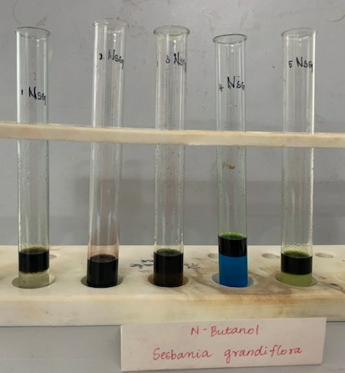

Fig.4. Butanol extract of Sesbania grandiflora
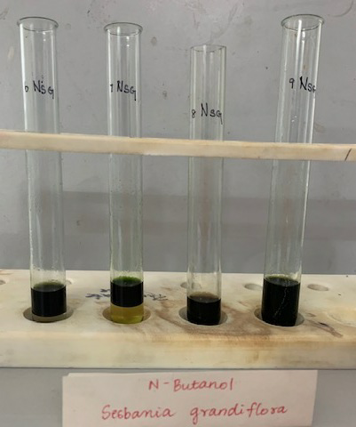
Fig.5. Butanol extract of Sesbania grandiflora
Phytochemical screening of water and n-butyl alcohol medium extracts of Amaranthus viridis revealed the presence of alkaloids, terpenoids, phenols, sugars, saponins, flavanoids, quinines and proteins by positive reaction with the respective test reagent. The test specimens of the extracts are noted in Fig.6,7,8,9.

.
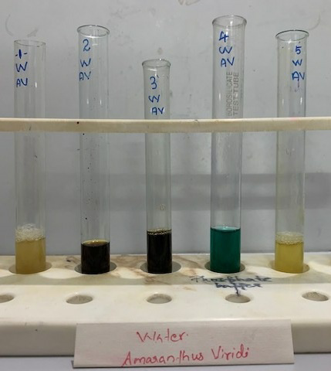

Fig.6 Test specimens of Aqueous extract of Amaranthus viridis
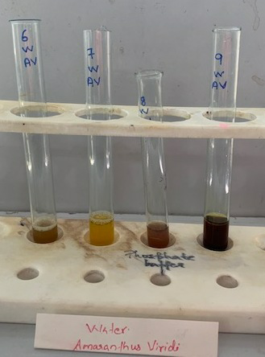
Fig.7 Test specimens of Aqueous extract of Amaranthus viridis
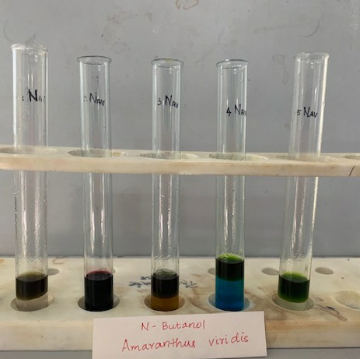
Fig.8 Test specimens of n-butanol extract of Amaranthus viridis
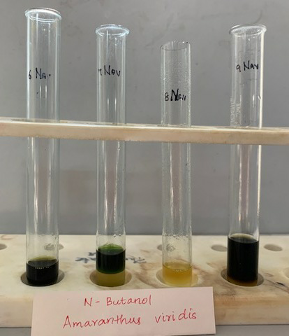
Fig.9 Test specimens of n-butanol extract of Amaranthus viridis

The phytochemical examination of the sesbania plant give out the presence of phytochemicals including alkaloids, terpenoids, phenols, sugars, saponins, flavanoids, and quinines by demonstrating a good reaction with the proper test reagent. However, numerous investigations have demonstrated that the analgesic and anti-inflammatory properties of flavonoids and other phenolic compounds are accompanied by membrane stabilising activity⁷. The amaranthus plant's phytochemical analysis showed that it included compounds like alkaloids, terpenoids, phenols, sugars, saponins, flavonoids, quinines, and proteins.

The ability of phenolic compounds to scavenge free radicals makes them one of the most significant families of antioxidants. However, the presence of phytochemical substances like alkaloids, terpenoids, phenols, sugars, saponins, flavanoids, quinines, and proteins has exhibit momentous pharmacological properties, including antiviral, anti-inflammatory, antioxidant, anti-microbial, anti-mutagenic, and chemopreventive activity. The presence of phenolic compounds in various medicinal plants, such as chlorogenic acid, apigenin, kaempferol, asiaticosides, brahmic acid, asiatic acid, steroids, glycosides, and rosmarinic acid, may be responsible for scavenging free radicals and enhancing antioxidant activities, according to a previous study ³⁻⁴. According to numerous publications, the therapeutic qualities of plant extracts are caused by the presence of phytochemicals ^{5,7-9}.
3.2UV-VIS spectrum analysis of Sesbania grandiflora:
The butanol extract of Sesbania grandiflora's qualitative UV-VIS spectrum profile was choosen at a wavelength between 200 and 800 nm due to the clarity of the peaks and adequate baseline. The profile (Table 2 and Fig. 10) showed peaks at 240, 260, and 300 nm with absorption values of 2.345, 1.812, and 2.512, respectively. This plant extract's UV-VIS spectra shows absorption bands at 420 and 223 nm. Flavonoids often have two absorption maxima in their spectra, one in band II at wavelengths of 300–350 nm and the other in band I at wavelengths of 230–285 nm. The valuable spot and relative intensities of these maxima provide crucial information about the structure of the flavonoids.
Table 2: Peak values for Sesbania grandiflora butanolic extract in the UV-VIS spectrum

S.NO | Wavelength(nm) | Absorbance(abs)
1. | 240.00 | 2.345
2. | 260.00 | 1.812
3. | 300.00 | 2.512
4. | 325.00 | 2.503
5. | 365.00 | 2.360
6. | 430.00 | 2.600
7. | 540.00 | 1.397
8. | 615.00 | 2.192
9. | 755.00 | 0.087
10. | 785.00 | 0.077

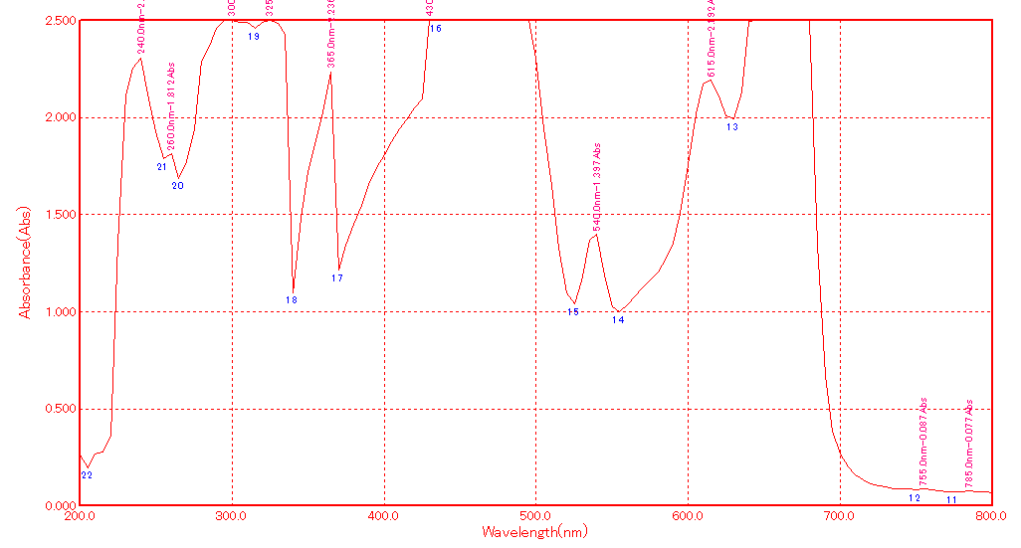

Fig.10.UV-VIS Spectrum of butanol extract of Sesbania grandiflora
3.2 UV-VIS spectrum analysis of Amaranthus viridis:
Due to the clarity of the peaks and appropriate baseline, the qualitative UV-VIS spectrum profile of the butanolic extract of Amaranthus viridis was chosen at a wavelength between 200 and 800 nm. In Table 3 and Fig. 11, the profile showed peaks at 223, 271 and 340 nm with absorption values of 0.25, 0.25, and 0.230, respectively.
This plant extract's UV-VIS spectra shows absorption bands at 420 and 223 nm. These bands of absorption are typical of flavonoids and their derivatives. Flavonoids often have two absorption maxima in their spectra, one in band II at wavelengths of 300–350 nm and the other in band I at wavelengths of 230–285 nm. The precise position and relative intensities of these maxima provide crucial information about the structure of the flavonoids. UV-Vis absorption spectrum of Amaranthus viridis extract in butanol, reveals that all of these compounds display maximum absorption in the vicinities of 260-270 nm and 320-360 nm, which are attributed to the presence of coumarins, saponins, alkaloids, tannins, reducing sugars, catechins, epicatechins, flavonoids and polyphenolic (catechins, hydroxyl benzoicacids, hydroxyl cinnamic acids) ¹⁰.
Table3: Peak values of Amaranthus viridis butanolic extract in the UV-VIS spectrum:

S.NO | Wavelength(nm) | Absorbance(abs)
1. | 215.0 | 0.352
2. | 235.0 | 2.264
3. | 300.0 | 2.494
4. | 315.0 | 2.395
5. | 325.0 | 2.380
6. | 540.0 | 0.342
7. | 620.0 | 0.753
8. | 665.0 | 2.500
9. | 750.0 | 0.026
10. | 785.0 | 0.022
According to a UV-Vis study, Flavonoids typically have two absorption maxima in band I, which has a wavelength range of 230-285 nm, and band II, which has a wavelength range of 300-350 nm. These maxima's exact location and relative intensities provide important details about the flavonoids⁵. To assess the IR fingerprint of Sesbania Grandiflora, FT-IR techniques were used. The findings indicated the existence of terpenes due to the CH group, polyphenols and flavonoids due to the O-H stretching, and alkaloids due to the N-H stretching. The FTIR spectrum detected alcohols, phenols, alkanes, alkynes, alkyl halides, aldehydes, carboxylic acids, and amines in the test plant. Traditionally, Sesbania Grandiflora has been used in healthcare systems to treat coughs, fevers, and colds because of its glycosides and alkaloids. By FTIR spectrophotometer study, the presence of the following groups was confirmed: C-F, O-H, C-H, C=C, C=O, C≡N, N-H, C-H, carbonates and nitrates stretching. According to the functional group analysis, Sesbania Grandiflora does not contain any toxic compounds.
The UV-Vis absorption spectrum of Amaranthus viridis extract in butanol reveals that all of these compounds have maximum absorption between 260 and 270 nms and 320 and 360 nms, which is attributed to the presence of coumarins, saponins, alkaloids, tannins, reducing sugars, catechins, epicatechins, flavonoids, and polyphenols. The FTIR technique was then used to evaluate s. It confirmed the presence of the following groups: C-F, O-H, C-H, C=C, C=O, CN, N-H, C-H, carbonates and nitrates. There may be distinctive therapeutic qualities due to carboxylic acids, anhydrides, alcohols, phenols, amines, amides, esters, ethers, sulfur derivatives, glycosides, nitrates, nitriles, organic halogens, and carbohydrates.
The different extracts of both leaves have clearly indicated that all the major phytochemicals are available in the extracts, making this flora an excellent source for the extraction of bioactive compounds. It is possible to conduct many more experiments with this plant, including growing it under different conditions and measuring its phytochemical content. This experimentation is suggested because these plants grown in arid regions and also in acidic and alkaline soil regions⁸.
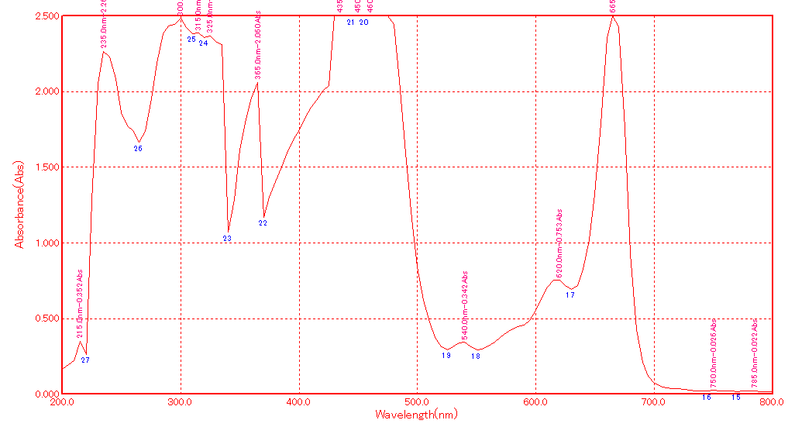
Fig.11 UV-VIS Spectrum of butanolic extract of Amaranthus viridis
3.4 FT-IR analysis of Sesbania grandiflora plant extract:
On the basis of the peaks in the region of IR radiation, FT-IR spectrum was used to identify the functional groups of the active components in extract. FTIR was used to separate the functional groups of the components based on their peak ratios. The FTIR spectrum profile was illustrated in Fig.12. As shown by the large peak at 3858 cm⁻¹, O-H stretching was present. It produced strong peaks at 2947 cm⁻¹ that indicated the presence of C-H, 2839 cm⁻¹ that was attributed to carboxylic acid, 2361 cm⁻¹ that was attributed to C-N, 1651 cm⁻¹ that was attributed to C=O stretching, 1450 cm⁻¹ that was attributed to alkanes, 1288 cm⁻¹ that was attributed to carboxylic acid, 1211 cm⁻¹ that was attributed to alkyl amine,679 cm⁻¹ that was attributed to alcohols, phenols, alkanes, alkynes, alkyl halides, aldehydes, aromatics, nitro compounds, and amines were all identified in the powder pellet by the FT-IR spectrum.

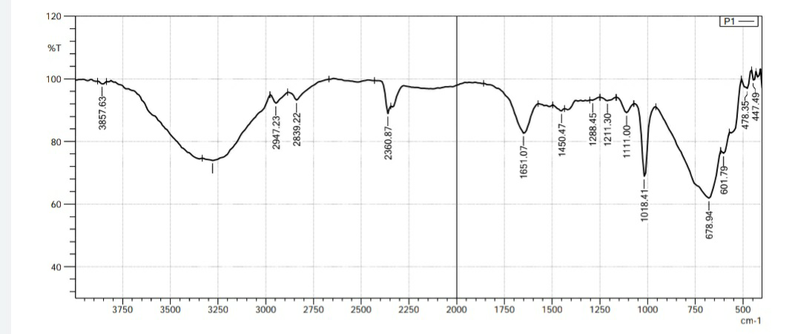

Fig. 12 FT-IR Spectrum of butanol extract of Sesbania grandiflora
3.5 FT-IR analysis of Amaranthus viridis:
Fig.13 displays the FT-IR spectra of the butanol extract of Amaranthus viridis.the wide peak at 3811 cm⁻¹, which showed that C-H stretching was present. The peak around 3279 cm-¹ is due to O-H strong peak, 2978 gave CH stretching, 2901 cm⁻¹ gave CH and CH₂ stretching, peak obtained at 2361 cm⁻¹, 2337 cm⁻¹ indicated the presence of C-C conjugated and C=C, and the peaks at 1643 cm-1 indicated the presence of C=O aromatic groups. It also produced a strong peak at 3726 cm⁻¹, which indicated the presence of the O-H group.Amide H-linkage was detected at 1520 cm-1, O-H carbohydrates, proteins, and polyphenols were detected at 1389 cm⁻¹, C-O stretching was detected at 1157 cm⁻¹, and C=H stretching was detected at 949 cm⁻¹. The FT-IR spectrum confirmed the presence of alcohols, phenols, alkanes, alkynes, aldehydes, aromatics and amines in powder pellet.
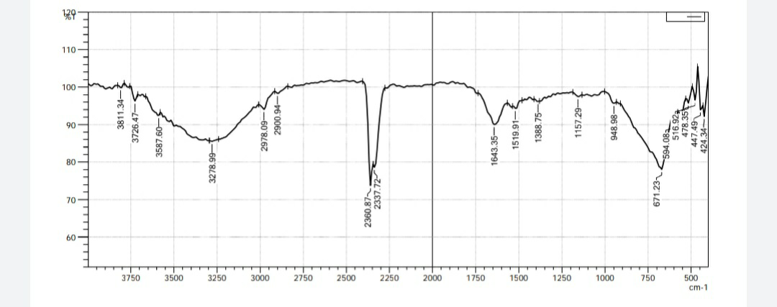

Fig. 13 FT-IR Spectrum of butanolic extract of Amaranthus viridis

CONCLUSION
Sesbania grandiflora and Amaranthus viridis plants were investigated for their phytochemical components and their therapeutic effect. The findings showed that the plants under study had components with significant therapeutic value. There are many pieces of evidence from past investigations that support the bioactivity of the discovered phytochemicals. Alkaloids, terpenoids, phenols, sugars, saponins, flavanoids, and quinines were found in the qualitative phytocompounds examined in S. gradiflora and A. viridis. According to the findings, since S. grandiflora and A. viridis leaf extracts exhibit antioxidant and antibacterial properties, they can be employed in folk medicine. The existence of phenolic chemicals and flavonoids, which are responsible for the test plant's diverse therapeutic characteristics, was revealed by the UV-VIS spectrum and FTIR analysis of the plant in the current study.
References:
- Larbie Christopher, et al., Anti-proliferative Effect of Amaranthus Viridis Linn on Human Leuckemic cell Lines –Preliminary Study. International Journal of Biological and Pharmaceutical Research,2015;6(3):236 – 243.
- Pandhare R.B, Sangameswaran B Mohite P.B and Khanage S.G. Antidiabetic Activity of Aqueous leave extract of Sesbania grandiflora (L) Mess, in Streptozotocin induced Diabetic rats. Journal in Medicinal Biotech, 2011; 3(1): 37-43.
- Qui˜nones Islas L, Meza-M´arquez O, Osorio-Revilla G, and Gallardo-Velazquez T. Detection of Adulterants in Avocado Oil by Mid-FTIR Spectroscopy and Multivariate Analysis. Food Research International,2013; 51:148–154.
- Radhika J, Ruth Christia C and Jothi G. Effect of the aqueous extract of Sesbania grandiflora in alloxan induced diabetes in albino rats. World Journal of Pharmaceutical Research, 2014; 3(9): 677-685.
- Rajagopal P.L, Premaletha K and Sreejith K.R. Anthelmintic Activity of the Flower of Sesbania grandiflora Pers. Journal of Innovations in Applied Pharmaceutical Sciences,2016;1(2): 8-11.
- Musharaf Khan, Shahana Musharaf,Mohammad Ibrar and Farrukh Hussain. Phytochemical and Pharmacological Potential of Amaranthus viridis. Journal in Pharmaceutical Biotechnology, 2011; 3(1):11-16.
- Rodr´ıguez-Carpena J.G, Morcuende D, Andrade M.J,Kylli P, and Estevez M.In Vitro Antioxidant and Antimicrobial Activities, and Inhibition of Lipid and Protein Oxidation in Porcine Patties. Journal of Agricultural and Food Chemistry,2011; 59:5625–5635.
- Sangeetha, Sriram Prasath G and Subramanian S. Anti hyperglycemic and Antioxidant Potential of Sesbania grandiflora leaves studied in STZ induced experimental diabetic rats. International Journal of Pharmaceutical Science And Research, 2015; 2266-2275. Sarma R,et al., Polyphenol rich extract of Garcinia pedunculata fruit attenuates the hyperlipidemia induced by high fat diet. Journal in Front Pharmacol. 2016 ; 7 :294.
- Muhammad Javid,et al., Anti-Oxidant and Anti-Microbial Activity of Amaranthus Viridis. Journal of Medicinal Plants Research, 2012; 6(27):4450 – 4455.
- Nadkarni A.K. Phytochemical,Pharmacological and Phytopharmaceutics Aspects of Sesbian grandiflora; Journal of Pharmacy Research ,1991;1: 52.

