Synthesis, Characterization and Application of CdS:Pr³⁺ nano-material

Jitendra Pal Singh^{1*} Sudha Pal²
Department of Physics, School of Sciences Department of Physics,
IFTM University, Moradabad-244102, India M.B. Govt. P.G. College,
paljitendra124@gmail.com Haldwani, Uttrakhand-263139, India
palsudh2011@gmail.com

Y. K. Sharma³ Atanu Nag⁴
Department of Physics, Department of Physics, School of Sciences

Sri Dev Suman Uttarakhand University IFTM University, Moradabad-244102, India

Pt. L. M. S. Campus Rishikesh, India tnnag79@gmail.com

dryksharma@gmail.com

Richa Sexena⁵ Narender Singh⁶
Department of Physics, School of Sciences Department of Physics, School of Sciences
IFTM University, Moradabad-244102, India IFTM University, Moradabad-244102, India
saxena.rich23@gmail.com nspal_physics@rediffmail.com

Corresponding author : paljitendra124@gmail.com

Abstract
Pr³⁺ doped CdS nano-material are successfully synthesized and characterized through an easy, inexpensive and single-step simple chemical precipitation method. The synthesized particles are nearly spherical in shape and their size is found to decrease with the increase in Pr³⁺ ion concentration. The chemical identity of the synthesized nano-particle was confirmed by the representative EDAX spectra. The absorption spectra of the prepared nano-material have been recorded at room temperature in the UV-visible region. The structure, shape, band gap and optical behavior are also investigated. The obtained CdS:Pr³⁺ nanomaterial exhibit approximately sphere-like shapes of about 1μ-200nm diameter. The synthesized CdS:Pr³⁺ nanoparticles can be potential for different optoelectronic applications.

Keyword: CdS:Pr³⁺, SEM, EDAX, FTIR, UV-visible spectra

1. Introduction
Generally, nano-materials have structured components with at least one dimension less than 100 nm and distinctly different physical and optical properties in different scientific and technological fields [1]. Nano-science is basically study of materials at atomic or molecular scales, where their properties are remarkably different from those at a larger scale. Nano-technology, on the other hand, refers to the production and application of those structured devices and systems by controlling the shape and size of these nano-materials [2]. In nano-materials the properties like electrical, mechanical, optical, magnetic etc. can be selectively managed by engineering the morpholopy of the material. This is made possible by using a variety of synthesis methods, in the various forms of quantum confined systems like thin films, powder, quantum wires, quantum wells, quantum dots etc [3]. The necessity for quantum confinement is to obtain nano-crystals smaller than the excitation Bohr radius of the material [4]. Group II-VI semiconductor nano-materials are a type of materials composed of group II and VI elements which have a wide and direct band gap and are very crucial in many modern electronic domains, due to their tunable electrical and optical properties [5-7]. Cadmium sulfide (CdS) is considered to be amongst the most common semiconductor owing to its high band gap value of 2.42eV. CdS structures are classified into three types viz. hexagonal wurtzite, high pressure rock-salt and cubic zinc blend out of which the hexagonal wurtzite is the most important due to its stability and easy to be synthesized [8, 9]. Rare earth elements possess remarkable optical properties due to their excellent interaction with light [10, 11]. Praseodymium (Pr³⁺) doped CdS have particles have been extensively considered in the recent year due to their describable properties and applications in different domains of interest like computing, opto-electronics, bio-medicine, structural engineering, aerospace etc [12-14].

2. Experimental Details
Pr³⁺ ions doped CdS nano-particles were synthesized by simple chemical precipitation synthesis method (CPSM) [15]. These nano-particles are commonly referred as CdS:Pr³⁺. A similar paper, has been published recently by Jitendra Pal Singh et al, which describes elaborately the synthesis of CdS:Pr³⁺ nano-particles using the CPSM [16]. CPSM is a single-step, easy and inexpensive method. The chemicals, used in this work, were of analytical grade without purification. Cadmium nitrate tetrahydrate [Cd (NO₃)₂.4H₂O], sodium sulfide [Na₂S], diethylene glycol [DEG], ethanol [C₂H₅OH], praseodymium chloride [PrCl₃] and distilled water were used as a source material. At first 0.1M of Cd(NO₃)₂.4H₂O solution (50ml) was poured in a conical flask and about 20 ml of DEG was added to this solution under constant stirring. Then 50 ml Na₂S solution and different concentration (0.1 mol %, 0.2 mol % and 0.3 mol %) of PrCl₃ were added drop by drop under constant stirring and it was kept for reaction for 4 hours at 60⁰C with constant stirring. Finally, a yellow precipitate of CdS is formed. It was washed with ethanol and distilled water. Thereafter it was dried at room temperature [17].

3. Result and Discussion
The CdS: Pr³⁺ nano-particles have been synthesized by simple CPSM and it is then characterized in terms of scanning electron microscopy (SEM) imageries, energy dispersive X-ray (EDAX) spectra, Fourier transform infrared (FTIR) spectra and absorption spectra to compute the shape, size and band gap.
3.1 SEM
Representative SEM imageries of CdS: Pr³⁺ nano-particles, prepared by simple CPSM at room temperature, is shown in Fig. 1. These imageries indicate approximate spherical shape of the CdS: Pr³⁺ nano-particles and the size of the particles are around 1μ-200nm. It clearly demonstrates the formation of spherical shaped CdS nano-particles. The morphology of the nano-particles was found to be changed with the Pr³⁺ ions concentration.
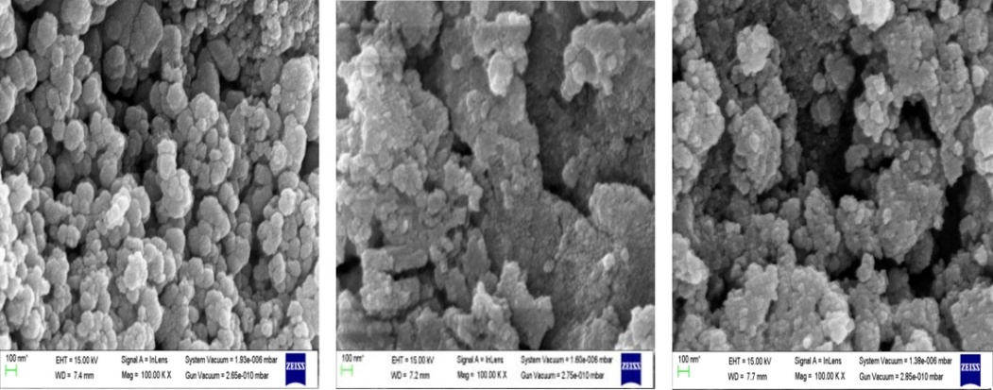
Fig. 1: SEM imageries of CdS: Pr³⁺ nano-particles
3.2. EDAX
Repersentative EDAX spectrum of CdS: Pr³⁺ nano-material specimen is shown in Fig. 2. This reveals that all the elements are present in the final composition which was taken initially [18].

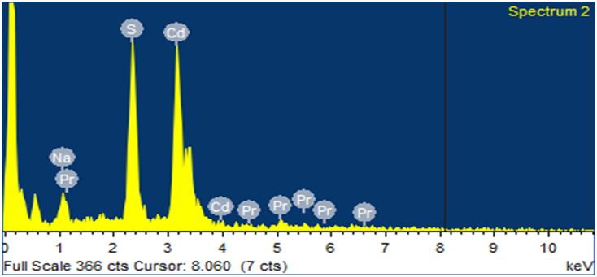
Fig. 2: Representative EDAX spectrum of CdS: Pr³⁺ nanomaterial.

3.3. FTIR Spectroscopy

Absorption of the electromagnetic radiation at a particular frequency of vibration with specific sets of chemical bonds within a molecule is the source of generation of FTIR spectra [19]. The FTIR spectra of CdS:Pr³⁺ nano-material observed expermentally in the 400-4000cm⁻¹ range is shown in Fig. 3. These spectra of CdS:Pr³⁺ nano-material consists of several peaks having broad and moderate in bandwidth. The peaks around 607-636cm⁻¹ are due to metal-oxygen (Pr³⁺/CdS) bonds. The peak in the range 1613-1623cm⁻¹ is associated with the asymmetric stretching vibrations of CdS bonds from metal-oxygen group. The broad band around 3427-3456 cm⁻¹ is due to the fundamental O-H stretching vibrations indicating the presence of H₂ groups.

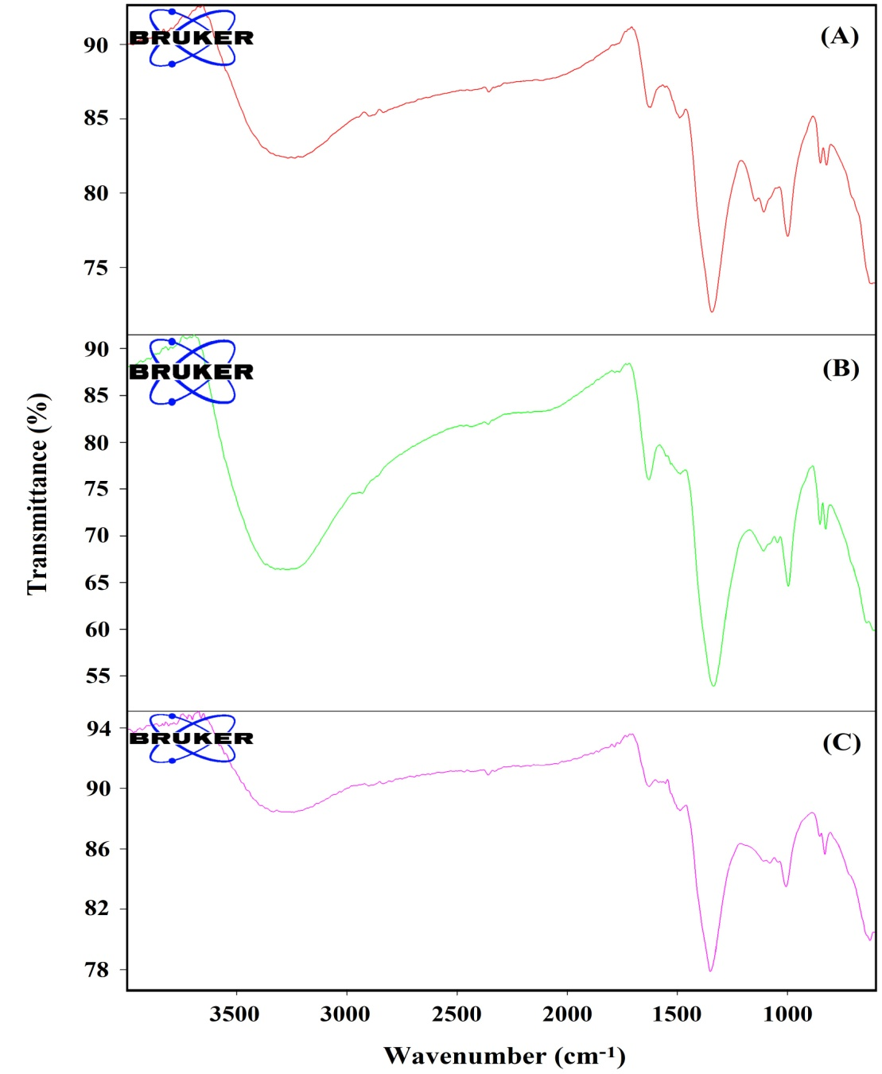
Fig. 3: FTIR spectrum of CdS nanomaterial doped with (A) 0.1 mol%, (B) 0.2 mol% and (C) 0.3 mol% Pr³⁺ ion.

3.4 Absorption spectra

The absorption spectra of CdS: Pr³⁺ nano-particles were recorded for different concentration of Pr³⁺ ions at room temperature. The absorption spectra of CdS:Pr³⁺ was recorded for a wavelength range of 300-1000 nm and it corresponds to transitions from the ground level to different excited levels as indicated by the representative absorption spectrum in Fig. 4.
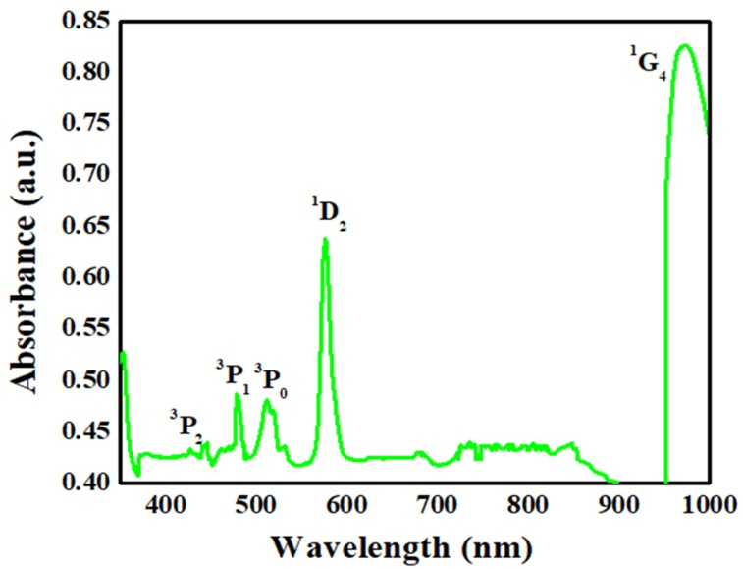
Fig. 4: Representative absorption spectrum of CdS: Pr³⁺ nano-material.

3.5 Energy band gap
Table 1 shows the optical band gap (E_{g}) energy of CdS: Pr³⁺ nano-particles, as revealed from the absorption spectrum, for different Pr³⁺ ion concentrations. The observed variation in the band gap is due to the effect of quantization according to which it is obvious that the value of band gap increases with the size of crystallite formation of nano-metric Pr³⁺ ions doped CdS nano-particles. It is clear from Table-1 and Fig. 5 that there with an increase in the concentration of Pr³⁺ ions the band gap decreases.
Table.1: Absorption spectrum derived optical band gap (E_{g}) energy of CdS: Pr³⁺ nano-particles doped with different Pr³⁺ ion concentrations

0.1 mol% Pr³⁺ |  | 0.2mol% Pr³⁺ |  | 0.3mol% Pr³⁺
Wavelength  λ (nm) | Optical Band gap Energy (eV) | Wavelength  λ (nm) | Optical Band gap Energy (eV) | Wavelength  λ (nm) | Optical Band gap Energy (eV)
446 | 2.78 | 445 | 2.78 | 448 | 2.76
480 | 2.58 | 482 | 2.57 | 481 | 2.57
513 | 2.41 | 512 | 2.42 | 513 | 2.41
576 | 2.15 | 576 | 2.15 | 577 | 2.14
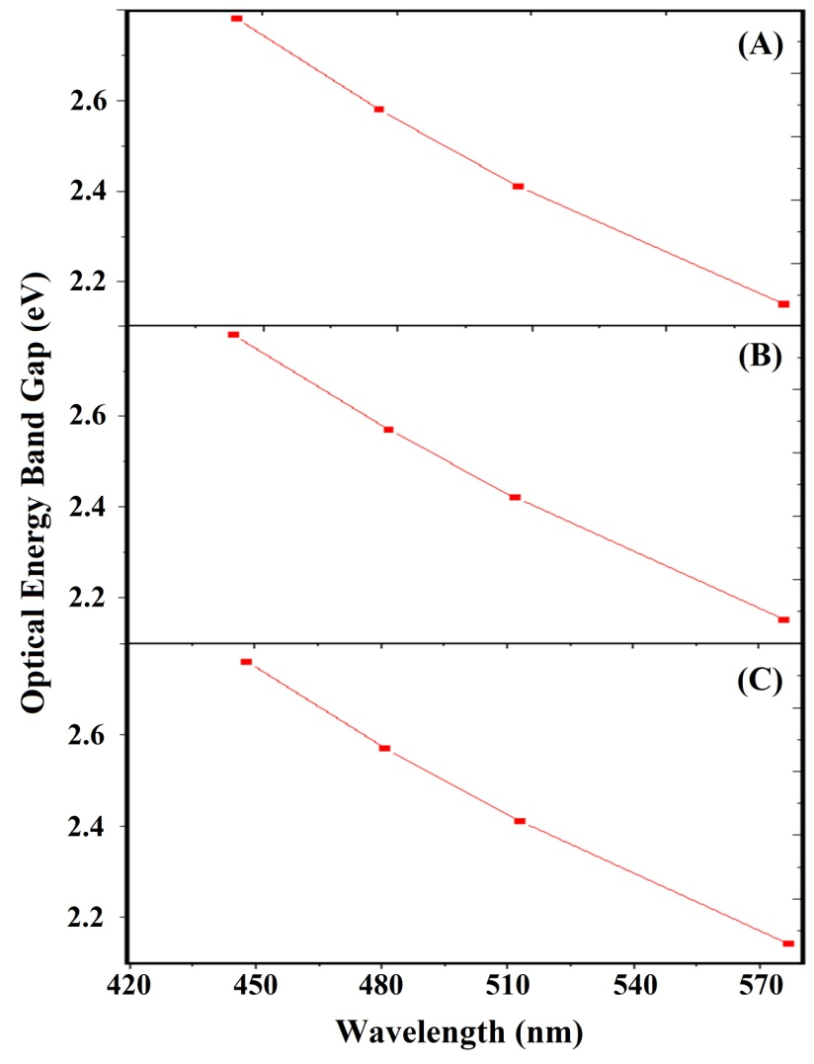
Fig. 5: Band gap concentration CdS nanoparticles doped with (A) 0.1 mol%, (B) 0.2 mol% and (C) 0.3 mol% Pr³⁺ ion.
4. Conclusion
The physical properties of nano-materials depend on their sizes and they possess size dependent electrical and optical properties in the nano-metric region. Considering the fundamental and technological importance, the tunability in the energy band gap of semiconductors is very much crucial for modern electronic devices. Semiconductors, possessing the tunable property of energy band gap, are considered to be the next generation materials of interest for display devices, photovoltaics, opto-electronic devices, lasers, photonic band gap devices etc. CdS is considered to be amongst the most usable semiconductor owing to its high value of band gap and potential applications in opto-electronic domain [20]. We have successfully prepared Pr³⁺ doped (0.1 mol%, 0.2 mol% and 0.3mol%) CdS: Pr³⁺ nano-particles by simple CPSM with an objective to use this for different opto-electronic applications. The chemical identity of the synthesized nano-particles was confirmed by EDAX spectra and the absorption peaks was confirmed by the FTIR spectra. The SEM imageries clearly signify the morphological change of the spherical CdS nano-particles with the different doping concentrations of Pr³⁺ ion. The band gap decreases with increasing concentration of Pr³⁺ ion. The band gap values show that it is suitable to use in solar cell fabrication as well as opto-electronic and high frequency applications. The developed CdS: Pr³⁺ nano-particles could also be useful for display devices like LEDs, and UV temperature measurement sensors [21].

REFERENCES
- M. F. Kotkata, A. K. Masoud, M. B. Mohamed and E. A. Mahmoud, “Synthesis and structural characterization of CdS nanoparticles”, Physica E 41(2009)1457-1465.
- “Nanoscience and Nanotechnologies: Opportunities and uncertainties”, The Royal Society and The Royal Academy of Engineering (2004).
- N. Qutub, Ph.D Thesis; “Cadmium Sulphide Nanoparticles” A .M .U., India (2013) .
- S. Muruganandam, G. Anbalagan and G. Murugadoss, “Optical, electrochemical and thermal properties of Co²⁺-doped CdS nanoparticles using polyvinylpyrrolidone”, App.Nanosci., 5 (2015) 245-253.
- Md. U. Khan, A. L. Fanai and S. Rai, “Spectroscopic properties of Sm³⁺and CdS co- doped in sol-gel silica glass”, Indian .J. of Pure & Applied Physics, 58 (2020) 157-163.
- B. S. Rao, B. R. Kumar, V. R. G. Reddy and T. S. Rao, “Preparation and characterization of CdS nanoparticles by Chemical co-precipitation technique”, Chalcogenide letters, 8 (2011) 177-185.
- S. Rai and L. Bokatial, “Effect of CdS nanoparticles on photoluminescence spectra of Tb³⁺ in sol-gel-derived silica glasses”, Butt.Mater., 34 (2011) 227-231.
- V. P. Singh and J. Chauhan, “Synthesis and structural properties of wurtzite type CdS Nanoparticles” Chalcogenide .lett., 6 (2009) 421-426.
- J. P. Singh, P. Goyal, Y. K. Sharma, V. Kumar and H. O. Yadav., “Optical Energy band and Absorption spectra of CdS:Pr³⁺Nanomaterials”, International Journal of Current Advanced Research, 10 (2021) 2319-6505.
- P. Tian, Z. Zhang, J. Yuan, W. Zheng, H. Li and S. Zhu., “Crystallization and luminescence of Pr³⁺-doped CdS QDs silicate glass”, Functional Materials letters, (2018) 1-4.
- A. A. Safi and M. I. Ibrahim., “The effect or rare earth doping CdS nanostructure on structural, optical and photoconductivity properties”, 17 (2019) 108-118.
- S. Kumar and J. K. Sharma, “Stable Phase CdS nanoparticles for optoelectronics: A study on surface morphology, structural and optical characterization”, Materials Sci. Poland, 34 (2016) 368-373.
- M. N. Khan, A. Almoharmmedi, M. A. M. Khan and M. A. Shar, “Metal doped CdS quqntum dots:Structural,Optical and Photocatalytic Properties under Visible light Irratiation”, 5 (2020) 2-17.
- J. Zhang, H. Chen, K. Xu, D. Deng, Q. Zhang and L. Luo, “Current progress of radiometric fluorescence sensors based on carbon dots in Foodbornne Contaminant Detection &Biosensors”, 13 (2023) 233.
- L. Bokatial and S. Rai, “Optical properties and up-conversion of Pr³⁺doped CdS nanoparticles in sol-gel glasses”, Journal of Luminescence, 130 (2010) 1857-1862.
- J. P. Singh, P. Goyal, Y.K .Sharma, D. R. Prakash “Synthesis and Characterization of Pr³⁺ doped CdS Nanomaterial”. J. Emerging Technologies and Innovative Research 6(2019) 3093-3101.
- L. Saravanan, R. Jayavel, A. Pandurangan, J. H. Liu and M. H. Yuan, “Synthesis Structural and optical properties of Sm⁺³ and Nd³⁺ doped Cadmium Sulfide nanocystals”, Materials Research Bulletin, 52 (2014) 128-133.
- J. P. Singh, Y. K. Sharma, S. Pal and A. Nag, “Fluorescence study of Pr³⁺doped CdS Nanoparticles and its application in Sensors and detectors”, Journal of fluorescence, Published (online) July 2023. https://doi.org/10.1007/s10895-023-03325-w.
- Y. K. Sharma, P. Goyal, S. Pal and U. C. Bind, “Laser action in Praseodymium doped Borosilicate Glasses in visible region”3(2016)1031-1035.
- A. B. El-Bially, R. Seoudi, W. Eisa, A. A. Shabaka, S. I. Soliman, R. K. Abd El-Hmaid and R. A. Ramdan, “Preperation characterization and Physical properties of CdS Nanoparticles with different sizes”, Journal of Applied Science Research, 8 (2011) 676-685.
- S. Zhou, G. Jiang, X. Wei and C. K. Duan, “Pr³⁺-doped beta-NaYF4 for Temperature Sensing with Fluorescence Intensity Ratio Technique”, Journal of Nanoscience and Nanotechnology, 14 (2014) 3739-3742.

