Deep Learning-Based Classification of Agricultural Soil Textures for Enhanced Crop Productivity

Jayashree G.   
Department of Computer Science and Engineering  
Thiagarajar College of EngineeringThiruparankundram, Madurai  
jayashreeg2805@gmail.com

Mathan Kumar M.  
Department of Computer Science and Engineering  
Thiagarajar College of EngineeringThiruparankundram, Madurai  
muthukuttymathankumar@gmail.com Madhu Priya Dharshini S.   
Department of Computer Science and Engineering  
Thiagarajar College of EngineeringThiruparankundram, Madurai  
madhupriyadharshini17@gmail.com

Santhiya C.  
Assistant Professor Department of Computer Science and Engineering  
Thiagarajar College of EngineeringThiruparankundram, Madurai  
csit@tce.edu Lokesh D.   
Department of Computer Science and Engineering  
Thiagarajar College of EngineeringThiruparankundram, Madurai  
lokeshtrt0108@gmail.com

*Abstract*—

# **Accurate soil analysis is crucial for optimizing crop cultivation and management since soil quality and texture are so important in the agricultural industry. We have incorporated deep learning (DL) into agriculture for classifying different soil textures, to enable farmers to increase crop output. Convolutional Neural Networks (CNNs), a powerful DL framework, are used in our method to automatically recognise silts, stones, and other colour categories by learning detailed patterns inside soil images. 11 different agricultural soil types, including clay, loam, loamy sand, peat, and more, are included in our large dataset. We used image augmentation techniques to expand the dataset and improve model generalisation. The implementation leveraged Keras, a high-level neural networks API running on TensorFlow, for model creation and training. We harnessed the power of the ImageGenerator library to efficiently manage the image dataset. We experimented the evaluation of four CNN models: Baseline, Augment, Dropout, and Padding. The Baseline model achieved an accuracy of 52%. The Augment model, which incorporated image augmentation, delivered an accuracy of 28%, while the Dropout model, utilizing dropout layers, achieved 20%. Notably, the Padding model excelled, yielding an impressive accuracy of 68%. The implications of our soil texture analysis using CNN extend to the creation of more precise soil maps, which can revolutionize land use planning, soil conservation efforts, and environmental management. This study marks a significant stride in harnessing DL technology for the betterment of agriculture, offering farmers the tools they need to make informed decisions and enhance their crop yields sustainably.**

# Introduction

The basic principle of soil texture analysis is to measure the size of soil particles and categorize them into sand, silt, and clay fractions. The most widely used method for determining soil texture is the texture triangle. The texture triangle is a graphical representation of the proportion of sand, silt, and clay in a soil, and is used to classify soils into one of twelve textural classes, ranging from sand to clay.

The twelve textural classes include,

1. Sand
2. Loamy sand
3. Sandy loam
4. Loam
5. Silt loam
6. Silt
7. Sandy clay loam
8. Clay loam
9. Silty clay loam
10. Sandy clay
11. Silty clay
12. Clay

For plantation and agricultural decision-making, soil texture is crucial. The soil type can be identified using a variety of techniques, including technology, expertise, and traditional methods. Farmers and professionals must figure out the type and texture of the soil. For an assessment of the soil texture, professionals occasionally need to travel to the geographical area. The primary issue here is its reliance on human understanding of soil texture. The soil texture varies from place to place and is influenced by a number of factors, including temperature, humidity, pH, rainfall, and others. There are no specific data simulations available right now that can categorize the various soil textures. Deep learning is therefore suggested in this study for soil texture classification because of its capacity to evaluate large volumes of data and identify patterns and trends that may not be immediately apparent or would take a long time for people to notice.

# RELATED WORKS

In addition to providing ecosystem services for human well-being, soil serves as a pivot point for global challenges including reducing greenhouse gas emissions and ensuring food security [2]. To detect and identify the different types of soil, artificial intelligence (AI) and machine learning (ML) are employed in the image processing domain; in [1], they used TensorFlow and Keras Deep Learning (DL) frameworks with pre-trained weights. Several ML models have previously been put into practice for the classification of soil image. Only four different types of soil—alluvial, black, clay, and red—are present in the dataset. A training dataset and a validation dataset were created from these photos. The dataset was subjected to the image augmentation procedure, and the models were trained using these enhanced images.

They only evaluated the soil in the region of Denmark in [2]. They looked at the historical development of soil mapping techniques, the growth of soil and environmental inventories, and how these things helped us comprehend the spatial distribution of soil functions. They had specifically talked about how soil regulates water (e.g., drainage, interactions between groundwater and the water surface, water table), filters water (e.g., nitrogen leaching), sequesters carbon (e.g., peatlands), supports agricultural production (e.g., land suitability, wheat yields), and poses risks to soil quality (e.g., soil erosion). A government-coordinated strategy that promoted thorough and systematic national soil surveys and environmental monitoring programs has benefited Denmark.

In recent years, advances in machine learning have allowed us to map many soil properties and functions at ever-higher resolutions using the enormous databases generated by their surveys. They found a dearth of spatial data on soil biodiversity in contrast to methodological developments in soil mapping and pertinent contributions to pedometric research.

Convolutional neural networks (CNN) have been employed in [3] to evaluate the spatial groundwater engineering. They wanted to examine how well deep learning algorithms could analyze the spatial distribution of groundwater potential zones and land cover. They also mentioned that CNN gives a better option when there is a limited dataset available for validation.

Visual comparison of several geophysical parameters, such as seismic wave velocity and vulnerability, along with gravity data, is frequently used to qualitatively evaluate the different types of soil and rocks in a given area. A combined investigation of distinct and independent geophysical factors can provide better understanding and less reliance on human interpretation of soil types [4]. They explain using a neural network approach to extract rock characteristics and seismic vulnerability from seismic wave velocity and horizontal to vertical seismic ratio data records in [4].

They noted in [5] that the existing method of determining soil type takes a long time and mainly relies on agricultural experts. For the soil categorization, they had used Random Forest, Naive Bayes, and k-Nearest Neighbour.

PROBLEM DESCRIPTION

## Problem Statement

Soil acts as the backbone for proper cultivation of crops. Therefore, it is very important to maintain the properties of the soil for a sound crop production. Poor soil conditions can ruin the yield of the cultivation. Therefore, we aim to use machine learning, which involves using algorithms and statistical models to analyse and predict soil texture.

## Problem Description

* In order to cultivate crops successfully, good soil is essential since it provides the groundwork for plant growth and development. As a result, maintaining ideal soil characteristics is essential for achieving healthy crop production.
* Poor soil quality can reduce crop production and ultimately cause farmers and the agricultural sector to suffer large financial losses. To guarantee that the appropriate actions can be taken to maintain or improve the quality of the soil, its characteristics must be established in advance.
* These techniques allow for more accurate and efficient analysis and prediction of soil characteristics such texture, organic matter content, pH levels, and nutrient levels.
* In order to analyse vast databases of soil samples and forecast the characteristics of future samples based on those patterns, machine learning can be utilized.

# PROPOSED METHODOLOGY

### 1.Convolutional Neural Network

### A common type of neural network used for analyzing visual imagery, such as images and videos, is the convolutional neural network (CNN). Among other things, they excel at tasks like segmentation, object recognition, and image categorization.

### CNNs can be trained to recognise and categorize soil particles according to their size and form in soil texture analysis. Images of soil particles obtained through microscopy or other imaging methods serve as the network's input data. The CNN is made up of several convolutional layers that each apply a distinct set of filters to the input images in order to detect various properties like edges and corners. The soil particles are ultimately categorized based on their texture by combining these features in later layers to find increasingly complicated patterns.

In conclusion, CNNs are an effective method for classifying soil particles according to their size and form, making them a useful tool for soil texture characterization. CNNs can offer useful insights into soil qualities that can guide agricultural practices and boost crop output by automating the feature extraction process and utilizing the hierarchical structure of neural networks.

## 2. Modelling using CNN

Convolutional Neural Network (CNN) models were employed in this project for picture classification. The models were built and trained using the TensorFlow Keras library, with 8 iterations, a ReLU activation function, and the Adam optimizer as the loss function.Baseline model, Padding model, Dropout model, and Augment model were the four different CNN models used.

*3. Model Architecture*

The CNN in this design is straightforward and efficient for image classification applications. The network can learn hierarchical representations of the input image through the combination of convolutional layers and max pooling layers, while the fully connected layers offer the final classification determination based on the learnt features.

1. **The input layer:** It describes the data's input shape, which is an image with three color channels (R, G, and B) and dimensions of 100 pixels in height by 100 pixels in width.
2. **Convolutional layers**: There are three convolutional layers in the network, each with 32, 64, and 128 filters. Each filter applies a dot product operation between the filter weights and the input pixel values as it slides over the input image.
3. **Max pooling layers**: They are used to down sample the feature maps by taking the highest value contained inside a specific window size after each convolutional layer.
4. **Flatten layer:** The feature maps are flattened into a 1-dimensional vector after the third max pooling layer and then sent to the fully linked layers.
5. **Fully connected layers:** Two fully connected layers with 512 and 12 neurons each are connected to the flattened feature maps. ReLU activation function is used in the first fully connected layer to give the model non-linearity and aid in the learning of complex representations. A probability distribution over the 12 potential classes is produced by the softmax activation function in the last layer.

## Training and Validating Model

The model training is done using the fit() method.

* The model receives batches of training and testing data from the **training_iterator** and **testing_iterator**, the two previously generated data generators, respectively.
* The number of iterations the model should do across the full training dataset is determined by the **epochs** parameter. One complete pass through the entire training dataset is what makes up an epoch.
* The testing_iterator in this case will be the data used for validation during training, as specified by the validation_data option. After each epoch, the model's performance on this data is assessed, and the results are recorded in the history object.
* The validation phase of a CNN's training procedure entails assessing the model's performance using a collection of data called the validation set that is distinct from the training set. To determine if the model is overfitting or underfitting, this is done.

# RESULTS

*1.Models Built*

In order to improve the accuracy of the baseline model built several techniques are used to obtain new and better results. The techniques include,

1. Data Augmentation
2. Model with increased number of filters
3. Dropout
4. Padding

*2.Results as Visualization*

Data analysis and machine learning both require visualization. Data is presented in a graphical format, which facilitates understanding and analysis. Visualization can be used to evaluate model predictions. The training and validation loss and accuracy of a model can be plotted via visualization.

*3.Baseline Model*

A baseline model is a basic model that serves as the basis for more complex models. It provides a baseline for assessing how well more advanced technologies operate. The basic model frequently has an uncomplicated design and is easy to operate. 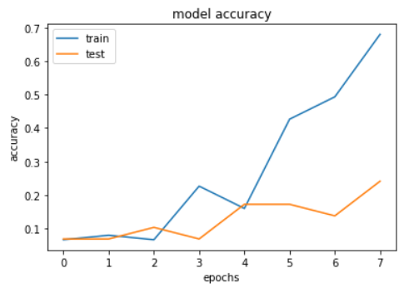Figure 2

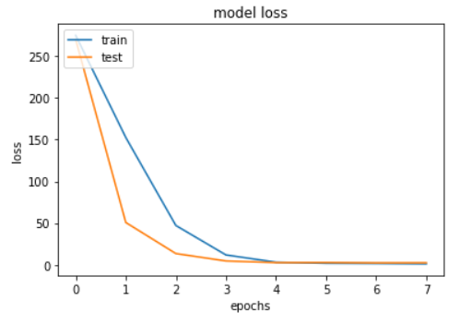

Figure 3

Performance of the baseline model is shown as a visualization. The above visualization represents the trend of the accuracy and loss after each epoch. The trend in accuracy seems to be promising with a steady increase. A steady decrease in the loss of train and test dataset is a positive sign.

*4.Augmentation Model*

A convolutional neural network (CNN) architecture with augmented images is one that is intended to learn from a larger and more varied dataset by producing augmented images.  Enhanced pictures can also be used to avoid the overfitting phenomena, which occurs when a model gets highly specialized to its training data and performs poorly on new, unknown data. Overall, the model's usefulness and ability to generalize can be improved by include augmented photos in the training process.

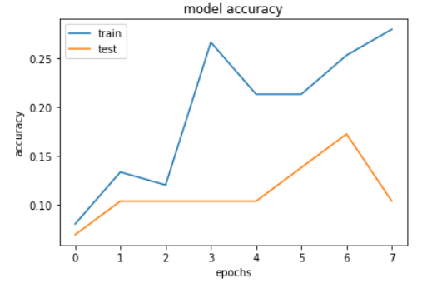

Figure 4

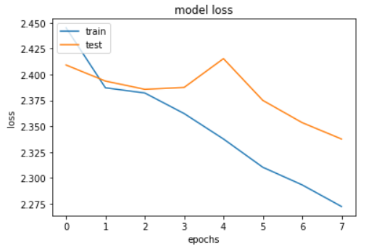

Figure 5

Performance of the augmented model is shown as a visualization. The above visualization represents the trend of the accuracy and loss after each epoch. The trend in accuracy does not seem to be promising. A steady decrease in the loss of train and test dataset is a positive.

*5.Model with increased filters*

A CNN model may perform better if it has more filters since it will be able to learn more intricate and abstract features from the input data. However, adding more filters also adds more parameters to the model, which, if improperly regularized, might result in overfitting. To prevent overfitting, it's crucial to find a balance between the quantity of filters and the model's generalizability.

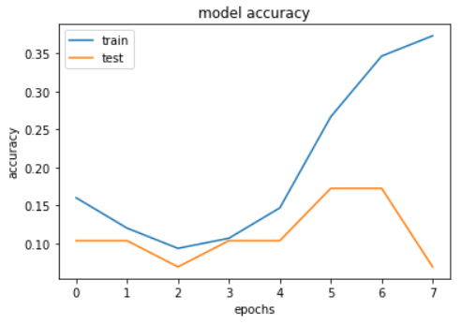

Figure 6

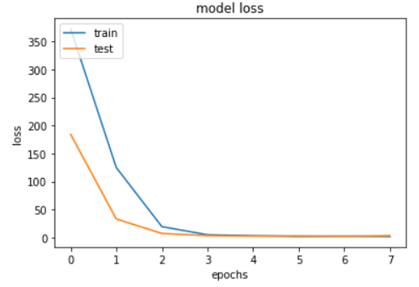

Figure 7

Performance of the model with increased filter is shown as a visualization. The above visualization represents the trend of the accuracy and loss after each epoch. A steady decrease in the loss of train and test dataset is a positive sign.

*6.Dropout Model*

A well-liked regularization method in deep learning to avoid overfitting is the dropout model. During training, certain neurons in a neural network are randomly removed (i.e., set to zero), which forces the remaining neurons to take up the slack and grow more resilient. This helps the model generalize to new data more effectively and makes it less sensitive to the precise weights of individual neurons.

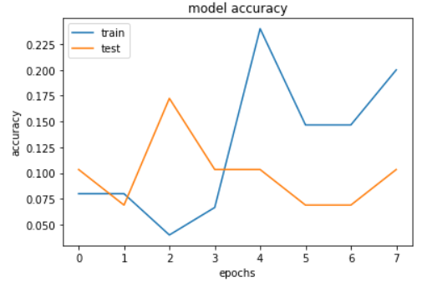

Figure 8

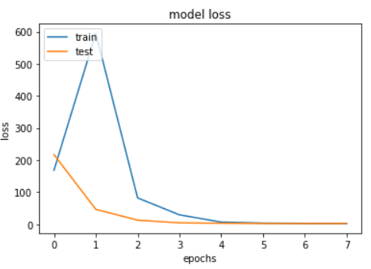

Figure 9

Performance of the dropout model is shown as a visualization. The above visualization represents the trend of the accuracy and loss after each epoch. The trend in accuracy does not seem to be so promising. A steady decrease in the loss of train and test dataset is a positive.

*7.Padding*

Padding allows the filters to slide over the whole input while maintaining the input's original spatial dimensions by adding extra rows and columns of zeros to the input data's edges. Without padding, the size of the output feature map will be smaller than the input, which will result in information loss at the edges.

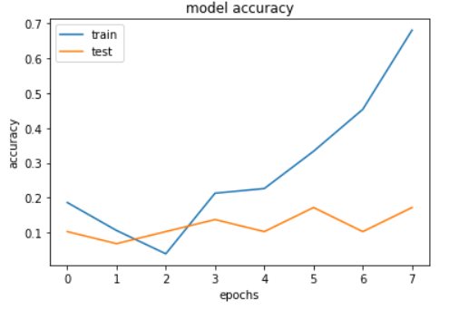

Figure 10

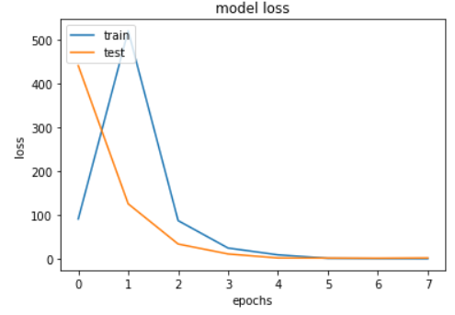

Figure 11

Performance of the augmented model is shown as a visualization.The trend in accuracy does not seem to be promising. A steady decrease in the loss of train and test dataset is a positive.

*8.Prediction and Post-Preprocessing*

The image is passed to the predict() method and the prediction result is stored in result. There is a defined Python dictionary named class labels that associates a distinct integer label with each soil type. The soil kinds' names are used as the dictionary's keys, and their corresponding integer labels are used as the dictionary's values.

Table 1

|  |  |
| --- | --- |
| **Class Label** | **Key** |
| Clay Loam | 0 |
| Clay Soil | 1 |
| Loam | 2 |
| Loamy Sand | 3 |
| Peat | 4 |
| Sandy Clay Loam | 5 |
| Sandy Clay | 6 |
| Sandy Loam | 7 |
| Silt Loam | 8 |
| Silty Clay Loam | 9 |
| Silty Clay Soil | 10 |
| Sand | 11 |

To interpret the output of the model and extract meaningful predictions additional post-processing steps are performed.

# CONCLUSION

*1.Significance of the Results*

1. The outcomes of soil texture analysis using CNNs can be used to create more accurate soil maps, which can be useful for planning land use, conserving soil, and managing the environment.
2. For soil management and conservation, a precise measurement of soil texture is essential. Water infiltration, nutrient availability, and root development are all influenced by soil texture, and these factors can have an effect on crop output and plant growth. To make wise decisions about soil management techniques like irrigation and fertilization, reliable information about soil texture is essential.
3. Compared to conventional techniques, using CNNs for soil texture analysis can yield more precise and thorough results. Large data sets may be swiftly and reliably analysed by CNNs, enabling more thorough soil investigation and a better knowledge of soil properties.

*2. Comparison of Models*

We can conclude the following things:

1. The baseline model has the best accuracy on the training set (52%), but overfits the data because its accuracy on the validation set (24%) is much lower.
2. With an accuracy of only 28% on the training set and 10% on the validation set, the augment model performs worse than the baseline model on both sets of data.
3. With an accuracy of only 20% on the training set and 10% on the validation set, the dropout model similarly performs badly.
4. With accuracy of 68% on the training set and 17% on the validation set, the padding model performs reasonably well, indicating that information preservation during convolution can enhance model performance.
5. With an accuracy of 37% on the training set and 6.9% on the validation set, the model with additional filters outperforms the augment and dropout models but falls short of the baseline and padding models.

Overall, these findings imply that padding, which preserves information during convolution, can enhance model performance, whereas data augmentation and dropout may not be as efficient for this particular task.

*3.Model Improvement*

Here are a few potential ways about how to make this model better:

1. Increase the number of epochs: Because the model was trained over a shorter period of time (8 epochs), it might not be able to fully capture the patterns in the data. By increasing the number of epochs and tracking the validation performance, the model's accuracy may be improved.Adjust hyperparameters: The performance of a model can be greatly impacted by hyperparameters like learning rate, batch size, and optimizer. Finding the ideal hyperparameters for the model can be accomplished by experimenting with various combinations of hyperparameters and tracking the validation results.
2. Attempt various architectures: The present model employs a dense layer after a single layer of convolutional filters. Better performance might result from experimenting with other topologies, such as utilizing a different kind of neural network architecture or including more convolutional layers.

*4.Scope*

The potential for employing CNNs to analyse soil texture is vast, and it offers a fantastic way to advance our knowledge of soil characteristics and how they affect environmental sustainability and agricultural productivity. The area where it can be employed are as follows

1. The analysis of soil moisture content is one use for CNNs. Accurate soil moisture assessment is crucial for irrigation management and agricultural yield optimisation since soil moisture is a crucial component that affects plant growth and nutrient uptake.
2. Analysis of the amount of soil organic matter (SOM). Accurate SOM assessment is crucial for managing and conserving soil since SOM is a key indication of soil production and fertility which can be forecasted using CNNs.
3. Finally, CNNs can be used to analyze soil compaction and erosion, two significant challenges to the productivity and health of the soil. CNNs can be used to analyze data from remote sensing and soil penetrometers to create models that forecast soil compaction and erosion.

Our model’s scope mainly focuses on analysis of several types of soil texture.

*5.Limitations*

Convolutional neural networks (CNNs) for soil texture analysis have a number of limitations despite their excellent performance in a variety of image and video processing tasks, including

1. Lack of high-quality labeled datasets is one of the major obstacles to employing CNNs for soil texture research. For soil texture research, obtaining the quantity of labeled data needed for CNN training can be time-consuming and expensive. Furthermore, soil texture can fluctuate significantly between various geographical regions and soil types, making it difficult to generate a dataset that is inclusive of all potential variances.
2. While CNNs can achieve excellent accuracy for specialized tasks when employed alone, they might not be able to capture the complexity of soil texture analysis. To get over this restriction, CNNs could be combined with other methods like hyperspectral imaging and particle size analysis.
3. Furthermore, CNNs' interpretability is frequently constrained, making it challenging to comprehend how they make their predictions. This can be a difficulty when analysing soil texture because it's crucial to comprehend the underlying processes and elements that affect soil texture.

It will take interdisciplinary cooperation and the creation of fresh methods and strategies for soil texture analysis to overcome these constraints.

*6.Future Works*

High-resolution information regarding soil characteristics can be found in remote sensing data, including hyperspectral and LiDAR data, which can be utilized to increase the precision of soil texture models. Finally, combining the measurement of soil texture with data on other soil characteristics, such as pH and soil organic matter, may help us gain a more complete knowledge of the fertility and health of our soil. This could be accomplished by creating multi-dimensional soil maps, which compile information from many sources to give a comprehensive understanding of soil characteristics.

##### References

[1].Lanjewar, Madhusudan G., and O. L. Gurav. "Convolutional Neural Networks based classifications of soil images." *Multimedia Tools and Applications* 81.7 (2022): 10313-10336.

[2].Beucher, Amélie, et al. "Interpretation of convolutional neural networks for acid sulfate soil classification." *Frontiers in Environmental Science* (2022): 679.

[3].Tegegne, Asnakew Mulualem. "Applications of convolutional neural network for classification of land cover and groundwater potentiality zones." *Journal of Engineering* 2022 (2022): 1-8.

[4].Muksin, U., et al. "Neural network-based classification of rock properties and seismic vulnerability." *Global Journal of Environmental Science and Management* 9.1 (2023): 15-30

[5].Sunori, Sandeep Kumar, et al. "Design of ANN Based Classifiers for Soil Fertility of Uttarakhand." *2022 3rd International Conference for Emerging Technology (INCET)*. IEEE, 2022.

[6].Azmin, Siti Nor Fatin Liyana Mohd, and Nureize Arbaiy. "Soil Classification based on Machine Learning for Crop Suggestion." *Journal of Soft Computing and Data Mining* 3.2 (2022): 79-91.

[7].Martinelli, Gaëtan, and Marc‐Olivier Gasser. "Machine learning models for predicting soil particle size fractions from routine soil analyses in Quebec." *Soil Science Society of America Journal* 86.6 (2022): 1509-1522.

[8].Motwani, Aditya, et al. "Soil Analysis and Crop Recommendation using Machine Learning." *2022 International Conference for Advancement in Technology (ICONAT)*. IEEE, 2022.