Revolutionizing Tax Compliance: Scrutiny of ITRs using Advanced AI-driven Tools
Dr. Reshma Banu¹, Mahanthesh H R², Gowtham J V³, Mohith B N⁴, Nadir durrani⁵
Professor, Department of Computer Science and Engineering 1
B.E Students, Department of Computer Science and Engineering2,3,4,5
Vidya Vikas Institute of Engineering and Technology, Mysore, India
Abstract: Scrutiny of ITRs using Advanced AI Tools" refers to the process of examining Income Tax Returns (ITRs) submitted by taxpayers with the aid of sophisticated Artificial Intelligence (AI) technology. The traditional method of manual scrutiny involves human tax officers manually checking and verifying the information provided in tax returns. However, with the advent of advanced AI tools, this process has been significantly enhanced and automated. The process starts with taxpayers filing their ITRs as usual. Once the returns are submitted, the AI-driven software takes over. The AI program is specially designed and self-automated, which means it can perform various tasks without direct human intervention.
Keywords: Scrutiny, ITRs, Advanced AI Tools, Taxpayers, Manual scrutiny, AI-driven software, Automation, Tax officers, Self-automated, Human intervention, Sophisticated technology.
Overview

"It Returns" is a term commonly used to refer to the process of filing income tax returns in India. Filing income tax returns is a fundamental requirement in most countries with an income tax system to ensure compliance and the collection of necessary tax revenue.
The process of scrutinizing Income Tax Returns (ITRs) has taken a transformative turn with the adoption of Advanced Artificial Intelligence (AI) Tools. In light of an increased emphasis on strict scrutiny and accuracy, tax authorities have introduced specially designed, self-automated, and modified AI software programs to analyze filed ITRs. This cutting-edge technology aims to enhance tax assessment efficiency while ensuring compliance and fairness.
The AI-powered ITR scrutiny process begins with the collection of data linked to the taxpayer's PAN card, followed by automatic cross-referencing with the Aadhar card. Subsequently, the AI system meticulously examines transactions associated with the linked Aadhar and PAN, meticulously evaluating bank accounts, fixed deposits, share dividends, mutual funds, shares, and various other financial instruments declared in the ITR. Moreover, it investigates undisclosed bank accounts, joint accounts, postal accounts, cooperative banks, and investments made with non-registered ITR filers. The AI program doesn't stop at financial data but extends its scrutiny to include government registry office records to identify any land and immovable property transactions in recent years. Additionally, it analyses debit and credit card transactions, passport and visa details, and even records related to the purchase or sale of vehicles. By effectively comparing the taxpayer's furnished data with TDS records and other relevant sources, the AI-ITR program calculates both declared and undeclared income obligations. In cases where discrepancies are identified, the program automatically generates tax demands under Section 143(i) of the Income Tax Act. The implementation of this full-proof AI-ITR program signifies a milestone in tax administration, promising swift processing of ITRs. However, the complexity of its analyses might lead to a slight delay in the income tax processing timeline, with ITRs expected to be processed later than usual, primarily in the last week of July or the first week of August. The amalgamation of advanced AI tools with tax scrutiny procedures marks a paradigm shift in tax assessment, ensuring more precise and thorough evaluations while easing the burden on human resources. As this AI-driven system evolves and refines over time, taxpayers can anticipate a more efficient, transparent, and equitable tax compliance landscape.

Literature review:
Income tax was introduced in India by Sir James Wilson, the then British Finance Minister, in 1860. It was initially a tax levied on individuals, but later expanded to include companies as well. After the introduction of income tax, it underwent several modifications over the years. It gained prominence during the British colonial rule and was one of the major sources of revenue for the colonial government. After India gained independence in 1947, the responsibility for taxation shifted to the Indian government. The Income Tax Act of 1961 became the foundational legislation for income tax matters in India, replacing the earlier 1922 Act. In recent years, the Indian government has made efforts to digitize the tax filing process, making it easier and more accessible for taxpayers. Online filing and e-filing of returns have been introduced to simplify the process. The concept of TDS was introduced to ensure a regular inflow of taxes to the government. Employers and other entities deduct a portion of an individual's income at the time of payment, and this deducted amount is remitted to the government on the taxpayer's behalf.
Evolutions of filing of IT returns:

1.Manual processing of IT returns (Era:1980s to early 2000):

Before the widespread adoption of technology and computerization, income tax refunds in India were processed manually. Manual processing involved physical handling of tax returns and related documents by tax officials. Here's how the manual processing of income tax refunds worked.
  - Paper-based Tax Returns: Taxpayers were required to file their income tax returns on paper. They had to fill out the relevant forms, provide details of their income, deductions, and tax liability, and attach supporting documents.
1.1.1. Submission of Tax Returns: Taxpayers submitted their completed tax returns and supporting documents to their respective income tax offices or designated collection centres.
1.1.2. Verification and Assessment: Tax officials manually verified the information provided in the tax returns and cross-checked it with the supporting documents. This process involved considerable paperwork and could be time-consuming, especially during the peak tax-filing season.
1.1.3. Calculation of Refunds: If a taxpayer was eligible for a refund, tax officials calculated the refund amount manually. This was based on the excess tax paid by the taxpayer, considering deductions, exemptions, and credits.
1.1.4. Refund Issuance: Once the assessment was complete, and it was confirmed that the taxpayer was entitled to a refund, a physical refund check was generated. The check was then sent to the taxpayer's mailing address through the postal system.
1.1.5. Processing Time: Manual processing of income tax refunds was generally slower compared to the automated systems used today. It often took several weeks or even months for taxpayers to receive their refunds.
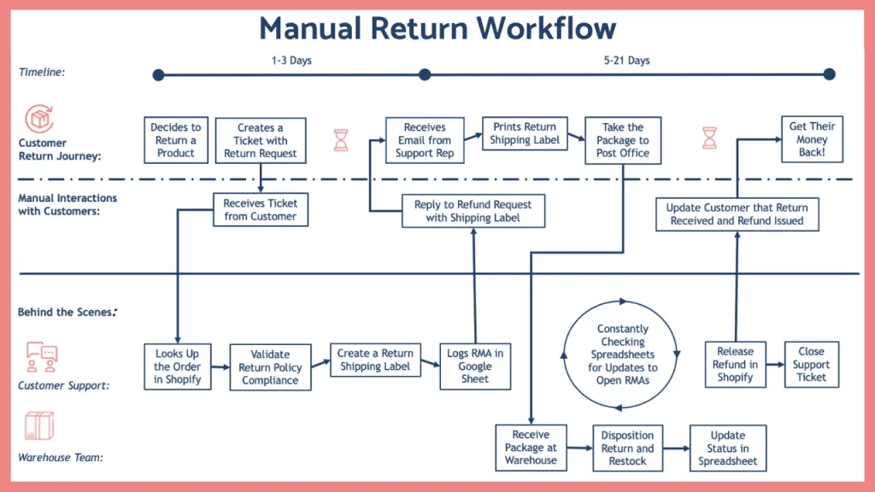
Fig 1. Manual return workflow

Manual processing had several limitations, including the potential for errors, longer processing times, and the need for physical storage of large volumes of paperwork advancements in technology and the implementation of electronic filing systems, the Income Tax Department in India gradually shifted towards a more efficient and streamlined process for income tax return filing and refund processing.
Challenges: 1. Human Error: Manual data entry and calculations can lead to errors in recording income, deductions, and credits, resulting in inaccurate tax assessments and potential disputes.
2.Time-Consuming: Manual processing of large volumes of paper-based returns can be time-consuming, leading to delays in tax refunds and processing times.
3.Resource-Intensive: Manual processing requires a significant workforce to handle data entry, verification, and validation, which can increase administrative costs for tax authorities.
4.Data Entry and Transcription Mistakes: Manual data entry can lead to transcription errors, where information from paper forms is incorrectly recorded into the system.
5.Limited Data Analysis: Manual processing may lack sophisticated data analysis capabilities, making it challenging to identify patterns or trends in tax compliance.
6.Handling of Exceptions: Special tax cases or complex returns may be challenging to process manually, leading to delays or inconsistencies in handling exceptions.
7.Storage and Retrieval Challenges: Manual processing generates a large volume of paper documents, making storage, retrieval, and archiving cumbersome and susceptible to loss or damage.
8.Higher Error Correction Time: Rectifying errors in manually processed returns can be time-consuming, leading to extended resolution times for taxpayers.
9.Reduced Taxpayer Convenience: Taxpayers may face geographical constraints or physical barriers in submitting paper returns, impacting compliance rates.
10.Limited Real-Time Insights: Manual processing may not provide real-time insights into the tax collection process, making it difficult for tax authorities to promptly respond to emerging issues.
11.Data Security Risks: Paper-based systems are more vulnerable to data breaches or unauthorized access compared to secure electronic systems.
12.Scalability Issues: Manual processing may struggle to handle sudden surges in the volume of returns during peak tax filing periods.
To address these limitations, many tax authorities have shifted towards electronic filing and automated processing systems, which offer advantages like increased accuracy, faster processing times, better data analysis, and enhanced taxpayer convenience. Electronic systems also allow tax authorities to implement security measures and safeguards to protect taxpayer data effectively.

1.2. Computerization and electronic filing (Era: early 2000 to present)
Computerization and electronic filing (e-filing) have been significant advancements in the income tax system in India. They have revolutionized the way taxpayers interact with the tax authorities, making the process more efficient, convenient, and transparent. Here's how computerization and electronic filing have impacted income tax compliance in India.
1.2.1. E-Filing of Tax Returns: The introduction of electronic filing (e-filing) allowed taxpayers to file their income tax returns online through the Income Tax Department's official website. This eliminated the need for physical paperwork and reduced the reliance on manual processing. E-filing made the process faster, more accurate, and reduced the chances of errors in tax return submission.
1.2.2. 24/7 Accessibility: E-filing allowed taxpayers to submit their returns at any time of the day, irrespective of office hours or holidays. This flexibility made it more convenient for individuals and businesses to comply with tax obligations.

1.2.3. Pre-filled Forms: The Income Tax Department started providing pre-filled tax return forms to taxpayers. These forms were auto-populated with certain information such as salary details, TDS (Tax Deducted at Source) information, and other data available with the tax department. Taxpayers only needed to verify and update the information, simplifying the filing process.
Fig 2: e-filling process

1.2.4. Faster Processing: Electronic filing enabled faster processing of tax returns. The Centralized Processing Centre (CPC) in Bengaluru played a crucial role in this regard The CPC, equipped with advanced technologies, electronically processed tax returns, refunds, and other related tasks, leading to quicker assessments and issuing of refunds.
1.2.5. Reduced Compliance Burden: Computerization and electronic filing simplified tax compliance for both taxpayers and tax authorities.
Overall, computerization and electronic filing have modernized the income tax system in India, improving efficiency, accuracy, and transparency. These technological advancements have made it more convenient for taxpayers to fulfil their tax obligations and for tax authorities to administer and monitor the tax system effectively.
Challenges
1.Technological Barriers: Not all taxpayers may have access to computers or the internet, particularly in rural or less-developed areas, which can hinder their ability to use electronic filing systems.
2.Data Security Concerns: Electronic filing involves the transmission and storage of sensitive taxpayer information, which can be vulnerable to cyberattacks or data breaches if proper security measures are not in place.
3.Digital Divide: The digital divide refers to the gap between those who have access to and can effectively use digital technologies and those who do not. Electronic filing may disproportionately disadvantage certain segments of the population who lack digital literacy or technology access.
4.Dependency on Internet Connectivity: Electronic filing relies on stable internet connectivity, which may be unreliable in some regions, leading to potential difficulties in submitting returns on time.
5.Software Compatibility: Taxpayers may encounter compatibility issues when using different software to file their returns, causing errors or submission problems.
6.System Downtime: Technical glitches or system maintenance may lead to temporary unavailability of electronic filing systems, causing inconvenience to taxpayers during peak filing periods.
7.Data Entry Errors: While electronic filing reduces some human errors, data entry mistakes can still occur, especially if taxpayers input incorrect information.
8.Fraud and Identity Theft: As with any digital process, there is a risk of fraudulent activities and identity theft if appropriate security measures are not in place.
9.Costs and Infrastructure: Developing and maintaining electronic filing systems require significant investment in technology and infrastructure, which may be a burden for some tax authorities, especially in less-developed regions.
10.User Support: Taxpayers may require assistance or guidance when using electronic filing systems, which may require additional resources and support from tax authorities.
While computerization and electronic filing offer compelling benefits, addressing these limitations is essential to ensure inclusive and reliable tax administration. Tax authorities must continuously improve security measures, provide user-friendly interfaces, bridge the digital divide, and offer alternative filing options for taxpayers who may face barriers in using electronic systems. Balancing technological advancements with taxpayer accessibility and security remains a critical challenge for modern tax administrations.

Self-automated and modified Artificial Intelligence software program (AI) for scrutinizing the filed ITRs

The process of scrutinizing Income Tax Returns (ITRs) has taken a transformative turn with the adoption of Advanced Artificial Intelligence (AI) Tools. In light of an increased emphasis on strict scrutiny and accuracy, tax authorities have introduced specially designed, self-automated, and modified AI software programs to analyse filed ITRs. This cutting-edge technology aims to enhance tax assessment efficiency while ensuring compliance and fairness.

Artificial Intelligence
Artificial Intelligence (AI) is an exciting and rapidly advancing field of computer science that aims to create intelligent machines capable of performing tasks that typically require human intelligence. It involves the development of algorithms, models, and systems that enable computers to learn from data, reason, perceive the environment, and make decisions based on the acquired knowledge.
Self-automated and modified Artificial Intelligence software programs refer to AI systems that have the capability to adapt, evolve, and improve their own performance without direct human intervention. These programs can make adjustments to their algorithms, models, or strategies based on new data, feedback, or changing conditions to enhance their efficiency and accuracy.
Key characteristics of self-automated and modified AI software programs may include:
1. Autonomy: The AI system can function independently without constant human supervision, making decisions and improvements on its own.
2. Machine Learning and Adaptability: The AI program is equipped with machine learning algorithms that enable it to learn from data, experience, and interactions, allowing it to evolve over time.
3. Dynamic Algorithm Adjustment: The software can modify its underlying algorithms, parameters, or configurations to optimize its performance based on changing conditions or objectives.
4.Continuous Improvement: The AI system continually seeks to improve its performance through self-optimization, without requiring manual updates from developers.
5.Self-Correction and Error Handling: The program can identify and rectify errors or inaccuracies in its own processes, reducing the need for human intervention.
6.Resource Management: The AI software efficiently allocates resources, such as computational power and memory, to handle varying workloads and tasks effectively.
7.Scalability: The program can scale its operations to handle increasing volumes of data and tasks, adapting to growing demands.
8.Real-time Decision Making: The AI system can make decisions and adjustments in real-time, ensuring quick responses to dynamic situations.
9.Security and Safety Measures: Self-automated AI software should be equipped with safety measures to prevent undesirable outcomes or harmful actions.
It's important to note that fully self-automated and modified AI systems are still in the realm of ongoing research and development. While some elements of autonomy and adaptability exist in certain AI applications, achieving complete autonomy with responsible decision-making remains a challenging task and an active area of exploration for AI researchers and developers.
Problem statements
- "Developing an AI-Driven Income Tax Return System for Improved Efficiency and Accuracy."
Objective:
- To design and implement an AI-driven tax return system that automates the tax filing process.
- Significantly reducing processing time while
- Ensuring high accuracy in tax calculations and return generation.
- "Scalability and Resource Management: Challenges in Implementing AI for High-Volume Tax Filing." –
Objective:
- To optimize the AI system's scalability and resource management to handle high-volume tax filing
- Ensuring efficient processing and quick response times during peak tax seasons.
- "Enhancing Customer Support and Assistance through AI-Powered Chatbots in Tax Filing."
Objective:
- To deploy AI-powered chatbots to provide real-time customer support and assistance, addressing taxpayer queries promptly and enhancing the overall tax filing experience.
- "Detecting and Preventing Tax Fraud with AI in Income Tax Returns." - Objective:
- To implement AI-based fraud detection techniques to identify suspicious patterns and anomalies in tax returns, preventing fraudulent tax filings and improving tax compliance.
Methodology:
The methodology of integrating artificial intelligence (AI) in income tax returns involves a systematic approach to develop and implement AI-driven solutions for tax return processing. Here's a step-by-step methodology for the integration process:
1. Requirement Analysis: - Understand Stakeholder Needs: This involves conducting interviews and consultations with taxpayers, tax professionals, and tax authorities to gather insights into their pain points, challenges, and expectations related to income tax return processing. Understanding their needs is crucial for designing an AI-driven solution that addresses specific requirements. - Define Objectives: Clear and well-defined objectives are essential for guiding the entire integration process. The objectives can include improving tax return accuracy, reducing processing time, enhancing fraud detection capabilities, providing better customer support, and streamlining tax planning and optimization.
2. Data Collection and Integration: - Identify Data Sources: Determine the various sources from which financial data required for tax return processing will be collected. These sources may include digital bank statements, invoices, receipts, financial management tools, and other relevant platforms. - Develop Data Connectivity: Establish connections and integration mechanisms to access and gather data from the identified sources. This may involve setting up data connectors, utilizing APIs provided by financial institutions, or using web scraping techniques to extract data from websites.
3. Data Preprocessing: - Clean and Transform Data: Before feeding the data into AI models, it must undergo preprocessing. This step involves handling missing values by either imputing them or removing rows with missing data. Duplicate entries are removed to avoid bias in the analysis. The data is transformed into a standardized format and normalized to ensure consistent scales for numerical attributes.
4. Machine Learning Model Selection: - Choose Relevant Algorithms: Depending on the specific tasks involved in income tax return processing, relevant machine learning algorithms are chosen. For example, regression algorithms may be used for tax calculations, while classification algorithms are employed for fraud detection. - Model Architecture: The architecture of the selected machine learning model is defined, including the number of layers, nodes in each layer, activation functions, and other parameters.
5. Model Training and Optimization: - Prepare Training Data: Historical tax data, containing past tax returns with labeled outcomes, is used to train the AI model. The data is split into training and testing sets, with the former used for model training and the latter for evaluating model performance. - Model Optimization: The AI model is trained iteratively, with optimization algorithms like backpropagation adjusting the model's internal parameters (weights and biases) to minimize errors in predictions. Hyperparameter tuning is performed to optimize the model's performance.
6. Tax Planning and Fraud Detection: - Develop AI Strategies: AI algorithms are implemented to analyze taxpayer financial data and identify tax planning opportunities. The AI system can simulate various scenarios and recommend tax-saving strategies. Additionally, the system employs anomaly detection techniques to detect potential fraud or irregularities in tax returns.
7. Automated Tax Filing: - Automate Tax Return Generation: The trained AI model is integrated into the tax return system to automate the process of tax return generation. The AI system uses the taxpayer's financial data to compute tax liabilities, deductions, and credits, generating accurate tax returns automatically.
8. Customer Support and Assistance: - Deploy Chatbots or Virtual Assistants: AI-powered chatbots or virtual assistants are deployed to interact with taxpayers and provide real-time support and assistance. These chatbots utilize natural language processing to understand taxpayer queries and provide relevant information promptly.
9. Compliance and Security: - Ensure Legal Compliance: The AI system is designed in collaboration with legal and tax experts to ensure that it complies with tax laws, regulations, and ethical guidelines. The system must adhere to the legal requirements of the jurisdictions it operates in. - Data Privacy and Security: Robust data privacy measures, such as data encryption and access controls, are implemented to protect sensitive taxpayer information from unauthorized access or breaches.
10. Continuous Learning and Monitoring: - Update Model Regularly: The AI model is continuously updated with new data and insights to keep it up-to-date with changing tax laws, taxpayer behavior, and new fraud patterns. Regular updates ensure that the AI system remains accurate and effective over time. - Monitor System Performance: The AI system is continuously monitored to assess its performance, accuracy, and fairness. Regular audits and reviews are conducted to detect and address any issues or biases that may arise.
11. User Testing and Feedback: - Gather User Feedback: The AI-driven tax return system is subjected to user testing, and feedback is collected from taxpayers and tax professionals. This feedback helps identify areas for improvement and enhancement to meet user needs and preferences.
12. Deployment and Integration: - Integrate with Tax Systems: The AI-driven income tax return system is deployed and seamlessly integrated with existing tax infrastructure and platforms. It is thoroughly tested to ensure that it functions smoothly and efficiently.
13. Training and Support: - Provide Training: Training and support are provided to tax professionals and users to familiarize them with the AI-driven tax return process. This training ensures a smooth transition and effective utilization of the AI system.
By following this comprehensive methodology, organizations can successfully integrate artificial intelligence into income tax return processing, leading to improved efficiency, accuracy, and compliance in tax filing and providing enhanced services to taxpayers and tax authorities alike

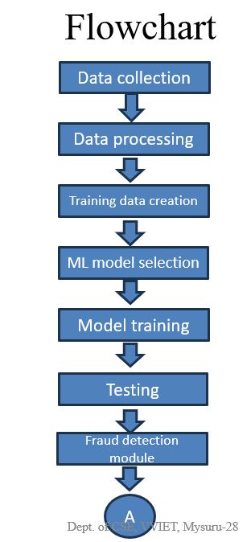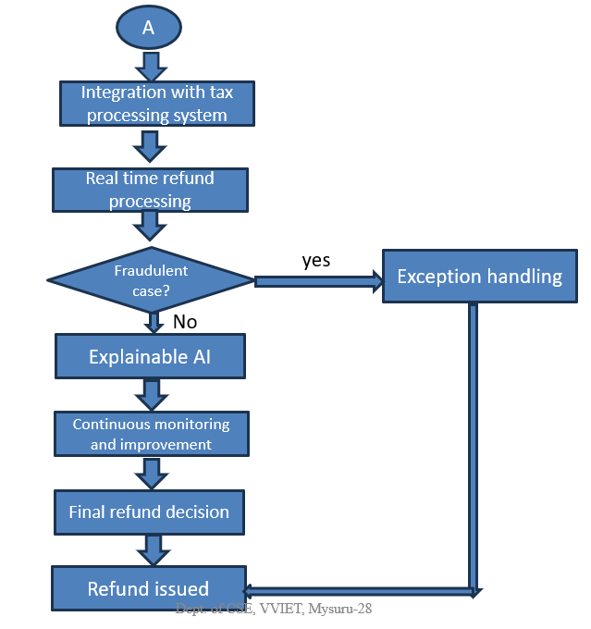
Automating Data Collection and Extraction:
Data Collection and Extraction in artificial intelligence (AI) in income tax refers to the process of automatically gathering relevant financial information from various sources and extracting key details necessary for tax return processing. This step plays a crucial role in automating and streamlining the tax filing process, reducing manual efforts, and improving the accuracy and efficiency of tax return preparation. Here's how Data Collection and Extraction work in AI-driven income tax:
1.Data Sources: AI-powered systems have the capability to access and collect data from multiple sources, including but not limited to: -
1.1.Bank Statements: AI can connect with banking systems and fetch transaction details, account balances, and other financial information directly from the taxpayer's bank account.
1.2. Invoices and Receipts: AI can scan and extract relevant data from invoices and receipts related to expenses, investments, and other financial transactions.
1.3. Digital Records: AI can pull data from various digital records, such as online payment platforms, e-commerce websites, and financial management tools.
2. Data Connectivity: AI systems use a combination of data connectors, Application Programming Interfaces (APIs), and web scraping techniques to access the required data from different sources. APIs allow AI to interact with external systems and pull data securely.
3. Natural Language Processing (NLP): NLP is a key component of data extraction. AI leverages NLP algorithms to interpret unstructured data, such as written or spoken language, to extract relevant financial details accurately.
4. Extracting Key Information: Once the data is collected, AI systems use NLP to identify and extract essential information such as: -
4.1. Income Sources: AI identifies the various sources of income, such as salary, dividends, rental income, etc.
4.2. Expenses: AI categorizes and extracts expenses related to utilities, medical bills, travel, and other deductible expenses.
4.3. Investments: AI identifies investments made by the taxpayer, such as stocks, bonds, mutual funds, etc.
4.4. Deductions and Credits: AI extracts information on eligible deductions and tax credits, such as home mortgage interest, education credits, etc.
5.Data Cleaning and Validation: After the extraction process, AI systems perform data cleaning and validation to ensure the accuracy and reliability of the collected information. This step involves removing duplicates, handling missing data, and verifying the correctness of extracted details.
By automating data collection and extraction, AI significantly reduces the manual effort involved in gathering financial information for tax return preparation. It also minimizes the chances of errors that may occur during manual data entry. The accurate and comprehensive data collected through AI integration contributes to the overall efficiency and accuracy of the tax return process, benefiting both taxpayers and tax authorities.
Advantages
Incorporating Artificial Intelligence (AI) in Income Tax (IT) returns offers numerous advantages that can significantly benefit both taxpayers and tax authorities. Some of the key advantages of using AI in income tax returns are:
- Improved Accuracy: AI-powered systems can process vast amounts of data with high precision, reducing the chances of errors in tax calculations and ensuring accurate tax returns.
- Faster Processing: Automation through AI speeds up the processing of tax returns, leading to quicker refunds for taxpayers and more efficient tax administration during peak filing periods.
- Enhanced Compliance: AI algorithms can help identify potential compliance issues and ensure taxpayers adhere to tax regulations, thereby increasing overall tax compliance rates.
- Personalized Tax Planning: AI can provide personalized tax planning advice to taxpayers based on their financial data, helping them optimize deductions and credits to reduce tax liabilities legally.
- Real-Time Insights: AI-powered dashboards and analytics offer tax authorities real-time insights into tax collection, compliance rates, and taxpayer behavior, enabling data-driven decision-making.
- Fraud Detection: AI algorithms can detect suspicious patterns and anomalies in tax data, aiding in the early detection and prevention of tax fraud and evasion.
- Efficient Auditing: AI can assist tax authorities in identifying high-risk tax returns for auditing, streamlining the auditing process and improving its effectiveness.
- Ease of Use: AI-powered interfaces can offer a user-friendly experience for taxpayers, simplifying the tax filing process and reducing the burden of tax preparation.
- Transparency and Trust: Explainable AI techniques provide clear explanations for tax calculations, promoting transparency and building trust between taxpayers and tax authorities.
- Cost Savings: Automation through AI reduces the need for manual data entry and processing, leading to cost savings for tax authorities and taxpayers alike.
Uniqueness and Novelty:
The application of Artificial Intelligence (AI) in Income Tax (IT) returns introduces uniqueness and novelty to tax administration and processing. AI automates data entry tasks, improving accuracy and compliance by applying complex algorithms to ensure precise tax calculations and adherence to regulations. It offers smart tax planning and predictions based on taxpayers' financial data and historical information, enabling personalized tax-saving strategies. AI-driven automation leads to faster processing times, benefiting taxpayers with quicker refunds and enhancing efficiency for tax authorities during peak seasons. Fraud detection algorithms analyse tax data, identifying anomalies and potential tax evasion cases for investigation. Real-time insights provided by AI-powered dashboards facilitate faster decision-making, and Natural Language Processing (NLP) enables conversational interfaces for taxpayer interactions. Explainable AI techniques offer transparent tax calculations, building trust with taxpayers. AI assesses risk and aids auditing processes, while adaptive learning ensures continuous improvement and relevancy. The uniqueness and novelty of AI revolutionize tax processing, offering personalized experiences and data-driven decision-making for enhanced revenue collection and tax enforcement.
Conclusion:
In conclusion, the research paper highlights the evolution of income tax return filing in India, from manual processing to the adoption of computerization and electronic filing (e-filing). The manual processing of tax returns involved several limitations, including time-consuming paperwork, potential errors, and longer processing times. However, with advancements in technology and the implementation of e-filing systems, the income tax department transitioned towards a more efficient and streamlined process. E-filing brought benefits such as faster processing, reduced compliance burden, and enhanced accessibility for taxpayers. To address the limitations of manual filing and further improve tax return processing, the paper proposes the integration of automated and advanced artificial intelligence (AI) software.
Artificial Intelligence (AI) plays a crucial role in automating data collection and extraction for tax return processing. By automating this process, AI significantly reduces manual effort, minimizes errors, and improves the overall efficiency and accuracy of tax return preparation. The research paper presents a comprehensive methodology for integrating AI into income tax return processing. It includes requirement analysis, data collection, preprocessing, machine learning model selection, training, tax planning, fraud detection, automated tax filing, compliance, security, and continuous monitoring. Following this systematic approach ensures the successful implementation of AI-driven solutions, leading to improved efficiency, accuracy, and compliance in tax filing. Furthermore, the paper addresses specific problem statements related to AI implementation, including developing an AI-driven tax return system, optimizing scalability and resource management, enhancing customer support with AI-powered chatbots, and implementing AI-based fraud detection techniques.
Reference
[1] Monika Arora1* and Hari Parkash Gupta2 The Changing Face of Indian Income Taxpayers in E-Filing Era: An Evaluation SIBM Pune Research Journal, Vol XIV, 1-6, December 2017.
[2]Ankit Rathi1 , Dr. Saurabh Sharma2 , Dr. Gaurav Lodha3 ,Dr. Manoj Srivastava4 A Study on Application of Artificial Intelligence and Machine Learning in Indian Taxation System PSYCHOLOGY AND EDUCATION (2021) 58(2): 1226-1233.
[3]Huang, Z. (2018). Discussion on the Development of Artificial Intelligence in Taxation. American Journal of Industrial and Business Management , 08 (08), 1817-1824.
[3]Wooldridge, M., Endriss, U., Kraus, S., & Lang, J. (2013). Incentive engineering for Boolean games. Artificial Intelligence , 195, 418- 439.
[4]E-Filing of Income Tax Return: A Study on Awareness and Satisfaction Level of Tax Payers in Trichy City K.Saravanan1 Dr.K.MuthuLakshmi2 IJSRD - International Journal for Scientific Research & Development| Vol. 5, Issue 09, 2017 | ISSN (online): 2321-0613
[5]Huang, Z. (2018) Discussion on the Development of Artificial Intelligence in Taxation. American Journal of Industrial and Business Management, 8, 1817-1824. doi:*Manu Nandal and ** Dr. Gulab Singh STUDY ON REVIEW OF LITERATURE ON INCOME TAX IN INDIA http://www.sciencepub.net/researcherRSJ2022;14(6):22-25] ISSN 1553-9865.
[6]Dr. Chanchal Chawla, Dr. Vipin Jain, Anand Joshi And Dr. Vinayak Gupta(2013) A Study Of Satisfaction Level And Awareness Of Tax-Payers Towards E-Filing Of Income Tax Return – With Reference To Moradabad City, International Monthly Refereed Journal Of Research In Management & Technology, Issn – 2320- 0073, Volume Ii, November’13, 60-66
[7]Jyoti Arora, E-Filing Of Income Tax Returns In India – An Overview, Scholarly Research Journal for Humanity Science & English Language, ISSN.2348-3083, FEBMAR, 2016, VOL. 3/14,3434-3442.
[8]Website References: Available at: http://incometax India.gov.in/, (accessed 12 August, 2016).
[9]Sun, T., & Medaglia, R. (2019). Mapping the challenges of Artificial Intelligence in the public sector: Evidence from public healthcare.
[10]Adimasu, N. (2017). Tax awareness and perception of tax payers and PSYCHOLOGY AND EDUCATION (2021) 58(2): 1226-1233 ISSN: 00333077 International Journal of Scientific and Research Publications , 7 (11),
[11]Alqadi, M., & Ismail, S. (2019). Taxation and Economic Growth: Theoretical and Empirical Literature Review
[12]Kalyanakrishnan, S., Panicker, R., Natarajan, S., & Rao, S. (2018). Opportunities and Challenges for Artificial Intelligence in India. AIES 2018Kumar Das, P. (2018). Insightinto Black Money and Tax Evasion Indian Context. JOURNAL OF INTERNATIONAL BUSINESS RESEARCH AND MARKETING ,

