Chapter Title: Pharmacodynamics

Akansha Singh¹, Priyadarshini Soni*¹, Neeru Singh¹, Kulsoom Hamid¹.

1. Faculty of Pharmacy, Swami Vivekanand Subharti University, Meerut, Uttar Pradesh, India.
*Corresponding Author: Priyadarshini Soni, Assistant Professor, Faculty of Pharmacy, Swami Vivekanand Subharti University, Meerut, Uttar Pradesh, India.; +91-8851040274., priyadarshinisoni274@gmail.com

Introduction
"Pharmacodynamics, often referred to as the actions of a drug on the body, encompasses the comprehensive study of the biochemical, physiological, and molecular impacts of drugs. It delves into various aspects such as receptor binding, including receptor sensitivity, post receptor effects, and chemical interactions. By combining pharmacodynamics with pharmacokinetics, which focuses on the body's actions on a drug and the drug's fate within the body, one can gain insight into the intricate relationship between drug dosage and its resulting effects. Essentially, the pharmacological response hinges on the drug's ability to bind to its intended target, and the concentration of the drug at the receptor site plays a crucial role in influencing the drug's overall effect."
The pharmacodynamics of a drug may be influenced by various physiological changes resulting from:
- A disorder or disease
- The aging process
- Interactions with other drugs
Certain disorders can significantly impact pharmacodynamic responses, often due to factors like genetic mutations, thyrotoxicosis, malnutrition, myasthenia gravis, Parkinson's disease, and specific types of insulin-resistant diabetes mellitus.¹ These disorders have the potential to modify receptor binding, affect the levels of binding proteins, or reduce receptor sensitivity. As a consequence, the drug's effectiveness and mode of action can be notably affected in individuals with these conditions.

PRINCIPLES OF DRUG ACTION
Drugs (except gene-based ones) are not contagious for new functions of any system, organ and cell. It just changes the pace of the activity in progress but deep medicinal effects can be expected from this alone as a toxicological effect.
Actions can be broadly categorized as follows:
(i) Stimulation
(ii) Depression
(iii) Irritation
(iv) Replacement
(v) Cytotoxic action
(i) Stimulation
A targeted increase in activity level of specialized cells.
Example - adrenaline stimulates the heart and pilocarpine stimulates the Stimulates salivary glands.
However, overstimulation is common suppression of this function.
Example – high dose Picrotoxin, a central nervous system stimulant, causes seizures followed by coma and respiratory depression Picrotoxin, a central nervous system stimulant, causes seizures Coma and respiratory depression follow.
(ii) Depression
Means selective reduction of activity for specialized cells, e.g., barbiturates depress the central nervous system, quinidine Omeprazole suppresses gastric acid secretion. Certain drugs stimulate cell types but suppress them Others, for example: Acetylcholine stimulates intestinal smooth muscle. But press the cardiac SA node. Therefore, this is not possible with most drugs It is easily classified as a stimulant or depressant.
(iii) Irritation
This is non-selective and often means detrimental effects and used especially in non-specialized cells. (Epithelium, connective tissue). Intense stimulation, inflammation, corrosion, necrosis, morphological damage. It may lead to degradation or loss of functionality.
(iv) Replacement
This means using natural substances. deficiencies of metabolites, hormones, or their congeners; Examples: levodopa for Parkinson's disease, insulin for diabetes, iron in anemia.

(v) Cytotoxic action
selective cytotoxic effect on penetrating parasites and cancer cells weakens them. It has profound effects on host cells and is used to cure/reduce infections and neoplasias. Penicillin, chloroquine, zidovudine, cyclophosphamide, etc.
MECHANISM OF DRUG ACTION
Pharmacodynamic mechanisms is to control the effects of drugs on the human body.² As previously mentioned, drug-receptor binding involves multiple complex chemical interactions. The site on the receptor where the drug binds is called the binding site. The reactivity of the drug and the reactivity of the binding site determine how tightly the two molecules bind to each other. Facilitating the drug-receptor interaction is called the drug's affinity for the binding site on the receptor.
Affinity is based on intrinsic properties of a particular drug-receptor pair and is represented by the dissociation constant (K_{d}). The K_{d} is defined as the drug concentration at which 50% of the available receptors are occupied. When a sufficient number of receptors are occupied on or within a cell, the cumulative effect of receptor occupancy on that cell becomes visible. Thus, we find that the drug-receptor binding relationship is closely related to the dose-response relationship.
There are two major types of dose-response relationships: graded and quantal. The graded dose-response curve (Figure 1) demonstrates the effect (E) of various doses or concentrations (L) of a drug on an individual from which two important parameters can be deduced: potency and efficacy. Potency (EC₅₀) of a drug is defined as the (L) at which the drug elicits 50% of its maximal response. Efficacy (Emax) is the maximal effect of a drug when all available rectors are occupied.
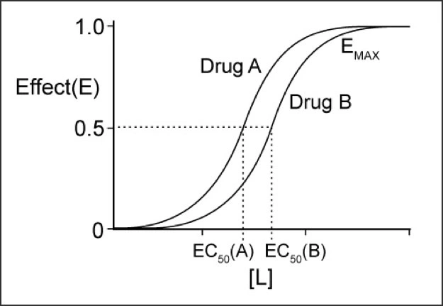
Figure 1. Graded dose-response curves for two drugs
Note that drug A is more effective than drug B. However, in this example, drug A and drug B have the same effect.

A quantitative dose-response curve (Figure 2) shows the mean effect of a drug as a function of drug dose in a population, from which three important parameters can be derived. Efficacy, Toxicity, Lethality. Reactions are classified as either present or absent. The doses that produce these responses in 50% of the population are defined as the median effective dose (ED50), median toxic dose (TD₅₀) and median lethal dose (LD₅₀), respectively.

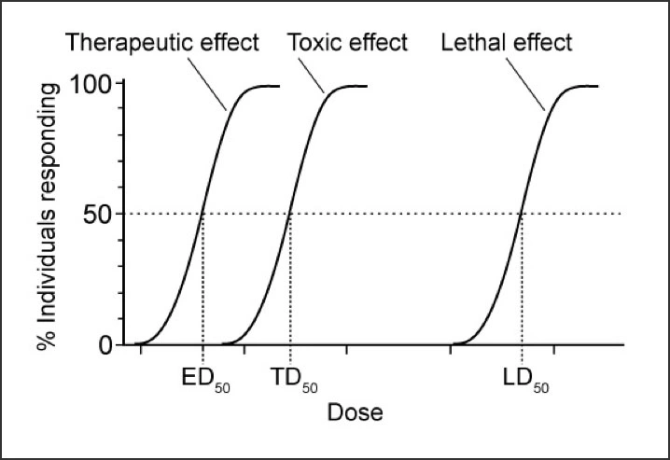
Figure 2 Quantal dose-response curve
Note that ED₅₀ is the dose at which 50% of the subjects respond to the drug, whereas EC₅₀ (see Figure 2) is the dose at which a drug elicits a half-maximal effect in an individual.

The therapeutic window is a range of doses of a drug that elicits a therapeutic response in a population of individuals without unacceptable toxic (adverse) effects. The therapeutic window can be quantified by the therapeutic index (TI): TI = TD₅₀/ED₅₀. A large TI represents a wide therapeutic window, e.g., a hundred-fold difference between TD₅₀ and ED₅₀. A small TI represents a narrow therapeutic window, e.g., a two-fold difference between TD₅₀ and ED₅₀. Drug receptors exist in two conformational states in equilibrium with one another: an active state and an inactive state.³
Majority of drugs produce their effects by interacting with a discrete target biomolecule, which usually is a protein

PROTEIN TARGETS FOR DRUG ACTION
In this chapter, we are learning about proteins that drugs can affect in our bodies. (Figure 3) These proteins can be divided into different groups.
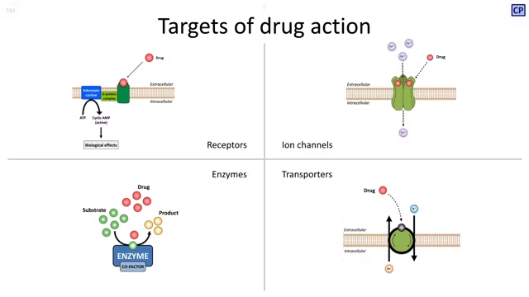

Figure 3. Types of targets for drug action
(A) Receptor; (B) Transmembrane ion channel; (C) Enzyme; (D) Membrane bound transporter. (see text for description)
• receptors
• ion channels
• enzymes
• transporters (carrier molecules)
There are some exceptions, but most significant medications affect one or both of these protein types. For instance, the gout medication colchicine interacts with the structural protein tubulin while a number of immunosuppressive medications, such as ciclosporin, bind to cytosolic proteins called immunophilins.⁴

- RECEPTORS
Receptors are glycoproteins usually located in cell membranes that specifically recognize and bind to ligands. These are smaller molecules (including drugs) that are able to "bind" to the receptor protein. This binding triggers a conformational change in the receptor protein, which leads to a series of intracellular biochemical reactions ("signal transduction"), often involving the formation of "secondary messengers" that ultimately manifest in a biological response (eg, muscle contraction, hormone secretion). Although the ligands of interest to clinicians are exogenous compounds (ie, drugs), human tissue receptors have evolved to bind endogenous ligands such as neurotransmitters, hormones, and growth factors. Drug-receptor complex formation is usually reversible, and the proportion of receptors used (and thus the response) is directly related to drug concentration. Reversibility allows modulation of biological responses and means that similar ligands can compete for access to the receptor. The term "receptor" is usually limited to describing proteins whose sole function is ligand binding, but is sometimes used more broadly in pharmacology to include other types of drug targets, such as voltage-sensitive ion channels, enzymes, and transporter proteins.
Receptor ligands can be distinguished by their ability to initiate a biological response after binding to the receptor:
Agonist: Agonists bind to the receptor protein to produce the conformational change necessary to initiate a signal associated with a biological response. As the concentration of free ligand increases, the proportion of receptors used also increases and thus the biological effect. When all receptors are used, the maximum biological effect is achieved. In many receptor systems, it has been found that full agonists can produce the greatest effect without occupying all available receptors, suggesting the concept of "reserve receptors". The apparent excess of receptors allows full responses to be achieved at lower ligand concentrations than would otherwise be required.
Inverse agonist: It produce the opposite effect of a full agonist when they bind to a receptor. To recognize inverse agonists, the relevant endogenous receptor must show some degree of association with the biological response even in the absence of ligand binding (ie, constitutive activity). Many receptors have constitutive activity.
Antagonist Antagonists bind to the receptor but do not cause the conformational change that triggers intracellular signaling. Occupancy of the receptor by a competitive antagonist prevents the other ligand from binding and thus "antagonizes" the biological response to the agonist. Inhibition caused by antagonists can be overcome by increasing the dose of the agonist. Some antagonists affect the response to an agonist by means other than competition with the receptors and are called non-competitive antagonists. Increasing the agonist dose alone cannot overcome their effects, and thus the maximal response to the agonist (its "efficacy") is reduced.
Partial agonist Partial agonists are able to activate a receptor but cannot produce a maximal signaling effect equivalent to that of a full agonist even when all available receptors are occupied. When mixed with full agonists, partial agonists block receptor sites that could potentially be occupied by the full agonist, which reduces the overall response (i.e., they seem to antagonize the effect of the full agonist). Partial agonists have some advantages as therapeutic agents. Although they are unable to achieve the same maximum effect as the full agonist, they are less likely to produce receptor-mediated adverse effects at the top of their dose–response curve (e.g., the partial opioid receptor agonist buprenorphine does not cause as much respiratory depression as morphine when it is used as an analgesic).
Ligand Any molecule which binds selectively to certain receptors or sites. A term only indicates affinity or ability to bind independently of functional changes: agonists and competitive antagonists are both mediators’ same receiver.⁵⁻⁶
- ION CHANNELS
Proteins acting as ion-selective channels participate in and regulate transmembrane signaling intracellular ionic composition. Some cells, often called excitable cells, are unique in that they can generate electrical signals. Although there are several different types of neurons, including nerve cells, muscle cells, and touch receptors, they all use ion channel receptors to convert chemical or mechanical messages into electrical signals. Like all cells, an excitable cell maintains a different concentration of ions in its cytoplasm than in the extracellular environment. Together, these concentration differences create a small electrical potential across the plasma membrane. Then, when the conditions are right, special channels in the plasma membrane open and allow the rapid movement of ions into or out of the cell, and this movement creates an electrical signal.
Ion channel receptors: They are usually multimeric proteins located in the plasma membrane. Each of these proteins forms a channel or pore that extends from one side of the membrane to the other. These passageways, or ion channels, are able to open and close in response to chemical or mechanical signals. When an ion channel is open, ions move in or out of the cell in single file. Individual ion channels are specific for certain ions, meaning that they usually only let one type of ion through. Both the amino acids lining the channel and the physical width of the channel determine which ions can move from outside to inside the cell and vice versa. Ion channel opening is a transient event. Most ion channels close and go into a resting state within a few milliseconds of opening, making them unresponsive to signals for a short time.
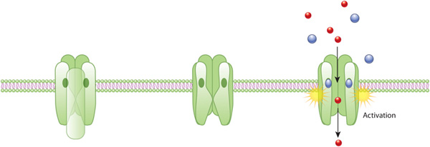

Figure 4. An example of ion channel receptor activation
The acetylcholine receptor (green) forms a closed ion channel in the plasma membrane. This receptor is a membrane protein that is hydro porous, meaning it allows solutes to pass through the plasma membrane when it is open. If there is no external signal, the pore is closed (middle). When acetylcholine molecules (blue) bind to the receptor, it triggers a conformational change that opens the water pore and allows ions (red) to flow into the cell.

Generation of electrical signal: The opening of ion channels changes the charge distribution in the plasma membrane. Remember that the ionic composition of the cytoplasm is quite different from that of the extracellular environment. For example, the concentration of sodium ions in the cytoplasm is much lower than in the external environment of the cell. Conversely, potassium ions are in higher concentrations inside the cell than outside. Such differences create the so-called electrochemical gradient, which is a combination of a chemical gradient and a charge gradient. The opening of ion channels permits the ions on either side of the plasma membrane to flow down this dual gradient. This flow of ions creates an electrical signal.⁷

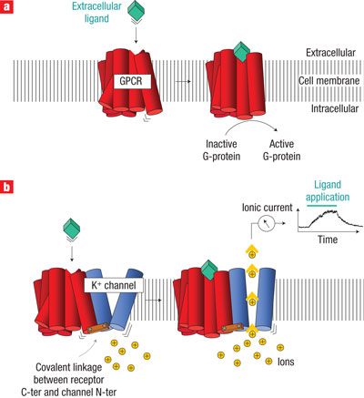

Figure 5: Comparing the activation of an ion channel receptor with that of a G-protein-coupled receptor.
Activation of both a G-protein-coupled receptor (a) and an ion channel receptor (b) cause a conformational change in the receptor protein. G protein activation can lead to multiple intracellular events through a variety of intracellular proteins, and this signaling can take seconds to minutes. When a G protein activates transcription, this can take up to 20 minutes. In contrast, ion channel receptors open pores in the cell membrane, causing the formation of electrical current. This receptor activation therefore causes a much faster response within the cell, on the order of milliseconds.

- ENZYMES
Almost all biological reactions are carried out under the catalytic action of enzymes; therefore, enzymes are a very important target of drug action. Medicines can either increase or decrease the speed of enzyme-mediated reactions. On the other hand, in physiological systems, enzyme activity is often optimally fixed. Thus, the stimulation of enzymes drugs that are really foreign substances
unusual Enzyme stimulation is suitable for some only natural metabolites work, e.g., pyridoxine
cofactor and increases decarboxylase activity. Several enzymes are stimulated by the receptors
and other messengers, e.g., adrenaline stimulates liver glycogen phosphorylase via b receptors and cyclic AMP. Stimulation of an enzyme increases its affinity for the substrate so that rate constant (kM) of the reaction is lowered.

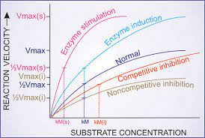
Figure 6. Effect of enzyme induction, stimulation and inhibition on kinetics of enzyme reaction
Vmax—Maximum velocity of reaction; Vmax (s) of stimulated enzyme; Vmax (i)—in presence of noncompetitive inhibitor; kM—rate constant of the reaction; kM (s)—of stimulated enzyme; kM (i)—in presence of competitive inhibitor.

Apparent increase in enzyme activity can also occur by enzyme induction, i.e. synthesis of more
enzyme protein.
Enzyme inhibition: Some chemicals (salts of heavy metals, strong acids and bases, formaldehyde, phenol, etc.) denaturation proteins and non-selectively inhibits all enzymes. They have limited medicinal value external application only. However, selective inhibition of a specific enzyme is common the way of action of the drug. Such blocking is either competitive or non-competitive.
Types of Enzyme Inhibition
- Normal Enzyme Reaction
- In a normal reaction, the substrate binds to the enzyme (through the active site) to form an enzyme-substrate complex.
- The shape and properties of the substrate and active site complement each other, resulting in enzyme-substrate specificity.
- Upon binding, the active site undergoes a conformational change for optimal interaction with the substrate (induced fit).
- This conformational change destabilizes the chemical bonds of the substrate, which lowers the activation energy.
- As a result of the interaction of enzymes, the substrate becomes a product at an accelerated rate.

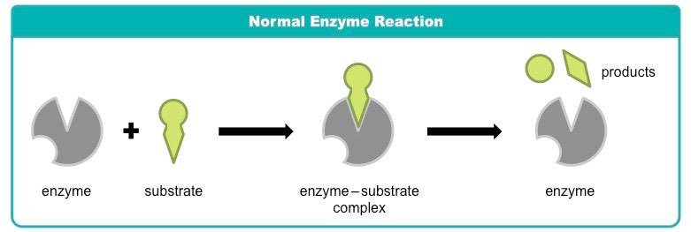
Figure 7. Normal Enzyme Reaction
- Competitive Inhibition
- In competitive inhibition, a molecule other than the substrate binds to the active site of the enzyme.
- The molecule (inhibitor) is structurally and chemically similar to the substrate (and thus can bind to the active site).
- Competitive inhibitors block the active site and prevent substrate binding.
- Since the inhibitor competes with the substrate, increasing the substrate concentration reduces its effect.

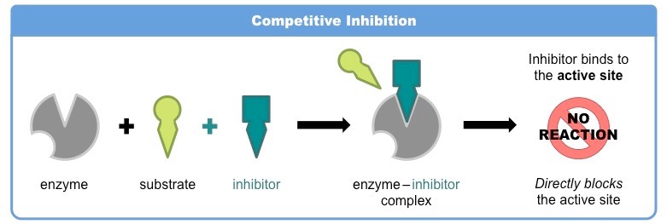
Figure 8. Competitive Inhibition

- Noncompetitive Inhibition
- In non-competitive inhibition, molecules bind to sites other than the active site (allosteric sites).
- Binding of an inhibitor to the allosteric site results in a conformational change in the active site of the enzyme.
- As a result of this change, the active site and substrate no longer share specificity and the substrate cannot bind.
- Since the inhibitor does not directly compete with the substrate, increasing the amount of substrate cannot reduce the effectiveness of the inhibitor.⁸

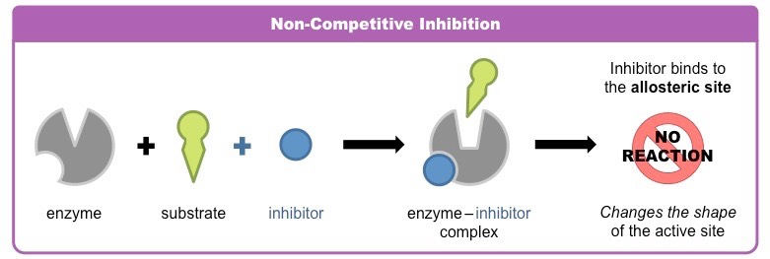
Figure 9. Noncompetitive Inhibition

- TRANSPORTERS
Some substrates are transported across membranes by binding to specific transporters (carriers). It promotes diffusion in that direction, or concentration gradient or pump Metabolite/ion pair concentration gradient Use of metabolic energy. Many drugs have a direct effect Interaction with solute carrier class (SLC). Transporter proteins that inhibit progression Physiological transport of metabolites/ions.
Examples are:
- Desipramine and cocaine block neurons reuptake of noradrenaline by interaction with Norepinephrine transporter (NET).
- Fluoxetine (and other SSRIs) inhibit neurons Reuptake of 5-HT through interaction with serotonin Transporter (SERT).
- Amphetamines selectively block dopamine Reuptake into brain neurons by dopamine Transporter (DAT).

References

- Currie GM. (2018). Pharmacology, Part 1: Introduction to pharmacology and pharmacodynamics. J Nucl Med Technol 46:81–86. https://pubmed.ncbi.nlm.nih.gov/29599397/
- Baca QJ, Golan DE. Pharmacodynamics. Principles of Pharmacology: The pathophysiologic basis of drug therapy, 4th edition. David E. Golan (Ed). Philadelphia, PA. Wolters Kluwer. 2017. 17-26.
- FDA. Milestones in U.S. Food and Drug Law History. 2018 Feb 01. Accessed March 21, 2019.
- RANG AND DALE’S Pharmacology EIGHTH EDITION, H. P. Rang, et. al., (2014).
- IUPHAR, Pharmacology Education Project in our Clinical Pharmacology and Therapeutics Practice article that was published in the journal's Therapeutic Innovations themed January 2019 issue: https://doi.org/10.1002/cpt.1278 PMID: 30588614.
- Ashcroft, F.M., 2000. Ion Channels and Disease. Academic Press, London. (A useful textbook covering all aspects of ion channel physiology and its relevance to disease, with a lot of pharmacological information for good measure).
- 2008 Nature Publishing Group Moreau, C. J. et al. Coupling ion channels to receptors for biomolecule sensing. Nature Nanotechnology 3, 620-625 (2008) doi:10.1038/nnano.2008.242.
- 2016 The creator of the BioNinja, Cornell, B., The following is a link to a Harvard Referencing Generator for websites: http://harvardgenerator.com).
- Lippincott, Illustrated Reviews: Pharmacology, South Asian Edition.
- Essentials of Medical Pharmacology, K D Tripathi. Seventh Edition: 2013, ISBN: 978-93-5025-937-5.

