Function of diet in inflammatory bowel disease.

Abstract:- The condition of inflammatory bowel disease (IBD) is steadily growing larger in Western as well as in developing countries paralleling the increase of Westernized diets, characterized by high protein and fat as well as high sugar intake, with less vegetables and fiber. A fascinating assumption is that environmental (food-) switched-on changes in the intestinal microbiome might result in pro-inflammatory circumstances preceding the development of IBD. Inflammatory bowel diseases (IBDs) are closely connected to nutrition. The latest research indicates that diet and nutrition are significantly involved in the etiopathogenesis of the disease, although their specific role throughout its clinical course remains unclear. This study reviewed how diet and nutrition are linked with IBD development and management. Even though particular diets have been shown to bring about affirmative outcomes, there is currently no scientific consensus regarding an appropriate diet that would benefit all IBD patients. I suggest only that individualized dietary recommendations are of the greatest significance and that diets should be planned to provide individual IBD patients with particular nutrient requirements while keeping all the clinical facets of the patients in mind.

Keywords: inflammatory bowel disease, Diet, Nutrition.FODMAP.

Introduction:-Inflammatory bowel diseases (IBDs) are distinguished by chronic and relapsing inflammation of different segments in the gastrointestinal tract. The etiology is not yet fully understood and the course of the condition is characterized by duration of exacerbation and remission. A multifactorial etiology has been confirmed. An interaction between environmental factors and gut microbiota in genetically susceptible individuals may cause dysregulation of both innate and adaptive immune responses. The environmental aspects include anxiety, pollution, breastfeeding, smoking, usage of antibiotics, chemical products, and food. Some of these risk factors are potentially reversible, such as smoking, use of antibiotics, and diet. Some studies point to the link between the incidence of IBD with dietary excess or even a deficit of several nutrients. Additionally, dietary constituents are involved in dysbiosis on the intestinal mucosa, which can become lighter and more permeable to pathogens and antigens, leading to a
low-grade, but persistent inflammation. Inflammatory bowel disease is associated with intestinal dysbiosis, which is represented by a generalized alteration in the variousness and abundance of bacterial species.

What is Inflammation?:- In straightforward words, when your body switches on your immune system, it sends out inflammatory cells. These cells raid bacteria or heal injured tissue. If your body sends out inflammatory cells when you are not unwell or injured, you may have chronic inflammation. Inflammation is a symptom of many chronic illnesses, such as arthritis or Alzheimer’s disease. When your body encounters an offending agent (like viruses, bacteria, or toxic chemicals) or suffers damage, it turns on your immune system. Your immune system sends out its first responders to inflammatory cells and cytokines (substances that enable more inflammatory cells) cells begin an inflammatory response to trap bacteria and other offending agents or start healing injured tissue. The consequence can be pain, swelling, bruising or redness. But inflammation also influences body design.

There are two different types of inflammation:-

- Acute inflammation:-
The reaction to sudden body harm, such as cutting your finger. To heal the cut, your body sends inflammatory cells to the injured area. These cells start the healing process. Acute inflammation may cause-
Flushed skin at the place of the wound, Discomfort or tenderness, Swelling, Heat.

- Chronic inflammation:-
Your body continues sending you inflammatory cells even when there is no outside danger. Chronic inflammation symptoms may be more difficult to spot than acute inflammation signs. Symptoms of chronic inflammation can include, Abdominal discomfort, Chest discomfort, Fatigue, (e.g.: systemic lupus)
Fever,(example: tuberculosis) Joint pain, or immobility. (example: rheumatoid arthritis) Mouth sores. (example: HIV disease)
Skin inflammation. (example: psoriasis).
Chronic inflammation is involved in the disease procedure of many situations, including- Alzheimer’s disease, Asthma, Cancer, and Heart illness.
Rheumatoid arthritis and ankylosing spondylitis, type 2 diabetes. I have inflammation in both kinds of intestines.

The most common reasons for chronic inflammation:-
Autoimmune disorders, such as lupus, where your body assaults healthy tissue, Exposure to toxins, like pollution or industrial chemicals. Untreated acute inflammation, such as from a disease or wound, Some lifestyle facets also contribute to inflammation in the body. You may be more likely to develop chronic inflammation if you drink liquor in excessive quantities. Have a high body mass index (BMI) that falls within the ranges for obesity, unless that is a consequence of being very athletic. Work out at your highest intensity too repeatedly, or you don’t exercise sufficiently. Experience chronic anxiety. Smoke. Fast food etc.
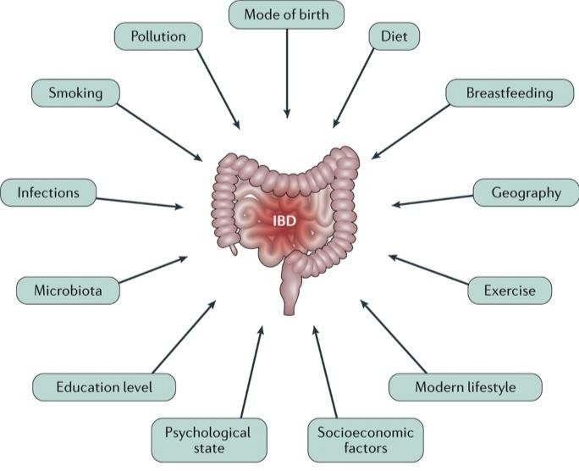

What is inflammatory bowel disease:-

Inflammatory bowel diseases (IBD) are chronic inflammatory diseases involving potentially the whole gastrointestinal tract. Most frequently, the beginning of IBD is during young adulthood, but in 15-20% of patients, the illness starts before their 18th anniversary. Based on clinical, endoscopic, but again immunological, and physical parameters, various phenotypes of IBD can be determined. Usually, the existence of granulomatous lesions and/or the involvement of the tiny bowel with typical ulcerations orientate towards the diagnosis of Crohn's disease (CD), while isolated continuous colonic involvement is in favor of ulcerative colitis (UC). The recent Correction of the Porto criteria for the diagnosis of pediatric IBD provides a helpful tool in the diagnostic workup and classification of children/adolescents with IBD. IBD is defined in two ways as:-

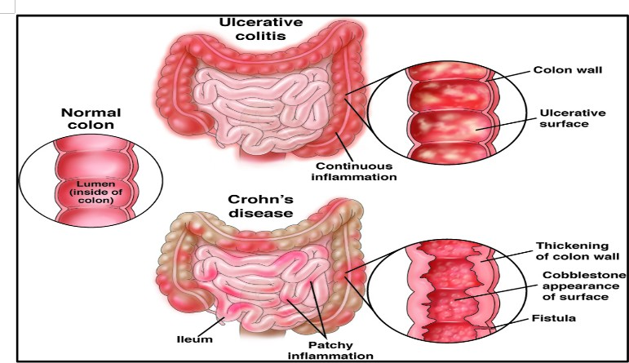

  - Crohn's disease: Crohn's disease is a chronic inflammatory disease of unknown cause that can involve any portion of the digestive tract. Inflammation can develop entirely

through the intestinal wall, often consequently in diarrhea, strictures (narrowing), fistulas (abnormal opening), malabsorption, and the need for surgical resections of portions of the digestive tract.

Symptoms: Crohn's disease can cause abdominal pain, diarrhea, weight loss, anemia, and fatigue. Some people may be symptom-free, most of their lives, while others can have intense chronic symptoms that never go away. Pain in the abdomen, lower abdomen, or rectum. Pain types can be mild or painful. Gastrointestinal, bloating, blood in stool, bowel obstruction, diarrhea, nausea, vomiting, or flatulence.Overall body fatigue, fever, or loss of appetite. Also common are anal fissures, cramping, sadness, burst, mouth ulcer, slower growth, or weight loss.

  - Ulcerative colitis:-Ulcerative colitis is an inflammatory illness of the colon, or large intestine, which is often attended by bloody diarrhea. This inflammation does not go through the whole wall of the intestines and accordingly does not result in fistulas. However, extensive inflammation may ultimately require surgery for the removal of the affected area.

Symptoms:- Symptoms include rectal bleeding, bloody diarrhea, abdominal cramps, and pain.Pain in the abdomen, joints, or rectum. Pain classifications can be intermittent in the abdomen. Gastrointestinal, abdomen bloating, blood in stool, diarrhea, inability to empty bowels, leaking of stool, or urgent need to defecate. Whole-body anemia, fatigue, fever, or loss of appetite are also very common cramping or weight loss.

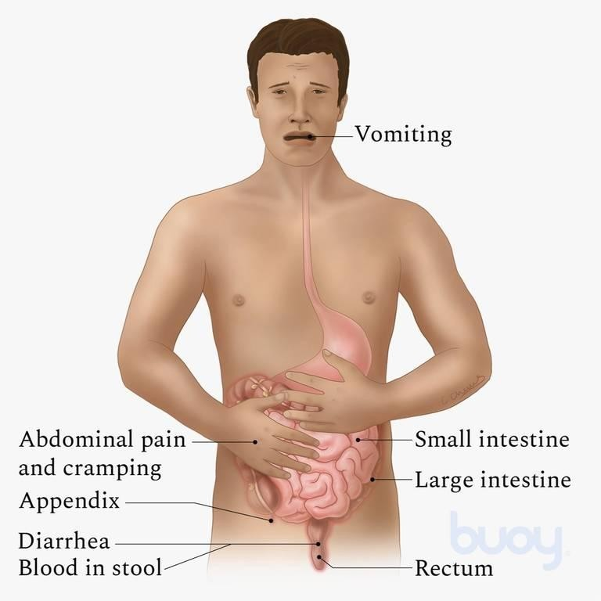

Function of Food/Diet in the Treatment of IBD:-

The finest and most powerful evidence for the potential to treat IBD with a particular nutritional intervention comes from the use of enteral nourishment as induction therapy for Crohn's disease. Initially, enteral nourishment was used as additional nutritional therapy in undernourished adult patients before resection surgery for Crohn's Disease. This nutritional intervention was revealed to be very adequate and to have anti-inflammatory effects, finally making surgery unnecessary in some patients' cases. It rapidly became clear that enteral nourishment, used on an exclusive basis, is a potent anti-inflammatory treatment, greatly efficacious in inducing remission in patients with Crohn'diseasese. However, patients with UC* seem not to respond to exclusive enteral nutrition. Other nutritional interventions are presently discussed and tested since more and more patients are inquisitive about regulating their IBD nutritional interventions rather than using immunosuppressive agents for treatment.

Dietary Management of IBD:-

Information regarding dietary treatments for IBD is usually incoherent. Many people received information telling them to avoid whole food groups or distinct foods. However, there is no need to avoid foods unless they worsen your symptoms. It is best to restrict as many foods as possible to increase the chances that you are getting a balanced, nutritious diet. This is important for maintaining the function of your digestive tract and your overall health specific diet has been shown to prevent or treat IBD. However, some nutritional diet strategies help control Symptoms.

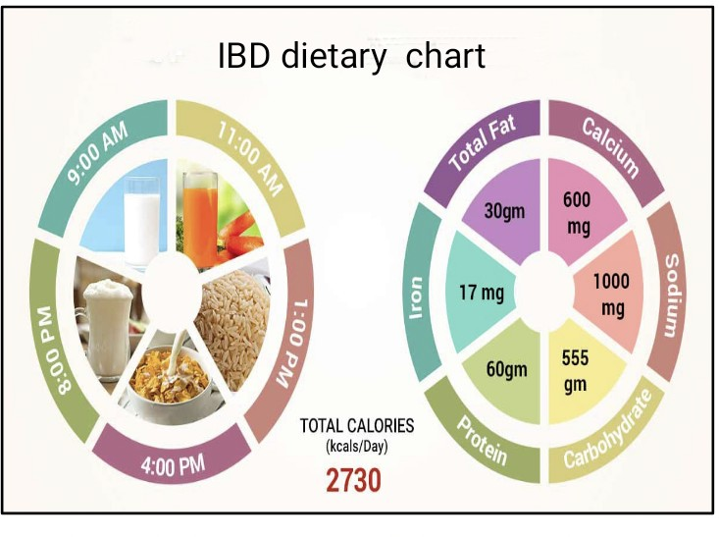

Diet Recommendations for Ulcerative Colitis Flare:-
Follow a low-residue diet to relieve abdominal pain and diarrhea.
Sidestep eats that may increase stool output such as fresh fruits and vegetables, prunes, and caffeinated beverages.
Reduce concentrated sweets in your diet, such as juices, candy, and soda, to help decrease the amounts of water pulled into your intestine, which may contribute to watery stools. Decrease alcohol consumption. Go to combine more omega-3 fatty acids into your diet. These fats may have an anti-inflammatory effect. They are based on fish, including salmon, mackerel, herring, and sardines.
Patients often find that smaller, additional frequent meals are better tolerated. This eating habits pattern can help to increase the mass of nutrition you receive in a day.
Consider grabbing nutritious supplements if appetite is poor and solid foods are not tolerated well.
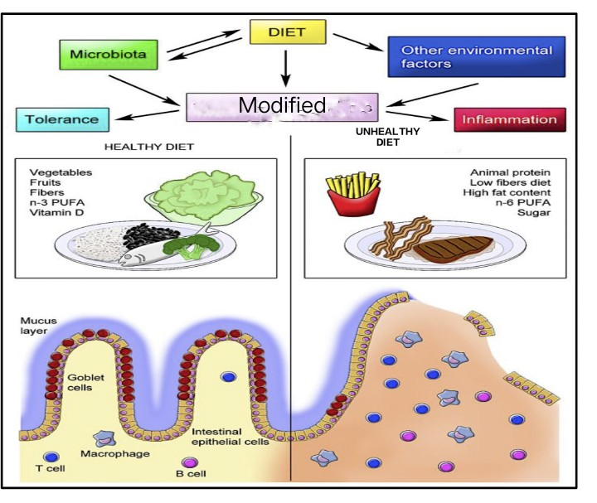

How is simple/chronic inflammation treated?
Simple inflammation does not always require treatment. For acute inflammation, rest, ice, and good wound care, a nourishment diet often relieves the discomfort in a few days.

- Supplements: Certainly vitamins (vitamin A, vitamin C, vitamin D) and supplements (zinc) may diminish inflammation and enhance restoration. For example, your healthcare provider may specify a fish oil supplement or vitamin(s). Or you may use spices with
anti-inflammatory properties, such as turmeric, ginger, garlic, tulsi, and curry leaves.

- Nonsteroidal anti-inflammatory drugs (NSAIDs): These over-the-counter medicines lower inflammation. Your healthcare provider may recommend ibuprofen (Advil®), aspirin (Bayer®), or naproxen (Aleve®).

- Anti-Inflammatory Diet:-The anti-inflammatory diet for IBD (IBD-AID) is derived from the SCD and was developed by a group at the University of Massachusetts Medical School. This diet was proposed for patients who are refractory to pharmacological therapy. The cure was not as useful as needed and its purpose was to obtain and maintain remission with a decreased frequency and stringency of flares.
The IBD consists of five components, The first includes the modification of carbohydrates, such as lactose, and refined or processed to complex carbohydrates. The second incorporates the ingestion of prebiotics and probiotics. The third modifies dietary fatty acids. The fourth detects the all-around dietary pattern and missing nutrients and identifies intolerances, and the fifth element modifies the food texture according to phase four. Beginning with soft or pureed foods if in active flare, or based on the symptoms reported. Patients usually progressed to an additional whole-food diet according to the modification of their symptoms. You may choose to follow an anti-inflammatory diet. Some analysis shows that people who follow a Mediterranean nourishment or diet have lower levels of inflammation in their bodies. The things you eat and drink can also play an important action in inflammation. An anti-inflammatory diet concentrates on fresh fruits and vegetables. Numerous plant-based foods are good sources of antioxidants. Several foods, however, can trigger inflammation for example include foods that people fry in repeatedly heated cooking oil, over cooked food, or refrigerated foods. For an
anti-inflammatory diet, include foods in your diet food that may have anti-inflammatory properties like:-

- Oily fish, such as mackerel, salmon, or sardines.
- Leafy greens like spinach and kale.
- Olive oil.
- Tomatoes.
- Tomatoes.
- Olive oil.
- Leafy green vegetables (spinach, collards).
- Nuts (almonds, walnuts).
- Fatty fish (salmon, tuna, sardines).
- Fruits (berries, oranges).
- Start with a low-fiber or liquid diet until the situation resolves. Avoid identified trigger foods.
- Eat a low-fiber diet. Limiting foods such as seeds/grains, nuts , beans, fruit, and bran.
- Try a low “FODMAP” diet. FODMAP is placed for fermentable, oligo-, di-, monosaccharides and polyols. This variety of diet cuts back on a company of sugars that can be incorrectly absorbed through your gastrointestinal tract. This includes foods containing fructose, lactose, sugar polyols, such as sorbitol and mannitol, fructans, which are base in garlic, leeks, artichokes, and grain, and galacto-oligosaccharides, which are found in lentils, chickpeas, and green peas.

- Drink water to stay hydrated for a long.

The specific carbohydrate diet (SCD) is an exclusion diet composed predominantly of monosaccharides, hard proteins, and fats, with an essential feature of a primarily modified carbohydrate diet excluding complex carbohydrates. An underlying vision is that monosaccharides are soaked up in the proximal small intestine, unlike disaccharides and polysaccharides, which may take off undigested products that stimulate bacterial overgrowth and perpetuate inflammation or inflammatory disease.

4.-Diet you should avoid: Eating too much of certain foods may increase inflammation. If you have chronic inflammation, you may feel better if you avoid what is written below. These specialties can switch on inflammation, so avoid them as much as you can.

- Fried foods, including many fast/junk food items.
- Fixed meats with nitrates, such as hot dogs.
- Highly refined oils and trans fats. Refined carbohydrates, such as sugar, pastries, or white bread.
- Refined carbohydrates (white bread).
- Fried foods (French fries/pakode).
- Sugary drinks (soda/ cold drinks).
- Red and processed meats (beef, hot dogs).
- Margarine, shortening, and lard.

- Prevention:-You may decrease your risk of chronic inflammation by developing a healthy lifestyle to adopt good habits Some of these habits include-

- Achieving and maintaining a healthy body weight.
- Avoiding or quitting smoking.
- Exercising three to five times per week at least (daily exercise is best).
- Limiting your alcohol intake (maximum 2 ounces per day) or no alcohol.
- Managing stress with healthy tools such as meditation, journaling, writing, yoga, traveling, music, etc.

Conclusion:-Your diet does not cause inflammatory bowel disease, or induce a flare. However, modifying your diet/ food intake can manage symptoms during a flare. While several specialized nutrition may assist or help specific patients, no plan has been proven to prevent or fully control inflammatory bowel disease, except for enteral nutrition and diet , which is provided in a
nutrient-rich formula. Obeying a food diary is a great way to manage flare-ups. A dietitian specializing in inflammatory bowel disease may recommend a particular diet based on your signs.

References

  - Jostins L, Ripke S, Weersma RK, Duerr RH, McGovern DP, Hui KY, et al: Host-microbe interactions have shaped the genetic architecture of inflammatory bowel disease. Nature 2012;491:119-124.

  - Nagalingam NA, Lynch SV: Role of the microbiota in inflammatory bowel diseases. Inflamm Bowel Dis 2012;18:968-984.
  - Pfeffer-Gik T, Levine A: Dietary clues to the pathogenesis of Crohn's disease. Dig Dis 2014;32:389-394.
  - Ruemmele FM, Garnier-Lengline H. Transforming growth factor and intestinal inflammation: the role of nutrition. Nestle Nutr Inst Workshop Ser 2013;77:91-98.
  - Amre DK, D'Souza S, Morgan K, et al. Imbalances in dietary consumption of fatty acids, vegetables, and fruits are associated with risk for Crohn's disease in children. Am J Gastroenterol 2007;102:2016-2025.

Dr. Sandhya Assistant professor
Department of Home Science Jananayak Chandrashekhar University, Ballia, Uttar Pradesh.

