Authors:
Dr. Isha Malik, Professor, Pt. BDS PGIMS, Rohtak
Dr.Pawan Kumar, Junior Resident, Pt. BDS PGIMS, Rohtak

Biochemical mechanisms in the Etiopathogenesis of Glaucoma and Role of Vitamin D in disease prevention
Glaucoma
Introduction: Glaucoma is an acquired and progressive optic neuropathy, which can lead to irreversible blindness and no definite causative treatment has yet been identified. Glaucoma is a group of eye conditions that damage the optic nerve, the health of which is vital for good vision. This damage is often caused by an abnormally high pressure in the eye. Some of the main risk factors of glaucoma are advanced age, positive family history, higher cup-to-disc ratio, central corneal thickness and increased intraocular pressure (IOP). The numerous factors which have been reported to influence IOP are systemic blood pressure, time of day, supine position, caffeine, alcohol, nicotine or cannabis consumption, steroid medication, age, genetic background, ethnicity, body mass index and diabetes. Glaucoma involves a progressive loss of retinal ganglion cells and characteristic changes in neuro retinal rim tissue in the optic nerve head which are accompanied by visual field constriction.
Etiopathogenesis:
Glaucoma, a neurodegenerative disease has the characteristic feature of loss of retinal ganglion cells (RGCs). The death of RGCs is initiated when a pathological event, such as ischemia, axonal injury, or changes in the lamina cribrosa lead to activation of apoptosis. Following are the possible biochemical mechanisms responsible for glaucomatous degenerative changes and which may prove to be the new frontier in glaucoma management.
- Glutamate Excitotoxic Hypothesis- The major excitatory amino acids of the central nervous system like glutamate, aspartate and others are implicated in the common final pathway of neural damage. Endothelin-1-induced ischemia of the optic nerve has been found to be associated with a significant elevation in the vitreous concentrations of glutamate, aspartate, and glycine.
The “glutamate excitotoxic hypothesis” was put forward to explain the mechanism of ischemic injury. The lack of oxygen itself is not sufficient to cause damage to ischemic tissue. Instead, the release and receptor binding of glutamate makes the subsequent damage more likely. Glutamate transporters (excitatory amino acid transporter or EAAT) or molecules, which ordinarily regulate extracellular glutamate, have also been implicated in raised levels of glutamate. Failure of these transporters leads to elevated glutamate, which can cause alterations in glutamate receptor expression.
B) Excitotoxic neural degeneration- Excitotoxicity refers to the clinical condition in which amino acids excite the nerve excessively, resulting in neurotoxicity and neuronal death. The synaptic vesicles of nerve terminals contain glutamate. Depolarization of the nerve terminal releases glutamate into the synaptic cleft which generates its effects through specific glutamate receptors. Carriers in neurons and glial cells are responsible for removal of glutamate from the synaptic cleft. This timely glutamate removal from the nerve terminal stops glutamate's effects on neurons. Excessive stimulation of the nerves alters the Ca⁺⁺ homeostasis and leads to excitotoxicity. The mechanism of excitotoxicity includes hypersensitivity of postsynaptic neurons to glutamate, insufficient removal of glutamate or abnormality in glutamate receptors. In hypoxic and ischemic states, large increases in extracellular glutamate and marked depression of glutamate uptake system are found to occur.

C) Oxygen free radicals- Oxygen free radicals (OFRs) have also been implicated in RGC death. OFRs are molecules with one or more unpaired electrons. In brain trauma and ischemia OFRs are formed due to extensive oxidation of proteins and lipid peroxidation. OFRs are responsible for tissue injury during ischemia and in secondary degeneration following reoxygenation (reperfusion) once the ischemic injury has ceased.
Intracellular calcium is also responsible for free radical formation. Increased calcium level on one hand activates phospholipases, leading to arachidonic acid oxidation and free radical formation. On the other hand, it also activates xanthine dehydrogenase to xanthine oxidase, which produces uric acid and superoxide radical. Xanthine oxidase is a rich enzymatic source of free radicals. Increased intracellular calcium and exposure to glutamate also decreases cysteine uptake. Cysteine is a precursor of glutathione, which is important for the removal of free radicals. Free radical accumulation in the cell activates nitric acid synthase which leads to nitric oxide (NO) production. High levels of certain reactive species are formed through generation of hydroxyl radical (because of the Fenton reaction) or peroxynitrite (resulting from the reaction of NO and superoxide anion). In brain trauma and ischemia OFRs are formed due to extensive oxidation of proteins and lipid peroxidation. A dysfunction in the RGCs endogenous superoxide/peroxide scavenging systems has also been found.
D) Nitric oxide synthase-2 (NOS-2)- Elevated hydrostatic pressure induces astrocytes in the optic nerve head to express NOS-2. The excessive NO production, which is associated with NOS-2 may contribute to the neurotoxicity of RGCs in eyes with chronic moderately elevated intraocular pressure. NO is produced in response to activation of the NMDA subtype of glutamate receptor. When glutamate activates NMDA, Ca⁺⁺ channels open and Ca⁺⁺ influx occurs. High levels of intracellular Ca⁺⁺, along with intracellular calmodulin and NADPH stimulate the NOS enzyme to produce NO from arginine. NO is not stored in synaptic vesicles and diffuses out. In the presence of large, toxic levels of glutamate, NOS neurons behave like macrophages releasing large amounts of NO to kill nearby neurons. As a free radical, NO can damage DNA and result in mutations. The DNA strand breaks activate polyadenosine diphosphate(poly-ADP) ribose synthetase (PARS). This enzyme is important for DNA repair, cellular differentiation, transformation, and gene arrangements. With overstimulation of PARS in stroke or metabolic stress, NAD, which is a substrate for PARS is depleted. The destruction of DNA overwhelms its repair, and the neuron dies. Excessive NO, released by reactive astrocytes leads to the formation of peroxynitrite, which damages the axons of the RGCs at the level of the lamina cribrosa.
E) TNF-α- Tumor necrosis factor (TNF-α) is a cytokine produced by glia in human glaucomatous optic nerve head (ONH). The expression of TNF-α and its receptor-1 (TNF-R1) have been studied in glaucomatous ONHs using double labelling fluorescence immunohistochemistry. Normal tissue shows constitutive expression of TNF-R1 in the vasculature of the ONHs but no positive labelling for TNF-alpha. In the glaucomatous ONHs expression of both TNF-alpha and TNF-R1 is upregulated, primarily in glial fibrillary acidic protein (GFAP)-positive astrocytes and appears to parallel the progression of optic nerve degeneration. Astrocytes constitutively express TNF-R1 and TNF-alpha stimulation has been found to induce expression of NOS-2. Thus, TNF-alpha contributes to the progression of optic nerve degeneration in glaucoma by both a direct effect on the axons of the RGCs and by inducing NOS-2 in astrocytes.
F) Neurotrophins- Neurotrophins are molecules essential for neuronal survival, development, function and in experimental models, regeneration of neurons. Initially thought to be derived from the brain, there is evidence of neurotrophin production locally in the retina also. Neurotrophic molecules are found to travel from the lateral geniculate body to the RGCs by retrograde axonal transport. Thus, a normal axonal transport is essential for the health, support and survival of the RGCs. One of the NT molecules, found to have deficient supply to the retina in animal models of glaucoma is brain-derived neurotrophic factor (BDNF) which is an important factor found in the brain and periphery including the kidneys and the prostrate. When the target neurons are deprived of retrograde neurotrophic support, they undergo apoptotic death. The retrograde transport of BDNF is found to be obstructed when IOP is acutely elevated. The loss of BDNF to the RGCs results in NT support deprivation. This results in apoptotic death of the RGCs. Application of exogenous BDNF to the superior colliculus reduces RGC death. In vitro application of NTs, especially BDNF to isolated RGCs prolongs their survival. In vivo RGC survival is also found to be prolonged by intravitreal injection of BDNF in cases of RGC injury.
G) Matrix Metalloproteinases- The regulation and maintenance of aqueous humor outflow is dependent on a constant trabecular meshwork (TM) matrix turnover. This TM matrix turnover is mediated by a family of endopeptidase enzymes known as matrix metallo-proteinases (MMPs). The normal tissue homeostasis requires a balanced interaction between MMPs and tissue inhibitors of MMPs (TIMPs). Normally, the ratio of enzyme to inhibitor is 1:1. A disturbance in this ratio results in excessive or insufficient matrix degradation and matrix accumulation. Decreased aqueous levels of endogenous MMP-2 activity also contribute to the abnormal matrix accumulation in the juxtacanalicular meshwork in patients with Primary open angle glaucoma (POAG). In the TM of patients with POAG there is an accumulation of abnormal extracellular matrix (ECM) in the form of a plaque. This leads to increased outflow resistance and chronic elevation of IOP.

Vitamin D
Vitamin D is a fat-soluble vitamin that is naturally present in few foods and available as a fortified dietary supplement. It is also produced endogenously when ultraviolet (UV) rays from sunlight strike directly on the skin and induce Vitamin D synthesis. Most people in the world meet at least some of their Vitamin D needs through exposure to sunlight. It promotes calcium absorption in the gut and maintains adequate serum calcium and phosphate concentrations to enable normal bone mineralization. Hence, it is also needed for bone growth and bone remodelling by osteoblasts and osteoclasts.
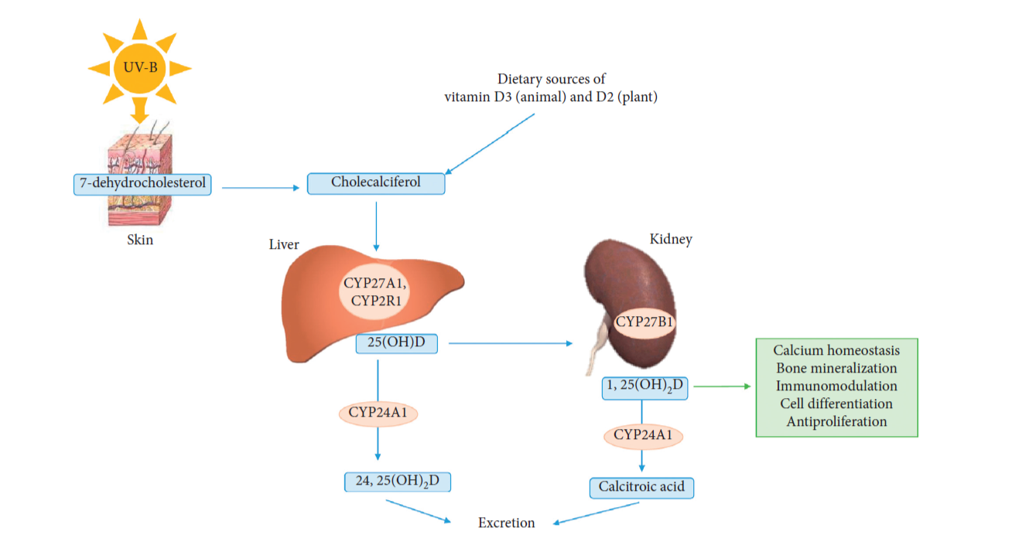
Diagram no 1: - Showing normal Vitamin D metabolism.
Vitamin D can either be produced in the skin from 7-dehydrocholesterol under the influence of UV light, so-called Vitamin D3 (cholecalciferol), or from ergosterol or directly absorbed from the diet as Vitamin D3 and Vitamin D2 (ergocalciferol).
Vitamin D has other roles in the body including reduction of inflammation as well as modulation of processes such as cell growth, immune function and glucose metabolism. Many genes encoding proteins that regulate cell proliferation, differentiation and apoptosis are modulated in part by Vitamin D.
Recently, Vitamin D has become a major area of interest in medical research. Vitamin D is an important secosteroid hormone that plays a role in the signalling pathways related to bone and mineral metabolism, cellular proliferation, immune modulation, and oxidative stress. In general, 25-hydroxyVitamin D (25(OH)D) is considered the most reliable biomarker for assessing an individual’s Vitamin D status. Based on the results of serum 25(OH)D measurements in large, population-based studies, Vitamin D deficiency is associated with neurodegenerative effects on the central nervous system. Several biological experiments have indicated that Vitamin D regulates neuroprotective functions in the central nervous system, including the optic nerve. Moreover, Vitamin D status can affect chronic metabolic diseases, including diabetes, hypertension, and dyslipidaemia, which are considered important metabolic risk factors of elevated IOP and reduced ocular blood flow.

Vitamin D and Glaucoma
The following possible biochemical mechanisms are found to be responsible for glaucomatous degenerative changes in the presence of Vitamin D deficiency,
First, Vitamin D may affect immunomodulation in the pathogenesis of Glaucoma. Recent research has shown that imbalance of the immune system is a major contributor to neurodegenerative injuries on the optic nerve axons and ganglion cell bodies. Since it has been well established that Vitamin D has marked effects on regulating immune cell functions, this effect may play a key role in the protection of the optic nerve.
Second, Vitamin D also regulates important neurotrophic factors in the central nervous system and the plasticity process in neural networks. The research using animal models has found that Vitamin D has the neurotrophic property associated with the synthesis of neurotrophic growth factors and neurotransmitter metabolism. It is possible that this effect may help in the regeneration of the optic nerve after injury.
Third, Vitamin D regulates oxidative stress on neurons by activation of calcium channels. In support of this view, evidence accumulating over two decades has shown that Vitamin D is closely associated with several neurodegenerative or psychiatric diseases such as Alzheimer's disease, Parkinson's disease, depression and schizophrenia. Studies have suggested that the oxidative stress-induced amyloid β-peptide deposition could involve the optic nerve in Glaucoma.
Another possible explanation for the association of lower Vitamin D status with Glaucoma may lie in the mechanism of impaired ocular blood flow. Several studies have shown the influence of Vitamin D on peripheral or micro-vessel circulation. An anti-inflammatory effect of Vitamin D also inhibits endothelial dysfunction from metabolic damage or oxidative stress which is achieved by blocking the activation of T‑helper cells and cytotoxic T cells and reducing the production of inflammatory mediators such as interleukin (IL)‑2, IL‑6, IL‑8 and IL‑12.
Some studies have revealed that Vitamin D regulates the rennin–angiotensin system and improves endothelial cell-dependent vessel vasodilatation. In one animal-based study, it was discussed that suppression of the rennin-angiotensin system can decrease the risk of open angle glaucoma by improving ocular blood flow. Furthermore, Vitamin D status might reflect chronic non-specific illness that could affect systemic circulation. Various research has shown that improving Vitamin D status may have a beneficial effect on the vascular dysregulation leading to local vasospasm.
Oxygen free radicals (OFRs) have also been implicated in RGC death. Normal cellular metabolism constantly produces them. However antioxidant enzymes like superoxide dismutase, catalase and glutathione peroxidise remove them, as also free radical scavengers like glutathione, alpha-tocopherol (vitamin E) and beta-carotene. Vitamin D regulates oxidative stress in neurons by activating calcium channels, an important factor in glaucomatous optic nerve damage. Recent studies have shown that an imbalance of the immune system is a major contributor to neurodegenerative injuries of the optic nerve axons and ganglion cell bodies. Since Vitamin D significantly affects the regulation of immune cell functions, this effect might play a key role in protecting the optic nerve. It is possible that, this effect aids in the regeneration of the optic nerve after injury. Several studies have shown that these diseases can affect the development of glaucoma.

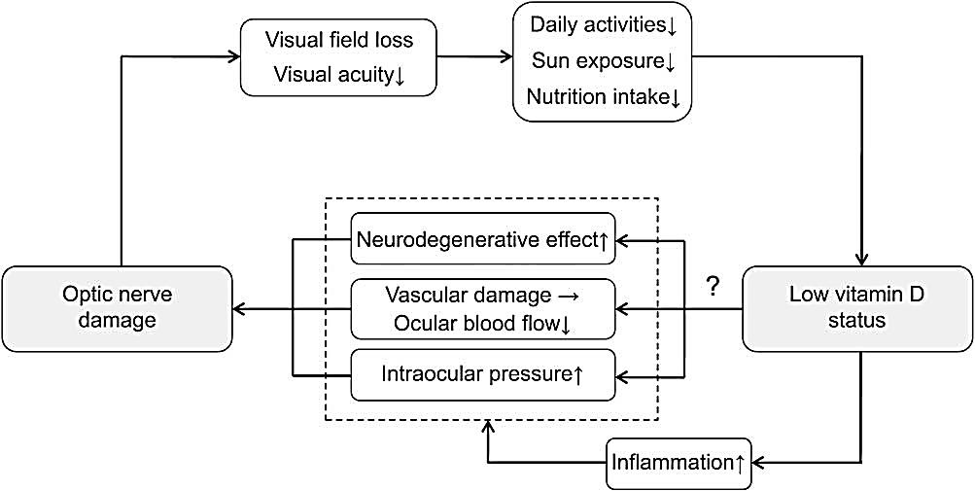
Diagram no 2: - Possible relationship between optic nerve damage and reduced Vitamin D status.
In a study done in South Korean population for Vitamin D association with open-angle glaucoma, it was found that there was a reverse J-shaped association between Vitamin D level and the risk of POAG, with significantly elevated risk at lower level of Vitamin D.
Another similar study concluded that POAG cases had a lower mean serum Vitamin D concentration than controls, as well as a greater prevalence of Vitamin D insufficiency. One cross-sectional study was done to explore the relationship between Vitamin D and glaucoma, which showed that lower level of Vitamin D was significantly associated with an elevated risk of glaucoma in subjects compared with higher Vitamin D level.
Conclusion
The findings of various research showed that lower levels of Vitamin D can be considered as a potential risk factor for the development of Glaucoma. Hence should be estimated routinely in all the suspects of glaucoma, that will help the ophthalmologist for the management and follow-up of patients suffering from glaucoma.
References:
- Quigley HA, Broman AT. The number of people with glaucoma worldwide in 2010 and 2020. Br J Ophthalmol 2006; 90:262-7.
- Ronnie George, Ramesh S V, Lingam Vijaya. Glaucoma in India: estimated burden of disease. J Glaucoma 2010; 19:391-7.
- Coleman AL, Miglior. Risk factors for glaucoma onset and progression. Surv Ophthalmol 2008; 53,3-10.
- Leske MC, Heijl A, Hussein M, et al. Factors for glaucoma progression and the effect of treatment. Archives of Ophthalmology 2003; 121;48-56.
- Hoehn R, Mirshahi A, Hoffmann EM, et al. Distribution of intraocular pressure and its association with ocular features and cardiovascular risk factors. Ophthalmology 2013; 120:961-8.
- Nilforushan N. Neuroprotection in glaucoma. J Ophthalmic Vis Res. 2012; 7:91-3.
- Dreyer EB, Zurakowski D, Schumer RA, Podos SM, Lipton SA. Elevated glutamate levels in the vitreous body of humans and monkeys with glaucoma. Arch Ophthalmol 1996; 114:299-305.
- Kim TW, Kang KB, Choung HK, et al. Elevated glutamate levels in the vitreous body of an in vivo model of optic nerve ischemia. Arch Ophthalmol 2000; 118:533-36.
- Vorwerk CK, Naskar R, Dreyer EB. The excitotoxicity theory of glaucoma 1999; 214:2-11.
- Vorwerk CK, Naskar R, Schuettauf F, et al. Depression of retinal glutamate transporter function leads to elevated intravitreal glutamate levels and ganglion cell death. Invest Ophthalmol 2000; 41:3615-21.
- Ramos-Zúñiga R, Velázquez-Santana H, Mercado-Pimentel R, Cerda-Camacho F. Neuroprotection in selective focal ischemia in rats by nitrates, an alternative redox manipulation on nitric oxide: experimental model. Minim Invasive Neurosurg 1998; 41:152-60.
- Li M, Huang JF, Li Y, Shen J, Yang LJ, Chen Q, Zhang QP, Yi XN. Dynamic changes of inducible nitric oxide synthase expression in rat's retina and its role on blood-retinal barrier injury after acute high intraocular pressure. Int J Ophthalmol 2022; 7:1053-1061.
- Kaur C, Foulds WS, Ling EA. Hypoxia-ischemia and retinal ganglion cell damage. Clin Ophthalmol 2008; 2:879-89.
- Liu B, Neufeld AH. Nitric oxide sytahse-2 in human optic nerve head astrocytes induced by elevated pressure in vitro. Arch Ophthalmol 2001; 119:240-5.
- Yuan L, Neufeld AH. Tumor necrosis factor-alpha: a potentially neuro destructive cytokine produced by glia in the human glaucomatous optic nerve head. Glia 2000; 32:42-50.
- Schlotzer-Schrehardt U, Lommatzsch J, Küchle M et al. Matrix metalloproteinases and their inhibitors in aqueous humor of patients with pseudoexfoliation glaucoma and primary open-angle glaucoma. Invest Ophthalmol Vis Sci 2003; 44:1117-25.
- Kim TM, Kim JM et al. The Relationship between vitamin D and glaucoma: A Kangbuk Samsung health study. Korean J Ophthalmol 2016; 30:426-33.
- Maeda S, Kunii S, Hayashi L. The effect of sun exposure on 25-hydroxy vitamin D concentrations in young healthy subjects living in the city of Sao Paulo, Brazil. Braz J Med Biol Res 2007; 40:1653-9.
- Peterlik M, Cross HS. Vitamin D and calcium deficits predispose for multiple chronic diseases. Eur J Clin Invest 2005; 35:290-304.
- Krishnan AV, Feldman D. Mechanisms of the anti‑cancer and anti‑inflammatory actions of vitamin D. Annu Rev Pharmacol Toxicol 2011; 51:311-36.
- Shoeb Ahmad S, Abdul Ghani S, Hemalata Rajagopal T. Current Concepts in the Biochemical Mechanisms of Glaucomatous Neurodegeneration. J Curr Glaucoma Pract 2013; 7:49-53.
- McKinnon SJ. The cell and molecular biology of glaucoma: common neurodegenerative pathways and relevance to glaucoma. Invest Ophthalmol Vis Sci 2012; 53:2485-7.
- Balion, C, Griffith LE, Strifler L. Vitamin D, cognition, and dementia: a systematic review and meta-analysis. Neurology 2012; 79:1397-1405.
- McKinnon SJ. Glaucoma: ocular Alzheimer's disease. Front Biosci 2003; 8:1140-56.
- Shah GB, Sharma S, Mehta AA. Oculohypotensive effect of angiotensin-converting enzyme inhibitors in acute and chronic models of glaucoma. J Cardiovasc Pharmacol 2000; 36:169-75.
- Yoo TK, Oh E, Hong S. Is vitamin D status associated with open-angle glaucoma? A cross-sectional study from South Korea. Public Health Nutr 2014; 17:833-43.
- Goncalves A, Milea D, Gohier P, Jallet G, Leruez S, Baskaran M, et al. Serum vitamin D status is associated with the presence but not the severity of primary open angle glaucoma. Maturitas 2015; 81:470-4.
- Kim TM, Kim JM. The Relationship between vitamin D and glaucoma: A Kangbuk Samsung health study. Korean J Ophthalmol 2016; 30:426-33.

