GROWTH OF OPEN BANKING IN DIGITILISED ERA
Dr DEVI KRISHNA V
PDF Scholar
University of Kerala

devikerala.krishna@gmail.com
8281806381
ABSTRACT
Open banking is a new and secure product which is used by consumers and small business undertakings for sharing their information, which allows existing and new companies to offer super-fast payment methods and advanced banking products. It is the initial attempt in the field of banking. This paper gives an overview about open banking and describes the growth and future of open banking internationally. The article is an outcome of the descriptive study.It also describes the benefits and security factors provided by the open banking to its users. The study states that open banking helps the customers of bank to share their data securely to third parties so that a wide range of businesses compete each other for providing more choice, lower price, and better financial services to bank customers. Open banking is the optimal path to digitization.
Keywords: Open Banking, Digitization, Consumers, Bank, Business
INTRODUCTION
Open banking was authorised by the competition and Market Authority and the approval was given by Retail Banking Market Investigation Order 2017 (Brodsky & Oakes, 2017). Open Banking is a new initiative intended to increase competition and modernisation in the UK’s banking market. According to CMA’s Retail Banking Market Investigation the small levels of innovations and competitions in banking were important reason that makes the retail banking products expensive and service quality poor (Brodsky & Oakes, 2017) As a result Open Banking was mandated by CMA’s as a remedy to overcome the problems in retail banking products.
Open banking is a process of opening the internal banking informations and processes to external parties through digital networks. In this type of banking customers share their authorized banking data with third parties with the expectation of getting returns through low cost digital products and market expansion , it also assist the banks in extending its core systems to customers and partners . Besides the process of selecting third party partners, open banking can also provide a secure and controlled strategy to help and develop a consumer commitment model in this digital world.
In this digital era every aspect of life is converting into a digital experience. Before the digital era a mail which took days to reach at the destination but know it takes only seconds to reach the recipient through email likewise every aspect of over life such as shopping converting into online shopping and also now we are at the stage where the cars drive themselves. So in this digital world every thing is easier,better and faster.In this digital era one of the important requirement of any individual is the ability to access,share and edit the digital data easily and fast
Every body is using digital data for fulfilling their needs such as paying utility bill,shopping,transferring money with the help of mobile app and websites.But in case of financial transations one will face a lot of problems if there is no third parties such as Paypal,skrill,Ali pay (Brodsky & Oakes, 2017)This happens because every banks are build with a legacy system and they do not even think of supporting online transactions.This problem is overcome to a large extent by the emergence of credit cards and debit cards such as Master card ,VISA,American Express and banks itself bulid their own online transaction systems to bridge the gap,beyond all these systems we can do a lot that can ease the process of financial transactions that is where the importance of Open Banking comes into.Open banking is in its initial stage so it is very difficult to assess its impact and the banks have not fully finished its implementation.However the foundations have been successfully established such as API standards and trust structure and many countries are using these standards as a blue print for their open banking plans.
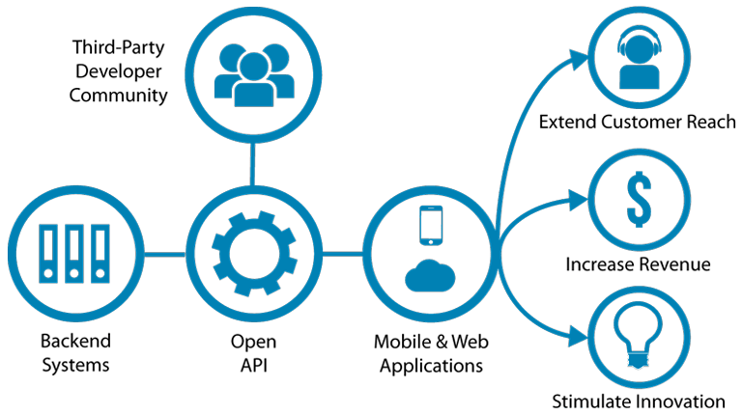 Source (Nasscom.in)
REVIEW OF LITERATURE
- Brodsky & Oakes,( 2017) study the importance of financial data sharing using various algorithms and anlytics.Accessing the data become difficult and open banking has intoduced to reduce the difficulty in data sharing .The study descibes the importance of open banking and how it reduce the complexity in data anlysis and sharing .
- Guibaud, S. (2016) descibes that banks are implementing new digital strategies but the way of access amd processing of data by customers is not easy .This study gives a detail information about the opportunities and threats faced by banks in adopting open strategy
METHODOLOGY
The study was mainly confined with secondary data available from current affairs, news dailies, journals, internet and so forth.
OBJECTIVES
- To study the growth of open banking in digitalised era
- To study the benefits and security factors provided by open banking to its customers

LIMITATIONS
- Time availability was very limited
- Study is limited to data from secondary form
ANALTSIS AND DISCUSSION
Open banking is a process of providing the internal standard informations and secured API’s of banks to external third parties, to provide better application and services to general public on the basic of existing financial institutions. Revealing an API by the banks to the outside parties will help in providing bank services to customer, by following a common standard for all the banks (Guibaud, 2016).The banks will provide API’s to those authorized third parties for providing better facilities to the general public .The third parties can build a single application for each bank, as the API’s bare common to all the banks. Therefore with the help of open banking the third parties can develop a single app that support all the banks.
GROWTH OF OPEN BANKING FROM AN INTERNATIONAL PERSPECTIVE

Open banking was originated from UK where the UK Government has been looking at the way in which establish large banks and financial institutions could make it easier for new financial service provider to offer new products and better service for customers. Following an enquiry into the supply of retail banking facilities to personal current account customers and to medium and small-sized enterprises (SMEs) in the United Kingdom, it was concluded that there was a requirement to improve opposition in retail banking and financial services.
Since open banking was made official in the UK, governments in other countries like Canada, Singapore, South Korea, Hong Kong and others have attempted to guide their open banking implementation in a similar fashion, In Australia and Mexico, the influence of UK-style Open Banking is more obvious (Guibaud, 2016)The UK’s Prosperity Fund has been instrumental in getting Mexico to take the same method as the UK, and the Australian Government issued its first guidance on the topic with no less than 50 references to UK Open Banking, including the key recommendation:
From 2018 onwards a number of countries where started adopting open banking formally and there is much anticipation around its progress in coming years. Open banking was originally proposed to increase competition in a business that was focused by a few number of players in most of the countries. Open banking is transforming the banking business model where the banking manufactures own and distribute its products and service through its own channels to one which chooses to only manufacture. Distribute or aggregate own and their party offering in a financial marketplace (Guibaud, 2016). While the early adopting banks with most mature technologies and business strategies will develop well in the open a long and distinct period of history, the laggards-typically mid-tier small institutions will become increasingly vulnerable unless if they don’t act quickly take the advantage of this free movement of data allowed by open banking.
If they haven't act very quickly, it will leads in to lose their customer to progressive rivals and eventually their existence itself .This will leads in to merger and acquisition. Because of this itself in 2019 we have seen that all banks big and small, augmenting and enriching their offering
Since the traditional banking model changes to an open banking. Banking key performance indicator will need to adopt based on whether the banking is a manufacturer, distributor, market place or the combination of all these three. The metrics banks use to assess a branch, self-service and digital network, such as footsteps or customer traffic, stop to be significant when there’s a third party distributing a bank’s products (Ozcan, 2018). . As an example, for services such as Personal Financial Management, measuring the number of sign-ups would no longer be adequate, but quantifying how customers benefit from the service will evidence to be a more vital measure of success and adoption of the service. (Ozcan, 2018) Also, metrics such as Net Promoter Score, quality of service and new revenue streams will become more critical Even in regions where open banking is not a regulatory requirement yet, banks and financial services providers are proactively taking the plunge into the API economy (Ozcan, 2018). Banks that have previously launched their API stores have anywhere between 5 to 60 APIs.
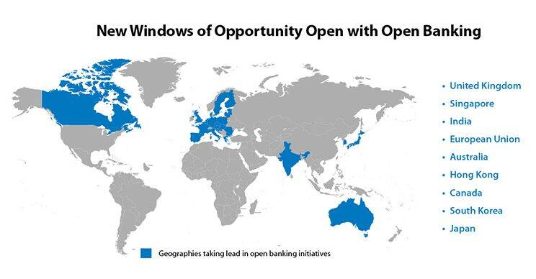

Source (https://www.edgeverve.com/finacle/trends-2019/open-banking)

As banks look to cultivate rich ecosystems and platforms, we can see that the trend to grow for open banking is stronger more diverse .In 2019 we have seen that API's are increased on breadth as well as depth, that is, not only that we saw more APIs allowing digital firm (Ozcan, 2018). Most of the banks currently having API's running in sandbox environment with dummy data. Heading in to 2020, this will changes as banks will have made sufficient progress to develop the necessary governance controls to take their APIs live with production data (Ozcan, 2018).
One of the challenge is the existence of multiple API standards. Even within a single country, which marks it very tough for an entity such as a FinTech firm to renovate quickly and frequently with the APIs of different banks.

In 2020 banks should resolve to let their business organization and lines of business lead the charge towards adopting open banking. The ones that do this rapidly will gain substantial advantage over the stragglers. Banks will also need to determine the extent of access to third-party providers, to make certain they don’t play into the hands of agencies watching to grab their clients (Ozcan, 2018) .It’s best to strike a balance by allowing access to developers and innovators but at the same time monitoring their actions closely to avoid being caught off guard.

OPEN BANKING – CUSTOMERS VIEWPOINT
Most of the banks are handling their transactions in an existing manner and they are not interested in building new solutions to help customers, this is because banks are not IT companies and that they are not able to develop tech savvy apps to help customers in their transactions (Guibaud,2016). On other side we have the thirds party developers having awesome apps which will help the customers but they are not having any customer support. Here comes the importance of open banking which bridges the gap between these two, banks and third party developers.
Under open banking banks will provide API’s to third party and function as usual .The third party developers will solve the solutions of the general public with the help of an open API’s provided by banks .Open banking help the bankers not to concern about developing apps to satisfy the customers and it also help the third parties in finding the customers base and they can solve the solutions of existing bank customers. So open banking help to transform our financial transactions through electronic medias such as mobile or computer, it help in more faster and secure transaction
BENEFIT OF OPEN BANKING TO ITS CUSTOMERS
In this digitalised era open banking provides a lot of benefits to customers, they can compare the data in their current accounts and can do other banking services. The open banking also provide details about ATM’s and branches (Phillip Hammond, 2019). The consumers can share their banking information easily and securely with the help of new mobile and online applications which is developed by open banking standards and technology to other banks.
Applications able to personal customers include
- Individual Finance Management: It is an application which help the customers in knowing where their money is spent and where it is coming from (Phillip Hammond, 2019) this application of open banking help customers to analyse their fixed payments and to identify where to save their money.
- Open banking helps in viewing all our accounts at one place
- Debt management tools: The tools provides the customers overdraft alerts and it also help the customers by recommending them to select better products which will lower their interest rates
For business, the application include
- Applications to help with your accounts
- Application to control cash flow that help the business in choosing lower rates and allow help to reduce the overdraft charges
- Tools that help to get better unsecured term loans

PRINCIPLES SUPPORTING CONSUMER SECURITY AND TRUST IN OPEN BANKING
Under open banking a standard is defined by every bank for exposing their services to the third parities as API. It is easy for third parties to combine all the customer’s account into single bank account and all the payments and transaction are done through it .This is possible because all banks follows same standard API. The bank provides the API of customers only to authorised and verified third parties. Besides all these security measures adopted by bank it also promotes the third parties to develop and build new and better services and solutions for users which will help them in using new ways in payments and acceptance.
Open banking offers better transparency to the user’s data. Customers can easily see and check each of their bank accounts at one place. With the help of third party apps open banking reduces frauds in user’s transactions in all types of bank accounts. It also helps in identifying frauds. The following are the security measures provided by open banking to its users.
- The customer not ever has to share their password and username with anyone other than their bank.
- It depends on unambiguous agreement given by the customer
- Under Open banking accessing of data to third is optional. The will be get to third only after getting consent from customers
- It is as easy to cancel consent as to give it
- If whatever goes incorrect there is a customer compensation mechanism.
- Only authorised units can participate

CONCLUSION
To conclude by saying that UK is playing a leading role in open banking projects and these projects are the most important in booming a globally competitive FinTech sector. Other countries suggest that standards follow by uk in open banking implementation will help them to move effectively in future Even though open banking help the banks and customers but it comes with its own drawbacks also. In open banking data are centralized at one place, it is safe and secure as we have to protect only one place, but on other hand if this place get attacked all of our data will be exposed. Open banking involves a lot of sharing of data so there is a risk of getting the data into external parties hand instead of bank, to avoid this bank have introduce standards and strict rules to see who are accessing the data. Likewise for any other system, when you go digital nothing is 100 percent safe and easy. The customers of the bank have to make a decision based on the trade-off between the pros and cons in Open Banking about whether you need to use third-party applications or not. Open Banking is a great alternative to the modern financial system. It bids many advantages, but it also has some disadvantages, the security risks of sharing data is one of the most important drawback. This part can be eased if you have an appropriate software solution.
Executing a successful open banking design is critical for a bank to completely leverage the benefits of open banking. To identify what the important requirements of an open banking policy are and how they can be executed, choosing the right technology is a highest priority.
REFERENCES
Brodsky, L., & Oakes, L. (2017). Data sharing and open banking, (July), 16–23.
Guibaud, S. (2016). How to develop a profitable , customer-focused digital banking strategy : Open banking services and developer-friendly APIs. 6 Journal of Digital Banking Vol., 1, 6–12.
Ozcan, P. (2018). The API Economy and Digital Transformation in Financial Services: The Case of Open Banking. SSRN Electronic Journal, (June). https://doi.org/10.2139/ssrn.2975199

Phillip Hammond. (2019). Open Banking , Preparing for lift off.

https://www.edgeverve.com/finacle/trends-2019/open-banking

