A Critical review of the various Challenges of Conventional teaching and Blended teaching for enhancing the learning outcomes of the B.Ed learners.

Dr. Priya Dhingra ( Associate Professor)
Swati Tyagi ( Research Scholar)
Department of Education
Bhagat Phool Singh Mahila Vishwavidhalya, Haryana

Abstract
In today’s digital era, technology has entered every field of human endeavor. During the Covid pandemic, there was a paradigm shift from conventional teaching to online teaching. Lots of research have been occurs to focus on the amenable aspects of digital technologies in Education. National Education Policy 2020, itself focuses on promoting digital literacy through online or blended mode to the young generation as well as teachers. It has now become an essential competency skill for teachers to be equipped with the usage of digital tools in pedagogy. Due to the present demand, future teachers must be highly compatible in using technology in education. Therefore, this paper focuses on the various challenges of conventional teaching and blended teaching for enhancing the learning outcomes of B.Ed learners. For this realization, around 20 research papers were reviewed to provide qualitative data.
Keywords- Conventional teaching, Blended teaching, Learning outcomes, Digital divide.

1.0 Introduction
Education is a crucial phenomenon for the advancement of the overall nation. The National Education Policy 2020 recognizes the importance of leveraging the advantages of technology while acknowledging its potential risks and dangers. However, the benefits of online/digital education cannot be leveraged unless the digital divide is eliminated. It is important that the use of technology for online and digital education adequately addresses concerns of equity. Teachers require suitable training and development to be effective online educators. It cannot be assumed that a good teacher in a traditional classroom will automatically be a good teacher in an online classroom. In the meantime, the existing digital platforms and ongoing ICT-based educational initiatives must be optimized and expanded to meet the current and future challenges in providing quality education for all. In this regard, utilizing the appropriate methodology is essential for enhancing the learning outcomes of the students as they are potential human capital.

2.0 Operational definition of the keywords
2.1 Conventional teaching-
It is the traditional kind of teaching where the instructors and students meet together in the same place at the same time. Operationally, it is a teacher-centered teaching and lecturing is the most common teaching method used for B.Ed learners.
2.2 Blended teaching-
Graham (2006) defines blended learning as "a combination of instruction from two historically separate models of teaching and learning: traditional face-to-face learning systems and computer-mediated learning". Operationally blended learning is defined as a teaching method that blends the use of technology in the learning environment with the traditional learning setting and tools to maximize learning as it turns the setting from a teacher-centered class into a student-centered class. This helps in improving the quality of a teaching-learning process, by enhancing its outputs, creating new potentials for self-learning as well as lifelong learning.
2.3 Learning outcomes-
Learning outcomes means how much knowledge or skills a student should acquire through the different mode of teaching. Operationally learning outcomes are measurable statements that articulate at the beginning what the learner should know and will be able to do or demonstrate upon completion of the course.
2.4 Digital divide- According to the NEP 2020, the benefits of online/digital education cannot be leveraged unless the digital divide is eliminated through concerted efforts, such as the Digital India campaign and the availability of affordable computing devices. It is important that the use of technology for online and digital education adequately addresses concerns of equity. There is evidence that a digital divide may impede the learning process as students do not have access to technology sufficiently. Bridging this divide will enhance students' ability to study, share and work together.

3.0 Brief review of related literature
The following review of scholarly articles collected which support the study –
An Executive summary posted by the United Nations (August 2020) stated, "The COVID-19 pandemic has created the largest disruption of education systems in history, affecting nearly 1.6 billion learners in more than 190 countries and all continents. Closures of schools and other learning spaces have impacted 94 percent of the world's student population, up to 99 percent in low and lower-middle income countries" .
Due to the outbreak of the Covid-19 pandemic, there was a sudden shift in the teaching-learning paradigm from conventional, classroom-based learning to online learning. While students and teachers are still trying to cope with this sudden change, there are many shortcomings and challenges of online learning methods. However, there are also many advantages of online learning it is accessible to a wide range of students, there is flexibility in terms of time and better interface as well as the content of learning which improves the performance of the students . Moreover, the prevalence of the conventional teaching-learning processes for a long period has resulted in creating a habit for students to learn and adapt the course in a different manner as opposed to online learning .
The blended learning approach is a significant alternative for allowing students to enjoy the best of both methods. Blended teaching is referred to as the educational technique of combining digital learning materials with traditional face-to-face classroom instruction. In a true blended learning scenario, both the student and the teacher should be physically present in the same place. For example, a student may attend traditional classroom courses and then supplement the curriculum with online multimedia homework . It is found that blended teaching is a significant alternative that can fulfill the needs of diverse students that may prefer online learning or conventional learning as it amalgamates both practices into one .

Various challenges students faced in each institution during the COVID-19 Parameters (An International Perspective: Teaching Chemistry and Engaging Students During the COVID-19 Pandemic Rodney A. Tigaa* and Swapnil L. Sonawane https://dx.doi.org/10.1021/acs.jchemed.0c00554)

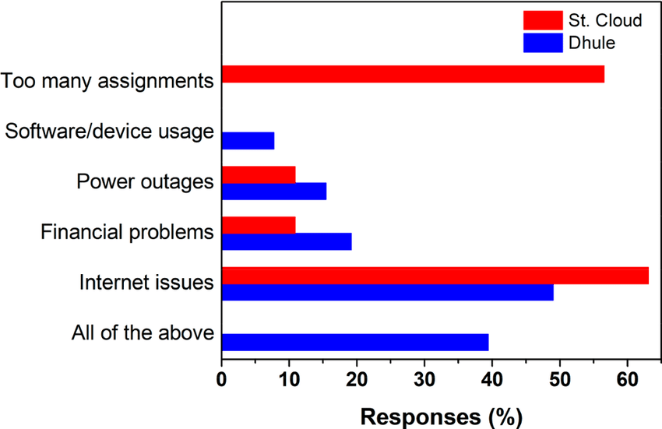

Comparison of (a) F2F and online learning to determine student preference and (b) student self-assessment of the level of chemistry learned from instructor-shared materials during the COVID-19 pandemic.
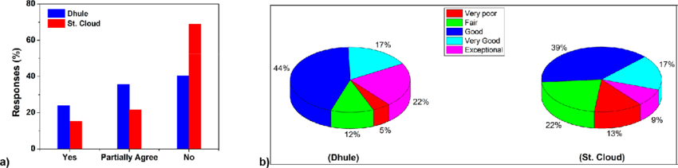

S. Maria Josephine Arokia Marie (2021) conducted study on Improved pedagogical practices strengthens the performance of student teachers by a blended learning approach. This study is aimed at exploring the innovative teaching and learning approach called the Blended Learning approach. The innovative teaching and learning approach of Blended Learning with a rotational model where students learn in the presence of a teacher and internet platform was used in teaching the Experimental group which comprise 29 student teachers, while the Conventional method was used with the Control group which consists of 24 student teachers. The experiment lasted for eight weeks. The study findings revealed that there were significant differences at 0.05 level in the mean scores of the test in favor of the experimental group. The findings also pointed out that there were statistically significant differences at 0.05 level in the participants' pedagogical performance level before and after implementing the Blended learning method of teaching in favor of the post-application. This was endorsed to the Blended Learning Program in the teaching of science.
Prabhas Ranjan (2020) conducted research on - Is Blended Learning Better than Online Learning for B.Ed Students? This study was an experimental spread over two years, to compare the effectiveness of the blended learning mode and the online learning modes (including their specific teaching-learning strategies) for a B.Ed curriculum. A randomly selected sample of students with a comparable level of intelligence quotient (IQ) was subjected to both controlled (face-to-face) and experimental treatments (online and blended learning). The participants were the students of a predominantly face-to-face mode of a B.Ed Course. The researcher found that the average achievement scores of the blended learning mode were higher than the online learning mode. It appears that the interaction of the instructor and the learners was a critical factor for the better performance of blended learning. This research also suggests that blended learning resulted in better learning attainment and motivation. Blended learning has the potential to support learner-centric teaching-learning endeavors. It is an important finding for the emerging trend towards online learning in India.
Alsalhi, N. R., Eltahir, M. E., & Al-Qatawneh, S. S. (2019) conducted research on the effect of blended learning on the achievement of ninth-grade students in science and their attitudes toward its use. It was a quasi-experimental study comprised of 112 students, experimental-61 and control-51. The finding revealed that there were significant differences between the experimental and control group. The study recommends further research into the use of blended learning in higher education institutions.
Dhawan, S. (2020) conducted a study on Online learning: A panacea in the time of COVID-19 crisis. This study includes the importance of online learning and the Strengths, Weaknesses, Opportunities, and challenges analysis of e-learning mode in the time of crisis. It throws light on the growth of EdTech during the time of pandemic and suggests how to deal with challenges associated with online learning.
Darojat ,O .(2016) studied – Improving curriculum through blended learning pedagogy. The purpose of the study is to understand the issues related to the implementation of blended learning pedagogy. The Qualitative case study was employed on two open and distance learning (ODL) universities in Southeast Asia. This study provides a practical recommendation that internet-based instruction is now becoming a strategic choice for ODL in developing countries to widen access and meet challenges for a better future.
Herman Lusa , et. al. (2021) studied the effect of blended learning on students' learning outcomes: meta-analysis. This research aims to determine the effect of blended learning implementation in Indonesia. This study reported the effect size of blended learning on learning outcomes consisting of subgroups of elementary school, and junior high school and subgroups of learning outcomes- knowledge, thinking ability, and attitude. This study concluded that blended learning positively affects knowledge mastery, thinking ability, motivation, and learning independence at all levels of education.

4.0 Blended Learning Strategy in Teacher Training Programs

Blended learning (C. Graham ) tends to address three commonly related aspects of instructional learning:
- a blend of online and face-to-face instruction,
- a blend of instructional methods,
-a blend of instructional modalities.
BL is not a mere mix of online and face-to-face modes, but it refers to a well-planned combination of meaningful activities in both modes. The blend demands consideration of several factors, mainly focusing on learning outcomes and the learner-centered instructional environment. Given the emergence of digital technologies and the emerging importance of leveraging technology for teaching-learning at all levels from school to higher education, the NEP 2020 recommends for use of blended models of learning. The NEP-2020 states that while promoting digital learning and education, the importance of face-to-face in-person learning is fully recognized. Accordingly, different effective models of blended learning will be identified for appropriate replication for different subjects.

4.1 Significance of blended learning for enhancing the learning outcomes of the B.Ed learners

-removes barriers of time and place;
-provides ample opportunities for experiential learning;
-fosters higher levels of interaction between learner and instructor, between learner and learner, between learner and content, and between learner and course interface ;
- fosters not only the use of different information and communication technologies but also facilitates the emergence and development of different kinds of interactions and encounters among participants ;
-enhances the skills for technologically integrated lesson plans;
-offers instructional flexibility (via Face to face (F2F), online instructor-led activities, and web-based self-access activities) by using a practical, up-to-date, and time-effective complement to lessons;
-provides an opportunity to customize the learning using synchronous and asynchronous delivery modes ;
-offers the possibility to design and implement inquiry-based learning activities through unrestricted interaction and critical discourse, which fosters more reflective and creative learners;
-offers the opportunity for learners to customize their learning experiences according to their needs, pace, styles, skills, demographics, previous learning history with online formats, and beliefs ;
-offers various interacting platforms to enhance learning like google classroom, google meet, Chat GPT, etc.

5.0 Contrasting the curriculum components between conventional teaching and blended teaching in a teacher training program

Conventional teacher training program | Blended learning teacher training program
Content delivery
On-campus sessions  Fixed schedule  time-based;  live lectures;  a missed lecture cannot be repeated. | online;  optional on/off-campus sessions;  free schedule;  on-demand:  asynchronous and synchronous lectures;  IT support;  Recorded lectures that can be repeated on demand.
Learner’s Activities
Face-to-face in on-campus mode ;  passive learning;  active learning;  interactive learning;  work in a group;  individual project;  pen-paper test. | Face-to-face on digital mode;  online instructor-led activities;  web-based self-access activities;  individual project;  work online: e-mail, text chat, forum;  unrestricted interaction and critical discourse;  computer-mediated;  e-learning;  online modules;  online seminars.  Computer-based test
Instructional Materials
oral lecture presentations;  oral lecture text;  Mega teaching lesson plan;  traditional and constructive teaching methodology;  Mostly hardware-based teaching aids used like charts, models, etc;  classroom discussions. | online lecture presentations;  online lecture text;  technologically integrated lesson plans;  technologically based methodologies;  including software-based teaching aids like PowerPoint, websites, excel, chat GTP, etc;  an online forum for group discussions.
Required competencies
the basic level of professional competence;  communicative competence. | Techno-pedagogical skills competence;  -ICT competence;  self-learning competence;  self-management competence.

6.0 Conclusion
A concern of NEP 2020 for the implementation of the Blended learning strategy in the classroom will be highly superfine when initially the training for the same will be provided in the professional courses. So it is highly recommended every educational institute supports future teachers to get well-equipped with the latest digital technologies in pedagogies. According to S. Sethy “ an effective blended learning TTP should ensure that it: promotes connections and conversations, guides, directs, and tracks learning routes, nurtures a world-class global workforce, provides consistent and updated messages, utilizes the technologies efficiently, fosters independent habits for learning and reference, encourages learning and work and improves performance and control costs”.
A lot of research concluded that blended teaching is more highly beneficial than conventional teaching in enhancing the learning outcomes of the learners. Therefore, Blended teaching should be viewed as an opportunity to change the way that teacher training curriculum should be developed, scheduled, and transact through a combination of online and offline modes or synchronously and asynchronously.

Bibliography
Alsalhi, N. R., Eltahir, M. E., & Al-Qatawneh, S. S. (2019). The effect of blended learning on the achievement of ninth-grade students in science and their attitudes towards its use. Heliyon, 5(9), e02424.

Anthony, E. (2019). (Blended) Learning: How Traditional Best Teaching Practices Impact Blended Elementary Classrooms. Journal of Online Learning Research, 5(1), 25-48.

Darojat, O. (2016). Improving curriculum through blended learning pedagogy. Turkish online journal of distance education, October, 17(4), 203-218.

Dhawan, S. (2020). Online learning: A panacea in the time of COVID-19 crisis. Journal of Educational Technology Systems, 49(1), 5-22.
Dumford, A. D., & Miller, A. L. (2018). Online learning in higher education: exploring advantages and disadvantages for engagement. Journal of Computing in Higher Education, 30(3), 452-465.

Geng, S., Law, K. M., & Niu, B. (2019). Investigating self-directed learning and technology readiness in blending learning environment. International Journal of Educational Technology in Higher Education, 16(1), 1-22.

Herman, Lusa. (2021). Effect of blended learning on students' learning outcomes: Meta-analysis.Jurnal Pendidikan Progresif, 11 (2), 309-25.
International Perspective: Teaching Chemistry and Engaging Students During the COVID-19 Pandemic Rodney A. Tigaa* and Swapnil L. Sonawane https://dx.doi.org/10.1021/acs.jchemed.0c00554

Ministry of Education (2021), Government of India. Covid Action Plan, https://www.education.gov.in/en/covid-action-plan-mitigating-loss-learning-action-plan-access-retention-continuous-learning-capacity

Ministry of Education, Government of India. (2020). National Education Policy 2020. http://www.education.gov.in/sites/upload_files/mhrd/files/NEP_Final_English_0.pdf

Park, Y. S., Konge, L., & Artino, A. R. (2020). The positivism paradigm of research. Academic Medicine, 95(5), 690-694.

Rahi, S. (2017). Research design and methods: A systematic review of research paradigms, sampling issues, and instruments development. International Journal of Economics & Management Sciences, 6(2), 1-5.
Ranjan, Prabhas. (2020). Is Blended Learning Better than Online Learning for B.Ed Students? Journal of learning for development. Vol. 7, No. 3, pp. 349-366.

S. Maria Josephine Arokia Marie (2021). Improved pedagogical practices strengthen the performance of student teachers through a blended learning approach. https://doi.org/10.1016/j.ssaho.2021.100199 .
University Grant Commission. (2021). Blended mode of teaching and learning: Concept notes. New Delhi. http://www.ugc.ac.in/pdfnews/6100340

Xhaferi, Brikena. (2020). ONLINE LEARNING BENEFITS AND CHALLENGES DURING THE COVID 19 - PANDEMIC- STUDENTS' PERSPECTIVE FROM SEEU. SEEU Review Volume 15 Issue 1: Challenges and Perspectives of Covid – 19, DOI: 10.2478/secure-2020-0006

WESP, United Nations (August 2020). Executive summary. http://www.un.org/development/desa/dpad/wp-content/uploads/sites/45/WESP_2021_Executive-summary_E.pdf

------------------------------------------------------------------------------------------------

Ministry of Education, Government of India. (2020). National Education Policy 2020. http://www.education.gov.in/sites/upload_files/mhrd/files/NEP_Final_English_0.pdf
WESP, United Nations (August 2020). Executive summary. http://www.un.org/development/desa/dpad/wp-content/uploads/sites/45/WESP_2021_Executive-summary_E.pdf
Hermant,o, Y. B., & Srimulyani, V. A. (2021). The challenges of online learning during the covid-19 pandemic. Jurnal Pendidikan Dan Pengajaran, 54(1), 46-57.
Dumford, A. D., & Miller, A. L. (2018). Online learning in higher education: exploring advantages and disadvantages for engagement. Journal of Computing in Higher Education, 30(3), 452-465.
Kaur, N., Dwivedi, D., Arora, J., & Gandhi, A. (2020). Study of the effectiveness of e-learning to conventional teaching in medical undergraduates amid the COVID-19 pandemic. National Journal of Physiology, Pharmacy, and Pharmacology, 10(7), 563-567.
Geng, S., Law, K. M., & Niu, B. (2019). Investigating self-directed learning and technology readiness in blending learning environment. International Journal of Educational Technology in Higher Education, 16(1), 1-22.
Anthony, E. (2019). (Blended) Learning: How Traditional Best Teaching Practices Impact Blended Elementary Classrooms. Journal of Online Learning Research, 5(1), 25-48.
S. Maria Josephine Arokia Marie (2021). Improved pedagogical practices strengthen the performance of student teachers through a blended learning approach. https://doi.org/10.1016/j.ssaho.2021.100199 .
Ranjan, Prabhas. (2020). Is Blended Learning Better than Online Learning for B.Ed Students? Journal of learning for development. Vol. 7, No. 3, pp. 349-366.
Alsalhi, N. R., Eltahir, M. E., & Al-Qatawneh, S. S. (2019). The effect of blended learning on the achievement of ninth-grade students in science and their attitudes towards its use. Heliyon, 5(9), e02424.
Dhawan, S. (2020). Online learning: A panacea in the time of COVID-19 crisis. Journal of Educational Technology Systems, 49(1), 5-22.
Darojat, O. (2016). Improving curriculum through blended learning pedagogy. Turkish online journal of distance education, October, 17(4), 203-218.
Herman, Lusa. (2021). Effect of blended learning on students' learning outcomes: Meta-analysis.Jurnal Pendidikan Progresif, 11 (2), 309-25.

