A Comprehensive Analysis of Water DEMAND - SUPPLY Management in Chennai
P. Sujatha¹, Jai Shirisha PVS², Krishna Nivash J³ and P.V.S. Janardhanam⁴
1 Asst. Professor, Dept. of Geography, Bharathi Women’s College (A), Chennai-108, TN, India
2 Final Year - MBBS, Trichy SRM Medical College Hospital & Research Centre, Irungalur, Trichy – 621 105.
3 IIIrd Year - B.E., Dept. of Electronic Communication, Sathyabama University (Deemed), Chennai.
4 Head-IT, LYCA TECH., Chennai.
sujathaj3998@gmail.com , jaishirisha@gmail.com, Krishnanivash.j@gmail.com, Jana_pvs@rediffmail.com

ABSTRACT
This study aims to comprehensively analyze the water dynamics of the Chennai Metropolitan Area (CMA) for effective water planning and reveal the complex interactions between urban objectives. The research has three primary objectives: (a) assessment of inflows, outflows and effluents to determine water mass balance; (b) demonstrating how economic, political, social and other factors affect the flow of water and affect the hydrology of the city; and (c) revealing spatial diversity in the driving forces of water flow. The study examines the city's growth, water management, resources, infrastructure and risk factors and offers recommendations for sustainable management. By addressing these aspects, the research aims to improve water resource management and sustainable development in the rapid urbanization of the CMA.
Keywords: Water flows, Waste water, Water quality, Sustainable water management.

1. INTRODUCTION
Chennai is completely dependent on groundwater resources to meet its water needs. Groundwater supplies in Chennai are replenished by rainwater and the average rainfall in the city is 1,276 mm. (Srinivasan, M. S., 2003) Chennai receives 985 billion against the required 1,200 billion and the demand is expected to reach 2,100 billion by 2031. Water resources include desalination plants, aquifers, Cauvery and Krishna rivers, Poondi reservoir and lakes . (Mariappan, Julie, 2014). The Chennai Metropolitan Water Supply and Sewage Board (Metro Water) is responsible for the supply of ground water and sewage management in Chennai. In 2011, MetroWater served a population of 5 million in Chennai. The expansion of the corporation to 426 km2, with 200 departments and 15 zones, will add 1.7 million more customers, greatly increasing its reach. (Lakshmi, K., 2013). As of 2012, MetroWater supplies about 830 million liters of water to residents and commercial establishments every day (Lakshmi, K., 2012). Of the 800 billion delivered to Chennai, around 710 billion is delivered by pipeline. The projected demand for the expanded city is 1,044 billion, and MetroWater must treat and dispose of an additional 219 billion of wastewater in the combined areas. (Lakshmi, K., 2013). Having developed into a metropolis, Chennai is now known as the Chennai Metropolitan Area (CMA) for planning purposes. The CMA boasts 22 waterways that include three rivers, a canal and four reservoirs, alongside 16 smaller waterways. (Thooyavan, K, 2013), (Mariappan, Julie, 2014).
Chennai is geographically divided into northern and southern parts by the Cooum, Adyar and Kosasthalaiyar rivers flowing into the Bay of Bengal. The Buckingham Canal connects all three rivers. The city's four reservoirs - Red Hills, Cholavaram, Poondi and Chembarambakkam - have a total capacity of 11,057 mcft. Each reservoir has different capacities: Red Hills (3,300 mcft), Cholavaram (881 mcft), Poondi (3,231 mcft) and Chembarambakkam (3,645 mcft). Unfortunately, the reservoirs lose 5 mcft of water per day to evaporation. (Lakshmi, K., 2013), ("State shifts center for fifth tank in Chennai", 2013) According to the water resources department, only 19 out of 29 major water bodies in the city can be restored. Nine lakes are impaired and cannot be rejuvenated, including Valasaravakkam, Virugambakkam, Mogappair, Adambakkam, Kolathur, Senneerkuppam, Thalakancheri, Ullagaram and Maduravoyal. Once restored, the remaining lakes will store 1,000 mcft of water, and desilting the four primary reservoirs may add 500 mcft. (Lakshmi, K., 2018).
At present, the city supplies 830 million liters of water per day and gets another 880 billion from the Minjur and Nemeli desalination plants, the Krishna River and the Veeranam reservoir. ("Chennai: new plant to secure water supply", 2013). As of December 2013, the Nemmeli and Minjur desalination plants along with the new Veeranam project contributed more than 60% of Chennai's water supply, amounting to 575 MLD. ("Nemmeli desal plant generates at full capacity", 2014). About 3,600 reservoirs around Chennai, if maintained and interconnected, could meet five times the city's water needs, about 80,000 million cubic feet (TMC). (Ramakrishnan, T., 2017). In 2018, 50 to 60 percent of Chennai's water supply came from private water tankers that supplied 20,000 loads daily from various areas. 80% of households used bottled drinking water and sold 20 million liters per day." ("To tackle water crisis, Metrowater pitches in", 2018)

1.1 RESEARCH METHODOLOGY
Collected data on water demand, supply, and use from a variety of sources, including government records, surveys, and satellite imagery. Analyze collected data to assess water availability, identify trends and understand usage patterns. Study successful water management projects in other regions and draw lessons applicable to Chennai. Develop models to simulate water demand, supply and distribution scenarios under different conditions. Formulate practical recommendations for policy makers and stakeholders to improve water management practices.

1.2 OBJECTIVE
The general objectives are listed below:
- Conduct an in-depth assessment of water demand and supply dynamics in Chennai to understand current water use patterns.
- Identify key challenges and opportunities in water resource management, including groundwater depletion and water quality degradation.
- Develop effective and sustainable strategies for managing water demand, focusing on conservation, recharge and wastewater treatment.

2. CITY GROWTH AND THE ENVIRONMENT
2.1 Geographical characteristics
Geographic characteristics considered in this study included location, physiography and landforms, climate, forests and biodiversity.
2.1.1 Location
Chennai, the capital of Tamil Nadu, stands as a vibrant cultural gateway to South India. It is located at 13.0827°N and 80.2707°E and rests on the southeastern coast, bordered by the Bay of Bengal on the east and Kanchipuram and Thiruvallur districts on the other sides. Chennai is spread over 25.6 km along the gulf coast and includes two classifications: Chennai District and CMA.
Chennai District:
The Chennai Central Business District (CBD) comprises the historic core and served as the core of early settlements that now extend beyond the district boundaries. Originally covering an area of 178 km², the Chennai district grew to 426 km² in 2018 and included the extended city limits administered by the Chennai Municipal Corporation.
Chennai Metropolitan Area:
The Chennai Metropolitan Area (CMA), covering an area of 1,189 km², is administered by the Chennai Metropolitan Development Authority. It includes Chennai district and parts of Kanchipuram and Tiruvallur districts. About 637 km² of Thiruvallur districts and 376 km² of Kanchipuram districts come under the jurisdiction of the CMA.

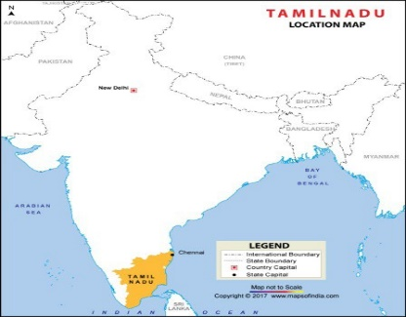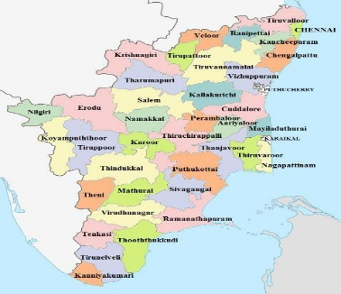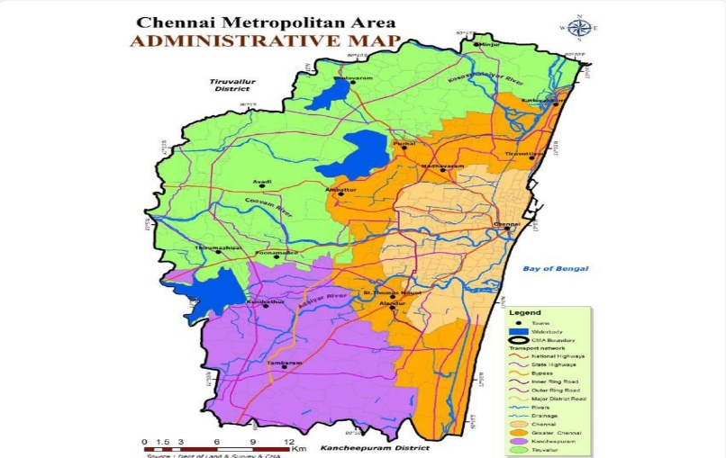
Chennai Metropolitan Area (Study Area)
India Tamil Nadu State

FIGURE 1: Geographical location of Chennai Metropolitan Area

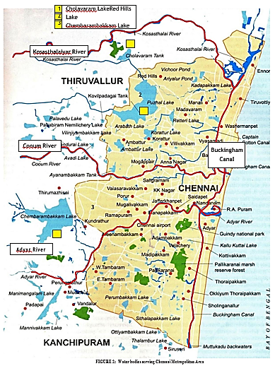

Physiography and Landform
The Chennai Metropolitan Area (CMA) comprises a flat coastal plain with an average elevation of 6.7 meters above sea level, which presents drainage challenges, particularly in the more remote inland areas. Its ecological diversity ranges from mangrove ecosystems on the east coast to dense forests with rich tropical flora and fauna in the west.
Predominant soil types include clay, shale and sandstone, with sandy soil along the rivers and coasts. Geological divisions categorize the CMA into three sub-regions: sandy zones along rivers and coasts, clayey areas in most inland parts and hard rock areas mainly in Guindy, Velachery, Adambakkam and Saidapet. Areas of clay and hard rock tend to retain rainwater due to slow percolation.
Three key rivers – the Cooum, Adyar and Kosasthalaiyar – cross the area, the latter contributing significantly to the water resources. However, Coou and Adyar suffer from pollution due to untreated waste, while western lakes and groundwater serve as key water sources.
2.1.2 CLIMATE
Located on the equator, Chennai experiences a tropical wet and dry climate with temperatures ranging from 19 °C to 40 °C throughout the year. Rainfall is driven by the southwest and northeast monsoons from June to December, which are critical for reservoir recharge and water supply. Annual average rainfall is approximately 1400 mm, occasionally intensified by cyclones in the Bay of Bengal.
2.1.3 FOREST AND BIODIVERSITY
Within the Chennai Metropolitan Area (CMA), the total forest area occupies 943 hectares. Notably, 320 hectares lie in Chennai district, while 623 hectares are in Thiruvallur district; no forest area is designated in Kancheepuram district under CMA. According to the State of the Environment Report, the Chennai metropolitan region consists of five major ecosystems as shown in Table 1.
TABLE 1: Ecosystems in Chennai Metropolitan Area 8
S. No. | Name of the  Ecosystem | Total Area (in  hectares) | Type of Flora | Type of Fauna
1 | Guindy National Park | 270 | Dry evergreen  scrub and thorn forest  , grasslands, and waterbodies.  350 species of plants including shrubs, climbers, herbs, and grasses.  24 varieties of trees, including sugar apple, wood apple, and neem | 130 species of birds, 14 species of mammals, over 60 species  of butterflies and spiders
2 | Pallikaranai Marsh Land | 8000 | 114 species of plants, 29 species of grass | 10 species of mammals,  112 species of birds,  21 species of reptiles, 9 species of amphibians, 46 species of fish, 7 species of butterflies, 5 species of Crustaceans and 9 species of Mollusk
3 | Nanmangalam Reserve Forest | 320 | Scrubland with some rare territorial orchids | 85 species of birds like Red- wattled Lapwing, Crested Honey Buzzard, Grey Partridge, Coucal, Indian Eagle-owl, White-breasted Kingfisher, Pied Kingfisher, Southern Bush Lark, and  Red-whiskered Bulbul
4 | Adyar Estuary (Protected Wildlife Reserve) | 120 | Islands and mangrove including river, marsh, woods, backwaters, islets, sea, and open  ground | 150 species of birds and small wildlife including jackals, foxes, wild cats, snakes, and other reptiles
5 | Chennai coast between Neelankarai and Napier  Bridge stretch | - | - | Olive ridley turtles

2.1 URBAN GROWTH AND LAND USE
This section delves into the spatial growth, land use and coverage in Chennai district. It examines urban sprawl, the role of land such as residential, commercial, and recreational, and assesses existing land cover—vegetation, built-up areas, water bodies, and more—and offers insight into urbanization and the dynamics of land change.
2.1.1 SPATIAL GROWTH PATTERN
The urban sprawl of Chennai district is characterized by a grid pattern with wide roads and neighborhoods arranged in a north-south and east-west orientation, promoting accessibility and connectivity, supported by radial road and rail networks.
2.1.2 SPATIAL GROWTH PATTERN
The central area of ​​Chennai district has seen urban expansion that adheres to a grid layout, organizing roads and neighborhoods along north-south and east-west orientations. During the 20th century, substantial improvements in road and local infrastructure led to the establishment of wide roads and the implementation of Cartesian grid patterns. These intentional layouts have systematically structured communities and thoroughfares, facilitating movement and connectivity.
The road and rail network radiates outwards from the Chennai core in a radial fashion, shaping urban growth throughout the metropolitan area. This model involves the outward expansion of residential, commercial and industrial zones from a central core. While the central business district (CBD) remains densely populated and continues to attract more residents, the periphery of the district and the wider Chennai Metropolitan Area (CMA) are experiencing extensive urban development, particularly along transit routes to the north, south and west. .
Achieving a balance between economic progress, sustainable practices and efficient infrastructure will be key to Chennai's future. Addressing issues related to transport, housing and environmental sustainability will significantly impact Chennai's identity as a vibrant and livable metropolis. However, the rapid growth of a metropolitan area presents unique challenges such as protecting agricultural land, addressing environmental issues, and ensuring comprehensive and sustainable development for both urban and rural communities. Finding equitable and inclusive solutions will be vital to the future development of Chennai and the prosperity of its metropolitan area. (Fig. 3 and 4)
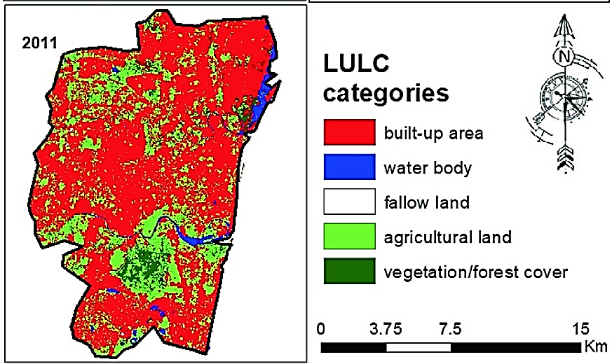
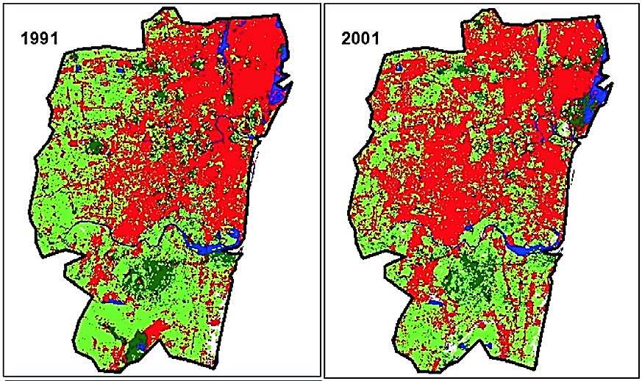
FIGURE 3: Urban sprawl pattern in Chennai district (with 178 km2 area) from 1991 to 2011
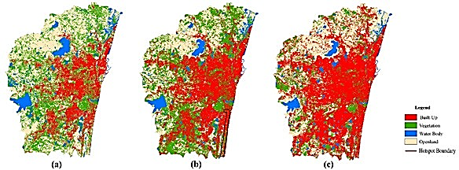
FIGURE 4: Urban sprawl pattern in Chennai Metropolitan Area from 2010 to 2017

Land Utilization and Land Cover
Over the three decades from 1988 to 2017, the Chennai Metropolitan Area (CMA) has undergone significant changes in land use patterns, primarily due to rapid urbanization and population growth. The most significant transformation was the expansion of the built-up area, which includes residential, commercial, industrial, transport and mixed zones, which almost tripled from 211.2 km2 in 1988 to 578.3 km2 in 2017. This radial growth extended westward from the core of the district Chennai, driven by domestic and foreign investment in various industries such as automotive, electronics, finance and others. (Fig. 5)
The rise of the IT and service sectors has further contributed to the expansion of commercial and industrial areas, reflecting the changing economic landscape of Chennai as a major economic hub. From 1997 to 2006, the scattered settlements were transformed into dense urban areas with the establishment of educational institutions and industries. After 2006, accelerated growth was seen due to the emergence of software companies, high-tech services and medical tourism, which attracted more settlers. Projections indicate that the built-up area may reach 708.3 km2 by 2025.
However, this rapid urban expansion came at the expense of farmland and vegetation, which by 2017 had shrunk to half of their 1988 area as they were converted to built-up areas. Barren land such as sandy areas, beaches, open spaces and empty riverbeds have gradually increased due to land degradation caused by the use of agrochemicals. (Fig. 6)
Water bodies and wetlands, which are critical to the region's water resources and ecosystems, have also faced significant decline, falling from 117 km2 in 1997 to 55 km2 in 2017. Encroachment and pollution from urbanization and landfilling have contributed to this decline. Conservation efforts are necessary to protect these water bodies and preserve them as vital water sources for the region.
In addition, until 2006, wastelands and landfills increased, but decreased after interventions such as plantations. Expanding built-up areas have implications for climate change, deforestation and increased emissions, leading to changes in regional climates and increasing the risk of climate-induced disasters.
To address these challenges, sustainable urban planning and conservation measures are essential to mitigate the adverse impacts of urban growth on the region's climate and environment. Balancing urban development while preserving ecological integrity and protecting natural habitats is key to the resilience and well-being of the Chennai metropolitan area. Policy makers and stakeholders must make informed decisions on how to effectively manage land use, taking into account urbanization, population dynamics, economic growth and environmental protection for the sustainable development of the region.

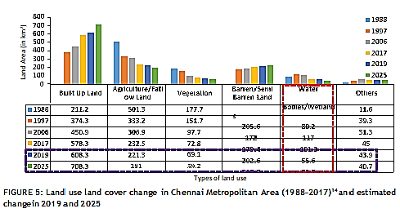

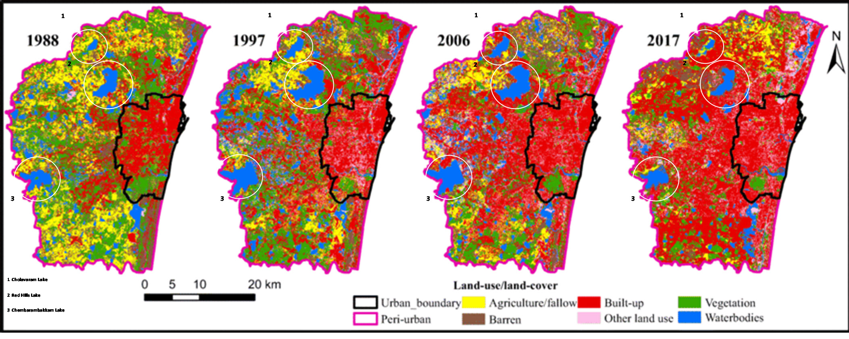
FIGURE 6: Graphical representation of land use land cover change in Chennai Metropolitan Area with highlighted change in waterbodies (1988–2017)

Demographic Description
This segment delves into the dynamic trajectory of population growth within the Chennai Metropolitan Area (CMA) and the profound implications it has for the urban landscape. As one of India's most prominent cities, Chennai has witnessed a remarkable increase in population, climbing from 3,505,502 lakhs in 1971 to 8,653,521 lakhs in 2011. This increase is intricately linked to the rapid expansion of industries such as hardware manufacturing, automobile manufacturing, and IT sectors, which are mostly located on the outskirts of Chennai district. These industries acted like a magnet, attracting a significant influx of population to the CMA. Projections highlight that this growth trajectory will continue, with the population expected to reach 11,882,610 by 2025.
Population growth rates in the CMA have shown fluctuations over the decades. After an impressive ten-year growth rate of 31.27% in 1981, the pace gradually moderated and narrowed to 21% by 2001, marking a period of deceleration. However, from 2001 to 2011, a slight increase in the decadal variance was observed, with the growth rate rising to 22.9%, indicating a slight recovery in population growth during the early years of the 21st century. (Fig. 7)
The CMA's population density has shown a consistent upward trend due to strong industrial and economic expansion that attracts a migrant population in search of job prospects. This density increased from 2948 persons/km2 in 1991 to 5921 persons/km2 in 2011. Projections indicate a further increase to 7918 persons/km2 by 2025. While this increase reflects growing economic opportunities, it also presents formidable infrastructure challenges, provision of housing, and resource management. (Fig. 8)
In order to accommodate the growing population and increase the quality of life of CMA residents, the imperative of sustainable urban planning is obvious. The amalgamation of urban and rural enclaves within the CMA presents significant prospects and challenges for planners in meeting the demands of both demographics. Grasping population trends and density oscillations becomes paramount for effective urban planning and promoting sustainable progress in the Chennai metropolitan area. This means a balanced approach to growth that is consistent with prudent management of resources. (Fig. 9)

.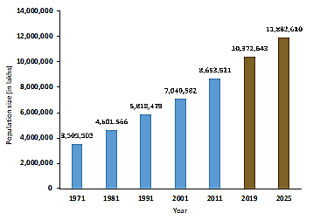
FIGURE 7: Population increase in Chennai Metropolitan Area
from 1971 to 2011 And estimated population change in 2019 and 2025
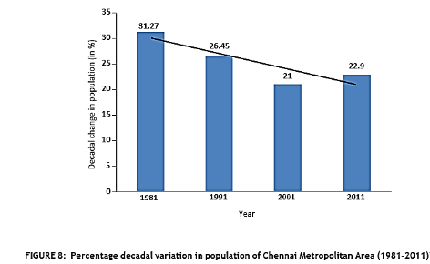

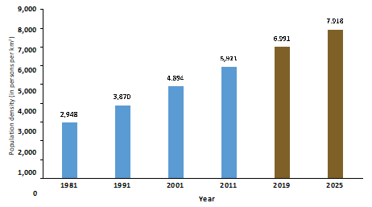
FIGURE 9: Population density change in Chennai Metropolitan Area
(1981–2011) And estimated change in 2019 and 2015

Socio-economic Description
The socio-economic analysis of the Chennai Metropolitan Area (CMA) presents a comprehensive overview of various sectors, including the economy, agriculture, industry, and housing. The region's economy has witnessed a significant shift from manufacturing to the tertiary sector, particularly the IT industry, driving economic growth and employment opportunities. The agricultural sector faces challenges due to declining groundwater levels and siltation of irrigation tanks, necessitating sustainable water management for agriculture. Rapid industrial growth in manufacturing industries, such as automobiles and IT firms, has contributed to the Gross District Domestic Product (GDDP) and employment. The housing sector has experienced substantial growth, requiring comprehensive policies to address water access for slum settlements. The analysis serves as valuable guidance for policymakers to develop integrated strategies for sustainable development, water management, and urban planning in the CMA. (Table 2,3 & 4)
TABLE 2: Employment structure in Chennai Metropolitan Area
S. No. | Occupational  Structure |  | 1971 (in %) | 1981 (in %) |  | 1991 (in %) | 2001 (in %)
1 | Primary |  | 4.01 | 3 |  | 6.5 | 2.9
2 | Secondary |  | 34.21 | 32 |  | 26.7 | 97.1
3 | Tertiary |  | 61.78 | 65 |  | 66.8
TABLE 3: Number of households in Chennai district (1991–2011)
Year |  | Total No. of Households |  |  | Percentage Change (%)
1991 |  | 798,279 |  |  | NA
2001 |  | 962,213 |  |  | 20.5
2011 |  | 1,154,982 |  |  | 20.03
TABLE 4: Slum statistics in Chennai district (1956–2011)
Year | Slum Population (in lakhs) | Number of Slums
1956 | 2.87 | 306
1961 | 4.12 | 548
1971 | 7.37 | 1202
1986 | 6.5 | 996
2001 | 8.2 | 1431
2011 | 13.2 | Not available
3. Water Governance and Administration
India's water resource legal framework is intricate, deriving from the constitution, court rulings, central and state laws, and irrigation acts. Yet, a comprehensive water law is lacking. Water is governed by the State List in the 7th Constitution Schedule, granting states authority over its planning and management. The absence of a defined law has resulted in uncertainty, relying on court decisions and traditions. The 'right to water' isn't explicitly a fundamental right but is determined through court appeals, with governments mainly responsible for supplying water for essential needs. National policies like the National Water Policy aim to tackle water challenges. The Ministry of Jal Shakti oversees water nationally, while local entities manage it, such as the Chennai Metropolitan Water Supply and Sewerage Board. Coordinating such bodies poses a major challenge. Establishing urban water planning boards in cities could enhance governance. An exclusive water law is crucial for ownership clarification and better agency coordination, essential for effective water resource management.
4. WATER SOURCE MANAGEMENT AND INFRASTRUCTURE
4.1 Water Sources
4.1.1 Historical Background
Before 1870, Chennai relied on wells and tanks for water. In 1872, an organized water supply system began with a weir on the Kosasthalaiyar River, channeling water to Cholavaram and Redhills Lakes, then distributed via pipes to Kilpauk. A treatment plant in Kilpauk started in 1914. Between 1946 and 1966, projects like the Poondi reservoir and groundwater aquifer development were undertaken to enhance water supply infrastructure and meet the city's growing demands
4.1.2 Current Scenario
Chennai Metropolitan Area meets water demand through diverse sources: surface water, rainwater, seawater, and crucially, groundwater aquifers historically and during water-deficient months alongside surface water utilization.
RainWater
Chennai receives heavy monsoon rainfall (1400 mm annually) vital for lakes, rivers, and groundwater recharge. Inadequate rainwater management results in severe summer water shortages. Table 5 highlights rainfall and evapotranspiration data (2001-2011), emphasizing October as the wettest month and November with the lowest evapotranspiration. FIGURE 11 outlines Chennai Metropolitan Area's surface, sea, and groundwater sources (2013).
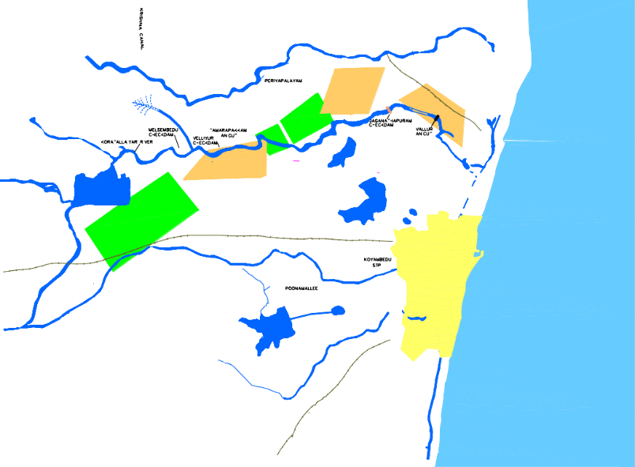
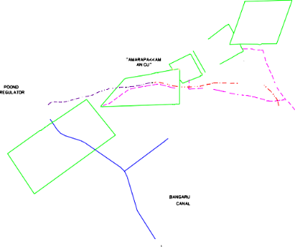
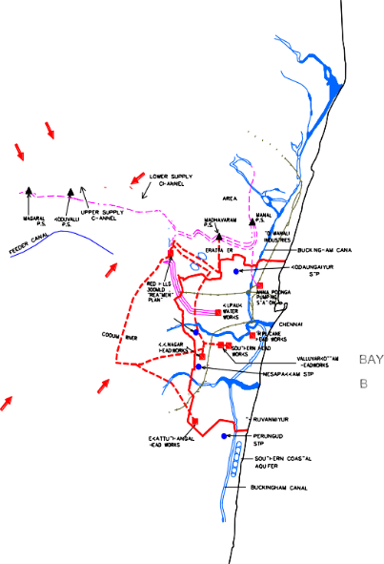
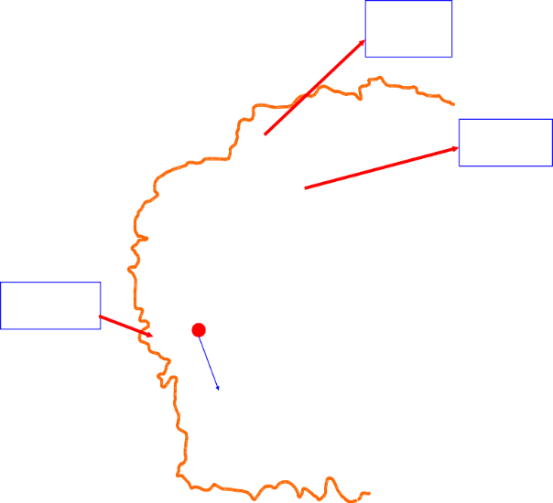
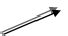
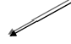
FIGURE 11: Surface, sea, and groundwater sources in Chennai Metropolitan Area (2013)
Capacity
PANJETTY WELL FIELD
881 mcft
KANNIGAIPER WELL FIELD
FLOOD PLAINS WELL FIELDS
100 mld Desalination Plant at Minjur
CHOLAVARAM TANK
MINJUR WELL FEILD
POONDI RESERVOIR
TAMARAPAKKAM WELL FEILD
Capacity
3300 mcft
POONDI WELL FEILD
REDHILLS RESERVOIR
Capacity
3645 mcft
PORUR LAKE
CHEMBARAMBAKKAM
TANK
SRIPERUMPUDUR
Surface water Ground water
TANK
CHENNAI METROPOLITAN AREA BOUNDARY
530 mld
Plant
Sea water
New Veeranam 180 mld pipe line alignment
100 mld Desalination Plant
at Nemmeli under trail run
7
Source Map (Water)
Capacity
3231 mcft

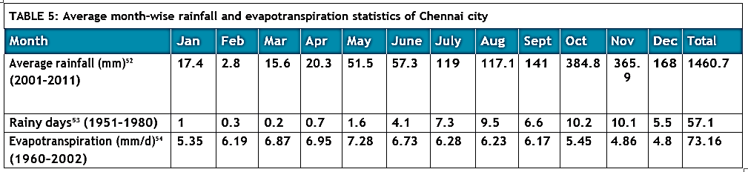
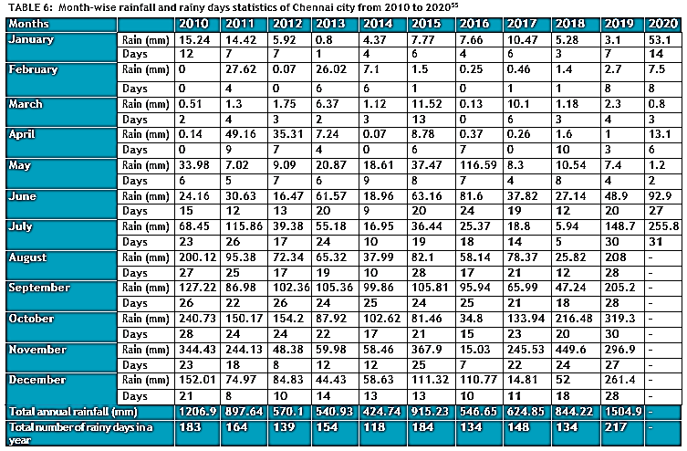
Table 6 illustrates Chennai's rainfall trends from 2010 to 2019, revealing irregular non-monsoon rainfall and increased November rainfall. Monsoon months remain the peak rainfall period, except for the anomaly in May 2016 when heavy rainfall occurred. Fluctuations in annual rainfall led to devastating floods in 2015. Global climate change, including global warming and greenhouse gas emissions, may be contributing to these unpredictable patterns. Unauthorized development and inadequate flood preparedness exacerbate the risk of flooding in CMA, necessitating proactive measures and improved flood management.

Surface Water
Chennai relies on five main surface water sources - Poondi, Cholavaram, Red Hills, Chembarambakkam, and Veeranam lakes (reservoirs) - which get replenished by the annual rainfall. Together, these lakes have a combined capacity of 360.01 MCM, as indicated in Table 7.
TABLE 7: Storage capacity at full reservoir level of surface water sources and capacity of desalination plants (seawater) supplying water to Chennai Metropolitan Area
Source of Water |  | Storage Capacity at Full Reservoir Level (MCM)57
Lakes  (Surface water) | Poondi | 91.43
 | Cholavaram | 30.59
 | Redhills | 93.39
 | Chembarabakkam | 103.15
 | Veeranam | 41.45
Total Combined Capacity |  | 360.01
Desalination Plant  (Seawater) | Minjur | 0.1
 | Nemmeli | 0.1
Chennai's water supply infrastructure features reservoirs including Poondi (initial capacity: 72.8 MCM), Tamaraipakkam anicut, and Cholavaram Lake for diversion. The Veeranam reservoir, operational since 2004, contributes 0.18 MCM daily via Cauvery River and rainwater. An interstate pact allocates 339.6 MCM/year of Krishna river water from Andhra Pradesh to Poondi reservoir. Desalination plants in Minjur and Nemmeli (100 MLD each) enhance resilience. Figure 12 outlines CMA's water flow system from surface and seawater sources.
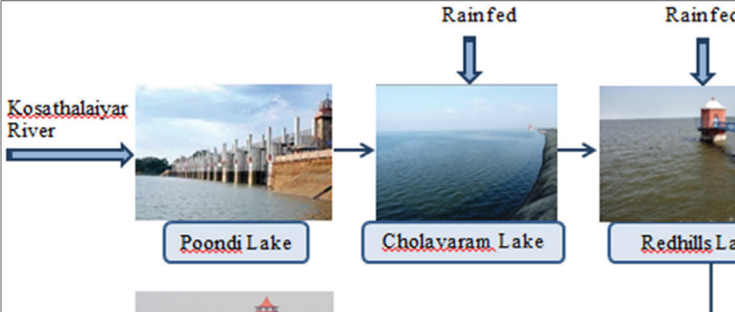
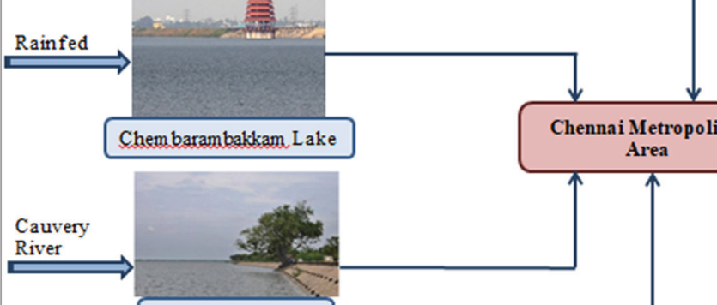
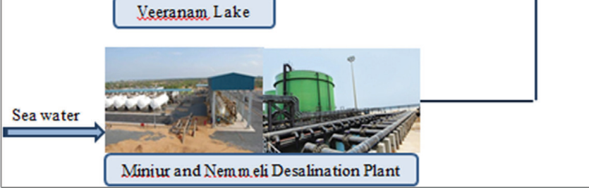
FIGURE 12: Water supply system in Chennai Metropolitan Area from surface and seawater sources
Rainfed
Rainfed
Kosathalaiyar River
Poondi Lake
Cholavaram Lake
Redhills Lake
Rainfed
Chem baram bakkam Lake
Chennai Metropolitan Area
Cauvery River
Veeranam Lake
Sea water
Miniur and Nemmeli Desalination Plant
Tables 8–11 show month-wise live water storage of the four reservoirs located in CMA, that is, Poondi, Cholavaram, Red Hills, and Chembarabakkam from 2011 to 2019.
TABLE 8: Live storage of water in Poondi reservoir in Chennai Metropolitan Area from 2011 to 2020 (in MCM)
Months | 2011 | 2012 | 2013 | 2014 | 2015 | 2016 | 2017 | 2018 | 2019 | 2020
January | 91.4 | 80.3 | 43.04 | 4.16 | 13.7 | 88.1 | 17.4 | 28.6 | 8.43 | 40.3
February | 88 | 86.3 | 38.4 | 7.19 | 6.65 | 74.3 | 20.5 | 39.2 | 5.38 | 44.8
March | 77.3 | 80.9 | 27.9 | 14.8 | 6.65 | 58 | 22.6 | 56.9 | 13.5 | 43.8
April | 71.6 | 72.9 | 11.6 | 2.63 | 2.18 | 54.1 | 4.53 | 45.6 | 9.42 | 40.7
May | 67.4 | 66.4 | 11.4 | 8.32 | 4.3 | 35 | 1.64 | 11.2 | 5.46 | 24
June | 48.1 | 58.8 | 9.54 | 12.1 | 2.7 | 30.1 | 1.104 | 5.2 | 1.58 | 10.6
July | 33.4 | 48.2 | 6.2 | 2.97 | 2.26 | 28.8 | 0.53 | 3.7 | 0.509 | -
August | 50.9 | 26.6 | 5.6 | 2.29 | 1.47 | 18.2 | 0.56 | 1.41 | 0.45 | -
September | 65.4 | 17.3 | 8.69 | 16.2 | 1.67 | 16.1 | 0.76 | 0.36 | 0.45 | -
October | 86.4 | 16.7 | 9.31 | 11.6 | 1.67 | 8 | 1.18 | 2.63 | 16.9 | -
November | 75.4 | 19.6 | 12.9 | 8.09 | 1.98 | 6.4 | 9.4 | 19.6 | 47.6 | -
December | 70.3 | 22.5 | 21.1 | 7.92 | 77.7 | 5.49 | 28.4 | 10.7 | 28 | -
Average | 68.8 | 49.7 | 17.14 | 7.8 | 10.24 | 35.21 | 9.05 | 18.75 | 11.47 | -
The above-mentioned data depicts the storage as on the first day of the month
TABLE 9: Live storage of water in Cholavaram reservoir in Chennai Metropolitan Area from 2011 to 2020 (in MCM)
Months | 2011 | 2012 | 2013 | 2014 | 2015 | 2016 | 2017 | 2018 | 2019 | 2020
January | 23.1 | 24.2 | 13.3 | 4.8 | 3.48 | 20.3 | 2.32 | 14.5 | 1.35 | 1.92
February | 23.7 | 14.01 | 11.2 | 2.6 | 3.19 | 15.09 | 1.95 | 12.7 | 1.35 | 2.03
March | 21.8 | 8.4 | 2.5 | 2.2 | 2.12 | 10.6 | 0.7 | 11.2 | 1.35 | 2.03
April | 19.1 | 2.8 | 2.1 | 1.4 | 1.81 | 7.1 | 0 | 2.8 | 1.18 | 2.03
May | 17.6 | 2.43 | 1.1 | 0.1 | 0.5 | 3.3 | 0 | 1.98 | 0.3 | 2.03
June | 6.1 | 2.3 | 0 | 0.08 | 0 | 2.3 | 0 | 1.92 | 0.02 | 2.03
July | 2.5 | 2.406 | 0 | 0 | 0 | 2.2 | 0 | 1.72 | 0 | -
August | 2.6 | 2.406 | 0 | 0 | 0 | 2.06 | 0 | 0.7 | 0 | -
September | 3.4 | 2.406 | 0 | 0 | 0 | 1.95 | 0.6 | 0.02 | 0 | -
October | 3.9 | 2.6 | 0 | 0 | 0 | 2.8 | 1.01 | 0.2 | 1.5 | -
November | 19.3 | 6.1 | 4 | 1.3 | 0 | 2.03 | 5.09 | 0.5 | 5.4 | -
December | 23.6 | 9.3 | 9.3 | 17.2 | 16.8 | 2.03 | 16.8 | 1.1 | 2.7 | -
Average | 13.89 | 6.61 | 3.62 | 2.47 | 2.32 | 5.982 | 2.37 | 4.1 | 1.26 | -
The above-mentioned data depicts the storage as on the first day of the month.
TABLE 10: Live storage of water in Red Hills reservoir in Chennai Metropolitan Area from 2011 to 2020 (in MCM)
Months | 2011 | 2012 | 2013 | 2014 | 2015 | 2016 | 2017 | 2018 | 2019 | 2020
January | 91.6 | 74.5 | 61.2 | 61.3 | 44.7 | 81 | 12.7 | 44.8 | 26.6 | 69.5
February | 92.1 | 78.4 | 62.6 | 56.4 | 49.3 | 80 | 8.6 | 38.7 | 20.3 | 82.2
March | 87.9 | 72.8 | 61.9 | 63.3 | 51.9 | 76.7 | 20.3 | 33.8 | 14.7 | 71.8
April | 76.5 | 64.8 | 48.8 | 61.6 | 42.5 | 66.4 | 18.2 | 47 | 8.5 | -
May | 64.08 | 51.5 | 35.5 | 49.4 | 38.4 | 53.2 | 11.8 | 50.3 | 3.5 | -
June | 62.4 | 37.3 | 23.2 | 42.6 | 28.5 | 45.6 | 4.7 | 40.4 | 0.08 | 78.7
July | 53.3 | 34 | 13.4 | 36.2 | 19.5 | 34 | 0.5 | 31.7 | 0 | -
August | 49.04 | 39.02 | 9.5 | 26.2 | 12.1 | 30.6 | 0 | 26 | 0 | -
September | 57.1 | 38.9 | 16.2 | 25.2 | 6.8 | 19 | 2.3 | 20.1 | 0 | -
October | 83.7 | 43.5 | 27.6 | 29.5 | 2.3 | 18.6 | 3.8 | 13.5 | 1.5 | -
November | 86.7 | 53.4 | 37.7 | 27.5 | 0.7 | 11.6 | 17.3 | 22.9 | 23.7 | -
December | 85.1 | 55.7 | 52.3 | 37.9 | 79 | 7.5 | 44 | 31.2 | 46.4 | -
Average | 74.12 | 53.65 | 37.49 | 43 | 31.3 | 43.6 | 12.01 | 33.3 | 12.1 | -
The above-mentioned data depicts the storage as on the first day of the month.
TABLE 11: Live storage of water in Chembarambakkam reservoir in Chennai Metropolitan Area from 2011 to 2020 (in MCM)
Months | 2011 | 2012 | 2013 | 2014 | 2015 | 2016 | 2017 | 2018 | 2019 | 2020
January | 88.6 | 79.9 | 35 | 24.7 | 27.4 | 89.2 | 15.2 | 52.1 | 2.8 | 47.9
February | 87.2 | 76.9 | 27.7 | 20.3 | 21.1 | 85.4 | 9.5 | 47.9 | 1.4 | 43.8
March | 77.1 | 67.6 | 40.9 | 22.3 | 20.6 | 80.8 | 4.5 | 42.6 | 0.6 | 56.1
April | 62.5 | 56.3 | 50.2 | 21.1 | 24.4 | 67.3 | 13.1 | 34.4 | 0.2 | -
May | 48.2 | 44.5 | 40.2 | 25.9 | 22.6 | 65.3 | 8.1 | 33.9 | 0.05 | -
June | 51.5 | 33.3 | 28.6 | 35.7 | 16.1 | 65.4 | 2.6 | 34.3 | 0.02 | 56.9
July | 56.1 | 21.4 | 21.4 | 31.2 | 14.4 | 55.9 | 1.3 | 25.6 | 0 | -
August | 69 | 31.7 | 15.7 | 24 | 9.1 | 44.2 | 2.3 | 17.7 | 0 | -
September | 80.5 | 39.7 | 12.6 | 17.9 | 4.6 | 32.4 | 5 | 12.6 | 0 | -
October | 79 | 33.9 | 18.9 | 20.3 | 4.1 | 27.5 | 6.2 | 9.5 | 0.3 | -
November | 77.4 | 33.7 | 21.2 | 34.2 | 6.4 | 16.1 | 17.4 | 6.6 | 2.1 | -
December | 75.6 | 32.3 | 27 | 33.6 | 88.9 | 6.7 | 49.8 | 5.2 | 21.2 | -
Average | 71 | 45.9 | 28.2 | 25.9 | 21.6 | 49.6 | 11.25 | 26.8 | 2.3 | -
The above-mentioned data depicts the storage as on the first day of the month.
Figure 13 highlights the erratic live water storage pattern in Chennai's reservoirs over the last decade, not consistently correlating with increased average annual rainfall intensity. Inconsistent rainfall resulted in extended dry periods, depleting groundwater levels and impacting reservoir storage. Mismanagement of rainwater, encroachments, and unregulated construction in reservoir catchments worsened the situation, limiting water recharge and causing water wastage. The Red Hills, Poondi, and Chembarambakkam reservoirs experienced significant declines in storage, while Cholavaram remained relatively stable. These challenges exacerbate water scarcity issues in the Chennai Metropolitan Area.
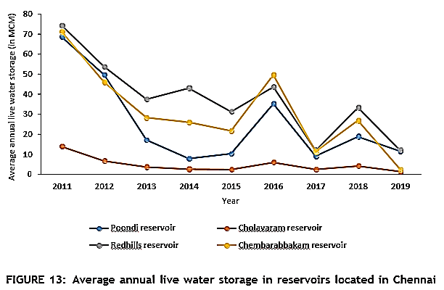
The graph shows a concerning trend of declining water storage levels in the Chennai Metropolitan Area, leading to water shortages. However, post-2015, water storage levels have shown some improvement, possibly due to desilting efforts. Table 12 presents the month-wise live water storage of Veeranam reservoir from 2011 to 2019.
TABLE 12: Live storage of water in Veeranam reservoir in Chennai Metropolitan Area from 2011 to 2020 (in MCM)
Months | 2011 | 2012 | 2013 | 2014 | 2015 | 2016 | 2017 | 2018 | 2019 | 2020
January | 27.6 | 25.8 | 14.1 | 21.6 | 33.8 | 13.8 | 7.1 | 22.8 | 41.1 | 33.1
February | 12.9 | 40 | 3.5 | 36.6 | 39 | 12.9 | 1.9 | 11.5 | 37.9 | 41.1
March | 2.1 | 38.7 | 0.7 | 30.1 | 35.6 | 0 | 0 | 3.1 | 28.6 | 39.2
April | 0 | 20.3 | 6.7 | 20.5 | 23.7 | 0 | 0 | 0 | 16.6 | -
May | 0 | 10.8 | 1.5 | 28.4 | 22.3 | 0 | 0 | 0 | 33.8 | -
June | 0 | 14.1 | 0 | 29.7 | 36.3 | 0 | 0 | 0 | 21.4 | 7.6
July | 0 | 3.1 | 0 | 22.1 | 27.3 | 0 | 0 | 0 | 10.1 | -
August | 14.3 | 2.7 | 0 | 13.2 | 18.5 | 0 | 0 | 0 | 2.7 | -
September | 19.9 | 0 | 32.8 | 17.3 | 27.3 | 0 | 0 | 38 | 35.4 | -
October | 19.4 | 0 | 13.4 | 26.4 | 26.1 | 0 | 0 | 22.8 | 35.9 | -
November | 19.4 | 24.6 | 19.9 | 29 | 27.6 | 0 | 12 | 15.9 | 33.4 | -
December | 19.4 | 12 | 28.4 | 23.7 | 16.2 | 15.7 | 20.3 | 33.4 | 38 | -
Average | 11.25 | 16 | 10 | 24.8 | 27.8 | 3.5 | 3.4 | 12.2 | 27.9 | -
The data for Veeranam reservoir in the last decade shows an undulating pattern of live water storage, influenced by inconsistent rainfall. The reservoir experienced both highs and lows in storage levels between 2011 and 2019. Notably, efforts to enhance rainwater management through desilting waterbodies have yielded positive results, with the average live water storage reaching its highest at 27.9 MCM in 2019. Such interventions are crucial in CMA to improve reservoir storage levels and ensure a sustainable water supply for the region in the face of changing rainfall patterns and water scarcity challenges.
Groundwater
The increasing population and inconsistent rainfall in CMA led to a shift towards groundwater as an alternative water source. Well fields were established, but by 2005, only 12 out of 74 wells remained active, yielding 11 MLD compared to the designed yield of 190 MLD, indicating a decline in groundwater availability.
TABLE 13: Groundwater yield information of well fields located in Chennai Metropolitan Area
Name of Well Field | Number of Wells  Yielding Water | Designed Yield  (MLD) | Average Yield from Wells in  2005 (MLD)
Tamaraipakkam | 2 out of 30 | 50 | 1.6
Panjetty | 1 out of 13 | 41 | 0.08
Minjur | 5 out of 9 | 34 | 3.1
Poondi | 4 out of 12 | 27 | 1.2
Floodplains | 0 out of 5 | 14 | 0
Kannigaipair | 0 out of 5 | 14 | 0.01
Southern coastal aquifers | - | 10 | 5
Total | 12 out of 74 | 190 | 10.99
Excessive groundwater extraction and inadequate recharge have caused a decline in the water table and reduced groundwater yielding capacity in CMA. Table 14 shows block-wise groundwater development, with Minjur classified as "over-exploited," Poonamallee as "dark area," St. Thomas Mount and Cholavaram as "grey areas," and Puzhal, Villivakkam, Sriperumbudur, Kattankulathur, and Kundrathur as "white areas" with lower water extraction.
TABLE 14: Groundwater yields in Chennai Metropolitan Area
Groundwater Source | Yield in 1996 (MLD) |  | Yield in 2006 (MLD)
Northern well fields | 148 |  | 100
Southern coastal aquifers | 10 |  | 5
Stage of Development |  | Category
Greater than 100% |  | Over exploited
85%–100% |  | Dark area
65%–85% |  | Grey area
Less than 65% |  | White area
Table 15 presents detailed information on block-wise groundwater development in CMA. For instance, Minjur exhibits high groundwater exploitation, while St. Thomas Mount and Cholavaram have moderate levels of development. Puzhal and Villivakkam show relatively lower water extraction, while Ponnamalle, Sriperumbudur, Kundrathur, and Kattankulathur fall in between.
Table 15 shows the block-wise groundwater development in CMA. Based on the development
Block | Total Area (km2 ) | Total Annual Groundwater Recharge  (Mm3 ) | Net Annual Groundwater Availability  (Mm3 ) | Existing Gross Groundwater Draft for All  Uses (Mm3 ) | Stage of Groundwater Development  (%)
Minjur | 478.30 | 123.72 | 111.35 | 147.31 | 132
Cholavaram | 193.69 | 98.40 | 88.56 | 68.43 | 77
Puzhal | 60.41 | 34.87 | 31.38 | 16.01 | 51
Villivakkam | 175.78 | 60.65 | 54.59 | 28.72 | 53
Ponnamalle | 156.13 | 72.01 | 64.81 | 57.39 | 89
Sriperumbudur | 365.69 | 134.03 | 120.62 | 23.74 | 20
Kundrathur | 270.38 | 87.66 | 78.90 | 45.26 | 57
St.Thomas  Mount | 236.51 | 41.61 | 37.45 | 23.85 | 64
Kattankulathur | 361.76 | 83.40 | 75.06 | 45.49 | 61
Table 16 highlights the net groundwater availability in the Chennai district basin for 2013, which was found to be lower than in 2011. All 20 firkas in the Chennai district were classified as "over-exploited," indicating a critical situation in groundwater availability and highlighting the urgent need for sustainable water management practices in the region.
TABLE 16: Groundwater availability and draft information of Chennai district
District | 2011 |  | 2013
 | Net Groundwater  Availability (ham) | Groundwater  Draft (ham) | Net Groundwater  Availability (ham) | Groundwater  Draft (ham)
Chennai | 1707 | 3780 | 1497 | 2768
Chennai's groundwater recharge zone is found about 3 meters below the ground near the coast, with varying depths of 4 to 23 meters in different areas. The south-eastern region, with less permeable crystalline rocks, poses challenges for recharge. Groundwater quality is heterogeneous due to diverse rock formations, leading to alkaline water with high chloride and sulfate levels, rendering it unsuitable for drinking. Artificial recharge techniques can help improve groundwater quality and ensure sustainable management of this crucial resource in Chennai.
4.2 Water and Wastewater Treatment Infrastructure
The Chennai Metropolitan Water Supply and Sewerage Board manages the city's water supply infrastructure. Water is sourced from Poondi and Cholavaram reservoirs and treated at Kilpauk, Puzhal, and Surapet Water Treatment Plants before distribution in CMA.4.2.1 Water Treatment Plants
Current Scenario
Two new lakes, Chembarambakkam and Veeranam, were identified for water supply in the early 2000s. Water from these lakes is treated at Chembarambakkam and Vadakuthu WTPs to meet growing demands. Dedicated wastewater treatment plants effectively treat and discharge wastewater back into the rivers.
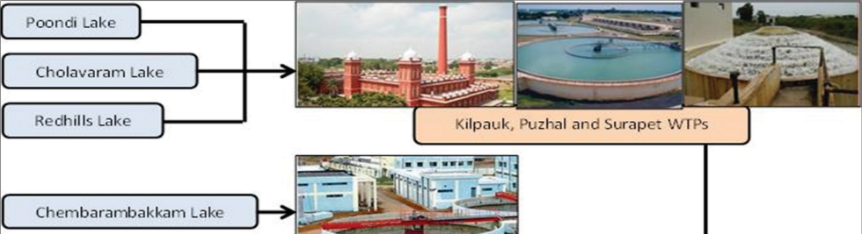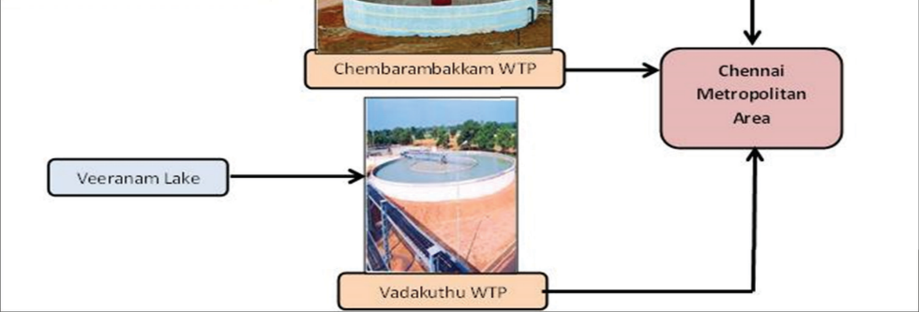
Poondi Lake
Cholavaram Lake Redhills Lake
Kilpauk, Puzhal and Surapet WTPs
Chembarambakkam Lake
Chembarambakkam WTP
Veeranam Lake
Vadakuthu WTP
Chennai metropolitan Area

There are five WTPs in CMA with combined water treatment capacity of 1294 MLD, as given in Table 17.
TABLE 17: Water treatment plants in Chennai Metropolitan Area with their treatment capacities
S. No. | Water Treatment Plant | Capacity (MLD)
1 | Kilpauk | 270
2 | Puzhal | 300
3 | Surapet | 14
4 | Chembarambakkam | 530
5 | Vadakuthu | 180
 | Total | 1294
4.2.2 Sewage Treatment Plants
Historical Background
The sewage system in Chennai has a long history, dating back to 1910, designed for a population of 6.6 lakhs by 1961. It underwent upgrades over the years, serving the growing population of 27.2 lakhs by 1991. Managed by CMWSSB, it includes sewer lines covering 5200 km and open drains spanning 1894 km. The city's sewage network divides into five zones, each with its collection, conveyance, treatment, and disposal system. Chennai has 12 STPs, generating bio-gas utilized for operations, leading to energy cost savings and reduced greenhouse gas emissions through Clean Development Mechanism adoption.
4.2.4 Water Quality of Waterways Carrying Wastewater
Chennai's major waterways, including Cooum, Adayar, Buckingham Canal, and Otteri Nullah, face degradation due to untreated sewage discharge, population growth, waste disposal, and encroachments. The drainage system consists of rivers, waterways, and drains that serve as flood carriers but also carry sewage. This leads to sludge accumulation, sandbars, and challenges for flood protection, stormwater drains, and public health. Urgent interventions are needed to improve the sewage disposal network and restore water quality, necessitating a comprehensive study to identify gaps and develop effective solutions for the health of these vital water bodies.
5. SUMMARY AND CONCLUSION
The analysis of water resources in the Chennai Metropolitan Area (CMA) reveals several critical challenges and potential opportunities. Rapid urban growth and economic development are increasing the demand for housing and civic amenities, including water supply. However, this growth is leading to the development of slums, posing a challenge in providing adequate water connections to lower-income areas. Industrialization and urban expansion are exerting pressure on land and water resources, affecting the ecological balance. Shrinking water bodies due to encroachments and waste disposal contribute to intensify flooding during monsoons. Significant water consumption by residential, commercial, and industrial sectors, coupled with declining agriculture, demands alternative water sources like reclaimed water. Unpredictable rainfall patterns affect water storage in reservoirs, necessitating strategies to address water scarcity, including treated sewage water utilization and water-efficient technologies. Groundwater depletion is concerning, and the lack of up-to-date data hampers understanding of water usage. Improved water meter coverage through initiatives like the Smart Cities Mission will enhance monitoring. Water quality in rivers and lakes is deteriorating due to untreated sewage and industrial wastewater discharge. Rejuvenating these water bodies can serve as potential alternative sources if pollution is addressed. Addressing these challenges and exploring opportunities is vital for building a water-secure and sustainable future for the CMA.
6. REFERENCES
- Lakshmi, K. "The vanishing waterbodies of Chennai". The Hindu. Chennai: Kasturi & Sons. p. 2. Retrieved 21 October 2018.
- Srinivasan, M. S."Desalination: Answer to Chennai's water woes". Business Line. Chennai: Kasturi & Sons. Retrieved 21 July 2013.
- Mariappan, Julie."As population surges, Chennai's water needs to double in 3 years". The Times of India. Chennai: The Times Group. Retrieved 9 August 2014.
- Lakshmi, K. "Metrowater to fathom needs of merged areas". The Hindu. Chennai: Kasturi & Sons. Retrieved 21 July 2013.
- Lakshmi, K."Water level in reservoirs goes up over past ten days". The Hindu. Chennai: Kasturi & Sons. Retrieved 15 December 2012.
- Thooyavan, Kr. "River basins, not stretches, should be looked at". XX (4). Retrieved 14 July 2013.
- Mariappan, Julie"Public consultation for Adyar river restoration to be held in Chennai on Wednesday". The Times of India. Chennai: The Times Group. Retrieved 18 February 2014.
- Lakshmi, K."Rains replenish city's reservoirs". The Hindu. Chennai: Kasturi & Sons. Retrieved 14 July 2013.
- Jump up to:ª ^{b} "State moves Centre for fifth reservoir in Chennai". The Times of India. Chennai: The Times Group. 21 November 2012. Retrieved 14 July 2013.
- "Chennai: new plant to ensure water supply". IBN Live. Chennai: The New Indian Express. 12 June 2012. Archived from the original on 14 July 2013. Retrieved 14 July 2013.
- "Nemmeli desal plant generates at full capacity". The Hindu. Chennai: Kasturi & Sons. 23 December 2013. Retrieved 21 March 2014.
- Ramakrishnan, T. (11 September 2017). "Well-maintained tanks can bail out city". The Hindu. Chennai: Kasturi & Sons. Retrieved 30 September 2017.
- "To tackle water crisis, Metrowater pitches in". The Hindu. Chennai: Kasturi & Sons. 16 October 2018. Retrieved 16 October 2018.
- The Energy and Resources Institute (TERI) 2013. Water Sustainability Assessment of Chennai Metropolitan Area.
- Narmada K and B Govindarajan. 2017. Multi-temporal analysis and quantification of the carbon stocks in the urban forests of Chennai Metropolitan Area using geoinformatics techniques to identify their role in climate change mitigation. Geoinformatics & Geostatistics: An Overview. doi: 05.10.4172/2327-4581.1000172
- Geographical and physical features. Chennai District. Archived from the original on 30 July 2013. Retrieved 28 December 2012
- Department of Economics and Statistics, Government of Tamil Nadu. District Statistical Handbook Chennai District 2016-17
- ENVIS Centre, Department of Environment, Government of Tamil Nadu. State of Environment Report of Chennai Metropolitan Area, 2013.
- Prof. Dr. S.P. Sekar and S. Kanchanamala. 2011. An analysis of growth dynamics in Chennai Metropolitan Area. Institute of Town Planners, India Journal 8–4, October–December, 31–57
- Sikarwar, A and A Chattopadhyay. 2016. Change in land use-land cover and population dynamics: A town-level Study of Ahmedabad city sub-District of Gujarat. International Journal of Geomatics and Geosciences. 7
- Devendran, A A and G Lakshmanan. 2019. Comparison of urban growth modeling using deep belief and neural network based cellular automata model—a case study of Chennai Metropolitan Area, Tamil Nadu, India. Journal of Geographic Information System. 11: 1–16
- Mathan, M and M Krishnaveni. 2019. Monitoring spatio-temporal dynamics of urban and peri-urban land transitions using ensemble of remote sensing spectral indices: A case study of Chennai Metropolitan Area, India. Environmental Monitoring and Assessment
- Mathan, M and M Krishnaveni. 2019. Monitoring spatio-temporal dynamics of urban and peri-urban land transitions using ensemble of remote sensing spectral indices—a case study of Chennai Metropolitan Area, India. Environmental Monitoring and Assessment
- District Statistical Handbook Chennai District 2016-17 & 2011, Department of Economics and Statistics, Government of Tamil Nadu
- An analysis of growth dynamics in Chennai Metropolitan Area, 2020, Institute of Town Planners. India Journal 8-4.
- An analysis of growth dynamics in Chennai Metropolitan Area, ., 2021. Institute of Town Planners, India Journal 8-4
- State of Environment Report of Chennai Metropolitan Area, 2013, Envis Centre, Department of Environment, Government of Tamil Nadu
- Sikarwar, A and A Chattopadhyay. 2016. Change in land use-land cover and population dynamics: A town-level Study of Ahmedabad city sub-District of Gujarat. International Journal of Geomatics and Geosciences.
- Resettlement and rehabilitation of objectionable slums on waterways – Role of TNSCB report. Thiru T.K. Ramachandran, TNSCB
- District Statistical Handbook Chennai District 2016-17, Department of Economics and Statistics, Government of Tamil Nadu
- State of Environment Report of Chennai Metropolitan Area 2013, ENVIS Centre, Department of Environment, Government of Tamil Nadu.
- Climatological Table of observations in India, IMD.
- Boyaj, A, K Ashok, S Ghosh, A Devanand, and G Dandu.2018. The Chennai extreme rainfall event in 2015: The Bay of Bengal connection. Clim Dyn 50: 2867–2879
- Excreta Matters Vol. 2, State of India’s Environment, A Citizen’s Report, Centre for Science and Environment, 2012.
- K.R.Sivaraman and Dr. S. Thillaigovindarajan, Chennai River Basin Micro Level Report, 2020
- State Ground and Surface Water Resources Data Centre 2003
- Report on AQUIFER MAPPING AND GROUND WATER MANAGEMENT, Chennai Aquifer System, Tamil Nadu, CGWB, March 2017.

