"Towards a Greener Future: The Importance of Green Banking in Sustainable Development"
¹Dr Sofia Ahmed Sait and ²Lekha Kasmir
¹Assistant Professor, Department of Commerce, Loyola Academy Degree and PG College, Telangana, Email id: sofiamaqbool@ymail.com, Ph: 8309754653
2Assistant Professor, Department of Management, Baselios Centre for Management Studies, Baselios Mathews II College of Engineering, APJ Abdul Kalam Technological University, Email id: lekhakasmir@gmail.com, Ph: 8289917370
Abstract
As a result of the comforts and luxuries that globalization, technical advancement, and economic growth have brought to human life, there has been a significant loss of biodiversity, environmental degradation from climate change, resource depletion, and loss of greenery. Environmental protection and sustainable development are regarded as crucial steps in the protection of our planet. In order to survive, change is vital, and ongoing efforts must be made to manage the environment sustainably. The role that financial institutions play in the country's economic development and progress, both in terms of number and quality, is a factor. One of the main sources of finance for investments, the banking sector is in charge of overseeing the nation's economic activity.
One of the main sources of finance for investments, the banking sector is in charge of overseeing the nation's economic activity. Green banking is a concept in which banks work to improve the environment and encourage greener business practices.It seeks to maximize environmental impact by using IT and physical infrastructure to make banking operations as efficient and effective as possible. This essay aims to examine the application of green banking.In order to promote sustainable development, it seeks to understand the significance of green banking.
Keywords: green banking, sustainable development, green finance, climate change.

INTRODUCTION

Finance is considered as a life blood of business enterprise. Similarly every firm depends directly or indirectly depends on the financial institutions for purpose of fund. Among these financial institutions banks are the major source of providing finance. These financial institutions affect the economic growth and development of country both in terms of quality and quantity. Bank helps in encouraging environmental protection by investing in environmentally and socially responsible projects that save costs, minimize risk, enhance bank reputation and also contribute the customary good that will help to build the sustainability development. This helps bank to serve its both commercial as well as social objective. Sustainable development and preservation of environment are considered to be globally important, as an initiative to protect our planet.
The report submitted by world commission in the year 1987 on environment and development mentioned about the environmental protection. It mentioned that in developing country like India the environmental protection and growth of the economy are interrelated
The problem related to environment, ecological balance and environment sustainability has become an issue around the world. The consumers as well as organizations have understood the importance of environment for survival of human beings. So for protection of the environment the green movement was begun. The main focus is on reducing the demand of fossil fuels by implementing the 3 R’s viz reduce, reuse and recycle. All over the world institutions are concerned with the depletion of environment. Green banking is a part of India’s Mission to “Go Green “and it plays Avery important role to include environment and ecological aspect as its main principle. Green banking is considered to be a new development in the finance world. Green banking means promoting environmental friendly practices and reducing the usage of carbon footprints from banking activities. It can also be said as combining the operational movements, technologies, and changing the habits of clients in the banking business. Such form of banking takes into account the social and environmental aspect and its main motive is to protect and preserve environment. Foreign banks are practicing green banking very seriously. Whereas the Indian banks are still taking baby steps in such form of banking. In December 2007, Reserve bank of India highlighted the banks to contribute to sustainable development.
REVIEW OF LITERATURE
(Mortgage & Loan, 2015)In their study ‘green banking in India : A study on various strategies adopted by banks for sustainable development emphasized on recent development made by the banks for adoption of sustainable development and challenges faced by the banks in its implementation . The findings of the study states that there is utmost need for creating awareness among people. He study suggests providing environmental friendly awards to those customers who are promoting and using green banking. The study also focuses on reducing carbon emission by reducing paper and energy.
(Tara, Singh, & Kumar, 2015)In their paper Green banking for environmental management: A paradigm shift studied about the green banking philosophy adopted by banks. The paper viewed guidelines for environmental conservation and sustainability along with the initiatives taken by state bank of India, ICICI. The study state the current situation of banks after adopting green banking. It states that there has been a positive effect of green banking on all customers as well as bank and the society.
(Sahoo, Singh, & Jain, 2016)Studied green banking in India: problems and prospects. In their study they have linked the performance of the banks with their performance. They have found there exist positive relationship among the performance of banks for adoption of green banking.
(Ahmad, Zayed, & Harun, 2013)In their study factors behind the adoption of green banking by Bangladeshi commercial banks. they applied factor analysis in their study and findings revealed that six factors namely economic factor, policy guideline, loan demand, stakeholder pressure, environmental interest, and legal factor were the major factors behind the green banking adoption in Bangladesh
(Giramkar, 2018)Conducted a study on sustainable green banking in India. The study showed that that customer is ready to go green and concerned about the environmental protection. They are willing to take an initiative of going green along others who have already started the practice of going green. Green construct as a construct of socially influence dimension significantly influence the use of internet banking. The study also stated that word of mouth also influence the usage of internet banking.
(Gorakhpur & Pradesh, 2016) In their study on the title Green banking practices and their impact to reduce stress in public sector banks. the study aims to identify the opinion and awareness of bank employees and customers as regard to green banking practices in public sector banks. The result of the study states that it had positive impact in reducing the stress of bank employees and helped the bank to maintain sustainable environment.
OBJECTIVES OF THE STUDY
- To understand the concept of Green banking
- To understand the importance and role of green banking in the term of sustainable development.
- To understand the various types of strategies used by different banks in India as a part of green banking
- To find out the difficulties faced by the customers while using the green banking services.
SIGNIFICANCE OF THE STUDY
People have been able to transition to more comfortable lifestyles thanks to this era of globalization and industrialization. While it is assisting individuals in making their work easier on the one hand, it also poses a serious threat to the environment. India's banking industry has advanced to the point where profit is now the sole important consideration. where there is a deficit in social responsibility. The banking sector has started looking for potential solutions to the government's severe environmental protection regulations. "Green banking" is one such move taken in this approach. A recent development in the finance industry is green banking. The United States is where the concept of green finance first emerged, and many other nations have adopted it. The phrase "green banking" refers to a collection of laws and regulations that enable banks to be sustainable in both the economic and social spheres. It also strives to minimize or eliminate any environmental impact associated with banking operations, IT use, and the use of physical infrastructure. In order to pursue new prospects, Enterprise is now interested in developing and putting into action plans that will improve the environment. There are various motivations to go green, some of which include rising energy usage, rising customer interest in eco-friendly products and services, and tight government laws and compliance. Banks indirectly impact the environment. Therefore, it is crucial to comprehend the necessity for sustainable banking operations. To grow green banking in India, new strategies must be developed.
METHODOLOGY
The paper is mainly conceptual and descriptive in nature and it is based on the different
research papers, journals, articles related to merger and acquisition available over internet
based sources. Various other related books and journals which are available in physical form
are also accessed to develop the foundation of the paper. The present paper is based on the
literature available on health care in India
The work is conceptual and descriptive in nature and is based on numerous research papers, journals, and articles on green banking and sustainable development that can be found online. To lay the groundwork for the paper, numerous other pertinent physical copies of books and periodicals were also consulted.
THEORETICAL FRAMEWORK
Banking that promotes sustainable development in a nation sets green banking apart from standard banking. Green banking is seen as a recent development in the financial industry that focuses on socially and environmentally responsible investing. Worldwide, there is a serious problem with global warming that is destroying resources for land, water, and people. Concern over the depletion of natural resources has led to organizations beginning to practice corporate social responsibility. They have begun working while considering the impact on the environment. Green banking is a bank endeavor to promote environmentally friendly projects and give preferential lending to sectors that have already gone green or are making efforts to do so. Using biodegradable materials and improving energy efficiency are two goals of turning green. Banks have begun offering their services to consumers around-the-clock. The establishment of bank accounts, making bill payments online, making investments online, and using ATMs are only a few of the services offered by banks.
"Green banks are normal banks that take into account all social, environmental, and ecological factors with a motive to protect the environment and conserve natural resources," according to the Indian Bank Association (IBA, 2014). An ethical bank or sustainable bank is frequently referred to as a "green bank."
Green finance is advantageous to everyone in general. Consumers, businesses, and the economy gain from it. By giving customers the option to use online services through online and mobile banking for deposits and loans, green banking would benefit consumers. Banks are giving clients who use green banking better deposit rates. By imposing reduced interest rates on mortgages, it also benefits the clients. The implementation of green banking services will result in paperless operations, energy savings, etc. The global economy greatly benefits from green banking.
ANALYSIS AND FINDINGS
A viable business concept for sustainable banking is green banking. The different banking business methods used by banks are
- Carbon Credit
A carbon credit is a certificate that may be traded that entitles the owner to emit one ton of carbon dioxide or an equivalent amount of greenhouse gas. In accordance with the Kyoto Protocol, all countries are required to cut greenhouse gas emissions in order to protect the environment. Carbon credits (also known as CERs, or Certified Emission Reductions, or CERs) must certify these emissions. This company may be launched by the banking industry.
2. Financial services related to green banking
Banks can create novel green financial products and provide low-interest green loans. By doing this, they can encourage their clients to adopt a greener lifestyle.Evaluating the importance of women in Financial decision making
3. Online banking.
All banks are transitioning to offering their consumers online services. They offer services and goods related to electronics. As a result, banks have the potential to go paperless or use less paper than PSUs, which use a lot of paper.
4. Energy awareness
Banks must make an effort to use energy-efficient office equipment. Banks need to update their workplace waste disposal systems, energy-efficient technological products, and green banking hardware.
5. Making use of the transit system
To ensure that everyone working in the same office has access to a shared transportation system, banks must
6. Green structures
Branches, ATMs, and residential homes are all owned by banks. Additionally, banks must practice green banking and work to keep them safe.
7. Plantation
Plantation As part of their social obligation, numerous banks run plantation initiatives.In this program, local schools and universities receive many trees and grass plants as well as education about environmental protection.
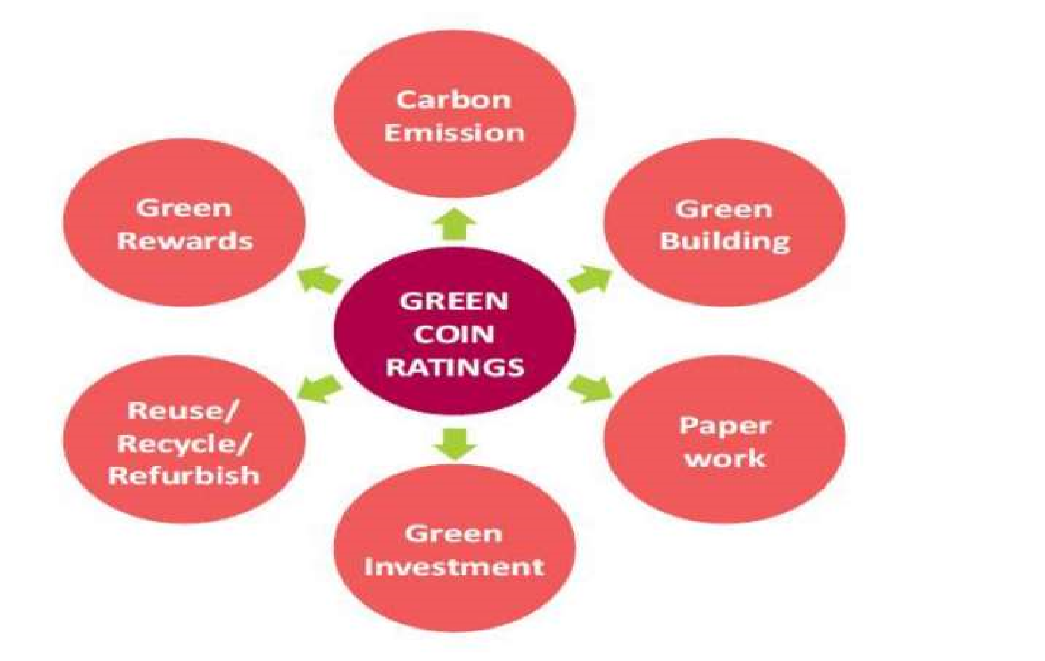
Role of green banking
Like any other business, banks have an impact on the environment. While banks use a lot of stationary, paper, electricity, air conditioners, and other electrical equipment during regular business hours, they contribute relatively little to overall carbon emissions when compared to other heavy industries like steel, oil, and gas. Through financial intermediaries who have an external impact on the environment, banks have an indirect impact on the environment. As banks are a significant source of funding for several businesses that severely harm the environment, such as cement, fertilizers, nuclear power, oil, gas, and electricity. Banks, who are a significant source of funding, should take an active role in preserving the environment and make investments that will be sustainable and advantageous to the environment. Banks should try to minimize the carbon emissions they directly or indirectly produce. Credit risk, legal risk, and reputational risk could result from the banks' improper lending decisions in light of environmental factors.
Threat to credit
When banks extend credit to businesses whose operations are negatively impacted by changes in environmental rules, credit risk may result. Companies may cease operations in order to adapt to environmental changes. When a bank makes loans to owners of real estate whose properties have lost value due to changes in environmental rules, credit risk may also result.
Legal hazard
If the bank does not adhere to the environmental standards, they put themselves at risk.Due to loan default or possession of collateral property under SARFARASI, the banks may also be at legal peril. Banks may be able to mitigate risk to some extent by implementing an effective proactive management system. Reputation risk If banks adopt a sizable project that pollutes the environment and has an adverse impact on the environment, they risk losing their good name. Additionally, if banks give loans to businesses that significantly harm the environment, they may be forced to close by public pressure.
Role of green banking in sustainable development
By spreading knowledge and providing education, green banking may benefit a large number of people. Sustainable development can be attained with the aid of green banking.People can raise their level of awareness through conversation. The target audiences and the means of communication might be the initial phase in the communication process. The internal system and the external system can be separated for communication purposes. While the external system is concerned with websites, roadshows, event meetings, benchmarking, media, etc., the internal system can be used to raise awareness through the publication of weekly green news on the internet, high level meetings, the bank's newsletter, publication, etc. and the targeted groups are managers. The target group, however, is the general public and clients. Interactive electronic media can be used to spread communication to people.
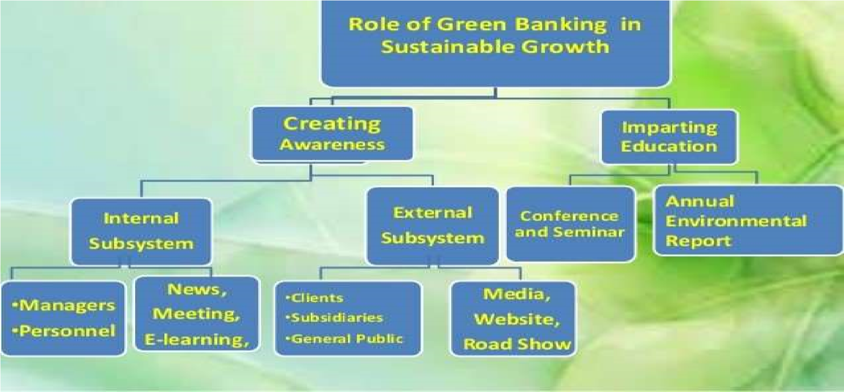
Contributions made by banks in India

Several Indian banks have embraced numerous green banking projects. The actions taken by different banks are

ICICI Bank Go Green Initiative
The "Go Green" concept spans the entire company. The goal of this effort is to create a healthy workplace environment.
The main goal of ICICI is to promote both internal and external investment in private businesses. to promote private investment in industrial projects. The banks have introduced a range of services to help with the green environment aim. Customers can use the Instabanking service to evaluate bank services at any time and from any location. IVR banking, net banking, and mobile banking are all included. Banks can lessen their carbon footprint thanks to it. One was also introduced by ICICI Bank. It consists of online banking, telephone banking, and mobile banking. By doing so, banks can lessen their carbon footprint. Additionally, ICICI Bank has created a program under which it will eliminate 50% of costs for customers who purchase energy-saving products and use alternative energy sources. For customers who buy LEED-certified properties, the bank has significantly lowered processing costs. The purpose of ICICI's celebration of environment day is to raise people's awareness of the issue.
IDBI bank.
The IDBI is a specialized organization that advises customers on carbon credits, clean development mechanisms, Kyoto Protocol carbon credits, and voluntary emission reduction. IDBI has agreements with a number of multilateral organizations.
SBI
SBI offers home lending programs that assist environmentally friendly housing projects and lower interest rates. "Indusland Bank"
They are encouraging and supporting environmental financing programs. The bank's "Human and Hariyali" campaign led to the introduction of solar-powered ATMs. The banks should save 1980 kwh of electricity each year.
The Axis Bank
Banks now offer the option of an electronic statement. Banks are giving one notebook to the underprivileged and needy for every electronic statement from a customer.
Yes bank
First Indian private bank to sign the UNEP declarations on the environment and sustainable development is Yes Bank. The first bank to disclose a carbon disclosure programme is Yes Bank.
Difficulties faced by customers while using green banking
- Since green banking is a relatively new concept. It is challenging for the clients to adopt it while it is just getting started.
- In order to properly serve its consumers, green banking needed highly technical and experienced employees, which comes at a significant cost of operation.
- Green banking calls for expensive but renewable and recycling solutions.
- Green finance suffers a difficulty with diversification. Due to the fact that green banking only allows consumers who pass their screening process to transact with them.
CONCLUSION
Every nation's banking sector is regarded as its lifeblood. The world has become a global financial market thanks in large part to the banking industry. The world is advancing toward new technology, which is easing human labor and causing man-made environmental catastrophe. Therefore, the globe has made the decision to "go green" in order to safeguard the environment. This is an eco-friendly strategy that helps to protect sustainable development while also lowering the carbon footprint. The latest trend in the financial industry is green banking. A broad word used to describe techniques, tactics, and principles used by banks to safeguard the environment in both the economic and social spheres is "green banking." Thus, the study was conducted to learn more about the idea of green banking. The study's main goal was to identify the green banking-related business strategies used by banks. The study found that banks and financial institutions ought to concentrate more on disseminating information about the environment. Thus, green banking is the way of the future, and it will be advantageous to businesses, consumers, and society as a whole.
REFERENCES
Mortgage, G., & Loan, G. (2015). Green Banking in India : A Study of Various Strategies Adopt by Banks for Sustainable Development. 3(10), 1–10.
Sahoo, B., Singh, A., & Jain, N. (2016). Green Banking In India: Problems And Prospects.
International Journal of Research -Granthaalayah, 4(8), pp.92-99. https://doi.org/10.5281/zenodo.61169
Tara, K., Singh, S., & Kumar, R. (2015). Green Banking for Environmental Management: A Paradigm Shift. Current World Environment, 10(3), 1029–1038. Retrieved from https://doi.org/10.12944/cwe.10.3.36
Ahmad, F., Zayed, N. M., & Harun, M. A. (2013). Factors behind the Adoption of Green Banking by Bangladeshi Commercial Banks. ASA University Review, 7(2), 241–255. Retrieved from https://pdfs.semanticscholar.org/

Giramkar, S. (2018). Green Banking in India: a Study for Sustainable Devlopment. (September),
138–152. Retrieved from https://doi.org/10.20472/efc.2018.010.010
Gorakhpur, D. D. U., & Pradesh, U. (2016). Green Banking Practices and Their Impact To Reduce Stress in Public Sector Banks. (April), 294–296.

