POLYCYSTIC OVARY SYNDROME (PCOS) AND ITS HEALTH CARE STRATEGIES
Sanasam Birjeni Devi
Department of Nursing, Bareilly International University, Bareilly, Uttar Pradesh, 243006, INDIA
E-mail: sanasambirjenidevi@gmail.com

ABSTRACT:
Polycystic ovary syndrome (PCOS) is a condition characterized by elevated levels of the male hormone called androgen and the presence of multiple small fluid-filled cysts in the ovaries. This condition affects approximately 5-18% of reproductive women and has lifelong implications on reproductive, metabolic, and psychological well-being. While the exact cause of PCOS remains unknown, it is believed to have genetic and epigenetic components. According to the Rotterdam criteria established in 2003, PCOS is diagnosed when at least two of the following criteria are met: hyperandrogenism, ovulatory dysfunction, and polycystic ovaries. Women with PCOS are at an increased risk of developing serious health problems such as type 2 diabetes, hypertension, cardiovascular diseases, and even uterine cancer. Additionally, they often face challenges in conceiving, leading to infertility. Medical care for PCOS involves addressing irregular menstruation, treating hirsutism, managing infertility, and addressing insulin resistance. Treatment options may include lifestyle modifications (e.g., dietary changes, exercise, yoga, and stress management) or medication. PCOS is a chronic condition that significantly impacts both health and economic well-being. However, certain symptoms can be mitigated through lifestyle modifications and appropriate medical interventions.
Keywords: Polycystic ovary syndrome, PCOS, lifestyle modification, Health care strategies
INTRODUCTION:
Polycystic ovary syndrome (PCOS) is a complex and heterogeneous condition characterized by the overproduction of androgens (male sex hormones) by the ovaries. Typically, women have low levels of these hormones. However, in PCOS, excessive androgen production leads to the development of multiple small cysts on the outer edge of the ovaries. This hormonal imbalance results in various issues, including irregular menstrual periods, excessive hair growth, acne, and infertility. Treatment for PCOS may involve the use of medications, lifestyle modifications, or a combination of both approaches.
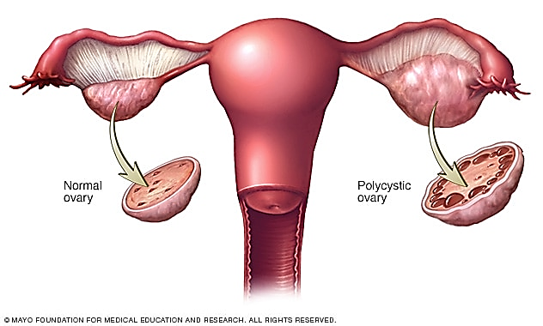Fig.1: Normal ovary vs Polycystic ovary

Definition:
PCOS, or Polycystic Ovary Syndrome, is a hormonal disorder
that impacts a significant number of women in their
reproductive age group
Causes:
The exact cause of PCOS is unknown. Some other causes of
PCOS include-
- High level of Androgens
- High levels of insulin and Obesity
- Low-grade inflammation
- Heredity

Common Symptoms:
Symptoms include-
- Excessive hirsutism (body hair growth)
- Weight increase and challenges in weight loss
- Presence of ovarian cysts
- Irregular or absent menstrual cycles
- Androgenic alopecia or thinning hair
- Elevated levels of testosterone
- Insulin resistance
- Fatigue
- Acne breakouts
- Mood fluctuations
- Difficulty conceiving or infertility

Diagnosis:
Some of the tests commonly used for diagnosis may include:
- Thyroid function test
- Fasting glucose test
- Lipid level test
- vaginal ultrasound
HEALTH CARE STRATEGIES:
- DIET:
1. A low glycaemic index (GI) diet (Fig: 2.1):  The diet does not lead to a swift and substantial rise in insulin levels compared to other foods. It mainly comprises the following food groups:  - Seeds  - Fruits  - Potatoes and root vegetables  - Other unrefined Low-Carbohydrate Foods  - Whole Grains  - pulses  - Nuts | 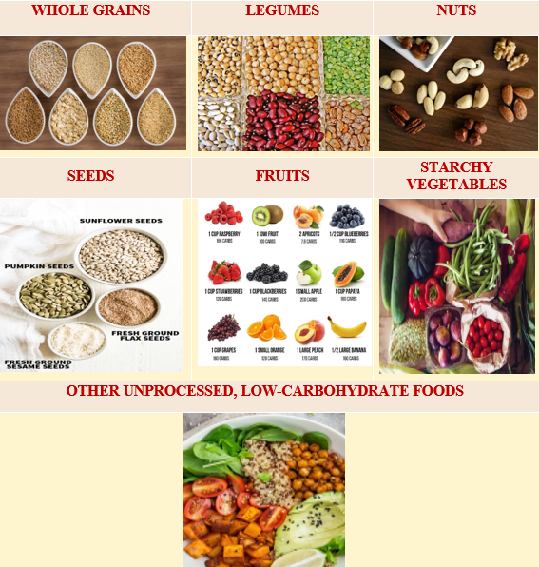  Fig. 2.1: low Glycaemic Index (GI) diet
2. An anti-inflammatory diet (2.2):  Anti-inflammatory foods, including:  - Berries  - Fatty Fish  - Green Leafy Vegetables  - Extra Virgin Olive Oil | 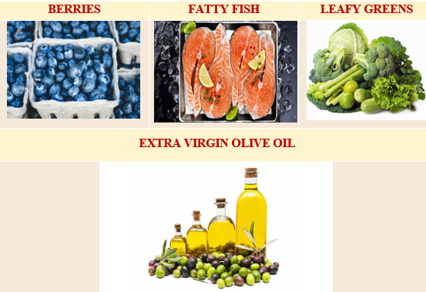  Fig. 2.2: Anti-inflammatory diet
3. The DASH diet (Fig.2.3):  The DASH diet provides advantages for heart disease risk and has the potential to lower insulin levels in PCOS patients. It should consist of:  - Various Fruits and Vegetables  - Whole Grains Fish and Poultry  - Legumes  - Nuts and Seeds  - Low-Fat Dairy Product | 4. Fibre (Fig. 2.4):  It lowers insulin levels and works as an antioxidant which fights to reduce inflammation and improves gut bacteria.  - Seeds  - Legumes  - Berries  - Whole Grains
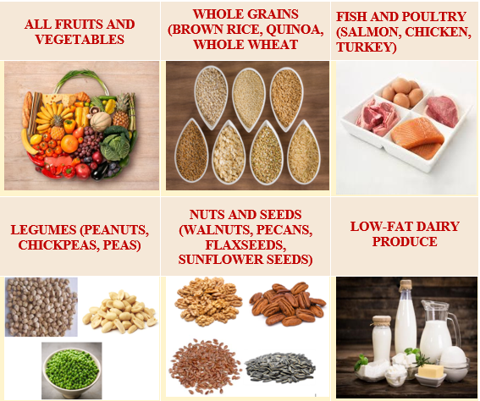  Fig. 2.3: DASH Diet | 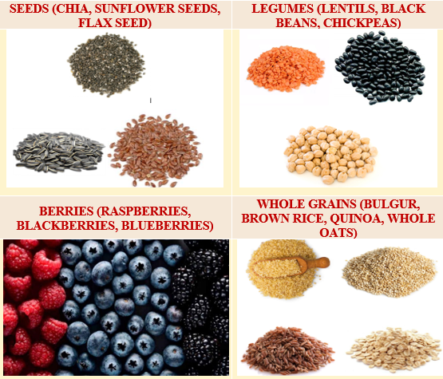  Fig. 2.4: Fibre Diet
5. Lean protein (Fig. 2.5):  Lean protein could aid in weight loss and prolong your feeling of fullness. It includes-  - Fish  - Lean Poultry  - Plant Protein | 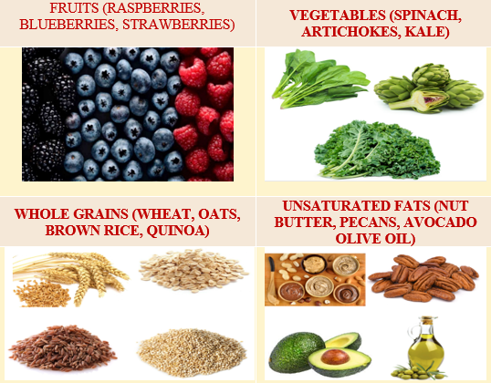  Fig. 2.5: Lean Protein
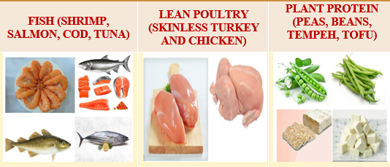  Fig. 2.6: Antioxidant heavy foods | 6. Antioxidant-heavy foods (Fig. 2.6):  The best inflammation-fighting antioxidant-filled foods include-  - Fruits  - Whole Grains  - Unsaturated Fats  - Vegetables
7. Organic whole soy foods (Fig. 2.7):  It may increase the chances of achieving pregnancy. Studies have indicated that organic whole soy can enhance fertility in women with PCOS-  - Miso  - Tempeh  - Edamame | 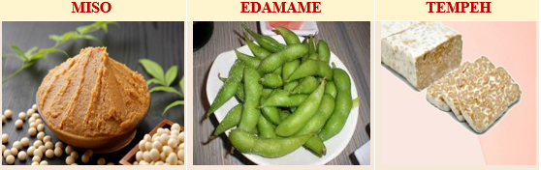  Fig. 2.7: Organic whole soy foods
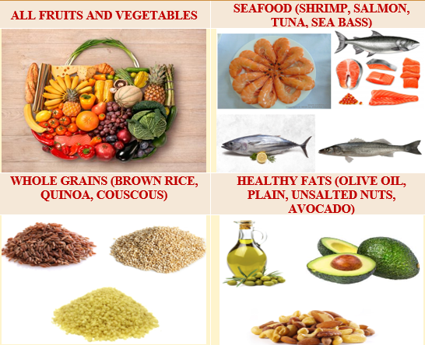  Fig. 2.8: Foods compliant with a Mediterranean diet | 8. Foods compliant with the Mediterranean diet (Fig. 2.8):  - All Fruits and Vegetables  - Whole Grains  - Healthy Fats  - Seafood

II. FOODS TO AVOID ON A PCOS DIET:
When aiming to reduce PCOS symptoms, steer clear of the following foods as they can elevate blood sugar levels, trigger inflammation, and lead to weight gain.
- Refined carbs (Fig. 3.1):  PCOS women often have impaired carbohydrate absorption, primarily due to elevated insulin levels. Therefore, the following sources of refined carbohydrates should be avoided :  - White Bread  - Pizza Dough  - Regular Pasta  - White Rice. | Fig. 3.1: Refined carbs
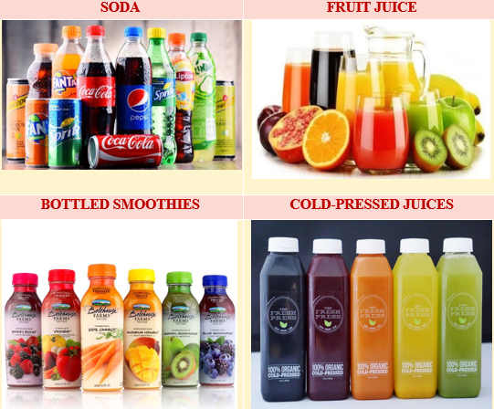  Fig. 3.2: Sugary beverages | - Sugary beverages (Fig. 3.2):  It will spike blood sugar.  - Soda  - Bottled Smoothies  - Cold-Pressed Juices  - Fruit Juice
- Sugary and processed foods (Fig. 3.3):  When adhering to a PCOS diet plan, It is crucial to avoid sugary foods and beverages. Avoid the following:  - Candy, Cookies, and Other Sweets  - Yogurts with Sugar  - Ice Cream  - Sweetened Cereals | Fig. 3.3: Sugary and processed foods
Fig. 3.4: Saturated fats and trans fats | - Saturated and trans fats (Fig. 3.4):  These fats are not conducive to weight loss or a balanced diet and may have adverse effects on PCOS patients. Avoid foods rich in:  - Saturated  - Trans Fats
- Dairy, in some cases (Fig. 3.5):  Limiting dairy consumption may help some PCOS patients lose weight and lessen some of the symptoms of their hormonal condition. Take into account lowering your intake of the following :  - Yogurts with Sugar  - Artificial Cheeses  - Ice Creams | 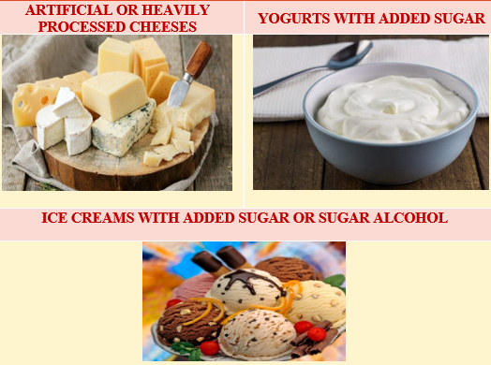  Fig. 3.5: Dairy products
Fig. 3.6: Alcohol | - Alcohol (Fig. 3.6):  Women with PCOS are at higher risk of fatty liver and can be detected through an ultrasound. Moreover, Alcohol can harm the gut microbiome and the liver. Avoid beverages containing:  - Cocktails with Sugar  - Canned Cocktails

- EXERCISES:
1. Cardio (Fig. 4.1):  - Cardiovascular exercise is highly beneficial for reducing insulin resistance, enhancing fertility, and promoting stable moods.  - Engaging in activities like brisk walking, jogging, cycling, and swimming are excellent PCOS-friendly options.  - This improves insulin sensitivity, thereby reducing the risk of type 2 diabetes and cardiovascular disease.  - Regular exercise has been shown to help promote weight loss,reduce depression,improve menstrual cycle regularity,and ease anxiety. | 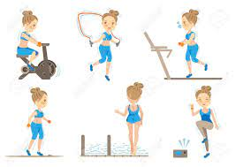  Fig. 4.1: Cardio Exercise
Fig.4.2: Weight training | 2. Weight training (Fig. 4.2):  - Weight training is highly advantageous for PCOS.  - Shedding excess body fat improves daily functional abilities.  - For PCOS-afflicted obese ladies, weight loss is essential to optimize treatment outcomes, promoting overall health and well-being.
3. High-Intensity Interval Training (HIIT) (Fig. 4.3):  - HIIT is particularly effective in reducing stress and improving the quality of life in PCOS women, as supported by clinical evidence.  - It also benefits the metabolic and cardiovascular profiles of PCOS women.  - Moreover, HIIT enhances tissue sensitivity to insulin, helping to prevent the onset of insulin resistance. | 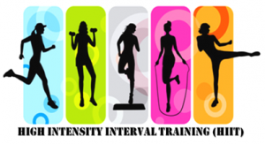  Fig. 4.3: High -Intensity Interval Training (HIIT)
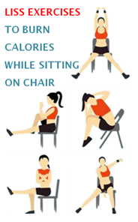  Fig.4.4: Low-intensity steady-state cardio (LISS) | 4. Low-Intensity Steady-State Cardio (LISS) (Fig.4.4):  - Combining LISS with HIIT is recommended for enhanced benefits. LISS involves performing a steady or moderate-paced repetitive movement for an extended period.  - It contributes to the reduction of fasting insulin levels and fat mass in women, while also minimizing physiological stress.  - Mental health practitioners advocate outdoor steady-state cardio to improve mental well-being, making it beneficial for PCOS women's mental health.
5. Swimming (Fig. 4.5):  - • Swimming is often recommended by medical professionals to maintain a healthy body and burn calories.  - • For PCOS women, it contributes to both weight management and the maintenance of uterine health through calorie burning. | Fig. 4.5: Swimming
Fig. 4.6: Cycling | 6. Cycling (Fig.4.6):  - Cycling aids in weight loss for PCOS women and increases calorie burn by improving tissue glucose uptake. This glucose is absorbed in the cells and converted into energy for further physical activity.  - It is a highly beneficial and accessible exercise for the body.  - Cycling also helps in building and maintaining muscle strength in the legs and thighs.
7. Zumba (Fig.4.7):  - Zumba is a form of cardio that aids in weight loss, making it an effective exercises for PCOS.  - It assists in shedding excess fat and calories in PCOS women, preventing the accumulation of fat deposits. Zumba workouts are enjoyable and can reduce stress for the participants. | Fig. 4.7: Zumba Dance
Fig. 4.8: Walking | 8. Walking (Fig.4.8):  - Walking is a beneficial exercise for women, as it can be easily done anytime and anywhere. It is necessary to routinely walk and to gradually lengthen walks over time.  - Regular walking helps in maintaining hormonal balance and improving fat profiles, while also providing relaxation to the mind and body. Daily brisk walking for 30-50 minutes has been observed to prevent weight gain, even without significant dietary changes.
9. Pilates (Fig.4.9):  - Doctors recommend Pilates as a helpful exercise for PCOS. It aids in strengthening the uterus with gentle workouts.  - Pilates reduces stress levels, helps prevent depression, and improves hormonal balance.  - This exercise has demonstrated the ability to remove toxins from the body, which could be related to acne and hair loss issues. | 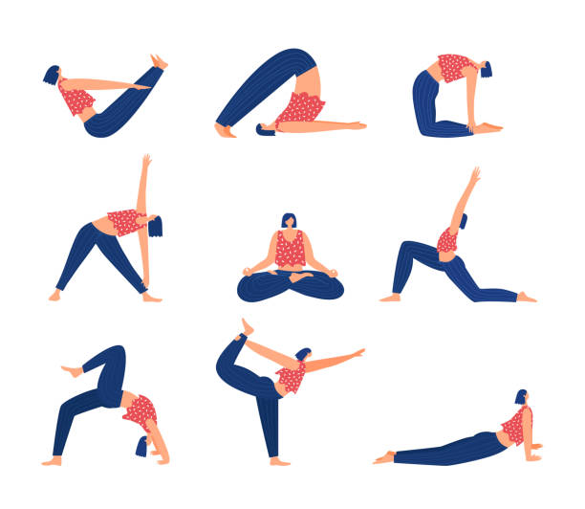  Fig. 4.9: Pilates
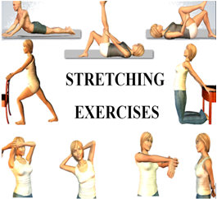  Fig. 4.10: Stretching Exercise | 10. Stretching Exercise (Fig.4.10):  - In PCOS, caution is necessary when considering stretching exercises due to the body's heightened tissue sensitivity. However, Stretching carefully can help you lose weight, by eliminating excess fat.  - Smart stretching can strengthen internal tissues, focusing on specific areas within the body.  - Gentle stretching is recommended, avoiding excessive bouncing, and warming up the muscles before stretching makes it easier and safer.
11. Yoga:
- Yoga is beneficial in relieving stress, which is often prevalent in females affected by PCOS. By managing stress, it directly addresses hormonal imbalance associated with PCOS.
- It aids in weight reduction, as Weight gain is a typical sign of PCOS. Yoga stabilizes the mind, burns calories, and supports weight loss.
- Yoga also promotes fertility, countering the major outcome of PCOS, which is infertility. By improving blood flow and maintaining hormonal balance in the brain, yoga helps prevent infertility in PCOS women, contributing to healthier lives
Some of those yoga asanas that help to provide relief for PCOS include-
- Sun Salutation or Surya Namaskar (Fig.5.1):  Surya Namaskar is considered one of the best yoga poses for PCOS. It is effective in targeting waist and hip fat, promoting weight loss, and regulating the menstrual cycle. | 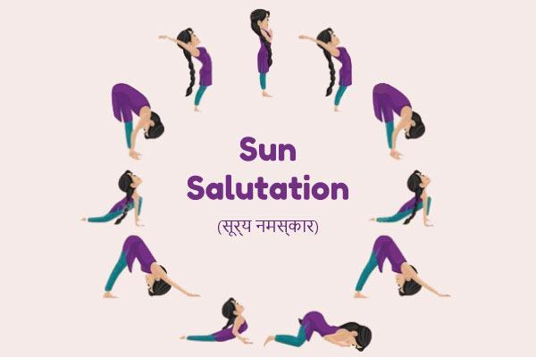  Fig. 5.1: Sun Salutation or Surya Namaskar
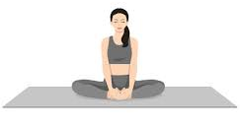  Fig. 5.2: Badhakonasana (butterfly pose) | - Badhakonasana (butterfly pose) (Fig.5.2):  The Butterfly Pose promotes relaxation and stress reduction. It also widens the pelvic floor and supports maintaining a regular menstrual cycle.
- Supta Badhakonasana (reclining butterfly pose) (Fig.5.3):  The Reclining Butterfly Pose is a variation of the traditional butterfly pose. It emphasizes strengthening pelvic muscles, relieving pain and stress during menstruation, and improving blood flow to the ovaries and uterus. | Fig. 5.3: Supta Badhakonasana (reclining butterfly pose)
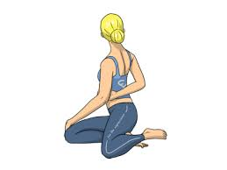  Fig. 5.4: Bharadvajasana (Bharadvaja’s twist) | - Bharadvajasana (Bharadvaja’s twist) (Fig.5.4):  A seated spinal twist known as Bharadvaja's Twist stimulates the reproductive and digestive systems. It also releases and tones the muscles around the spine, helps lower blood pressure, and soothes the nervous system.
- Bhuajangasana (cobra pose) (Fig.5.5):  The Cobra Pose enhances flexibility and reduces stress. It is commonly included in yoga poses for PCOD. This asana is believed to promote healthy ovaries by soothing the stomach and supporting proper functioning. | 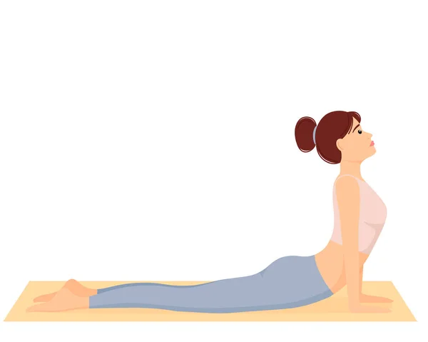  Fig. 5.5: Bhuajangasana (cobra pose)
Fig. 5.6: Naukasana (boat pose) | - Naukasana (boat pose) (Fig.5.6):  Naukasana is a yoga pose that targets the abdominal muscles and organs. It is believed to have a positive impact on thyroid function. This pose is renowned for strengthening the abdominal muscles and organs, reducing stress, and improving ovulatory function.
- Dhanurasana (bow pose) (Fig.5.7):  The reproductive organs are stimulated by the bow pose. and provides relief from menstrual cramps. Additionally, it offers a beneficial stretch for the body. | Fig. 5.7: Dhanurasana (bow pose)
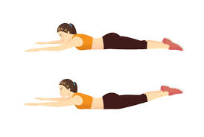  Fig. 5.8: Viparita shalabhasana (Superman pose) | - Viparita shalabhasana (Superman pose) (Fig.5.8):  The Superman Pose is an effective PCOS exercise that enhances ovarian function and helps maintain normal insulin resistance and sugar levels.
- Balasana (child’s pose) (Fig.5.9):  Balasana is a beneficial asana for hip strengthening. It is included in the PCOD yoga asana list because it allows the body to return to its natural position after being stretched and lengthened in previous asanas. | Fig. 5.9: Balasana (child’s pose)
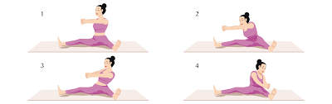  Fig.5.10: Chakki achalasia | - Chakki achalasia (Fig.5.10):  The Mill Churning Pose, also known as Chakki Achalasia, is an asana that supports reproductive organ function and strengthens other abdominal organs.
- Marjaryasana and Bitilasana (Cat and cow pose) (Fig.5.11):  Marjaryasana and Bitilasana, collectively known as the Cat and Cow Pose, provide various benefits, including enhancing spinal flexibility, strengthening and stimulating abdominal organs, offering stress relief, improving chest opening for better breathing, providing sciatica relief, increasing flexibility in the shoulders, spine, and neck, stretching muscles in the hips, belly, and back, stimulating the adrenal glands, promoting body balance, and relieving stress from menstrual cramps. | 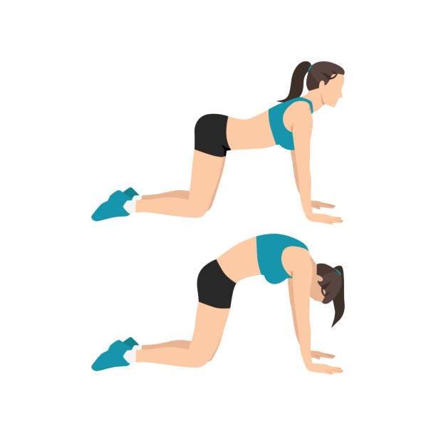  Fig. 5.11: Marjaryasana and Bitilasana (Cat and cow pose)
Fig. 5.12: Bridge Pose or Setu Bandha (Sarvangasana) | - Bridge Pose or Setu Bandha (Sarvangasana) (Fig.5.12):  The Bridge Pose or Setu Bandha (Sarvangasana) is beneficial for controlling thyroid function, which is directly related to PCOS. Additionally, it helps in easing menopausal symptoms by relaxing and energizing the abdominal organs.
- Corpse Pose or Savasana(Fig.5.13):  The Corpse Pose or Savasana is effective in de-stressing, as stress is frequently a factor in PCOS.. This yoga pose helps in relaxation and maintaining a healthy cortisol level, contributing to overall well-being in PCOS. | Fig.5.13: Corpse Pose or Savasana
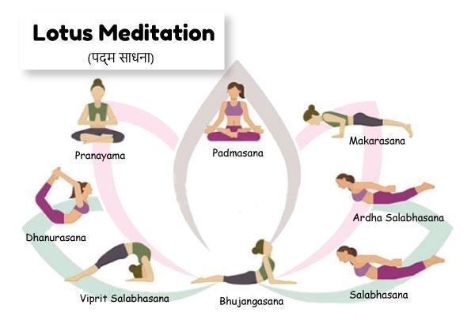  Fig. 5.14: Lotus Meditation or Padma Sadhna | - Lotus Meditation or Padma Sadhna (Fig.5.14):  Lotus Meditation or Padma Sadhna is a yoga practice that promotes deep relaxation and is beneficial for PCOS. It affects the reproductive organs of both men and women. For women during the menstrual cycle, sitting in padmasana (lotus pose) can significantly reduce cramps and discomfort.
- Locust Pose or Shalabhasana(Fig.5.15):  Lotus Meditation or Padma Sadhna is a yoga practice that promotes deep relaxation and is beneficial for PCOS. It affects the reproductive organs of both men and women. For women during the menstrual cycle, sitting in padmasana (lotus pose) can significantly reduce cramps and discomfort | Fig.5.15: Locust Pose or Shalabhasana
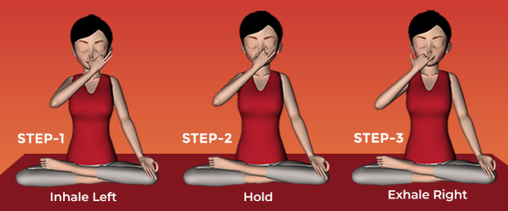  Fig.5.16: Breathing Exercise or Kapalbhati Pranayam | - Breathing Exercise or Kapalbhati Pranayam (Fig.5.16):  Kapalbhati Pranayam is a breathing technique that aims to reduce oxidative stress, enhance blood circulation, and balance glandular output. It contributes to weight reduction by stimulating the pancreas, making it one of the most effective PCOD exercises and a successful approach to managing PCOD symptoms.

.IV. HEALTH INFORMATION:
DIETARY MODIFICATIONS FOR PCOS
1. Turmeric:
Turmeric contains curcumin, which has medicinal properties and acts as a natural source of estrogen. It can be beneficial for regulating menstrual cycles and improving fertility.
How to use: Add turmeric powder to water or use it as a spice in your meals. Incorporating turmeric milk into your daily routine is also recommended.
2. Omega-3:
Omega-3 is beneficial in reducing bad cholesterol and increasing good cholesterol levels, regulating menstrual intervals, and reducing waist circumference.
Include these omega-3-rich foods in your diet:
- Fish oil: Enhances insulin sensitivity and reduces androgen secretion.
- Flaxseeds: Some evidence suggests their potential for PCOS management, but further research is needed.
- Tuna
- Salmon
- Walnuts
- Soybeans
3. Vitamin D and Calcium:
- Vitamin D deficiency is common in women with PCOS, impacting their ability to effectively absorb calcium from food.
- This essential vitamin also plays a crucial physiological role in reproductive health, particularly in ovarian follicular development.
- Ensuring adequate vitamin D levels is important to prevent poor bone mineralization and alleviate PCOS symptoms.
4. Magnesium:
- Excessive magnesium excretion in urine is linked to type 2 diabetes and/or insulin resistance.
- Prolonged loss of significant amounts of magnesium can lead to deficiency, possibly contributing to the development of insulin resistance.
Some excellent food sources to meet your daily magnesium needs are-
- green leafy vegetables
- nuts
- whole grains
- legumes
- dairy foods
- meat
5. Vitamins- B:
- Vitamin B-rich foods can help alleviate PCOS symptoms by enhancing the optimal functioning of the hormonal system and reducing androgen levels, which may contribute to feelings of exhaustion.
- Include more whole grains, nuts, and skim milk in your diet, as they are abundant in B vitamins and can assist in managing symptomatic fatigue.
V. LIFESTYLE AND SELF-CARE:
Many PCOS symptoms can be improved with positive lifestyle choices.
1. Keep a healthy weight. :
Women who are overweight often experience more severe PCOS symptoms. Only strict weight management can guarantee that ovaries work correctly. Healthy weight management can help in reducing the risk of other chronic health issues that usually develops with PCOS.
2. Have regular health checks:
PCOS may increase the risk of developing other chronic medical conditions. Regularly monitoring overall health through a doctor can aid in the early detection and timely treatment of any PCOS-related conditions before they become serious.
3. Keep stress in control with yoga and meditation:
- Yoga offers therapeutic effects not only for the physical body but also for the mind and soul.
- Specific yoga poses gently massage internal organs, promoting abdominal relaxation, restoring gastrointestinal balance, and improving digestion. These asanas enhance blood flow, open up the pelvic area, and induce a sense of relaxation.
- Meditation, an essential part of yoga, helps center the mind and redirect energies inward, allowing individuals to tune out external stressors.
- Regular practice of Yoga can help people lose weight and keep their metabolisms high.
4. Exercise to re-energize (for cramps):
- Regular exercise can help reduce insulin resistance in the body, effectively addressing many unwanted health consequences of PCOS.
- Even if it doesn't lead to significant changes in weight or body fat, exercise remains highly beneficial for women with PCOS.
- A multifaceted fitness regimen is often recommended for women with PCOS, emphasizing improvements in both heart health and muscle strength.
5. Quit smoking:
- According to studies, smoking increases the risk of diabetes, metabolic syndrome, and cardiovascular problems in PCOS women.
- In women with PCOS, quitting smoking can greatly lower the likelihood of these issues and is crucial for general health.
6. Consider a ketogenic diet :
- A ketogenic diet focuses on foods that are low in carbs and high in fat to meet the body's energy needs.
- Following this diet may lead to faster weight loss as the reduced carb intake forces the body to utilize fat reserves for energy.
7. Avoid processed foods and sugary drinks. :
- For women with PCOS, maintaining a healthy body weight is essential to prevent ovulation issues and infertility.
- To achieve this, it's essential to avoid certain foods, such as:
- Milk chocolate
- Potato chips
- Ice cream
- Candy
- Muesli bars
- Fruit juice
- Soft drinks
VI. STRESS REDUCTION STRATEGIES:
- Ensuring sufficient sleep is essential for stress reduction and overall well-being.
- Avoiding over-commitment can help prevent feelings of overwhelm and burnout.
- Making time to relax and engage in activities that bring joy and calmness can effectively reduce stress levels.
REFERENCES
1. PCOS diet: Foods to eat and avoid [Internet]. [cited 2023 Jul 18]. Available from: https://www.medicalnewstoday.com/articles/323002
2. PCOS Diet: Foods to Eat and Avoid With PCOS | CCRM Fertility [Internet]. [cited 2023 Jul 18]. Available from: https://www.ccrmivf.com/news-events/food-pcos/
3. Gaither K. Understanding PCOS: Causes, Symptoms, and Treatment [Internet]. 2021 [cited 2023 Jul 18]. Available from: https://www.emedihealth.com/womens-health/reproductive-health/understanding-pcos
4. The Best Types of Exercise for PCOS - Exercise Right [Internet]. [cited 2023 Jul 18]. Available from: https://exerciseright.com.au/best-types-exercise-pcos/
5. 10 EFFECTIVE EXERCISES FOR PCOS – Chereso Health [Internet]. [cited 2023 Jul 18]. Available from: https://cheresohealth.com/10-effective-exercises-for-pcos/
6. Women’s Health [Internet]. 2020 [cited 2023 Jul 18]. Can Yoga Relieve Symptoms of PCOS ? | Jiva Blogs. Available from: https://www.jiva.com/blog/pcos-stressing-you-out-these-3-yoga-asanas-will-re
7. Yoga for PCOS: Benefits & Specific Poses that Can Help [Internet]. 2022 [cited 2023 Jul 18]. Available from: https://www.finessyoga.com/yoga-asanas/yoga-for-pcos
8. 10 Yoga Asanas You Must Do If You Have PCOS - The Fitness India Show [Internet]. 2022 [cited 2023 Jul 18]. Available from: https://www.fitnessindiashow.com/10-yoga-asanas-must-pcos/
9. 9 Yoga Poses for PCOS : Steps, Benefits and Tips [Internet]. [cited 2023 Jul 18]. Available from: https://www.bajajfinservhealth.in/articles/yoga-for-pcos
10. 10 Yoga for PCOS: Steps to follow and Yoga Tips for PCOD [Internet]. [cited 2023 Jul 18]. Available from: https://www.wellcurve.in/blog/yoga-poses-asanas-for-pcos/
11. Cartoon Female Doing Cardio Exercise.Vector Illustrations Royalty Free SVG, Cliparts, Vectors, And Stock Illustration. Image 91375938. [Internet]. [cited 2023 Jul 18]. Available from: https://www.123rf.com/photo_91375938_cartoon-female-doing-cardio-exercise-vector-illustrations.html
12. Premium Vector | Fitness character | Exercise, Fitness, Cartoon [Internet]. [cited 2023 Jul 18]. Available from: https://in.pinterest.com/pin/premium-vector--430867889361570697/
13. Girl walking side | OpenGameArt.org [Internet]. [cited 2023 Jul 18]. Available from: https://opengameart.org/content/girl-walking-side
14. 617 Pilates Teacher Training Illustrations & Clip Art - iStock [Internet]. [cited 2023 Jul 18]. Available from: https://www.istockphoto.com/search/2/image?mediatype=illustration&phrase=pilates+teacher+training
15. Bound Angle Pose Butterfly Pose Beautiful Girl Practice Baddha Konasana Stock Illustration - Download Image Now - iStock [Internet]. [cited 2023 Jul 18]. Available from: https://www.istockphoto.com/vector/bound-angle-pose-butterfly-pose-beautiful-girl-practice-baddha-konasana-gm1351788728-427408294
16. pose-test - Forte Yoga [Internet]. [cited 2023 Jul 18]. Available from: https://www.forteyoga.com/pose-test/page/4/
17. Premium Vector | Boat pose naukasana navasana woman practicing paripurna navasana yoga exercise [Internet]. [cited 2023 Jul 18]. Available from: https://www.freepik.com/premium-vector/boat-pose-naukasana-navasana-woman-practicing-paripurna-navasana-yoga-exercise_49471561.htm
18. Yoga Poses For PCOS: Steps, Benefits And Tips [Internet]. [cited 2023 Jul 18]. Available from: https://www.lifecell.in/blog/general/yoga-poses-for-pcos-know-steps-benefits-and-tips
19. Saoji AA, Raghavendra BR, Manjunath NK. Effects of yogic breath regulation: A narrative review of scientific evidence. J Ayurveda Integr Med [Internet]. 2019 Jan 1 [cited 2023 Jul 18];10(1):50–8. Available from: https://7pranayama.com/nadishodana-anuloma-viloma-alternate-nostril-breathing-pranayama/

