Chapter
Mangrove associated endomycota as a reservoir of anticancer drug L-asparaginase

Neema Job, Ashly Augustine, Kottayath Govindan Nevin

Contents
Introduction………………......................................................................................................3
L-asparaginase as an anticancer agent......................................................................................4
L-asparaginase as an acrylamide nueratilizing agent ………………......................................5
Generic L-asparaginase drugs……..........................................................................................5
Natural Sources…………........................................................................................................6
Marine endophytic fungi as a source of L-asparaginase..........................................................7
Assay for screening and quantifying L-asparaginase………………………………..……….8
Production, optimization, and purification of L-asparaginase...……………………………..9
Enzyme Kinetics……………………………………………………………………………..9
Recombinant cloning and expression of Asn gene …………………………..……………...10
Structure Analysis…..………………………………………………………………………..10
Analysis of biocompatibility and anticancer potential of L-asparaginase…………………...11
Conclusion……………………………………………………………………………………13
Acknowledgment……………………………………………………………….……………14
References……………………………………………………………………………………14

Job N •Augustine A • K G Nevin (*)
Department of Marine Biosciences, Faculty of Ocean Science and Technology, Kerala University of Fisheries and Ocean Studies, Panangad PO, Kochi-682506, India
Centre for Bioactive Substances from Marine Organisms, Kerala University of Fisheries and Ocean Studies, Panangad PO, Kochi-682506
e-mail: nevinkg@kufos.ac.in
Abstract
Mangroves are a fluctuating intertidal zone between land and marine habitats. They exhibit high levels of biodiversity along tropical and subtropical coastlines as they embrace both these dynamic environments. Since mangrove forests remains the second largest nesting ground for marine fungal community, they are always regarded as biodiversity "hotspots." The mycotic inhabitants of mangroves, especially endophytes, are adapted to changing environmental conditions and can withstand a variety of physical and biological stressors, making them promising sources for the recovery of novel bioactive chemicals. Additionally, several mangrove species are useful sources of secondary metabolites with therapeutic benefits. As a result, the pharmaceutical, food, and agricultural industries have recognized extensive potential use for secondary metabolites generated from mangrove endophytic fungus. L-asparaginase is a renowned chemotherapeutic drug that is widely used in the treatment of acute lymphoblastic leukaemia (ALL), the most common pediatric cancer. This enzymes selectively differentiates normal cells and promotes apoptosis of only cancerous cells due to their mode of action. Fungal asparaginases being eukaryotic appears more promising in light of the increased similarity to human beings, thereby minimalizing the immunological side reactions. Another advantage of L-asparaginase is its application in food and processing industry for reducing acrylamide production in fried and processed food meals with high starch contents. To identify asparaginase production, extensive screening and quantification approaches have been developed, however, the majority of them have shown to be more complicated and deficient in established pharmaceutical quality control standards. To get around these restrictions, this review provides information on straightforward screening techniques using modified Czapek Dox medium incorporated with phenol red and bromothymol blue as dye detectors, a well reasonable, simple and accurate colorimetric techniques for enzyme quantification (Nessler method, L-aspartic acid -hydroxamate (AHA), and indo-oxine). It is also worth noting that this method is better suited for assuring accurate and representative asparaginase activity in research. Finding innovative remedies is critical in today's world, where cancer and other terrible diseases are so prevalent. Despite the fact that asparaginase production from medicinal plants has been extensively studied, this review will look at the potential benefits of using marine fungi associated with mangroves as a tool for biotechnological, therapeutic, and industrial applications.

Key words: Endophytic fungi;Mangroves; lymphoblastic leukaemia; L-asparaginase

Introduction
Marine fungi form an ecological group that is either obligate or facultative. Among them, Strict obligates mutiply and sporulate solely in marine environment, whereas facultative fungi thrive in freshwater or terrestrial surroundings and migrate to marine environment for sporulation under varying physiological conditions (Raghukumar 2008). Out of the expected fungal diversity of 1.5 million species, only a very minor percentage of about 74,000 fungal species was identified so far. This is mainly due to lack of exploration from unexplored and underexplored habitats, for example, marine fungi from sediments and other related associations (Rateb and Ebel 2011).
These marine fungi are mainly important in coastal systems, as decomposers of vascular plants and are also found among the “symbionts”, the “parasites” and the “super parasites”. (Sieburth 1979). The fluctuating environmental parameters in marine ecosystems, such as a change in pressure, temperatures, salinity, and relative oxygen amount (Raghukumar 2008) induce great challenges. The endophytic organisms that are inhabitants of these extreme habitats got adapted and display metabolic plasticity thereby producing novel biometabolites that can be a promising drug lead. Therefore, many researchers are interested in bioprospecting the newly emerging group of association, endophytic fungi that are less investigated in the marine field.
Because of their peculiar environment, plant endophytic fungi associated with mangrove plants are of particular interest. Mangroves are halophytes that grow in the intertidal zone of tropical or subtropical climates. Mangrove plants exhibit significant biodiversity along the tropical and subtropical coastlines because they embrace both marine and terrestrial habitats. Furthermore, mangrove forests are regarded as biodiversity "hotspots," and dwelling place for the second biggest fungal assemblage among marine fungi (Thatoi et al. 2012). The tremendous richness seen in mangrove species emphasizes the relevance of studying these plants as part of a series of studies on fungi connected with marine plants (Kohlmeyer and Volkmann-Kohlmeyer 1991).
Various natural metabolites are reported from mangrove associated fungi including antimicrobial, antiphlogistic, antitumor, antituberculosis, and antimalarial activities (Gunatilaka 2006; Hazalin et al. 2009; Gordien et al. 2010; Elfita et al. 2011; Ahmed et al. 2011; Mohana et al. 2012; Praptiwi et al. 2013; Zhang et al. 2014). Moreover, endophytes are valuable source of various extracellular enzymes with potential biotechnological applications (Firáková et al. 2007; Pimentel et al. 2011). This includes numerous hydrolytic and oxidative enzymes; such as amylase, cellulase, lipase, chitinase, pectinase, tyrosinase, protease, ligninase and DNAases (Bonugli-Santos et al. 2015). These extracellular hydrolytic enzymes actively contribute in litter degradation of mangrove soil bed (Kumaresan and Suryanarayanan 2002). This knowledge paves way for the role of the enzymes and promote the significance of mangroves are one of the most productive natural ecosystems and breeding ground for marine organisms (Kohlmeyer and Volkmann-Kohlmeyer 1998).
Exploration for enzymes, like asparaginase and tyrosinase has recently augmented due to their medicinal value in cancer therapy, and in treatment of neurodegenerative and myocardial diseases. Among them, L-asparaginase is the pioneer and largest group of anticancer agent widely employed in the treatment of leukemias especially Acute Lymphoblastic Leukaemia (ALL) and in related non-Hodgkin’s lymphomas (Kumar and Sobha 2012). Yet another exciting application of L-asparaginase is its role in food processing industry to lower acrylamide in fried and oven-cooked meals. This enzyme is produced by diverse source of organisms including plants and animals, to bacteria, and fungi. As extraction of L-asparaginase from eukaryotic cells is very challenging and expensive, the best-known source was from bacterial origin chiefly E. coli and Erwinia carotovora. But, in most cases, it ends up with solemn medical complications like sensitized immunologic responses, cytoxicity, and even death. Additionally, bacterial asparaginases are often associated with glutaminase, and triggers blood sugar level, disrupts the homeostatic balance, and lipid metabolism, and create nervous disorders (Geuenich et al. 1998; Duval et al. 2002; Kumar et al. 2011b). Moreover, another concomitant urease leads to hydrolysis of urea in blood and causes toxic reactions, also demands additional purification steps needed to maintain the drug efficacy.
Due to this hypersensitive allergic side effects linked with the currently used bacterial sources mainly E. coli and Erwinia carotovora, there is a requisite to switch to new candidates with with comparatively less sideeffects and high yield of L-asparaginases. Nowadays, endophytic fungi gains much attention because of their efficacy in producing diverse metabolites including enzymes. The main reason for studying endophytic fungi is that they are phylogenetically related to the host and are non-immunogenic. Being eukaryotic their post-translational modifications are the same and considered an unexplored source of novel drugs. As fungal endophytes reside in the host as a mutualistic partner, they may share some metabolic pathways and mimics the host. This might have assisted the inhabitant fungi a consistent and promising supplier of L-asparaginase. It was also found that several species of this ecological group i.e., halophilic mangrove endophytes are an excellent source of L-asparaginase and are considered comparatively safe for the treatment of hypersensitive patients. Thus, in this present scenario, where cancer-like dreadful diseases are so prevalent, the discovery of novel therapeutics is of utmost importance for the treatment. As a result, this review focuses on the enzyme L asparaginase, various preliminary screening methods, quantitative estimation, testing the efficacy and biocompatibility of the enzyme in different cancer cell lines, the possibility of cloning, and its future applications in industrial and medical fields. The potential of a fungal endophyte generated from mangroves to create the novel anticancer medication L-asparaginase is a starting point for further research into its metabolic activity.
L-asparaginase as an anticancer agent
L-asparaginase (E.C.3.5.1.1, L-asparagine amidohydrolase) are hydrolases that convert L-asparagine into L-aspartic acid and ammonia (Goodsell 2005; Verma et al. 2007). Normally, L-asparagine is synthesized from aspartate and glutamine using ATP by asparagine synthetase a gene located on chromosome no. 7q 21.3. But, in certain tumour conditions, cells solely depend on external source of asparagine for their development and progression, as they are defective or devoid of asparagine synthetase. Therefore, starvage or shortage of asparagine by L-asparaginase cause the death of tumour cells alone (Broome 1968). L-asparaginase breakdown the serum asparagine, and the tumor cells without asparagine synthetase will undergo cell cycle hault at the G0/G1 stage (Kumar and Sobha 2012; Offman et al. 2011). Purified L-asparaginase is administed intravenously to lower the level of serum asparagine thereby, terminating the cancer cell development and multiplication. The developmental deficiency induced by asparaginase damage the central dogma of various cancers like Acute Lymphoblastic Leukaemia (ALL), acute myeloblastic leukemia (AML), and related tumor conditions consequential in programmed cell death (Fig. 1).

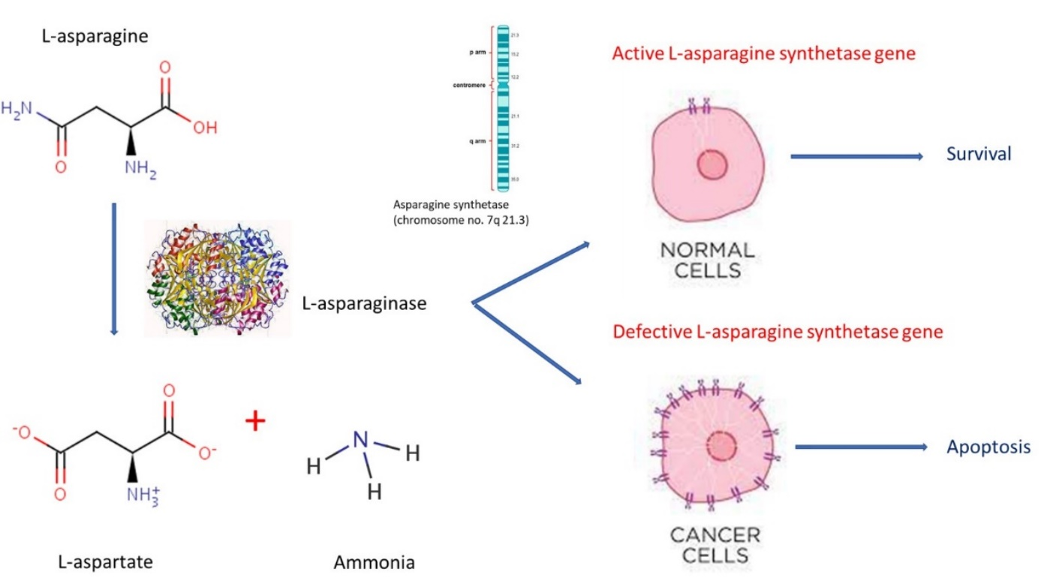
Fig. 1 Functional mode of action of L-asparaginase in healthy and leukemic cells

L-asparaginase as an acrylamide nueratilizing agent
Enhancing flavour and appearance by browning and crispening of bread and carbohydrate containing foods at high temperatures of about 120 °C (Maillard reaction), may result in the production of a neurotoxin, called acrylamide. At high temperatures, alpha-amino group of asparagine and carbonyl group of glucose in bread, potato, and other starch foods, reacted to form this carcinogenic acrylamide. As L-asparaginase has the ability to breakdown L-asparagine, this opens the way to minimize the precursor availability and thus preventing the formation of acrylamide in baked and fried foods. Moreover, being tasteless and odourless, they can be readily incorporated in bread doughs and other baked products to avoid acrylamide formation (Fig. 2). Nowadays fungal asparaginases particularly extracted from A.oryzae and A niger are widely used to serve this puropse (Mottram et al. 2002; Pedreschi et al. 2008; Morales et al. 2008).
Generic L-asparaginase drugs
Prospect of using L-asparaginase as an anticancer agent was first effectively confirmed by Oettgen et al. (1967). E.coli asparaginases are marketed with commercial brands Kidrolase, Elspar (US), Crasnitin (Germany), Leunase (France), and many more. A PEGylated enzyme, Oncaspar1 (Maryland), is widely used for pediatric ALL and is widely available in market (Kumar and Sobha 2012). Without hindering the antitumor activity, PEGylation successfully modifies the chemical nature of an enzyme with reduced immunogenicity. Asparaginase and PEGylated forms of asparaginase are effective adjuncts for standard chemotherapy (Blain et al. 2002). Recombinant Erwinia L-asparaginase was marketed as Erwinase (UK) (Allas et al. 2009).

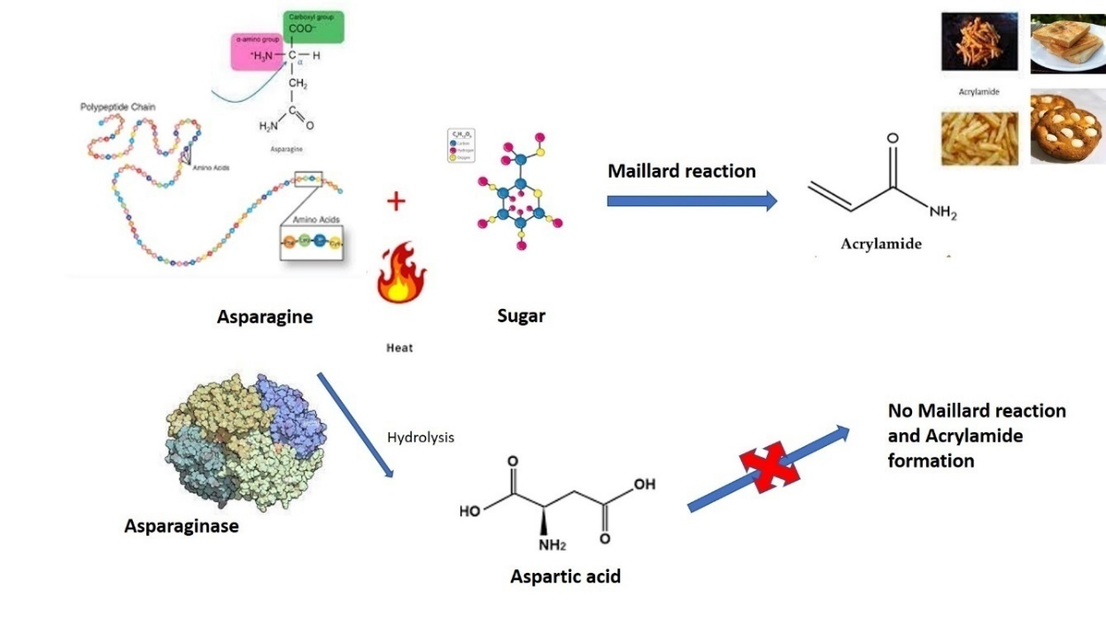

Fig. 2 Mode of action of L-asparaginase in baked food products
Natural sources
During 1920’s, there was an initial attempt to extract L-asparaginase from blood serum of an animal source like guinea pig (Clementi 1922). Later Kidd (1953) described the antitumor activity of this serum against lymphosarcoma in mice and rats. Identification of L-asparaginase as the key constituent in inhibition of tumor was reported by Broome (1963). Then onwards, L-asparaginase holds a pivotal role in the cancer treatment (Boyse et al. 1967; Alpar and Lewis 1985). Afterwards, there were several reports on L-asparaginase from animal tissues of rodents, fishes, mammals and even from aves (Adamson and Fabro 1968; Cooney and Handschumbcher 1970). Similarly, plant species like Pisum sativum, Glycine max, Oryza sativa, Hordenum vulgareroots, and Lupinus, were extensively studied for extraction of L-aparaginases (Konrad et al. 1988; Sieciechowicz and Ireland 1989; Borek and Jaskolski 2001). In the case of microbial origin, the major bacterial source reported were Escherichia coli, Bacillus subtilis, Corynebacterium glutamicum, Erwinia chrysanthemi, Rhodosporidium toruloides, Serratia marcescens, Thermus thermophiles, Vibrio proteus and Zymomonas mobilis(Cedar and Schwartz 1967; Stern et al. 1976; Mesas et al. 1990; Sinha et al. 1991; Ramakrishnan and Joseph 1996; Aghaiypour et al. 2001; Prista and Kyridio 2001; Pinheiro et al. 2001; Kelo et al. 2002; Fisher and Wray 2002; Kotzia and Labrou 2007). Two major forms of L-asparaginases was found in E. coli, among which Asn I was considered to be cytosolic and Asn II to be periplasmic in origin. The amido-hydrolytic activity was observed only for ECAII (E.coli asparaginase II). Numerous Streptomyces species were also identified with active asparaginase production (Narayana et al. 2008). Similarly several microscopic filamentous fungal species, molds and yeasts were identified as asparaginase producers. Mitosporic fungal species such as Penicillium, Mucor, Aspergillus, and Fusarium sp. and the yeast variety Candida utilis, were also acknowledged to yield L-asparaginase that is nontoxic and ensure myelosuppressive and immunosuppressive activity (Ali et al. 1994; Patil et al. 2012).
Correspondingly attempts were also made to purify L-asparaginase from marine microalgae, Chlamydomonas sp. (Paul 1982), a pioneer study of this sort with restricted antitumor activity. Asparaginase was even reported to be isolated from protozoans like Tetrahymena pyriformis. Even if there are several reports of L-asparaginase from varying souces, only limited candidate displayed promising yield and antitumor property to be considered for further scale up processes. Among the bacterial sources, Escherichia coli, Erwinia carotovora,and Serratia marcescens showed the prevalence of both periplasmic and cytoplasmic forms of enzymes with notable antineoplastic property (Schwartz et al. 1966). Thus these findings suggest the importance of further research in localization of an enzyme and its significant role in development of a suitable bioprocess (Moorthy et al. 2010).
Marine endophytic fungi as a source of L-asparaginase
Hidden endomyconts live symptomless inside the host tissue and the share communication signals with their host leading to the production of a cascade of bioactive metabolites. Fungal endophytes were screened for L-asparaginase on modified Czapek Dox agar with L-asparagine as sole nitrogen supplier (Jain et al. 2012). Similarly, endomyconts inhabitant of Thai medicinal plants were also evaluated to produce asparaginase (Theantana et al. 2007). Several fungal residents in soil and sediment samples, medicinal plants, and tropical pitcher plants also showed the presence of L-asparaginase (Patil et al. 2012; Lee et al. 2014). Microorganisms living in harsh conditions like marine environments are expected to yield halophilic proteins and enzymes with modified structures and diverse immunological properties. During long term coexistence, the endophytic partner might have progressively adapted to the microenvironment through genetic variation, by uptaking certain host DNA into their own genomes, and vice versa, that might have resulted in biochemical metabolic diversity, having distinct medicinal and industrial applications (Debashish et al. 2005; Zhang and Kim 2012). Studies by Thirunavukkarasu et al. in 2011 revealed that apart from the fungal genera like Aspergillus, Penicillium, and Fusarium, several other endophytic fungal species Plectosphaerella, Stemphylium, Alternaria, Phoma, and Cladosporium are also good sources of L-asparaginase. The absorptive mode of nutrition in marine endophytic fungi results in the secretion of this enzyme.
An interesting fact is that fungal asparaginases are not always allied with glutaminase as seen in the case of bacterial sources. The association of glutaminase activity with L- asparaginase enhances the toxic side effects, by converting blood glutamine to glutamate and ammonia. The glutamate thus formed combine with sodium in the blood, resulting in the formation of monosodium glutamate (Kurtzberg et al. 2003). Glutaminase activity of the asparaginase cumulatively activates side effects in patients (Kravchenko et al. 2008; Ramya et al. 2011). Hence, the exploration for L-asparaginase enzyme devoid of glutaminase activity is still a genuine scientific mission. Similarly, in addition to all the parameters, L-asparaginase production vary on culture media nitrogen and carbon composition, aeration conditions, pH and temperature of the culture medium, inoculum size, and fermentation time and also alter considerably with source microbe (Bascomb et al. 1975). Eventhough both solid-state fermentation (SSF) and submerged fermentation (SmF) are exclusively employed for fungal asparaginase production, submerged fermentation conditions were considered more ideal. This was mainly due to the easefulness in opmitimization of individual components to achieve desired enzyme activity (Warangkar et al. 2009). Production, purification and characterization of asparaginase is also a very crucial part for the evaluation of the toxicity of the drug (Kumar and Sobha 2012).

Assay for screening and quantifying L-asparaginase
Considering the pharmacological and food significance of L-asparaginase, there should be a simple, sensitive, reliable and cost effective estimation method to determine L-asparaginase activity. Although basic function of L-asparaginase is to deaminate asparagine to aspartate and ammonia (NH₃), it also undergo a reversible aspartate hydroxymate to asparagine, and hydroxylamine interconversion (DeGroot and Lichtenstein 1960 a, b; Ehrman et al. 1971).
Primary analysis can be done using Czapek Dox (MCD) medium with asparagine as sole nitrogen source and incorporating phenol red and bromothymol blue as pH indicators. Individual control can be kept with NaNO₃, urea, L-asparagine and glutamine as the sole nitrogen source. Modified Czapek Dox medium with L-asparagine as an individual nitrogen source were inoculated with test organisms and their colony diameter and zone diameter can be estimated by measuring fungal mycelium and enzyme zone respectively after 7-8 days of incubation. The zone index was calculated as
Zone Index = $External zone diameter$
Inner mycelium diameter

L-asparaginase quantification is done by measuring the amount of ammonia released during the conversion of asparagine, with a distinctive yellowish orange colour detected spectrophotometrically (Meister 1955). The quantity of ammonia liberated was estimated with ammonium sulphate (NH₄)₂SO₄ . One Unit (IU) of L-asparaginase is represented as the quantity of enzyme required to catalyse the formation of 1μ mole of NH₃ from L-asparagine per minute at ambient temperature and pH. Even though this method exhibits good reproducibility, Nessler’s reagent can give false positive results, when used in complex media, and with contaminants thereby interfering in the actual quantification and estimation of enzyme (Miller and Miller 1948). To overcome the limitations of the Nesslerization process, another approach was used, based on the AHA method (L-aspartate β-hydroxamate). In the presence of hydroxylamine, L-asparaginase can also convert asparagine into L-aspartic acid β-hydroxamate (AHA), when reacted with ferric chloride (FeCl₃) yielded a brown colouration determined spectrophotometrically (Grossowicz et al. 1950). Yet alternative echnique uses the hydrolysis of L-aspartate β-hydroxamate to release hydroxylamine, which when reacted with oxine at basic pH, to form an deep green-coloured, indooxine spectrophotometrically detectable at 705-710 nm (Lanvers et al. 2002; Wehner et al. 1992). The enzyme activity was defined as nmol substrate formed per minute per milligram of protein. Aspartyl transferase activity can be interrelated with the NH₃ production determined using nessler’s method (Imada et al. 1973).
Latest methods employing high-performance liquid chromatography (HPLC), helps in direct quantification of depleting asparagine using an isocratic HPLC fluorescence, thereby overcoming the drawbacks of colorimetric methods (Nath et al. 2009; Gentili et al. 1994). Direct amino acid quantification can also be done using circular dichroism (CD), and electrophoresis assays (Kudryashova and Sukhoverkov 2016; Broome 1968). Further detection invoves the estimation of indo-8-hydroxyquinoline, L-Aspartic acid b-benzyl ester 7-amido-4-methylcoumarin (a fluorogenics substrate), NADH, asparagine analogue- 5-diazo-4-oxo-L-norvaline, and the use of conductometry to detect elevation of conductivity in response to the production of L-aspartic acid and ammonia (Magri et al. 2018; Lanvers et al. 2002; Ylikangas and Monone 2000; Cooney and Handschumacher 1970; Handschumacher et al. 1968; Drainas and Drainas 1985). Protein quantification can be carried out using the Bradford’s or Lowry’s method. With the most predictability and accuracy, our aim was to analyse, compare, and highlight convention colourimetric assays with the latest methods to estimate and quantify the enzyme activity.
Production, optimization, and purification of L-asparaginase
Production of L-asparaginase may vary considerably depending on the species and is controlled by the media composition, and numerous physical parameters. Optimization of culture medium and cultivation parameters were critical aspects, that ensure the efficient growth of organisms and thus production of L-asparaginase. Statistical experimental design and data analysis tools like Design of Experiments (DoE) can be used to systematically optimize medium and process parameters, and to scale up the production process. Plackett-Burman design was widely used and found successful in evaluating and optimising enzyme production (Baskar and Renganathan 2009). Similarly, optimization using Response Surface methodology (RSM) and Computational Model Networking in association with Genetic Algorithms can also be employed to solve complex optimization process and to elevate asparaginase production (Baskar and Renganathan 2011, 2012). Furthermore, statistical softwares such as Simplex mixture design, Latin square design (LSD), Central composite rotatable design, and Box-Behnken design (Dias et al. 2015; Baskar and Renganathan 2009a; Baskar et al. 2010; Mohan Kumar and Manonmani 2013; Uppuluri et al. 2013) can be successfully employed in bioprocess optimization, allowing researchers to systematically explore and identify the best conditions for maximizing asparaginase production. Even though most of the studies often reported submerged liquid fermentation and solid-state fermentation (Dias et al. 2015; Mohan Kumar and Manonmani 2013), usage of agricultural wastes such as wheat bran, groundnut oil, corn flour, oat flour, and sesame oil cake as substrates enhanced L-asparaginase production (Dias et al. 2015; Baskar and Renganathan 2009, 2011; Gurunathan and Sahadevan 2011; Baskar et al. 2010; Huang et al. 2014; Uppuluri et al. 2013)
All the investigated L-asparaginase displayed a wide range of molecular size from 35-133 kDa. The enzyme was found as tetramers with identical subunits ranging from 20–70 kDa (Eisele et al. 2011; Huang et al. 2014). A major aspect involved in this is the elevated affinity of the enzyme towards the substrate asparagine (reduced Km). Among the selected studies that evaluated enzyme purification, the major steps used for asparaginase purification were acetone or ammonium sulphate precipitation, dialysis, ion chromatography, gel permeation chromatography, and affinity chromatography (Dutta et al. 2015; Mohan Kumar and Manonmani 2013; Patro et al. 2014; Huang et al. 2014).
Enzyme Kinetics
L-asparaginase enzyme is a conjugative homotetramer with 4 identical subunits, having carbohydrate moiety. Various studies reported that metallozyme inhibitors Zn²⁺, Fe²⁺, Cu²⁺, Hg²⁺, and Ni²⁺ possibly degrdade the enzyme activity, while metallic cofactors like Na⁺, diphosphates, Li⁺, Mg⁺, CN⁻, cysteine, etc., improved the activity. Its activity was also enhanced in the presence of reduced glutathione and the catalytic activity was found to be dependent on K⁺ (Bruneau et al. 2006). Glucose and maltose were found to activate L-asparaginase production and were elevated by MgCl₂ and repressed by EDTA. A detailed dynamic study involving thermal inactivation for the L-asparaginases at different temperatures can be performed along with other kinetic parameters using the experimental design having different concentraton of asparagine, chelators, and metal ions. The stability of this enzyme at optimum pH, temperature, and with specific substrates helps us to utilize it in medicinal and therapeutic industries (Dias et al. 2019).

Recombinant cloning and expression of Asn gene
Eventhough most of the Asn genes are cloned from bacteria, very few information have been reported in fungal L-asparaginases. As fungal asparaginases are widely accepted in cancer treatment with less toxic side reactions, an effective consolidation of information about fungal Asn gene cloning and expression is the need of the hour. Here we will be discussing a general strategy for cloning the L-asparaginase gene, its heterologous expression, along with its purification, and characterization.
Based on the conserved sequences of already reported L-asparaginase genes, a known sequence will be used for amplification with degenerate forward and reverse primers using genomic DNA from fungal isolates. The 5’and 3’ regions of the fragment can be deduced by rapid amplification of cDNA ends. Thus it can be assembled with main central region to create a putative full-length Open Reading Frame. This region can be sequenced and can be subjected to MEGA BLAST analysis in NCBI. For amplification of this L-asparaginase region from the fungal DNA, specific primers can be designed for the amplification of the gene and the PCR product will be purified, restricted and ligated with a suitable high-efficiency TA cloning vector and transformed into competent cells for sequencing. Deduced nucleotide and thus amino acid sequences can be be analyzed using different software packages like Swiss-Prot or TrEMBL.
Later the purified PCR product after digestion with suitable restriction enzymes will be subcloned into the suitable expression vector, and transformed into competent cells for protein expression (Fig. 3). The recombinant L-asparaginase can be purified using any specialized tagged column like histidine or Ni-NTA nickel-nitrilotriacetic acid. The purified L-asparaginase can be electrophoresed on the SDS-polyacrylamide gel to check the molecular range.
Structure Analysis
Understanding the structure is essential to study the function and property of L asparaginase. Gene sequence of L asparaginase gives an insight into the primary structureof the protein. Secondary and tertiary structure elucidation can be aquired from aminoacid sequences and structure prediction softwares. As this enzyme can form complexes or multimeric structures further confirmation of tertiary structure can be accomplished by experimental techniques like X-ray crystallography and nuclear magnetic resonance (NMR) spectroscopy. Knowledge of active site of the enzyme can identify the residues and motifs involved in binding and catalysis. These functional awareness helps in designing the L-asparaginase drug to specifically target cancer cells. In summary it is a multidisciplinary approach that combines bioinformatics, molecular and structural biology to understand the function and application in cancer treatment.
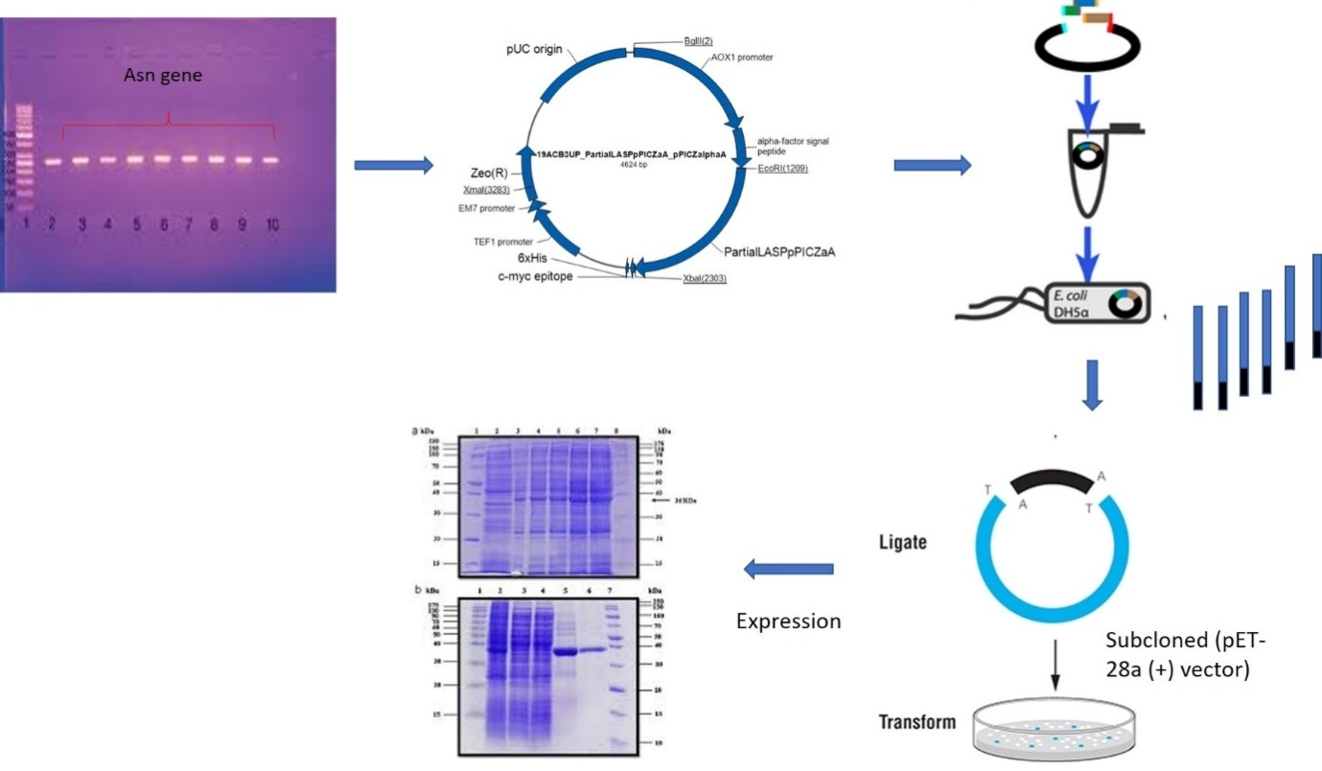
Fig. 3 General overview of cloning and expression of fungal asparaginase gene
Analysis of biocompatibility and anticancer potential of L-asparaginase
A toxicological evaluation of asparaginase can be performed to investigate the erythrolytic effect on human blood. For testing the antitumor property of a drug, the US National Cancer Institute (NCI) has suggested an in vitro sreening cell line cluster involving about sixty tumor cell line of 9 cancer origin. This include cancer of Bronchus, instestine, Melanocytes, Kidney, Ovary, Central nervous system, blood, breast, and endocrine glands (Boyd and Paull 1995). Cytotoxicity evaluation can be performed using different cell viability assays. Cell viability were analysed using tetrazolium reduction assay (MTT assay (3-[4,5-dimethylthiazol-2-yl]-2,5 diphenyl tetrazolium bromide), XTT methoxynitrosulfophenyl-tetrazolium carboxanilide assay, Sulforhodamine B assay), DNA fragmentation, Comet assay, Necrosis assays, enzyme assays, proteomics assays, expression array assays etc.
Furthermore, purified asparaginases can be tested for their antineoplastic activity against leukaemia (U937, and K562 cell lines) and carcinomas of kidney, breast and prostrate origin (Hep-G2, MCF-7, PC3) (Huang et al. 2014; Shafei et al. 2015). The relation between the amount of viable cells and asparagine was plotted to get the viability curve of each cancer cell line after treatment and the Inhibitory Concentration (IC₅₀) will be noted. It is the concentration required to inhibit 50% of intact cells, and can be estimated for dose-dependent curve, using Probit analysis. Cell morphology and DNA fragmentation pattern can be used as an initial confirmation for the apoptotic action of L-asparaginase on tumour cells. Cancer regulating gene profiling by RT-PCR and protein analysis (Western blotting) validate the potential of L-asparaginase enzyme to undergo proapoptotic activity (Fig. 4).
Similarly specific in vitro cell-based assays like flow cytometric cell cycle analysis, topoisomerase inhibition assay, Hoechst 33342 staining, dUTP Nick End Labelling assay, Annexin V– PI double staining, Caspase activation analysis, Immunocytochemistry staining methods can be employed to establish the cytotoxic ability of the enzyme. Cytotoxicity may be due to sudden cell damage or necrosis, and it is essential to prove that the mode of cell lysis is by apoptosis accompanied by cell shrinkage, Karyorrhexis, activation of caspases etc. RT- PCR is an essential tool to analyze the expression pattern of cancer-controlling genes, cell cycle-associated genes, non-caspase protease genes, interferon-induced immune genes, and cytokine-associated immune genes in compound-treated cell lines, which will be compared with untreated control.
Table 1 NCI 60 cell line panel (Boyd and Paull 1995)
Tissue of origin | Cell lines
Alveolar & Bronchial | NCI-H23, NCI-H522, A549-ATCC, EKVX, NCI-H226, NCI-H332M, H460, H0P62, HOP9
Instestinal | HT29, HCC-2998, HCT116, SW620, COLO205, HCT15, KM12
Breast | MCF7, MCF7ADRr, MDAMB231, HS578T, MDAMB435, MDN, BT549, T47D
Ovary | OVCAR3, OVCAR4, OVCAR5, OVCAR8, IGROV1, SKOV3
Blood | CCRFCEM, K562, MOLT4, HL60, RPMI8266, SR
Kidney | UO31, SN12C, A498, CAKI1, RXF393, 7860, ACHN, TK10
Melanocytes | LOXIMVI, MALME3M, SKMEL2, SKMEL5, SKMEL28, M14, UACC62, UACC257
Endocrine | PC3, DU145
Brain | SNB19, SNB75, U251, SF268, SF295, SM539

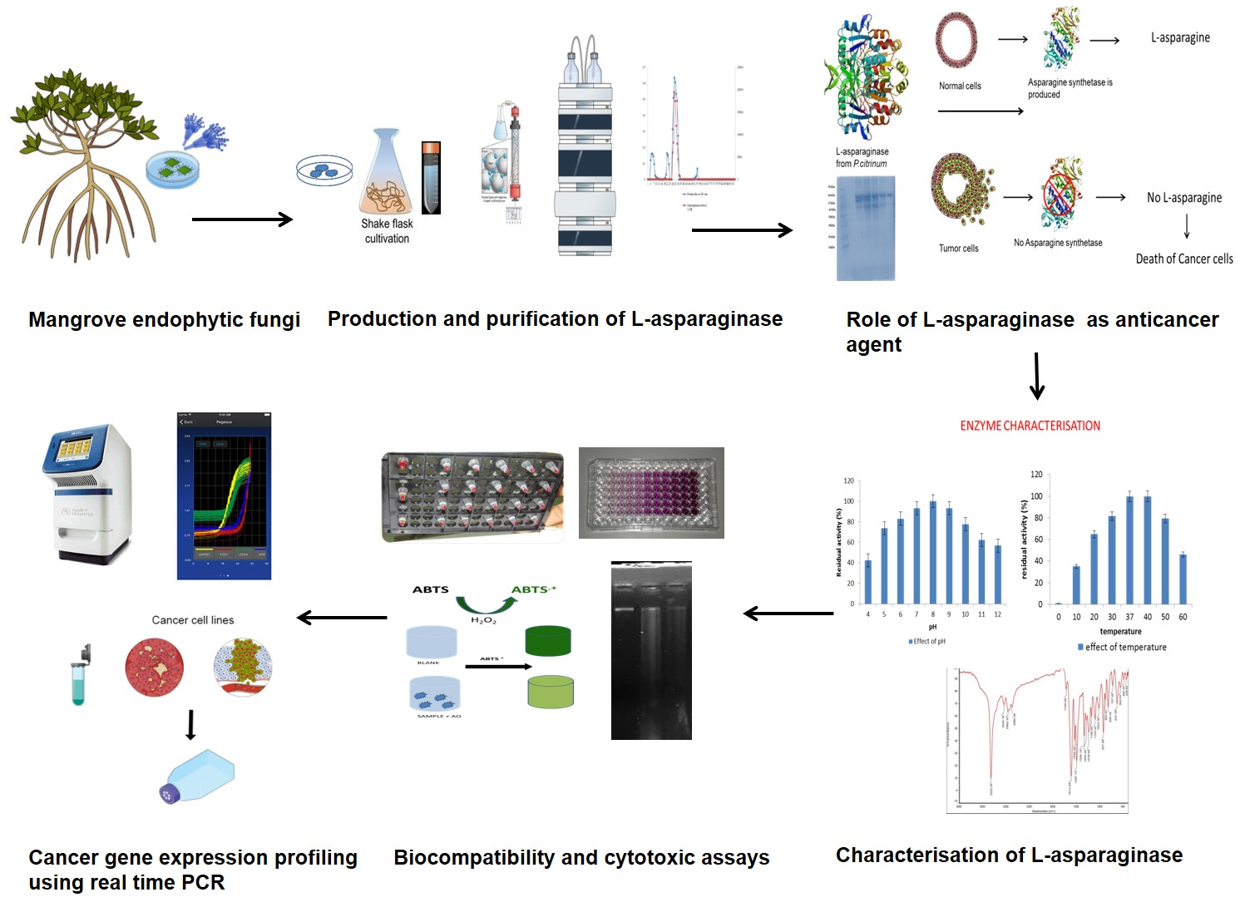
Fig. 4 A general approach for screening and downstream processing of L-asparaginase from mangrove endophytic fungi.
Conclusion
In this review, we have presented a general method to screen and characterize the economically relevant enzyme L-asparaginase that found its application in the clinical and food processing industry. Due to the deamination property of L-asparaginase, a lot of research has been conducted to show their role in cancer therapy. Besides, this enzyme also benefits the food sector in the neutralization of carcinogenic acrylamide. Though these enzymes are widely studied in bacteria, their production in manglicolous endophytic fungi is considered significant as they reduce several side effects and the short life of enzymes in association with their applications. As we are using different screening procedures to select a potent strain that solely produces L-asparaginase enzyme, various undesirable allergic reactions such as hypersensitive effects, and immunogenic complications, of the drug, can be eliminated. L-asparaginase is often found associated with glutaminase, urease, and other contaminants, hence it induces different side effects that can be fatal. This review will give a comprehensive insight and will be a benchmark study that describes the preliminary screening of manglicolous endophytic mycobionts living in extreme harsh environment as a source of L-asparaginase, its quantification protocols, media optimization, enzyme kinetics, and purification parameters. To increase the yields of L-asparaginase, genetic engineering and cloning strategies can be made possible to increase the expression rate of this enzyme. Towards improving the knowledge about the mode of action of this enzyme as an anticancer source, biocompatibility tests, cell cytotoxicity assays, and various anticancer assays along with the importance of in vitro gene expression analysis of cancer-controlling genes were discussed. Currently, the available strategy was collected and summarized here to initiate a study on L-asparaginase to widen the scope of non-immunogenic L-asparaginase production and downstream processing.
Acknowledgment
We extend our sincere gratitude towards the Directorate of Environment and Climate Change, Government of Kerala, India for providing the Ujjwal fellowship as Financial support. We also thank the Faculty of Ocean Studies and Technology, Kerala University of Fisheries and Ocean Studies, India for providing the support and lab facility.
References
Adamson R H, Fabro S (1968) Antitumor activity and other biologic properties of L-asparaginase (NSC-109229)-a review. Cancer Chemotherapy Reports 52(6): 617-626.
Aghaiypour K, Wlodawer A, Lubkowski J (2001) Structural basis for the activity and substrate specificity of Erwinia chrysanthemi L-asparaginase. Biochemistry 40(19): 5655-5664.
Ahmed I, Hussain H, Schulz B, Draeger S, Padula D, Pescitelli G, Ree V, Krohn K (2011) Three new antimicrobial metabolites from the endophytic fungus Phomopsis sp. Eur J Org Chem 15: 808–812.
Ali S S, Rai V, Soni K, Kulshrestha P (1994) A fungal L-asparaginase with potential antitumor activity. Indian Journal of Microbiology 34: 73-73.
Allas S, Sahakian P, Fichtner I, Abribat T (2009) Pharmacokinetics and Pharmacodynamics in Mice of a Pegylated Recombinant Erwinia chrysanthemi-Derived L-Asparaginase. Blood 114(22): 2033.
Alpar H O, Lewis D A (1985) Therapeutic efficacy of asparaginase encapsulated in intact erythrocytes. Biochemical pharmacology 34(2): 257-261.
Bascomb S, Banks G T, Skarstedt M T, Fleming A, Bettelheim K A, Connors T A (1975) The properties and large-scale production of L-asparaginase from Citrobacter. Microbiology 91(1): 1-16.
Baskar G, Renganathan S (2009) Statistical screening of process variables for the production of L-asparaginase from cornflour by Aspergillus terreus MTCC 1782 in submerged fermentation. Indian J Sci Technol 2(5): 45-48.
Baskar G, Renganathan S (2009a) Production of L-asparaginase from natural substrates by Aspergillus terreus MTCC 1782: Effect of substrate, supplementary nitrogen source and L-asparagine. International Journal of Chemical Reactor Engineering 7(1).
Baskar G, Renganathan S (2011) Statistical and evolutionary optimisation of operating conditions for enhanced production of fungal l-asparaginase. Chemical Papers 65(6): 798-804.
Baskar G, Renganathan S (2012) Optimization of L-asparaginase production by Aspergillus terreus MTCC 1782 using response surface methodology and artificial neural network-linked genetic algorithm. Asia-Pacific Journal of Chemical Engineering 7(2): 212-220.
Baskar G, Sriharini C, Sripriya R, Renganathan S (2010) Statistical screening of supplementary nitrogen source for enhanced production of L-Asparaginase by Aspergillus terreus 1782. Chemical and Biochemical Engineering Quarterly 24(4): 467-472.
Blain F, Tkalec A L, Shao Z, Poulin C, Pedneault M, Gu K, ....., Su H (2002) Expression system for high levels of GAG lyase gene expression and study of the hepA upstream region in Flavobacterium heparinum. Journal of bacteriology 184(12): 3242-3252.
Bonugli-Santos R C, dos Santos Vasconcelos M R, Passarini M R, Vieira G A, Lopes V C, Mainardi P H, ....., Sette L D (2015) Marine-derived fungi: diversity of enzymes and biotechnological applications. Frontiers in microbiology 6: 269.
Borek D, Jaskólski M (2001) Sequence analysis of enzymes with asparaginase activity. Acta Biochimica Polonica 48(4): 893-902.
Boyd M R, Paull K D (1995) Some practical considerations and applications of the National Cancer Institute in vitro anticancer drug discovery screen. Drug development research 34(2): 91-109.
Boyse E A, Old L J, Campbell H A, Mashburn L T (1967) Suppression of murine Leukemias By L-asparaginase: Incidence of sensitivity among leukemias of various types: comparative inhibitory activities of guinea pig serum L-asparaginase and Escherichia coli L-asparaginase. The Journal of experimental medicine 125(1): 17-31.
Broome J D (1963) Evidence that the L-asparaginase of guinea pig serum is responsible for its antilymphoma effects: I. properties of the L-asparaginase of guinea pig serum in relation to those of the antilymphoma substance. The Journal of experimental medicine 118(1): 99-120.
Broome J D (1968) Studies on the mechanism of tumor inhibition by L-asparaginase: effects of the enzyme on asparagine levels in the blood, normal tissues, and 6C3HED lymphomas of mice: differences in asparagine formation and utilization in asparaginase-sensitive and-resistant lymphoma cells. The Journal of experimental medicine 127(6): 1055-1072.
Bruneau L, Chapman R, Marsolais F (2006) Co-occurrence of both L-asparaginase subtypes in Arabidopsis: At3g16150 encodes a K+-dependent L-asparaginase. Planta 224(3): 668-679.
Cedar H, Schwartz J H (1967) Localization of the two L-asparaginases in anaerobically grown Escherichia coli. Journal of Biological Chemistry 242(16): 3753-3755.
Clementi A (1922) Presence of L-asparaginase in animals and its significance. Arch Int Physiol 19: 369-398.
Cooney D A, Handschumacher R E (1970) L-asparaginase and L-asparagine metabolism. Annual review of pharmacology 10(1): 421-440.
De Groot N, Lichtenstein N (1960) The action of mammalian liver enzyme preparations on asparagine and asparagine derivatives. Biochimica et biophysica acta 40: 92-98.
De Groot N, Lichtenstein N (1960) The action of Pseudomonas fluorescens extracts on asparagine and asparagine derivatives. Biochimica et biophysica acta 40: 99-110.
Debashish G, Malay S, Barindra S, Joydeep M (2005) Marine enzymes. Marine Biotechnology I: 189-218.
Dias F F G, de Castro R J S, Ohara A, Nishide T G, Bagagli M P, Sato H H (2015) Simplex centroid mixture design to improve L-asparaginase production in solid-state fermentation using agroindustrial wastes. Biocatalysis and Agricultural Biotechnology 4(4): 528-534.
Dias F F G, Santos Aguilar J G D, Sato H H (2019) l-Asparaginase from Aspergillus spp.: production based on kinetics, thermal stability and biochemical characterization. 3 Biotech 9(7): 1-10.
Drainas D, Drainas C (1985) A conductimetric method for assaying asparaginase activity in Aspergillus nidulans. European journal of biochemistry 151(3): 591-593.
Dutta S., Ghosh, S., &Pramanik, S. (2015). L-asparaginase and L-glutaminase from Aspergillus fumigatus WL002: Production and some physicochemical properties. Applied biochemistry and microbiology, 51(4), 425-431.
Duval M, Suciu S, Ferster A, Rialland X, Nelken B, Lutz P, ....., Philippe N (2002) Comparison of Escherichia coli–asparaginase with Erwinia-asparaginase in the treatment of childhood lymphoid malignancies: results of a randomized European Organisation for Research and Treatment of Cancer- Children's Leukemia Group phase 3 trial. Blood, The Journal of the American Society of Hematology 99(8): 2734-2739.
Ehrman M, Cedar H, Schwartz J H (1971) L-Asparaginase II of Escherichia coli: Studies on the enzymatic mechanism of action. Journal of Biological Chemistry 246(1): 88-94.
Eisele N, Linke D, Bitzer K, Na’amnieh S, Nimtz M, Berger R G (2011) The first characterized asparaginase from a basidiomycete, Flammulinavelutipes. Bioresource technology 102(3): 3316-3321.
Elfita E, Muharni M, Munawar M, Legasari L, Darwati D (2011) Antimalarial compounds from endophytic fungi of Brotowali (Tinasporacrispa L). Indonesian Journal of Chemistry 11(1): 53-58.
Firáková S, ŠturdíkováM, Múčková M (2007) Bioactive secondary metabolites produced by microorganisms associated with plants. Biologia 62(3): 251-257.
Fisher S H, Wray Jr L V (2002) Bacillus subtilis 168 contains two differentially regulated genes encoding L-asparaginase. Journal of Bacteriology 184(8): 2148-2154.
Gentili D, Zucchetti M, Conter V, Masera G, D'Incalci M (1994) Determination of L-asparagine in biological samples in the presence of L-asparaginase. Journal of Chromatography B: Biomedical Sciences and Applications 657(1): 47-52.
Geuenich S, Haberl C, Egger D, Kaspers U, Hültner L, Wilmanns W, Denzlinger C (1998) Induction of leukotriene production by bleomycin and asparaginase in mast cells in vitro and in patients in vivo. Biochemical pharmacology 55(4): 447-453.
Goodsell D S (2005) The Molecular Perspective: l‐Asparaginase. Stem Cells 23(5): 710-711.
Gordien A Y, Gray A I, Ingleby K, Franzblau S G, Seidel V (2010) Activity of Scottish plant, lichen and fungal endophyte extracts against Mycobacterium aurum and Mycobacterium tuberculosis. Phytotherapy Research: An International Journal Devoted to Pharmacological and Toxicological Evaluation of Natural Product Derivatives 24(5): 692-698.
Grossowicz N, Wainfan E, Borek E, Waelsch H (1950) The enzymatic formation of hydroxamic acids from glutamine and asparagine. J Biol Chem 187(1): 111-125.
Gunatilaka A L (2006) Natural products from plant-associated microorganisms: distribution, structural diversity, bioactivity, and implications of their occurrence. Journal of natural products 69(3): 509-526.
Gurunathan B, Sahadevan R (2011) Production of L-asparaginase from natural substrates by Aspergillus terreus MTCC 1782: Optimization of carbon source and operating conditions. International Journal of Chemical Reactor Engineering 9(1).
Handschumacher R E, Bates C J, Chang P K, Andrews A T, Fischer G A (1968) 5-Diazo-4-oxo-L-norvaline: Reactive asparagine analog with biological specificity. Science 161(3836): 62-63.
Hazalin N A, Ramasamy K, Lim S S M, Wahab I A, Cole A L, Abdul Majeed A B (2009) Cytotoxic and antibacterial activities of endophytic fungi isolated from plants at the National Park, Pahang, Malaysia. BMC complementary and alternative medicine 9(1): 1-5.
Huang L, Liu Y, Sun Y, Yan Q, Jiang Z (2014) Biochemical characterization of a novel L-Asparaginase with low glutaminase activity from Rhizomucor miehei and its application in food safety and leukemia treatment. Applied and environmental microbiology 80(5): 1561-1569.
Imada A, Igarasi S, Nakahama K, Isono M (1973) Asparaginase and glutaminase activities of micro-organisms. Microbiology 76(1): 85-99.
Jain R, Zaidi K U, Verma Y, Saxena P (2012) L-asparaginase: A promising enzyme for treatment of acute lymphoblastic leukiemia. People’s Journal of Scientific Research 5(1): 29-35.
Kelo E, Noronkoski T, Stoineva I B, Petkov D D, Mononen I (2002) β-Aspartylpeptides as substrates of L-asparaginases from Escherichia coli and Erwinia chrysanthemi. FEBS letters 528(1-3): 130-132.
Kidd J G (1953) Regression of transplanted lymphomas induced in vivo by means of normal guinea pig serum: I. course of transplanted cancers of various kinds in mice and rats given guinea pig serum, horse serum, or rabbit serum. The Journal of experimental medicine 98(6): 565-582.
Kohlmeyer J, Volkmann-Kohlmeyer B (1991) Illustrated key to the filamentous higher marine fungi.
Kohlmeyer J, Volkmann-Kohlmeyer B (1998) A new marine Xylomyces on Rhizophora from the Caribbean and Hawaii. Fungal Diversity 1: 159-164.
Konrad A S, Kenneth W J, Robert J (1988) The metabolism of asparagine in plants. Phytochemistry 27(3): 663-671.
Kotzia G A, Labrou N E (2007) L-Asparaginase from Erwinia chrysanthemi 3937: cloning, expression and characterization. Journal of biotechnology 127(4): 657-669.
Kravchenko O V, Kislitsin Y A, Popov A N, Nikonov S V, Kuranova I P (2008) Three-dimensional structures of L-asparaginase from Erwinia carotovora complexed with aspartate and glutamate. Acta Crystallographica Section D: Biological Crystallography 64(3): 248-256.
Kudryashova E V, Sukhoverkov K V (2016) “Reagent-free” L-asparaginase activity assay based on CD spectroscopy and conductometry. Analytical and bioanalytical chemistry 408(4): 1183-1189.
Kumar D S, Sobha K (2012) L-asparaginase from microbes: a comprehensive review. Advances in Bioresearch 3(4).
Kumar N M, Ramasamy R, Manonmani H K (2013) Production and optimization of L-asparaginase from Cladosporium sp. using agricultural residues in solid state fermentation. Industrial Crops and Products 43: 150-158.
Kumar S, Dasu V V, Pakshirajan K (2011) Purification and characterization of glutaminase-free L-asparaginase from Pectobacterium carotovorum MTCC 1428. Bioresource technology 102(2): 2077-2082.
Kumaresan V, Suryanarayanan T S (2002) Endophyte assemblages in young, mature and senescent leaves of Rhizophora apiculata: evidence for the role of endophytes in mangrove litter degradation. Fungal Diversity 9: 81-91.
Kurtzberg J, Yousem D, Beauchamp N (2003) Cancer Medicine. Holland J, Fries E, Kurtzberg J, editors, American Chemical Society IV: 699-705.
Lanvers C, Pinheiro J P V, Hempel G, Wuerthwein G, Boos J (2002) Analytical validation of a microplate reader-based method for the therapeutic drug monitoring of L-asparaginase in human serum. Analytical biochemistry 309(1): 117-126.
Lee J M, Tan W S, Ting A S (2014) Revealing the antimicrobial and enzymatic potentials of culturable fungal endophytes from tropical pitcher plants (Nepenthes spp.). Mycosphere 5(2): 364-377.
Magri A, Soler M F, Lopes A M, Cilli E M, Barber P S, Pessoa A, Pereira J F (2018) A critical analysis of L-asparaginase activity quantification methods—colorimetric methods versus high-performance liquid chromatography. Analytical and bioanalytical chemistry 410(27): 6985-6990.
Meister A (1955) Glutaminase, Asparaginase and Alpha-keto acid-omega-amidase. Methods in enzymology 2: 380-385.
Mesas J M, Gil J A, Martn, J F (1990) Characterization and partial purification of L-asparaginase from Corynebacterium glutamicum. Microbiology 136(3): 515-519.
Miller G L, Miller E E (1948) Determination of nitrogen in biological materials. Analytical Chemistry 20(5): 481-488.
Mohan Kumar N S, Manonmani H K (2013) Purification, characterization and kinetic properties of extracellular L-asparaginase produced by Cladosporium sp. World Journal of Microbiology and Biotechnology 29(4): 577-587.
Mohana Kumara P, Zuehlke S, Priti V, Ramesha B T, Shweta S, Ravikanth G, ..., Uma Shaanker R (2012) Fusarium proliferatum, an endophytic fungus from Dysoxylumbinectariferum Hook. f, produces rohitukine, a chromane alkaloid possessing anti-cancer activity. Antonie Van Leeuwenhoek 101(2): 323-329.
Moorthy V, Ramalingam A, Sumantha A, Shankaranaya R T (2010) Production, purification and characterization of extracellular L- asparaginase from a soil isolate of Bacillus sp. African J Microbiol Res 4(1): 1862-1867.
Morales F, Capuano E, Fogliano V (2008) Mitigation strategies to reduce acrylamide formation in fried potato products. Annals of the New York Academy of Sciences 1126(1): 89-100.
Mottram D S, Wedzicha B L, Dodson A T (2002) Acrylamide is formed in the Maillard reaction. Nature 419(6906): 448-449.
Narayana K J P, Kumar K G, Vijayalakshmi M (2008) L-asparaginase production by Streptomyces albidoflavus. Indian Journal of Microbiology 48(3): 331-336.
Nath C E, Dallapozza L, Eslick A E, Misra A, Carr D, Earl J W (2009) An isocratic fluorescence HPLC assay for the monitoring of l‐asparaginase activity and l-asparagine depletion in children receiving E. coli l‐asparaginase for the treatment of acute lymphoblastic leukaemia. Biomedical Chromatography 23(2): 152-159.
Oettgen H F, Old L J, Boyse E A, Campbell H A, Philips F S (1967) Clarkson, BD. In Tallal L, Leeper RD, Schwarta MD, Kim JH: Inhibition of Leukemias in Man by L-asparaginase. ACS-NCI Conference on Acute Leukemia and Burkitt's Tumor (Rye 1967), Cancer Res (Vol. 27, p. 2619).
Offman M N, Krol M, Patel N, Krishnan S, Liu J, Saha V, Bates P A (2011) Rational engineering of L-asparaginase reveals importance of dual activity for cancer cell toxicity. Blood, The Journal of the American Society of Hematology 117(5): 1614-1621.
Patil M P, Patil R H, Maheshwari V L (2012) A novel and sensitive agar plug assay for screening of asparaginase-producing endophytic fungi from Aegle marmelos. Acta BiologicaSzegediensis 56(2): 175-177.
Patro K R, Basak U C, Mohapatra A K, Gupta N (2014) Development of new medium composition for end production of L-asparaginase by Aspergillus ﬂavus. Journal of environmental biology 35: 295-300.
Paul J H (1982) Isolation and characterization of a Chlamydomonas L-asparaginase. Biochemical Journal 203(1): 109-115.
Pedreschi F, Kaack K, Granby K (2008) The effect of asparaginase on acrylamide formation in French fries. Food chemistry 109(2): 386-392.
Pimentel M R, Molina G, Dionísio A P, Maróstica Junior M R, Pastore G M (2011) The use of endophytes to obtain bioactive compounds and their application in biotransformation process. Biotechnology research international 2011.
Pinheiro I O, Araujo J M, Ximenes E C P A, Pinto J C S, AlvesT L M (2001) Production of L-asparaginase by Zymomonas mobilis strain CP4. Biomaterial and Diagnostic BD6: 243-244.
Praptiwi P, Jamal Y, Fathoni A, Nurkanto A, Agusta A (2013) Antibacterial activity of Bisanthraquinone (+)-1, 1’-bislunatin. Microbiology Indonesia 7(4): 4-4.
Prista A A, Kyridio D A (2001) L-asparaginase of Thermus thermophilus: purification, properties and identification of essential amino acids for catalytic activity. Mol Cell Biochem 216: 93-101.
Raghukumar C (2008) Marine fungal biotechnology: an ecological perspective. Fungal Divers. 31, 19–35.
Ramakrishnan M S, Joseph R (1996) Characterization of an extracellular asparaginase of Rhodosporidium toruloides CBS14 exhibiting unique physicochemical properties. Canadian Journal of microbiology 42(4): 316-325.
Ramya L N, Doble M, Rekha V P B, Pulicherla K K (2011) In silico engineering of L-asparaginase to have reduced glutaminase side activity for effective treatment of acute lymphoblastic leukemia. Journal of PediatricHematology/Oncology 33(8): 617-621.
Rateb M E, Ebel R (2011) Secondary metabolites of fungi from marine habitats. Natural product reports 28(2): 290-344.
Schwartz J H, Reeves J Y, Broome J D (1966) Two L-asparaginases from E. coli and their action against tumors. Proceedings of the National Academy of Sciences 56(5): 1516-1519.
Shafei M S, El-Refai H A, Mostafa H, El-Refai A M H, El-Beih F M, Easa S M, Gomaa S K (2015) Purification, characterization and kinetic properties of Penicillium cyclopium L-asparaginase: Impact of L-asparaginase on acrylamide content in potato products and its cytotoxic activity. Current trends in biotechnology and pharmacy 9(2): 132-140.
Sieburth J M (1979) Sea microbes: a survey of the habitats, field and laboratory methods, morphology, nutrition, taxonomy, and ecology of marine bacteria, fungi, microalgae, and protozoa.
Sieciechowicz K A, Ireland R J (1989) Isolation and properties of an asparaginase from leaves of Pisum sativum. Phytochemistry 28(9): 2275-2279.
Sinha A M, Manna, S U, Roy S K, Chakrabarty S L (1991) Induction of L-asparaginase synthesis in Vibrio proteus. The Indian Journal of Medical Research 93: 289-292.
Stern M L, Phillips A W, Gottlieb A J (1976) Physical properties of L-asparaginase from Serratia marcescens. Journal of bacteriology 125(2): 719-727.
Thatoi H N, Behera B C, Dangar T K, Mishra R R (2012) Microbial biodiversity in mangrove soils of Bhitarkanika, Odisha, India.
Theantana T, Hyde K D, Lumyong S (2007) Asparaginase production by endophytic fungi isolated from some Thai medicinal plants. Current Applied Science and Technology 7(1-1): 13-18.
Uppuluri K B, Dasari R K V, Sajja V, Jacob A S, Reddy D S R (2013) Optimization of L-asparaginase production by isolated Aspergillus niger C4 from sesame (black) oil cake under SSF using Box–Behnken design in column bioreactor. International Journal of Chemical Reactor Engineering 11(1): 103-109.
Verma N, Kumar K, Kaur G, Anand S (2007) L-asparaginase: a promising chemotherapeutic agent. Critical reviews in biotechnology 27(1): 45-62.
Warangkar S C, Khobragade C N, Dawane B S, Bhosale R B (2009) Effect of dihydropyrimidine derivatives on kinetic parameters of E. carotovora L-asparaginase. Int J BiotechnolAppl 1(1): 05-13.
Wehner A, Harms E, Jennings M P, Beacham I R, Derst C, Bast P, Rohm K H (1992) Site- specific mutagenesis of Escherichia coli asparaginase II: None of the three histidine residues is required for catalysis. European journal of biochemistry 208(2): 475-480.
Ylikangas P, Mononen I (2000) A fluorometric assay for L-asparaginase activity and monitoring of L-asparaginase therapy. Anal Biochem 280(1): 42–5.
Zhang C, Kim S K (2012) Application of marine microbial enzymes in the food and pharmaceutical industries. Advances in food and nutrition research 65: 423-435.
Zhang Q, Zhang J, Yang L, Zhang L, Jiang D, Chen W, Li G (2014) Diversity and biocontrol potential of endophytic fungi in Brassica napus. Biological control 72: 98-108.

