Prefabrication Building Construction: A Thematic Analysis Approach
Shashikant Nishant Sharma^{1*} ; Dr. Kavita Dehalwar²; Arjun Singh Lodhi³; Gopal Kumar⁴
^{1, 3} PhD Scholar, Department of Planning and Architecture, Maulana Azad National Institute of Technology Bhopal, MP India
*Corresponding author Email id: urp2025@gmail.com
²Assistant Professor, Department of Planning and Architecture, Maulana Azad National Institute of Technology Bhopal, MP India

Abstract
The study uses a comprehensive search strategy to identify relevant studies, including peer-reviewed articles, conference proceedings, and technical reports. A total of 42 studies were selected for inclusion in the review, and their findings are synthesized using a thematic analysis approach. Prefabrication building construction is an emerging trend in the Indian construction industry. This paper aims to provide an overview of prefabrication technology and its use in building construction in India. The benefits and challenges of prefabrication, as well as the factors that influence its adoption in India, are discussed. The paper also provides an overview of the current state of the prefabrication industry in India, and the key players in the market. Finally, the paper highlights successful prefabrication projects in India and concludes that prefabrication technology has the potential to revolutionize the construction industry in India and address some of its key challenges.

Keywords
Building Construction, Prefabrication, Prefabrication Technology, Construction Technology, Construction Industry

Introduction
Prefabricated buildings have been around for centuries and have evolved to meet the needs of society. After World War II, the industry grew rapidly, and two main types of prefabrication emerged: volumetric or modular and panelized. Steel, timber, concrete, and fiberglass are the most commonly used materials for prefabricated buildings. The components of prefabricated buildings are engineered at a factory and delivered to a location where they are assembled. Prefabricated panels are two-dimensional components that are put together on-site to form a building. Different types of prefabricated panels vary according to material and form. The most common types are Structural Insulated Panels (SIPs), Insulated Precast Concrete Panels, Insulated Concrete Forms (ICFs), Timber Frame Panels, and Lightweight Steel Frame Panels (Sun et al., 2023).
Prefabrication has significantly impacted the construction industry worldwide in recent decades due to its ability to ensure structural strength, cost efficiency, and environmental performance compared to on-site construction. The manufacturing of modular units on-site or off-site can be described using various terms such as pre-assembly, prefabrication, modularisation, system buildings, and industrialised buildings. There are different types of modular precast building construction techniques prevalent globally, and this article provides an overview of these techniques, as well as available standards and codal provisions, advantages, and disadvantages. Large panel technology using prefabrication was initially developed in the mid-1960s, and it is a cost-effective way to construct a large number of building units quickly (Song et al., 2023). This off-site construction technique involves fabricating some or all elements of the structure in industrial units, transporting them to the construction site, and assembling them to create the building. While this technique has been used for centuries, it has evolved significantly over time, with precast concrete buildings systems now offering wide applicability due to their accessibility in various shapes, sizes, and structural elements. Prefab mechanisms do not limit creativity in design, and standardized components offer customization at lower costs through economies of high volume work. In the construction industry of every country, prefabrication is the backbone for the expansion of new ideas, and its excellent quality construction produced under controlled conditions holds large potential for the future of construction sites (Li, et al., 2023).
Prefabricated buildings, also known as prefabs, are constructed by manufacturing components such as walls, roofs, and floors in a factory or manufacturing plant. These components can be partially or fully assembled in a factory and then transported to the site for installation. This method of building construction is preferred due to its cost-effectiveness, fast turnaround, and reusability, making it suitable for temporary construction facilities, medical camps, evacuation centers, schools, apartment blocks, and single-detached houses (Cai et al., 2023).
Prefabrication is more efficient than conventional on-site construction because it is a controlled manufacturing process that can be optimized through the development of a sequence of operations for repeating sections of walls, roofs, and floors. Although prefabricated structures are produced from modules, they must comply with the same building codes as permanent structures, which can vary from state to state or county to county (Buitrago et al., 2023).
The history of prefabricated buildings can be traced back to nomadic times, where people used transportable houses and camps. However, it was only extensively developed in the 20th century, during the first and second world wars, when labor for construction was reduced due to the manufacture of war goods. This led to housing shortages that endured until the postwar era, where alternative methods of housing construction were considered to meet the demand (Steinhardt et al., 2020). Before the installation of a prefabricated building, the site for its construction is inspected to ensure that it meets the local, state, and international building codes. The site must also be inspected by a third party for approval, and modular companies must obtain building permits, utility permits, and occupancy permits (Ding et al., 2020). The rise in demand for housing and office spaces, coupled with advancements in construction practices and building regulations, has led to a shift towards the use of prefabricated buildings instead of traditional construction methods. In addition, the advent of new technologies like Building Information Modeling (BIM) has allowed architects, engineers, and contractors to digitally create and manage various aspects of the structure (Cuellar Lobo et al., 2021). By facilitating better coordination and management of the prefabrication process, BIM helps reduce risks associated with such construction methods (Patil et al., 2023).
Prefabricated buildings are becoming increasingly popular due to the development of construction codes and standards, as well as the need for more housing and office spaces. These structures are created off-site and then transported and installed on-site as load-bearing structural blocks. This method has environmental benefits such as less construction waste and CO2 emissions, as well as less noise and dust on the building site. This is driving the expansion of prefabricated building systems in Europe and other countries such as the US, Canada, and Japan. The use of prefabricated construction improves quality, safety, productivity, and efficiency, while also reducing construction waste, noise, dust, and energy use (Navaratnam et al., 2022).
In India, Hindustan Prefab Limited (HPL) is a government-run corporation that mainly produces precast concrete components for architectural and civil projects (Gupta et al., 2021). Prefabrication can improve the quality of construction by manufacturing components in a stable environment, using materials more efficiently, and protecting them from climate damage. The Indian infrastructure and construction sector has grown rapidly in recent years, and there is a need to adopt more versatile and technically intense projects (Gupta et al., 2021). The government has launched programs to manufacture millions of houses, and prefabrication is seen as a solution to the lack of skilled labor and deteriorating workmanship standards. Mass housing is a potential solution to the housing crisis in Indian cities, and prefabrication can help make it more cost-effective by standardizing resources and structural components. However, there are some challenges to the widespread adoption of prefabrication in India, including contractors' preference for low-cost labor, transportation issues, and a lack of standardization in technology (Bras et al., 2020).

Methodology
This systematic literature review aims to provide an overview of the current state of prefabricated building construction and identify future directions for research. The review covers studies published between 2020 and 2023, focusing on the benefits and challenges of prefabrication, its impact on construction productivity and quality, and its potential for sustainable building practices. The study uses a comprehensive search strategy to identify relevant studies, including peer-reviewed articles, conference proceedings, and technical reports. A total of 42 studies were selected for inclusion in the review, and their findings are synthesized using a thematic analysis approach.
Systematic Literature Review conducted in April 2023, database searches were ScienceDirect and Google Scholar. Keyword Search was Prefabricated Building Construction.
Search Results Filtered | Screening Creteria
10,869 | Search term used, 'Prefabricated Building Construction'
4,392 | Filtered by Year '2020 to 2023'
3,493 | Filted Based on Research Papers
559 | Based on Open Access
153 | Based on Abstract Reading
42 | Detailed study based on relevance

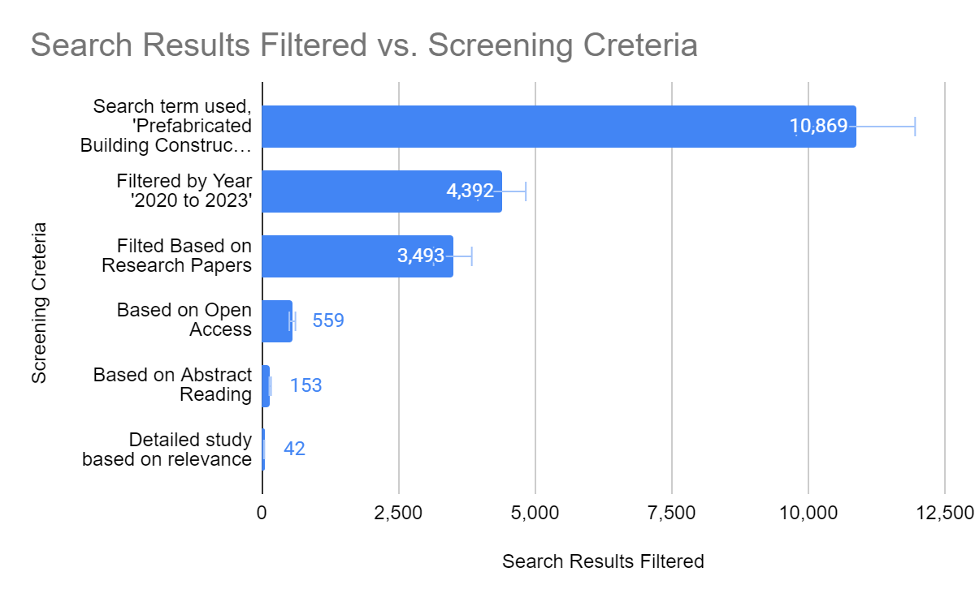
Figure 1 : Systematic Literature review graphical representation.

Results and Discussion

Benefits of Using Prefabricated Buildings
Prefabricated buildings offer numerous advantages for manufacturers, contractors, and end-users. The approach of splitting activities between on-site and off-site operations provides greater flexibility in terms of project schedule and costs, as long as the planners are equipped with effective project management skills. The use of off-site fabrication also brings the benefits of optimized assembly lines. In terms of market prospects, prefabricated buildings are well-positioned to benefit from the growing trend towards eco-friendly or sustainable construction. As a result, the market share for both residential and non-residential prefabricated buildings is anticipated to increase in the coming years (Tavares et al., 2021).

Faster On-site Construction
Prefabrication using a production line offers the advantage of faster production as workers perform their specific tasks in a repetitive and defined sequence, making their actions more efficient compared to workers on a traditional construction site. Additionally, some operations can be automated to further increase efficiency. Planning for prefabricated construction is also faster since certain activities can be done simultaneously, such as site clearing and foundation construction, before the actual construction of walls, roofs, floors, and finishing starts. With prefabrication, a building can be delivered to a site up to 90% complete, allowing for a complete facility to be occupied in just a matter of days or weeks after delivery (Lu et al., 2021).

Resistance to Uncontrollable Factors
The construction industry is heavily impacted by weather, which can cause project delays and disrupt workflow, since it is an uncontrollable factor. However, this is not the case with prefabricated buildings, which are constructed primarily in a controlled environment. In fact, weather has little effect on the assembly of prefabricated buildings since up to 90% of the construction process is carried out in this controlled environment. This enables the construction of new facilities regardless of weather conditions, which is not possible with permanent construction projects. In adverse weather or emergency replacement situations where conventional construction methods may not be feasible, prefabrication can be used to complete a project. By constructing structural components under more controlled conditions, using methods such as shop welding and precast concrete manufacturing, external factors can be minimized (Baghdadi et al., 2021).

Higher Quality and Consistency
Prefabricated building construction has a significant advantage in terms of quality control. In traditional site construction, local inspectors would inspect the site at different stages of the construction process. However, for prefabricated building manufacturing, inspections are carried out throughout every stage of the manufacturing process, with a focus on rigorous inspections and scrutiny (Yao et al., 2021). Prefabricated building manufacturing facilities often have quality control inspectors, state inspectors, and third-party inspectors who meticulously approve prefabricated components at every stage of production for strict adherence to drawing and quality control. In a modular plant, key employees and crew foremen are experienced in working on projects of various types and designs. In contrast, traditional construction workers are often unskilled laborers who are assigned to projects to fulfill labor needs, regardless of their level of skill. In prefabricated construction, quality control is easier to implement compared to on-site construction since structural components are designed with repeating features that can be standardized in terms of component dimensions and tolerances (Vijayalaxmi, 2010). For instance, molds, formworks, and temporary fasteners are the same for typical building components that produce constant dimensions. Moreover, the quality of prefabricated buildings is more likely to be consistent with other prefabricated buildings constructed at different locations, provided that they use the same components. This is because prefabricated construction is less affected by local site conditions (Agrawal et al., 2021).

Time and Efficiency
Prefabricated buildings may have a similar or higher cost compared to traditional construction, but their main advantage lies in their speed and efficiency, which is why they are preferred. Regular construction projects usually take six to nine months to finish, while prefabricated structures can be completed in half the time with the same level of quality. This results in cost savings and the immediate availability of a structure. Since each project has unique and customized features, precise engineering and design are required, which is a significant benefit of prefabricated buildings (Jadhav et al., 2022).
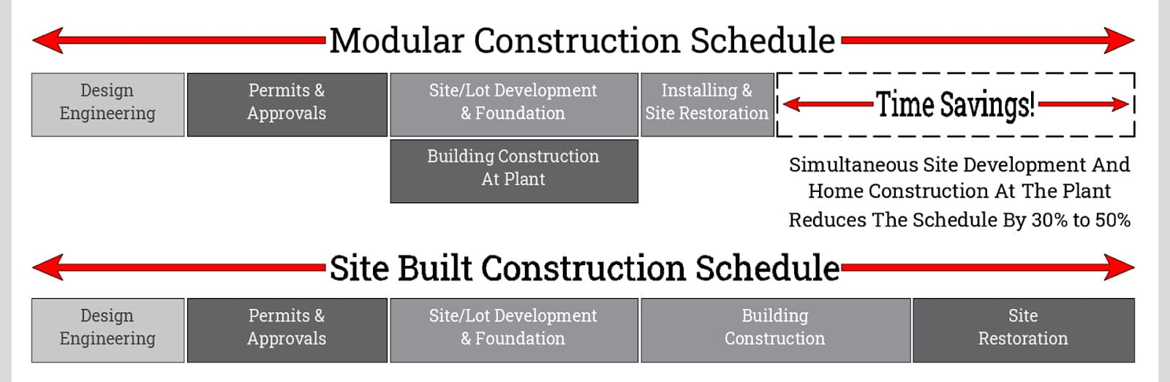
Figure 2. Modular Construction Schedule for Prefabricated Buildings

Reusability and Disassembly
Prefabricated buildings are sometimes intended to be used on a temporary basis. They are particularly useful for situations where temporary workspaces are needed, such as for construction projects, remote healthcare services, research activities, and so on. Because they are designed to be easily taken apart and moved, prefabricated buildings are ideal for projects that require frequent relocation. This also means that there is minimal disruption or damage to the site where they are installed (Hu et al., 2022).

Environmentally Friendly Materials
The advantage of efficient raw material utilization and reusability is a result of the prefabrication process. Compared to conventional construction, prefabrication generates less waste, as it doesn't require temporary components like formworks, temporary fasteners, jigs, and fixtures, which are typically discarded after construction. In contrast, most on-site constructed buildings are permanent and remain unoccupied after their intended use until they are repurposed or demolished. However, prefabricated modular buildings are more mobile, which makes them easier to repurpose (Pawar et al., 2022). Many other scholars have suggested use of bamboo and other materials to be used in combination with precast structures to make it more sustainable (Vijayalaxmi & Singha, 2021).

Improved Worker Safety
The controlled environment of fabrication shops presents a significant advantage over the conditions present on construction sites. The risk of workers being exposed to safety hazards and threats, such as working at heights, adverse weather, limited space, and adjacent construction activities, is greatly reduced since the majority of the work is conducted in the fabrication shops. The construction operations in these shops can be effectively separated and designed to be ergonomically friendly (Sukeerthi & Rao, 2022).

Performance and Lifespan Inspection
The durability of a building is influenced by several factors, including its installation, maintenance, and environment. Typically, prefabricated buildings have a lifespan of at least 30 years and can even surpass their intended use. The construction of prefabricated buildings adheres to the same standards as traditional construction, with similar inspections and regulations. However, the key difference is the constant monitoring and inspection of components and materials throughout the manufacturing and assembly process. This makes prefabricated buildings more responsive to potential defects, errors, and the use of inferior materials (Bhuskade & Ambadkar, 2022).

Challenges in Prefabricated Construction
Prefabricated construction presents a departure from conventional construction methods and may not always be suitable, leading to potential disadvantages instead of the anticipated advantages. Prefabricated construction is a high-stakes endeavor that could pose significant risks to the trust of all involved parties. Here are some of the potential risks and obstacles associated with prefabricated construction (Chippagiri et al., 2023).
Prefabrication Technologies
Table 1 provides examples of the prefabricated construction techniques adopted by India, which are seen as a viable solution to address technical, social, economic, and sustainability issues in construction. This approach is becoming increasingly important, and with recent advancements in design and technology, prefabricated construction is gaining acceptance in many advanced nations, as it offers advantages over traditional construction methods.
Table 1: Prefabrication Technology
Prefabrication Technology | Types
Formwork Systems | - Monolithic concrete construction system  - Modular tunnel form  - Kayson's formwork system:  - Sismo building technology
Precast Sandwich Panel Systems | - Panel prefab system:  - Advanced building system  - Ferrocement sandwich panel  - Structural insulated panels (SIPs)  - Glass fibre reinforced gypsum (GFRG) panel system  - Prefabricated modular units using organo-clay/ glass fibre reinforced polymer composite
Light Gauge Steel Structural Systems | - Pods- Small rooms of light steel frame with all fittings and finishing
Precast Concrete Construction Systems | - Industrialized 3-S System using cellular light weight concrete slabs & precast columns:  - Pre-stressed precast system using hollow core slab, beams, columns etc:  - Waffle crete building system:
Steel Structural Systems | - Speed floor system:  - Timber-concrete prefabricated composite wall system:  - Factory made fast track modular building system.

SWOT analysis table for prefabrication technology in building construction:
Strengths | Weaknesses
- Increased efficiency and speed of construction due to the ability to manufacture components off-site and assemble them on-site. | - Prefabrication technology can be limited in terms of design flexibility and customization.
- Reduced waste and cost due to the ability to optimize material usage and reduce on-site labor requirements. | - There may be higher upfront costs associated with implementing prefabrication technology due to the need for specialized equipment and facilities.
- Improved quality control as components can be manufactured in a controlled environment and tested prior to installation. | - Transportation and logistics can be a challenge due to the size and weight of prefabricated components, and the need to coordinate delivery schedules.
- Prefabrication can be more environmentally sustainable as it can reduce the carbon footprint of construction projects by minimizing on-site construction waste and transportation emissions. | - The need for accurate measurements and detailed planning can be greater with prefabrication, which may require additional time and effort in the early stages of a project.

Opportunities | Threats
- There is growing demand for sustainable and efficient building construction, which can drive the adoption of prefabrication technology. | - Traditional construction methods may still be preferred by some stakeholders who are unfamiliar or skeptical of prefabrication technology.
- Prefabrication can enable construction projects to be completed faster and more efficiently, which can help reduce labor costs and improve overall project timelines. | - There is potential for supply chain disruptions that could impact the availability of materials and components needed for prefabrication.
- Technological advancements in areas such as 3D printing and robotics could further enhance the capabilities and efficiency of prefabrication technology. | - The regulatory environment and building codes may not yet be fully adapted to the use of prefabrication technology, which could create barriers to adoption.
- Prefabrication can provide opportunities for greater collaboration and communication between architects, engineers, contractors, and manufacturers, leading to improved project outcomes. | - The lack of skilled workers in the construction industry may limit the ability of companies to fully adopt prefabrication technology.

Futuristic Pathways
Prefabrication is a promising approach for achieving lean construction, with modular buildings offering the greatest time savings due to their higher degree of pre-fabrication. Modular buildings are constructed according to local building codes and standards, ensuring that they are of equal quality to on-site built construction. However, it should be noted that maintenance during occupancy, deconstruction, and the recycling or reuse of modular buildings are not limited to the design, manufacturing, and construction stages [28]. Many successful projects involving prefabrication have already been completed, and there are many more planned. Prefabrication has the potential to drive growth in the building industry by improving output, sustainability, workplace conditions, and workforce safety. This potential was once just a hypothesis, but it is now a reality that is being realized through the use of prefabrication [7]. The factors that contribute to this effectiveness are presented in Table 2.
Table 2: Effective factors in increased used of prefabrication systems in future
Effective factor | Effect of using prefabrication
Program | The ability to progress work as a parallel operation in a factory and on a construction site
Factory tolerances and workmanship | They will show a higher quality and consistency to that achieved on site
Energy consumption | Reduction in energy consumption due to the automation
Labour markets | Access to cheaper labor markets according to factory base systems
Program certainty | Greater program certainty as a result of computerization
Safety | The factory environment can allow better safety than the construction site

Issues in Prefab Construction
The connections between the core structure and components in prefabricated buildings must be strong enough to withstand all types of stresses, as the strength and durability of the entire building depend on the strength of these connections (Nguyen-Van et al., 2020). Therefore, it is important to conduct comprehensive studies of the entire system rather than focusing solely on individual components. However, a major obstacle to the acceptance of prefabrication technologies in construction is the need for skilled labor and on-site automation to ensure accuracy and precision. Therefore, it is essential to develop the necessary skills and implement automation at the manufacturing and installation stages. In addition, the transportation and erection of heavy machinery units can be a challenge, especially in congested areas where precise positioning is required. Finally, the maintenance of skilled labor is also a concern in prefabricated construction, as this approach requires machine-oriented skills both on-site and in the manufacturing process, which differ from those required for in-situ construction (Teja & Chamberlain, 2020).

Conclusion
Prefabricated buildings, commonly known as "prefabs," are structures made up of components such as walls, roofs, and floors that are produced in a factory or manufacturing plant. These components can be fully or partially assembled in the factory and then transported to the site. The use of prefabrication in construction offers advantages over traditional on-site construction, as the production process is more controlled and less affected by external factors. The benefits of prefabrication include faster on-site construction, increased quality and consistency, reduced costs, and less waste of raw materials, as well as improved safety. Prefabricated buildings can be classified based on their level of construction, such as component, panel, module, hybrid, or complete building. The cost of prefabricated buildings is comparable to or higher than that of traditional structures. However, the cost savings associated with their use are mainly due to the shorter installation time, resulting in a higher return on investment.
This mainly focuses on the challenges faced by the construction sector at national, as well as at the international level and its adoption in the construction sector. It also discusses the new prefab-technologies developed, along with benefits of this technique in the construction industry. Therefore, the paper comes to a conclusion that prefabrication technology with huge advantages is an essential technological upgradation in the construction sector to defeat the present challenges world-wide and it has the capacity to make a difference in the sector in terms of financial, social, ecological sustainability in India as well.

References
Agrawal, A., Sanghai, S. S., & Dabhekar, K. (2021, November). Comparative Studies between Precast and Conventional Cast-In-Situ Structural Systems. In IOP Conference Series: Materials Science and Engineering (Vol. 1197, No. 1, p. 012062). IOP Publishing.
Bhuskade, S. R., & Ambadkar, S. (2022). Experimental investigation of self compacting concrete in the precast technology to be used for the staircase. Materials Today: Proceedings, 62, 6819-6823.
Buitrago, M., Makoond, N., Moragues, J. J., Sagaseta, J., & Adam, J. M. (2023, June). Robustness of a full-scale precast building structure subjected to corner-column failure. In Structures (Vol. 52, pp. 824-841). Elsevier.
Cai, K., Wang, H., Wang, J., Bai, J., Zuo, J., Chan, K., ... & Song, Q. (2023). Mitigating lifecycle GHG emissions of building sector through prefabricated light-steel buildings in comparison with traditional cast-in-place buildings. Resources, Conservation and Recycling, 194, 107007.
Cuellar Lobo, J. D., Lei, Z., Liu, H., Li, H. X., & Han, S. (2021). Building information modelling-(BIM-) based generative design for drywall installation planning in prefabricated construction. Advances in Civil Engineering, 2021, 1-16.
Ding, Z., Liu, S., Luo, L., & Liao, L. (2020). A building information modeling-based carbon emission measurement system for prefabricated residential buildings during the materialization phase. Journal of Cleaner Production, 264, 121728.
Gupta, L. M., Ray, M. R., & Labhasetwar, P. K. (2021). Advances in Civil Engineering and Infrastructural Development. Lecture Notes in Civil Engineering, 87.
Hu, R., Chen, K., Fang, W., Zheng, L., & Xu, J. (2022). The technology-environment relationship revisited: Evidence from the impact of prefabrication on reducing construction waste. Journal of Cleaner Production, 341, 130883.
Jadhav, O., Minde, P., Yadhav, A., & Gaidhankar, D. (2022). A Review of Emerging Trends & Advances in Construction Technology in the Indian Scenario. Materials Today: Proceedings.
Li, X., Xie, W., Yang, T., Lin, C., & Jim, C. Y. (2023). Carbon emission evaluation of prefabricated concrete composite plates during the building materialization stage. Building and Environment, 232, 110045.
Lu, W., Lee, W. M., Xue, F., & Xu, J. (2021). Revisiting the effects of prefabrication on construction waste minimization: A quantitative study using bigger data. Resources, conservation and recycling, 170, 105579.
Navaratnam, S., Satheeskumar, A., Zhang, G., Nguyen, K., Venkatesan, S., & Poologanathan, K. (2022). The challenges confronting the growth of sustainable prefabricated building construction in Australia: Construction industry views. Journal of Building Engineering, 48, 103935.
Patil, D., Bukhari, S. A., Minde, P. R., & Kulkarni, M. S. (2023). Review on comparative study of diverse wall materials for affordable housing. Materials Today: Proceedings, 77, 823-831.
Pawar, P., Minde, P., & Kulkarni, M. (2022). Analysis of challenges and opportunities of prefabricated sandwich panel system: A solution for affordable housing in India. Materials Today: Proceedings, 65, 1946-1955.
Sukeerthi, B. K., & Rao, B. C. M. (2022). Evaluation of critical connections in an irregular precast building. Materials Today: Proceedings, 71, 332-338.
Song, Y., Wang, J., Lu, J., & Si, X. (2023). Research on collaborative scheduling of multiple projects of prefabricated building based on the niche genetic-raccoon family optimization algorithm. Alexandria Engineering Journal, 64, 1015-1033.
Steinhardt, D., Manley, K., Bildsten, L., & Widen, K. (2020). The structure of emergent prefabricated housing industries: a comparative case study of Australia and Sweden. Construction management and economics, 38(6), 483-501.
Sun, Z., Zhu, Z., Xiong, R., Tang, P., & Liu, Z. (2023). Dynamic human systems risk prognosis and control of lifting operations during prefabricated building construction. Developments in the Built Environment, 100143.
Tavares, V., Gregory, J., Kirchain, R., & Freire, F. (2021). What is the potential for prefabricated buildings to decrease costs and contribute to meeting EU environmental targets?. Building and Environment, 206, 108382.
Teja, M. U. R., & Chamberlin, K. S. (2020). Comparative analysis on composite construction (structural steel and concrete) and precast concrete construction WRT cost and time. Materials Today: Proceedings, 33, 170-178.
Vijayalaxmi, J. (2010). Towards sustainable architecture–a case with Greentainer. Local environment, 15(3), 245-259.
Vijayalaxmi, J., & Singha, H. R. (2021). Use of Bamboo as a Construction Material in the North-East and Southern Vernacular Settlements of India. ISVS e-journal, 8(4), 86-100.
Yao, F., Ji, Y., Tong, W., Li, H. X., & Liu, G. (2021). Sensing technology based quality control and warning systems for sleeve grouting of prefabricated buildings. Automation in Construction, 123, 103537.

