“RECENT ADVANCES IN PROCESSING AND VALUE ADDITION IN
COFFEE (Coffea)”
Sandeep T.N., T.N. Gopinandhan, Sharanagouda Hiregoudar, Udayakumar Nidoni and Pramod Katti
Corresponding author: Sandeep T.N., Email: sandeepnvy@gmail.com
1. Introduction
Coffee, a popular beverage brewed from the roasted and ground seeds of evergreen coffee plants, holds a prominent place among the world's favourite drinks, alongside water and tea. Its origins trace back to Ethiopia, where local consumption dates back centuries. The early 18th century saw Arab traders embracing coffee, leading to its transportation to the Arabian Peninsula. This newfound demand spurred coffee cultivation in Yemen. Subsequently, the 18th and 19th centuries witnessed a global surge in coffee consumption. Arabica coffee, with its roots in Ethiopia and Yemen, spread across various countries. Another variety, Coffea Canephora var. robusta, was identified in the forests of tropical central Africa, later establishing itself in Africa, Asia and the America (Jean, 2004).
Coffee-producing nations are categorized into Africa, Asia and Oceana, Mexico and Central America, and South America. These regions collectively yield around 175.35 million bags (60 kg bag⁻¹) of coffee. Notable among them are Brazil, Vietnam, Colombia, Indonesia, Honduras, Ethiopia, India, Uganda, Peru, and Mexico, contributing significantly to global production (www.ico.org).
In India, coffee cultivation began when Baba Budan introduced Yemeni coffee beans to Chikkamagalur, Karnataka, in 1670. This marked the genesis of coffee plantations in India, extending to Kodagu and beyond. The country's coffee-growing areas are divided into traditional regions encompassing the Western Ghats of Karnataka, Kerala, and Tamil Nadu; non-traditional areas including Andhra Pradesh and Orissa; and the North Eastern region covering the northeastern states. The total coffee cultivation area is approximately 4.65 lakh hectares, yielding about 3,34,000 MT. Arabica and Robusta varieties contribute 99,000 MT and 2,35,000 MT, respectively. Leading in production, Karnataka produces 71.4%, trailed by Kerala (19.8%), Tamil Nadu (5.2%), Andhra Pradesh and Orissa (3.5%), and the North-Eastern region (www.indiacoffee.org).
Botanically, coffee belongs to the Coffea genus of the Rubiaceae family. With around 100 species primarily native to Africa, only two species, Coffea arabica and Coffea Canephora var. Robusta, are commercially cultivated in India and beyond. The Central Coffee Research Institute in Chikkamagaluru, Karnataka, has developed several Arabica and Robusta selections for commercial cultivation, with seven Arabica and two Robusta selections gaining popularity among growers (Anon., 2014).
Recognizing the significance of India's distinct Regional and Specialty Coffees, the Coffee Board has secured Geographical Indications registration for five coffee types, affirming their unique origin and quality (www.pib.gov.in).
Fig. 1. GI-certified five varieties of Indian coffee
Geographical parameters like elevation, aspect and environmental factors like rainfall, temperature and atmospheric humidity can influence the economic production of coffee much more than soil factors (Anon., 2014).
Table 1. Soil and climatic requirements for Arabica and Robusta coffee
Sl. No. | Factors | Arabica | Robusta
1 | Elevation | 1000 to 1500 m | 500 to 1000 m
2 | Soils | Deep, rich in organic matter, well-drained and slightly acidic in reaction (6 to 6.5 pH)
3 | Slopes | Gentle to moderate slopes | Gentle slopes to fairly level fields
4 | Temperature | 15ºC to 25ºC | 20ºC to 30ºC
5 | Relative humidity | 70 to 80% | 80 to 90%
6 | Annual rainfall | 1600 to 2500 mm | 1000 to 2000 mm
7 | Blossom showers | March-April (25 to 30 mm) | February-March (25 to 40 mm)
8 | Backing showers | April-May (50 to 75 mm) | March-April (50 to 75 mm)

2. Primary processing of coffee
The primary harvest window for Arabica coffee spans from November to January, whereas Robusta coffee is typically harvested from December to February. When employing the wet method to produce parchment coffee, Arabica beans undergo manual harvesting in 2 to 3 phases, while Robusta beans are usually harvested manually in 1 to 2 phases. Regarding cherry coffee production, the fruits are collected when approximately 90% of them have reached ripeness.
Coffee after harvesting at the estate is processed by two methods viz., dry (Fig.2). and wet (Fig.3) method.
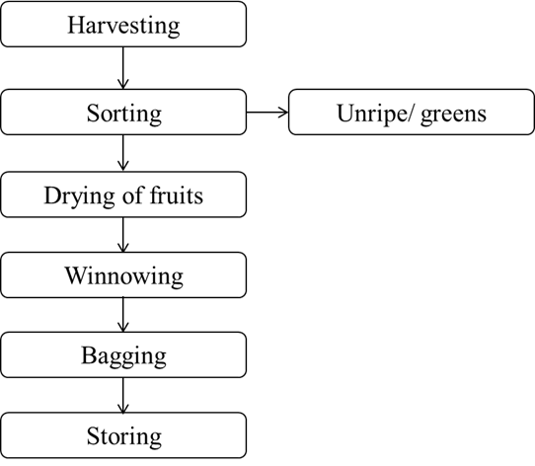
Fig. 2 Steps involved in the dry method of processing coffee
In the dry processing method, harvesting occurs when around 90% of the fruits have reached ripeness. Before initiating the drying process, any unripe, tree-dried, or damaged cherries are carefully separated and dried independently. Subsequent to this sorting, the remaining healthy and intact cherries are evenly spread to a depth of approximately 7 to 8 cm on drying yards made of concrete or tiles.
Throughout the drying period, which typically spans 12 to 15 days under clear and sunny weather conditions, the coffee fruits are regularly stirred, ensuring even drying. Each evening, the coffee is gathered into heaps and covered, only to be spread out again the following morning after the mist has cleared. By the end of this process, the coffee reaches full dryness, achieving a moisture content of 11-12% (w.b.).
After the drying phase, the dry cherries undergo a winnowing process to eliminate dried leaves, twigs, dirt, and other impurities. This meticulous cleaning is conducted before the coffee is packed and stored. Coffee that is produced using the dry processing technique is referred to as cherry coffee.
Under the wet processing method, the freshly harvested coffee cherries go through a sequence of processing stages. This includes pulping, which eliminates the outer skin of the fruit, followed by a process of fermentation and washing aimed at removing the pectin-rich mucilage that clings to the coffee bean. The next step involves sun drying, typically spanning 6 to 8 days (see Figure 3). Coffee that emerges from this wet processing route is referred to as parchment coffee. Notably, parchment coffee generally exhibits a superior cup quality when compared to coffee processed through the dry method.
In the context of India, the wet method predominates in the processing of most Arabica coffee, while the dry method is primarily employed for processing the majority of Robusta coffee (Anon., 2014).

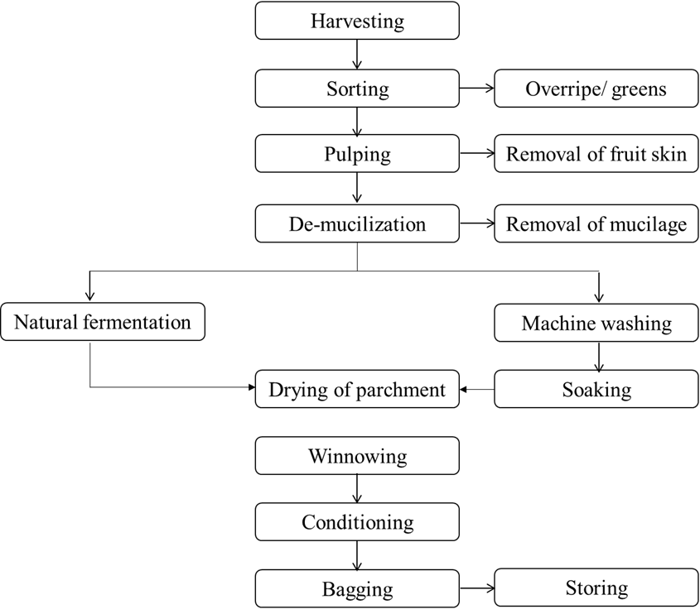
Fig. 3 Steps involved in the wet method of processing coffee

3. Secondary processing
The various steps involved in the secondary processing of coffee are as follows
Receipt of raw coffee from the planters
Immediately upon receipt of coffee from the planters, the moisture content is checked using moisture meters in the curing works.
Drying
If coffee received from growers is observed to be insufficiently dried, it undergoes further drying at the curing works to bring its moisture content to the standard level. To achieve this, the coffee is placed on drying surfaces that comply with specific area requirements. The floor space necessary for drying an amount of coffee equivalent to one tonne of clean coffee measures 7.273 square feet. Conversely, the floor area needed for spreading uncured coffee equivalent to one tonne of clean coffee is established at 1200 square feet. The average duration for drying is assumed to be one day, with a total of 165 drying days available annually. To create these drying surfaces, a variety of materials can be employed for the flooring, including cement, concrete, bricks, tiles, or Cuddapah stone.

Hulling, grading and garbling
The machinery installed at the curing factory for the various curing operations is as follows:
- Dust / Twig / Stone separator
- Huller
- Peeler-cum-polisher
- Winnower
- Unpeeled coffee separator
- Grader
- Catador
- Specific gravity separator
- Pneumatic separator
- PB band separator
- Bucket elevators
- Electronic colour sorting machine

Steps in hulling and grading of coffee
The initial stage in coffee processing involves the passage of raw coffee through a pre cleaner, designed to remove foreign elements like stones, sticks, and twigs. Following this, the coffee is directed into a huller or a peeler-cum-polisher and subsequently into a horizontal or vertical winnower. The coffee then enters a pre-grader, where fragments are sorted. From here, the coffee proceeds through various sizing graders, responsible for segregating distinct coffee grades such as PB, A, B, and C.
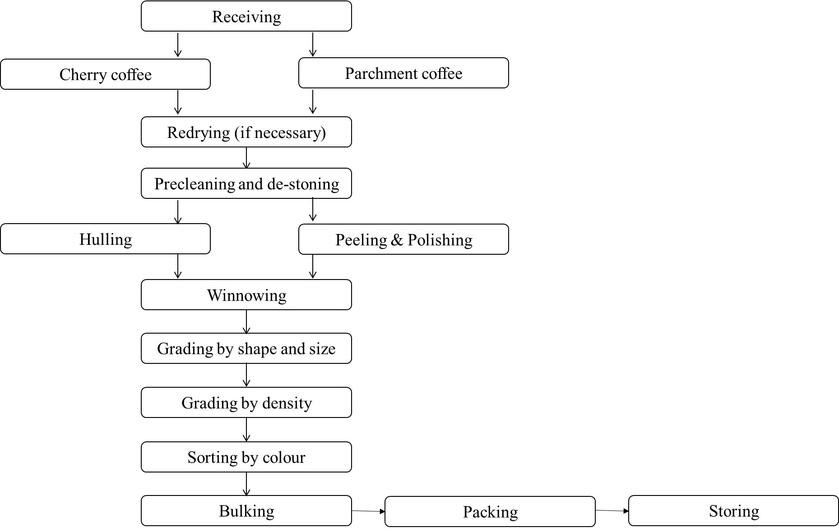
Fig. 4 Secondary processing of coffee in curing works

Hulling and peeling
The cherry coffees are hulled using 'hullers'. The parchment coffees are peeled using 'peelers' and then subjected to polishing.
Grading
The initial grading stage focuses on the size of the coffee beans and is conducted using a rotary grader. Subsequent to this, a secondary grading process employs densimetric classification methods. Catadors and gravity separators are utilized to classify coffee based on density.
Garbling and Sorting
Manual sorting of defective and discolored beans is performed by female garblers. Many curing facilities also incorporate electronic color sorting machines for separating discolored beans, such as blacks and browns. These electronic machines complement the manual garbling process.
Out-Turn Process
Following the garbling process, the coffee batch is out-turned, involving the weighing and recording of the quantity for each grade.
Packaging
Cured coffee is packed using double gunny bags, specifically of "B-Twill" or "DW" quality. Each bag contains 75 kg of coffee.
Coffee Storage
The capacity of a curing factory is determined by factors like drying capacity, machine capacity and storage capacity. Storage capacity is calculated based on established norms by the Board. For instance, storing raw coffee (uncured) equivalent to one tonne of clean coffee requires a floor area of 13.5 square feet when the warehouse's height is 15 feet. In terms of volume, storing raw coffee equivalent to one tonne of clean coffee necessitates 202.5 cubic feet of space. For storing one tonne of clean coffee, the required floor area is 7.5 square feet with a wall height of 14 feet.
Guidelines for Proper Coffee Storage:
To ensure appropriate storage of coffee in warehouses, the following guidelines have been established:
- Maintain clear demarcations between different lots of raw coffee to preserve individual lot identity in terms of quality and quantity.
- Avoid leaning coffee stacks against the warehouse walls.
- Provide stacks of raw coffee with dunnage made of parchment husk-filled gunny bags.
- Employ wooden dunnage for stacks of clean coffee.
- Ensure that both raw and clean coffee storage areas are rodent-proof.
- Avoid storing materials like fertilizers and pesticides inside or near coffee warehouses.

Cup Quality Evaluation:
Cupping, or cup tasting, serves as a method to consistently and impartially assess coffee. This process demands significant time investment and in-depth knowledge of coffee production and processing stages. The role of a cup taster involves the ability to discern subtle variations in taste and aroma – a highly effective sensory technique. Cupping holds paramount importance in the commercial coffee market.
Exporters use cup tasting to evaluate coffee before sale or to determine the price paid to growers. Importers rely on it to maintain uniformity and uphold standards set by their companies, thus influencing consumer satisfaction and pricing.
Numerous factors contribute to cup quality. Intrinsic coffee quality is shaped by plant material, cultural practices, and processing methods. Both estate-level and curing works processing impact coffee quality. Mistakes such as delayed pulping, excessive fermentation, improper washing, storage near pesticides, subpar gunny bag packing, and inadequate drying can lead to undesirable tastes, which cupping helps identify.
Cupping is a systematic approach to evaluating the aroma and taste attributes of coffee beans. Specific brewing techniques and steps facilitate a comprehensive sensory assessment involving smell, taste, and mouthfeel. Cupping is commonly employed for economic purposes such as coffee buying or blending (Anon., 2014).
The Cupping Process:
Sampling Roasting: The cupping process kicks off with a pivotal step known as sample roasting. Roasting coffee is an intricate and dynamic process where flavor development takes center stage. Approximately 50-100 grams of coffee sample are subject to light to medium roasting in a roasting machine at the optimal temperature of 205°C. This process continues until the coffee beans attain a desirable golden brown hue. The beans are meticulously roasted until they emit the distinctive "pop" sound, signifying an optimal roasting point.
Grinding: Subsequently, the roasted sample is ground into a medium to coarse powder using a grinder. This grinder plays a significant role as it encourages the release of an array of fatty acids, oils, and proteins into the extract. Importantly, this method also ensures the preservation of volatile aromatics, contributing to an intensified aroma in the final cup.
Brewing: For the brewing phase, using fresh coffee powder of a standard roast and maintaining the correct powder-to-water ratio is essential. This entails placing 10 grams of coffee powder into a porcelain cup and infusing it with 250 ml of boiling water (ensuring the water temperature remains at or above 95°C). After a precisely timed five-minute brewing period, any suspended particles are removed. The resulting brew is allowed to cool down to a palatable temperature, typically within the range of 45-50°C. Throughout this process, 5-7 cups are evaluated per sample.
Tasting: Tasting, a nuanced and multifaceted process, is conducted by a proficient panel of tasters. A spoonful of the brewed coffee is deftly drawn into the mouth while simultaneously inhaling deeply. This technique disperses the brew across the upper palate, aiding the rise of aromatic elements into the nostrils. The brew is then skillfully rolled across the tongue, allowing the taster to discern intricate taste impressions. Once evaluated, the used brew is discreetly discarded into a designated spittoon. Importantly, the number of cups tasted by each taster is strictly limited.
The tasters meticulously assess and evaluate the quality of the coffee liquor, classifying it into distinct categories: fine, good, FAQ (Fair Average Quality), falling off, and poor. This judgment is based on pivotal characteristics including body, acidity, flavor, and the presence of any undesirable off-flavors.
Key Characteristics Evaluated:
- Acidity: A desirable trait manifesting as a dry sensation beneath the edges of the tongue and at the back of the palate.
- Aroma: An intricate sensation interwoven with flavor, where aroma significantly contributes to the nuanced taste experienced on the palate.
- Body: The mouthfeel sensation, encompassing viscosity, heaviness, and thickness, perceived on the tongue.
- Flavor: A comprehensive experience encapsulating taste, aroma, and mouthfeel.
This meticulous cupping process serves as a valuable tool for gaining insights into diverse coffee varietals and blends. The amassed information facilitates the identification and rectification of defects in marketable products, whether through additional processing, refined drying or sorting techniques, or improvements in cultural practices, planting methods, marketing strategies, or transportation systems. Cupping fosters a deeper understanding, enabling production to be guided toward a quality-focused trajectory.
Some of the desirable flavour characteristics
- Caramelly - candy-like or syrupy
- Chocolaty - An aftertaste similar to unsweetened chocolate or vanilla.
- Delicate - A subtle flavour perceived on the tip of the tongue.
- Earthy - A soil characteristic
- Fragrant - An aromatic characteristic ranging from floral to spicy.
- Fruity - An aromatic characteristic reminiscent of berries or citrus.
- Mellow - A round, smooth taste typically lacking acid
- Nutty - An aftertaste similar to roasted nuts.
- Spicy - A flavour and aroma reminiscent of spices
- Sweet -Free of harshness
- Winey - An aftertaste reminiscent of well-matured wine.
Some of the undesirable flavour characteristics
- Bitter -Perceived on the back of the tongue usually the result of over-roasting.
- Bland -Neutral in flavour
- Carbony -Burnt charcoaly over toned - lack of acidity, aroma and aftertaste.
- Dirty –mustiness reminiscent of eating dirt.
- Grassy -An aroma and flavour reminiscent of freshly cut law
- Harsh -A caustic, clawing, raspy characteristic
- Muddy -A thick and dull
- Musty -A slightly stuffy or mouldy smell
- Rioy -A starchy texture similar to water in which pasta has been cooked.
- Rubbery -An aroma and flavour reminiscent of burnt rubber
- Soft -Neutral in flavour
- Sour -Taste flavour reminiscent of unripe fruit
- Thin -Lacking acidity, typically a result of under brewing
- Turpeny -Turpentine-like in flavour.
- Watery -A lack of body or viscosity in the mouth.

Cupping serves as an excellent approach to acquaint oneself with diverse coffee varietals and blends. Leveraging this information, it becomes feasible to address specific imperfections in marketable coffee products through supplementary processing, enhanced drying methods, or meticulous sorting techniques. Furthermore, the insights gained from cupping contribute to refining cultural practices, optimizing planting methodologies, refining marketing strategies, and even enhancing transportation systems. Ultimately, cupping fosters a deeper understanding, leading to the reorientation of production towards a trajectory focused on delivering higher quality outcomes.
5. Coffee quality standards
The grading of Indian coffee is based on the size of the coffee beans and the percentage of defects. (Anon., 2014). The quality specifications for Indian coffee are as follows:
Table 2. Moisture standards for the different types of coffee
Types of coffee |  | Moisture content (%) w.b.
Arabica parchment (Washed/ Plantation) | 10.5
Arabica cherry | 11.5
Robusta parchment (Washed Robusta) | 10.5
Robusta cherry | 11.5
Mysore nuggets EB | 9.0 to 10.5
Robusta kaapi royale | 9.0 to 10.5
Monsooned Malabar coffees | 13.0 to 14.5
Grading and garbling standards
Based on grading, the washed and unwashed arabica and robusta are broadly categorized as commercial grades, premium grades, specialty grades and miscellaneous grades.
I. Premium Grades
Washed Arabica (Plantation) | Unwashed Arabica (Arabica Cherry) | Washed Robusta (Robusta Parchment) | Unwashed Robusta (Robusta Cherry)
Plantation AA | Arabica Cherry AA | Robusta Parchment A | Robusta Cherry AA
Plantation PB Bold | Arabica Cherry A | Robusta Parchment PB Bold | Robusta Cherry A
 | Arabica Cherry PB Bold |  | Robusta Cherry PB Bold

II. Commercial Grades
Washed Arabica (Plantation) | Unwashed Arabica (Arabica Cherry) | Washed Robusta (Robusta Parchment) | Unwashed Robusta (Robusta Cherry)
Plantation PB | Arabica Cherry PB | Robusta Parchment PB | Robusta Cherry PB
Plantation A | Arabica Cherry AB | Robusta Parchment AB | Robusta Cherry AB
Plantation B | Arabica Cherry C | Robusta Parchment C | Robusta Cherry C
Plantation C | Arabica Cherry Blacks | Robusta Parchment Blacks | Robusta Cherry Blacks
Plantation Blacks | Arabica Cherry Bits | Robusta Parchment Browns | Robusta Cherry Browns
Plantation Bits | Arabica Cherry Browns | Robusta Parchment Bits | Robusta Cherry Bits
Plantation Bulk | Arabica Cherry Bulk | Robusta Parchment Bulk | Robusta Cherry Bulk
 |  |  | Robusta Cherry Clean Bulk

III. Specialty Coffees
- Mysore Nuggets Extra Bold
- Robusta Kaapi Royale
- Monsooned Malabar Coffees
- Monsooned Malabar Arabica Coffees
- Monsooned Malabar AAA
- Monsooned Malabar AA
- Monsooned Malabar A
- Monsooned Malabar Arabica Triage
- Monsooned Malabar Robusta Coffees
- Monsooned Malabar Robusta RR
- Monsooned Malabar Robusta Triage
IV. Miscellaneous Grades
1. Liberia Bulk (Bulk coffee from Liberica)
2. Excesia Bulk (Bulk coffee from Exceisa)

FSSAI standards and additives of coffee
The Food Safety Standards Authority of India has specified the limits of heavy metal contamination and pesticide residues as given in Tables 3, 4 & 5 (www.fssai.gov.in).
Table 3. Maximum permissible limits of contaminants/toxins/residue in coffee beans
Name of the metal contaminant/ toxin/ residue | Maximum  permissible limits
Copper | 30.0 ppb
Monocrotophos | 0.10 ppm
Ethephon | 0.10 ppm
Table 4. Standards and additives of roast and ground coffee powder
Parameters | Roasted & ground coffee | Decaffeinated roast and ground coffee
Moisture Content (m/m) | <5% (d.b.) | <5% (d.b.)
Total Ash (m/m) | 3-6% (d.b.) | 3-6% (d.b.)
Acid insoluble ash (m/m) | <0.1% (d.b.) | <0.1% (d.b.)
Water soluble ash (m/m) | ≥65% (d.b.) | ≥65% (d.b.)
The alkalinity of soluble ash (m/m) | 3.5-5 ml 0.1 N HCl (d.b.) | 3.5-5 ml 0.1 N HCl (d.b.)
Aqueous extracts (m/m) | 26-35% (d.b.) | 26-35% (d.b.)
Caffeine (m/m) | ≥1% (d.b.) | ≤0.1% (d.b.)

Table 5. Standards and additives of soluble coffee powder
Parameters | Soluble coffee powder | Decaffeinated soluble coffee powder
Moisture Content (m/m) | ≤4% (d.b.) | ≤4% (d.b.)
Total Ash (m/m) | ≤12% (d.b.) | ≤12% (d.b.)
Caffeine (m/m) | ≥2.8% (d.b.) | ≤0.3% (d.b.)
Solubility in boiling water | Dissolves in 30 sec | Dissolves in 30 sec
Solubility in cold water (16±2ºC) | Dissolves in 3 min | Dissolves in 3 min

Table 6. Maximum permissible limits for OTA (ppb)
Country | Maximum limits for OTA (ppb)
 | Green Bean | Roasted | Instant
Czech Republic | 10 | 10 | 10
Finland | 5 | 5 | 5
Germany | - | 3 | 6
Greece | 20 | - | -
Hungary | 15 | 10 | 10
Italy | 8 | 4 | 4
Netherlands | - | 10 | 10
Portugal | 8 | 4 | 4
Spain | 8 | 4 | 4
Switzerland | 5 | 5 | 5
Aspergillus and Penicillium are two prevalent types of molds frequently found in coffee. These molds are responsible for producing Ochratoxin-A (OTA), a primary toxin associated with their growth. It's noteworthy that OTA is recognized as a nephrotoxin, capable of inducing kidney damage, both in animals and humans. In response to this health concern, countries that import coffee have established specific thresholds for permissible OTA levels in various coffee forms, including green beans, roasted and ground coffee, as well as instant coffee (source: www.ico.org).

Value Addition in Coffee Processing
1. Roast and Ground Coffee Production
Roasting Process
Roasting is a dynamic and temperature-dependent process that induces both chemical and physical changes within coffee beans. The critical transformations occur at bean temperatures around 190°C and can reach up to 240°C in less than 12 minutes. This process takes place in batch-operated horizontal rotating drum roasters, where hot air from a furnace or burner passes through the tumbling green coffee beans. Various heat transfer methods, including conduction, convection, and radiation, contribute to the roasting. The chemical changes involve Maillard reactions and sucrose caramelization, leading to the development of a volatile complex with compounds such as furan derivatives, pyrazines, pyridines, benzenoid aromatics, aliphatics, alicyclics, and sulphur compounds. These compounds significantly contribute to the flavor and aroma of medium-roast Arabica coffee. Roasting results in changes in color, surface cavities or cracking, and a significant increase in size. The loss of mass ranges from 2-3% for Light roast to up to 12% for Very dark roast. The beans experience a loss of 15-20% weight but expand by up to 25% in size.
Cooling Process
Roasted beans are rapidly cooled after roasting to halt the process and prevent over-roasting. This is typically achieved by discharging the beans into a cooling vessel with upward-flowing cold air. Water quenching, which involves spraying water on the beans just before the end of the roast, aids in cooling and enhances uniform particle size for subsequent grinding.
Grinding Process
Roasted beans must be ground before brewing. A multistage twin horizontal roller system with up to 4 stages can be employed for uniform particle size distribution. The first two stages crack or crush the beans into smaller units, while the subsequent stages progressively grind them finer. The grind size depends on the brewing method and equipment used.
Packaging and Brewing
Packaging roasted and ground (R & G) coffee requires addressing the release of entrapped CO₂ gas, which can lead to package bursting. Vacuum packaging or the use of CO₂ scavengers can mitigate this issue. The brewing process involves extracting soluble compounds and volatile substances that contribute to the overall flavor. Various brewing methods are employed:
Espresso: Hot water is passed through finely-ground coffee under high pressure to yield a spicy coffee with a creamy layer.
Fresh Brew: Accelerated extraction is achieved using a quick filter method with a stainless steel permanent filter.
Instant Coffee: Produced through freeze-drying or spray-drying brewed coffee, offering a quick and convenient coffee preparation method.
Percolation: Hot water rises through coffee grounds in a percolator to create a range of coffee strengths based on percolation time.
Quick Filter: A classic method for making coffee in small or large amounts, using a paper filter.
Filter Coffee: Popular in South India, it involves using a filter for gravity-driven water flow through coffee grounds and chicory, producing a sweet milky coffee.
2. Instant Coffee Production
Instant coffee, also known as soluble coffee, is derived from brewed coffee beans. It is the dried soluble portion of roasted coffee, presented as powder or granules for quick preparation in hot water. Instant coffee is produced through freeze-drying or spray-drying, offering advantages such as speed of preparation, reduced shipping weight, and extended shelf life. This processing method accounts for about 20% of all processed coffee beans, with production capacities reaching up to 500 kg per hour.
Incorporating value addition processes like roasting, grinding, packaging, and various brewing methods enhances the diversity of coffee products available to consumers while allowing for optimization of flavor profiles and quality.
Classification of Instant Coffee Powder
Instant coffee powder comes in different forms based on its physical characteristics and processing methods:
- Non-Agglomerated Instant Coffee Powder: This type of powder consists of individual spherical bead-like particles, offering free-flowability and good solubility in hot water. It is commonly produced using spray dryers with tower drying chambers. The bulk density of the powder can be adjusted by injecting inert gas into the concentrated coffee extract before atomization.
- Agglomerated Instant Coffee Powder: Agglomerated powder is made up of medium-sized or large agglomerates with minimal fines, providing superior free-flowability and solubility in both hot and cold water. Medium-sized agglomerates are typically produced in spray bed dryers with fluid bed agglomeration. Large agglomerates are created by rewetting and drying spray-dried instant coffee in a controlled process.
- Granulated Instant Coffee Powder: This type of powder consists of large granules without fine particles, offering excellent free-flowability and solubility in hot water. Granulated powder is often produced in freeze dryers, which maintain a low-temperature drying environment to preserve aroma. The size of granules is determined by size reduction and classification of frozen extract.
Production Method for Instant Coffee:
- Roasting and Grinding: Green coffee beans are roasted to develop flavor and aroma. The beans are then finely ground, usually to pieces around 0.5-1.1mm in size, preparing them for extraction.
- Extraction: Coffee is extracted from the ground beans using water in percolation columns at elevated temperatures, concentrating the coffee solution.
- Drying Techniques: Instant coffee is produced through drying methods that determine the particle size and characteristics of the final product:
  - Spray Drying: Concentrated coffee extract is atomized and dried using hot air. This method produces non-agglomerated spherical particles.
  - Freeze Drying: The concentrated extract is frozen, granulated, and dried under vacuum. This method preserves the quality of the coffee, creating a premium product.
3. Decaffeinated Coffee:
Decaffeination processes involve various methods and solvents to reduce caffeine content. Commonly used methods include:
- Extraction with Organic Solvents: Dichloromethane (DCM) and ethyl acetate are organic solvents used to decaffeinate beans. The beans are contacted with steam and water, followed by extraction with the solvent, removal of residual solvent, and drying.
- Extraction with Water: Beans are extracted with water, and the solution passes through an activated carbon absorber to remove caffeine. The solution is concentrated and added back to beans, which are then dried.
- Extraction with Pressurized Carbon Dioxide (CO₂): CO₂ in liquid or supercritical state is used to dissolve caffeine selectively. Beans are extracted with CO₂, and the solvent is recycled.
Packaging of Coffee Powder:
Packaging methods for coffee powder include:
- Metal Cans: Metal cans offer durability, barrier properties against moisture, oxygen, and light, and protection against flavor and odor contamination. They are popular for retail packaging.
- Multilayer Pouches: Aluminium foil/plastic film laminates are used as flexible pouches, reducing packaging volume, costs, and waste. These pouches include barrier layers to protect against moisture, oxygen, and light. Different plastic layers provide sealing and mechanical protection.
These processes and packaging methods contribute to the variety of instant coffee products available to consumers, ensuring convenience, quality, and preservation of flavor and aroma.

Coffee Consumption and Health Aspects:
A typical cup (150 ml) of brewed coffee contains 80-120 mg of caffeine, while instant coffee contains around 50-65 mg. Caffeine is a central nervous system stimulant that can induce physiological dependence. Low doses (20-200 mg) of caffeine can have positive effects such as increased alertness and energy, while higher doses (>200 mg) might lead to negative effects like nervousness and anxiety, especially in individuals not accustomed to caffeine consumption. Coffee also contains tannin, a compound that can interfere with the absorption of iron. Therefore, it's recommended to avoid consuming coffee at least one hour before and after meals to prevent hindering iron absorption.
Coffee as a Nutraceutical and Food Additive:
- Nutraceutical Benefits: Coffee has been recognized for its nutraceutical properties. It exhibits anti-inflammatory, antioxidant, anti-obesity, and potential benefits for type-2 diabetes mellitus and cardiovascular diseases.
- Food Additive Applications: Coffee is used as a food additive due to its various properties. It demonstrates antimicrobial activity, can inhibit lipid peroxidation, and act as a prebiotic, promoting the growth of beneficial gut bacteria.
Innovative Coffee Products:
- Coffee-Leaf Tea: Made from the roasted and ground leaves of the coffee plant, coffee-leaf tea is similar in taste to green tea but with less caffeine content. It has been traditionally consumed in Ethiopia for centuries.
- Coffee Cherry Tea (Cascara): This herbal tea is prepared from the dried skins of the coffee fruit, often including the dried berries left after coffee bean extraction. It's consumed in countries like Bolivia, Yemen (qishr), and Somalia (bun).
- Instant Coffee Cubes: An innovative way to enjoy instant coffee, these cubes can be easily dissolved in hot water for a convenient coffee experience.
- Probiotic Cold Coffee: Combining the popularity of cold coffee with the health benefits of probiotics, this product offers a refreshing and gut-friendly beverage.
- Beverages from Green Coffee: Different beverages are made from green coffee, which is unroasted coffee beans. These beverages might offer distinct flavors and potential health benefits.
- Coffee-Infused Products: Various products like Coca-Cola with coffee, coffee almonds, coffee cookies, chocolates, coffee paste, coffee-filled items, and even cosmetics are commercially available, showcasing the versatility of coffee as an ingredient.
In conclusion, coffee is not only a widely consumed beverage but also a versatile ingredient with various potential health benefits. From traditional brewed coffee to innovative coffee-based products, its popularity continues to grow due to its unique flavors and potential health-promoting properties.

Coffee By-Products Utilization:
Coffee cherries, the raw material for coffee production, have various components that can be utilized, resulting in different by-products throughout the processing journey.
Components of the Coffee Cherry:
- Outer Skin: The outer skin of the coffee cherry can be green in unripe fruits and red in ripe ones.
- Pulp: This is a sweet and soft layer beneath the outer skin.
- Mucilage (Pectin Layer): A highly hydrated layer that follows the pulp.
- Endocarp: A thin yellowish layer beneath the mucilage.
- Parchment: The bean is covered by parchment after the mucilage.
- Silver Skin: The thin tegument covering each hemisphere of the green coffee bean.
By-Products Generation and Processing:
- Cascara: The first by-product generated during coffee processing. Its composition depends on the processing method used: wet or dry. Cascara from the dry method constitutes about 45% of the coffee cherry. Dry processing involves sun drying the cherries and mechanically removing the outer layers.
- Wet Processing: Used for Arabica coffee, involves depulping to remove the skin and pulp, followed by fermentation to eliminate mucilage, washing, drying, and hulling to remove the parchment. Significant by-products at various stages include skin, pulp, and mucilage.
- Silver Skin (CS): Generated during coffee roasting. When roasting 120 kg of coffee, approximately 2.5 kg of CS is generated.
- Spent Coffee Grounds (SCGs): Produced during grinding of roasted beans for coffee preparation or processing into soluble/instant coffee. About 2 kg of wet SCGs is generated per kilogram of soluble coffee produced.
Utilization of Coffee By-Products:
- Cascara: Cascara is utilized to make herbal tea with potential health benefits due to its antioxidant content. It is consumed in various cultures and is being explored as an ingredient in functional foods.
- Spent Coffee Grounds (SCGs): SCGs are rich in residual bioactive compounds and fibers. They have potential applications in different sectors such as agriculture, cosmetics, pharmaceuticals, and food industries. For example, they can be used as a source of natural antioxidants, dietary fiber, and even in the production of biofuels.
Utilizing coffee by-products can lead to reduced waste and the extraction of valuable compounds, contributing to sustainable practices in the coffee industry (Amaia et al., 2020).

Table 7. Origin, type of processing, processing step and the nutritional and bioactive compound composition of coffee by-products
Food applications of coffee processing by-products
Certainly, the nutritional composition of coffee processing by-products, including dietary fiber and protein, opens up various food applications that align with health-conscious trends and sustainable practices. Here are some specific food applications based on the nutritional components of coffee by-products (Table 8).
Absolutely, cascara and silver skin from coffee processing by-products offer more than just dietary fiber and protein. They are also rich sources of various micronutrients, vitamins, minerals, and bioactive compounds that have the potential to contribute to overall health and wellness (Saeed et al., 2019; Shalini et al., 2022).

Table 8. Food applications of coffee processing by-products
By-product | Applications | Reference
Cascara | Biofuel  Enzymes  Bio-sorbents  Particle board  Animal feed | Gouvea et al. (2009)  Murthy et al. (2009)  Oliveira et al. (2008)  Bekalo and Reinhardt (2010)  Mazzafera (2002)
 | Extraction of honey  High fibre salty cookies  Anthocyanin-food colour | Ramirez and Jaramillo (2015)  Moreno et al. (2019)  Hartati et al. (2012)
Mucilage | Source of pectin, antioxidants and flavanoids | Rathinavelu and Graziosi (2005)
Parchment | Functional ingredient  Gluten free bread (6.25%)  Cookies (2%)  Cellulose as a source of packaging material | Benitez (2019)  Cubero (2017)  Apuzzo (2018)
Silver skin | Bread  Biscuit  Cake | Pourfarzad (2013)  Garcia (2014)  Ates and Elmac (2019)
Spent Coffee Ground | Nutraceuticals-anti inflammatory  Food Ingredient- bakery products  Novel beverages with coffee aroma  Food preservative  Skincare products extracted from SCG  Animal feed  Biodiesel and Bioethanol  Solid biofuel  Composting  Material for construction  Bioplastics  Adsorbent of contaminants | Lopez (2016)  Oseguera (2019)  Sampaio (2013)  Jimenez (2015)  Marto (2016)  Seo (2015)  Rocha (2014)  Limousy (2015)  Ronga (2016)  Arulrajah (2017)  Williamson (2019)  Macnutt (2019)

Nutritional value and health promoting properties
Table 9. Nutrition value and health promoting properties of coffee by-products
By product | Nutrition claims | Health promoting properties
Cascara | High in fibre  Low in fat  Source of potassium, calcium, magnesium and vitamin C | Anti-diabetic  Anti-oxidant  Anti-inflammatory
Mucilage | Low in fat  Source of potassium, calcium and magnesium | Anti-oxidant
Parchment | High in fibre  Low in fat  Source of calcium and magnesium | Hypoglycemic  Hypolipidemic
Silverskin | High in fibre  Low in fat  Source of proteins, potassium, calcium, magnesium and vitamin C | Prebiotic  Anti-obesity; Anti-diabetic  Antioxidant  Anti-inflammatory; Skin health
Spent coffee grounds | High in fiber  Source of proteins  Source of potassium and magnesium | Prebiotic ; Anti-diabetic  Antioxidant; Anti-inflammatory

Indeed, coffee by-products hold the potential to serve as valuable sustainable sources of various nutrients and bioactive compounds, offering a range of health benefits. It's important to note that the specific nutritional claims attributed to each coffee by-product may vary based on factors such as the processing method, composition of the sample, and the specific bioactive compounds present. As research in this field continues, the potential health benefits and applications of coffee by-products are expected to gain further recognition, offering innovative solutions for sustainable nutrition and wellness.

8. References
Amaia, I.D., Maite, I. D. and Maria, D, C., 2020, Applications of compounds from coffee processing by-products, Biomolecules. 10(9):1-20.
Anonymous, 2014, Coffee guide: A manual of coffee cultivation published by Central Coffee Research Institute, Coffee Research Station, Government of India, Chikkamagalur district, Karnataka, India.
Jean, N.W., 2004, Coffee: growing, processing, sustainable production: A guidebook for growers, processors, traders and researchers. WILEY-VCH Verlag GmbH & Co. KGaA, Weinheim.
Saeed, M., Naveed, M., Bibi, J., Ali, K., Asghar, Lucas, P. and Sun, C., 2019, Potential nutraceutical and food additive properties and risks of coffee: A comprehensive overview. Critical Reviews in Food Science and Nutrition, 59(20): 3293-3319.
Shalini, S. A., Rahul V., Pavankumar R. M. and Poornima V., 2022, The wastes of coffee bean processing for utilization in food: a review. Journal of Food Science and Technology, 59(1):429-444.
www.indiacoffee.org viewed on 20th August 2022
www.ico.org viewed on 10th September 2022
www.fssai.gov.in viewed on 16th August 2022
www.pib.gov.in viewed on 22nd August 2022

