Experimental investigation of strength properties of flexible concrete using plastic fibers

D. Manoj¹, Dr.K.Shanker², P.Jagan³, S.Kiran⁴, K.Sai Poojitha⁵

^{1,3,4}Assistant Professor, Department of Civil Engineering, Kamala Institute of Technology and Science,Huzurabad,Karimnagar,Telangana,India.
²Professor, Department of Civil Engineering, Kamala Institute of Technology and Science,Huzurabad,Karimnagar,Telangana,India.
⁵UGStudents,DepartmentofCivilEngineering, Kamala Institute of Technology and Science,Huzurabad,Karimnagar, Telangana,India.
ABSTRACT:
This study intents to analyze the performance of flexible concrete reinforced with plastic fibers which are extracted from plastic wraps and PET bottles with a proper aspect ratio. The development of the flexible concrete is due to the low strain capacity of conventional, brittle nature and rigidity. The flexible concrete advances the flexibility and resistance to strain failure and this research project focuses on experimentally investigate the strength properties of flexible concrete.
The concrete mixture consists of same fundamental materials as that of conventional concrete and the micro plastic fibers are incorporated to reinforce the flexible concrete. The significant issue with flexible concrete is less compressive strength than of conventional concrete to address this problem and to reduce the development of cracks in concrete the Pozzolana Portland Cement (PPC) is employed instead of Ordinary Portland Cement (OPC) due to its low heat of hydration and presence of cementitious materials that refines the compressive strength of flexible concrete. Additionally, High Water Reducing Agents (HRWR) are used to enhance workability.
The pollution caused by plastics is drastic and hazardous causing threat to environment and human existence. For sustainable development and also reflecting upon the prompt demand on concrete, the plastic wraps are used as plastic fibers to minimize the pollution to an extent possibility. The investigation involves testing concrete cubes, beams and cylinders to evaluate strength properties by % addition of plastic fibers usually about 0.5%, 1%, 1.5% and also the flexibility characteristics of concrete are determined during flexural strength test.

Key Words: Flexible Concrete, Strain capacity, aspect ratio, plastic fibers, strength properties, super plasticizer.

INTRODUCTION
Flexible concrete is also called as Engineered Cementitious Concrete (ECC) is futuristic construction material that access the surpassing flexibility and durability compared to conventional concrete. It is precisely designed to address the brittleness and limited strain capacity of standard concrete. In general, conventional concrete is characterized by its high compressive strength on one hand and on other hand it has low tensile strength, limited flexural strength, low resistance to formation of cracks that appear even before the load is applied as a result of volumetric changes resulting from shrinkage and temperature changes.
The materials used in the flexible concrete are same as that of conventional concrete expect the coarse aggregate is completely eliminated because the fundamental property of the flexible concrete is to reduce the formation of cracks whereas, the coarse aggregates tend to develop larger cracks which is not a prime property of ECC. The absence of coarse aggregates in flexible concrete assist to its upgraded flexibility and allowing to meet various design considerations and adapting to numerous construction challenges.
The addition of fibers to the concrete leads to confrontation of these problems and also enhances the properties of concrete. These addition of fibers to concrete is used in various applications such as industrial flooring, concrete paving, precast concrete, shotcrete and many other applications as well.
Flexible concrete imparts high tensile ductility, enabling it to elongate and absorb energy in reaction to applied forces. This ductility property makes it exclusively convenient for applications where resistance to cracking and augmented ductility is vital like seismic- resistant structures.
METHODLOGY
- Determination of properties of materials
- Design of mix proportion
- Preliminary studies on mix proportion and fiber content
- Study on workability of fresh concrete
- Casting of control concrete specimens and Flexible concrete specimens for varying fiber content
- Obtaining the strength properties such as compressive strength, flexural strength and split tensile strength of five series of flexible concrete.
- Study the load- deflection behaviour to obtain optimum fiber content for flexible concrete.
- Comparison of properties of Flexible concrete with Conventional concrete.

MATERIALS USED:
Pozzolana Portland Cement (PPC):
The primary pozzolanic material used in PPC cement is usually fly ash. Fly ash is rich in silica and alumina, which react with calcium hydroxide in the presence of water to form additional cementitious compounds. This results in increased strength and durability of the concrete.PPC cement offers several advantages like better workability, improved resistance to cracks, reduced heat generation during hydration. It also exhibits slower initial setting time, allowing for extended workability periods. Additionally, PPC cement is more eco- friendly as it utilizes industrial by-products.

Fine Aggregate:
Fine aggregate is typically composed of small particles, often smaller than 4.75 millimetres (mm) in size. It can consist of natural materials such as sand, crushed stone, or gravel, or it can be manufactured, such as with crushed rock fines or artificial sand.The primary function of fine aggregate in concrete is to fill the voids between the coarse aggregate particles, providing stability, workability, and strength to the mixture. It plays a crucial role in the overall performance of concrete by contributing to its density, workability, and durability.

Plastic Fibers:
Plastic fibers offer several advantages, including their versatility, durability and resistance to chemicals and moisture. They can be easily produced in different shapes and sizes, additionally plastic fibers can be engineered to have specific properties such as flame resistance, UV resistance and antimicrobial properties.

Super Plasticizer:
Superplasticizer, also known as a high-range water reducer, is a chemical additive used in concrete and cement mixtures to improve the workability and flow characteristics of the material. It is primarily used to reduce the amount of water needed to achieve a desired consistency while maintaining the desired strength and durability of the concrete. The use of superplasticizers offers several benefits, that includes the enhanced workability, high strength, improved durability.

MIX PROPORTION
We reviewed various research journals and found that different mix proportions (1:2, 1:3, and 1:6) have been used for casting flexible concrete. In our experiment, we focused on the 1:2 and 1:3 mix proportions for evaluating the flexural strength of conventional beams after 7, 14, and 28 days of curing. The results indicated that the beams cast with the 1:2 mix proportion exhibited higher strength compared to those cast with the 1:3 mix proportion. As a result, we decided to proceed with the 1:2 mix proportion for the remaining project phases to take advantage of its superior strength characteristics.

CONCRETE PLACEMENT:
Mixing
In this study, hand mixing is adopted. First clean the mixing area by removing all the dirt and debris. Now collect the materials required by ensuring good quality and accurately proportioned as per the mix design by weighing using measuring balance. Infuse the measured quantities of cement, Fine aggregates and mix the dry ingredients uniformly now incorporate the plastic fibers with different proportions into the dry mix with proper homogeneity. Add the water which is combined with superplasticizer to a precise dosage as per the W/C ratio and mix the whole matrix equitably using shovel.

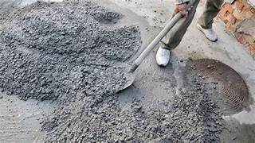
Fig 01: Mixing of the concrete
Casting of Concrete Specimens
After mixing all the ingredients is done in a required proportions, the concrete in its fresh state has to be cast into the cube, beam, cylinder specimens for both the conventional concrete and flexible concrete with varying proportions of plastic fibers. The specimens have to be corrected and fixed properly using bolts and nuts. The grease is applied all over the specimens before placing the concrete into the specimens. Now the concrete is added into 3 layers by properly tampered using a tamping rod for good compaction and to eliminate the air voids in concrete and once the concrete is filled into the specimens the surface is levelled using a trowel.
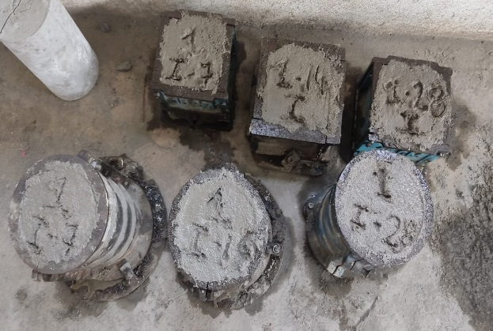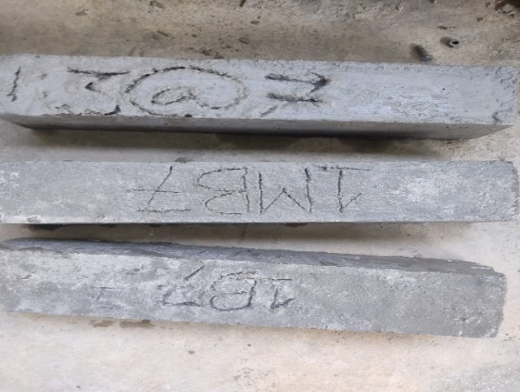
Fig 02: Casting of conventional and Flexible concrete specimens
Curing process
After the casting process of cubes, beams and cylinders specimens of conventional concrete and flexible concrete are completed leave the specimens for a day (24 hours). Then the concrete cubes, beams and cylinders are detached from the specimens and placed in the curing tank which is made ready previously before casting with good quality of water which are free from all the debris and is chemically inert. The concrete cubes, beams and cylinders are cured for the required days at subtle temperatures and are used for testing. These cubes, beams and cylinders are cured for 7 days, 14 days and 28 days.
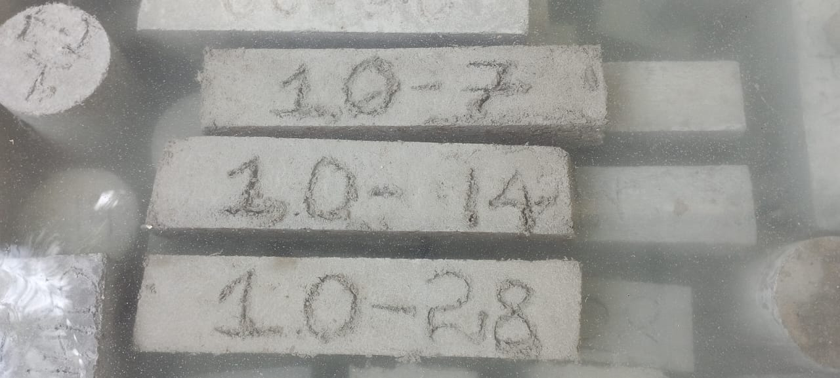

RESULTS AND DISCUSSIONS:
Flexural Strength
The prepared beam specimens of conventional concrete (M20, 1:2 and 1:3 proportion) and flexible concrete of 0.5%, 1%, 1.5% after casting and curing of 7 days, 14 days and 28 days are tested for Flexural strength using Flexural strength Testing Machine. Adjust the cube specimens under the load properly and apply the load gradually and record the values.
S.no | Specimens | 7 days  (N/mm²) | 14 days (N/mm²) | 28 days (N/mm²)
I | Conventional Concrete
1 | M20 | 3.23 | 3.89 | 4.24
2 | 1:2 | 3.42 | 4.10 | 4.38
II | Flexible Concrete ( % addition of fibers )
1 | 0.5 | 3.67 | 4.83 | 5.07
2 | 1 | 3.81 | 5.04 | 5.21
3 | 1.5 | 3.73 | 4.92 | 5.11
Table 01: Flexural test values of conventional and flexible beams

Graph 01: Flexural strength values of conventional and flexible concrete for 7 days of curing.

Graph 02: Flexural strength values of conventional and flexible concrete for 14 days of curing.

Graph 03: Flexural strength values of conventional and flexible concrete for 28 days of curing.

Compressive Strength
The prepared cube specimens of conventional concrete (M20 and 1:2 proportion) and flexible concrete of 0.5%, 1%, 1.5% after casting and curing of 7 days, 14 days and 28 days are tested for compressive strength using Compression Testing Machine (CTM). Adjust the cube specimens under the load properly and apply the load gradually and record the values.
S.no | Specimens | 7 days  (N/mm²) | 14 days (N/mm²) | 28 days (N/mm²)
I | Conventional Concrete
1 | M20 | 22.23 | 29.78 | 31.11
2 | 1:2 | 24.45 | 28.88 | 33.34
II | Flexible Concrete ( % addition of fibers )
1 | 0.5 | 28.88 | 32.88 | 36.89
2 | 1 | 33.77 | 35.56 | 40
3 | 1.5 | 31.11 | 33.34 | 36.44

Table 02: Compressive strength test values of conventional and flexible concrete.

Graph 04: Compressive strength values of conventional and flexible concrete for 7 days of curing.

Graph 05: Compressive strength values of conventional and flexible concrete for 14 days of curing.

Graph 06: Compressive strength values of conventional and flexible concrete for 28 days of curing.

Split- Tensile Strength
The prepared cylinder specimens of conventional concrete (M20 and 1:2 proportion) and flexible concrete after casting and curing of 7 days, 14 days and 28 days are tested for split- tensile strength using Compression Testing Machine (CTM). Adjust the cube specimens under the load properly and apply the load gradually and record the values.
S.no | Specimens | 7 days  (N/mm²) | 14 days (N/mm²) | 28 days (N/mm²)
I | Conventional Concrete
1 | M20 | 1.13 | 1.98 | 2.15
2 | 1:2 | 1.29 | 2.03 | 2.23
II | Flexible Concrete ( % addition of fibers )
1 | 0.5 | 1.32 | 2.05 | 2.58
2 | 1 | 1.58 | 2.4 | 3.08
3 | 1.5 | 1.48 | 2.26 | 2.84

Table 03: Split- tensile strength test values of conventional and flexible concrete

Graph 07: Split – tensile strength values of conventional and flexible concrete for 7 days of curing.

Graph 08: Split – tensile strength values of conventional and flexible concrete for 14 days of curing.

Graph 09: Split – tensile strength values of conventional and flexible concrete for 28 days of curing.

CONCLUSIONS
The following important conclusions were drawn based on the results obtained from the experimental studies;
- From the observations on test results on cubes, beams and cylinders for 7, 14 days the Flexible concrete with 1% of addition of plastic fiber has shown optimum results compared to 0.5% and 1.5%. Therefore, the optimum content of plastic fiber to be used is 1% to the volume of concrete.
- The compressive strength of conventional concrete for 28 days of curing was attained as 33.34 N/mm² and for flexible concrete is 40 N/mm² . The flexible concrete exhibited a significant 22.225% increase in compressive strength compared to standard concrete.
- The flexural strength of conventional concrete after 28 days of curing was measured at 4.24 N/mm², while the flexible concrete exhibited a significantly higher flexural strength of 5.21 N/mm². This indicates a notable increase of 15.83% in compressive strength compared to the standard concrete.
- After 28 days of curing, the split- tensile strength of conventional concrete was measured at 2.15 N/mm². In contrast, the flexible concrete demonstrated a significantly higher flexural strength of 3.08 N/mm², representing a notable increase of 30.19% compared to the standard concrete.

REFERENCES
- M S Shetty, “ Concrete Technology”, S Chand & company Ltd., First multi-coloured edition 2005.
- Concrete Technology by M.L Gambhir, Tata McGraw-Hill.
- “Building Materials”, by S.K.Duggal.
- IS 456-2000, “ Plain and Reinforced Concrete”, BIS New Delhi.
- IS 1199- 1959, “ Methods of sampling and analysis of concrete”, BIS New Delhi.
- IS 516-1959, “ Methods of tests for strength of concrete”. BIS New Delhi.
- IS 1489 (part 1)-2015, “ Specification for Portland pozzolana cement”, BIS New Delhi.
- IS 383-1970, “ Specification of fine aggregate”, BIS New Delhi.
- IS 1199-1959, “ Slump cone of concrete”, BIS New Delhi.
- IS 10262- 2019, “ Guidelines for concrete mix design proportioning”, BIS New Delhi.

