PLASTIC EATING BACTERIA : A NOBLE APPROACH

Dr. Tanmay Ghosh, Subhasree Roy

Department of Microbiology, Dinabandhu Andrews College, Baishnabghata, South 24 Parganas, Kolkata– 700084, West Bengal, India

Summary :- Plastics are tenacious polymers that, when accidentally used, are released into the environment where they accumulate and contribute to further soil and water pollution. Environmentalists are concerned about the refractory polymers being transported through agricultural soil, sediment, and water. Because they increase the bioavailability of substrates, the sharing of metabolites, and cell survival, the biofilm community that has developed on plastic polymers has a significant impact on how quickly they degrade. In order to degrade polymers, metabolic enzymes from microbes can be a powerful tool. Biodegradable polymers are made to degrade quickly by bacteria because they have the ability to degrade the majority of organic and inorganic components, such as lignin, starch, cellulose, and hemicelluloses. Use of sufficient biodegradable methods is required to reduce the burden of plastics.
Keywords :- Plastic, Degradation, Microorganisms, Polymer

Introduction :- Plastics are being considered as one of the most resilient poisons in the climate because it makes up about 80% of the litter found in rural areas, landfills, and water bodies, which causes its collection. Plastics are transported to horticultural settings accounting to a more impressive amount than sea waters, between 110,000 and 730,000 tons. The spillover and accumulation of plastics from family activities in WTP muck is a problem. Then it is transported to rural soils, where it begins to accumulate. Invading and dangerous species are transported as a result of the gathering and adsorption of these obstinate polymers. Additionally, the unfavorable outcomes include animals gulping because their food was mistaken for a trap and brought about. In this vein, numerous initiatives have been made to reduce plastic waste. There have been developed a few physical and substance degrading methods, such as UV treatment, actual pressure, oxidants, methanolysis, ammonolysis, hydrolysis, and so forth. In any case, these cycles typically

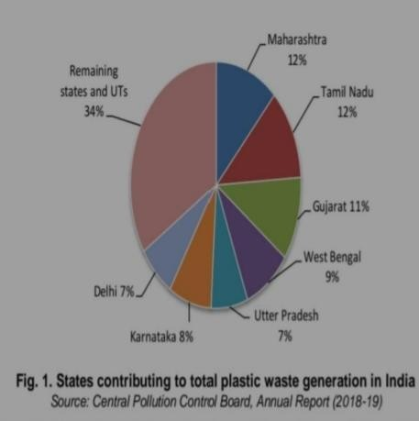
call for higher temperatures and produce poisonous substances in the majority of cases. Biocatalytic debasement, on the other hand, is an eco-friendly cycle that eliminates a variety of harmful metabolic side effects. However, the physical and chemical characteristics of plastics play a role in how much of them
biodegrade (Das and Kumar, 2013). By attaching and colonizing to the surface, microorganisms can debase ester bonds in the plastics by enzymatic hydrolysis. Thusly, the debasement instrument should be perceived and their items ought to be distinguished to find out likely natural dangers. Low thickness polyethylene (LDPE) is one of the significant wellsprings of natural contamination.
Polyethylene is a polymer framed by
lengthy chain ethylene monomers. The utility of polyethylene is extending overall at a pace of 12% per annum and every year engineered polymers are created roughly 140 million tons (MT). Since, huge measure of polyethylene is getting collected in the climate, their removal brings out a significant natural issue. In India, with the consistently expanding populace and urbanization, squander the board has turned into a significant test. Roughly 65 MT of metropolitan strong squanders (MSW) are delivered each year, which incorporates plastic, natural waste, wood, paper, glass, and so on. Plastic waste contributes 5% of metropolitan waste producing as much as 3.3 million metric tons every year [3]. Of the all out plastic creation, LDPE represents 60%, and the polythene convey packs which are non-degradable are the most generally seen as strong waste. The broad utilization of shopping packs (made of polythene) by general society is turned into a steadily expanding ecological issue in India. The civil and trash destinations are for the most part unloaded with more prominent amount of this waste material which is exceptionally headstrong. In India, the states significantly adding to add up to plastic waste age are Maharashtra Tamilnadu, Gujarat, West Bengal, Uttar Pradesh, Karnataka and Delhi as displayed in Plastic contamination in soil represents a serious danger to human, plant and creature life, since tiny measure of the

disposed of plastic is treated in squander offices, bigger amounts are arriving at landfills where in the deterioration cycle endures as long as 1000 years, and during this period the harmful synthetic substances gets retained in the dirt and water sources making them unsuitable for maintainable use.

Different types of non-biodegradable plastics:

Polyethylene :- Polyethylene (PE), otherwise called polyethene (IUPAC name) or polythene, is a significant gathering of thermoplastic polymers, delivered by the polymerization of ethylene.
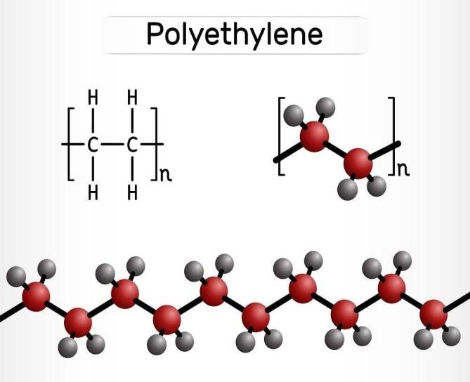
Contingent upon the polymerization interaction utilized, different kinds of polyethylene with contrasting properties can be acquired. They are ordered in view of their thickness, atomic weight, and stretching structure. For example, high thickness polyethylene (HDPE) is utilized for items, for example, milk containers, cleanser bottles, margarine tubs, trash cans, and water pipes. Ultra high atomic weight
polyethylene (UHMWPE) is utilized in can-and bottle-dealing wiolypropylene, a manufactured pitch constructed by the polymerization of propylene. One of the important group of polyolefin pitches, polypropylene is shaped or expelled into plastic items which are numerous where sturdinessth machine parts, heading, cog wheels, joints, and butchers’ hacking sheets, and may try and be tracked down in tactical arm or carriers. Low thickness polyethylene (LDPE) is utilized for the development of inflexible compartments and plastic film.

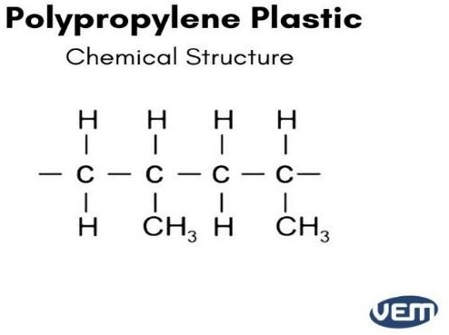
Polypropylene :- A synthetic pitch created by polymerizing propylene is called polypropylene. One of the most
significant groups of polyolefin pitches, polypropylene is molded or ejected into a wide variety of plastic products where durability, adaptability, light weight, and force resistance are required.
Furthermore, it is transformed into
strands for use in modern and domestic materials. In order to produce a flexible ethylene-propylene copolymer, ethylene and propylene can also be polymerized together. In the auto industry, PP (CnH2n) is the plastic that is used the most frequently. In any case, PP is protected from environmental oxidation by its spines, which contain long carbon chains, stabilizers, and cell reinforcements added during combination. These spines have high sub-atomic weights (10k–40k g/mol).

Polystyrene:- Polystyrene is a rigid, solid tar that is incredibly simple. It is the most commonly used plastic and is made by polymerizing styrene. When heated above
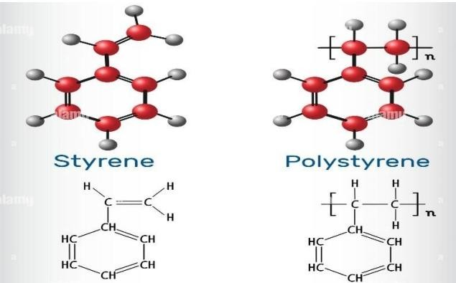
100 °C, the thermoplastic polymer, which is strong at ambient temperatures, streams. Water is not soluble in polystyrene. Polystyrene is a material that does not biodegrade, with a few exceptions. It is easily broken down by a variety of chlorinated solvents and sweet-smelling hydrocarbon solvents. Among other things, it is frequently

employed in the foodservice industry as an unbending plate, holders, disposable eating plates, and bowls. Styrene is a component of the polymer known as polystyrene. It is a synthetic hydrocarbon. It is naturally hydrophobic. Poly(1- phenylethane-1,2-diyl) is the name given to it by IUPAC. (C8H8)n is its general equation. PS squanders result from boundless business utilization of extended PS (EPS), otherwise called Styrofoam, in building protection and pressing, and of expelled PS (XPS) in holders, for example, espresso cups and food plate (Yang et al., 2018a). The exceptional construction of PS, with its direct carbon spine and exchanging spine iotas joined to phenyl moieties, makes its biodegradation truly challenging. In this manner, debasing PS has turned into a basic worldwide issue.

Polyethylene Terephthalate :- Ethylene glycol and terephthalic acid polymerize to form PET. Terephthelic corrosive is a glass-like strong obtained from xylene, and ethylene glycol is a boring fluid obtained from ethylene.
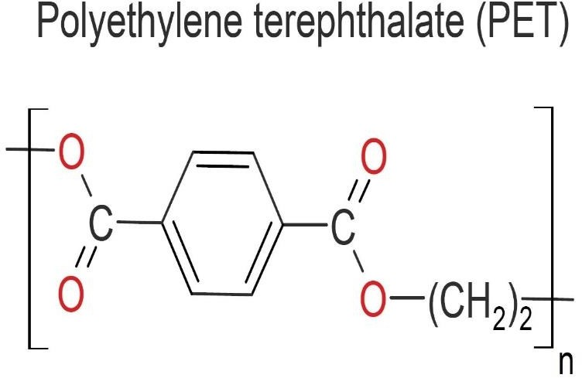
When heated together under the influence of chemical stimuli, ethylene glycol and terephthalic acid produce PET as a fluid, dense mass that can be cut easily into strands or cemented for use as plastic in the future. Ethylene glycol is a diol, an alcohol with a sub- nuclear structure and two hydroxyl (Gracious) gatherings, and terephthalic acid is a dicarboxylic sweet-smelling
acid. PET is transformed into a high-strength plastic that can be formed using all of the standard methods used with other thermoplastics at a slightly higher sub-atomic weight. PET movies are made by expulsion and are frequently offered for sale under the brand names Mylar and Melinex. PET fluid can be blow-framed into clear holders with high strength, rigidity, and basic gas and fluid impermeability. Here, PET is frequently used in bottles for carbonated beverages and in

insulated food storage containers. PET cannot be used as a compartment for hot food varieties because of its low melting temperature of around 70 °C (160 °F). The plastic that is reused the most is PET. However, only about 20% of PET material is recycled in the US.

Plastic degradation by microorganisms :-When a plastic material is exposed to certain ecological factors, such as light, intensity, dampness, or natural action, it undergoes polymer degradation, which is any alteration to the material’s physical or chemical properties. These methods of polymer corruption can be more specifically referred to as photodegradation, thermo-oxidative-debasement, and biodegradation, respectively. In order to degrade polymer materials, microorganisms such as microscopic organisms, growths, and green growth are required. This type of biodegradation can be carried out in high-impact or anaerobic conditions and does not require the addition of intensity energy. For instance, oxygen-consuming biodegradation causes CO2 and H2O to develop in the soil, whereas anaerobic biodegradation frequently results in the production of CO2, H2O, and methane. In general, the biodegradation of polymers is a very complex cycle that depends on a number of factors, including the substrate’s accessibility, the surface properties, the morphology, and the sub-atomic load of the polymers. Despite these factors, the overall process for the biodegradation of plastics begins with the emission of specific proteins that are able to damage plastic. These proteins vary depending on the microorganism and the polymer material that is being degraded. The bonds are then hydroperoxidized or hydrolyzed, and these chemicals participate in adsorption on the plastic surface. As a result, short corruption intermediates begin to appear before the final side effects of biodegradation are produced by the tricyclic corrosive (TCA) cycle.

Biodegration on the basis of synthetic plastic :-The biodegradation of engineered plastics can typically be divided into two groups: those with a carbon spine and those with heteroatoms in the primary chain. Polyethylene (PE), polypropylene (PP), polystyrene (PS), and polyvinyl chloride (PVC) are the four major types of plastics whose spines primarily consist of carbon particles. Similar to the first group, the second group of engineered plastics includes substances containing polyurethane (PU) and polyethylene terephthalate (PET). The waxworms Galleria mellonella and Achroia grisella, the cyanobacteria Phormidium lucidum and Oscillatoria subbrevis, and the two bacterial species Enterobacter asburiae YT1 and Bacillus sp. YP1.
A few PS-corrupting microorganisms have likewise been disengaged from different ecological examples including three soil microorganisms of Xanthomonas sp., Sphingobacterium sp., and Bacillus sp. STR-YO. The actinomycete Rhodococcus ruber C208 has likewise been found to
debase PS.

A few unique microorganisms have likewise been seen to aid the biodegradation of PP. Following their separation from plastic-unloading locales, Pseudomonas stutzeri, Bacillus subtilis, Bacilius flexus, Phanerocharte chrysosproium, and Engyodontium collection have
effectively delivered debasement results of PP. Extra microorganisms that have been viewed as equipped for corrupting PP incorporate Stentrophomonas panacihumi, Aneurinibacillus
aneurinilyticus, Brevibacillus agri, Breviibacillus sp., Brevibacillus brevis, Bacillus sp. Strain 27, and Rhodococcus sp. Strain 36.

Mechanism of plastic degradation by microbes :-

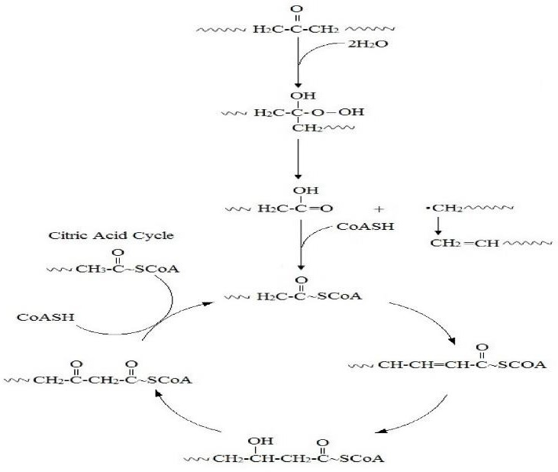
The mechanism of biodegradation by bacteria involves several processes that allow bacteria to break down complex organic compounds into
simpler, more manageable forms. Bacteria have evolved various strategies to degrade different types of organic matter, including pollutants, plant materials, and animal waste. Here's a general overview of the mechanisms involved Bacteria produce and release a wide array of enzymes into their surrounding environment. These enzymes, such as proteases, lipases, cellulases, and ligninases,
are specific to different types of organic compounds and help break them down into smaller components.Bacteria possess mechanisms to recognize and adhere to the target substrate. This can involve specialized surface structures or appendages that allow the bacteria to attach to the organic material, providing direct access to the nutrients. Once attached to the substrate, bacteria secrete enzymes that degrade the complex organic compounds into simpler molecules.
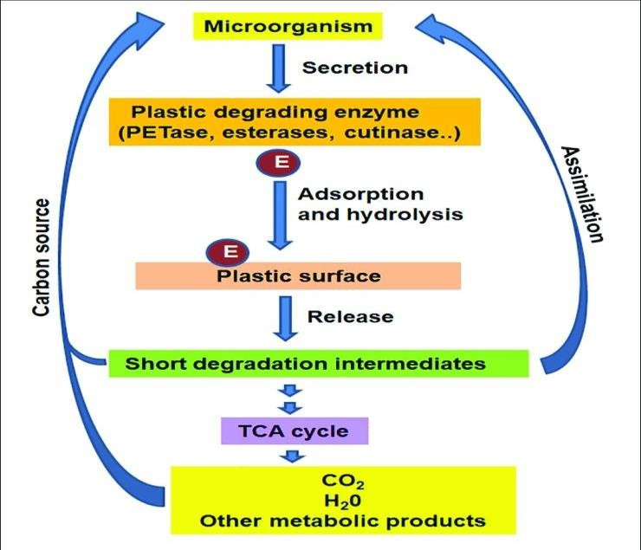
For example, cellulases break down cellulose, a complex carbohydrate found in plant cell walls, into glucose units.These simpler molecules
are more easily metabolized by the bacteria. Bacteria have metabolic pathways that allow them to utilize the breakdown products generated by the enzymes. The simpler molecules are taken up by the bacterial cells and undergo further metabolism to produce energy and essential building blocks for growth and reproduction. In some cases, biodegradation involves a consortium of bacteria working together. Different bacterial species may have complementary enzymes or
metabolic pathways, enabling them to break down complex compounds more efficiently as a team. Some bacteria possess the ability to detoxify harmful substances during the biodegradation

process. .It's important to note that different bacteria have specific capabilities and preferences for degrading different substances. Their effectiveness in biodegradation depends on their genetic makeup, environmental conditions, availability of necessary nutrients, and other factors. Scientists and engineers often leverage these natural abilities of bacteria for bioremediation purposes to clean up contaminated environments or for the treatment of wastewater and industrial waste.

Conclusion :-Plastics are polymers derived from oil and are used for a variety of purposes. PE packs are used extensively all over the world. Because of biodegradation, thermo-oxidative-decomposition, photodegradation, heat, and hydrolysis processes in the environment, the accessibility of small and nanoplastics in oceanic climate has multiplied many times, posing a serious threat to amphibian life (new and marine) and human existence via food web. To remove these polymers from the environment, sufficient biodegradable methods must be used. It is challenging to destroy or corrupt polymers because of their hydrophobic and dormant nature. Microorganisms have shown promising potential to degrade these polymers in addition to physical and synthetic methods. Utilizing specific polymers contaminated wastewater, it is also important to evaluate the potential use of organisms for polymer expulsion. The release of microplastics and nanoplastics, their danger, and their use in organisms still require attention. The technique to transfer these polymers from the wastewater to a reasonable spot for testimony/cremation and the exchange of plastic polymers from the loss into the sea- going environment, including streams and seas through various cycles, should appropriately be supported. It is expected that long-term, well up projects will evaluate the effects on the environment as it changes.
References :-

- Al-Thawadi, S., 2020. Microplastics and nanoplastics in aquatic environments challenges and threats to aquatic organisms. Arab. J. Sci. Eng. 45 (6), 4419–4440.

- Agustien, A., Mifthahul, J., Akmal, D., 2016. Screening polyethylene synthetic plastic degrading-bacteria from soil. Der Pharm. Lett. 8 (7), 183–187.

- Akmal, D., Asiska, P., Wangi, Q., Rivai, H., Agustien, A., 2015. Biosynthesis of copolymer poly (3-hydroxybutyrate-co-3-hydroxyvalerate) from palm oil and n-pentanol in a 10L bioreactor. Rasayan J. Chem. 8, 389–395.

- Allen, N.S., Edge, M., Mourelatou, D., Wilkinson, A., Liauw, C.M., Parellada, M.D., Barrio, J.A., Quiteria, V.R.S., 2003. Influence of ozone on styrene–ethylene– butylene– styrene (SEBS) copolymer. Polym. degrad. Stabil. 79 (2), 297–307.
- Alshehrei, F., 2017. Biodegradation of synthetic and natural plastic by microorganisms.
J. Appl. Environ. Microbiol. 5 (1), 8–19.

- Andrady, A.L., Hamid, S.H., Hu, X., Torikai, A., 1998. Effects of increased solar ultraviolet radiation on materials. J. Photochem. Photobiol. B 46 (1–3), 96–103.

- Awasthi, S., Srivastava, P., Singh, P., Tiwary, D., Mishra, P.K., 2017. Biodegradation of thermally treated high-density polyethylene (HDPE) by Klebsiella pneumonia CH001. 3 Biotech 7 (5), 332.

- Begum, M.A., Varalakshmi, B., Umamagheswari, K., 2015. Biodegradation of polythene bag using bacteria isolated from soil. Int. J. Curr. Microbiol. Appl. Sci. 4 (11), 674–680.

- Chen, Q., Lv, W., Jiao, Y., Liu, Z., Li, Y., Cai, M., Wu, D., Zhou, W., Zhao, Y., 2020a.
Effects of exposure to waterborne polystyrene microspheres on lipid metabolism in the hepatopancreas of juvenile redclaw crayfish, Cherax quadricarinatus. Aquat. Toxicol. 224, 105297.

- Chen, Y., Wen, D., Pei, J., Fei, Y., Ouyang, D., Zhang, H., Luo, Y., 2020b. Identification and quantification of microplastics using Fourier-transform infrared spectroscopy: Current status and future prospects. Curr. Opin. Environ. Sci. Health. 18, 14–19.

- Corami, F., Rosso, B., Bravo, B., Gambaro, A., Barbante, C., 2020. A novel method for purification, quantitative analysis and characterization of microplastic fibers using Micro- FTIR. Chemosphere 238, 124564.

- Danso, D., Chow, J., Streit, W.R., 2018. Plastics: Environmental and biotechnological perspectives on microbial degradation. Appl. Environ. Microbiol. 85 (19), e01095–19.

- Das, K., Mukherjee, A.K., 2005. Characterization of biochemical properties and biological activities of biosurfactants produced by Pseudomonas aeruginosa mucoid and non-mucoid strains isolated from hydrocarbon-contaminated soil samples. Appl. Microbiol. Biotechnol. 69 (2), 192–199.

- Jimenez, J.I., Minambres, B., Garcia, J.L. and Diaz, E. (2002). Genomic analysis of the aromatic catabolic pathways from Pseudomonas putida KT2440. Environmental Microbiology, 4: 824-841. https://doi.org/10.1046/j.1462-2920.2002.00370.x

- Joo, S., Cho, I.J., Seo, H., Son, H.F., Sagong, H.Y., Shin, T.J., Choi, S.Y., Lee, S.Y. and Kim, K.J. (2018). Structural insight into molecular mechanism of poly (ethylene terephthalate) degradation. Nature Communications, 9: 382.
https://doi.org/10.1038/s41467-018-02881-1.

- Kamini, N.R. and H. Iefuji. (2001). Lipase catalyzed methanolysis of vegetable oils in aqueous medium by Cryptococcus sp. S-2. Process Biochemistry. 37:405–410.
https://doi.org/10.1016/S0032-9592(01)00220-5.

- Kang, C.H., Oh, K.H., Lee, M.H., Oh, T.K., Kim, B.H. and Yoon, J.H. (2011). A novel family VII esterase with industrial potential from compost metagenomic library. Microbial Cell Factories, 10: 41. https://doi.org/10.1186/1475-2859-10-41.

- Kawai, F., Watanabe, M., Shibata, M., Yokoyama, S. and Sudate, Y. (2002). Experimental analysis and numerical simulation for biodegradability of polyethylene. Polymer Degradation and Stability, 76: 129-135. https://doi.org/10.1016/S0141-3910 (02)00006-X.

- Kawai, F., Watanabe, M., Shibata, M., Yokoyama, S., Sudate, Y. and Hayashi, S., (2004). Comparative study on biodegradability of polyethylene wax by bacteria and fungi. Polymer Degradation and Stability, 86: 05-114.
https://doi.org/10.1016/j.polymdegradstab.2004.03.015.

- Koutny, M., Lemaire, J. and Delort, A.M. (2006). Biodegradation of polyethylene films with prooxidant additives. Chemosphere, 64: 1243-1252.
https://doi.org/10.1016/j.chemosphere.2005.12.060.

