Preservation of Energy and the Fundamental Principle of Thermodynamics
Anupam Kumari
Arka Jain University Jharkhand

Abstract
The first law of thermodynamics extends the principle of energy conservation, affirming that energy remains constant in quantity, undergoing transformations rather than creation or annihilation. This principle applies to the entire universe: the amount of energy present at the beginning will remain unchanged at the end. However, delving into thermodynamics reveals that the first law is more intriguing than this simple explanation suggests. It also serves as a key to understanding the concept of "energy."

Utilizing the first law, an energy balance framework is constructed to enhance our comprehension of processes. It aids in process design, control, identification of areas for improvement, and eventual optimization. By comparing a process's energy utilization efficiency with other similar systems or the most efficient ones currently achievable, we can identify areas for optimization. This comparison helps prioritize optimization efforts, whether they target excessive energy consumption or particularly low efficiency.

Nevertheless, the energy approach has limitations. It generally doesn't consider the process's assumed direction; energy analysis allows heat to flow spontaneously from a higher temperature to a lower one. Energy doesn't differentiate between its forms either; for instance, 1 watt of heat is treated the same as 1 watt of work or electricity.
Introduction
The fundamental principle of thermodynamics, often referred to as the first law, articulates that the total energy of a system remains constant as it undergoes various transformations between different forms. To illustrate, when a moving car's kinetic energy is converted into heat energy through brake application, the sum of all energy within the system remains unchanged. This law establishes a crucial connection between the diverse energy forms within a system, its capacity to perform work, and the transfer of heat it experiences. In some contexts, it also introduces the concept of internal energy and introduces a thermodynamic property known as enthalpy. While the first law allows for a range of potential states for a system, empirical evidence suggests that only specific states are realized.
David Ting discussed the ideal Carnot cycle, a theoretical thermodynamic process that operates between two temperature reservoirs for maximum efficiency [1]. The sources of irreversibility within the DCHE (Direct Contact Heat Exchanger) system and quantify the extent of useful work lost during its cyclic operation has been identified. This framework integrates both the first law of thermodynamics (conservation of energy) and the second law of thermodynamics (entropy increase) to provide a holistic perspective on the system's efficiency and effectiveness [2]. Ventsislav D. Zimparov et.al. establishes that other forms of the Bejan number, which are based on the first law of thermodynamics and associated with convective heat or mass transfer, are combinations of the unique Bejan number with Prandtl (Pr) or Schmidt (Sc) numbers respectively [3]. Applying the first and second laws to practical engineering problems necessitates understanding the interplay between a substance's pressure, volume, and temperature. We outline the provision of such relationships, which can be accomplished through the use of equations of state or phase diagrams [4]. Dumitru Astefanesei et. al, investigation reveals a novel contribution to the total energy, contingent upon the scalar field's asymptotic value. This finding prompts a discussion on the significance of scalar charges in the context of the first law of thermodynamics [5]. Chen and Li derive both the differential and integral forms of the first law of thermodynamics for a holographic screen enclosing a spherically symmetric black hole. This formulation aligns with the equipartition principle and takes into account the structure of the Komar mass [6]. The first law of thermodynamics states that the total energy of a system remains constant, even if it is converted from one form to another [7]. Wassim M. Haddad presents a novel approach that combines energy-based modeling and hybrid dynamical systems to create a versatile framework for understanding and analyzing hybrid thermodynamic systems. This comprehensive methodology contributes to advancing the comprehension of critical thermodynamic behaviors and transitions, and extends the applicability of classical thermodynamic laws [8]. The evaluation of every power generation technology relies on the application of thermodynamic laws, which include the principles of energy conservation (the first law) and entropy generation (the second law). The utilization of these laws is imperative to attain a profound comprehension of the behavior and characteristics of power systems [9]. Jurgen M. Honig has significant emphasis on the significance of the surroundings in the context of heat and work transfers. This role of the surroundings is highlighted as a crucial factor in organizing and understanding the interactions involving heat and work within a thermodynamic system [10]. Bastian E. Rapp involves deriving the energy equation as an integral part of the process for solving for the various field variables. This equation solidifies the framework for analyzing fluid dynamics by integrating the principles of conservation of mass, momentum, energy, and thermodynamics [11].

Mathematical Modeling
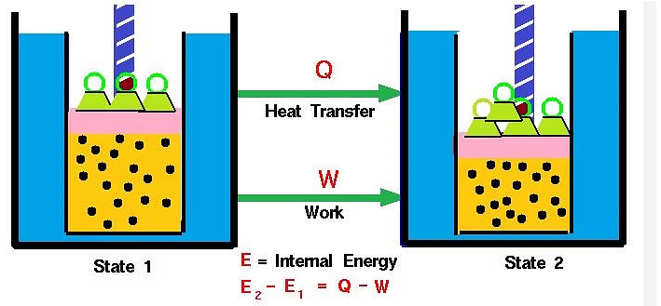
Figure 1 First Law of Thermodynamics
Conservation of Energy

The first law of thermodynamics articulates the principle of energy conservation. When applied to a system, it describes how the change in the system's internal energy is related to the total input energy, which is the sum of energy transferred as heat and energy involved in doing work. The power system encompasses both the internal energy stored within the system and the kinetic energy associated with its motion.

The following diagram visually illustrates this concept:
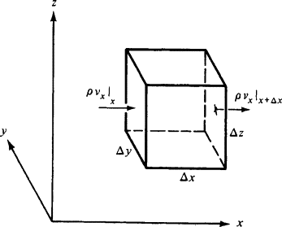
Figure 2 Control Volume for the energy conservation

In this representation, the internal energy and kinetic energy of the system play integral roles in determining the total power involved in the system's energy dynamics. The first law of thermodynamics ensures that energy is not lost within the system; instead, it is transferred between various forms such as heat and work. This principle forms the foundation for understanding energy transformations and exchanges within physical systems.

When a system transitions from state 1 to state 2, its internal energy undergoes a transformation from U1 to U2. This alteration in internal energy can be expressed as the change in internal energy;
ΔU = U₂ – U₁ (1)
The shift in internal energy occurs due to either the absorption or release of heat and/or the performance of work on or by the system. Since the total energy within the system must remain constant, we can express the mathematical formulation of the First Law as follows:
ΔU = q + w (2)
Where,
q - Represents the quantity of heat supplied to the system;
w - Signifies the work performed on the system

Other expressions of the first law of thermodynamics include:
- When a specific form of energy vanishes, an equivalent quantity of another form must emerge.
- The total energy of a system and its surroundings remains constant, preserving the principle of energy conservation.
- "Energy cannot be created nor destroyed, but it can change from one form to another."
- "The change in the internal energy of a closed system equals the energy that crosses its boundary as either heat or work."
The mathematical formulation of the first law of thermodynamics is:"
∆U = q + w

Case 1: For a cyclic process involving isothermal expansion of an ideal gas,
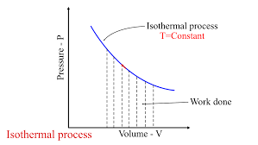
Figure 3 Isothermal Process

∆U = 0.

q = -w (3)

In simpler terms, for a cyclic process (a process where the system returns to its initial state), the heat absorbed by the system is equal to the work done by the system. This principle is known as the First Law of Thermodynamics and is often summarized as "energy cannot be created or destroyed, only converted from one form to another." In the context of a closed cycle, the energy input as heat is transformed into the energy output as work, and vice versa.

Case 2: For an isochoric process there is no work of expansion. i.e. ΔV = 0

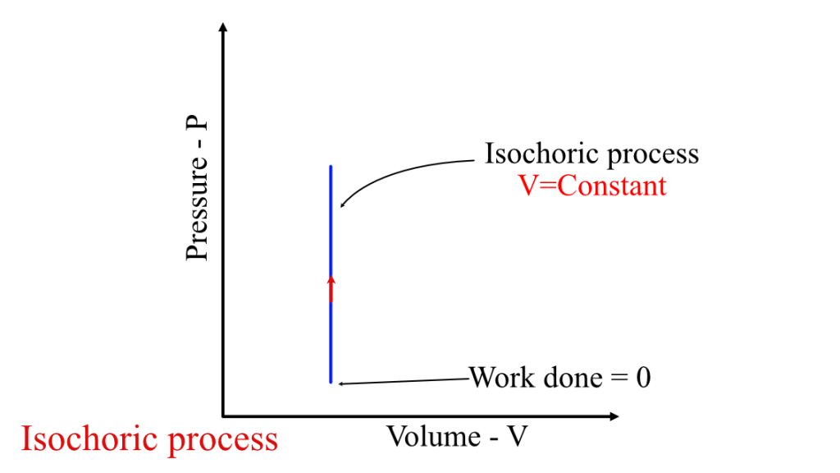
Figure 4 Isochoric Process

ΔU = q -w

ΔU = q – PΔV (4)
ΔV =0
ΔU = q (5)
During an isochoric process, which is also known as an isovolumetric process (constant volume process), the volume of the system remains constant while the pressure and temperature can change. In this type of process, no work is done by the system because there is no change in volume.
As a result, any heat supplied to the system is used solely to increase its internal energy. The internal energy of a system includes the kinetic energy of its particles (due to their motion) and potential energy (due to interactions between particles). So, in an isochoric process, any heat added to the system contributes to raising the internal energy, leading to an increase in temperature.
It's important to note that in an isochoric process, the internal energy change corresponds directly to the heat supplied, as no work is being done to change the volume.

Case 3: In an adiabatic process, there is no exchange of heat, meaning that q equals zero.
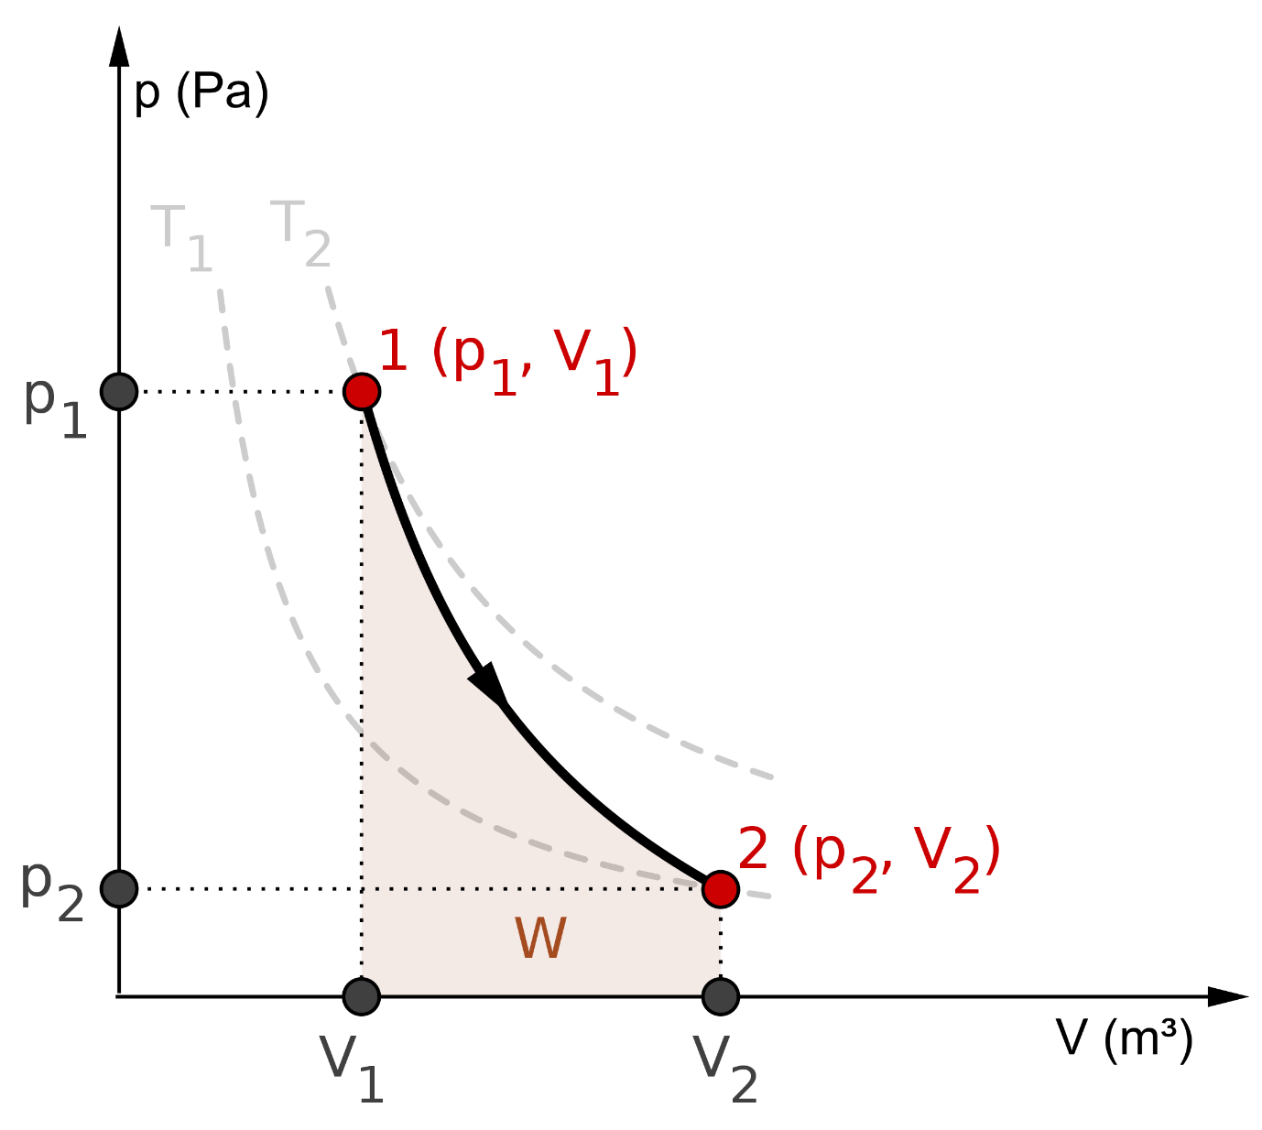
Figure 5 Adiabatic Process

As , q = 0
ΔU = w (6)

In an adiabatic process, characterized by the absence of heat exchange with the surroundings (Q = 0), the reduction in the system's internal energy corresponds to the work performed by the system on its surroundings. This connection arises from the First Law of Thermodynamics, which asserts that the change in a system's internal energy is the result of both the heat added to or removed from the system and the work executed on or by the system.
Since there is no heat exchanged (Q = 0) in an adiabatic process, the entire change in internal energy is accounted for by the work done. This often occurs in processes that happen rapidly or in well-insulated systems where heat transfer is negligible. Adiabatic processes are commonly found in thermodynamic engines and compressors.
Case 4: In an isobaric process, the pressure remains constant, experiencing no change.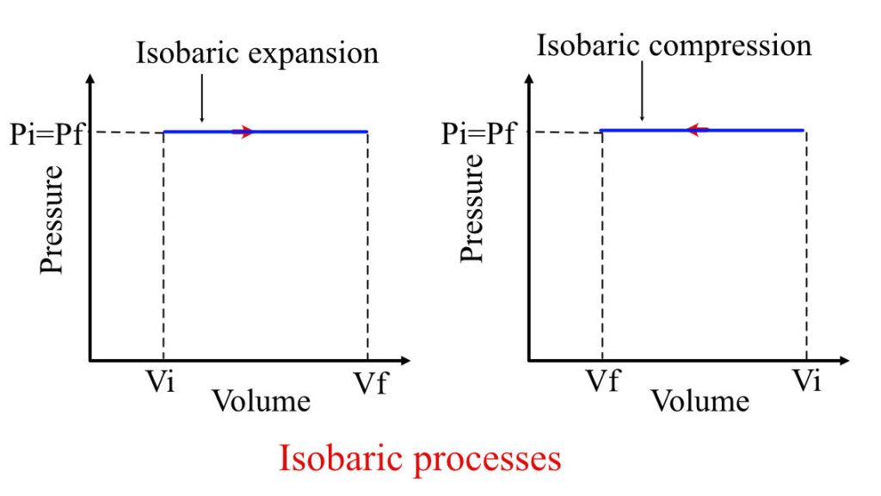
Figure 6 Isobaric Process

In an isobaric process, which is a process that occurs at constant pressure, heat can be exchanged with the surroundings. During such a process, a portion of the heat absorbed by the system is utilized to perform pressure-volume (PV) expansion work, while the remainder contributes to increasing the internal energy of the system.

Mathematically, for an isobaric process:

Q = ΔU + W

Where:
Q represents the heat added to the system.
ΔU signifies the change in internal energy.
W denotes the work done by the system.
Since pressure is constant in an isobaric process, the work done is given by:

W = PΔV (7)

Where:
P = Constant pressure
ΔV = Change in volume

So, during an isobaric process, the heat added (Q) is divided into two components: one part is used to do the PV expansion work (PΔV), and the other part contributes to the change in internal energy (ΔU). This is a result of the First Law of Thermodynamics, which accounts for the balance between heat transfer, work done, and change in internal energy in various thermodynamic processes.
CONCLUSION
In conclusion, the preservation of energy, as dictated by the fundamental principles of thermodynamics, stands as one of the most profound and universally applicable concepts in the realm of science and engineering. The first law of thermodynamics, often referred to as the law of energy conservation, tells us that energy cannot be created or destroyed; it can only change forms. This principle has far-reaching implications, not only in the field of thermodynamics but across all scientific disciplines. The preservation of energy, as enshrined in the fundamental principle of thermodynamics, serves as an enduring and indispensable guide in our pursuit of scientific knowledge and technological progress. It underscores the interconnectedness of energy, nature, and human society, emphasizing the importance of responsible stewardship for a sustainable future.

REFERENCE
- David Ting, Chapter 6 - The first law of thermodynamics, Thermofluids, Academic Press, 2022, Pages 85-108, ISBN 9780323906265, https://doi.org/10.1016/B978-0-323-90626-5.00019-7.
- P. Vivekh, D.T. Bui, M.R. Islam, K. Zaw, K.J. Chua, Experimental performance evaluation of desiccant coated heat exchangers from a combined first and second law of thermodynamics perspective, Energy Conversion and Management, Volume 207, 2020, 112-518, ISSN 0196-8904, https://doi.org/10.1016/j.enconman.2020.112518.
- Ventsislav D. Zimparov, Milcho S. Angelov, Jordan Y. Hristov, Critical review of the definitions of the Bejan number - first law of thermodynamics, International Communications in Heat and Mass Transfer, Volume 124, 2021, 105-113, ISSN 0735-1933, https://doi.org/10.1016/j.icheatmasstransfer.2021.105113.
- İsmaı̇l Tosun, Chapter 1 - Review of the first and second laws of thermodynamics, Editor(s): İsmaı̇l Tosun, The Thermodynamics of Phase and Reaction Equilibria (Second Edition), Elsevier, 2021, Pages 1-16, ISBN 9780128205303, https://doi.org/10.1016/B978-0-12-820530-3.00009-X.
- Dumitru Astefanesei, Romina Ballesteros, David Choque, Raúl Rojas, Scalar charges and the first law of black hole thermodynamics, Physics Letters B, Volume 782, 2018, Pages 47-54, ISSN 0370-2693, https://doi.org/10.1016/j.physletb.2018.05.005.
- Yi-Xin Chen, Jian-Long Li, First law of thermodynamics on holographic screens in entropic force frame, Physics Letters B, Volume 700, Issue 5, 2011, Pages 380-384, ISSN 0370-2693, https://doi.org/10.1016/j.physletb.2011.05.033.
- Bahman Zohuri, Chapter 5 - First Law of Thermodynamics, Physics of Cryogenics, Elsevier, 2018,Pages 119-163, ISBN 9780128145197, https://doi.org/10.1016/B978-0-12-814519-7.00005-7.
- Wassim M. Haddad, Condensed matter physics, hybrid energy and entropy principles, and the hybrid first and second laws of thermodynamics, Communications in Nonlinear Science and Numerical Simulation, Volume 83, 2020, 105096, ISSN 1007-5704, https://doi.org/10.1016/j.cnsns.2019.105096.
- Masood Ebrahimi, 2 - Thermodynamics of power plant, Power Generation Technologies, Academic Press, 2023, Pages 11-47, ISBN 9780323953702, https://doi.org/10.1016/B978-0-323-95370-2.00006-5.
- Jurgen M. Honig, The fundamental laws of thermodynamics; Role of surroundings in heat and work transfer, Reference Module in Materials Science and Materials Engineering, Elsevier, 2023, ISBN 9780128035818, https://doi.org/10.1016/B978-0-323-90800-9.00092-5.
- Bastian E. Rapp, Chapter 12 - Conservation of energy: the energy equation and the thermodynamic equation of state, In Micro and Nano Technologies, Microfluidics (Second Edition), Elsevier, 2023, Pages 311-322, ISBN 9780128240229, https://doi.org/10.1016/B978-0-12-824022-9.00030-9.

