**Chapter: Biofuels and future trends**

Dr. Parakh Sehgal

Asst Professor, Department of Lifescience

Shri Shankaracharya Professional University, Bhilai, Chhattisgarh- 490020

**Contents:**

**1. Introduction to biofuels**

**2. Methods for biofuel production**

**3. Types of biofuels**

**4. Available sources to produce biofuels**

**4.1 Plant sources**

**4.2 Microbial sources**

**5. Applications**

**6. Future trends**

**Chapter:**

**Biofuels and future trends**

Dr. Parakh Sehgal

Asst Professor, Department of Lifescience

Shri Shankaracharya Professional University, Bhilai, Chhattisgarh- 490020

**1. Introduction to Biofuels**

As the world seeks alternative sources of energy to combat the challenges posed by climate change and dwindling fossil fuel reserves, biofuels have emerged as a promising solution. Biofuels are renewable fuels derived from organic materials such as plants and plant-derived substances. In recent times, biofuels have captured significant importance due to limited oil reserves, energy security, and increasing environmental concerns because of rising climate change and greenhouse gas emissions.

Biofuels are referred to as any fuel derived and produced from organic material such as plants and their residues, agricultural crops, and byproducts that can be an adequate substitute for petroleum-derived fuel. Today with the growing cutting-edge technology, there is a considerable increase in energy demand leading to overconsumption of fossil fuels. Therefore, renewable energy is considered a possible substitute and is gaining importance globally for its social, economic, and environmental impacts. The idea behind using biofuels has been derived from ages.

Earlier in human history, biological materials were utilized for energy production. But due to the easy availability, and economically feasible reason, humankind went ahead with using fossil fuels over plant resources as their energy sources. Biofuels can be utilized as fuel additives or in their pure form. Further, biofuels are commonly classified into bioethanol and biodiesel. Liquid biofuels can be utilized as an alternative source for conventional fuels in the transportation sector, contributing to approximately 18% of primary energy consumption. Today, approximately 80% of liquid biofuel is manufactured in bioethanol, and the rest is via biodiesel. Biofuels differ from other petroleum feed-stocks in terms of oxygen content. They have oxygen levels ranging from 10% to 45% compared to petroleum products that have none. Biofuels also have lower sulfur and nitrogen levels when compared to petroleum sources. Biofuels can be produced via various methods, including biological, chemical, and physical methods. In this chapter, we will explore the types of biofuels, the plants used to create them, and the methods employed in their production. Biofuels can be solid, liquid, or maybe gaseous. Biofuels from organisms are defined as derived fuels, otherwise known as organic substances. This includes any plant or moss material including wood and animal waste. These kinds of fuels are considered renewable energy sources because they are sustainable for life and are naturally filled by rotation.

**2. Methods of Biofuel Production**

a. Fermentation

Fermentation is a common method used to produce biofuels, particularly ethanol. In this process, carbohydrates, such as sugars or starches, are broken down by yeast or bacteria under anaerobic conditions. The microorganisms convert the carbohydrates into ethanol and carbon dioxide. The ethanol can then be further purified and used as a fuel. The flow process is shown in Figure 1.

The below diagram shows the ethanol production process and illustrates the steps involved in ethanol production, including sugarcane or corn cultivation, extraction of sugars, fermentation, and distillation.

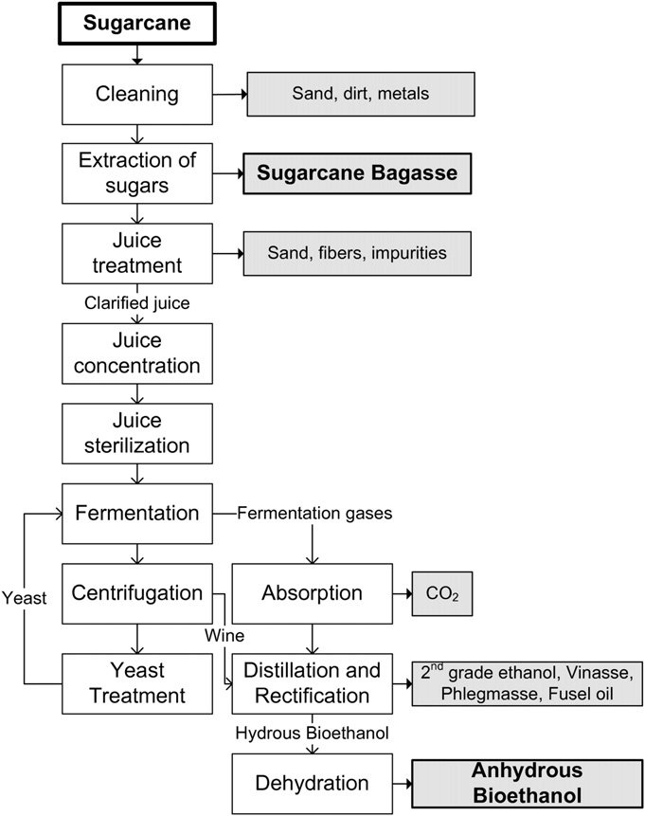

Figure 1: Ethanol Production Process

(Available at : [Block-flow diagram of the bioethanol production process from sugarcane (researchgate.net)](https://www.researchgate.net/figure/Block-flow-diagram-of-the-bioethanol-production-process-from-sugarcane-in-an-autonomous_fig1_267493488))

b. Transesterification

This process is used to produce biodiesel from vegetable oils. The vegetable oil is mixed with an alcohol, typically methanol, and a catalyst, such as sodium hydroxide or potassium hydroxide. This process is shown in figure 2. The reaction converts vegetable oil into biodiesel and produces glycerin as a byproduct. The biodiesel is then separated and purified for use. The biodiesel production process is illustrated in Figure 2 where the transesterification process, showcases the reaction between vegetable oil, alcohol, and catalyst to produce biodiesel and glycerin. As the demand for renewable energy continues to grow, biofuels offer a viable and sustainable alternative to fossil fuels. By utilizing various plant sources and employing different production methods, biofuels can contribute to reducing greenhouse gas emissions and mitigating climate change.

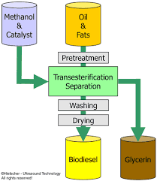

Figure 2 : [Biodiesel production process](https://www.vectorstock.com/royalty-free-vector/biodiesel-production-process-vector-15454166)

c. Anaerobic Digestion

Anaerobic digestion is employed to produce biogas from organic waste materials. The waste is placed in a sealed container, known as a digester, where it is broken down by microorganisms in the absence of oxygen. The resulting biogas, mainly composed of methane and carbon dioxide, can be collected, and used as fuel for various applications. Figure 3 is showcasing the anaerobic digestion process, depicting the decomposition of organic waste by microorganisms and the production of biogas.

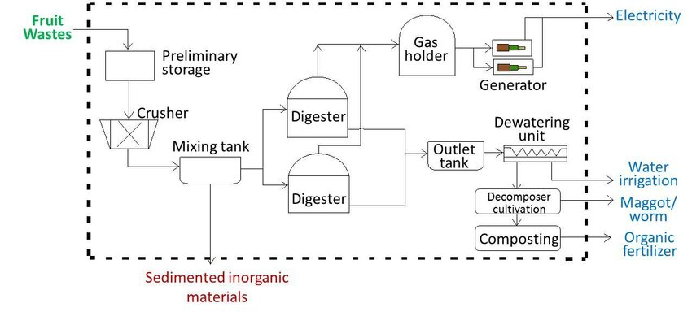

Figure 3: Flow process production of Biogas

(Available at [Process flow diagram of biogas plant (Download Scientific Diagram (researchgate.net)](https://www.researchgate.net/figure/Process-flow-diagram-of-biogas-plant_fig2_322081766)

**3. Types of Biofuels**

There are different biofuels that are prepared from wide natural sources are mentioned as

a. Ethanol

Ethanol is one of the most widely used biofuels. It is produced through the fermentation of sugar and starch crops, such as sugarcane, corn, and wheat. These crops contain carbohydrates that can be converted into sugars, which are then fermented by yeast or bacteria to produce ethanol. Ethanol can be blended with gasoline or used as a standalone fuel in vehicles.

b. Biodiesel

Biodiesel is another important biofuel that can be used as a substitute for conventional diesel. It is typically derived from vegetable oils, such as soybean oil, canola oil, or palm oil. The process of producing biodiesel involves a chemical reaction called transesterification, where the vegetable oil is reacted with an alcohol, usually methanol, to produce biodiesel and glycerin as a byproduct.

c. Biogas

Biogas is produced through the anaerobic digestion of organic materials such as animal manure, agricultural waste, and sewage. During this process, microorganisms break down the organic matter, producing a mixture of methane and carbon dioxide gases. Biogas can be used directly as a fuel for heating, and electricity generation, or as a replacement for natural gas.

**4. Available sources to produce Biofuels**

**4.1 Plant sources**

Different varieties of plant parts are available for the production of biofuel by using any of the above-mentioned process. The reported plants are mentioned below:

a. Sugarcane

Sugarcane is a primary feedstock for ethanol production. Its high sugar content makes it an ideal candidate for fermentation. The sucrose present in sugarcane is extracted, and the remaining fibrous material, known as bagasse, can be used as a biomass fuel to generate heat and electricity for the production process.

b.Corn

Corn, or maize, is widely cultivated for ethanol production, particularly in the United States. The starch present in corn kernels is converted into sugars, which are then fermented to produce ethanol. However, the use of corn for biofuel production has raised concerns about food security and potential environmental impacts.

c. Jatropha

Jatropha is a non-edible oilseed crop that has gained attention for its potential as a biodiesel feedstock. It is drought-resistant and can be grown on marginal lands unsuitable for food crops. The oil extracted from jatropha seeds can be used directly as biodiesel or blended with conventional diesel.

d. Camelina

Camelina is an oilseed crop that can be grown on marginal lands with minimal water and fertilizer requirements. It produces oil-rich seeds that can be processed into biodiesel. Camelina has the advantage of not competing with food crops for land and resources.

e.Pongamia

Pongamia is a tree native to tropical and subtropical regions. Its seeds contain oil that can be used for biodiesel production. Pongamia trees have the potential to thrive in arid and degraded lands, making them a sustainable option for biodiesel feedstock.

f. Lesquerella

Lesquerella is a native North American plant that produces oil-rich seeds. It is closely related to mustard plants and can be grown in arid regions. Lesquerella oil has properties similar to castor oil, making it a potential source of biodiesel.

g. Halophytes

Halophytes are plants that can tolerate high salinity levels, such as saltwater or saline soil. Some halophytes, like Salicornia and Suaeda, produce oil-rich seeds or biomass that can be used for biodiesel production. Growing halophytes on coastal or salt-affected lands could provide an additional feedstock source without competing with conventional agriculture.

h.Rice Straw and Hulls

Rice straws and hulls are agricultural residues generated during rice cultivation and processing. These residues have high lignocellulosic content, which can be converted into biofuels through various processes. Rice straws and hulls can undergo a process called biochemical conversion, where enzymes are used to break down the complex carbohydrates into simpler sugars. These sugars are then fermented by microorganisms, such as yeast, to produce bioethanol. The process involves pretreatment, enzymatic hydrolysis, fermentation, and distillation steps to obtain high-quality bioethanol.

Biogas Production: Rice straw and hulls can also be utilized for biogas production through anaerobic digestion. During this process, microorganisms break down the organic material in the absence of oxygen, resulting in the production of biogas composed mainly of methane and carbon dioxide. Biogas can be used directly as a fuel for cooking, heating, or electricity generation.

i. Rice Bran Oil

Rice bran is the outer layer of the rice grain and contains oil that can be extracted for biofuel production. Biodiesel Production: Rice bran oil can be processed through transesterification, a chemical reaction that converts the oil into biodiesel. This process involves mixing the oil with an alcohol (typically methanol) and a catalyst, resulting in the separation of biodiesel and glycerin. The produced biodiesel can be used as a renewable fuel in diesel engines, either as a blend with conventional diesel or as a pure fuel (B100).

Rice-Based Ethanol Fermentation

Apart from rice residues, rice itself can be used as a direct feedstock for bioethanol production. Starch conversion of rice grains as they contain starch, which can be hydrolyzed into sugars and then fermented into ethanol. The grains are first ground to a powder, and then enzymes are used to break down the starch into fermentable sugars. Yeast is then added to ferment the sugars, converting them into ethanol. It is important to note that the utilization of rice for biofuel production should be carefully balanced with its importance as a food crop. Policies and practices need to consider sustainable agricultural practices, food security, and regional priorities to ensure the responsible use of rice resources for biofuel production. Moreover, specific processing methods, technologies, and economic viability may vary, and it is advisable to consult local research institutions, agricultural departments, and biofuel experts for more region-specific information and guidance on utilizing rice as a biofuel feedstock.

It is important to note that while these plants show promise for biodiesel production, further research, and development are still needed to optimize their cultivation, oil extraction, and conversion processes. Additionally, factors such as land availability, sustainability, and economic viability will play crucial roles in determining their practical implementation.

**4.2 Microorganisms used to produce biofuels**

The consumption of organic substrates by a microorganism and its further utilization in the metabolic processes generates useful products, which can be used as a fuel to produce energy. The selection of microbes, substrates, and production processes is pivotal for biofuel synthesis. Biofuel with more positive net balance energy is considered suitable for commercialization. The other important concern is the selection of an efficient substrate for microbes. The lignocellulose which is composed of two kinds of carbohydrate polymers, cellulose and hemicellulose, and an aromatic-rich polymer called lignin containing substrates like agricultural waste and plant biomass are the most desirable alternatives compared to other types of feedstocks to produce biofuels.

**Some microorganisms are known for the production of biofuels:**

1. E.coli

E. coli strains can naturally utilize a variety of carbon sources (including sugars and sugar alcohols) under both aerobic and anaerobic conditions and are best suited for a variety of industrial products in addition to biofuels such as hormones, proteins, amino acids, and diverse high-volume chemicals including 1–3 propanediol and polyhydroxy butyrate.

b.Algae

Algae are microscopic organisms that can produce high amounts of oil, which can be converted into biodiesel. Algae can be cultivated in various environments, including ponds, tanks, or even wastewater, making them a promising feedstock for biodiesel production. Microalgae are single-celled organisms that can rapidly grow and accumulate high amounts of oil. They can be cultivated in photobioreactors or open ponds. Microalgae have the potential to produce large quantities of biodiesel and can utilize various carbon sources, including industrial emissions, making them an attractive option for future biodiesel production.

1. Saccharomyces cerevisiae

Saccharomyces cerevisiae can produce bioethanol through the fermentation of nonfood lignocellulosic wastes like rice husks, wheat straw, or corn stover.

d. Other organisms such as Corynebacterium glutamicum and Clostridium species are also successfully used in the production of various biofuels depending on the nature of the target material and the type of biofuel.

**5. Applications**

Biofuels are fuels derived from renewable biological sources, and they have the potential to play a significant role in reducing greenhouse gas emissions and mitigating climate change. Here are some applications of biofuels along with their types:

1. Transportation Fuels:

a. Biodiesel: Biodiesel is a renewable alternative to petroleum-based diesel. It is typically produced from vegetable oils (like soybean, canola, or palm oil), animal fats (such as tallow or used cooking oil), or even algae. The production process involves transesterification, where the triglycerides present in the feedstock are chemically converted into fatty acid methyl esters (FAME). Biodiesel can be used in diesel engines with little to no modification. It helps reduce greenhouse gas emissions, particulate matter, and other harmful pollutants compared to traditional diesel.

1. Bioethanol: Bioethanol, also known as simply ethanol, is a biofuel produced through the fermentation of sugars and starches found in various agricultural crops such as corn, sugarcane, wheat, and sorghum. It is commonly used as a blending agent with gasoline to produce ethanol-gasoline blends. Ethanol can improve engine performance, and it also reduces carbon monoxide and hydrocarbon emissions.
2. Aviation Fuels:
3. Biojet Fuel: They are renewable alternatives to conventional aviation fuels derived from crude oil. They are produced from various biomass feedstocks, such as algae, camelina, jatropha, and other plant oils. Biojet fuels are designed to have similar properties to traditional jet fuels to ensure compatibility with existing aircraft and infrastructure. They offer the potential to significantly reduce aviation-related greenhouse gas emissions and dependence on fossil fuels.
4. Heating and Electricity:
5. Biogas: Biogas is a mixture of methane and carbon dioxide produced through the anaerobic digestion of organic materials, such as agricultural waste, food scraps, and animal manure. Biogas can be used directly for cooking, heating, and electricity generation in small-scale systems or in large combined heat and power (CHP) units. It provides a sustainable alternative to fossil fuels, reduces methane emissions from organic waste decomposition, and helps manage waste effectively.
6. Biomass Pellets: Biomass pellets are compressed and granulated forms of organic materials, such as wood, sawdust, agricultural residues, and energy crops. They are used in pellet stoves, boilers, and industrial processes to generate heat for residential and commercial heating applications. Biomass pellets are considered carbon-neutral as the CO2 released during combustion is offset by the CO2 absorbed by the plants during their growth.
7. Industrial Applications:
8. Bio-Based Chemicals: Some biofuels, especially bioethanol and biodiesel, can serve as feedstocks for the production of bio-based chemicals and materials. These bio-based chemicals can replace petroleum-based products in various industries, including plastics, pharmaceuticals, textiles, and cosmetics. This can lead to a reduction in the consumption of fossil fuels and a lower carbon footprint.
9. Off-Grid Energy:

a. Biofuels in Remote Areas: In remote or off-grid locations with limited access to conventional energy sources, biofuels can offer a reliable and sustainable energy solution. For example, biodiesel-powered generators or biogas digesters can provide electricity and heat for remote communities, reducing their dependence on costly and polluting fossil fuels.

1. Backup Power Generation:
2. Biodiesel Generators: Biodiesel-powered generators can be employed as backup power sources during emergencies or power outages. Since biodiesel can be stored for extended periods without degradation, it can serve as a reliable option for critical facilities like hospitals, data centers, and telecommunications infrastructure.

Overall, the applications of biofuels offer various benefits, including reduced greenhouse gas emissions, improved energy security, rural development opportunities, and sustainable waste management. However, it's crucial to ensure the sustainable production and use of biofuels to avoid negative impacts on food security, biodiversity, and land use. Policies and practices should be implemented to promote responsible biofuel production and deployment to maximize their environmental and societal benefits.

**6. Future trends**

As the world continues to focus on addressing climate change and transitioning to a more sustainable energy future, biofuels are likely to play a crucial role. Researchers and scientists are actively working on various trends and advancements in biofuel technology to make them more efficient, cost-effective, and environmentally friendly. Here are some future trends and ongoing research areas related to biofuels:

1. **Advanced feedstock development:** Researchers are exploring new and more sustainable feedstocks for biofuel production. This includes non-food crops, algae, and lignocellulosic materials (such as agricultural residues, forestry waste, and dedicated energy crops). Algae, for instance, has the potential to yield high amounts of oil and can be cultivated in non-arable land or even in wastewater, reducing land-use competition.
2. **Synthetic Biology and genetic engineering:** Advances in synthetic biology and genetic engineering are enabling the development of bioengineered microorganisms and plants that can produce higher yields of biofuels. Scientists are modifying the metabolic pathways of microorganisms to enhance their ability to convert biomass into biofuels more efficiently.
3. **Consolidated bioprocessing:** This method is an approach that aims to streamline the production process by combining multiple steps (such as enzyme production, hydrolysis, and fermentation) into a single microorganism or process. CBP could significantly reduce production costs and increase the overall efficiency of biofuel production.
4. **Biochemical and thermochemical conversion:** Ongoing research is focusing on improving biochemical and thermochemical conversion processes. This includes optimizing enzymatic hydrolysis, gasification, pyrolysis, and other methods to convert feedstocks into biofuels and bio-based chemicals more effectively.
5. **Waste-to-Biofuel technologies:** Researchers are exploring innovative ways to convert various types of organic waste, including municipal solid waste, agricultural residues, and food waste, into biofuels. Waste-to-biofuel technologies can help address waste management challenges while simultaneously producing renewable energy.
6. **Biofuel Blending and compatibility:** Studies are being conducted to understand the effects of blending biofuels with conventional fossil fuels, such as gasoline and diesel. Researchers aim to optimize blending ratios to achieve better engine performance, reduced emissions, and seamless integration with existing infrastructure.
7. **Sustainability and life cycle assessment:** The sustainability of biofuels remains a critical concern. Researchers are conducting life cycle assessments to evaluate the environmental impact of different biofuel production pathways, including greenhouse gas emissions, land-use changes, and water consumption. This helps identify the most sustainable options and ensure that biofuels offer genuine carbon reductions compared to fossil fuels.
8. **Carbon Capture and utilization with biofuels:** Combining biofuels production with carbon capture and utilization technologies can result in negative emissions. By capturing CO2 from biofuel production facilities and using it for various purposes (e.g., in greenhouses or in enhanced oil recovery), the overall carbon footprint of biofuels can be further reduced.
9. **Commercialization and infrastructure:** As research progresses, the focus is shifting towards commercializing advanced biofuels and creating the necessary infrastructure to support their widespread adoption. This includes developing standards, regulations, and incentives to encourage the use of biofuels in transportation, aviation, and industrial applications.

In conclusion, the future of biofuels looks promising, with ongoing research and advancements aimed at making them a viable and sustainable alternative to fossil fuels. As technology evolves and policies favor renewable energy sources, biofuels are expected to contribute significantly to reducing greenhouse gas emissions, promoting energy security, and building a more sustainable energy landscape.

……………………………………………………………………………………………………….