FECAL MICROBIOTA TRANSPLANTATION IN ASTHMA

Dattatraya Kature¹, Vikesh Kukade², Rajendra Patil³
^{1,2,3} Delonix Society’s Baramati College of Pharmacy, Baramati, Maharashtra, India.
dattakaturebcop@gmail.com

Abstract
Asthma is a chronic lung disease that affects people of all ages and is expected to affect 400 million people by 2025, with over 250,000 deaths recorded each year and enormous health-care costs. Chronic inflammation causes airway hyper responsiveness, which results in recurring episodes of wheezing, dyspnea, chest tightness, and/or coughing that increase in frequency and intensity over time. Although the pathophysiology of asthma is unknown, it has been linked to a variety of genetic, environmental, viral, and dietary factors. Asthma has been linked to microbial triggers in the gut as a major environmental component.
Human body inhabits large number of different types of bacteria and they have close contact with human cells in the gut and they have numerous effects on host intestine because of this, human gut microbiome considered important and active. Human health is dependent on various microbial species in the gastrointestinal and respiratory tract. Antibiotics, antiulcer medications, and other medications severely degrade gut and lung microbiota. Dysbiosis and decreased microbial diversity result in the dysregulation of bidirectional interaction across the gut-lung axis, resulting in hypersensitivity and hyperreactivity to respiratory and food allergens. Overall, gut and lung dysbiosis appear to be important causes of the increased emergence of asthma.
Fecal microbiota transplantation (FMT) is a simple therapy that manipulates the human gastrointestinal (GI) microbiota by transferring a healthy donor microbiota into an existing but disturbed microbial ecosystem. Fecal microbiota transplantation (FMT) has successfully alleviated symptoms of several diseases and restored gut microbiota balance. This review aims to provide several insights into the development of FMT therapy for asthma.
Key Words- FMT, Asthma, Microbiota transplantation

INTRODUCTION
Asthma is a chronic lung disease that affects people of all ages and is expected to affect 400 million people by 2025, with over 250,000 deaths recorded each year and enormous health-care costs [1]. Chronic inflammation causes airway hyperresponsiveness, which results in recurring episodes of wheezing, dyspnea, chest tightness, and/or coughing that increase in frequency and intensity over time [2]. Although the pathophysiology of asthma is unknown, it has been linked to a variety of genetic, environmental, viral, and dietary factors. Asthma was once thought to be a single disease, but as it has become more complex, more precise therapy, such as microbiome analysis, is becoming available for diagnosis and treatment [3].
The gut microbiota is made up of a large and diverse community of bacteria that live in the gut. It has around 1014 species, divided into major phyla and 3000 to 5000 species weighing between one and two kilogrammes [4]. Bacteria in the gut provide the host with a number of benefits, including vitamin production, ion absorption, pathogen protection, histological improvement, improved immune functions, and food fermentation [5].
In healthy adults the most common genera are “Bacteroidetes, Firmicutes, Proteobacteria, Actinobacteria, Tenericutes, Faecalibacterium, and Bifidobacterium”. The “Streptococcaceae, Pasteurellaceae, Veillonellaceae, Prevotellaeaceae” and “Neisseriaceae” families, as well as Gemella genus, colonise in the oral cavity; the Lactobacillaceae family dominates the stomach; and “Lactobacillaceae”, “Enterobacteriaceae” and Streptococcaceae dominate the small intestine. In the large intestine bacteria densely colonized belongs to the families named “Enterococcaceae, Enterobacteriaceae, Bacteroidaceae, Bifidobacteriaceae, Lachnospiraceae, Rikenelleace”[6].
Asthma has been linked to microbial triggers in the gut as a major environmental component [7]. Human body inhabits large number of different types of bacteria and they have close contact with human cells in the gut and they have numerous effect on host intestine because of this, human gut microbiome considered important and active. Human health is dependent on various microbial species in the gastrointestinal and respiratory tract. The mature gut microbiota, which includes microorganisms such as “bacteria”, fungi, “archaea”, and viruses, is stable, adaptable, resistant, and diverse, and can regularly be regained to its pre-perturbation state [8].
Microbial dysbiosis and Asthma
Microbial dysbiosis in lungs and stomach can be produced by a range of lifestyle and environmental factors in people who have asthma. Dysbiosis, or microbial imbalance, has been related to the emergence of a number of ailments, including allergies and asthma [9].
Antibiotic therapy and alterations in the microbiome, particularly in infancy are important fields of research, meanwhile the microbiome has been linked to people's health in a variety of disorders, including asthma [10].
The changes in the gut “microbiome” among young adults, old asthmatic, nonasthmatic people are being explored and revealed that, in asthmatics compared to nonasthmatics genes involved in the “pentose phosphate pathway”, lipopolysaccharide “biosynthesis”, flagellar assembly and “bacterial chemotaxis” as well as “nitric oxide” production remained upregulated, which could be linked to increased “inflammation” and bacterial colonisation in young adult patients of asthma. Furthermore, non-asthmatics of both ages showed higher levels of genes linked to inflammation reduction and the degradation of air pollutants [11]. Another study found that asthma patients had lower levels of prostaglandin E2 (PGE2) and higher levels of chemicals linked to respiratory tract inflammation for example metabolites of “arachidonic acid”, “lysine residues” and mucopolysaccharides [12]. Children who developed asthma at school age exhibited decreased “gut microbiome” diversity up to one month of age when compared to “non-asthmatic” children [13]. One more study showing intestinal microbiome of asthmatic infants in their first three months of life and comparative number of the species “Lachnospira”, “Veillonella” and “Faecalibacterium” was much lower in these children [14]. The stool samples of asthmatic children aged between 4 to 7 yrs were compared to healthy children in a recent study based on metabolomics, with a emphasis on gut metabolites such as “amino acids” and “butyrate” and found that asthmatic children containing lesser amount of gut metabolites [38].
According to taxonomic categorization, the phylum “Firmicutes” (67.8%), “Actinobacteria” (20.7%), and “Bacteriodetes” (8.4%) existing 97 % of all sequences analysed among gut bacteria. When compared to healthy controls and children with asthma had significantly reduced abundances of the genera Faecalibacterium and Roseburia whereas significantly increase in the Enterococcus and Clostridium. In asthmatic children, microbial dysbiosis in the phylum Firmicutes was shown to be substantially lower, which could be connected to an increased asthma risk. It is necessary to discover a relationship between the microbiome of the lungs and the microbiome of the gut. An early life period for microbiome development, bacterial diversity, abundance and bacterial effects on the immune system are all important determinants for the establishment of the microbiome in all habitats [15].
Despite the fact that research on the gut microbiota is still in its early stages, data suggests that it could be a potential target for allergic asthma prevention and therapy. As a result, faecal microbiota transplantation (FMT) may be an alternative for treating asthma.
“Factors affecting the composition of gut microbiota”
The composition and amount of the “gut microbiota” is largely influenced by several environmental factors. It is revealed that environment plays a significant role in development of inflammatory disorders; for example, asthma prevalence varies greatly between western and developing countries. The importance of the “gut microbiota” in regulating “inflammatory responses”, as well as the fact that it is heavily influenced by the environment, suggests that altering the gut microbiota is one of the key ways to disease development.
Diet
Because bacteria have diverse preferences for energy sources, diet has a direct impact on gut microbial composition. Beneficial microorganisms feed on complex plant polysaccharides, which favour their growth over that of other microbes. In reality, the symbiotic association with gut bacteria permitted the transition to an herbivorous niche: digestion of complex plant polysaccharides is impossible without the “enzymatic” capabilities of “gut commensals” [16, 17]. The differences in the Westernized diet have been cited as a possible cause of the rapid rise in asthma [18].
“Hygiene”
The “hygiene hypothesis” [19] is the most often accepted theory for the rise in “asthma” and atopic problems in “western countries”. It shows that increased environmental "cleanliness" has resulting in a reduction in the amount of infectious stimuli required for optimal immune system development, impacting the switch from Th2-predominant immunity (Th2 stimulates humoral immune response) to Th-1-predominant responses (Stimulates cellular immune response) after birth. However, hygiene could be linked to different levels of exposure to commensals, which could be crucial for immunological activating actions.
Antibiotic use
Antibiotics have transformed Western medicine, significantly reducing infectious illnesses and their accompanying morbidity. Antibiotic use, on the other hand, could be connected to an increase in allergy illnesses in Western countries [20,21].
Maternal transfer
Infants are born sterile, but their guts get colonised with bacteria, mostly from their mothers, in the hours and days following birth. Immunological learning is thought to be critical at this period, thus any interruption could have an impact on immune function. Colonization of a newborn is influenced by the delivery method, hospital hygiene, and breast-feeding [22,23,24]. There were differences in colonisation between those who were born vaginally and those who were born via caesarean section. In vaginally born newborns, Bifidobacteria and Bacteroides were more common, whereas Candida difficile colonisation was more common in caesarean-section-born infants [25]. Premature infants were also more likely to be infected with Clostridium difficile with higher numbers [23].
Stress
Stress has been shown to affect the immunological, metabolic systems and it also appears to affect the gut flora. Study found that monkeys exposed to stress during pregnancy had different microbial colonisation in their offspring, with lower levels of Bifidobacteria and Lactobaccili [26]. Stress lowers Lactobacilli and increases E. coli, Pseudomonas growth and epithelial adhesion, according to other studies. Early life stress has been responsible to modify the “brain-gut axis” in rats, with increases in “plasma” “corticosterone” level, enhanced peripheral immunological response to lipopolysaccharide and changes in “gut microbiota” [27].
Pathogens
Colonization resistance is the ability of commensal organisms to protect themselves from infections by competing for nutrition and space. Pathogens, on the other hand, sometimes outsmart commensals due to the fact that various pathogens have unique survival strategies. Salmonella enterica induces and spreads intestinal inflammation by competing with the healthy bacteria in the gut [28].

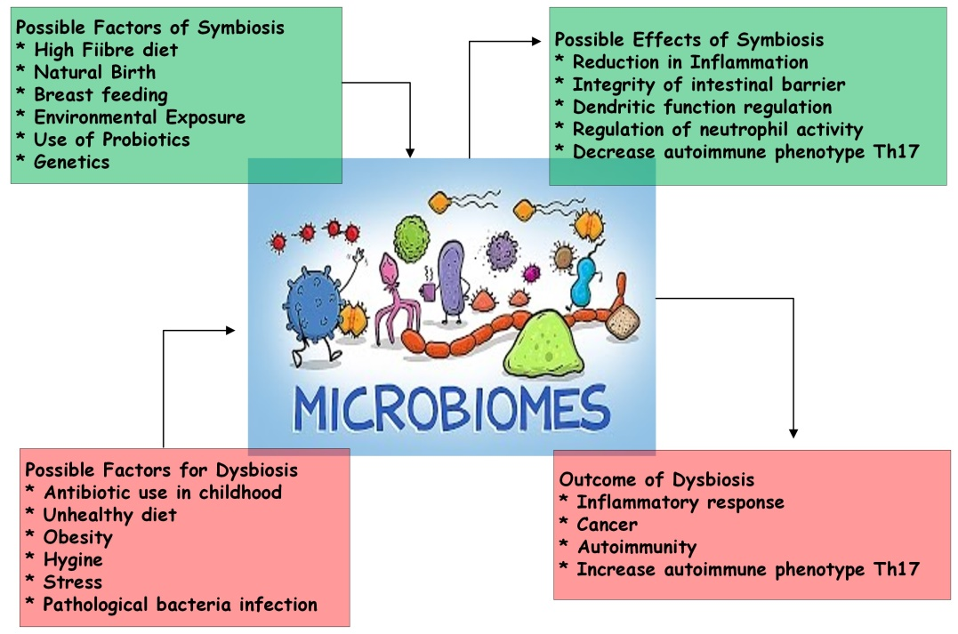
Fig 1 Factors affecting gut microbiota
“FAECAL MICROBIOTA TRANSPLANTATION”
“Faecal microbiota transplantation” (FMT) is the transport of faecal material comprising colonic “microbiota” from a healthy individual (donor) to colon of patient (recipient) with a dysbiosis-related disease condition or a changes in their "normal" gut microbiota. FMT has been practiced to cure disease by returning diversity of gut microbiota that is typical of a "healthy" individual. In various experimental research and clinical applications in the treatment of various diseases, FMT has already demonstrated a relatively excellent therapeutic effect.
FMT has been widely marketed as a treatment for Clostridium difficile (CDI) infections due to its efficacy in treating recurrent Clostridium difficile infections, particularly in Western countries [29]. In several case studies, retrospective case designs and a single “randomized controlled study”, FMT has been proven to be helpful in patients with severe or recurrent CDI, with a average cure rate of 87-90 percent for the over 500 cases reported to date [30, 31]. Irritable bowel syndrome, obesity, autoimmune diseases, diabetes, anorexia nervosa, “inflammatory bowel disease”, “cancer”, metabolic syndrome, neuropsychiatric disorders, multiple sclerosis and cardiovascular illnesses are among the diseases associated with gut microbiota alteration [32].
Probiotics and/or prebiotics oral administration as supplementary therapy in asthma has been supported by solid evidence. Numerous “clinical trials” of probiotics in human individuals with asthma have been conducted as significant experimental research [33].
In the restoration of altered gut microflora, “faecal microbiota transplantation” may be more effective than “probiotics” and overcomes probiotics' inherent quantitative gap. Furthermore faecal flora injection causes a long-term change in the gut microbiota of the recipient, whereas probiotics colonise the gut lumen only temporarily [34, 35].
FMT can be utilized to treat both GIT and non-GIT disorders in which the intestinal microbiota has been disturbed. According to the previous research data, FMT therapy has been used in the treatment of “Parkinson's disease”, myoclonus dystonia, “chronic fatigue syndrome”, metabolic syndrome, “multiple sclerosis”, fibromyalgia, insulin resistance, obesity and “childhood regressive autism”[36].
GIT disorders | Non GIT disorders
Recurrent Clostridium difficile infection | “Arthritis”
“Inflammatory bowel disease” (IBD) | Asthma
“Cholelithiasis” | “Atopy”
“Idiopathic constipation” | Autism
“Colorectal Cancer” | “Autoimmune disorder”
“Irritable bowel syndrome” | Chronic fatigue syndrome
“Hepatic encephalopathy” | Diabetes mellitus and insulin resistance
 | Fibromyalgia
 | Hay fever
 | Metabolic syndrome
 | Multiple sclerosis
 | Obesity
 | Parkinson’s disease
Table 1 Disorders developed by changed gut “microbiota”.
FMT PROCEDURES
- Donor selection
FMT has the potential to transfer infectious pathogens, hence thorough screening tests are recommended to limit this risk [37]. Once a donor has been chosen, microbes must be screened in blood and faeces. Donors are selected from the family member, close partners, unrelated volunteers or friends. Intimate partners benefit from the fact that they share “environmental” risk factors which may reduce the chance of transmission of infection.
First-degree relatives of the maternal line may benefit from sharing the most bacteria in their intestine with the receiver. As a result, adaptive immunological components in the intestine's “mucosal immune system” (such as “antigen-specific antibodies”) may be more accepting of “microbiota” from such donors [38].
- Donor screening
The possible transfer of infectious illnesses is a major risk linked with FMT therefore; potential donors are subjected to strict screening procedures. HIV, Hepatitis A, B, and C, syphilis viruses are all tested for in blood samples from potential donors. Also donor stool must be checked for Clostridium difficile toxins, Helicobacter pylori, parasites, and other enteric pathogens including Giardia, Cryptosporidium, Isospora, and Rotavirus [38]. The potential donors with risk of infection should follow given criteria that are at high risk of microbiome associated infection (Table 2).

Criteria
Age should not less than 18 years or more than 65 years
BMI not more than 30 kg/m2
Diabetes or other metabolic diseases
Malnutrition (moderate to severe)
Antibiotics use history (in the last 6 month)
Diarrhea or Dysentery (in the last 3–6 month)
History of Clostridium difficile infection
Immune disorder
Travel history to a tropical countries in last 3 month
Gastrointestinal disorders -IBD, IBS, gastrointestinal malignancy
Table 2 Criteria for stool donors who are at high risk of microbiome associated disease or infection.
- Sample Preparation
In terms of preoperative preparation, irrespective of the mode of administration, recipients generally take a large-volume stool preparation. GIT motility inhibitors like loperamide are used in some cases to improve faecal microbiota retention [39]. Patients who receive FMT through the upper GI tract should also be given proton pump inhibitors. The optimal faecal quantity for FMT has yet to be determined, but 50 to 60 gm of 250 ml to 300 ml diluent is generally preferred. A sample of stool is suspended in either tap or bottled water or a sterile saline solution, with the latter thought to be less likely to influence the "microbiota" of the donor stool. After that, the donor stool is homogenised by stirring or using a motorised blender. Following that, the mixture is filtered through piece of cloth to remove larger particles from the stool samples [40].

4. Sample administration
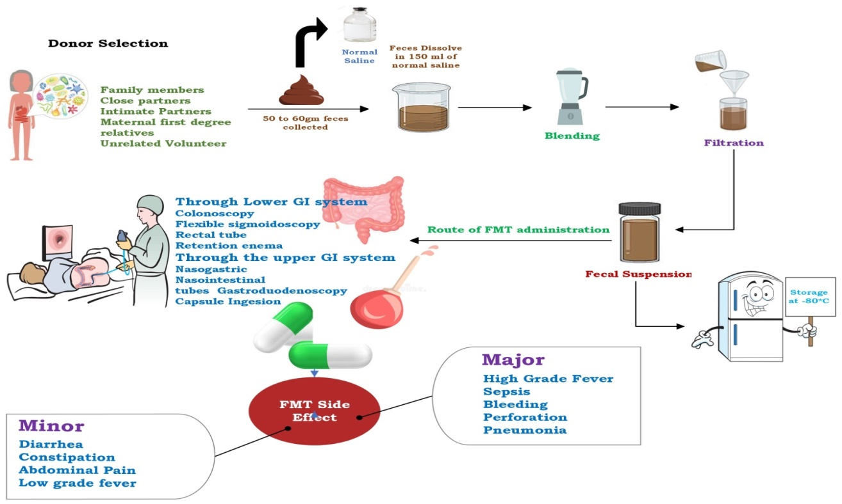
Donor faeces can be administered by the lower GI system, such as colonoscopy, “sigmoidoscopy”, rectal tube enema or through the upper GIT system such as nasogastric or gastroduodenoscopy. There is no conclusive proof to support the use of one modality over another. FMT by using colonoscopic is generally safe, well-tolerated and simple to perform with the benefit of consenting evaluation of the whole colon though it should be used with caution in patients with “colitis” and colonic distention because of the increased risk of perforation [38]. Retention enema and “flexible sigmoidoscopy” may be options in such cases, although a few patients may find it difficult to retain the transplanted stool, necessitating repeated small volume infusions use for 2 to 3 days course. FMT through the upper GI tract is simple and low-risk but it may inconvenient and develop the risk of vomiting and aspiration in some patients [39]. Furthermore, donor stool sample may not be spread evenly throughout the colon and increasing the possibility of small intestinal bacterial overgrowth.
Fig 2 The FMT procedure and its consequences.
POTENTIAL ADVERSE EVENTS
The FMT procedure has been used on people with serious medical comorbid illnesses on a regular basis, and it is well tolerated, safe, and has few serious side effects [40]. The most common initial side effects are “abdominal discomfort”, bloating, “latulence”, diarrhoea, constipation, “vomiting”, and a temporary fever [41]. The majorities of these side effects is self-limiting and disappear within two days of FMT. However, little is known about FMT's long-term effect on the immune system, such as the emergence of dormant infections. Asthma, “obesity”, “diabetes mellitus”, “atherosclerosis”, IBD, IBS, colon cancer, “nonalcoholic fatty liver disease”, and autism are all caused by changes in the microbial flora of the intestine [40]. A recent systematic study of FMT for recurrent infection of CDI found no significant adverse effects [42]. Following FMT without donor screening, a patient with ulcerative colitis developed cytomegalovirus infection [43]. Furthermore, even when extensive donor screening is performed, FMT has the potential to transmit occult illnesses because faeces extracts act as intermediaries between the donor and the recipient. It has been proposed that norovirus infection can be transmitted via colonoscopic FMT, but this has yet to be proven [44].
CONCLUSION
Finally, FMT appears to be a promising treatment option for asthma. Still, the existing data in this area is incomplete, and important scientific work has recently initiated. The new technologies have enabled a systematic study of the “intestinal microbiota” providing more accurate information about its composition and clinical modifications. It is important to work out how FMT alters the gut microbiota's composition or restores intestinal “bacterial flora” and how this relates to asthma. The changes in the “gut microbiome” and health status of asthma patients before and after FMT treatment should be carefully examined.

REFERENCES
1. Christiansen SC, Zuraw BL. Treatment of hypertension in patients with asthma. New England Journal of Medicine. 2019 Sep 12;381(11):1046-57.
2. Bokulich NA, Chung J, Battaglia T, Henderson N, Jay M, Li H, D Lieber A, Wu F. 527 Perez-Perez GI, Chen Y, Schweizer W, Zheng X, Contreras M, Dominguez-Bello MG, 528 Blaser MJ. Antibiotics, birth mode, and diet shape microbiome maturation during early 529 life. Sci Transl Med. 2016;8:343ra82-.
3. Desai M, Oppenheimer J. Elucidating asthma phenotypes and endotypes: progress towards personalized medicine. Annals of Allergy, Asthma & Immunology. 2016 May 1;116(5):394-401.
4. Hooper LV, Midtvedt T, Gordon JI. How host-microbial interactions shape the nutrient environment of the mammalian intestine. Annual review of nutrition. 2002 Jul;22(1):283-307.
5. Hillman ET, Lu H, Yao T, Nakatsu CH. Microbial ecology along the gastrointestinal tract. Microbes and environments. 2017:ME17017.
6. Barcik W, Boutin RC, Sokolowska M, Finlay BB. The role of lung and gut microbiota in the pathology of asthma. Immunity. 2020 Feb 18;52(2):241-55.
7. Johnson CC, Ownby DR. The infant gut bacterial microbiota and risk of pediatric asthma and allergic diseases. Translational Research. 2017 Jan 1;179:60-70.
8. Levy M, Kolodziejczyk AA, Thaiss CA, Elinav E. Dysbiosis and the immune system. Nature Reviews Immunology. 2017 Apr;17(4):219-32.
9. Sokolowska M, Frei R, Lunjani N, Akdis CA, O’Mahony L. Microbiome and asthma. Asthma research and practice. 2018 Dec;4(1):1-9.
10. Walter J, O'Mahony L. The importance of social networks—An ecological and evolutionary framework to explain the role of microbes in the aetiology of allergy and asthma. Allergy. 2019 Nov;74(11):2248-51.
11. Lee JJ, Kim SH, Lee MJ, Kim BK, Song WJ, Park HW, Cho SH, Hong SJ, Chang YS, Kim BS. Different upper airway microbiome and their functional genes associated with asthma in young adults and elderly individuals. Allergy. 2019 Apr;74(4):709-19.
12. Kim BS, Lee E, Lee MJ, Kang MJ, Yoon J, Cho HJ, Park J, Won S, Lee SY, Hong SJ. Different functional genes of upper airway microbiome associated with natural course of childhood asthma. Allergy. 2018 Mar;73(3):644-52.
13. Abrahamsson TR, Jakobsson HE, Andersson AF, Björkstén B, Engstrand L, Jenmalm MC. Low gut microbiota diversity in early infancy precedes asthma at school age. Clinical & Experimental Allergy. 2014 Jun;44(6):842-50.
14. Arrieta MC, Stiemsma LT, Dimitriu PA, Thorson L, Russell S, Yurist-Doutsch S, Kuzeljevic B, Gold MJ, Britton HM, Lefebvre DL, Subbarao P. Early infancy microbial and metabolic alterations affect risk of childhood asthma. Science translational medicine. 2015 Sep 30;7(307):307ra152.
15. Hufnagl K, Pali-Schöll I, Roth-Walter F, Jensen-Jarolim E. Dysbiosis of the gut and lung microbiome has a role in asthma. In Seminars in immunopathology 2020 Feb (Vol. 42, No. 1, pp. 75-93). Springer Berlin Heidelberg.
16. Martinez-Medina M, Aldeguer X, Lopez-Siles M, González-Huix F, López-Oliu C, Dahbi G, Blanco JE, Blanco J, Garcia-Gil JL, Darfeuille-Michaud A. Molecular diversity of Escherichia coli in the human gut: new ecological evidence supporting the role of adherent-invasive E. coli (AIEC) in Crohn's disease. Inflammatory bowel diseases. 2009 Jun 1;15(6):872-82.
17. Heilbronn LK, Campbell LV. Adipose tissue macrophages, low grade inflammation and insulin resistance in human obesity. Current pharmaceutical design. 2008 Apr 1;14(12):1225-30.
18. Devereux G. The increase in the prevalence of asthma and allergy: food for thought. Nature Reviews Immunology. 2006 Nov;6(11):869-74.
19. Strachan DP. Family size, infection and atopy: the first decade of the'hygiene hypothesis'. Thorax. 2000 Aug;55(Suppl 1):S2.
20. Wickens K, Pearce N, Crane J, Beasley R. Antibiotic use in early childhood and the development of asthma. Clinical and experimental allergy: journal of the British Society for Allergy and Clinical Immunology. 1999 Jun 1;29(6):766-71.
21. Farooqi IS, Hopkin JM. Early childhood infection and atopic disorder. Thorax. 1998 Nov 1;53(11):927-32.
22. Penders J, Thijs C, Vink C, Stelma FF, Snijders B, Kummeling I, van den Brandt PA, Stobberingh EE. Factors influencing the composition of the intestinal microbiota in early infancy. Pediatrics. 2006 Aug 1;118(2):511-21.
23. Biasucci G, Rubini M, Riboni S, Morelli L, Bessi E, Retetangos C. Mode of delivery affects the bacterial community in the newborn gut. Early human development. 2010 Jul 1;86(1):13-5.
24. Grölund MM, Lehtonen OP, Eerola E, Kero P. Fecal microflora in healthy infants born by different methods of delivery: permanent changes in intestinal flora after cesarean delivery. Journal of pediatric gastroenterology and nutrition. 1999 Jan 1;28(1):19-25.
25. Penders J, Thijs C, Vink C, Stelma FF, Snijders B, Kummeling I, van den Brandt PA, Stobberingh EE. Factors influencing the composition of the intestinal microbiota in early infancy. Pediatrics. 2006 Aug 1;118(2):511-21.
26. Bailey MT, Lubach GR, Coe CL. Prenatal stress alters bacterial colonization of the gut in infant monkeys. Journal of pediatric gastroenterology and nutrition. 2004 Apr 1;38(4):414-21.
27. O'Mahony SM, Marchesi JR, Scully P, Codling C, Ceolho AM, Quigley EM, Cryan JF, Dinan TG. Early life stress alters behavior, immunity, and microbiota in rats: implications for irritable bowel syndrome and psychiatric illnesses. Biological psychiatry. 2009 Feb 1;65(3):263-7.
28. Stecher B, Robbiani R, Walker AW, Westendorf AM, Barthel M, Kremer M, Chaffron S, Macpherson AJ, Buer J, Parkhill J, Dougan G. Salmonella enterica serovar typhimurium exploits inflammation to compete with the intestinal microbiota. PLoS biology. 2007 Oct;5(10):e244.
29. O'Hara AM, Shanahan F. The gut flora as a forgotten organ. EMBO reports. 2006 Jul;7(7):688-93.
30. Cammarota G, Ianiro G, Gasbarrini A. Fecal microbiota transplantation for the treatment of Clostridium difficile infection: a systematic review. Journal of clinical gastroenterology. 2014 Sep 1;48(8):693-702.
31. Van Schooneveld TC, Gross A, Kalil AC. Duodenal infusion of feces for recurrent Clostridium difficile. N Engl J Med. 2013 May 30;368(22):2143.
32. Kang Y, Zhang X, Cai Y, Su J, Kong X. Gut microbiota and metabolic disease: from pathogenesis to new therapeutic strategies. Reviews in Medical Microbiology. 2016 Oct 1;27(4):141-52.
33. Kang Y, Cai Y, Zhang X, Kong X, Su J. Altered gut microbiota in RA: implications for treatment. Zeitschrift für Rheumatologie. 2017 Jun;76(5):451-7.
34. Grehan MJ, Borody TJ, Leis SM, Campbell J, Mitchell H, Wettstein A. Durable alteration of the colonic microbiota by the administration of donor fecal flora. Journal of clinical gastroenterology. 2010 Sep 1;44(8):551-61.
35. Tannock GW, Munro K, Harmsen HJ, Welling GW, Smart J, Gopal PK. Analysis of the fecal microflora of human subjects consuming a probiotic product containing Lactobacillus rhamnosus DR20. Applied and environmental microbiology. 2000 Jun 1;66(6):2578-88.
36. Xu MQ, Cao HL, Wang WQ, Wang S, Cao XC, Yan F, Wang BM. Fecal microbiota transplantation broadening its application beyond intestinal disorders. World journal of gastroenterology: WJG. 2015 Jan 7;21(1):102.
37. Brandt LJ, Aroniadis OC. An overview of fecal microbiota transplantation: techniques, indications, and outcomes. Gastrointestinal endoscopy. 2013 Aug 1;78(2):240-9.
38. Bakken JS, Borody T, Brandt LJ, Brill JV, Demarco DC, Franzos MA, Kelly C, Khoruts A, Louie T, Martinelli LP, Moore TA. Treating Clostridium difficile infection with fecal microbiota transplantation. Clinical Gastroenterology and Hepatology. 2011 Dec 1;9(12):1044-9.
39. Wang ZK, Yang YS, Chen Y, Yuan J, Sun G, Peng LH. Intestinal microbiota pathogenesis and fecal microbiota transplantation for inflammatory bowel disease. World journal of gastroenterology: WJG. 2014 Oct 28;20(40):14805.
40. Kelly CR, Kahn S, Kashyap P, Laine L, Rubin D, Atreja A, Moore T, Wu G. Update on fecal microbiota transplantation 2015: indications, methodologies, mechanisms, and outlook. Gastroenterology. 2015 Jul 1;149(1):223-37.
41. Colman RJ, Rubin DT. Fecal microbiota transplantation as therapy for inflammatory bowel disease: a systematic review and meta-analysis. Journal of Crohn's and Colitis. 2014 Dec 1;8(12):1569-81.
42. Drekonja D, Reich J, Gezahegn S, Greer N, Shaukat A, MacDonald R, Rutks I, Wilt TJ. Fecal microbiota transplantation for Clostridium difficile infection: a systematic review. Annals of internal medicine. 2015 May 5;162(9):630-8.
43. Hohmann EL, Ananthakrishnan AN, Deshpande V. Case 25-2014: a 37-year-old man with ulcerative colitis and bloody diarrhea. New England Journal of Medicine. 2014 Aug 14;371(7):668-75.
44. Schwartz M, Gluck M, Koon S. Norovirus gastroenteritis after fecal microbiota transplantation for treatment ofclostridium difficileinfection despite asymptomatic donors and lack of sick contacts. Official journal of the American College of Gastroenterology| ACG. 2013 Aug 1;108(8):1367-.

