**Biogenic Synthesis of Zinc Oxide Nanoparticles Using the Aqueous Leaf Extract of *Murraya Koenigii***

**Prof.A.CERIL JEOFFREY* S.DINESHKUMAR**

Assistant Professor, II-M.Sc Chemistry,

PG & Research Department of Chemistry, PG & Research Department of Chemistry,

St.Joseph’s College (Autonomous), St.Joseph’s College (Autonomous),

Affiliated to Bharathidasan University, Affiliated to Bharathidasan University,

Tiruchirapalli-2, Tamilnadu, India Tiruchirapalli-2, Tamilnadu, India.

**S. VIGNESH**

II-M.Sc Chemistry,

PG & Research Department of Chemistry,

St.Joseph’s College (Autonomous),

Affiliated to Bharathidasan University,

Tiruchirapalli-2, Tamilnadu, India.

Email ID: [dineshkumar2582002@gmail.com](mailto:dineshkumar2582002@gmail.com)

**Abstract**

Naturally, the plants, fungi, algae and yeast were occurring as a bio-laboratory which are made of bio-molecules i.e. active compounds. The utilization of these naturally existing bio-molecules were actively participate to the formation of nanomaterials/ Nanoparticles with the various shapes and sizes. These plant materials can be served as a bio-catalyst for the establishment of safer, more safe, and less harmful techniques for the nanoparticles production. This study targeted to examine the presence of several phyto-compounds in the methanol and aqueous extracts of Murraya koenigii leaves. In addition, the synthesis of zinc oxide nanoparticles using the aqueous extract of Murraya Koenigii is studied. The existence of several phytochemicals, including polyphenols, alkaloids, terpenoids, flavonoids, carbohydrates, and steroids, was examined using typical biochemical techniques. the utilization of Murraya koenigii leaf extract as a natural additive / reducing agent will enhance the medicinal properties of the synthesized nano-materials. Under ecologically friendly reaction conditions, the nano-particles of zinc oxide (ZnONPs) were produced. The UV-Vis spectroscopy, FT-IR, EDAX, and SEM were used to characterize the synthesized zincoxide nanoparticles (CuNPs). It was found that the produced nanoparticles possessed spherical shapes with an average size of 28.65 nm. The outcomes of the study showed that the Murraya koenigii leaf aqueous extract is an effective bio-reductant for the fabrication of zinc oxide nanoparticles.

**Key words:** Zinc oxide nano particles, *Murraya koenigii***,** UV-Vis spectroscopy, FT-IR, XRD, EDAX and SEM

1. **Introduction:**

Nanoscience is an emerging scientific discipline that integrates concepts from various academic domains. Nanoscale phenomena can be conceptualized as a comprehensive comprehension of the fundamental attributes inherent in objects at the nanoscale. Throughout history, humanity has seen a series of technical transformations that have significantly influenced the trajectory of historical events. The initial phase, commonly referred to as the Industrial Revolution, was characterized by significant advancements such as the introduction of the steam engine and innovations in steel production techniques. The second phenomenon was facilitated by the widespread utilization of power in the industrial sector. The recent era of technological advancements, commonly called the Information Revolution, was characterized by the extensive adoption of computers and the internet. According to Ramsden and Luca Marchiol, The prevailing belief among individuals is that nanotechnology will serve as the fundamental basis for the forthcoming wave of technological advancement.

Nanoscience/nanotechnology has been applied extensively in pharmacological activities (drug delivery, biological applications) to develop and improve the therapeutic outcomes of several diseases. Nanostructured materials of semiconductor acquire much more attention in the recent years owing different properties and wide range of application in numerous fields such as sensors, catalyst, highly effective and functional devices and photoelectron device, etc., zinc oxide is the best semiconductor with the wide (energy gap) band gap of 3.37eV at room temperature. Specially, it is greatly applicable in catalytic reaction because of their high catalytic activity with the large surface area. The properties, behavior and applications of zinc oxide are depending on the size and surface morphology of the materials. [1-3] This size and morphology are directly controlled by the reducing and capping agents which was used in the synthesis. They are also widely used in the daily used commercial products, such as plastics, food packaging, soaps, pastes, food, and textiles, which has increased their market value to a great extent. Plenty of physical, chemical and biological methods were reported in the zinc oxide nanomaterial synthesis among all the biological method is the low cost, eco-friendly and most efficient compare to others.

An alternate method of synthesizing nanoparticles utilizing plant extracts, fungi, bacteria, algae, and yeast as a reducing agents. the term biosynthesis, also referred to as "green synthesis,". using the above bio-reductant many nano-particles were synthesised. The incorporation of plant extracts in the nanoparticles synthesis is the most bio-compatible, efficient, safe, and economical process. Additionally, the plant extracts serves as reducing, capping and stabilizing agents in the synthesis of numerous nanomaterials. According to previously published research findings, the plant extracts are successfully used to synthesize the mono and bimetallic nanoparticles such as silver, copper, gold, Tio2@Ag, SiO2 @Ag, Cu@Ag and etc. The Zinc oxide nanomaterials mediated by the plant extracts also serve as a potent therapy for the malaria, cancer, hepatitis, and other acute diseases. The application of nanoparticles as replacements for antibiotics in the fight against different bacteria and bacterial infectious illnesses which has been grown recently. [4-6] Zinc oxide nanoparticles are used in bacterial detection systems, antibacterial vaccinations, antibiotics, wound healing, and prevention of infection. They are also used to treat infectious diseases and control bacterial infections. ZnO has reported a wide range of therapeutic properties in addition to antibacterial actions, including antioxidant effects, anti-cancer effects, immunomodulatory effects and sunscreen effects. A surplus of phytocompounds were used in the synthesis of plant extract-mediated nano-materials, which could have an impact on the final zinc oxide nanomaterials' shape, size, and other characteristics.

The *Bergera koenigii* or *Murraya koenigii* tree commercially known as curry tree which is Asia native and are tropical to sub-tropical tree belongs to Rutaceae family i.e. rue family that includes citrus, rue and satinwood. It is also called as sweet neem even though *Murraya koenigii* is in a different family to neem which was related to *Meliaceae* family. Its leaves are called as curry leaves and it is used in various dishes in Indian subcontinent. The literature survey revealed that the *Murraya koenigii* whole tree has lot of pharmacological effects such as anti-bacterial activity, anti-fungal activity, anti-inflammatory activity and anti-oxidant activity. Even though it possess numerous medicinal values its seeds are could be toxic to humans. [7,8] Generally in leaves, bark, seeds and stems of *Murraya koenigii* contains various carbazole alkaloids such as mahanine, girinimbine, and mahanimbine. In additionally the leaves of *Murraya koenigii* has the terpenoids of beta-carotene, carotenoids and also contains micro nutrients like iron and calcium, etc.

From the literature studies in the plants it clearly showed that the pharmacological potential of the plant *Murraya koenigii* and this triggers us to study the usage whole plant extract as a reducing agent for zinc oxide nanomaterial preparations. By reducing the toxicity of nanomaterials, the use of medicinal plant extracts could improve the therapeutic uses in pharmacological disciplines. The main benefits of using a plant are the avoidance of capping and stabilizing chemicals. Due to the existence of numerous phytocompounds in a single extract, plant extracts serve as all three reagents. The objective of the current investigation was to describe and validate the Murraya koenigii leaf extract-mediated ZnONPs through their production.

**II. Experimental Methods**

**2.1. Collection and Extraction of *Murraya koenigii* :**

Plant material *Murraya koenigii* leaf were collected from palakarai, Trichy district. The taxonomy of the plant is identified by the Rapinat Herbarium, St. Joseph’s College (Autonomous) Trichy. About 500gms of disease free leaves of *Murraya koenigii* was chopped and grind. Then transfer into the 500 ml beaker to that, 500ml of double distilled water was added and mixed well. Maintain the solvent level in beaker at 2cm above than the plant material, kept for 5 to 8 hrs on heating mantle for the complete extraction of all the phyto constituents from the leaves. Final extract was first filtered by normal filter paper then followed by Whatman No-1 filter paper. Filtrate was stored in refrigerator for further qualitative screening and nanoparticle preparations.

**2.2. Qualitative Analysis of of Aqueous Extract of *Murraya koenigii*:**

The different qualitative chemical tests can be performed to establish or screen the phytochemical profile of extract of *Murraya koenigii*. It is an essential test for detecting bioactive compounds (plant products) present in the different extracts of plants. The standard screening tests and procedures were carried out which is performed on the extract to detect various phytocompounds present in them.

**2.3. Biogenic Synthesis of ZnO nanoparticles from the aqueous extract of *Murraya koenigii:***

50ml of 0.1 M Zinc acetate solution was taken in a 250ml beaker, and placed on the magnetic stirrer at 60⁰C. To this, 10ml of the filtered aqueous extract of *Murraya koenigii* was slowly added at every 30 minutes intervals. After completion of 50ml extract addition, the reaction mixture was kept overnight at room temperature. ZnO nanoparticles deposited in the beaker bottom and it was collected by centrifuging at 6,000 rpm. In order to achieve the maximum purity of ZnO nanoparticles, the collected ZnONPS were washed with D.D water, followed by ethanol. Solvent free ZnONPS was dried in an oven for complete conversion of Zn(OH)2 into ZnO. Synthesized ZnO nanoparticles were confirmed with the help of UV-Visible Spectroscopy, FT-IR Spectral analysis, X-Ray Diffraction (XRD), Scanning Electron Microscope (SEM) and Energy Dispersive X-Ray Analysis (EDAX) analysis. [9-13]

1. **Results and Discussion**

The phytochemical components present in the leaves extract of *Murraya koenigii* was investigated by standard phytochemical screening procedure. Results showed the presence of carbohydrates, glycosides, proteins, amino acids, phenolic compounds, flavonoids, terpenoids, phlobatannins in the plant extract (as reducing agents) which plays synergistic effect in the reduction of zinc in zinc acetate.

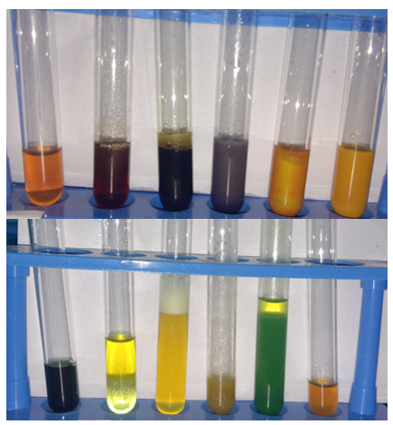

**Figure-1: Phytochemical Screening results of aqueous extract of *Murraya koenigii* leaves**

UV-visible spectra of *Murraya koenigii* extract shows the maximum absorbance at 219nm, 271nm, 329nm, and 338nm which is due to unsaturated groups or hetero atoms (C=C, S, N, O) in the extract and are mainly flavonoids, phenolics, alkaloids, etc., absorbance at 663nm is because of chlorophyll (organic chromophores) (fig-2). In ZnONPs UV spectrum, the maximum absorption peak observed at 234nm and 330nm which confirms the formation of ZnONPs (due to surface plasmon resonance effect) (fig-3). FT-IR spectra of plant extracts reveals the functionalities of OH, C=O, C=C, C-O which indicates the presence of phyto-molecules (fig-4). Usually, metal-oxygen (M-O) bond showed FT-IR frequencies at below 600 cm-1. The FT-IR spectrum of ZnO nanoparticles (fig-5) absorbed multi peaks between 433 cm-1 to 548 cm-1. [14-16]

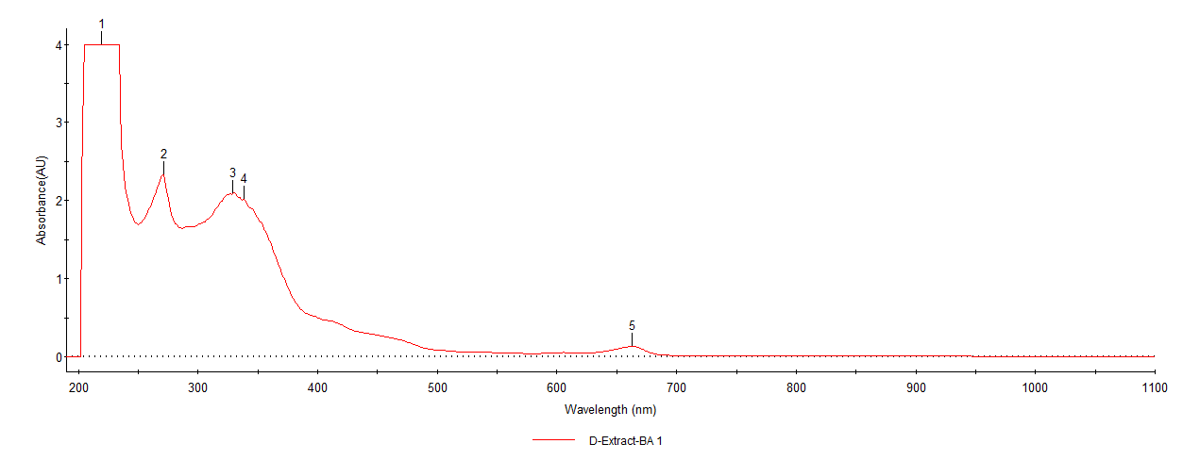

**Figure-2: UV-Visible of aqueous extract of *Murraya koenigii* leaves**

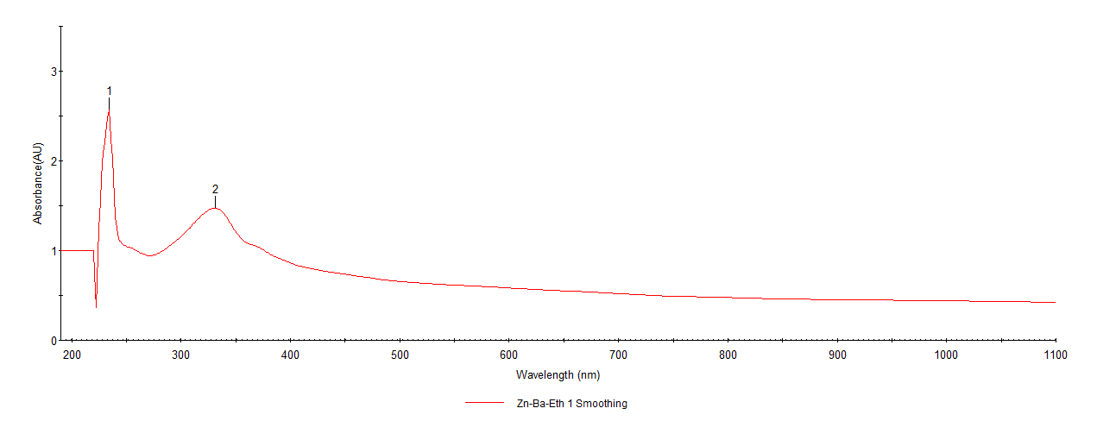

**Figure-3: UV-Visible Spectrum of *Murraya koenigii* mediated ZnONPs**



**Figure-5: FT-IR Spectrum of aqueous extract of *Murraya koenigii***



**Figure-5: FT-IR Spectrum of *Murraya koenigii* mediated ZnONPs**

XRD was used to determine the crystal structure of a material system. The 2ϴ values of synthesized zinc nanoparticles (fig.6) were found to be 31.840, 34.520, 36.380, 47.640, 56.700, 63.060 and 68.100. The peaks of the graph were in good agreement with the literature report (JCPDS File no: 36-1451). Using Debye Scherrer equation **[Dp = (0.94*λ) / (β*Cosϴ)]**, the average size of the nanoparticles was determined. The average crystalline size of the formed ZnONPs was found to be 28.65 nm. XRD patterns obtained in this study are similar to XRD patterns obtained in the other biologically synthesized ZnO nanoparticles.[17,18]

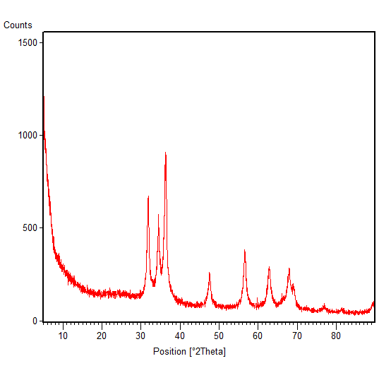

**Figure-6: XRD Pattern of *Murraya koenigii* mediated ZnONPs**

SEM analysis was used to identify the morphology, size and shape of the nanoparticles. The obtained SEM image showed the spherical shape of obtained ZnO nanoparticles (Fig. 7).As the synthesized nanoparticles are in spherical shape, they can easily penetrate into the cell wall of the pathogens which contributed to its effective anti-bacterial activity of the ZnO nanoparticles.

C:\Users\God\AppData\Local\Microsoft\Windows\INetCache\Content.Word\Zn-Nps-BA-07.tif 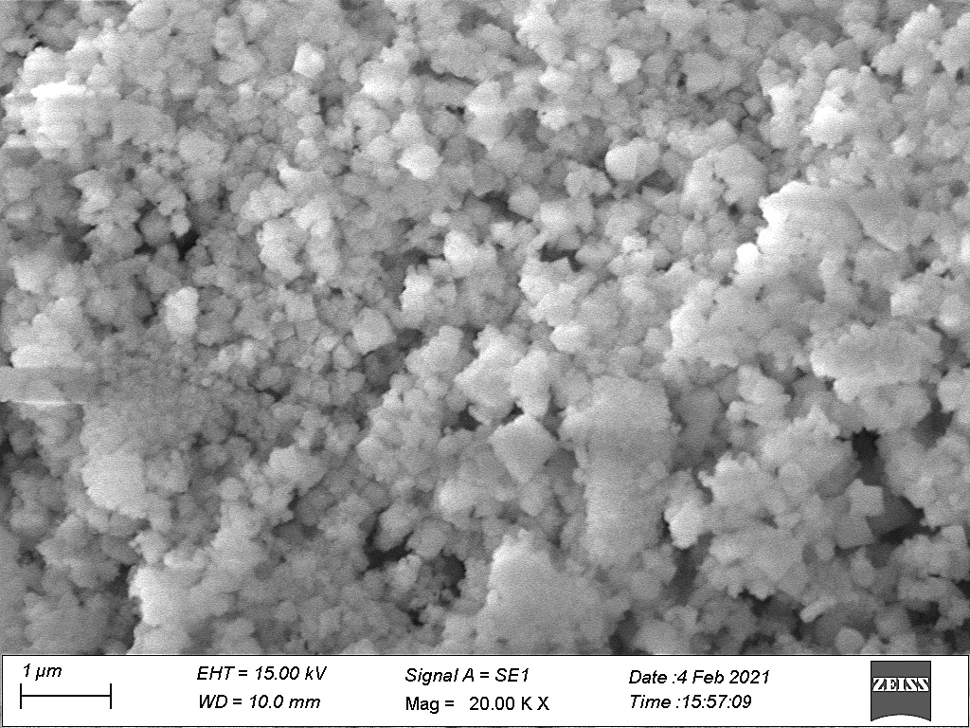

**Figure-7: SEM Images of *Murraya koenigii* mediated ZnONPs**



**Figure-7: EDAX Image of *Murraya koenigii* mediated ZnONPs**

The Energy-Dispersive X-ray (EDAX) investigation was done to check the elemental composition of synthesized zinc oxide nanoparticles.[19] The EDAX spectrum showed highest percentages of Zinc and oxygen with the elemental composition of 70.04% and 29.96%respectively (Fig. 7).

1. **CONCLUSION:**

In comparison to physical and chemical procedures, green production of the nanoparticles utilized in the research was shown to be more environmentally benign, non-toxic, and chemically sparing. The leaf extract's has the phytochemicals which contribute to the formation of metal oxide nanoparticles. Alcohols and phenols, which are frequently found in secondary metabolites of flavonoids, were the functional groups present that caused the production of nanoparticles. According to the literature, 70% ethanol extract contains flavonoid components (a significant phytomolecule), which are also supported by qualitative and UV-Visible testing. The XRD study further demonstrated the ZnO NPs' spherical crystalline structure and average size of 28.65 nm. The purity of the ZnONPs was validated by the presence of substantial elemental percentages of zinc and oxygen without any extra peaks. The above research work reveals that, the aqueous extract of Murraya koenigii leaves is a very good bioreductant for the synthesis of zincoxide nanoparticles.

1. **References**
2. Matej Balaz, Michal Goga, Michal Hegedus, Nina Daneu, Maria Kovacova, Ludmila Tkacikova, Ludmila Balazona, Martin Backor (2020) Biomechanochemical Solid-state synthesis of Silver Nanoparticles with Antibacterial activity using Lichens, ACS Sustainable Chemistry & Engineering*,* 8(37), 13945-13955.
3. M. Jazmin Silveroc, Kiamela M. Rocea, Emilce Artur de la Villarmois, Kelsay Fourneir, Anabel, E. Lanterna, Mariela, F. Perz, M. Cecilia Becerra, Juan C. Scaiano (2018) Selective Photoinduced Antibacterial activity of Amoxicillin – coated Gold Nanoparticles: From one-step synthesis to in Vivo Cytocompatibility, ACS Omega*,* 3(1), 1220-1230.
4. Ameu Azam, Arham S. Ahmed, Mohammed Oves, Mohammad S. Khan, Sami S. Habib (2012) Antimicrobial activity of metal oxide nanoparticles against Gram-positive and Gram-negative bacteria – a Comparative Study, International Journal of Nanomedicine,7, 6003-6009.
5. D. Saravanakumar, Hicham Abou Oualid, Younes Brahmi, A. Ayeshamariam, M. Karunanaithy, A. Mohamed Saleem, K. Kaviyarasu, S. Sivaranjani, M. Jayachandran (2019) Synthesis and characterization of CuO/ ZnO/ CNTs thin film on Copper substrate and its photocatalytic applications, Open Nano*,* 4, 100025, 1-15.
6. Jianhui Zhang, Baodan Zhao, Zhongda Pan, Min Gu, Alex Punnoose (2015) Synthesis of ZnO Nanoparticles with controlled Shapes, Sizes, Aggregations and Surface Complex compounds for Tuning or Switching the Photoluminescence, Crystal Growth & Design,15(7), 3144-3149.
7. Xiaosheng Tang, Eugene Shi Guang Choo, Ling Li, Jun Ding, Junmin Xue (2010) Synthesis of ZnO Nanoparticles with Tunable Emission Colors and their Cell Labeling Applications, Chemistry of Materials*,* 22(11), 3383-3388.
8. K. Nithya, S. Kalyana Sundharam (2019) Effect of chemically synthesis compared to biosynthesized ZnO nanoparticles using aqueous extract of C. halicacabum and their antibacterial activity, Open Nano,4, 100024, 1-12.
9. Eric A. Meulenkamp (1998) Synthesis and Growth of ZnO Nanoparticles,The Journal of Physical Chemistry B, 102(29), 5566-5572.
10. Joghee Suresh, Ganeshan Pradheesh, Vincent Alexramani, Mahalingam Sundrarajan, Sun lg Hong (2018) Green synthesis and Characterisation of Zinc oxide nanoparticles using insulin plant *(Coctus pictus D. Don)* and investigation of its antimicrobial as well as anticancer activities, Advances in Natural Sciences: Nanoscience and Nanotechnology*,* 9, 015008, 1-8.
11. Deepali Sharma, Myalowenkosi I. Sabela, Suvardhan Kanchi, Krishna Bisetty, Adam A. Skelton, Bahareh Honarparvar (2018) Green synthesis, characterization and electrochemical sensing of silymarin by ZnO nanoparticles: Experimental and DFT studies, Journal of Electroanalytical Chemistry,808, 160-172.
12. Hamid Reza Ghaffarian, Mahboobeh Saiedi, Mohammad Ali Sayyadnejad, Ali Morad Rashidi (2011) Synthesis of ZnO Nanoparticles by Spray Pyrolysis Method, Iranian Journal of Chemistry and Chemical Engineering,30 (1), 57, 1-6.
13. Nehal A. Salahuddin, Maged El-Kemary, Ebtisam M. Ibrahim (2015) Synthesis and Characterisation of ZnO Nanoparticles via Precipitation method: Effect of Annealing Temperature on Particle size, Nanoscience and Nanotechnology*,* 5(4), 82-88.
14. J. Santhoshkumar, S. Venkat Kumar, S. Rajeshkumar (2017) Synthesis of zinc oxide nanoparticles using plant extract against urinary tract infection pathogen, Resource-Efficient Technologies, 3(4), 459-465.
15. M.S. Geetha, H. Nagabhushana, H.N. Shivananjaiah (2016) Green mediated synthesis and characterization of ZnO nanoparticles using Euphorbia Jatropa latex as reducing agent, Journal of Science: Advanced Materials and Devices, 1(3), 301-310.
16. W.Y. Ming, L.J. Hua, H.R. Yu (2012) Large scale synthesis of ZnO nanoparticles via homogeneous precipitation, Journal of Central South University, 19, 863–868.
17. Joghee Suresh, Ganeshan Pradheesh, Vincent Alexramani, Sun Ig Hong (2018) Phytochemical Screening, Characterization and Antimicrobial, Anticancer Activity of Biosynthesized Zinc Oxide Nanoparticles Using Cyathea nilgiriensis Holttum Plant Extract, Journal of Bionanoscience, 12(1), 37-48.
18. Hamid Reza Ghorbani, Ferdos Parsa Mehr, Hossein Pazoki, Behrad Mosavar Rahmani (2015) Synthesis of ZnO Nanoparticles by Precipitation Method, Oriental Journal of Chemistry, 31(2), 1219-1221.
19. A. Jafar Ahamed, P. Vijaya Kumar (2018) Synthesis and characterization of ZnO nanoparticles by co-precipitation method at room temperature,Journal of Chemical and Pharmaceutical Research, 8(5), 624-628.
20. Julian Medina, Harold Bolanos, Lyda Patricia Mosquera‑Sanchez, J.E Rodriguez‑Paez (2018) Controlled synthesis of ZnO nanoparticles and evaluation of their toxicity in *Mus musculus* mice, International Nano Letters, 8,165–179.