Emerging Applications of Biosensors in Medical Theranostics

Koushik Mukherjee*
Department of Microbiology
Kalyani Mahavidyalaya
Kalyani, Nadia, West Bengal, India
Email: koushikmukh@gmail.com
*First and corresponding author

Pritam Saha
Department of Chemistry
Kalyani Mahavidyalaya
Kalyani, Nadia, West Bengal, India
Email: pritamsaha300882@gmail.com

ABSTRACT

Healthcare sector is observing great advancement in terms of development of newer diagnostics and therapeutics. Over the years, researchers have developed methods for faster and reliable diagnosis of diseases using various biomolecules. Biosensors were first invented in 1962 and have been improvised to make them compact, user friendly, robust, cost-effective for use as point-of-care testing devices. Furthermore developments in the field of nanomaterials have boosted the research and development of biosensors with the integration of biosensing and drug delivery mechanisms. While biosensors are being extensively used in diagnostics and therapeutics, they also find use in monitoring of soil, food and water quality, detection of toxins, pesticides and heavy metals as well as pathogen detection. This chapter discusses in detail the definition of biosensors, classification of biosensors and their advantages over the traditional methods of diagnosis. Moreover, the chapter delves into the details of use of biosensors in various fields of medical diagnostics like biochemicals, medical imaging, cancer detection, diagnosis of viral and bacterial infections, etc. The chapter also provides insights into the various therapeutics applications of biosensors like drug delivery, management of pain and neurological diseases, and others and concludes with the discussion of various challenges and future prospects of biosensor technology.

Keywords – Biosensor, Theranostics, Wearable Devices, Nanomaterials, Health Monitoring

- INTRODUCTION

Substantial advancement has been observed in the field of medicine and the science of diseases. With such advanced knowledge available, there is also a need for more advanced and sophisticated therapeutic and diagnostic approaches to tackle a disease. Human body has five senses of taste, sight, smell, touch and sound [1]. The reception and transduction of physical and chemical stimuli from specific receptors in the sensory organs to brain and the final action of the human body form a strong base for the research and development of biological analytical sensors or “biosensors”. Biosensors consist of a biological receptor which interprets the biophysical or biochemical signal and a physical transducer which transduces this signal to an electrical signal, which could be analyzed and presented to the end user [1–3]. Biosensors have been accepted by the International Union of Pure and Applied Chemistry(IUPAC) in the near past [2], although their history dates back to the 1960s when Clarke and Lyons invented the first glucose electrode using immobilized glucose oxidase to determine the blood glucose levels [4]. This invention has been at the center of every type of glucose biosensor developed thereafter, especially the widely used point-of-care (POC) glucose monitors [5, 6].
Biosensors have two modules as described earlier. The biological receptor could be an enzyme, antibody, cell, cell organelle or even DNA. The transducer of the biosensor could convert optical (fluorescence or luminescence), electrochemical, thermal and other signals into analytical data (Figure 1) [2, 7]. Biosensors are an important advancement to the field of medicine as they form compact, cost-effective, portable analytical devices which can provide a rapid and reliable readout. These advantages along with the ease of use by an unskilled person have made them a house-hold name and also at healthcare centers [3]. While diagnosis of a disease remains the first and foremost use of biosensors, they can also be used for imaging, continuous health monitoring and evaluating drug efficacy. While the first invention of biosensor technology was in 1962, the research ondevelopment of biosensor based devices has accelerated over the last two decades with more than 4000 research or review articles being published annually [1]. The research and development involves exploring the use of nano-materials and combination of different transducing materials to make smaller and wearable devices for continuous monitoring of bodily functions like heart rate, blood pressure, blood oxygen levels and biochemicals like blood glucose levels [2, 8–10]. Furthermore paper-based analytical devices are being developed for POC detection of pathogens like bacteria and viruses, cancer cells, proteins and also in food and environmental screening [11].
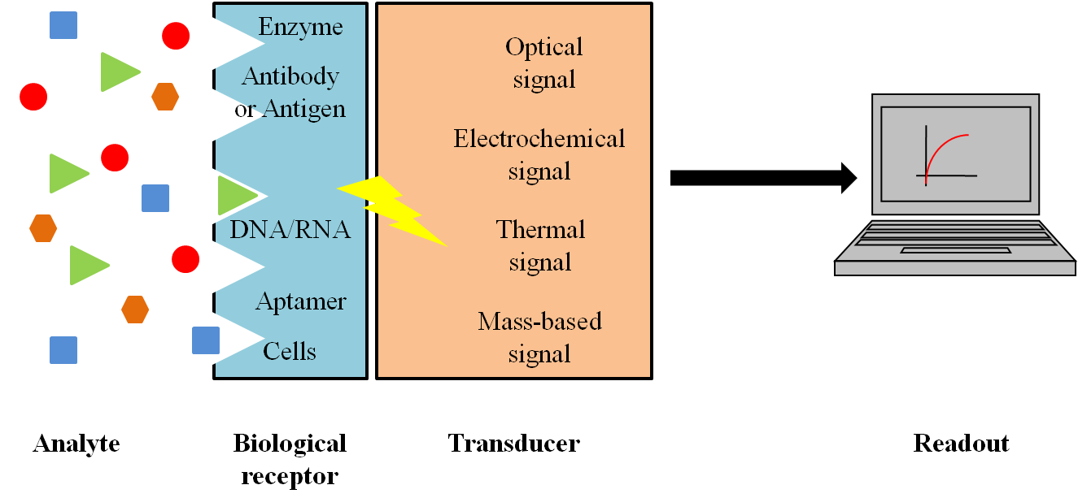

Figure 1 – A schematic diagram of a biosensor. The biochemical analyte interacts with the biological receptor and produces a signal (optical/electrochemical/thermal or mass-based) which is captured by the transducing element and converted into an observable, analytical readout. This readout allows the detection of the analyte in question.

This chapter will provide an insight into biosensors, their various types and classification based on the biological receptor or the transducer used. The chapter also includes the new age discoveries and research on the use of nano-materials in biosensors and the recent trends of using wearable devices for continuous health monitoring and their advances in the field. Further, the chapter discusses in detail the applications of biosensors in the field of therapeutics and disease management for neurological disorders, pain management, anti-oxidant therapies, etc. The chapter also sheds light on the use of biosensors as diagnostic devices for cancer, neurological disorders, cardiovascular disorders apart from the usual metabolic disorders like diabetes and other applications in fields like food industry, and environmental monitoring.The chapter concludes with the present known knowledge about biosensors and the possible future prospects for further development in biosensor technology.

- TYPES OF BIOSENSORS

Biosensors are small, movable, and reliable analytical devices which are being used widely for diagnostic and health monitoring purposes. They can be classified into various types depending on the type of biological receptor or the transducers being used.

Classification based on biological receptors used

Enzyme based Biosensors:This type of biosensor involves enzymes as the receptor module. The catalytic activity of an enzyme is exploited. The amount of product generated by the catalytic reaction gives readout of the analyte, which could be either a substrate or an inhibitor of the enzyme used. The most commonly used transducers are electrochemical transducers. The examples of enzyme-based biosensors include glucose and urea sensors [7, 12].

Microbial biosensors or whole cell biosensors: The microbial biosensors involve the use of whole cells of microbes like bacteria and fungi as bio-receptors. These organisms can replicate rapidly and can use their cellular receptors to detect various analytes. Hence, they form a preferable group of biosensors for environmental studies, drug screening, food analysis and analysis of presence of heavy metals, pesticides and organic contaminants [12–14].

Tissue based Biosensors: Tissue based biosensors use animal or plant tissues as receptors for in vitro and in vivo studies pertaining to drug screening, environmental stress, tissue engineering and disease modelling and monitoring [12, 15, 16].

Immuno-sensors: Immuno-sensors make use of the affinity of antigens and antibodies. Usually, antibodies form the receptors and are widely used for the diagnosis of various cancers and also for specific antigens. These are highly sensitive and specific and the antibody receptor could be either labelled (optical transduction) or label-free (structural changes detected by Surface Plasmon Resonance (SPR)) [7, 12].

DNA sensor and use of Aptamers: Single-stranded DNA molecules or oligos and even RNA molecules could be used for understanding the interaction of certain specific proteins and complementary strands into the sample with the DNA. Aptamers are synthetic DNA oligos which could fold into specific two- or three-dimensional structures. The nucleic acid molecules could also be embedded into or adsorbed onto nanoparticles and can be used for detection of cancers, pathogen spores and other proteins [12].

Use of nanomaterials as receptors:Nanoparticles and nanowires have been shown to have biomimetic activity and can be used as receptors. They can also be used to embed or adsorb biological entities, which can then be used as receptors. Gold and tungsten nanoparticles have been used very frequently. Graphene based nanomaterials are gaining larger use in biosensors [12, 17–20].

Classification based on transduction system used

Piezoelectric Biosensors:These can detect changes in the surface resonance frequency of the piezoelectric crystal brought about by the mass changes in the crystal. The material could be a quartz crystal microbalance or a surface acoustic wave device. The changes in the piezoelectric crystal elasticity due to the applied electric field is measured and analysed as the amount of analyte and receptor interaction (Figure 2) [7, 12].
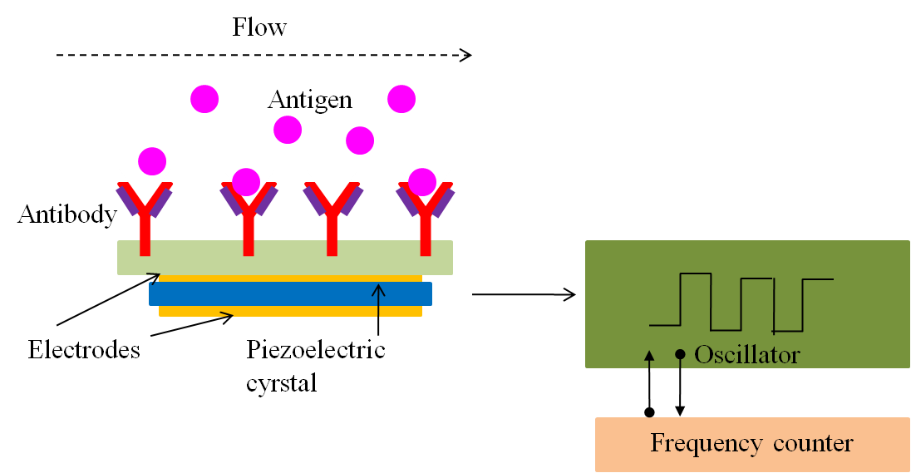

Figure 2 – A schematic of piezoelectric biosensor. Antigen binding to antibody causes a potential change across the electrodes, leading to change in the elasticity of the piezoelectric crystal, frequency of which is measured by the frequency counter allowing the estimation of antigen in the sample.

Thermal biosensors: Thermal biosensors used transducer which can sense the change in enthalpy or temperature due to the interaction between the analyte and the receptor. These are also called calorimetric biosensors. These type of biosensors have however not received much acclaim over the years [12, 21].

Optical Biosensors: Optical biosensors use a light source and other optical devices and a photo-detector to detect colorimetric, fluorescence or luminescence changes upon interactions between the analyte and the receptor [7, 12, 21].

Electrochemical biosensors: The electrochemical biosensor detects a biological analyte by converting the amount of interaction to an electrical signal, like a change in voltage (voltammetric biosensor), current (amperometric biosensor) or impedance (impedimetric biosensor). They are used for detecting presence of enzymes, viruses, proteins and antibodies and also biochemicals like glucose [7, 12, 22].

Wearable Smart biomaterial-based biosensor: The wearable smart devices use different biosensor based technology to continuously monitor various body parameters and thus one’s health. Chuang et al., have developed a wearable device using polymer stabilized liquid cholesteric crystal for detecting urine albumin levels and other biochemicals. The changes in the crystal structure was detected using the camera of a smartphone [10]. The rampant use of smart watches, rings and fitness bands nowadays allows continuous monitoring of various parameters like blood pressure, heart rate, respiratory rate, sleep, eye movements, blood glucose levels and others have shown that these have become an important discovery, especially for the elderly and high-risk population. In fact, the newer models have been approved by FDA for providing electrocardiogram (ECG) [23–26].

GENERAL APPLICATION OF BIOSENSORS

Biosensors find use in various fields apart from diagnostics and therapeutics. They are used for environmental monitoring like quality of water, presence of toxins, pesticides, heavy metals and contaminants in food and soil, drug discovery and detection of pathogens (Figure 3) [7, 21].
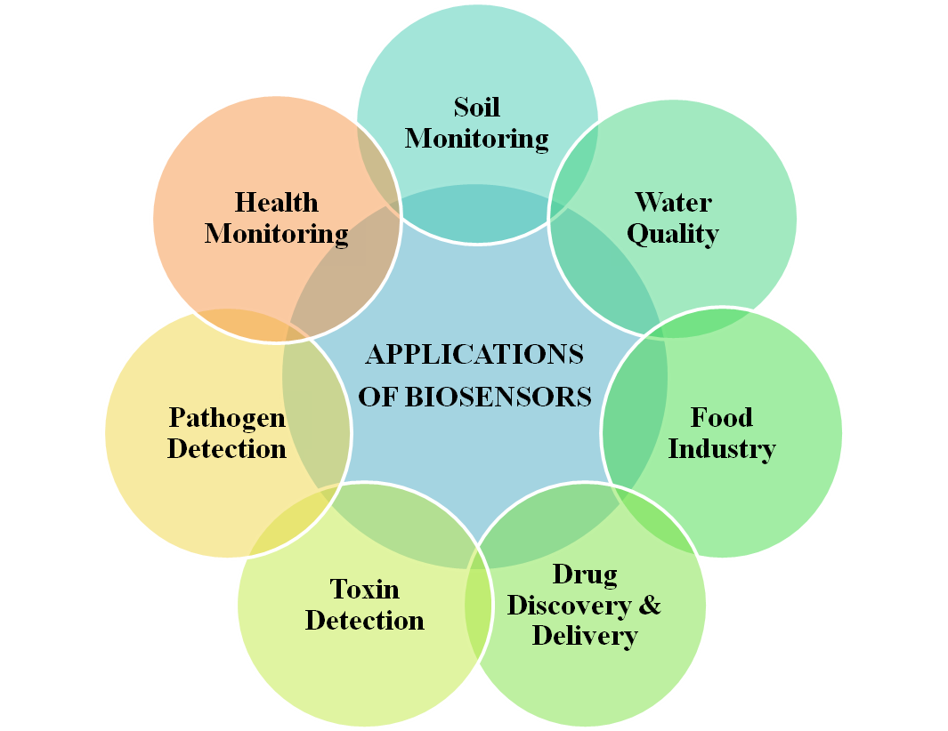

Figure 3 – Various applications of Biosensors

- BIOSENSOR IN DIAGNOSTICS

The first biosensor was invented to detect glucose levels [4] and thereafter, major focus for the development of biosensors has been their use in clinical diagnostics, be it metabolic diseases, infections, cancers or other lifestyle disorders. This section discusses in detail the various biosensors developed for diagnostic purposes (Figure 4).
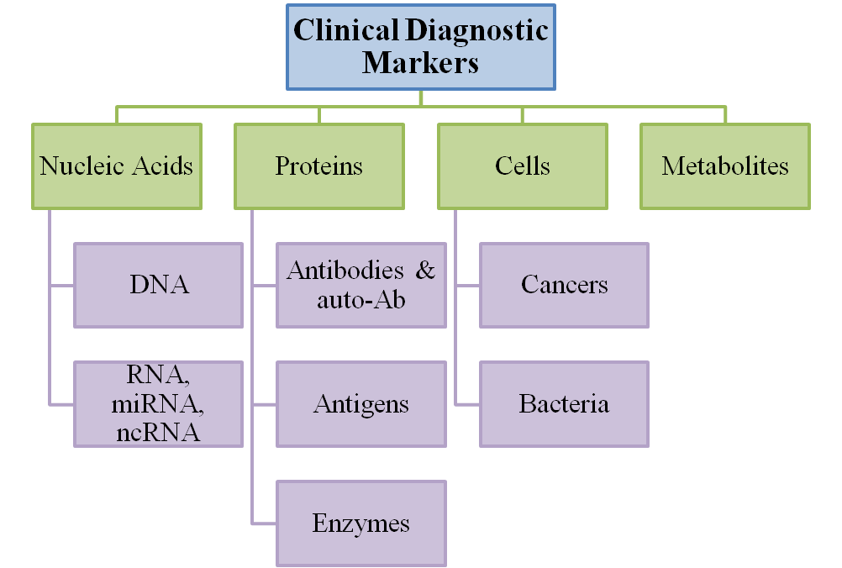

Figure 4 – Various clinical diagnostic markers detected using biosensors

Metabolic diseases
The first use of biosensors was for glucose estimation in the bloodstream [4]. Biosensors for blood glucose detection and estimation have undergone drastic development from being invasive to draw blood to being non-invasive wearable devices for continuous monitoring and management of diabetes. All the various generations were based on the use of Glucose oxidase enzyme as the biological receptor and various electrochemical electrodes as transducers. Table 1 provides an insight into the various generations of glucose biosensors developed over the years [5, 6, 27].

Table 1 – History of Glucose Biosensors

Year | Discovery
1962 | Discovery of the first biosensor by Clark and Lyons
1967 | First use of enzyme electrode by Updike and Hicks
1973 | Development of glucose enzyme electrode based on detection of hydrogen peroxide. This formed the basis for further development of either POC devices or the non-invasive in vivo and wearable devices.
1982 | First needle-type enzyme entrapped on platinum electrode for in vivo use demonstrated by Shinchiriet al.
1987 | Launch of first blood glucose biosensor (ExacTech) by MediSence Inc. For personal and home use
1999 | Commecrial availability of subcutaneously implantable in vivo glucose monitoring device by MiniMed (provides support up to 72 hours, with readings being taken every 5 minutes)
2000 | Introduction of wearable non-invasive GlucoWatch device for continuous glucose level monitoring (provides 36 readings in a period of 12 hours).

Another use of biosensors is to detect serum phosphate levels. Dyslipidemia and hyperphosphatemia are associated with hypothyroidism and are known risk factors of cardiovascular disease (CVD) [28]. Kulkarni and Karve developed a fibre-optic based biosensor for estimating phosphate levels in urine samples. This could also be used for detecting serum phosphate levels and thus for clinical diagnosis of hypothyroidism [3, 29]. Similarly, serum cholesterol levels could be estimated using cholesterol oxidase based biosensors, wherein the enzyme could be adsorbed onto cellulose based membrane or nanomaterial for bio-recognition [1]. For detecting serum levels of lactate and pyruvate, various biosensors have been developed over years which can detect either of the metabolites. Lactate levels are usually maintained between 0.5 and 2.2 mmol/L, However, physical activity can lead to transient increase in lactate levels. Inability to maintain low lactate levels in the blood or produce high amounts of lactate can be a marker of shock, and mortality. Thus measuring the levels of lactate and pyruvate is important for managing patient health. Dual metabolite biosensors (electrochemical, enzyme based) have been developed and used in laboratory settings with impressive results, however, commercialization of dual biosensors is still underway [30, 31].

Viral and bacterial infections

Biosensors have been extensively used for detection of pathogens like bacteria and viruses. The major use of biosensors has been recently in detecting COVID-19 infection [32]. Other diseases being diagnosed are urinary tract infections (UTIs), human immunodeficiency virus-1 (HIV-1) infection and cervical cancer arising due to human papilloma virus (HPV) infection. Major bio-recognition elements being used are DNA and antibodies against the known pathogens with electrochemical transducing systems [7, 21, 33]. Multiplexed biosensor platforms for multiple virus detection are being developed, with the advantages of rapid and reliable multiple diagnosis and one time sample requirement [3, 34].

Cardiovascular disease

Cardiovascular disease (CVD) is a major health risk across the globe. Various biomarkers like C-reactive protein (CRP), myoglobin, B-type natriuretic peptide (BNP), and cardiac Troponin I (cTnI) have been associated with CVD. The traditional methods of estimating their levels using ELISA and other fluorometric assays could be time consuming. Biosensors for these markers have made the process of detection and diagnosis rapid and reliable, allowing health practitioners to save lives. The biosensor technology for CVD includes use of optical, acoustic, electrochemical, and magnetic-based biosensors. Some of the examples of biosensors in CVD are triage cartridge, cardiac marker system, stratus, and alpha and they utilise fluorescent microfluidic devices, analyzers and table-top readers for rapid results with readout time ranging from 10 minutes to 18 minutes. With the advances in artificial intelligence (AI) and machine learning (ML), use of biosensors has allowed creation of modelling and predictions for clinical use [3, 7, 25, 35].

Cancers

Cellular proteins, enzymes like LDH, cancer or tumor cell DNA and RNA (mRNA, lncRNA, miRNA) and also interleukins are the major biomarkers for diagnosis of various types and subtypes of cancer. Biosensors have been developed using antibodies against the various proteins or exploiting DNA/RNA affinity for the complementary molecules from cancer cells. Table 2 lists out some of the biomarkers of different cancers, for which biosensors are either available or under development [33, 38]. Biomimetic capacities of nanoparticles and nanowires have also been explored for detection of cancer antigens like PGA, CA-125. The major transducers include optical mechanisms, especially chemiluminescence, electrochemical, SPR based and piezoelectric quartz crystals. Paper-based and microfluidic biosensors have also been developed for certain cancer antigens. Biosensors provide rapid and accurate results as compared to the traditional methods of ELISA, radio-immunoassay and imaging [3, 11, 21, 35–37].

Table 2 – Cancer biomarkers for which biosensors are being developed.

Antigen | Cancer type | Biosensor type
Carcinoembryonic antigen (CEA) | Colorectal cancer | Fluorescence based biosensor using MoS2 nanosheet and protein aptamers
HER2 | Breast Cancer | Optical fibre-based sensor using ssDNA aptamers adsorbed on gold nanowires
Prostate specific Antigen (PSA) | Prostate Cancer | SPR based immuno-biosensor

Immunological disease (Autoimmune disease, arthritis)

People with autoimmune diseases produce antibodies against their own cells leading to immune responses and hence death of self cells. Biosensors have been developed for detection of autoimmune disorders; however, the challenges are different as the biosensors detect the single common biomarker, autoantibodies like IgG and IgM. These antibodies are also present during infection in the bodies and also as natural immunity. Thus, finding a disease specific biomarker becomes inevitable to diagnose an autoimmune disorder. In case of rheumatoid arthritis, one of the best known biomarker, rheumatoid factor, is an autoantibody against IgG. A more specific biomarker is the autoantibody against citrulline amino acid moieties (i.e., anti-citrullinated protein antibodies, ACPA). This has been used for development of SPR- or quartz crystal microbalance (QCM)- based biosensors for rheumatoid arthritis, which have shown better sensitivity than ELISA [36].

Biosensors in medical imaging

Various fluorescent, chemiluminescent and radio-labelled enzymatic, antibody and nanomaterial based probes have been designed for in vivo imaging of the body using PET scan, MRI, and even CT scan. The use of probes allows multi-modal imaging along with methods like MRI and CT scan. The use of biosensor technology with non-invasive imaging techniques allows differentiation of diseased part of the body. It has been successfully used to diagnose conditions like hepatocellular carcinoma, Alzheimer’s disease, and breast cancer in laboratory settings. DNA based biosensors are also used for in vivo imaging of various conditions in conjunction with PET scan [39–42].

Other applications in various diseases

Use of biosensors has seen a rise in use at primary healthcare centres and at home for personal use. Their portable and compact design and user-friendliness are the reasons behind their wide usage. For rapid and reliable results, the biosensor technology is being explored for diagnosis of various diseases apart from metabolic disorders like diabetes. Small microfluidics-, chip- and paper-based biosensors have been developed for cancer diagnosis for point-of care (PoC) testing.

Immuno-biochip is an example of lab-on-a-chip type of biosensor, wherein nanomaterials are used to adsorb antibodies against various cancer antigens for better sensitivity, with electrochemical transducers. It is microfluidic device and has been successfully designed to detect epidermal growth factor receptor 2 (EGFR2) protein of breast cancer due to antigen–antibody conjugation. The most preferable nanomaterial is graphene nanosheets, because they have higher electrical and optical conductivity [43]. Furthermore, a lot of efforts are being taken to make the diagnosis readout available through applications on smart phones allowing quicker relay of the information [44].

BIOSENSOR IN THERAPY AND DISEASE MANAGEMENT

Apart from use in diagnostics, biosensors also find applications in therapeutics like drug delivery and disease management through detection of body parameters or biochemicals. This section discusses some of the applications of Biosensors in therapeutics and disease management.

Medical implants

Implantable biosensors are an important option for continuous monitoring of diseases. Implantable and wearable biosensors are available for continuous monitoring of blood glucose levels and good management of diabetes. Similarly, biotelemetry exploits implantable technology for remote sensing of bodily functions like Electromyogram (EMG), electroencephalogram (EEG), electrocardiogram (ECG), heart rate, blood pressure, body temperature, activity and circadian rhythm. This is important in the present era, where high mortality due to cardiac arrest and heart attacks is observed. Identifying end-stage heart failure patients, prone to adverse outcomes during the early phase of left ventricular assisted device implantation, is important [45, 46].

Increased level of interleukin-10 (IL-10) after left ventricular assisting device in end-stage heart failure patients is responsible for multi-organ dysfunction. A novel hafnium poxide based biosensor has been developed using fluorescence and electrochemical impedance principles to detect early stage increase in IL-10 levels to prevent treatment failures [7].

Neurological disease management

Tremors are a classic al symptom of Parkinson’s disease (PD), multiple sclerosis and essential tremors (ET). New-age wearable biosensors are being utilized for tremor detection and suppression. In case of PD, the wearable devices could be worn on any part of the body. They help in recording the orientation, amplitude, and frequency of movements and also the speed of the body part where they are attached. High-storage of data and sharing over internet allows the clinicians to access the data easily and decide over the course of treatment. Upper limb tremors could be sensed using such wearable biosensors and then suppressed using the new technologies of wearable orthosis or electrical stimulators to manage tremors better in patients [47, 48].

Nanozymes for anti-oxidant therapy

Oxidative stress due to free radicals (peroxides, super oxides) is detrimental to biomolecules. Free radicals cause oxidation of cellular proteins, lipids and nucleic acids leading to mutations and cell death. As mentioned earlier, a lot of nanomaterials have biomimetic activities, i.e. they can mimic activities of various biological molecules. One such class of nanomaterials is nanozymes, wherein the metal nanoparticles exhibit enzyme like activity. Many metal oxides like iron (III) oxide (Fe₃O₄), gold and silver nanoparticles, Vanadium pentoxide (Vn₂O₅) have been shown tio have peroxidise like activity, i.e. they are proficient in dissipating oxidative stress due to presence of peroxides like hydrogen peroxide (H₂O₂). Ceria nanoparticles (CeNPs) exhibit both catalase and superoxide dismutase (SOD) like activity. Nanoparticles or nanowires made from gold, silver, platinum, cobalt oxide and gold-platinum combination have catalase like activity. Figure 5 elicits the various anti-oxidant enzymes like activities of different nanomaterials. Owing to their stability, and intrinsic physicochemical and optoelectronic properties, nanoparticles of different shapes, sizes and compositions can be used in various biomedical settings (Adapted from [49]). The anti-oxidant nanozyme activity can be explored for anti-oxidant therapy in case of chronic inflammation and infections apart from being good biosensors for diagnosis of various medical conditions [49].

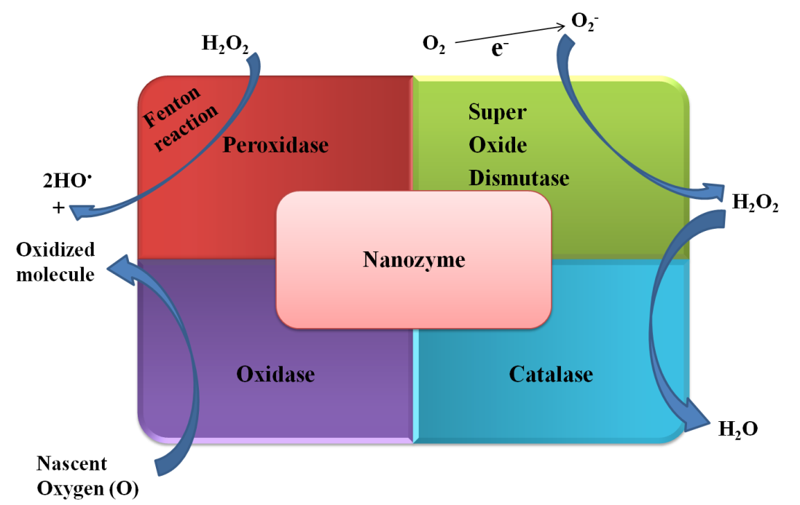

Figure 5 – Anti-oxidant enzymes like activity of nanomaterials.

Biosensor in pain management

Pain can be due to various conditions like wounds, burns and other medical conditions like surgery, cancer treatment, diabetes etc. Opioids and other analgesic medicines are prescribed for managing pain. However, use of so called pain killers can become addictive. Also, chronic pain can lead to stress and depression over a period of time. Thus, researchers have developed silver and gold based nanoparticles and wearable biosensors for detecting the levels of analgesics in the bloodstream or measuring the body functions like heart rate, brain activity, muscle activity and skin temperature amongst others. The changes in body parameters are usually taken to be markers of chronic or acute pain arising. The combination of biosensors (wearable or nanomaterial based) and drug delivery systems can be used for pain management as detection of low levels of drugs or change in the body parameters can trigger the release of analgesics providing relief to the patients. A further step for pain management and rehabilitation is the use of virtual reality (VR), wherein patients use VR camera to allow for rehabilitation after physical injuries and shocks to start movement again. The patients have wearable biosensors on their bodies, which relays the information about their pain and posture to the VR camera, which then processes the information and provides measures to correct the gait of the patients and allow them to move without any mishaps [24, 50–53].

Biosensor-based drug delivery

Integrating biosensors and drug delivery systems can be very useful as biosensors are rapid, robust and reliable detectors of a specific analyte from a sample, without the need to prepare any sample. Microneedles are one of the examples of such integrated sensing cum drug delivery devices which are used for drug delivery transdermally. Thus, microneedle do not make any contact with blood, overcoming the issue of contamination, but they can withdraw sample for biochemical analysis from the interstitial fluid. Other methods include use of Bio-Micro-Electro-Mechanical Systems (Bio-MEMS), where a microneedle and micro-pump along with a biosensor are integrated onto a wafer like chip. This transdermal device can be used for continuous monitoring of the intended biochemical and required release of drug. One of the examples of Bio-MEMS is the transdermal insulin release device for managing diabetes, where blood glucose levels are sensed and a piezoelectric pump release the insulin transdermally. Another drug delivery system was developed using Smart polymers, which act like biopolymers. Smart polymers change their structure due to external stimuli like changes in pH, ionic strength and protein-protein interactions. Such polymers can be used to adsorb antibodies and detect antigens, which then allow the change in polymer structure and either release of sequester the drug. Microfabricated devices utilise the microfluidics and other sensory mechanisms and integrate a biosensor and a drug delivery system. Once the biosensor gives the signal through the transducer, a gate like opening allows release of drug [45, 46, 54, 55]. Figure 6 depicts the working of a microfabricated vial.
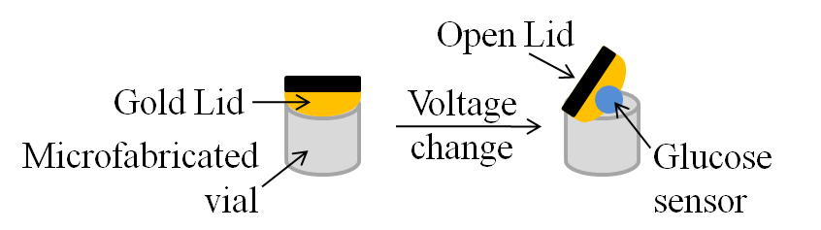

Figure 6 – Microfabricated device for glucose sensing and insulin release.

FUTURE PROSPECTS

The advances in the field of biosensor are impressive and humongous. From large devices to compact strip forms of biosensors which form the PoC testing essentials, biosensors have come a long way. The introduction of biosensors for personal use in the form of glucometers, oxymeters and wearable devices for continuous health monitoring indicates their indispensable presence in the lives of the human race in the present times. Recent pandemic of COVID-19 saw a surge in the usage of biosensors for detection of SARS-CoV 2 virus and also continuous health monitoring throughout the infection cycle. However, with all the advances, there still needs to be more research and development in the field of biosensors as diagnostic tools in a lot of different diseases like cancers, autoimmune disorders. Also, optimal designing and usage of the correct combination of bio-receptor, nanomaterials and transducers to make them more biocompatible, specific, non-invasive and cost-effective is a major task for further developments. In terms of integrating the biosensing technologies and drug delivery mechanisms, further development to make lab-on-chip and Bio-MEMS available for most of the diseases is needed and will prove to be a great advancement. Recent experimental studies have also shown the use of biosensors in genetic testing and designing platforms that could be commercialized, while having the readouts through the use of smart phones; this will be a significant leap of development in the field of diagnostics.

REFERENCES
[1] Banu ND, Jerca FA, Jerca VV. Biosensors. In: Food, Medical, and Environmental Applications of Polysaccharides. Elsevier, pp. 381–400.
[2] Ali J, Najeeb J, Asim Ali M, et al. Biosensors: Their Fundamentals, Designs, Types and Most Recent Impactful Applications: A Review. J Biosens Bioelectron; 08. Epub ahead of print 2017. DOI: 10.4172/2155-6210.1000235.
[3] Lino C, Barrias S, Chaves R, et al. Biosensors as diagnostic tools in clinical applications. Biochimica et Biophysica Acta (BBA) - Reviews on Cancer 2022; 1877: 188726.
[4] Clark LC, Lyons C. ELECTRODE SYSTEMS FOR CONTINUOUS MONITORING IN CARDIOVASCULAR SURGERY. Annals of the New York Academy of Sciences 2006; 102: 29–45.
[5] Yoo E-H, Lee S-Y. Glucose Biosensors: An Overview of Use in Clinical Practice. Sensors 2010; 10: 4558–4576.
[6] Turner APF. Biosensors: sense and sensibility. Chem Soc Rev 2013; 42: 3184.
[7] Mehrotra P. Biosensors and their applications – A review. Journal of Oral Biology and Craniofacial Research 2016; 6: 153–159.
[8] Altug H, Oh S-H, Maier SA, et al. Advances and applications of nanophotonic biosensors. Nat Nanotechnol 2022; 17: 5–16.
[9] Banerjee A, Maity S, Mastrangelo CH. Nanostructures for Biosensing, with a Brief Overview on Cancer Detection, IoT, and the Role of Machine Learning in Smart Biosensors. Sensors 2021; 21: 1253.
[10] Chuang E-Y, Lin P-Y, Wang P-F, et al. Label-Free, Smartphone-Based, and Sensitive Nano-Structural Liquid Crystal Aligned by Ceramic Silicon Compound–Constructed DMOAP-Based Biosensor for the Detection of Urine Albumin. IJN 2021; Volume 16: 763–773.
[11] Benjamin SR, De Lima F, Nascimento VAD, et al. Advancement in Paper-Based Electrochemical Biosensing and Emerging Diagnostic Methods. Biosensors 2023; 13: 689.
[12] Naresh Varnakavi, Lee N. A Review on Biosensors and Recent Development of Nanostructured Materials-Enabled Biosensors. Sensors 2021; 21: 1109.
[13] Riangrungroj P, Bever CS, Hammock BD, et al. A label-free optical whole-cell Escherichia coli biosensor for the detection of pyrethroid insecticide exposure. Sci Rep 2019; 9: 12466.
[14] Bhaskar A, Chawla M, Mehta M, et al. Reengineering Redox Sensitive GFP to Measure Mycothiol Redox Potential of Mycobacterium tuberculosis during Infection. PLoS Pathog 2014; 10: e1003902.
[15] Li Y-CE, Lee I-C. The Current Trends of Biosensors in Tissue Engineering. Biosensors 2020; 10: 88.
[16] Rajendran ST, Huszno K, Dębowski G, et al. Tissue-based biosensor for monitoring the antioxidant effect of orally administered drugs in the intestine. Bioelectrochemistry 2021; 138: 107720.
[17] Sekhon SS, Kaur P, Kim Y-H, et al. 2D graphene oxide–aptamer conjugate materials for cancer diagnosis. npj 2D Mater Appl 2021; 5: 21.
[18] Sondhi P, Maruf MHU, Stine KJ. Nanomaterials for Biosensing Lipopolysaccharide. Biosensors 2019; 10: 2.
[19] Krishnan SK, Singh E, Singh P, et al. A review on graphene-based nanocomposites for electrochemical and fluorescent biosensors. RSC Adv 2019; 9: 8778–8881.
[20] Holzinger M, Le Goff A, Cosnier S. Nanomaterials for biosensing applications: a review. Front Chem; 2. Epub ahead of print 27 August 2014. DOI: 10.3389/fchem.2014.00063.
[21] Singh S, Kumar V, Dhanjal DS, et al. Biological Biosensors for Monitoring and Diagnosis. In: Singh J, Vyas A, Wang S, et al. (eds) Microbial Biotechnology: Basic Research and Applications. Singapore: Springer Singapore, pp. 317–335.
[22] Singh A, Sharma A, Ahmed A, et al. Recent Advances in Electrochemical Biosensors: Applications, Challenges, and Future Scope. Biosensors 2021; 11: 336.
[23] Goergen CJ, Tweardy MJ, Steinhubl SR, et al. Detection and Monitoring of Viral Infections via Wearable Devices and Biometric Data. Annu Rev Biomed Eng 2022; 24: 1–27.
[24] Lin Y, Bariya M, Javey A. Wearable Biosensors for Body Computing. Adv Funct Mater 2021; 31: 2008087.
[25] Haleem A, Javaid M, Singh RP, et al. Biosensors applications in medical field: A brief review. Sensors International 2021; 2: 100100.
[26] Patel S, Nanda R, Sahoo S, et al. Biosensors in Health Care: The Milestones Achieved in Their Development towards Lab-on-Chip-Analysis. Biochemistry Research International 2016; 2016: 1–12.
[27] Wang J. Electrochemical Glucose Biosensors. Chem Rev 2008; 108: 814–825.
[28] Al-Tonsi AA, Abdel-Gayoum AA, Saad M. The secondary dyslipidemia and deranged serum phosphate concentration in thyroid disorders. Experimental and Molecular Pathology 2004; 76: 182–187.
[29] Kulkarni SJ, Karve MS. Fabrication of enzyme-based optical biosensor for estimation of inorganic phosphate in a urine sample. SN Appl Sci 2020; 2: 1118.
[30] Kucherenko IS, Topolnikova YaV, Soldatkin OO. Advances in the biosensors for lactate and pyruvate detection for medical applications: A review. TrAC Trends in Analytical Chemistry 2019; 110: 160–172.
[31] Kucherenko IS, Soldatkin OO, Topolnikova YV, et al. Novel Multiplexed Biosensor System for the Determination of Lactate and Pyruvate in Blood Serum. Electroanalysis 2019; 31: 1608–1614.
[32] Aziz A, Asif M, Ashraf G, et al. Trends in biosensing platforms for SARS-CoV-2 detection: A critical appraisal against standard detection tools. Current Opinion in Colloid & Interface Science 2021; 52: 101418.
[33] Kowalczyk A. Trends and perspectives in DNA biosensors as diagnostic devices. Current Opinion in Electrochemistry 2020; 23: 36–41.
[34] Zheng Y, Song X, Fredj Z, et al. Challenges and perspectives of multi-virus biosensing techniques: A review. Analytica Chimica Acta 2023; 1244: 340860.
[35] Metkar SK, Girigoswami K. Diagnostic biosensors in medicine – A review. Biocatalysis and Agricultural Biotechnology 2019; 17: 271–283.
[36] Rapp BE, Gruhl FJ, Länge K. Biosensors with label-free detection designed for diagnostic applications. Anal Bioanal Chem 2010; 398: 2403–2412.
[37] Zhou Y, Qi M, Yang M. Current Status and Future Perspectives of Lactate Dehydrogenase Detection and Medical Implications: A Review. Biosensors 2022; 12: 1145.
[38] Chaudhry G-S, Akim A, Safdar N, et al. Cancer and Disease Diagnosis - Biosensor as Potential Diagnostic tool for Biomarker Detection. J Adv Pharm Technol Res; 13.
[39] Pu K. Biosensors and Bioimaging. ChemBioChem 2019; 20: 420–421.
[40] Dou W-T, Zhang J-J, Li Q, et al. Fluorescence Imaging of Alzheimer’s Disease with a Flat Ensemble Formed between a Quinoline-Malononitrile AIEgen and Thin-Layer Molybdenum Disulfide. ChemBioChem 2019; 20: 1856–1860.
[41] Deng Y, Xu A, Yu Y, et al. Biomedical Applications of Fluorescent and Magnetic Resonance Imaging Dual‐Modality Probes. ChemBioChem 2019; 20: 499–510.
[42] Wiraja C, Yeo DC, Lio DCS, et al. Functional Imaging with Nucleic‐Acid‐Based Sensors: Technology, Application and Future Healthcare Prospects. ChemBioChem 2019; 20: 437–450.
[43] Iqbal MJ, Javed Z, Herrera-Bravo J, et al. Biosensing chips for cancer diagnosis and treatment: a new wave towards clinical innovation. Cancer Cell Int 2022; 22: 354.
[44] Zong H, Zhang Y, Liu X, et al. Recent trends in smartphone‐based optical imaging biosensors for genetic testing: A review. VIEW 2023; 20220062.
[45] Gray M, Meehan J, Ward C, et al. Implantable biosensors and their contribution to the future of precision medicine. The Veterinary Journal 2018; 239: 21–29.
[46] Ye S, Feng S, Huang L, et al. Recent Progress in Wearable Biosensors: From Healthcare Monitoring to Sports Analytics. Biosensors 2020; 10: 205.
[47] Mo J, Priefer R. Medical Devices for Tremor Suppression: Current Status and Future Directions. Biosensors 2021; 11: 99.
[48] Monje MHG, Foffani G, Obeso J, et al. New Sensor and Wearable Technologies to Aid in the Diagnosis and Treatment Monitoring of Parkinson’s Disease. Annu Rev Biomed Eng 2019; 21: 111–143.
[49] Das B, Franco JL, Logan N, et al. Nanozymes in Point-of-Care Diagnosis: An Emerging Futuristic Approach for Biosensing. Nano-Micro Lett 2021; 13: 193.
[50] Chen J, Abbod M, Shieh J-S. Pain and Stress Detection Using Wearable Sensors and Devices—A Review. Sensors 2021; 21: 1030.
[51] Pazuki D, Ghosh R, Howlader MMR. Nanomaterials-Based Electrochemical Δ9-THC and CBD Sensors for Chronic Pain. Biosensors 2023; 13: 384.
[52] Razlansari M, Ulucan-Karnak F, Kahrizi M, et al. Nanobiosensors for detection of opioids: A review of latest advancements. European Journal of Pharmaceutics and Biopharmaceutics 2022; 179: 79–94.
[53] Fang C, He B, Wang Y, et al. EMG-Centered Multisensory Based Technologies for Pattern Recognition in Rehabilitation: State of the Art and Challenges. Biosensors 2020; 10: 85.
[54] Ngoepe M, Choonara Y, Tyagi C, et al. Integration of Biosensors and Drug Delivery Technologies for Early Detection and Chronic Management of Illness. Sensors 2013; 13: 7680–7713.
[55] Lee EK, Kim MK, Lee CH. Skin-Mountable Biosensors and Therapeutics: A Review.

