Renewable energy sources
Mamta Chahar², Manisha Ruhela^{1*}, and Sarita Khaturia¹
¹Department of Chemistry , School of Liberal Arts and Sciences, Mody University of Science and Technology, Lakshmangarh, Sikar 332311, Rajasthan, India.
²Department of Chemistry (Applied Sciences), Institute of engineering & Technology, NIMS University, Jaipur, Rajasthan, India
manisharuhela570@gmail.com
mamtachahariitd@gmail.com
saritarajkhatri@gmail.com

Table of contents

1. Abstract
2. Introduction
3. The types of renewable energy sources
4. Future of renewable energy sources
5. The benefits of utilizing renewable energy
6. Facts about renewable energy
7. Conclusions
1. Abstract
Presently conventional energy sources are being replaced by renewable energy sources (RES), which harness energy from natural processes to meet the world's rising energy demands. The supply of conventional energy is limited and dwindling. On the other hand, new renewable energy sources are continually emerging from the natural world. Solar energy, wind energy, hydroelectricity, geothermal energy, and biomass are the primary RES sources. The use of RES has been implemented by numerous nations worldwide in an effort to achieve energy independence. No new technology associated with them can be successfully adopted without the social approval; hence the acceptance or rejection of RES by citizens is crucial.
Keywords: Renewable energy sources (RES), solar energy, wind energy, hydroelectricity, geothermal energy and biomass

2. Introduction:
Energy that can never run out or be exhausted, like the sun, is referred to as a renewable energy source. The term "alternative energy" frequently also refers to renewable energy sources [1-3]. It refers to alternate energy sources to the most popular non-sustainable sources, such as coal. Renewable energy, often known as clean energy, is derived from renewable natural resources or processes. For instance, even if their availability is dependent on the time and weather, sunlight and wind continue to shine and blow. While using the power of nature has long been used for transportation, lighting, heating, and other purposes, renewable energy is frequently considered of as a relatively recent technology. Wind has been used to propel ships across the oceans and power grain mills. The light warmed the day and assisted in starting fires that lasted into the evening. However, during the last 500 years or more, people have become more and more reliant on dirtier, more affordable energy sources like coal and fracked gas.
3. The types of renewable energy sources
Currently, the most widely used renewable energy sources are:
- Solar power
- Wind power
- Water power
- Tidal power
- Geothermal power
- Fuel from biomass

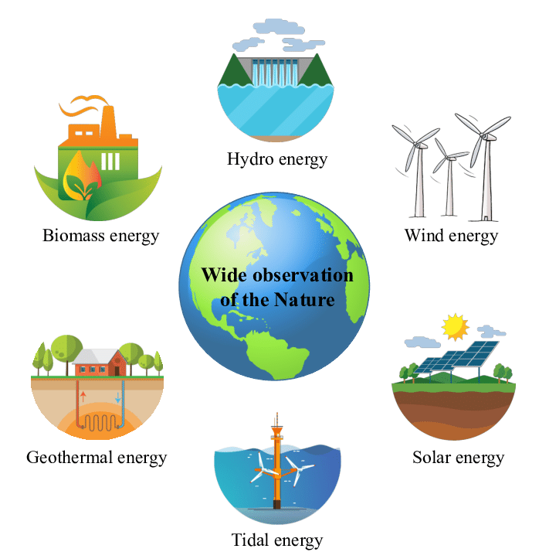

Figure 1: Various renewable energy sources

1. Solar power: One of the most plentiful and readily available energy sources on our planet is sunlight. The quantity of solar energy that reaches the surface of the globe in a single hour exceeds the planet's whole annual energy needs. The quantity of solar energy we can utilize varies depending on the time of day, the season of the year, as well as our geographic location, despite the fact that it may seem like the ideal renewable energy source. Solar energy [4, 5] is becoming a more and more common alternative to complement your energy use in the UK.
Working: A layer of silicon cells, a glass covering unit, a metal frame, and wire connections for energy flow from the cells make up a solar panel. Despite not being a metal, silicon is a good conductor. It enables the conversion of solar energy into useful energy through absorption.When sunlight hits a silicon cell, it causes the cells to move, which starts an electric current to flow. The photovoltaic effect, a general term for how solar panels operate, is described by the activation. Edmond Becquerel made the finding in 1839. This result is the basis for the scientific theory of solar energy electricity production. Semiconductors are substances that can produce an electric current when exposed to sunlight.
The entire process entails:
- Solar radiation absorbed by the silicon cell
- This photovoltaic solar cell reacts to the radiation and causes the electrons to move. Electric current starts to flow as a result of this.
- Direct current (DC) electricity is transported via cables to a solar inverter. DC is changed into alternating current (AC) in the converter. It is a widely used type of electricity in the US.
Thin-film photovoltaic solar modules make up around 5% of all solar modules on the market today. They don't make a panel out of many cells, but rather have at least one semiconductor on the surface of a single substrate. For a very long time, crystalline silicon has been more effective at converting solar radiation into electricity than thin-film photovoltaic technology. However, they are less expensive to build, and the technology is rising in popularity in the US. Additionally, the use of multi-junction cells is more effective than the use of conventional solar cells. They use more solar power. These cells have numerous layers rather than relying just on one semiconductor, such as silicon. Each layer has a semiconductor element that responds to a particular region of the light spectrum. Although using technology is expensive, it will probably become more commercially viable in the next years.

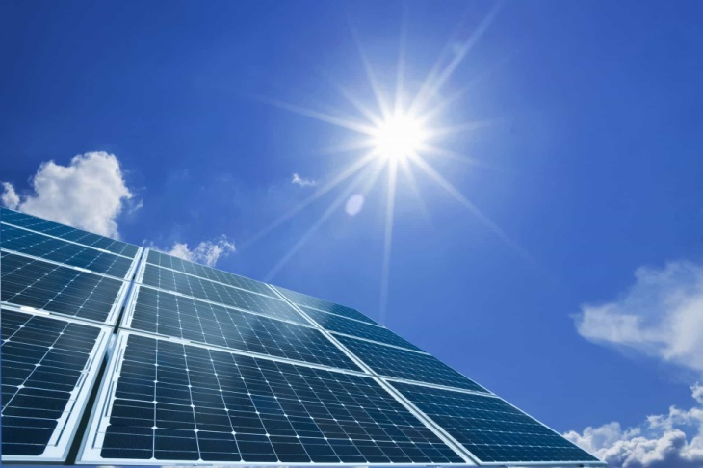

Figure 2: Solar energy
2. Wind energy: An abundant source of renewable energy is wind. With wind power contributing more and more to the National Grid, wind farms are becoming a more common sight in the UK. In order to generate electricity from wind energy, turbines power generators, which subsequently supply power to the National Grid. Even though there exist methods for "off-grid" or household power, not every property can accommodate a residential wind turbine.
Working: The technique of capturing wind energy [6-8] and transforming it into useful mechanical and electrical power is known as wind power. Today, turbines—basically huge windmills—provide the majority of the wind energy used. The wind rotates two or three of the turbine's blades, which resemble propellers, around the rotor. The generator, which rotates to produce power, is connected to the rotor by a main shaft. Sunlight produces variations in surface temperature, and these variations in surface temperatures cause warm air to rise and produce winds. Therefore, one of the functions of solar power is to capture the energy from these winds. The beauty of wind power is that it comes from the wind, which is a virtually limitless and inexhaustible resource. Wind energy generates significantly less pollution and carbon emissions than energy that is fueled by fossil fuels.
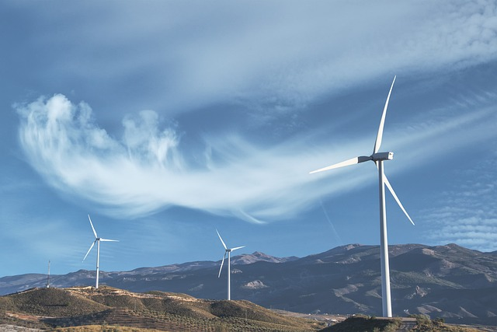

Figure 3: Wind energy
3. Hydro power: It is one of the most economically established sources of renewable energy. A big reservoir can be utilized to create a regulated flow of water that will drive a turbine, producing power, by erecting a dam or barrier. The ability to store electricity for use during times of peak demand makes this energy source often more reliable than solar or wind power (especially if it's tidal rather than river-based). Similar to wind energy, hydro can occasionally be more cost-effective as a commercial energy source (depending on the type and compared to other sources of energy), but it can also be utilized for domestic, "off-grid," generating. It is a significant renewable energy source that is currently used to generate electricity all over the world is hydroelectric power (HEP) [9-11]. It uses the fundamental principles of physics. Water falling under intense pressure has a lot of kinetic energy. The turbines in a HEP station are turned by the flowing water. The generator transforms the mechanical energy of the turbines into electrical energy via magnetic induction.
Working: Hydroelectric Power Station is a method of turning generator turbines by using dam water that is falling from a height. The national grid system is supplied with the electrically generated mechanical energy.
Three main parts make up a hydroelectric power plant.
- The dam that generates the water head is the first. High-velocity water falling from the dam's base gives the turbines kinetic energy to turn.
- The reservoir is the second element. The area behind the dam where water is held is known as the water reservoir. The reservoir's water level is higher than that of the remainder of the dam's construction. The reservoir's water level determines how much potential energy it contains. The potential energy of water increases with height.
- The third element is the power plant, which generates electricity and is wired into the grid.
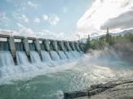

Figure 4: Hydro power energy

4. Tidal energy
This is another form of hydro energy that uses twice-daily tidal currents to drive turbine generators. Although tidal flow unlike some other hydro energy sources isn’t constant, it is highly predictable and can therefore compensate for the periods when the tide current is low. Tides are a common occurrence. They are susceptible to forecasting months and years in advance. Because of this, the energy generated by the enormous water movement may be captured and transformed into a useful type of energy. Tidal energy [12-14] has the potential to provide electricity in the future even if it is not now commonly employed. Tidal energy has struggled compared to other renewable energy sources because of its relatively high cost and scarcity of building sites. However, tidal energy generation appears to have a promising future because recent technology advancements suggest that the financial and environmental costs can be reduced to levels that are competitive.
Working:
Tidal Energy Generator: Tidal energy is the energy derived from the rise and fall of tides.Dams or tidal barrages are built to block off a small seaport. Whenever the sea level rises, water pours through the dam. The turbine blades that are mounted at the dam opening are moved as a result. As a result, electricity is produced.

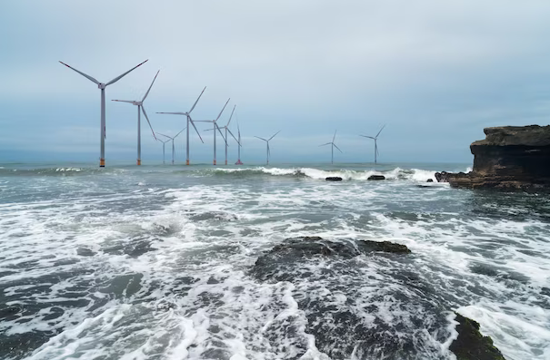
Figure 5: Tidal energy

5. Geothermal energy
Geothermal energy can be utilized to directly heat homes or to generate power by utilizing the natural heat that exists beneath the earth's surface. Geothermal energy is of minor importance in the UK compared to nations like Iceland, where geothermal heat is considerably more freely available, despite the fact that it harnesses a power that is just beneath our feet. Renewable energy derived from the Earth's core is known as geothermal energy [15-18]. It originates from heat produced during the planet's initial creation and the radioactive decay of elements.
Working: In the earth's core, rocks and liquids contain this thermal energy. Thermal energy is continuously transferred from the planet's interior to its surface due to the difference in temperature between the earth's core and its surface. Some of the rock in the Earth's core melts at temperatures over 4000°C to generate hot, molten rocks known as magma. Given that the mantle is lighter than the underlying rock, these heats also force some of it to convect upward and act plastically. The rock and water in the crust of the Earth can get as hot as 370°C. From surface-level all the way down to several miles below, thermal energy is present in the rocks and fluids.
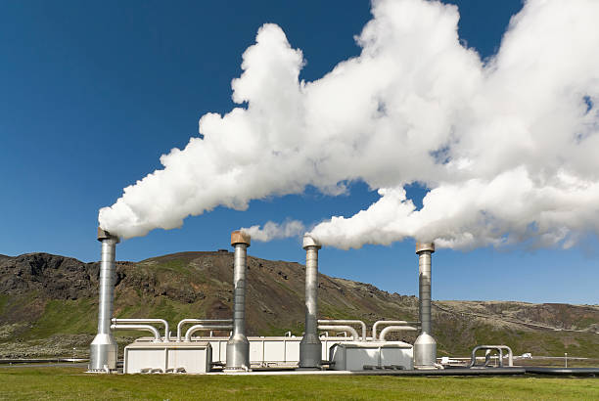

Figure 6: Geothermal energy

6. Biomass Energy
In this process, solid fuel created from plant resources is transformed into electricity. Although the core of biomass is the burning of organic materials to create electricity, this process is now cleaner and more energy-efficient. Biomass creates power at a significantly lower financial and environmental cost by turning home, industrial, and agricultural waste into solid, liquid, and gas fuel. Since people first started heating their homes and cooking their meals by burning wood, biomass has been used. The largest biomass energy source available today is still wood. Food crops, grassy and woody plants, forestry or agricultural wastes, oil-rich algae, and the organic portion of municipal and industrial wastes are some more sources. Even landfill fumes, which are primarily composed of methane, the principal gas in natural gas, can be used as a biomass energy source. Fuels, electricity, and other goods that would typically be made from fossil fuels can be substituted with biomass.
Working: Since it includes solar energy, biomass [19-22] is a renewable source of energy. In its simplest form, biomass is an organic material derived from plants and animals. Through the process of photosynthesis, chlorophyll in plants receives solar energy by transforming groundwater and atmospheric carbon dioxide into carbohydrates. The energy that these plants absorbed from the sun is released when they are burned into the air. This renewable energy source is boundless as long as biomass is generated. Plants, crop waste, wood chips, corn, and other sorts of rubbish are examples of biomass.
Thus, the captured solar energy is released when these plants and animals burn, reverting to carbon dioxide and water. This means that since we can always grow more plants and crops and because trash will always exist, biomass is a renewable source of energy.

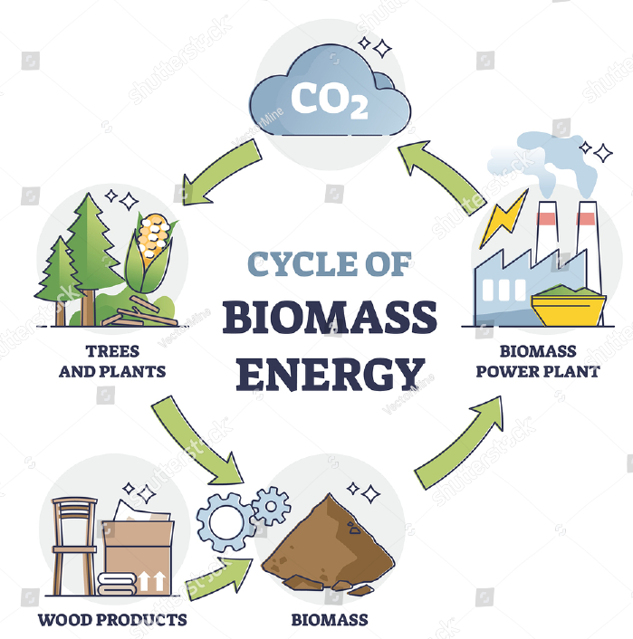

Figure 7: Biomass Energy

4. Future of renewable energy sources
The demand for energy to power our homes, businesses, and communities grows along with the global population. Maintaining a sustainable energy level and preventing climate change need innovation and expansion of renewable energy sources.The International Energy Agency (IEA) predicts that by 2024, 30% of the world's electricity would come from renewable sources, up from the current 26% share. The IEA's executive director, Fatih Birol, stated that "renewable energy is at a critical juncture right now." The UK achieved a brand-new incredible renewable energy milestone in 2020. For the first time ever, the nation celebrated two months of only using renewable energy on Wednesday, June 10. This is a fantastic move in favor of renewable energy.(1) It is anticipated that as electricity demand rises in the future, the number of renewable energy sources will keep growing. This will result in lower renewable energy costs, which is fantastic for the environment and economical for us.
5. The benefits of utilizing renewable energy in a household environment are compelling:
- Minimize your energy expenditures: Once the costs of establishing a renewable energy system have been covered, you can minimize your reliance on the National Grid and your energy prices. A great gas boiler substitute is air source heat pumps.
- Receive payment for the electricity you produce: The Feed-in Tariff program of the UK government compensates you for the electricity you produce, even if you use it.
- Refinance your electricity with the grid: You can get extra money from the Feed-in Tariff program if you are producing enough energy to export an excess back into the National Grid.
- Drive an electric vehicle: Did you know that our EV rates are renewable in addition to being cost-effective? View our electric vehicle pricing.
- Minimizing carbon footprint: Carbon dioxide and other dangerous pollutants are not released into the atmosphere while using green, renewable energy sources. The Solar panels page of the Energy Saving Trust states that a typical solar PV system might save 1.5 to 2 tonnes of carbon annually.
6. Facts about renewable energy
- By 2020, solar PV may supply 5% of world demand, and by 2030, it may supply up to 9%.
- Our energy requirements can be satisfied by 95% renewable energy by the year 2050.
- Price Waterhouse Cooper projects that by 2050, Africa will be entirely dependent on renewable energy.
- The cost of solar PV panels has decreased by 95% during the previous 40 years.
- According to a US research, renewable energy generates three times as many jobs as fossil fuels.
- Investment in renewable energy now exceeds that in fossil fuels. The market for renewable energy is now worth more than $250 billion.

7. Conclusion
By substituting renewable energy sources for fossil fuels in the transportation and power generation industries, CO₂ emissions could be reduced. It is vital to develop and promote renewable energy supply technologies as well as demand for renewable energy because there are some undesirable and irreversible externalities in the generation of conventional energy. To lower the cost of production per unit, more power should be generated from renewable energy sources. Numerous variables, such as population growth, energy prices, weather, and technology, affect how much energy is consumed.

References

1. Zhao, J., Patwary, A. K., Qayyum, A., Alharthi, M., Bashir, F., Mohsin, M., ... & Abbas, Q. (2022). The determinants of renewable energy sources for the fueling of green and sustainable economy. Energy, 238, 122029.
2. Kebede, A. A., Kalogiannis, T., Van Mierlo, J., & Berecibar, M. (2022). A comprehensive review of stationary energy storage devices for large scale renewable energy sources grid integration. Renewable and Sustainable Energy Reviews, 159, 112213.
3. Sher, F., Curnick, O., & Azizan, M. T. (2021). Sustainable conversion of renewable energy sources. Sustainability, 13(5), 2940.
4. Esmaeili Shayan, M., Esmaeili Shayan, S., & Nazari, A. (2021). Possibility of supplying energy to border villages by solar energy sources. Energy Equipment and Systems, 9(3), 279-289.
5. Heffron, R., Halbrügge, S., Körner, M. F., Obeng-Darko, N. A., Sumarno, T., Wagner, J., & Weibelzahl, M. (2021). Justice in solar energy development. Solar Energy, 218, 68-75.
6. Sadorsky, P. (2021). Wind energy for sustainable development: Driving factors and future outlook. Journal of Cleaner Production, 289, 125779.
7. Msigwa, G., Ighalo, J. O., & Yap, P. S. (2022). Considerations on environmental, economic, and energy impacts of wind energy generation: Projections towards sustainability initiatives. Science of The Total Environment, 849, 157755.
8. Zhao, X., Nashalian, A., Ock, I. W., Popoli, S., Xu, J., Yin, J., ... & Chen, J. (2022). A Soft Magnetoelastic Generator for Wind‐Energy Harvesting. Advanced Materials, 34(38), 2204238.
9. Chang, L., Lu, Q., Ali, S., & Mohsin, M. (2022). How does hydropower energy asymmetrically affect environmental quality? Evidence from quantile-based econometric estimation. Sustainable Energy Technologies and Assessments, 53, 102564.
10. Gemechu, E., & Kumar, A. (2022). A review of how life cycle assessment has been used to assess the environmental impacts of hydropower energy. Renewable and Sustainable Energy Reviews, 167, 112684.
11. Ugwu, C. O., Ozor, P. A., & Mbohwa, C. (2022). Small hydropower as a source of clean and local energy in Nigeria: Prospects and challenges. Fuel Communications, 10, 100046.
12. Chowdhury, M. S., Rahman, K. S., Selvanathan, V., Nuthammachot, N., Suklueng, M., Mostafaeipour, A., ... & Techato, K. (2021). Current trends and prospects of tidal energy technology. Environment, development and sustainability, 23, 8179-8194.
13. Shetty, C., & Priyam, A. (2022). A review on tidal energy technologies. Materials Today: Proceedings, 56, 2774-2779.
14. Duman, S., Akbel, M., & Kahraman, H. T. (2021). Development of the multi-objective adaptive guided differential evolution and optimization of the MO-ACOPF for wind/PV/tidal energy sources. Applied Soft Computing, 112, 107814.
15. Fridleifsson, I. B. (2003). Status of geothermal energy amongst the world's energy sources. Geothermics, 32(4-6), 379-388.
16. Fridleifsson, I. B. (2001). Geothermal energy for the benefit of the people. Renewable and sustainable energy reviews, 5(3), 299-312.
17. Stefansson, V. (2000, May). The renewability of geothermal energy. In Proceedings of the World Geothermal Congress 2000 (pp. 883-888).
18. Dickson, M. H., & Fanelli, M. (2013). Geothermal energy: utilization and technology.
19. Balat, M., & Ayar, G. (2005). Biomass energy in the world, use of biomass and potential trends. Energy sources, 27(10), 931-940.
20. Chuah, T. G., Wan Azlina, A. G. K., Robiah, Y., & Omar, R. (2006). Biomass as the renewable energy sources in Malaysia: an overview. International Journal of Green Energy, 3(3), 323-346.
21. Güney, T., & Kantar, K. (2020). Biomass energy consumption and sustainable development. International Journal of Sustainable Development & World Ecology, 27(8), 762-767.
22. Balat, M. (2009). Global status of biomass energy use. Energy Sources, Part A, 31(13), 1160-1173.

