Paper Title
Augmented Reality versus Virtual Reality and Impact of Mixed Reality in Future
Mrs.B.Divya Rekha
Dept: Computer Science
Bhavan’s Vivekananda Degree College
Sainikpuri, Secunderabad, India
b.d.rekha0310@gmail.com
Mrs.KVB.Saraswathi Devi
Dept: Computer Science
Bhavan’s Vivekananda Degree College
Sainikpuri, Secunderabad, India
Hod.cs@bhavansvc.ac.in
Or
Kvb.saraswathi19@gmail.com

- ABSTRACT
Technology is presiding the world in present Era, which is making people’s life more comfortable and they are Enhancing their knowledge, skills. It also helps Industries in Strategical planning for the development of their organization. One of the current trends going on is Virtual Reality, Augmented Reality and furtherly Mixed Reality is dominant now. VR and AR are creating very Pioneering Environment for Business, Education, Medical, Military and all other fields to successfully accomplish their goals. This paper is about the impact of the above latest trends prevailing in market, its future and how these technologies create innovative environment to gain knowledge and also support organizations to reach their goals.
II. Introduction
Virtual reality:
Virtual reality (VR) refers to a computer-generated simulation of a three-dimensional environment that can be interacted with and experienced by a user through specialized electronic devices, such as VR headsets or goggles. VR technology immerses users in a synthetic world, replicating real-world experiences or creating entirely fictional scenarios. It can be used for various purposes, including entertainment, training, education, and even therapeutic applications.
Key components of a virtual reality system typically include:
- VR Headset: A head-mounted display that covers the user's eyes and ears, delivering the virtual experience through screens and speakers. Modern VR headsets offer high-resolution displays, wide field of view, and tracking sensors for precise movement detection.
- Input Devices: VR systems usually come with specialized controllers or other input devices that enable users to interact with the virtual environment, such as grabbing objects, pointing, and navigating.
- Tracking System: VR requires accurate tracking of the user's movements to ensure seamless interaction with the virtual world. This is often achieved through external sensors or cameras that detect the headset and controller positions.
- Computer Hardware: VR applications demand substantial computing power to render high-quality graphics in real-time. As a result, a powerful computer or gaming console is usually necessary to run VR experiences.
VR can be experienced in different forms, such as:
- Non-Immersive VR: Basic VR experiences viewed on a computer or mobile screen, allowing limited interaction with the virtual environment.
- Semi-Immersive VR: Users experience a partial immersion through projection screens or semi-immersive headsets.
- Fully Immersive VR: Users are completely immersed in the virtual environment through high-quality headsets that block out the real world.

Virtual Reality makes imaginary world
Fig:1

History of Virtual Reality:
The history of virtual reality (VR) dates back several decades and has seen significant advancements over time. Here's an overview of the key milestones in the history of VR:
- 1930s - 1950s: The Concept Emerges The idea of virtual reality first appeared in science fiction literature and stories, such as Stanley G. Weinbaum's 1935 short story "Pygmalion's Spectacles," where characters could experience fictional worlds through goggles. This laid the foundation for the concept of immersing oneself in artificial environments.
- 1960s: The Birth of VR The term "virtual reality" was coined by Jaron Lanier in the 1980s, but the initial research and experimentation began in the 1960s. The first VR-like devices were developed during this period. Ivan Sutherland's "Sword of Damocles" (1968) is often regarded as the first head-mounted display (HMD) system, although it was quite primitive by today's standards.
First Virtual Reality work done in1950
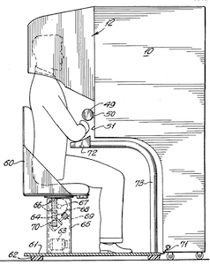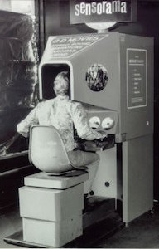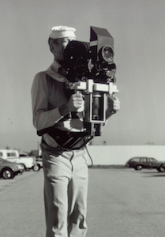
Fig 1.1
- 1970s - 1980s: Advancements and Research Throughout the 1970s and 1980s, various researchers and technology pioneers continued to explore VR concepts and build rudimentary systems. Notably, Myron Krueger created "Videoplace" (1975), an interactive virtual environment that allowed users to interact with projected images using their bodies.
- 1980s: The First Commercial VR Products The 1980s saw the introduction of some of the first commercial VR products. In 1982, Atari released "Battlezone," an arcade game that used vector graphics and a periscope-like display to create a 3D tank-battle simulation. In 1985, VPL Research, founded by Jaron Lanier, released the "Data Glove" and "Eyephone," which were early input devices for interacting with virtual environments.
The Improvised VR device
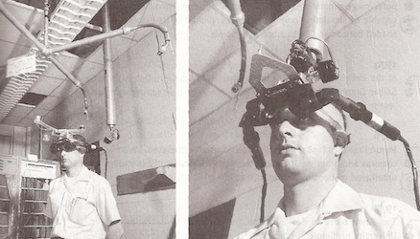
Fig 1.1.2
- 1990s: VR Gains Traction The 1990s saw significant developments in VR technology, as computers became more powerful. Companies like Sega and Nintendo attempted to enter the VR market with products like Sega VR and Virtual Boy, respectively. However, due to various issues, such as discomfort and motion sickness, these early consumer VR attempts were not successful.
- Late 1990s - Early 2000s: Decline of VR Towards the late 1990s, VR suffered a decline in interest and funding, often referred to as the "VR Winter." This period saw a lack of significant advancements and a decrease in public interest.

Group Virtual Machines created in year of 1990
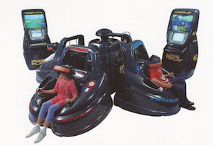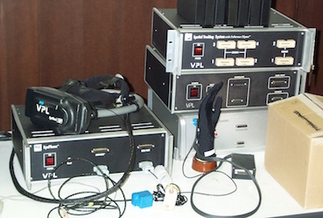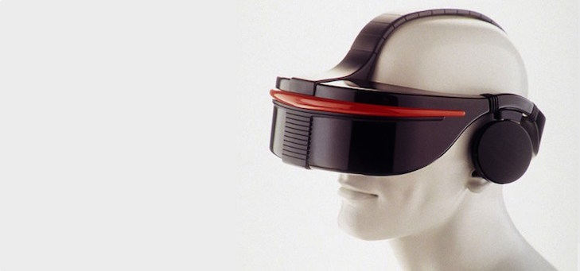
Fig 1.1.3

- 2010s: The VR Renaissance The emergence of new technologies and increased interest in gaming and entertainment led to a revival of VR in the early 2010s. Oculus Rift, a VR headset developed by Palmer Luckey and later acquired by Facebook, launched a successful Kickstarter campaign in 2012. This sparked renewed interest and investment in VR technology.
- Mid-2010s - Present: Mainstream VR Adoption The mid-2010s witnessed the release of various VR headsets, such as HTC Vive, PlayStation VR, and Samsung Gear VR, among others. These devices offered improved graphics, tracking, and user experiences. VR technology became more accessible to consumers, and developers started creating a wide range of VR applications, including games, educational tools, and social experiences.
The following are the programming languages we use for Virtual Reality
“C, C++, JAVA, JAVASCRIPT, PYTHON”.
Virtual Reality (VR) has a diverse range of applications, and its immersive nature makes it valuable across various industries. Here are a few prominent applications of VR:
Few applications of Virtual Reality:
- VR in Military:
Now a days Virtual Reality is implemented in different environments of service like navy, army and air force etc., VR in the military has proven to be a valuable tool for enhancing training, improving decision-making, and preparing soldiers for a wide range of real-world scenarios. Its ability to provide realistic and repeatable training experiences makes it an essential component of modern military training and operations.

The following image depicts how imaginary Environment is created in Military
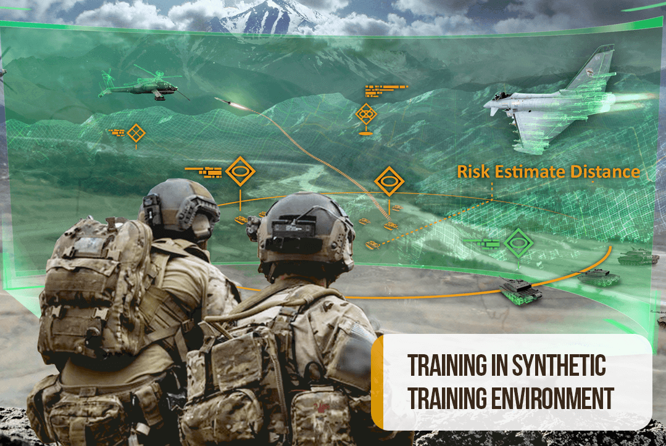
Fig 2

VR in Sports:
VR is applied in sports for training athletes and analysing their performance. It enables athletes to practice in virtual environments and helps coaches identify areas for improvement by providing data-driven insights.
Almost live training in Sports
Fig 2.1
VR in Education:
VR enhances traditional education by enabling students to go on virtual field trips to historical landmarks, museums, or even distant planets. It provides a more immersive and interactive learning experience, making complex subjects more accessible and enjoyable.
Role of VR in Class Education
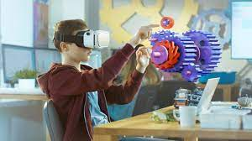
Fig 2.2
VR in Medical Training:
VR in medical training offers a safe, immersive, and effective way for medical professionals to develop and refine their skills. As the technology continues to evolve, VR is expected to play an increasingly vital role in medical education and healthcare practice.
The Virtual Reality in Medical field
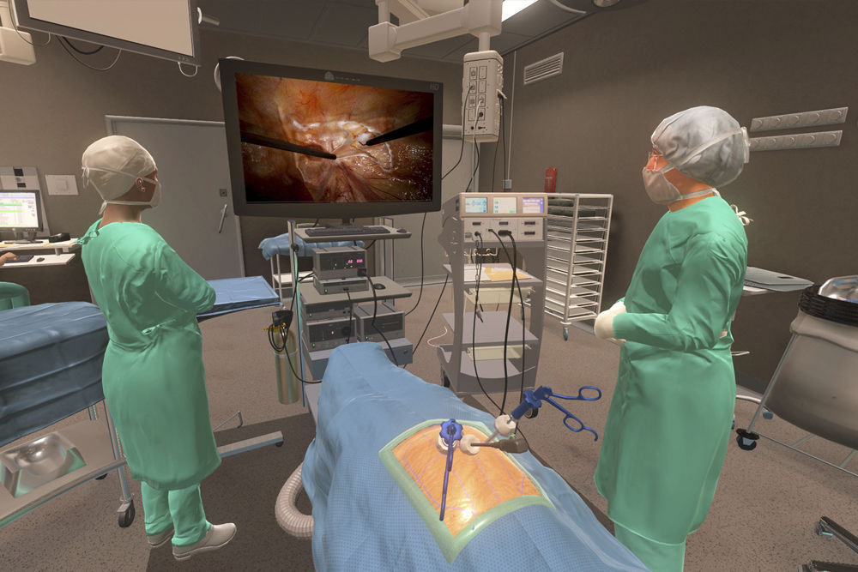
Fig 2.3

VR in Fashion:
Only few people know that VR is also used in the field of fashion. This has actually created a profound impact in creating the virtual simulations of store settings for retailers to display products Virtually, so that they can reduce man power, time and make them feel real.
VR offers suitable resources and allocate time for store layout. Few popular branded clothes like Tommy Hilfiger, Coach and Gap has now started applying VR as it gives a 3D (in 360 degree) experience of fashion shows and allows customers to try on clothes virtually.

Virtual Reality in the Fashion World
Fig 2.4

The following are the list of Industries which use Virtual Reality in percentage wise
Table 1
S. No | Name of the Industry | Percentage of use
1 | Gaming | 61%
2 | Health care and medical devices | 41%
3 | Education | 41%
4 | Manufacturing and automotive | 23%
5 | Movies and television | 21%
6 | Workplace development | 20%
7 | Marketing and advertising | 16%

Pros and cons of Virtual Reality
Table 1.1
Advantages | Disadvantages
It gives a very good work experience | Less interactive
VR is applicable in numerous fields | Still, it is not in Matured state
Gives greater business opportunities | It develops addiction
It is connected in better way basing on interests of users | Very expensive

Augmented Reality:
Augmented Reality (AR) is a technology that overlays computer-generated content, such as images, videos, or 3D models, onto the real-world environment, blending the virtual and physical worlds. Unlike virtual reality, which creates entirely simulated environments, AR enhances the user's real-world experience by adding digital elements to it. This technology allows users to interact with both the physical and virtual worlds simultaneously.
AR is commonly experienced through various devices, including smartphones, tablets, AR glasses, and headsets. These devices use cameras and sensors to capture the real-world environment and then superimpose digital content onto the user's view.
Key characteristics and components of augmented reality include:
- Real-Time Interaction: AR content is typically interactive and responds in real-time to the user's movements and actions, making the digital overlay feel integrated with the physical environment.
- Marker-based and Marker less AR: Marker-based AR uses predefined visual markers, such as QR codes or specific patterns, to anchor the digital content to the real world. Markerless AR, on the other hand, relies on computer vision and object recognition to place digital elements in the environment without the need for markers.
- Tracking Technology: AR devices use various tracking technologies, such as GPS, accelerometers, gyroscopes, and depth sensors, to understand the user's position and orientation in the real world accurately.
- Applications: AR has a wide range of applications across different industries. It is used in gaming, entertainment, advertising, education, retail, navigation, training, healthcare, and more.
History of Augmented Reality:
The history of augmented reality (AR) dates back several decades, with early conceptual ideas and research paving the way for the development and widespread adoption of AR technology. Here's a chronological overview of key milestones in the history of AR:
- 1968: Ivan Sutherland's "Sword of Damocles" AR's early roots can be traced back to Ivan Sutherland's seminal work in the late 1960s. In 1968, Sutherland, a computer scientist, created a head-mounted display (HMD) system called the "Sword of Damocles." This early AR device was bulky and expensive, but it allowed users to see simple computer-generated graphics overlaid on the real world.
- 1990s: Early Commercial Applications In the 1990s, AR technology began to find practical applications in specific industries. One notable example was Boeing's use of AR to assist aircraft assembly. They employed AR systems to project assembly instructions and wire-routing information directly onto the aircraft, aiding workers in the assembly process.
Virtual Fixtures created in 1992 for AR
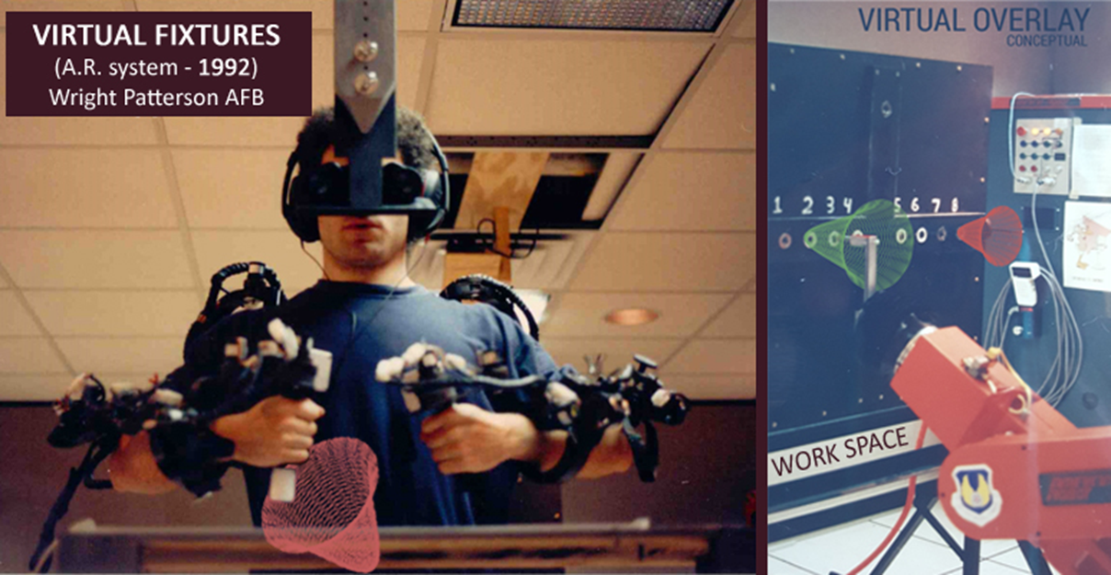
Fig 3
- 2000s: AR in Entertainment and Military In the early 2000s, AR started to gain attention in the entertainment and military sectors. For instance, the U.S. military used AR systems to enhance situational awareness for soldiers by displaying critical information, such as maps and enemy positions, on their heads-up displays.
- 2009: Layar and AR Apps In 2009, the Layar app was launched, which allowed users to access AR content through their smartphones' cameras and GPS. Layar provided digital overlays of information on top of the physical world, such as location-based data, points of interest, and real estate listings.
- 2013: Google Glass Google introduced Google Glass in 2013, a wearable AR device resembling eyeglasses. Google Glass allowed users to interact with information displayed on a small screen in front of their eyes, capturing photos, videos, and accessing contextual information through voice commands.

IKEA’S first AR app
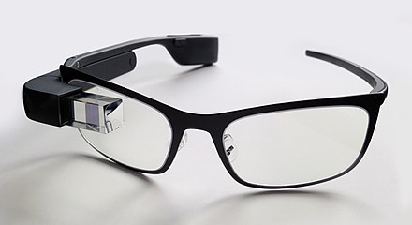
Fig 3.1
- 2016: Pokémon GO Pokémon GO, released in 2016, became a global phenomenon and brought AR gaming into the mainstream. The game allowed players to capture virtual Pokémon creatures superimposed onto the real world using their smartphones' cameras and GPS.
- 2017: ARKit and ARCore Apple and Google launched ARKit and ARCore, respectively, in 2017, bringing AR capabilities to millions of smartphones worldwide. These developer platforms enabled the creation of AR apps and experiences on iOS and Android devices.
- Present and Beyond: Growing Adoption and Applications In recent years, AR technology has continued to advance, and its adoption has grown across various industries. Companies are using AR in retail for virtual try-ons, in education for interactive learning experiences, in healthcare for medical training and visualization, and in manufacturing for assembly and maintenance support, among many other applications.
The following are the programming languages we use for Augmented Reality:
“C++, JAVA, JAVASCRIPT, SWIFT”
Top 5 Applications for AR:
- Healthcare and Medical Training
AR in Medical Training
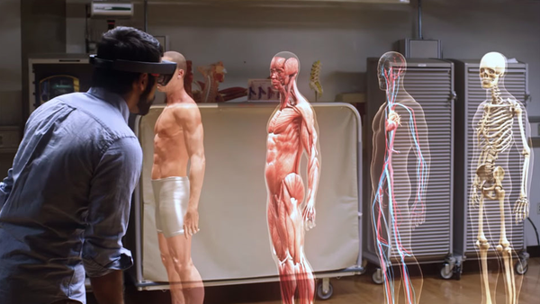
Fig 3.2

AR has significant applications in healthcare, from assisting surgeons during procedures to medical training for students. Surgeons can use AR overlays to display patient information, X-ray images, or other relevant data during surgery, reducing the need to look away from the operating field. Medical students can benefit from AR simulations and interactive anatomy models to gain a better understanding of the human body and various medical conditions.
.
- Interior Design and Modelling:

Impact of Augmented Reality in Interior Design

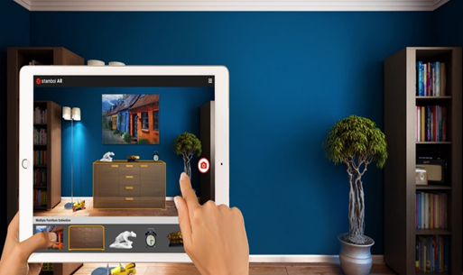
Fig 3.3

Interior Design and Modelling – in current era AR is commonly used in visualizing the final product even in the phase of construction. Person can select their favourite paint colour, wall hanging and desired furniture without buying according to their taste.
- Education and Training:
Usage of AR in classroom Education

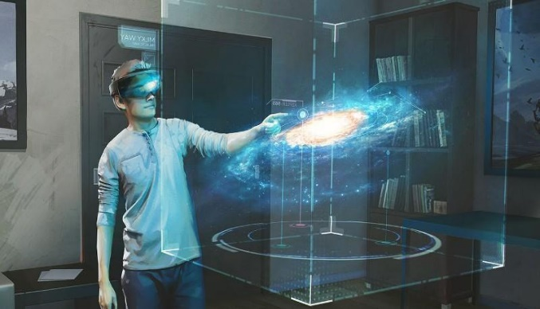
Fig 3.4
AR is increasingly being used in education to create interactive and engaging learning experiences. AR apps and tools can provide visual aids, 3D models, and simulations to help students grasp complex concepts more easily. In the training sector, AR is used for employee training and skill development, especially in industries where hands-on experience is crucial but difficult to provide in real-world settings
- Gaming and Entertainment:
How AR is playing its vital role in Entertainment field
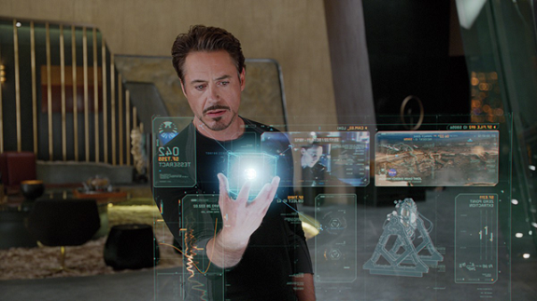
Fig 3.5

AR has revolutionized the gaming and entertainment industry by allowing users to interact with virtual content in their real-world environment. Popular examples include games like Pokemon Go, where players use their smartphones to capture virtual creatures in the real world. AR also enhances live events, concerts, and sports by overlaying digital elements onto the physical surroundings, creating immersive experiences for audiences.
- Retail and E-commerce:
AR is transforming the way people shop by enabling virtual try-ons, product visualizations, and in-store navigation. Customers can use AR apps to virtually try on clothing, accessories, and makeup, helping them make more informed purchasing decisions. E-commerce platforms are also integrating AR to allow customers to visualize products in their homes before buying, such as furniture, home decor, and appliances.

Benefits of AR:
Augmented Reality (AR) offers numerous benefits and has the potential to positively impact various aspects of our lives. Here are some key benefits of AR technology:
- Enhanced User Experience: AR enhances the user experience by overlaying digital content onto the real world. It allows users to interact with virtual objects in their physical environment, making experiences more engaging, immersive, and interactive.
- Improved Learning and Training: AR can be a valuable tool for education and training. It enables learners to visualize complex concepts, historical events, or scientific processes in a more tangible way, making learning more accessible and effective. In training scenarios, AR can simulate real-life situations, such as medical procedures or equipment operation, without real-world risks.
- Increased Productivity: AR can streamline workflows and boost productivity in various industries. In manufacturing, AR can provide workers with real-time instructions and visual aids, reducing errors and speeding up tasks. In maintenance and repair, AR can assist technicians by displaying relevant information and step-by-step guides, saving time and resources.
- Enhanced Marketing and Advertising: AR offers innovative marketing opportunities, allowing brands to create interactive and memorable experiences for customers. AR campaigns can engage users with virtual try-ons, product visualizations, or gamified experiences, enhancing brand awareness and customer engagement.
- Real-Time Data Visualization: AR can overlay real-time data onto physical objects, providing users with relevant information in context. For example, AR navigation apps can display directions and points of interest on the street in real-time, improving navigation experiences.
- Remote Collaboration: AR enables remote collaboration by allowing users to share and interact with virtual objects in real time. In business settings, team members can collaborate on projects, visualize 3D models, and conduct virtual meetings regardless of their physical locations.
- Accessibility and Inclusivity: AR can make information more accessible to individuals with disabilities. For instance, AR can provide audio or visual aids for people with visual impairments, aiding them in understanding their surroundings better.
- Entertainment and Gaming: AR has revolutionized the gaming and entertainment industries, providing users with interactive and immersive experiences. Games like Pokémon GO and AR escape rooms have captivated audiences worldwide, blending virtual content with the real world.
- Real Estate and Interior Design: AR can be used to visualize interior design concepts or architectural plans in real-world spaces. Homebuyers can use AR apps to preview how furniture and decor would look in their homes before making purchasing decisions.
- Medical Applications: In healthcare, AR can assist surgeons during procedures by overlaying patient data and vital information on their field of view. It can also aid in medical training and improve patient understanding of complex medical conditions.
Drawbacks of AR:
While Augmented Reality (AR) technology offers numerous benefits, it also comes with some drawbacks and challenges. Here are some of the key drawbacks of AR:
- Hardware Limitations: High-quality AR experiences often require powerful hardware, such as advanced cameras, sensors, and processing capabilities. This can make AR devices expensive and not easily accessible to everyone.
- Battery Drain: Running AR applications can be demanding on the device's battery, leading to rapid depletion and limiting the duration of AR experiences, especially on mobile devices.
- Comfort and Ergonomics: Some AR headsets and devices can be heavy, uncomfortable, or cause discomfort during extended use. This can impact the user experience and prevent widespread adoption.
- Limited Field of View: Many AR devices have a limited field of view, meaning users can only see AR content within a restricted area of their vision. This can lead to a disjointed experience and make it challenging to interact with virtual objects that fall outside the field of view.
- Motion Sickness and Disorientation: AR experiences that are not well-designed or do not provide stable tracking can cause motion sickness and disorientation for some users, similar to issues experienced in virtual reality.
- Privacy Concerns: AR applications can collect and use real-time data, including location, images, and user behaviour. This raises privacy concerns about how this data is used and shared, especially in public spaces.
- Content Quality and Standardization: The quality of AR content can vary significantly, with some experiences feeling gimmicky or low-quality. Additionally, the lack of standardized formats and development tools can lead to inconsistent experiences across different AR platforms.
- Dependency on Network Connectivity: Many AR applications require a stable internet connection to function optimally. In areas with poor network coverage, this can lead to a degraded AR experience or make certain features inaccessible.
- Distractions and Safety Concerns: While AR can enhance real-world experiences, it can also be distracting and potentially dangerous in certain situations, such as when used while driving or crossing busy streets.
- Learning Curve: As AR technology is still relatively new to many users, there can be a learning curve in understanding how to interact with AR interfaces effectively and make the most of the technology's capabilities.
- Social Acceptance and Norms: The use of AR in public spaces can be socially awkward or perceived as intrusive by others, leading to challenges in mainstream adoption.
Despite these drawbacks, ongoing advancements in AR technology, improvements in hardware, and thoughtful design approaches are addressing many of these challenges. As the technology matures, it is expected that many of these issues will be mitigated, leading to more seamless and user-friendly AR experiences.

Differences between Augmented Reality versus Virtual Reality
Augmented Reality (AR) and Virtual Reality (VR) are two distinct technologies that offer immersive experiences, but they have fundamental differences in how they present virtual content to users. Here are the main differences between Augmented Reality and Virtual Reality:
Definition:
Augmented Reality (AR): AR refers to a technology that overlays virtual elements onto the real-world environment. It enhances the real-world environment by adding computer-generated graphics, sounds, or other sensory stimuli to augment the user's perception of reality.
Virtual Reality (VR): VR, on the other hand, immerses users in a completely virtual environment, isolating them from the real world. Users wearing VR headsets are transported to a simulated world, where they can interact with the virtual environment as if it were real.
Environment Interaction:
Augmented Reality: AR enhances the user's real-world experience by adding virtual elements that interact with the surrounding environment. Users can see and interact with both real and virtual objects simultaneously.
Virtual Reality: VR creates a closed, fully immersive environment, isolating users from the real world. Interaction is limited to the virtual environment, and users cannot see or interact with their physical surroundings.
Hardware and Devices:
Augmented Reality: AR can be experienced through various devices, such as smartphones, tablets, smart glasses, and heads-up displays (HUDs). These devices use cameras to capture the real-world view and overlay virtual elements on top of it.
Virtual Reality: VR requires dedicated head-mounted displays (HMDs) or VR goggles, which completely cover the user's field of view and block out the real world. These devices often include motion sensors to track the user's movements and provide a seamless virtual experience.
Use Cases:
Augmented Reality: AR finds applications in a wide range of industries, including gaming, navigation, education, marketing, design, and training. It allows users to interact with digital content while still being aware of their physical surroundings.
Virtual Reality: VR is commonly used for gaming and entertainment, but it also has significant applications in training, simulation, healthcare, architecture, and therapy. VR offers a deeply immersive and controlled experience, making it useful for situations where real-world interaction is not feasible or safe.
Realism and Immersion:
Augmented Reality: AR maintains a connection to the real world, as users can see and interact with their surroundings. The virtual elements are overlaid on reality, blending the two seamlessly.
Virtual Reality: VR offers a higher level of immersion because it isolates users from the real world entirely. Users feel completely present in the virtual environment, which can be designed to be highly realistic or entirely fantastical.
In summary, Augmented Reality enhances the real world by adding virtual elements, while Virtual Reality transports users to entirely virtual environments. Each technology has its strengths and applications, catering to different use cases and user preferences.
Mixed Reality:
Mixed Reality (MR) is an advanced form of reality technology that combines elements of both virtual reality (VR) and augmented reality (AR) to create a seamless blend of the virtual and physical worlds. In MR, virtual objects are not only overlaid onto the real world (as in AR) but also anchored to and interact with the physical environment, allowing for a more immersive and realistic experience.
Key characteristics of Mixed Reality include:
- Virtual and Real Coexistence: In MR, virtual objects are integrated into the real-world environment and behave as if they exist alongside physical objects. Users can interact with and manipulate both the virtual and real elements simultaneously.
- Spatial Mapping: MR systems use sophisticated sensors and cameras to map and understand the physical environment in real-time, allowing virtual objects to be accurately placed and interact with real surfaces and objects.
- Realistic Interaction: Users can interact with virtual objects using natural gestures, touch, and physical movements, just like they would with real-world objects.
- Depth Perception: MR systems can accurately perceive depth, providing a sense of distance and three-dimensionality to virtual objects, making the experience more immersive.
- Continuum of Realities: MR exists on a continuum between fully virtual environments (VR) and purely real-world experiences (AR). The level of virtual content and its interaction with the real world can be adjusted based on the application and user's preference.
- User-Worn Devices: Mixed Reality experiences are typically delivered through head-mounted displays (HMDs) or smart glasses, equipped with cameras, sensors, and advanced computing capabilities.
Applications of Mixed Reality:
- Design and Visualization: MR is used in architecture, product design, and engineering to create and visualize 3D models in real-world contexts, allowing designers to see how virtual objects interact with physical spaces.
- Training and Education: MR can provide immersive training simulations, allowing learners to practice real-world tasks and procedures in a safe virtual environment.
- Entertainment and Gaming: MR offers innovative and interactive gaming experiences, where virtual characters and objects interact with the player's real environment.
- Remote Collaboration: MR enables remote teams to collaborate as if they were physically present in the same location, sharing and interacting with virtual content together.
- Healthcare: MR is used for medical training, surgical planning, and visualization of patient data in the context of the real-world environment.
- Retail and Commerce: MR can enhance the shopping experience by enabling customers to virtually try on products, visualize furniture or decor in their homes, and more.
As technology continues to advance, Mixed Reality is expected to become more widespread and transformative across various industries, creating new possibilities for how we interact with and perceive the world around us.

Mixed Reality its impact in executing work Efficiently
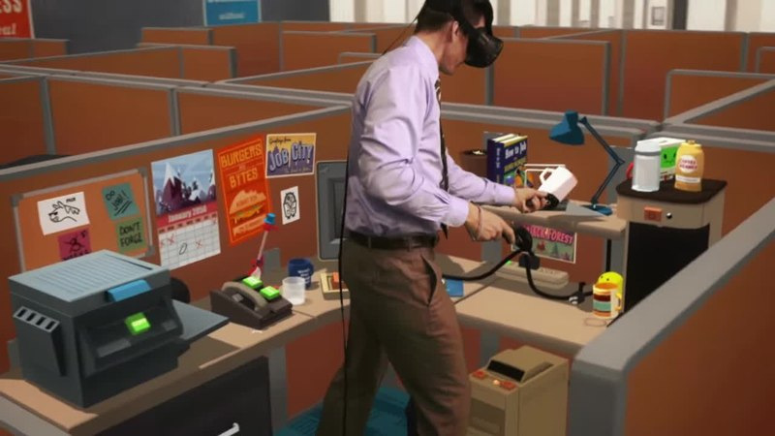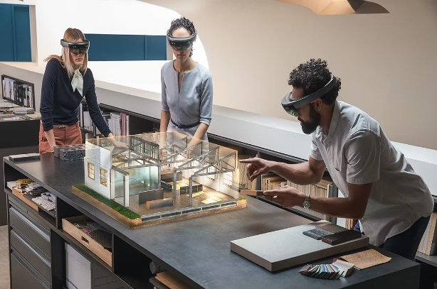
Fig 4
Impact of Mixed Reality in the Future:
Mixed Reality has the potential to revolutionize various industries and significantly impact how we interact with the world. Some potential future impacts of Mixed Reality include:
- Enhanced Productivity: In industries like manufacturing, maintenance, and healthcare, MR can streamline workflows, reduce errors, and improve efficiency by providing workers with real-time information and visualization tools.
- Immersive Learning: Mixed Reality can revolutionize education and training by providing learners with interactive and realistic experiences, making complex concepts more accessible and engaging.
- Remote Collaboration: MR can enable teams located in different parts of the world to collaborate seamlessly, improving communication and productivity across global organizations.
- Social Interaction: MR has the potential to transform social experiences by bringing people together in virtual spaces, allowing for shared experiences and interactions irrespective of physical distance.
- Personalized Retail: MR can enhance the retail experience by enabling customers to virtually try on products, visualize customization options, and receive personalized recommendations.
- Real-World Gaming: Mixed Reality games can extend beyond the boundaries of traditional gaming, offering unique and interactive experiences that blend virtual elements with the real world.

Conclusion:
In conclusion, AR, VR, and Mixed Reality represent a spectrum of reality-altering technologies that are transforming various industries and human experiences. As these technologies continue to advance and become more accessible, they hold the promise of reshaping how we work, learn, socialize, and entertain ourselves in the future. Embracing these technologies responsibly and ethically will be crucial in harnessing their full potential for the betterment of society.
.

References:
- https://www.marxentlabs.com/what-is-virtual-reality/
- https://www.vrs.org.uk/virtual-reality/history.html
- https://www.investopedia.com/terms/a/augmented-reality.asp
- https://www.g2.com/articles/history-of-augmented-reality
- Why Every Organization Needs an Augmented Reality Strategy (hbr.org)
- Google AR & VR | AR home
- https://www.liainfraservices.com/blog/top-5-applications-of-augmented-reality-ar/
- https:// www.Marketer.com
- https://www.guru99.com/difference-between-ar-vr.html
- https://zesium.com/whats-the-future-of-augmented-reality-in-2022/#:~:text=The%20AR%20market%20is%20growing,reality%20can%20make%20our%20lives.
- https://www.intel.com/content/www/us/en/tech-tips-and-tricks/virtual-reality-vs-augmented-reality.html
- https://www.techtarget.com/whatis/definition/mixed-reality
- https://www.researchgate.net/publication/338650679_A_Review_on_Mixed_Reality_Current_Trends_Challenges_and_Prospects

